**PNR Creation – Sabre**

Steps to Create a PNR

1. Five Key Elements to Create a PNR:

Ans: PRINT

P- Phone Field

R – Received from

I – Itinerary

N – Name Field

T - Ticketing

1. Command to add the Phone number in the phone field.

e.g Phone number – 8954126452

Ans: 9CHI8954126452-H

1. Save the changes using your name. E.g.Travel Test is the received name.

Ans: 6ATRAVELTEST

1. Command to check the flight availability from Del to Bom for 24Feb on Air Vistara.

Ans: 124FEBDELBOM?BA

1. Sell 1seats on M class of service from Line number 3.

ANS : 01M3

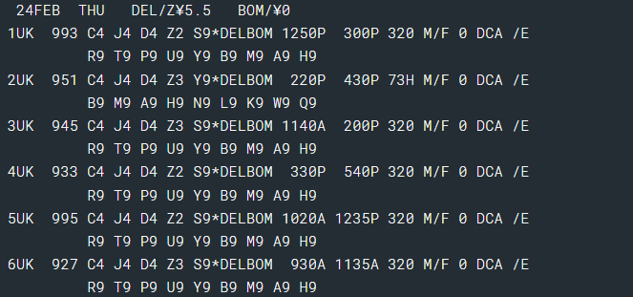

1. Add the name of the passenger. E.g Mr. Rohan Sharma

Ans: -Sharma/Rohan

1. Add the ticketing time in the taw for 20Feb.

Ans: 7TAW/20FEB

1. Delete the phone number in Phone field ( Line number 3)

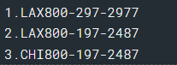

Ans: 93CHANGEKEY

1. Change and edit the phone number on line number 2.

Ans: 92CHANGEKEYLAX1800-197-2487-H

1. Change Email Address Field (line number 1)



Ans: PE1?EMAIL@ADDRESS.COM?

1. To change the name of passenger on line number 2.



Ans: -2.1CHANGEKEYLASTNAME/MR DAVIN

1. To delete the name on the line number 1.

Ans: -1.1CHANGEKEY

1. To Add remarks - PNR is non-Refundable.

Ans: 5- PNR IS NON-REUNDABLE

1. To delete remarks on line number 74.

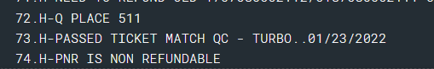

Ans: 574CHANGEKEY

1. Add Check FOP

Ans: 5-CK

1. Fill in the types of Card in the below format.

|  |  |
| --- | --- |
| **American Express** | **AX** |
| **VISA** | **VI** |
| **Diner's Club** | **DC** |
| **Master Card** | **CA** |
| **Discover** | **DS** |

1. Fill in below Format:

|  |  |
| --- | --- |
| **To display availability:** | **Use this format:** |
| **Default to current date/time** | 1PHLDFW |
| **With date** | 123MAYPHLDFW |
| **With specific departure time** | 123JUNATLDFW10A |
| **With specific arrival time** | 123JULATLDFW/2P |
| **Specific class of service** | 123JUNPHLSTL10A-Q |
| **Specific class of service for multiple passengers** | 123JUNPHLSTL10A-3Q |
| **Specific connecting city** | 123JUNATLLAX9AORD |
| **One Airline** | 108MAYMSPLAX?UA |
| **Exclude all code share flights for all airlines** | 120AUGMSPJFK |
|  |
| **More availability** | 1* |
| 1*7A(New Departure Time) |
| 1*/1P New arrival time |
| 1*C  (ADDITIONAL Uses of services) |
| 1*0A (back to top) |
| **Direct flights only** | 123JUNATLPDX/D |
| **Return Flight** | 1R |
| 1R10 (with new time) |
| 1R15 (with new day of month) |
| 1RUAUG (WITH NEW DAY OF NEW NEW MONTH ) |
| 1R-(NUMBER OF DAYS*/NEW TIME) |
| 1R‡(Number of days added) |
| 1R-9(number of day Subtracted) |
| **Display Last Availability** | 1*R |
| **Display Direct Access Availability** | (Changkey Host carrier code/Air availability Request) |
| **Shows hidden stop from availability** | VA*1 |

1. Fill in the format:

|  |  |
| --- | --- |
| **To cancel:** | **Use this format:** |
| **Air segments only** | X1 |
| **Single Segment 2** | X2 |
| **Segments 2 and 5** | X2/5 |
| **Segments 2 through 5** | X2-5 |
| **Segment 1 to B class** | WC1B |
| **All segments to Y class** | WCAY |
| **Cancel and rebook for new date** | X4? 0030JAN |
| **Segment and reference sell from availability X** | X4?01B3 |
| **Long sell** | X2?0AA4081Y30JANORDCVGNN1 |
| **Segment 2 to HK** | .2HK |
| **All segments to HK (schedule change)** | .HKALL |
| **Passive Cancel** | .1-3XK |

1. Fill in the Format:

|  |  |
| --- | --- |
| **To insert:** | **Use this format:** |
| **After segment 0, segment 2** | /0/2 |
| **After segment 1, segments 6 through 8** | /1/6-8 |
| **After segment 1, segments 5 and 7** | /1/5,7 |
| **After segment 1, insert ARNK** | /1/0A |

1. Fill in the format:

|  |  |
| --- | --- |
| **To:** | **Use this format:** |
| **Display Name Field** | *N |
| **Add Ticketing Field for Today** | 7TAW/ |
| **Change Ticketing Field** | 7@TAW/TICKETING OID(Date)/ |
| **Change Ticketing Field (exchange)** | 7@TAW/TICKETING OID(Date)/ EXCHANGE |
| **Add Ticketing Field (exchange)** | 7TAW/TICKETING OID(Date)/ EXCHANGE |
| **Modify Ticket Field to show already ticketed** | 7CHANGEKEYT-A |
| **Display Ticketing Field** | *T |
| **Display Active Tickets** | *TA |
| **Display Inactive Tickets** | *TIA |
| **Display Form of Payment** | *- |
| **Display Unique Remarks** | *P5 |
| **Display Lines of Remarks** | *P5*XX/YY |
| **Received field and Sabre record locator** | *P6 |
| **Seats** | *B |
| **Frequent Flyer** | *FF |
| **Display OSI/SSR** | *P3, *P4 |
| **Display Secure Flight Docs** | *P4D, *P3D |

1. Fill in the format:

|  |  |
| --- | --- |
| **To:** | **Use this format:** |
| **Display all ticket records** | *T |
| **Display ticket record 2** | WETR*2 |
| **Display by Ticket Number** | WETR*T00101234567891(Entire Ticket Number) |
| **Display ticketing history** | WETR*H |