## API Link

<http://localhost:3000/courseInfo>

## API Response from server to client

|  |  |  |  |
| --- | --- | --- | --- |
| |  |  |  | | --- | --- | --- | | object |  | {1} | |
|  |  | |  |  |  |  | | --- | --- | --- | --- | |  | array |  | [1] | |
|  |  | |  |  |  |  | | --- | --- | --- | --- | |  | 0 |  | {8} | |
|  |  | |  |  |  |  | | --- | --- | --- | --- | |  | _id | : | 5b09a277b7a9fac06bf8cee8 | |
|  |  | |  |  |  |  | | --- | --- | --- | --- | |  | course_id | : | 1001 | |
|  |  | |  |  |  |  | | --- | --- | --- | --- | |  | course_name | : | JAVA | |
|  |  | |  |  |  |  | | --- | --- | --- | --- | |  | course_desc | : | JAVA 8 Feature | |
|  |  | |  |  |  |  | | --- | --- | --- | --- | |  | course_key_features | : | JAVA 8 Features | |
|  |  | |  |  |  |  | | --- | --- | --- | --- | |  | topic |  | [3] | |
|  |  | |  |  |  |  | | --- | --- | --- | --- | |  | 0 |  | {6} | |
|  |  | |  |  |  |  | | --- | --- | --- | --- | |  | topic_id | : | 100101 | |
|  |  | |  |  |  |  | | --- | --- | --- | --- | |  | topic_name | : | Collections | |
|  |  | |  |  |  |  | | --- | --- | --- | --- | |  | topic_desc | : | collections | |
|  |  | |  |  |  |  | | --- | --- | --- | --- | |  | topic_video_link | : | ../server/topic_1 | |
|  |  | |  |  |  |  | | --- | --- | --- | --- | |  | topic_video_format | : | video/mp4 | |
|  |  | |  |  |  |  | | --- | --- | --- | --- | |  | topic_video_name | : | collection | |
|  |  |  |
|  |  | |  |  |  |  | | --- | --- | --- | --- | |  | 1 |  | {6} | |
|  |  | |  |  |  |  | | --- | --- | --- | --- | |  | 2 |  | {6} | |
|  |  |  |
|  |  | |  |  |  |  | | --- | --- | --- | --- | |  | recommended_vidio |  | [4] | |
|  |  | |  |  |  |  | | --- | --- | --- | --- | |  | 0 |  | {3} | |
|  |  | |  |  |  |  | | --- | --- | --- | --- | |  | recommended_id | : | 100111 | |
|  |  | |  |  |  |  | | --- | --- | --- | --- | |  | recommended_name | : | Phython | |
|  |  | |  |  |  |  | | --- | --- | --- | --- | |  | recommended_desc | : | python | |
|  |  |  |
|  |  | |  |  |  |  | | --- | --- | --- | --- | |  | 1 |  | {3} | |
|  |  | |  |  |  |  | | --- | --- | --- | --- | |  | 2 |  | {3} | |
|  |  | |  |  |  |  | | --- | --- | --- | --- | |  | 3 |  | {3} | |
|  |  |  |
|  |  | |  |  |  |  | | --- | --- | --- | --- | |  | course_faq |  | {2} | |
|  |  | |  |  |  |  | | --- | --- | --- | --- | |  | fq1 | : | what is java | |
|  |  | |  |  |  |  | | --- | --- | --- | --- | |  | fq2 | : | what is collections | |

## API for fetching the course_info

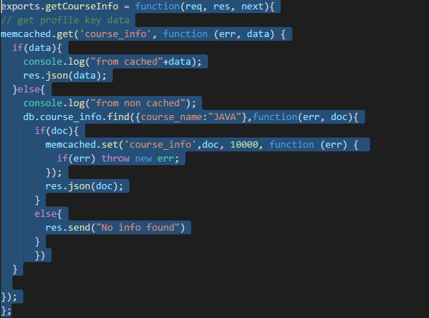

## Memcached

After implementation of memcached the performance of fetching the result from query increased from 39 MS to 2 MS.

