PCAP Network Analysis: A TShark-Based Engine and Dashboard
<Member 1 Full Name>  Roll No. | <Member 2 Full Name>  Roll No. | <Member 3 Full Name>  Roll No.

I. Introduction
Packet captures (PCAP files) show exactly what happened on a network. Tools like Wireshark decode them well, but understanding a capture still means scrolling through thousands of packets and knowing what each label really proves. For example, a retransmission does not always mean congestion [1], [4].
This project is an offline PCAP analysis tool. A Python engine lets TShark [9] decode the packets, then groups and calculates the results. A FastAPI backend serves the engine, a React dashboard shows an overview first and details on click, and two Jupyter notebooks use the same engine.
Contributions. (1) One TShark-based engine shared by the API and the notebooks. (2) Detailed TCP analysis: flows, RTT, flow control, options and a careful congestion check. (3) Detail pages for UDP, DNS, TLS, QUIC, ARP and IP; all other protocols are counted on the overview. (4) Every value is marked as observed, derived or inferred; missing values say "Not available" with a reason. (5) A check that compares 30 values with independent TShark counts. (6) Tests on synthetic captures and on captures up to 252,000 packets.

II. Problem Statement
Problem. Given a PCAP or PCAPNG file, show which protocols are present, who talks to whom, how each TCP connection behaves, and what the application protocols did, without presenting guesses as facts.
Input. One capture file, uploaded in the browser or passed to the engine from a notebook. Output. An overview page, detail pages (metrics, charts, tables, packet decode) and a JSON report with warnings.
Assumptions and limits. Analysis is offline and the capture comes from one point in the network. TShark 4.x must be installed. No decryption keys are used, so TLS and QUIC data stay hidden. Results are kept in memory (about 4 KB per packet).
Scope. In: TCP, UDP, DNS, TLS, QUIC, ARP and IP pages; an overview of all protocols; packet decode; validation; notebooks. Out: live capture, decryption, geolocation, QUIC-specific metrics.
Gap. Wireshark is manual, and many scripts only print tables without saying what a value proves. We use Wireshark's own analysis, add clear summaries, are careful about guesses, and check results automatically.

III. Project Objectives
- O1 Input. Accept PCAP/PCAPNG; reject bad files with a clear message.
- O2 Overview first. Show capture facts and all protocols; detail pages only for TCP, UDP, DNS, TLS, QUIC, ARP and IP.
- O3 TCP depth. Per-flow packets, bytes, throughput, retransmissions, out-of-order, duplicate ACKs, RTT, flow control, options and congestion hints.
- O4 Correctness. All 30 cross-checks match, and planted values in test captures are recovered exactly.
- O5 Scale. Analyse at least 250,000 packets in under one minute on a laptop.
- O6 One engine. The API and both notebooks use the same engine.
- O7 Honesty. Missing values show a reason, never 0.
- O8 Quality. At least 45 automated tests.

V. Architecture and Design
Fig. 1 shows the system. The browser sends JSON requests to a thin FastAPI layer (upload, analyze, report, packet pages, packet decode). All analysis is in the engine. One TShark runner builds every command. A chunked extractor turns TShark output into a table, and the analyzers turn it into page descriptions (metrics, charts, tables) that the dashboard and notebooks draw.
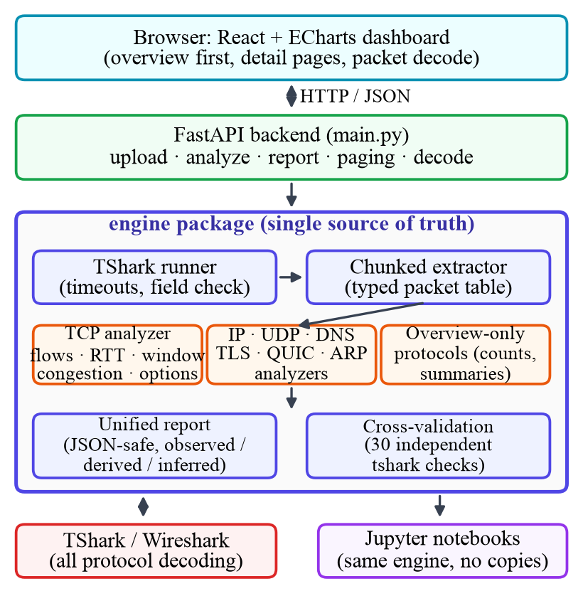
Fig. 1. System architecture.

A. Components
- Upload. Checks the file header and gives readable errors.
- Engine. Whole-capture totals from TShark statistics, plus a detailed pass over the packets.
- Analyzers. TCP [1], [5], IP, UDP, DNS [8], TLS [6], ICMP, HTTP, DHCP, RTP [7] and a generic view.
- Report and validation. One JSON report, and a check of 30 values against independent TShark counts.
- Dashboard. Overview, protocol cards, top navbar and tabs; any packet row opens its full decode.

B. Design decisions
- TShark for decoding. Wireshark's analysis is the reference users trust, so the engine uses its flags (tcp.analysis.*). Cost: TShark must be installed.
- One engine, thin API. No duplicate logic between notebooks and server.
- Page specs as data. One generic renderer serves many protocols; layouts are less custom.
- Results in memory. Simple and fast, but lost on restart.
- Chunked, typed parsing. Keeps memory near 4 KB per packet.
- Observed / derived / inferred. Each value shows how it was obtained; congestion is never shown as a measured number.

C. Request flow
The user uploads a file; the backend saves and checks it. Analyze then runs: (1) whole-capture totals; (2) packet extraction; (3) TCP analysis; (4) protocol detection and analyzers, in parallel; (5) summary and warnings. The report stays in memory. The browser fetches only what a page needs, and a packet decode runs tshark -V -x for that one packet.

D. Dashboard
The first page has capture facts, a protocol tree and chart for all protocols, cards for protocols with a detail page, and a table of the other protocols. A navbar is on every page. Detail pages use tabs; tables can be sorted, searched and paged.

VI. Implementation
Stack. Python 3.14 (FastAPI, pandas, NumPy), TShark 4.6.9, React 19, Vite and ECharts [10], and Jupyter. The code has about 2,600 lines in the engine (24 modules), 400 in the API and 1,800 in the frontend. Table I lists the engine modules.
TABLE I. ENGINE MODULES
Module | Job
tshark | Builds and runs TShark commands; checks which fields exist
capture | Validation and whole-capture statistics
extract | Chunked, typed packet extraction
tcp, tcp_views | Flows, RTT, window scaling, options, congestion; per-flow views
ip, udp, dns, tls, icmp, http, dhcp, rtp, generic | Protocol analyzers
detect | Protocol detection from TShark's protocol chain
report, validate | Final report and cross-validation
charts, util, config, errors | Helpers and error messages

A. TCP analysis
Flows follow tcp.stream. The client is the sender of the first pure SYN. The flow table has over 35 columns, including packets, bytes, duration, throughput, retransmissions, out-of-order, duplicate ACKs, zero windows and RTT. The dashboard shows ACK-based RTT and handshake RTT. Flow control is tracked per direction, and TCP options (MSS, window scale, SACK, timestamps, ECN) are split into those set in the handshake and those seen later.

B. Algorithms
Algorithm 1: effective receive window. Window scaling applies only if both SYNs carry the option [2].
client := sender of first pure SYN (else first packet)
shift[s] := window-scale option in side s's SYN
scaled := both SYNs captured and both have option
for each packet p from side s:
if p is SYN: eff := p.window
elif both SYNs captured:
eff := p.window * 2^shift[s] if scaled else p.window
else: eff := p.window; status := uncertain
Algorithm 2: congestion check (inferred). A flow is flagged only when several signs appear together.
loss := retx>0 or lostSeg>0 or dupACK>=3
rtt := p95/min >= 2 and samples >= 10
ecn := CE>0 or (ECN negotiated and ECE>0)
if few data packets and no loss/ecn/rwnd: insufficient
elif ecn: possible congestion (ECN signal)
elif loss and rtt: possible congestion
elif loss: possible loss or reordering
elif reorder/rwnd/rtt: weaker label
Conversation key. Conversations are grouped by (protocol, sorted endpoints), so two conversations with the same IPs but different ports are never merged.

C. Challenges and solutions
- Field names differ between TShark versions. The runner reads tshark -G fields and reports missing fields as unavailable.
- Query/response matching. DNS and ICMP matching needs a second pass, so those analyzers use -2.
- ICMP errors contain TCP/UDP headers. These are excluded from TCP and UDP counts.
- Memory. Chunked, typed parsing keeps it low.
Repository. https://github.com/CNProject
Folder layout. code/ holds backend/ (main.py, engine/), frontend/, notebook/, samples/ and start.sh/start.bat. ai/ holds the prompts, report/ this report, ppt/ the slides.

VII. Testbed Setup
Hardware and OS. Apple MacBook Air, M4 chip, 16 GB RAM, macOS 15.7.4. No GPU or sensors. Software. Python 3.14.0, TShark 4.6.9, FastAPI 0.162.0, pandas 3.1.0, NumPy 2.5.4, pytest 9.2.0, Node 24.1.0, npm 11.3.0, React 19, Vite 8, ECharts 6, Chrome.
Topology. No live network. Captures are analysed offline on one machine; the browser connects to 127.0.0.1:8000. Settings. Limits are off, TShark runs with -n, chunks of 200,000 rows.
Datasets. Table II lists the four sample captures with known content (made with Scapy) and five generated captures for scale tests.
TABLE II. DATASETS
Capture | Pkts | Content
demo | 42 | One TCP flow with loss and duplicate ACKs; DNS, ICMP, ARP
multi_flow | 313 | 4 TCP flows: clean, loss, reordering, slow RTT; DNS; UDP
tcp_features | 103 | MSS, window scale, SACK, timestamps, zero window, ECN, mid-stream flow
protocols_mix | 545 | multi_flow plus HTTP, TLS 1.2/1.3, ICMP, DHCP, RTP, NTP, ARP
scale (5) | 6.3k to 252k | Many TCP flows, 3.4 to 137.6 MB

VIII. Evaluation

A. Planted values
The sample captures contain known values. Table III shows the engine recovers all of them.
TABLE III. PLANTED VALUE VS ENGINE
Item | Planted | Engine
DNS queries / unanswered / NXDOMAIN | 9 / 2 / 1 | 9 / 2 / 1
HTTP requests / 4xx-5xx responses | 5 / 2 | 5 / 2
TLS ClientHellos / alerts | 5 / 1 | 5 / 1
ICMP errors / unanswered pings | 3 / 2 | 3 / 2
DHCP completed / NAK / no offer | 2 / 1 / 1 | 2 / 1 / 1
RTP streams / lost packets | 1 / 1 | 1 / 1
Zero-window advertisements | 2 | 2
Window updates | 1 | 1
Packets carrying SACK blocks | 4 | 4
CE-marked packets | 2 | 2
Window scale shifts (c / s) | 7 / 8 | 7 / 8
Client effective window, 500 x 2^7 (B) | 64,000 | 64,000

B. Cross-validation
After analysis, the check re-measures 30 values (packet, stream, retransmission, duplicate ACK, UDP, DNS, HTTP, TLS, DHCP, ICMP counts and more) with separate TShark commands. Table IV shows all 30 match on all four captures.
TABLE IV. CROSS-VALIDATION RESULTS
Capture | Pkts | Flows | Time (s) | Checks OK
demo | 42 | 1 | 1.04 | 30 / 30
multi_flow | 313 | 4 | 1.05 | 30 / 30
tcp_features | 103 | 3 | 0.93 | 30 / 30
protocols_mix | 545 | 11 | 1.34 | 30 / 30

C. Scalability
Five generated captures were analysed in a fresh process each. Time grows linearly at about 6,900 packets/s, and memory at about 4 KB per packet (Fig. 2, Table V). A 252,000-packet capture takes 36 s. A 1 GB capture would need roughly 5 to 7 GB of RAM (estimated, not measured).
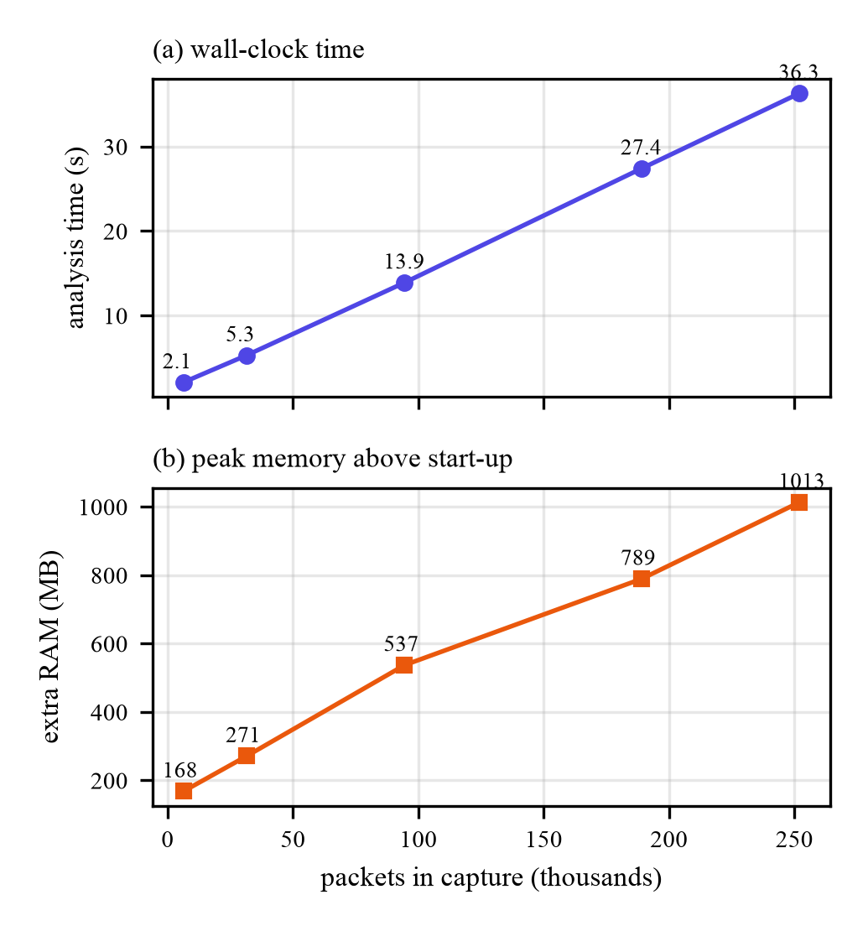
Fig. 2. Analysis time and memory versus capture size.
TABLE V. SCALE RESULTS
Packets | Size (MB) | Time (s) | RAM (MB)
6,300 | 3.4 | 2.1 | 168
31,500 | 17.2 | 5.3 | 271
94,500 | 51.6 | 13.9 | 537
189,000 | 103.2 | 27.4 | 789
252,000 | 137.6 | 36.3 | 1,013

D. Automated tests
48 tests passed. They cover flow roles, window scaling, conversation grouping, JSON safety, the sample captures (including one with no TCP), and the API (invalid files, unknown ids, paging).

E. Bad input
Table VI shows how the system handles bad or unusual input.
TABLE VI. INPUT HANDLING
Case | Behaviour
Empty or tiny file | Rejected with a message
Not a PCAP/PCAPNG file | Rejected with export advice
Corrupt file body | Readable engine error
TShark not installed | Message with install hints
Capture without TCP | Runs, with a warning
Handshake not captured | Window scale "uncertain"

F. Objectives
TABLE VII. OBJECTIVES VERSUS RESULTS
Obj. | Evidence | Met
O1 | Bad-input tests (Table VI) | Yes
O2 | All protocols counted; 7 detail pages | Yes
O3 | Flow table of 35+ columns; RTT, flow control, congestion, options | Yes
O4 | 30/30 checks on 4 captures; Table III exact | Yes
O5 | 252,000 packets in 36.3 s | Yes
O6 | API and notebooks use the engine | Yes
O7 | Not-available reasons shown | Yes
O8 | 48 tests passed | Yes

G. Limits of the evaluation
The test captures are synthetic, so they prove the decoding and maths are right but not that every real-world case is covered. Wireshark's own labels (for example retransmission versus out-of-order) are used as they are. Scale numbers come from one machine. Congestion results are inferences; a passive capture cannot confirm congestion.

IX. Summary
We built an offline PCAP analysis tool. The engine lets TShark decode packets and adds clear summaries and careful inference. The dashboard shows an overview first, with detail pages for TCP, UDP, DNS, TLS, QUIC, ARP and IP. On test captures every planted value was recovered, 30 of 30 cross-checks matched, 48 tests passed, and a 252,000-packet (138 MB) capture was analysed in 36 s using about 1 GB of memory.
Limitations. Memory grows with packet count; results are not saved; Analyze is one blocking request; QUIC and ARP use a generic page; tests use synthetic data on one machine. Future work. Background jobs with progress, a database for very large captures, QUIC-specific analysis, tests on large real captures, and live capture.

IX. Reproducibility
Repository: https://github.com/CNProject. Setup. Install TShark (brew install wireshark or sudo apt install tshark), Python 3.10+ and Node 18+. From the code folder:
./start.sh # builds UI, serves :8000
# open http://127.0.0.1:8000, upload a sample
cd backend && pip install -r requirements-dev.txt
pytest # 48 tests
RUN_LARGE=1 pytest tests/test_large.py -s
Sample captures and their generators are in samples/. The scale test builds N synthetic TCP flows and records time and peak memory of a fresh process. The notebooks (notebook/) print the same cross-validation table.

References
[1] W. Eddy, “Transmission Control Protocol (TCP),” RFC 9293, Aug. 2022.
[2] D. Borman, B. Braden, V. Jacobson, and R. Scheffenegger, “TCP extensions for high performance,” RFC 7323, Sep. 2014.
[3] P. Karn and C. Partridge, “Improving round-trip time estimates in reliable transport protocols,” in Proc. ACM SIGCOMM, Stowe, VT, USA, 1987, pp. 2–7.
[4] M. Allman, V. Paxson, and E. Blanton, “TCP congestion control,” RFC 5681, Sep. 2009.
[5] K. Ramakrishnan, S. Floyd, and D. Black, “The addition of explicit congestion notification (ECN) to IP,” RFC 3168, Sep. 2001.
[6] E. Rescorla, “The Transport Layer Security (TLS) protocol version 1.3,” RFC 8446, Aug. 2018.
[7] H. Schulzrinne, S. Casner, R. Frederick, and V. Jacobson, “RTP: A transport protocol for real-time applications,” RFC 3550, Jul. 2003.
[8] P. Mockapetris, “Domain names – implementation and specification,” RFC 1035, Nov. 1987.
[9] Wireshark Foundation, “TShark – dump and analyze network traffic,” manual page, https://www.wireshark.org/docs/man-pages/tshark.html.
[10] D. Li et al., “ECharts: A declarative framework for rapid construction of web-based visualization,” Visual Informatics, vol. 2, no. 2, pp. 136–146, 2018.

Appendix A: Team Work Distribution and Member Rating

A.1 Work Distribution
- Ratings are agreed by the whole team and must be UNIQUE no two members may receive the same rating (no ties).
- Scale: 1–10 (10 = highest contribution). With 3 members, use three different values (e.g., 10, 9, 8).

# | Member Name | Roll No. | Tasks Done | Rating (1–10, unique)
1 | <Member 1>
2 | <Member 2>
3 | <Member 3>

Appendix B: AI Usage Details

B.1 Prompts
The tool was Claude (Anthropic), used through the Claude desktop app (Claude Code), model Sonnet 5.5. The prompts are in the ai/ folder (ai/prompts.md).

# | AI Tool | Purpose
1 | Claude (Sonnet 5.5) | Turning the project brief into the analysis notebook based on TShark commands.
2 | Claude (Sonnet 5.5) | Writing the Python engine, FastAPI backend, React/ECharts dashboard and notebooks.
3 | Claude (Sonnet 5.5) | Writing sample-capture generators, tests and benchmarks; debugging.
4 | Claude (Sonnet 5.5) | Dashboard changes requested by the team and drafting this report.

Relevant Prompt queries and response .md files be shared on the github <AI Prompts> folder.

