**Hotel Management System**

Home Page:

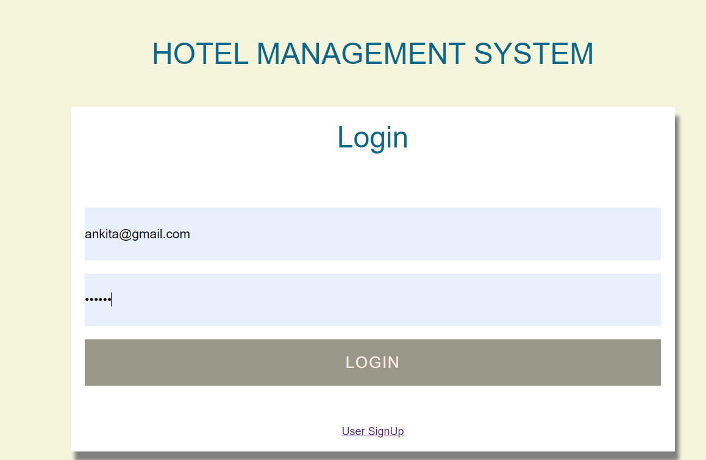

Superadmin Menu:

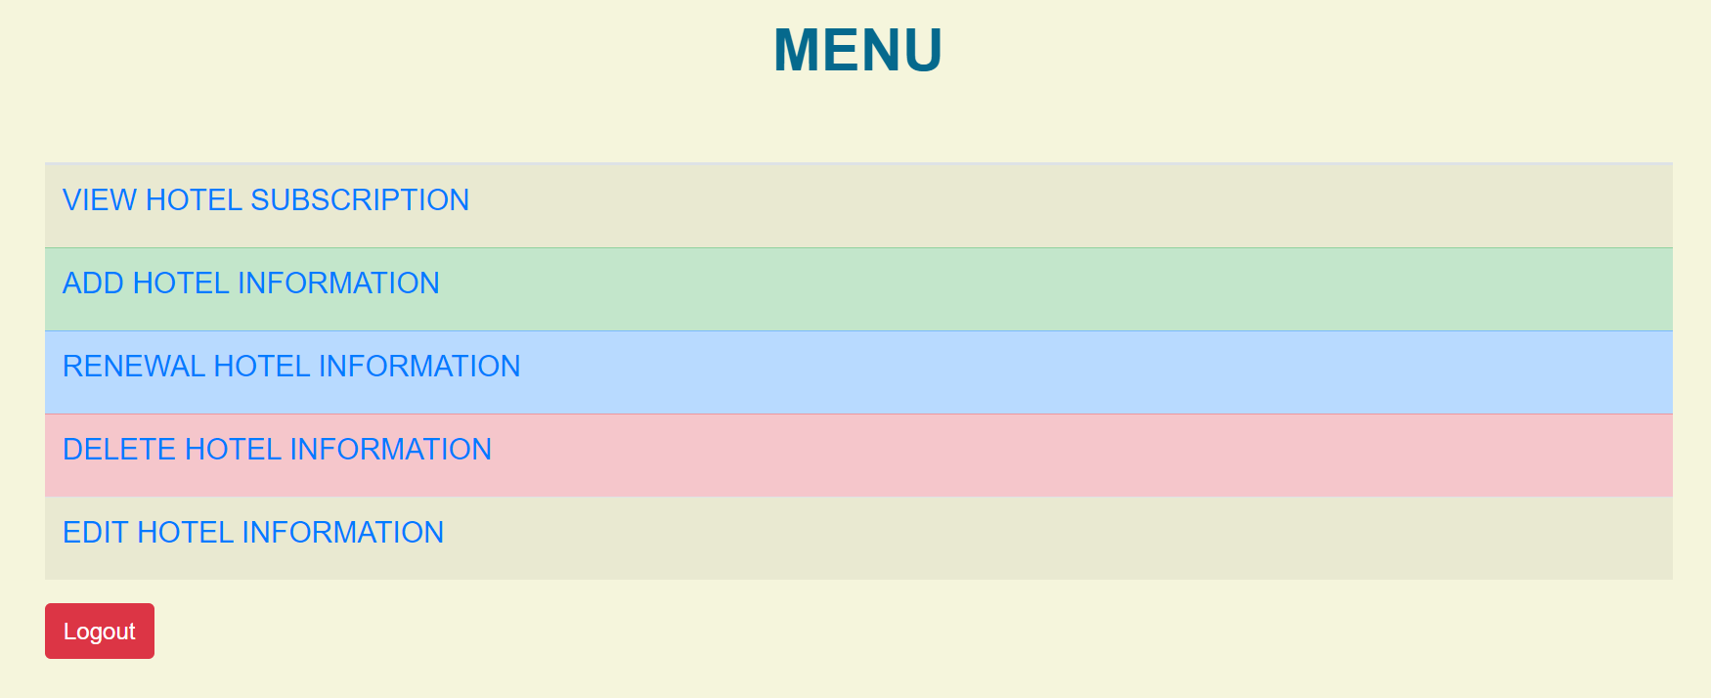

Add Hotel Detail:

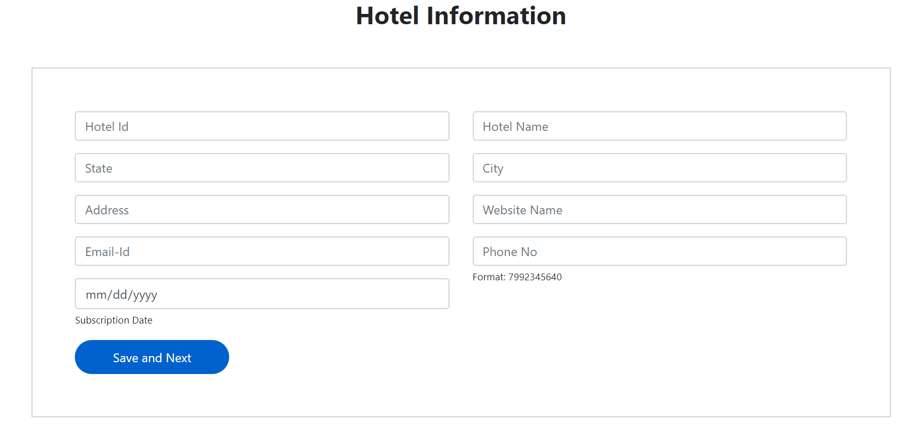

Add Manager Detail:

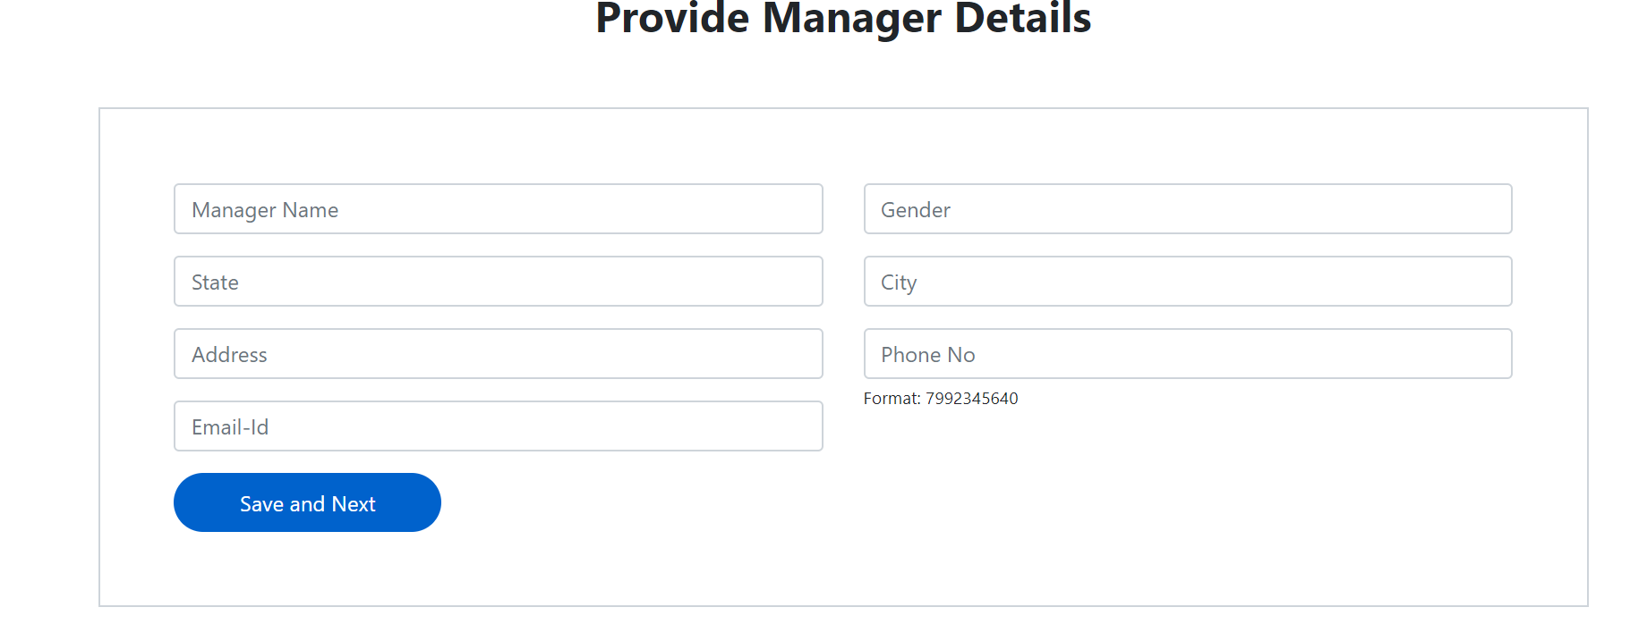

Set Hotel Admin Password:

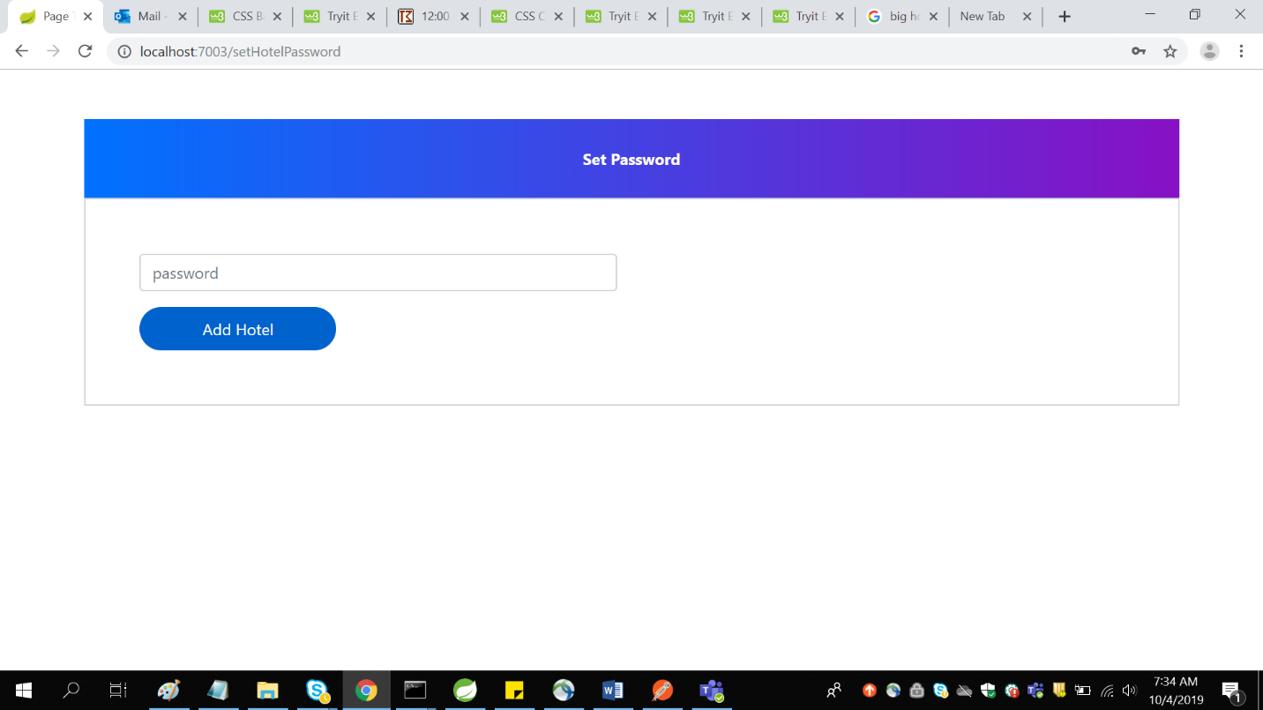

Delete Hotel Information:

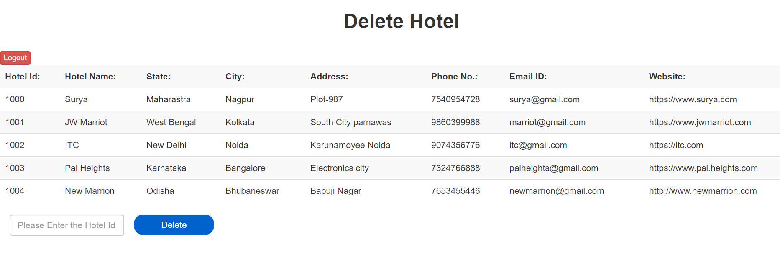

Renew Hotel Details:

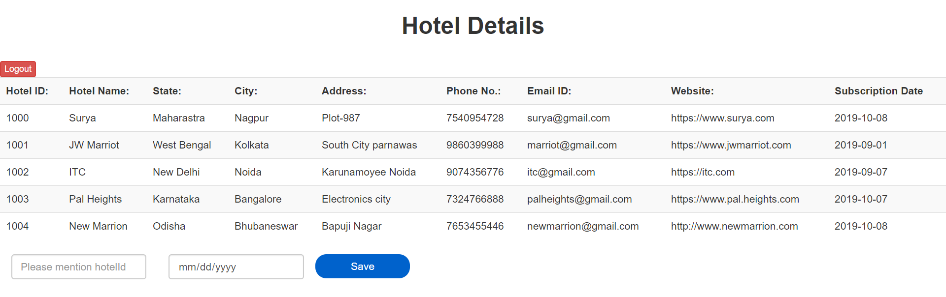

Edit Hotel Details:

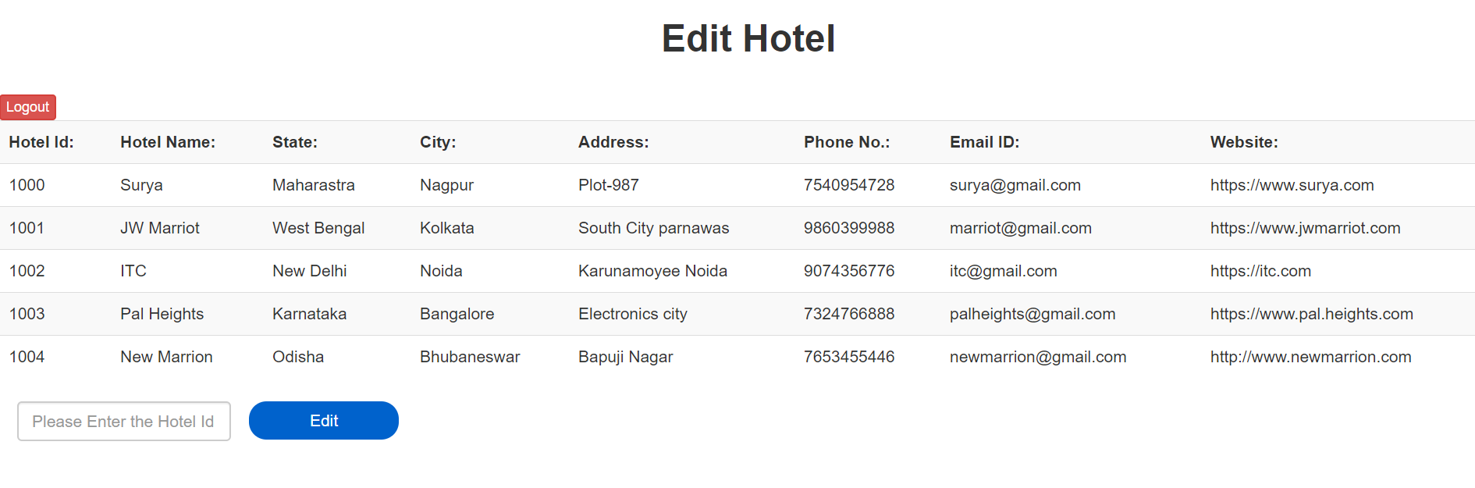

Edit Hotel Information:



View Active subscribed Hotels:

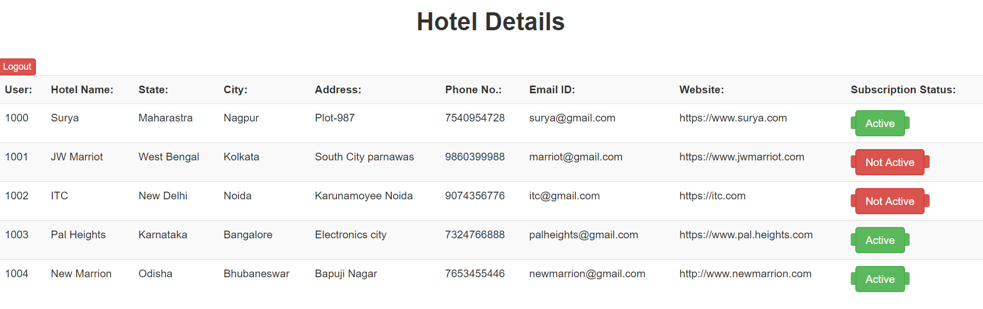

Invalid Hotel Id:

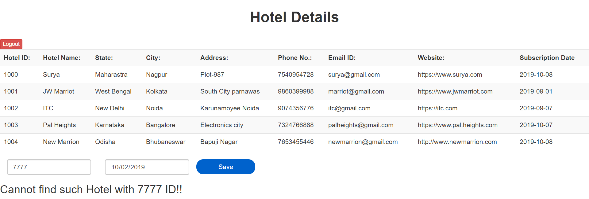

Invalid hotel details while deleting:

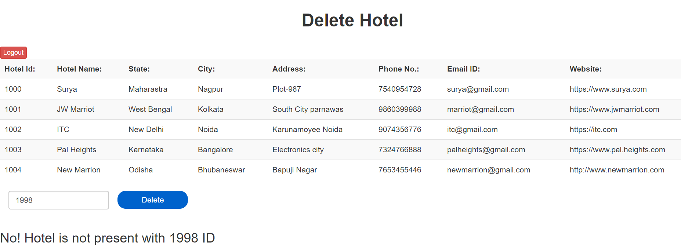

Invalid Hotel Details while editing:

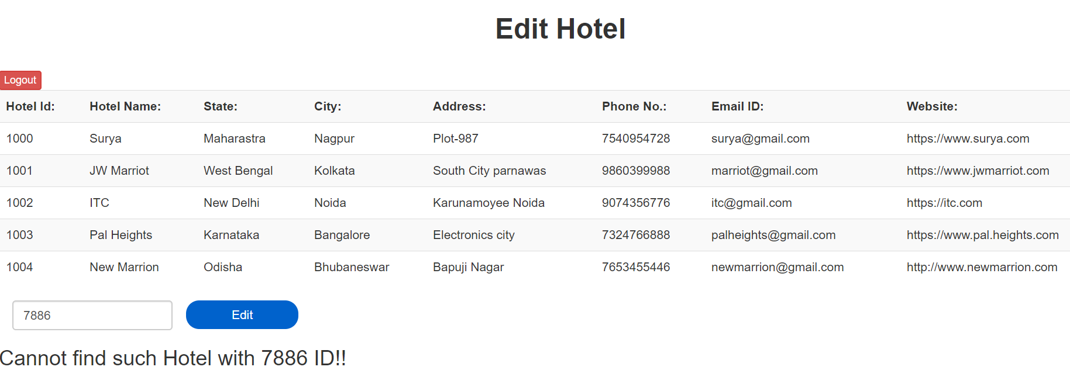

Admin Login:

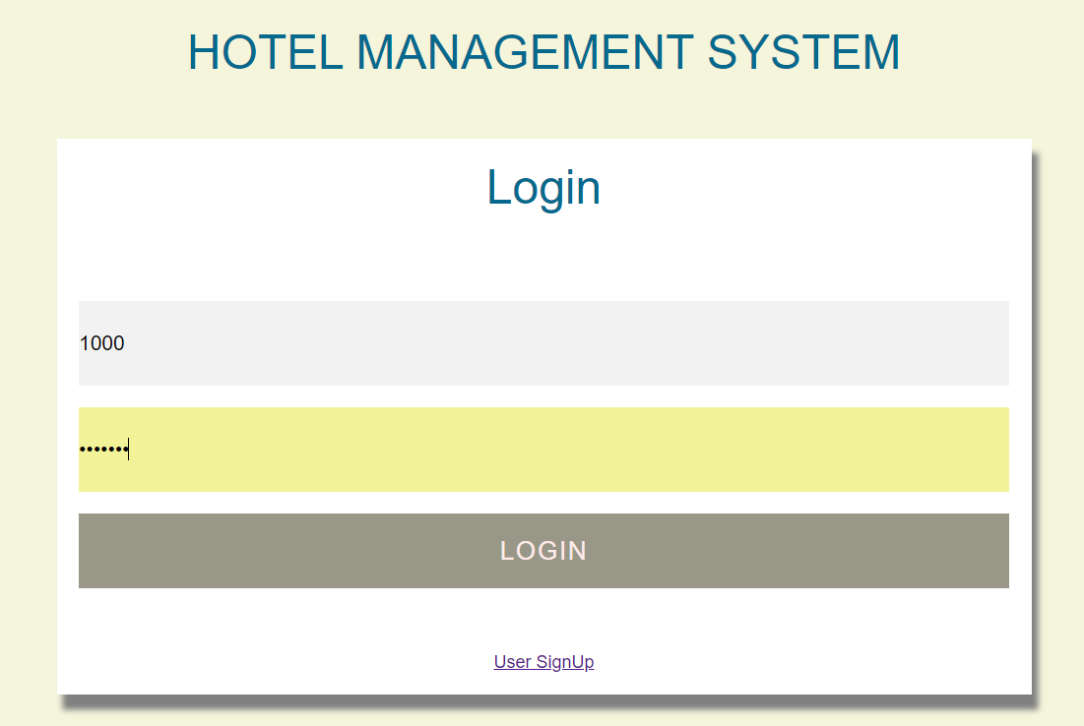

Admin Hotel Menu:

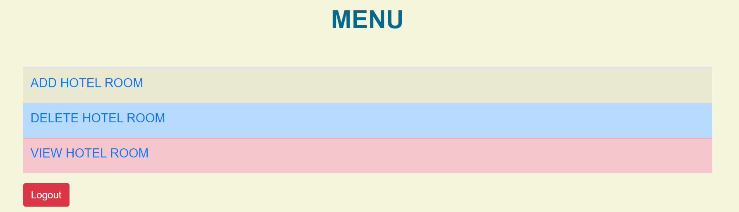

Add Hotel room:

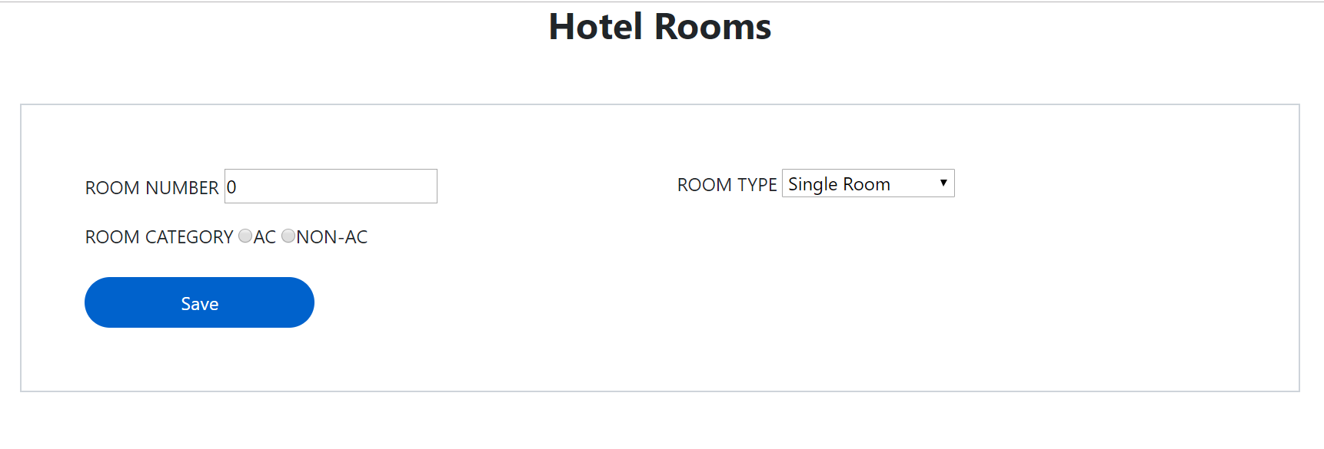

Delete Hotel room:

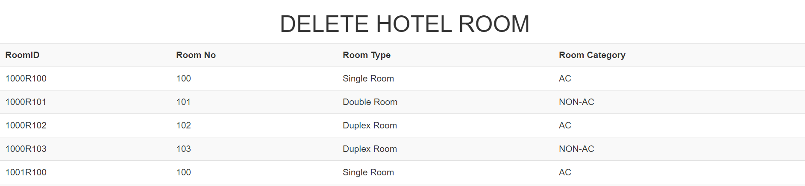



View Hotel Room:

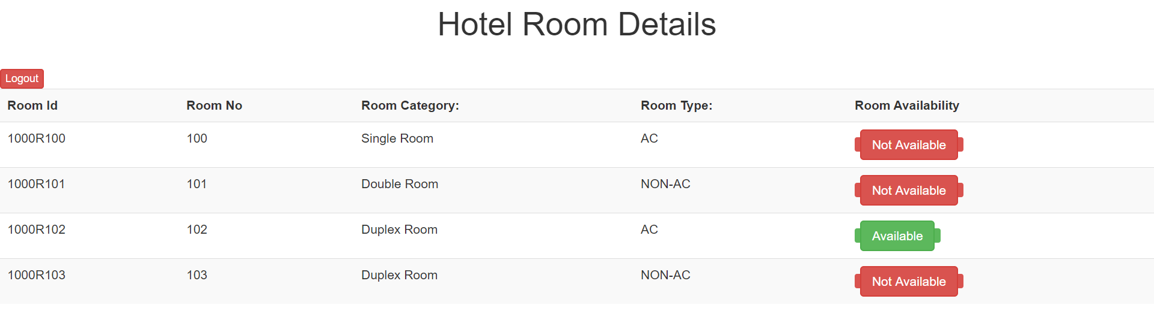

User Registration:

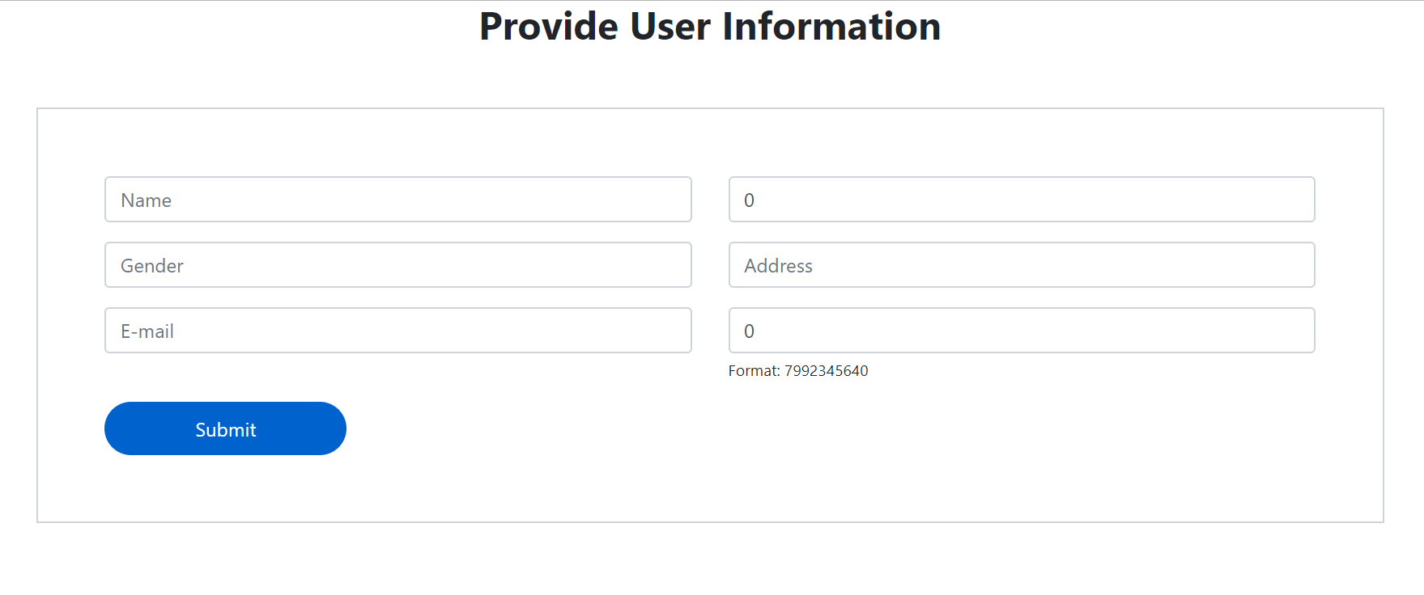

User Login:

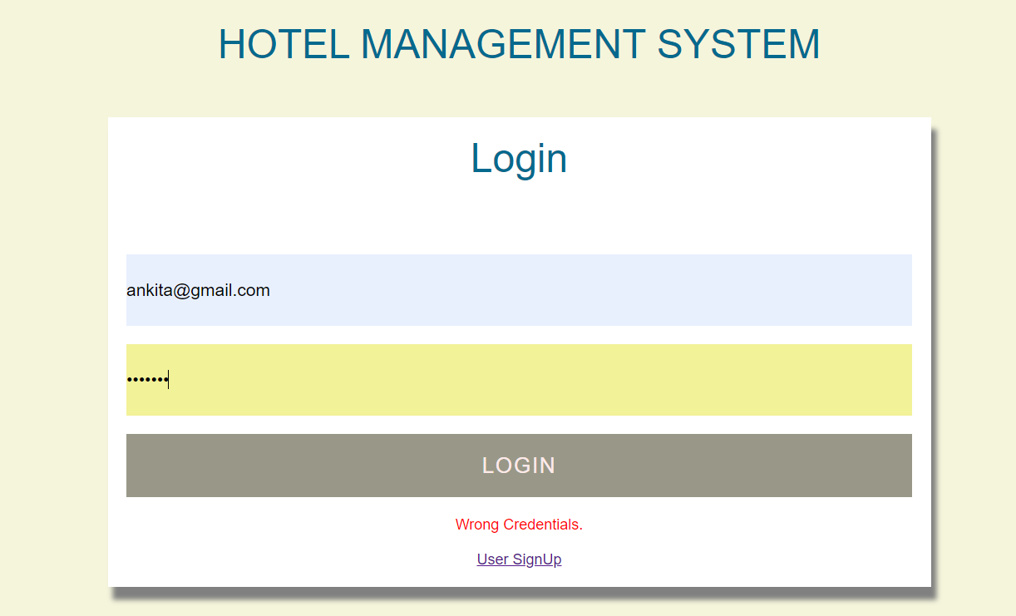

View Hotel Details to user:

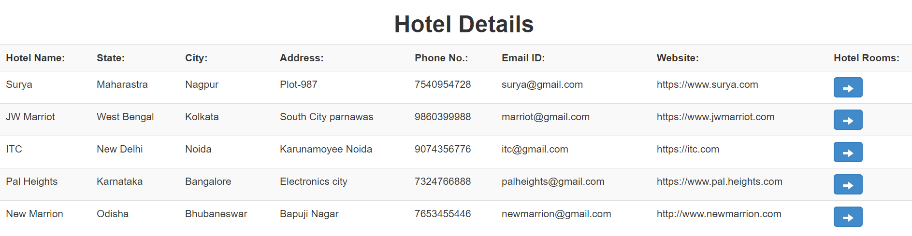

User selection room details:

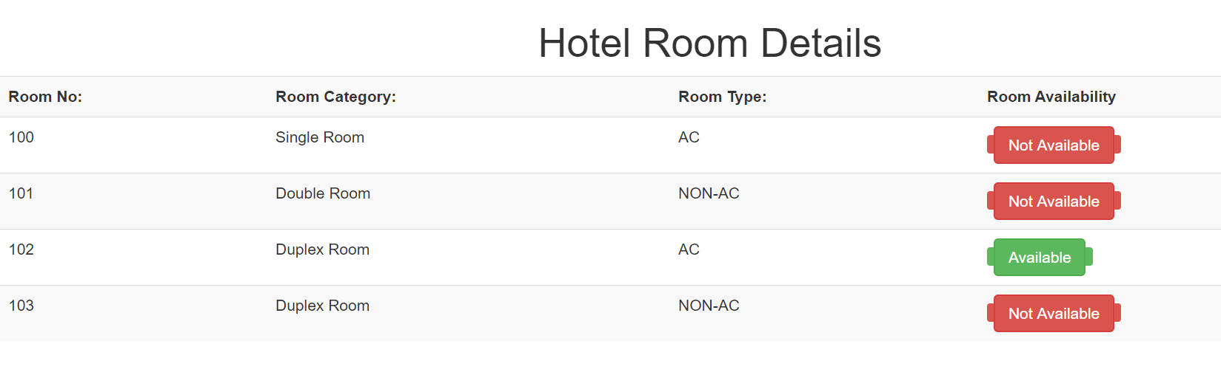

User filling room details:

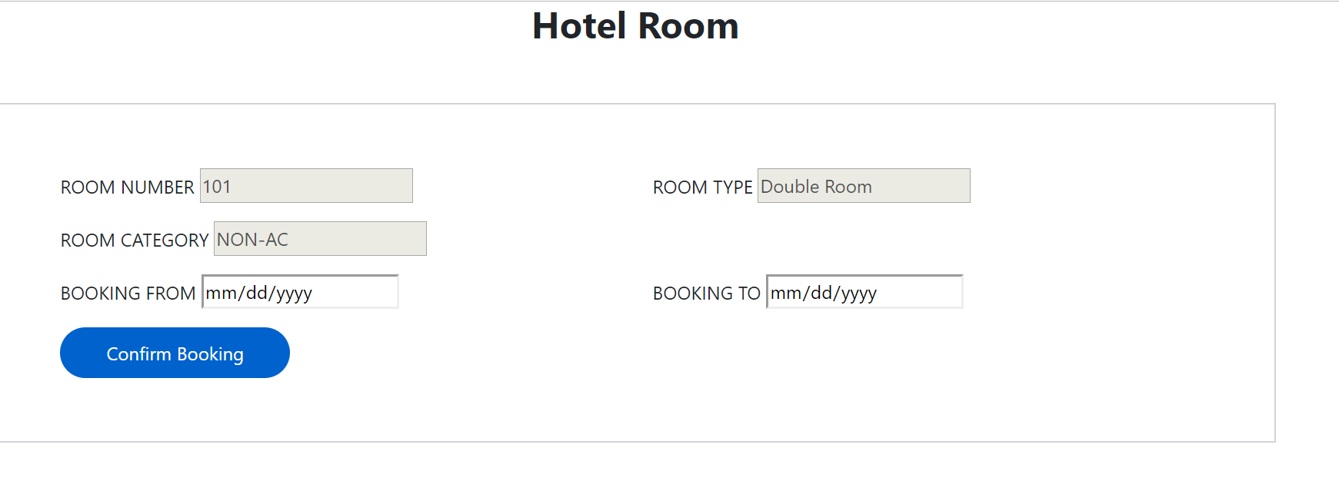

Booking Confirmation:

