Exception: An unwanted unexpected event that disturbs normal flow of the program is
called exception.

Example:
SleepingException
TyrePunchuredException
FileNotFoundException ...etc

• It is highly recommended to handle exceptions. The main objective of exception
handling is graceful (normal) termination of the program.

For every thread JVM will create a separate stack at the time of Thread creation. All
method calls performed by that thread will be stored in that stack. Each entry in the
stack is called "Activation record" (or) "stack frame".
After completing every method call JVM removes the corresponding entry from the
stack.
After completing all method calls JVM destroys the empty stack and terminates the
program normally.

Default Exception Handling in Java:
Default Exception Handling in Java:

1. If an exception raised inside any method then that method is responsible to
create Exception object with the following information.

A. Name of the exception.
B. Description of the exception.
C. Location of the exception.(StackTrace)

2. After creating that Exception object, the method handovers that object to the
JVM.

3. JVM checks whether the method contains any exception handling code or not. If
method won't contain any handling code then JVM terminates that method
abnormally and removes corresponding entry form the stack.

4. JVM identifies the caller method and checks whether the caller method contain
any handling code or not. If the caller method also does not contain handling
code then JVM terminates that caller method also abnormally and removes
corresponding entry from the stack.

5. This process will be continued until main() method and if the main() method also
doesn't contain any exception handling code then JVM terminates main()
method also and removes corresponding entry from the stack.
6. Then JVM handovers the responsibility of exception handling to the default
exception handler.

7. Default exception handler just print exception information to the console in the
following format and terminates the program abnormally.

Exception in thread “xxx(main)” Name of exception: description
Location of exception (stack trace)

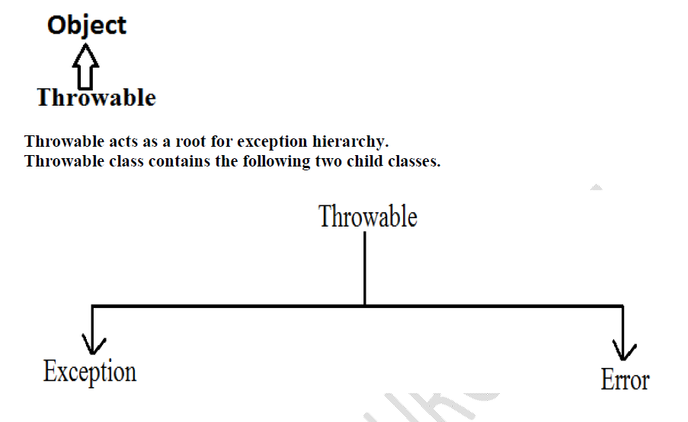

Checked Vs Unchecked Exceptions:

• The exceptions which are checked by the compiler whether programmer
handling or not, for smooth execution of the program at runtime, are called
checked exceptions.

1. HallTicketMissingException
2. PenNotWorkingException
3. FileNotFoundException

The exceptions which are not checked by the compiler whether programmer
handing or not ,are called unchecked exceptions.
1. BombBlastException
2. ArithmeticException
3. NullPointerException

Note: RuntimeException and its child classes, Error and its child classes are unchecked
and all the remaining are considered as checked exceptions.

Note: Whether exception is checked or unchecked compulsory it should occurs at
runtime only and there is no chance of occurring any exception at compile time.

Fully checked Vs Partially checked :
A checked exception is said to be fully checked if and only if all its child classes are also
checked.

Example:
1) IOException
2) InterruptedException

A checked exception is said to be partially checked if and only if some of its child classes
are unchecked.

:The only possible partially checked exceptions in java are:
1. Throwable.
2. Exception.

Customized Exception Handling by using try-catch:

• It is highly recommended to handle exceptions.
• In our program the code which may raise exception is called risky code, we have
to place risky code inside try block and the corresponding handling code inside
catch block.

Note:
1. Within the try block if anywhere an exception raised then rest of the try block
won't be executed even though we handled that exception. Hence we have to
place/take only risk code inside try block and length of the try block should be as
less as possible.

2. If any statement which raises an exception and it is not part of any try block then
it is always abnormal termination of the program.

3. There may be a chance of raising an exception inside catch and finally blocks
also in addition to try block.

Try with multiple catch blocks:

The way of handling an exception is varied from exception to exception. Hence for every
exception type it is recommended to take a separate catch block. That is try with
multiple catch blocks is possible and recommended to use.

If try with multiple catch blocks present then order of catch blocks is very
important. It should be from child to parent by mistake if we are taking from
parent to child then we will get Compile time error saying

"exception xxx has already been caught"

return Vs finally:
Even though return statement present in try or catch blocks first finally will be executed
and after that only return statement will be considered. i.efinally block dominates
return statement.

If return statement present try, catch and finally blocks then finally block return
statement will be considered.

There is only one situation where the finally block won't be executed is whenever we are
using System.exit(0) method.
When ever we are using System.exit(0) then JVM itself will be shutdown , in this case
finally block won't be executed.

throw statement:
Sometimes we can create Exception object explicitly and we can hand over to the JVM
manually by using throw keyword.

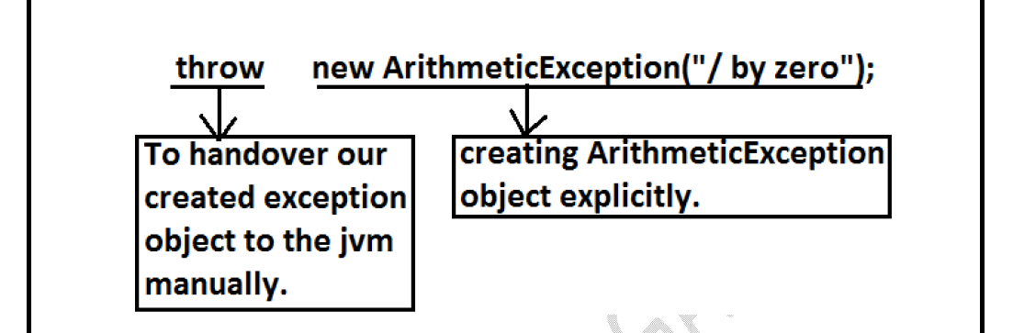

Note: In general we can use throw keyword for customized exceptions but not for
predefined exceptions.

Case 1:
If e refers null then we will get NullPointerException.

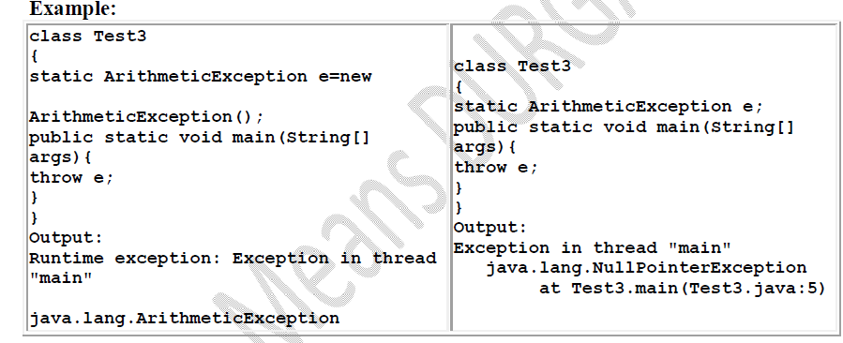

Case 2:
After throw statement we can't take any statement directly otherwise we will get
compile time error saying unreachable statement.

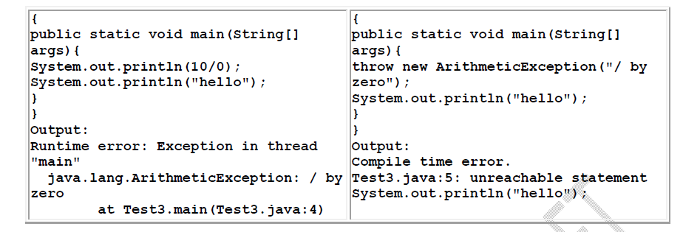

Case 3:
We can use throw keyword only for Throwable types otherwise we will get compile time
error saying incomputable types.

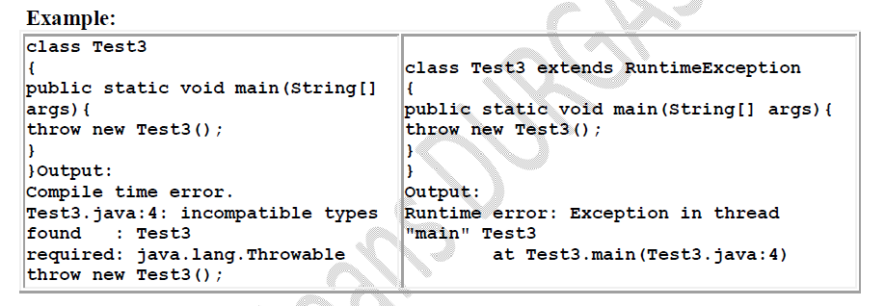

Throws statement:
In our program if there is any chance of raising checked exception then compulsory we
should handle either by try catch or by throws keyword otherwise the code won't
compile.
We can use throws keyword to delegate the responsibility of exception handling to the caller method. Then caller method is responsible to handle that exception.

Sometimes we can create Exception object explicitly and we can hand over to the JVM
manually by using throw keyword.

Hence the main objective of "throws" keyword is to delegate the responsibility of
exception handling to the caller method.
• "throws" keyword required only checked exceptions. Usage of throws for
unchecked exception there is no use.
• "throws" keyword required only to convince complier. Usage of throws keyword
doesn't prevent abnormal termination of the program.

We can use throws keyword only for constructors and methods but not for classes.

Customized Exceptions (User defined Exceptions):

Sometimes we can create our own exception to meet our programming requirements.
Such type of exceptions are called customized exceptions (user defined exceptions).

Note: It is highly recommended to maintain our customized exceptions as unchecked by
extending RuntimeException.
We can catch any Throwable type including Errors also.

They are:
1) JVM Exceptions:
2) Programmatic exceptions:
JVM Exceptions:

The exceptions which are raised automatically by the jvm whenever a particular event
occurs, are called JVM Exceptions.
Example:
1) ArrayIndexOutOfBoundsException(AIOOBE)
2) NullPointerException (NPE).

The exceptions which are raised automatically by the jvm whenever a particular event
occurs, are called JVM Exceptions.

Example:
1) ArrayIndexOutOfBoundsException(AIOOBE)
2) NullPointerException (NPE).

Programmatic Exceptions:

The exceptions which are raised explicitly by the programmer (or) by the API developer
are called programmatic exceptions.
Example: 1) IllegalArgumentException(IAE).

The main advantage of "try with resources" is
the resources which are opened as part of try block will be closed automatically
Once the control reaches end of the try block either normally or abnormally and hence
we are not required to close explicitly so that the complexity of programming will be
reduced.It is not required to write finally block explicitly and hence length of the code
will be reduced and readability will be improved.

2. All resources should be AutoCloseable resources. A resource is said to be auto
closable if and only if the corresponding class implements the java.lang.AutoCloseable
interface either directly or indirectly.
All database related, network related and file io related resources already
implemented AutoCloseable interface. Being a programmer we should aware and we
are not required to do anything extra.

