Collections in Java

The Collection in Java is a framework that provides an architecture to store and manipulate the group of objects.
All the operations that you perform on data such as searching, sorting, insertion, manipulation, deletion, etc. can be achieved by Java Collections.
Collection Framework defines several classes and interfaces to represent a group of objects as a single unit. Collections are used to store, retrieve, manipulate, and communicate aggregate data. Typically, they represent data items that form a natural group, such as a poker hand (a collection of cards), a mail folder (a collection of letters), or a telephone directory (a mapping of names to phone numbers).
Java Collections can achieve all the operations that you perform on a data such as searching, sorting, insertion, manipulation, and deletion.

Java Collection means a single unit of objects. Java Collection framework provides many interfaces (Set, List, Queue, Deque) and classes (ArrayList, Vector, LinkedList, PriorityQueue, HashSet, LinkedHashSet, TreeSet).

All collections frameworks contain the following:
- Interfaces: These are abstract data types that represent collections. Interfaces allow collections to be manipulated independently of the details of their representation. In object-oriented languages, interfaces generally form a hierarchy.
- Implementations: These are the concrete implementations of the collection interfaces. In essence, they are reusable data structures.
- Algorithms: These are the methods that perform useful computations, such as searching and sorting, on objects that implement collection interfaces. The algorithms are said to be polymorphic: that is, the same method can be used on many different implementations of the appropriate collection interface. In essence, algorithms are reusable functionality.

Collections in Java
- Java Collection Framework
- Hierarchy of Collection Framework
- Collection interface
- Iterator interface
Java Collection means a single unit of objects. Java Collection framework provides many interfaces (Set, List, Queue, Deque) and classes (ArrayList, Vector, LinkedList, PriorityQueue, HashSet, LinkedHashSet, TreeSet).

What is a framework in Java
- It provides readymade architecture.
- It represents a set of classes and interfaces.
- It is optional.

Hierarchy of Collection Framework
Let us see the hierarchy of Collection framework. The java.util package contains all the classes and interfaces for the Collection framework.
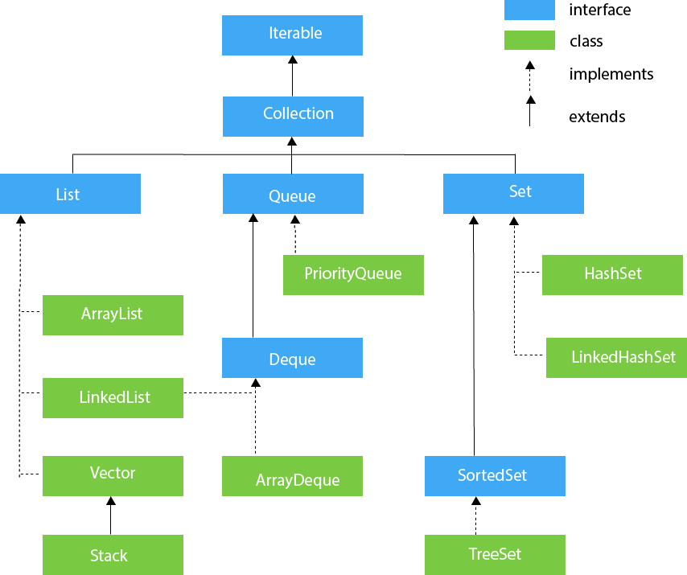

Methods of Collection interface
There are many methods declared in the Collection interface. They are as follows:
No. |  | Method | Description
1 | public boolean add(E e) |  |  | It is used to insert an element in this collection.
2 | public boolean addAll(Collection<? extends E> c) |  |  | It is used to insert the specified collection elements in the invoking collection.
3 | public boolean remove(Object element) |  |  | It is used to delete an element from the collection.
4 | public boolean removeAll(Collection<?> c) |  |  | It is used to delete all the elements of the  specified collection from the invoking collection.
5 | default boolean removeIf(Predicate<? super E> filter) |  |  | It is used to delete all the elements of the  collection that satisfy the specified predicate.
6 | public boolean retainAll(Collection<?> c) |  |  | It is used to delete all the elements of invoking  collection except the specified collection.
7 | public int size() |  |  | It returns the total number of elements in  the collection.
8 | public void clear() |  |  | It removes the total number of elements from  the collection.
9 | public boolean contains(Object element) |  |  | It is used to search an element.
10 | public boolean containsAll(Collection<?> c) |  |  | It is used to search the specified collection in  the collection.
11 | public Iterator iterator() |  |  | It returns an iterator.
12 | public Object[] toArray() |  |  | It converts collection into array.
13 | public <T> T[] toArray(T[] a) |  |  | It converts collection into array. Here,  the runtime type of the returned array is that  of the specified array.
14 | public boolean isEmpty() |  |  | It checks if collection is empty.
15 | default Stream<E> parallelStream() |  |  | It returns a possibly parallel Stream with the  collection as its source.
16 | default Stream<E> stream() |  |  | It returns a sequential Stream with the collection  as its source.
17 | default Spliterator<E> spliterator() |  |  | It generates a Spliterator over the specified  elements in the collection.
18 | public boolean equals(Object element) |  |  | It matches two collections.
19 | public int hashCode() |  |  | It returns the hash code number of the collection.

Iterator interface
Iterator interface provides the facility of iterating the elements in a forward direction only.

Methods of Iterator interface
There are only three methods in the Iterator interface. They are:
No. | Method | Description
1 | public boolean hasNext() | It returns true if the iterator has more elements otherwise it returns false.
2 | public Object next() | It returns the element and moves the cursor pointer to the next element.
3 | public void remove() | It removes the last elements returned by the iterator. It is less used.

Iterators are used in Collection framework in Java to retrieve elements one by one. There are three iterators. . By using Iterator, we can perform both read and remove operations. It is improved version of Enumeration with additional functionality of remove-ability of a element.
Iterator must be used whenever we want to enumerate elements in all Collection framework implemented interfaces like Set, List, Queue, Deque and also in all implemented classes of Map interface. Iterator is the only cursor available for entire collection framework.
Iterator object can be created by calling iterator() method present in Collection interface.
// Here "c" is any Collection object. itr is of
// type Iterator interface and refers to "c"
Iterator itr = c.iterator();

remove() method can throw two exceptions
- UnsupportedOperationException : If the remove operation is not supported by this iterator
- IllegalStateException : If the next method has not yet been called, or the remove method has already been called after the last call to the next method.

Iterable Interface
The Iterable interface is the root interface for all the collection classes. The Collection interface extends the Iterable interface and therefore all the subclasses of Collection interface also implement the Iterable interface.
It contains only one abstract method. i.e.,
- Iterator<T> iterator()
It returns the iterator over the elements of type T.

Collection Interface
The Collection interface is the interface which is implemented by all the classes in the collection framework. It declares the methods that every collection will have. In other words, we can say that the Collection interface builds the foundation on which the collection framework depends.
Some of the methods of Collection interface are Boolean add ( Object obj), Boolean addAll ( Collection c), void clear(), etc. which are implemented by all the subclasses of Collection interface.

Exception
- ArrayStoreException − If the runtime type of the specified array is not a supertype of the runtime type of every element in this list.
- NullPointerException − If the specified array is null.

List Interface in Java
The Java.util.List is a child interface of Collection. It is an ordered collection of objects in which duplicate values can be stored. Since List preserves the insertion order, it allows positional access and insertion of elements. List Interface is implemented by the classes of ArrayList, LinkedList, Vector and Stack.

public abstract interface List extends Collection
Creating List Objects:
List is an interface, and the instances of List can be created by implementing various classes in the following ways:
List a = new ArrayList();
List b = new LinkedList();
List c = new Vector();
List d = new Stack();
Generic List Object:
After the introduction of Generics in Java 1.5, it is possible to restrict the type of object that can be stored in the List. The type-safe List can be defined in the following way:
// Obj is the type of object to be stored in List
List<Obj> list = new ArrayList<Obj> ();
Operations on List:
List Interface extends Collection, hence it supports all the operations of Collection Interface, along with following additional operations:

Positional Access:
List allows add, remove, get and set operations based on numerical positions of elements in List. List provides following methods for these operations:

1. void add(int index, Object O): This method adds given element at specified index.
2. boolean addAll(int index, Collection c): This method adds all elements from specified
collection to list. First element gets inserted at given index. If there is already an
element at that position, that element and other subsequent elements(if any) are
shifted to the right by increasing their index.
3. Object remove(int index): This method removes an element from the specified index. It
shifts subsequent elements(if any) to left and decreases their indexes by 1.
4. Object get(int index): This method returns element at the specified index.
5. Object set(int index, Object new): This method replaces element at given index with
new element. This function returns the element which was just replaced by new element.

Search:
List provides methods to search element and returns its numeric position. Following two methods are supported by List for this operation:

- int indexOf(Object o): This method returns first occurrence of given element or
-1 if element is not present in list.

- int lastIndexOf(Object o): This method returns the last occurrence of given
element or -1 if element is not present in list.

Iteration:

ListIterator(extends Iterator) is used to iterate over List element. List iterator is bidirectional iterator. For more details about ListIterator refer Iterators in Java.

Range-view:
List Interface provides a method to get the List view of the portion of given List between two indices. Following is the method supported by List for range view operation.

- List subList(int fromIndex, int toIndex):This method returns List view of
specified List between fromIndex(inclusive) and toIndex(exclusive).

ListIterator:

- public interface ListIterator<E> extends Iterator<E>

It is only applicable for List collection implemented classes like arraylist, linkedlist etc. It provides bi-directional iteration.
ListIterator must be used when we want to enumerate elements of List. This cursor has more functionality(methods) than iterator.
ListIterator object can be created by calling listIterator() method present in List interface.
// Here "l" is any List object, ltr is of type
// ListIterator interface and refers to "l"
ListIterator ltr = l.listIterator();
ListIterator interface extends Iterator interface. So all three methods of Iterator interface are available for ListIterator. In addition there are six more methods.

// Forward direction

// Returns true if the iteration has more elements
public boolean hasNext();

// same as next() method of Iterator
public Object next();

// Returns the next element index
// or list size if the list iterator
// is at the end of the list
public int nextIndex();

// Backward direction

// Returns true if the iteration has more elements
// while traversing backward
public boolean hasPrevious();

// Returns the previous element in the iteration
// and can throws NoSuchElementException
// if no more element present
public Object previous();

// Returns the previous element index
// or -1 if the list iterator is at the
// beginning of the list
public int previousIndex();

// Other Methods

// same as remove() method of Iterator
public void remove();

// Replaces the last element returned by
// next() or previous() with the specified element
public void set(Object obj);

// Inserts the specified element into the list at
// position before the element that would be returned
// by next(),
public void add(Object obj);

Clearly the three methods that ListIterator inherits from Iterator (hasNext(), next(), and remove()) do exactly the same thing in both interfaces. The hasPrevious() and the previous operations are exact analogues of hasNext() and next(). The former operations refer to the element before the (implicit) cursor, whereas the latter refer to the element after the cursor. The previous operation moves the cursor backward, whereas next moves it forward.
ListIterator has no current element; its cursor position always lies between the element that would be returned by a call to previous() and the element that would be returned by a call to next()
set() method can throw four exceptions
- UnsupportedOperationException – if the set operation is not supported by this list iterator.
- ClassCastException : If the class of the specified element prevents it from being added to this list
- IllegalArgumentException : If some aspect of the specified element prevents it from being added to this list.
- IllegalStateException : If neither next nor previous have been called, or remove or add have been called after the last call to next or previous
add() method can throw three exceptions
- UnsupportedOperationException : If the add method is not supported by this list iterator
- ClassCastException : If the class of the specified element prevents it from being added to this list
- IllegalArgumentException : If some aspect of this element prevents it from being added to this list

Limitations of ListIterator : It is the most powerful iterator but it is only applicable for List implemented classes, so it is not a universal iterator.

Important Common Points
1 : Please note that initially any iterator reference will point to the index just before the index of first element in a collection.
2 : We don’t create objects of Enumeration, Iterator, ListIterator because they are interfaces. We use methods like elements(), iterator(), listIterator() to create objects. These methods have anonymous Inner classes that extends respective interfaces and return this class object. This can be verified by below code. For more on inner class refer.

// Java program to demonstrate iterators references
import java.util.Enumeration;
import java.util.Iterator;
import java.util.ListIterator;
import java.util.Vector;

public class Test
{
public static void main(String[] args)
{
Vector v = new Vector();

// Create three iterators
Enumeration e = v.elements();
Iterator itr = v.iterator();
ListIterator ltr = v.listIterator();

// Print class names of iterators
System.out.println(e.getClass().getName());
System.out.println(itr.getClass().getName());
System.out.println(ltr.getClass().getName());
}
}
Output:
java.util.Vector$1
java.util.Vector$Itr
java.util.Vector$ListItr
The $ symbol in reference class name is a proof that concept of inner classes is used and these class objects are created.

List Interface declaration
- public interface List<E> extends Collection<E>

Methods of Java List Interface
Method | Description
void add(int index, E element) | It is used to insert the specified element at the  specified position in a list.
boolean add(E e) | It is used to append the specified element at the end  of a list.
boolean addAll(Collection<? extends E> c) | It is used to append all of the elements in the  specified collection to the end of a list.
boolean addAll(int index, Collection<? extends E> c) | It is used to append all the elements in the  specified collection, starting at the specified position  of the list.
void clear() | It is used to remove all of the elements from this list.
boolean equals(Object o) | It is used to compare the specified object with the  elements of a list.
int hashcode() | It is used to return the hash code value for a list.
E get(int index) | It is used to fetch the element from the particular  position of the list.
boolean isEmpty() | It returns true if the list is empty, otherwise false.
int lastIndexOf(Object o) | It is used to return the index in this list of the last  occurrence of the specified element, or -1 if the  list does not contain this element.
Object[] toArray() | It is used to return an array containing all  of the elements in this list in the correct order.
T[] toArray(T[] a) | It is used to return an array containing  all of the elements in this list in the correct order.
boolean contains(Object o) | It returns true if the list contains the specified  element
boolean containsAll(Collection<?> c) | It returns true if the list contains all the specified  element
int indexOf(Object o) | It is used to return the index in this list of the first  occurrence of the specified element, or -1 if the  List does not contain this element.
E remove(int index) | It is used to remove the element present at the  specified position in the list.
boolean remove(Object o) | It is used to remove the first occurrence of  the specified element.
boolean removeAll(Collection<?> c) | It is used to remove all the elements from the list.
void replaceAll(UnaryOperator operator) | It is used to replace all the elements from the  list with the specified element.
void retainAll(Collection<?> c) | It is used to retain all the elements in the list that  are present in the specified collection.
E set(int index, E element) | It is used to replace the specified element in the list,  present at the specified position.
void sort(Comparator<? super E> c) | It is used to sort the elements of the list on the basis  of specified comparator.
Spliterator spliterator() | It is used to create spliterator over the elements  in a list.
List<E> subList(int fromIndex, int toIndex) | It is used to fetch all the elements lies within the  given range.
int size() | It is used to return the number of elements present  in the list.

Difference between ArrayList and LinkedList.
Comparision between ArrayList and LinkedList:-

- Insertions are easy and fast in LinkedList as compared to ArrayList because there is no risk of resizing array and copying content to new array if array gets full which makes adding into ArrayList of O(n) in worst case, while adding is O(1) operation in LinkedList in Java. ArrayList also needs to be update its index if you insert something anywhere except at the end of array.
- Removal also better in LinkedList than ArrayList due to same reasons as insertion.
- LinkedList has more memory overhead than ArrayList because in ArrayList each index only holds actual object (data) but in case of LinkedList each node holds both data and address of next and previous node.
- Both LinkedList and ArrayList require O(n) time to find if an element is present or not. However we can do Binary Search on ArrayList if it is sorted and therefore can search in O(Log n) time.

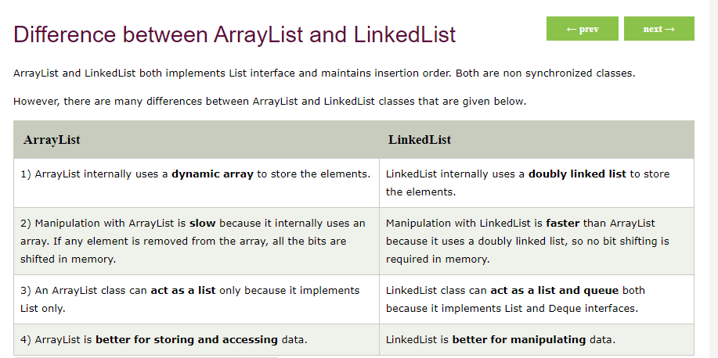

Difference between ArrayList and Vector
ArrayList and Vector both implements List interface and maintains insertion order.
However, there are many differences between ArrayList and Vector classes that are given below.
ArrayList | Vector
1) ArrayList is not synchronized. | Vector is synchronized.
2) ArrayList increments 50% of current array size if the number of elements exceeds from its capacity. | Vector increments 100% means doubles the array size if the total number of elements exceeds than its capacity.
3) ArrayList is not a legacy class. It is introduced in JDK 1.2. | Vector is a legacy class.
4) ArrayList is fast because it is non-synchronized. | Vector is slow because it is synchronized, i.e., in a  multithreading environment, it holds the other threads in  runnable or non-runnable state until current thread  releases the lock of the object.
5) ArrayList uses the Iterator interface to traverse the elements. | A Vector can use the Iterator interface or Enumeration interface to traverse the elements.

When Collections framework were added in J2SE 1.2, the original classes were reengineered to support the collection interface. These classes are also known as Legacy classes.

Queue Interface in Java Collections
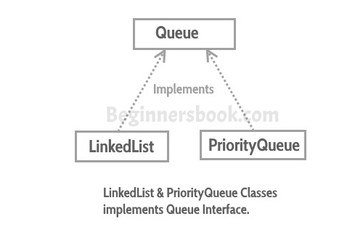
A Queue is designed in such a way so that the elements added to it work on FIFO (First In First Out).
Queue interface in Java collections has two implementation: LinkedList and PriorityQueue, these two classes implements Queue interface.
Queue is an interface so we cannot instantiate it, rather we create instance of LinkedList or PriorityQueue and assign it to the Queue like this:

Queue q1 = new LinkedList();
Queue q2 = new PriorityQueue();

Methods of Queue interface
boolean add(E e): This method adds the specified element at the end of Queue. Returns true if the the element is added successfully or false if the element is not added that basically happens when the Queue is at its max capacity and cannot take any more elements.
E element(): This method returns the head (the first element) of the Queue.
boolean offer(object): This is same as add() method.
E remove(): This method removes the head(first element) of the Queue and returns its value.
E poll(): This method is almost same as remove() method. The only difference between poll() and remove() is that poll() method returns null if the Queue is empty.
E peek(): This method is almost same as element() method. The only difference between peek() and element() is that peek() method returns null if the Queue is empty.

