Wrapper Classes in Java
A Wrapper class is a class whose object wraps or contains primitive data types. When we create an object to a wrapper class, it contains a field and in this field, we can store primitive data types. In other words, we can wrap a primitive value into a wrapper class object.

Wrapper classes are immutable. Once they are created, they cannot be changed. Primitive types are faster than boxed types.

Need of Wrapper Classes
- They convert primitive data types into objects. Objects are needed if we wish to modify the arguments passed into a method (because primitive types are passed by value).
- The classes in java.util package handles only objects and hence wrapper classes help in this case also.
- Data structures in the Collection framework, such as ArrayList and Vector, store only objects (reference types) and not primitive types.
- An object is needed to support synchronization in multithreading.

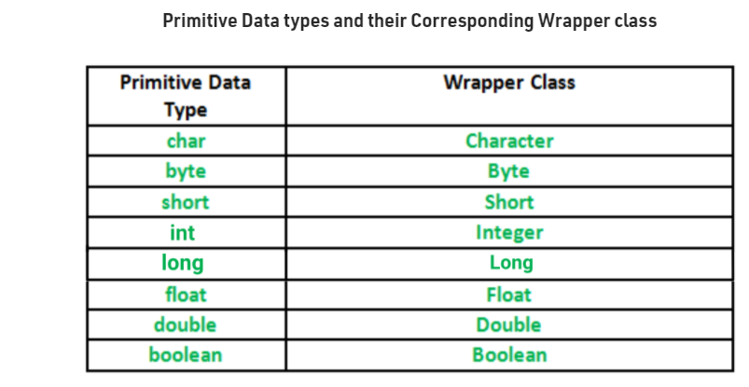
Autoboxing: Automatic conversion of primitive types to the object of their corresponding wrapper classes is known as autoboxing. For example – conversion of int to Integer, long to Long, double to Double etc.
/ Java program to demonstrate Autoboxing

import java.util.ArrayList;
class Autoboxing
{
public static void main(String[] args)
{
char ch = 'a';

// Autoboxing- primitive to Character object conversion
Character a = ch;

ArrayList<Integer> arrayList = new ArrayList<Integer>();

// Autoboxing because ArrayList stores only objects
arrayList.add(25);

// printing the values from object
System.out.println(arrayList.get(0));
}
}
Output:
25

Unboxing: It is just the reverse process of autoboxing. Automatically converting an object of a wrapper class to its corresponding primitive type is known as unboxing. For example – conversion of Integer to int, Long to long, Double to double, etc.
// Java program to demonstrate Unboxing
import java.util.ArrayList;

class Unboxing
{
public static void main(String[] args)
{
Character ch = 'a';

// unboxing - Character object to primitive conversion
char a = ch;

ArrayList<Integer> arrayList = new ArrayList<Integer>();
arrayList.add(24);

// unboxing because get method returns an Integer object
int num = arrayList.get(0);

// printing the values from primitive data types
System.out.println(num);
}
}

Output:
24
.

Java - valueOf() Method
The valueOf method returns the relevant Number Object holding the value of the argument passed. The argument can be a primitive data type, String, etc.
This method is a static method. The method can take two arguments, where one is a String and the other is a radix.
Integer x =Integer.valueOf(9);
Double c = Double.valueOf(5);
Float a = Float.valueOf("80");
Integer b = Integer.valueOf("444",16);

System.out.println(x);
System.out.println(c);
System.out.println(a);
System.out.println(b);

