report-2

September 30, 2019

**0.1 Distrbution of** null-count **in** training **dataset**

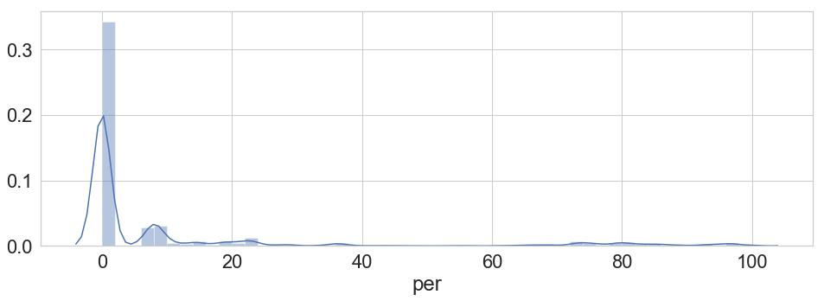

**0.2 Null handling**

1. We have 150 numerical feature with null percentage 50%
2. We have 148 categorical feature with null percentage > 0
3. To handle num value, i use two tech
   * 50% use generalized rank model to fill those value
   * Use MICE for all
   * use SVD on >50% and low feature impotance
4. For Cat feature,
   * make a new catgory(factorize them)
   * Use for encoding based feature(target encoding)

* **Target variable countplot**

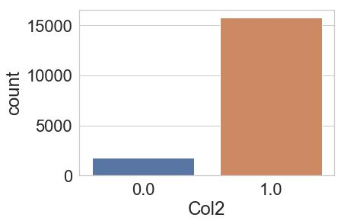

**1.1** **Correct** dtypes **of following two columns**

In [40]: df['Col754'] = df['Col754'].replace('-',0).astype('float')

df['Col843'] = df['Col843'].replace('-',0).astype('float')

**1.2** **There are some intersting feature, with good importance as well**

* create qunatile bins
* use them for feature-interaction

**1.3** **without considering class weight, while building the model**

* this is obvious, as if we don’t consider unbalance, while building model, it will shift towards majority class

2

* here we can see the 99% are choosing class-1
* to avoid that i count the weight for each class and assign it to class-pos-weight

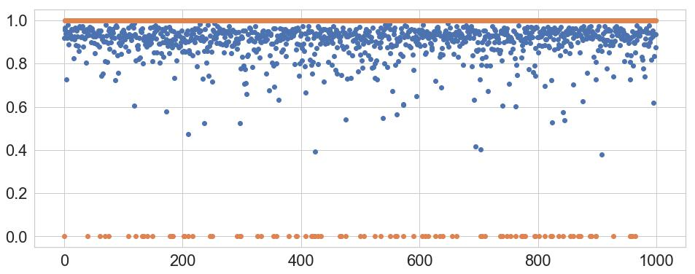

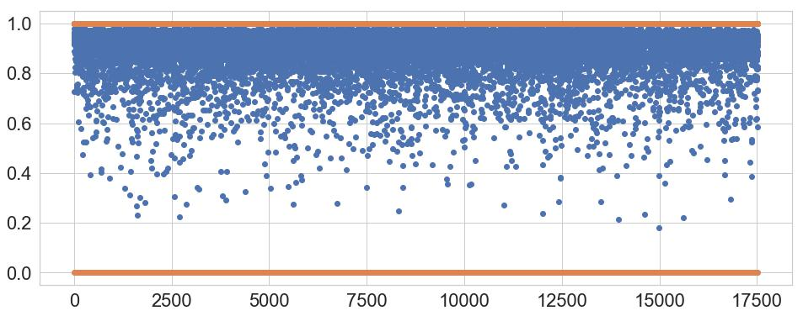

**1.4 Following feature is chosen by model, i was trying to observe that if the chosen have correlation among them**

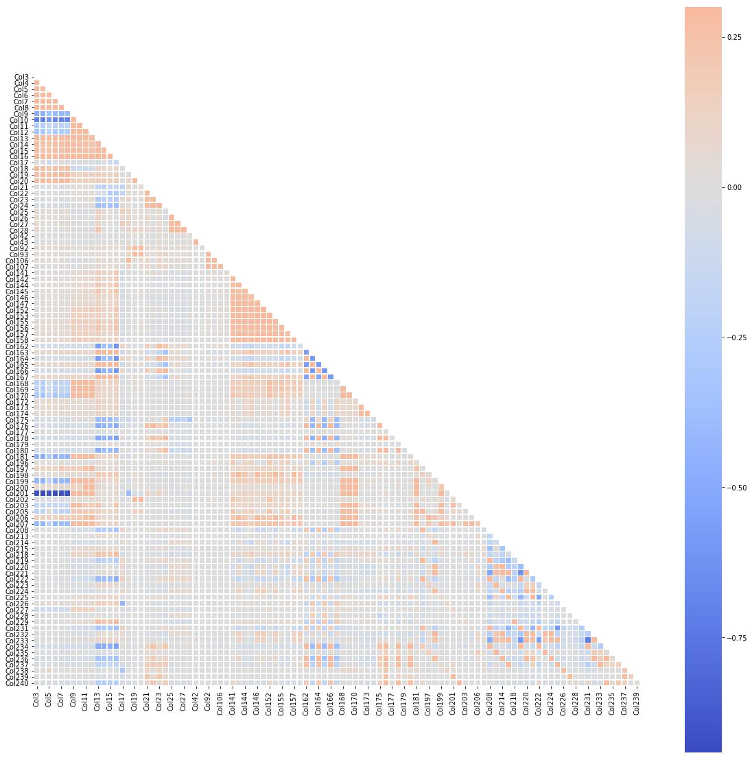

**1.5** **some of the variables have** 99.9% **missing value.**

* I dropped all category variable(I tried to create NULL as label, but none of my model find them interesting)
* i found all the categorical feature with NULL percentage more than 34% are useless

**1.6** **Some feature seems to be replica of others**

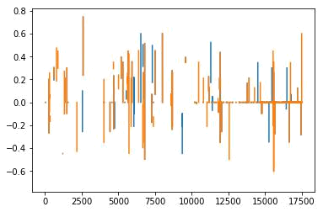

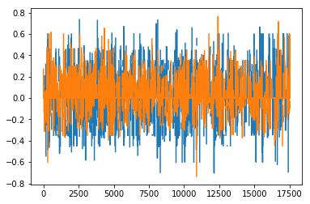

6

**1.7** **Joint-plot of few feature**

* i tried this to find, which feature could be helpful for feature engineering
* i also observe col3-col14 represents account detail such as saving, loan amount, other

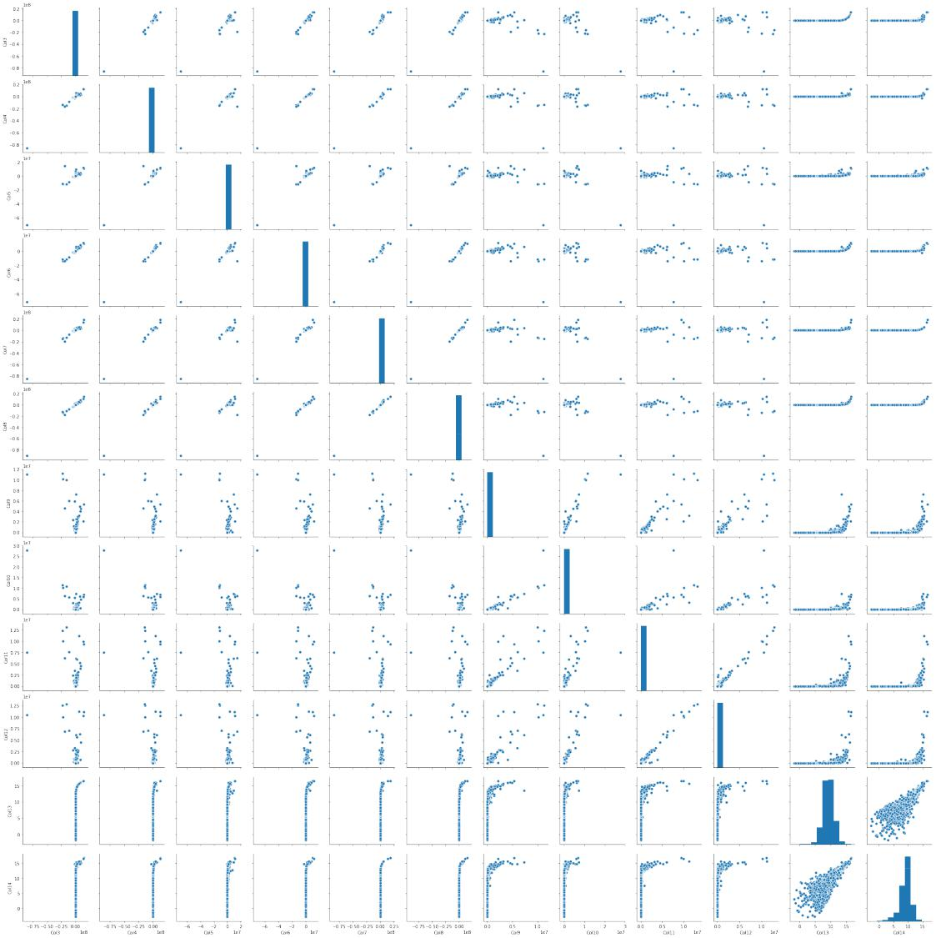

**1.8** **If we use only following** 30 **predictors/feature, we will have reasonable score**

• most of the numerical features have some importance in gbm model as well as in Auto ML

**1.9 I found a very interesting pattern that most of feature with** null-importance **lie in the columns range of** (1338 - 2385)

In [2]: # array(['Col1338', 'Col1340', 'Col1342', 'Col1343', 'Col1348', 'Col1349',

* 'Col1351', 'Col1354', 'Col1355', 'Col1356', 'Col1358', 'Col1362',
* 'Col1363', 'Col1366', 'Col1367', 'Col1368', 'Col1375', 'Col1379',
* 'Col1380', 'Col1382', 'Col1383', 'Col1384', 'Col1385', 'Col1387',
* 'Col1388', 'Col1389', 'Col1391', 'Col1397', 'Col1399', 'Col1400',
* 'Col1402', 'Col1403', 'Col1404', 'Col1406', 'Col1407', 'Col1411',
* 'Col1414', 'Col1415', 'Col1417', 'Col1419', 'Col1420', 'Col1421',
* 'Col1422', 'Col1423', 'Col1428', 'Col1430', 'Col1431', 'Col1432',
* 'Col1433', 'Col1436', 'Col1437', 'Col1438', 'Col1439', 'Col1440',
* 'Col1442', 'Col1443', 'Col1444', 'Col1446', 'Col1447', 'Col1448',
* 'Col1451', 'Col1453', 'Col1456', 'Col1457', 'Col1462', 'Col1468',
* 'Col1469', 'Col1472', 'Col1473', 'Col1474', 'Col1478', 'Col1484',
* 'Col1487', 'Col1488', 'Col1492', 'Col1493', 'Col1494', 'Col1496',
* 'Col1497', 'Col1499', 'Col1500', 'Col1502', 'Col1503', 'Col1505',
* 'Col1508', 'Col1510', 'Col1512', 'Col1513', 'Col1514', 'Col1515',
* 'Col1516', 'Col1520', 'Col1521', 'Col1527', 'Col1530', 'Col1531',
* 'Col1535', 'Col1538', 'Col1542', 'Col1545', 'Col1546', 'Col1547',
* 'Col1549', 'Col1551', 'Col1552', 'Col1554', 'Col1555', 'Col1560',
* 'Col1561', 'Col1562', 'Col1563', 'Col1565', 'Col1569', 'Col1570',
* 'Col1571', 'Col1576', 'Col1577', 'Col1578', 'Col1579', 'Col1581',
* 'Col1582', 'Col1583', 'Col1584', 'Col1587', 'Col1589', 'Col1590',
* 'Col1591', 'Col1593', 'Col1594', 'Col1595', 'Col1597', 'Col1601',
* 'Col1602', 'Col1603', 'Col1606', 'Col1607', 'Col1608', 'Col1609',
* 'Col1610', 'Col1611', 'Col1612', 'Col1617', 'Col1618', 'Col1619',
* 'Col1620', 'Col1622', 'Col1624', 'Col1626', 'Col1627', 'Col1629',
* 'Col1632', 'Col1633', 'Col1634', 'Col1635', 'Col1636', 'Col1638',
* 'Col1639', 'Col1640', 'Col1642', 'Col1643', 'Col1644', 'Col1645',
* 'Col1646', 'Col1649', 'Col1650', 'Col1652', 'Col1653', 'Col1654',
* 'Col1655', 'Col1656', 'Col1670', 'Col1672', 'Col1676', 'Col1679',
* 'Col1686', 'Col1690', 'Col1691', 'Col1698', 'Col1699', 'Col1704',
* 'Col1705', 'Col1707', 'Col1713', 'Col1715', 'Col1716', 'Col1720',
* 'Col1721', 'Col1722', 'Col1723', 'Col1724', 'Col1725', 'Col1729',
* 'Col1731', 'Col1735', 'Col1737', 'Col1739', 'Col1742', 'Col1743',
* 'Col1747', 'Col1749', 'Col1753', 'Col1758', 'Col1762', 'Col1763',
* 'Col1764', 'Col1765', 'Col1766', 'Col1768', 'Col1782', 'Col1785',
* 'Col1786', 'Col1788', 'Col1790', 'Col1792', 'Col1794', 'Col1796',
* 'Col1797', 'Col1801', 'Col1803', 'Col1804', 'Col1805', 'Col1806',
* 'Col1807', 'Col1808', 'Col1809', 'Col1810', 'Col1811', 'Col1812',
* 'Col1813', 'Col1815', 'Col1817', 'Col1822', 'Col1824', 'Col1826',
* 'Col1827', 'Col1832', 'Col1835', 'Col1837', 'Col1838', 'Col1839',
* 'Col1840', 'Col1841', 'Col1842', 'Col1855', 'Col1860', 'Col1862',
* 'Col1863', 'Col1864', 'Col1865', 'Col1866', 'Col1867', 'Col1868',
* 'Col1870', 'Col1874', 'Col1875', 'Col1877', 'Col1880', 'Col1882',
* 'Col1886', 'Col1887', 'Col1888', 'Col1889', 'Col1891', 'Col1895',
* 'Col1898', 'Col1899', 'Col1902', 'Col1905', 'Col1907', 'Col1909',
* 'Col1911', 'Col1913', 'Col1915', 'Col1918', 'Col1922', 'Col1923',
* 'Col1924', 'Col1925', 'Col1927', 'Col1930', 'Col1931', 'Col1932',
* 'Col1933', 'Col1936', 'Col1937', 'Col1946', 'Col1947', 'Col1949',
* 'Col1950', 'Col1951', 'Col1952', 'Col1955', 'Col1956', 'Col1957',
* 'Col1958', 'Col1959', 'Col1966', 'Col1967', 'Col1970', 'Col1971',
* 'Col1972', 'Col1973', 'Col1974', 'Col1975', 'Col1976', 'Col1977',
* 'Col1978', 'Col1979', 'Col1980', 'Col1981', 'Col1986', 'Col1987',
* 'Col1989', 'Col1991', 'Col1993', 'Col1996', 'Col1997', 'Col1998',
* 'Col1999', 'Col2001', 'Col2003', 'Col2005', 'Col2010', 'Col2011',
* 'Col2014', 'Col2015', 'Col2016', 'Col2019', 'Col2022', 'Col2023',
* 'Col2024', 'Col2025', 'Col2029', 'Col2031', 'Col2036', 'Col2038',
* 'Col2040', 'Col2041', 'Col2043', 'Col2044', 'Col2047', 'Col2049',
* 'Col2050', 'Col2052', 'Col2054', 'Col2057', 'Col2060', 'Col2062',
* 'Col2063', 'Col2068', 'Col2069', 'Col2070', 'Col2071', 'Col2072',
* 'Col2073', 'Col2074', 'Col2078', 'Col2079', 'Col2081', 'Col2085',

* 'Col2087', 'Col2092', 'Col2093', 'Col2094', 'Col2095', 'Col2096',
* 'Col2098', 'Col2099', 'Col2102', 'Col2104', 'Col2105', 'Col2110',
* 'Col2112', 'Col2113', 'Col2114', 'Col2118', 'Col2125', 'Col2126',
* 'Col2127', 'Col2128', 'Col2129', 'Col2130', 'Col2131', 'Col2132',
* 'Col2133', 'Col2134', 'Col2135', 'Col2138', 'Col2139', 'Col2140',
* 'Col2141', 'Col2145', 'Col2150', 'Col2151', 'Col2153', 'Col2158',
* 'Col2159', 'Col2161', 'Col2162', 'Col2167', 'Col2168', 'Col2169',
* 'Col2170', 'Col2172', 'Col2173', 'Col2174', 'Col2175', 'Col2176',
* 'Col2177', 'Col2178', 'Col2179', 'Col2181', 'Col2186', 'Col2188',
* 'Col2189', 'Col2191', 'Col2192', 'Col2193', 'Col2194', 'Col2195',
* 'Col2202', 'Col2203', 'Col2204', 'Col2205', 'Col2207', 'Col2208',
* 'Col2209', 'Col2213', 'Col2214', 'Col2215', 'Col2219', 'Col2220',
* 'Col2221', 'Col2222', 'Col2223', 'Col2224', 'Col2225', 'Col2226',
* 'Col2227', 'Col2230', 'Col2231', 'Col2234', 'Col2236', 'Col2240',
* 'Col2242', 'Col2243', 'Col2244', 'Col2251', 'Col2252', 'Col2254',
* 'Col2258', 'Col2259', 'Col2260', 'Col2262', 'Col2265', 'Col2266',
* 'Col2267', 'Col2269', 'Col2271', 'Col2272', 'Col2275', 'Col2282',
* 'Col2283', 'Col2284', 'Col2285', 'Col2291', 'Col2293', 'Col2294',
* 'Col2295', 'Col2298', 'Col2299', 'Col2305', 'Col2306', 'Col2307',
* 'Col2309', 'Col2310', 'Col2312', 'Col2313', 'Col2315', 'Col2316',
* 'Col2317', 'Col2320', 'Col2321', 'Col2323', 'Col2324', 'Col2325',
* 'Col2326', 'Col2327', 'Col2331', 'Col2333', 'Col2337', 'Col2340',
* 'Col2341', 'Col2343', 'Col2344', 'Col2345', 'Col2348', 'Col2350',
* 'Col2351', 'Col2354', 'Col2355', 'Col2356', 'Col2357', 'Col2358',
* 'Col2359', 'Col2362', 'Col2364', 'Col2366', 'Col2369', 'Col2372',
* 'Col2375', 'Col2377', 'Col2380', 'Col2381', 'Col2382', 'Col2383',
* 'Col2385', 'Col2394'], dtype=object)

**1.10 variable** **importance** **of** distributed-random-forest **and**

Gradient-boosting-tree

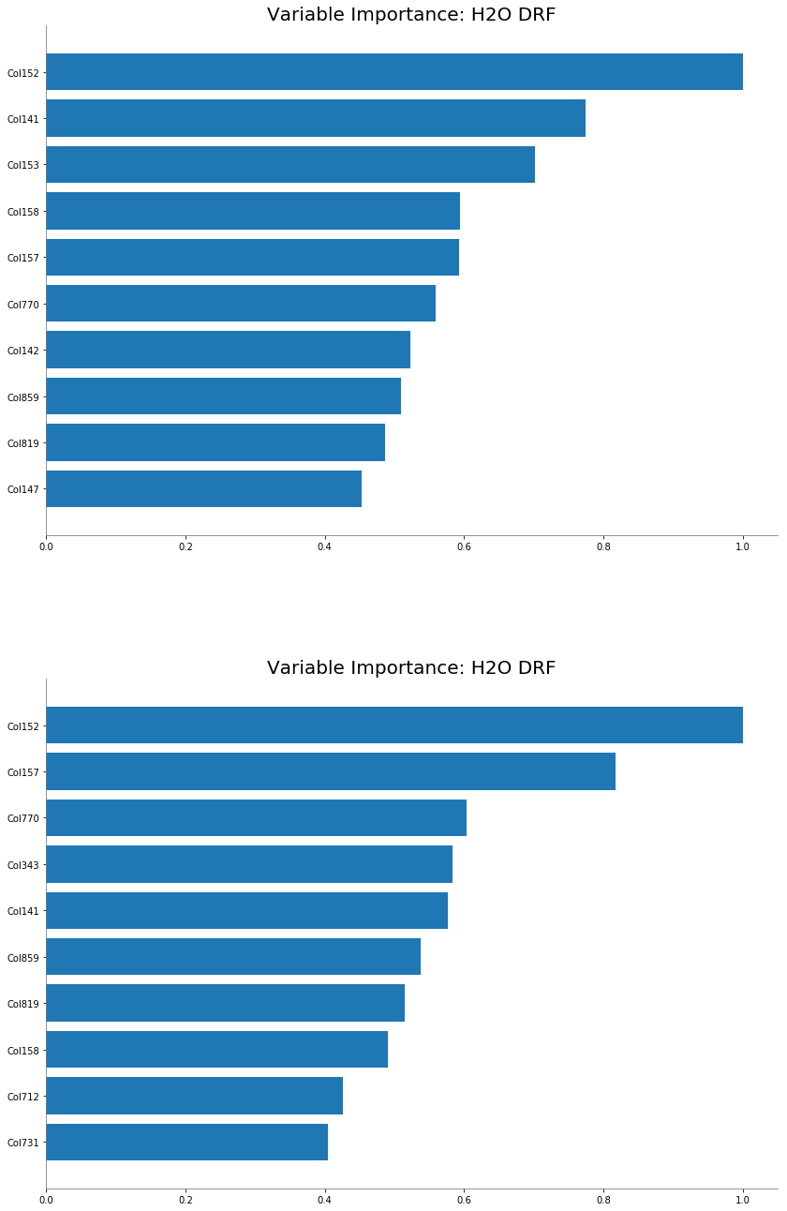

11

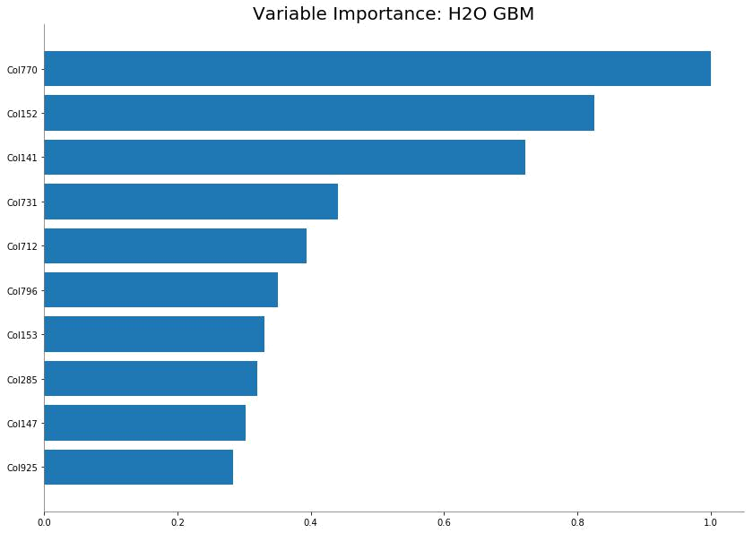

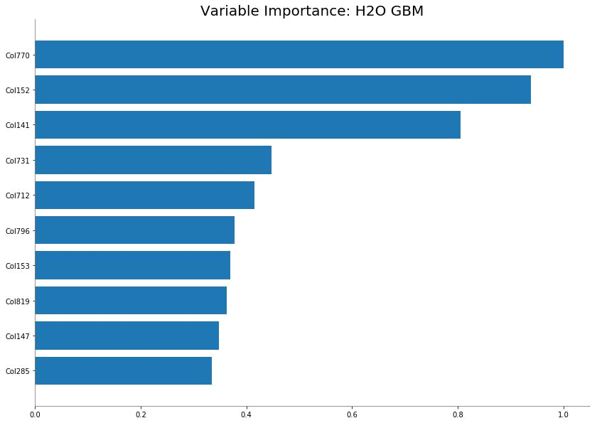

12

13