💻
Coding Walkthrough &
Tech Stack Deep-Dive
Interview Preparation Guide — Technical Supplement

Covers:
- "Explain this code" questions
- Live-coding scenarios
- Deep-dives on every tech in your stack

Table of Contents
Table of Contents 1
Endpoint Definition 1
YOLO Object Detection 1
CLIP Vector Generation 1
Embedding Handling 1
Room-Based Messaging 1
Challenge 1: Write a NestJS Guard from Scratch 1
Challenge 2: Write the Axios Interceptor for Handling 401 Errors 1
Challenge 3: Write a Custom React Hook for Debounced Search 1
Challenge 4: Write Cosine Similarity from Scratch in Python 1
Challenge 5: Write the TypeORM Entity for Conversation 1
Challenge 6: Write a NestJS Pipe for File Validation 1
Challenge 7: Write the Image Proxy Without Looking at Your Code 1
Challenge 8: Write a FastAPI Endpoint for Text-to-Vector Search 1
Challenge 9: Implement Soft Delete for Messages 1
Challenge 10: Write bcrypt Password Hashing 1
🟦 React 19 + TypeScript 1
🟩 NestJS 1
🐍 FastAPI + PyTorch 1
🐘 PostgreSQL + TypeORM 1
📐 Milvus / Zilliz Cloud 1
🔌 Socket.IO / WebSockets 1
☁️ Cloudinary 1
🐳 Docker + Docker Compose 1
🔐 Passport.js + JWT + bcrypt 1
⚡ Vite 1
🎨 TailwindCSS v4 1

🔍 Section 1: Code Walkthrough
"Walk me through this code line by line."

Interviewers will open your source files and say: "Walk me through this code line by line." Below are the top files they'll likely pick, with ready-made explanations.

🔥 FILE 1: CLIP Vector Generation
vision-service/src/main.py — /analyze endpoint

⭐ PRO TIP: This is the most impressive code in your project. If they open any file, hope it's this one.

Endpoint Definition

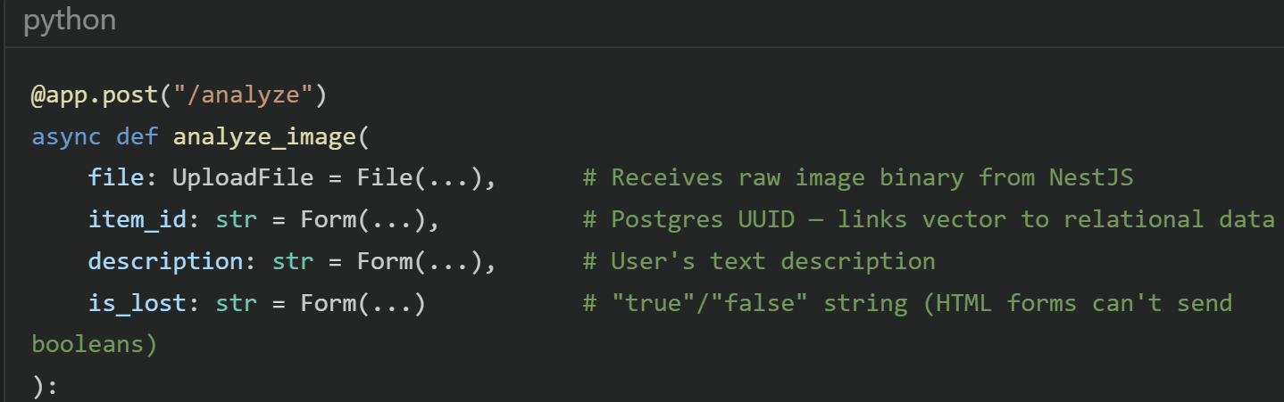

Q: Why Form(...) instead of Body(...)?
Answer:
Because the NestJS backend sends this as multipart/form-data (not JSON) since it includes a binary file. FastAPI requires Form() for multipart fields and File() for binary uploads. You CANNOT mix JSON body and file uploads in the same request — it must be multipart.

YOLO Object Detection

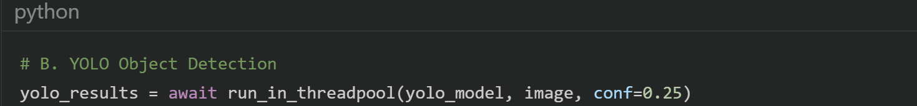

Q: What is run_in_threadpool and why do you need it?
Answer:
FastAPI is async (uses asyncio), but PyTorch/YOLO inference is CPU-bound blocking code. If I call it directly in an async function, it would block the entire event loop — no other requests could be served. run_in_threadpool offloads the blocking call to a separate thread, keeping the event loop free. It's FastAPI's equivalent of asyncio.to_thread().

CLIP Vector Generation
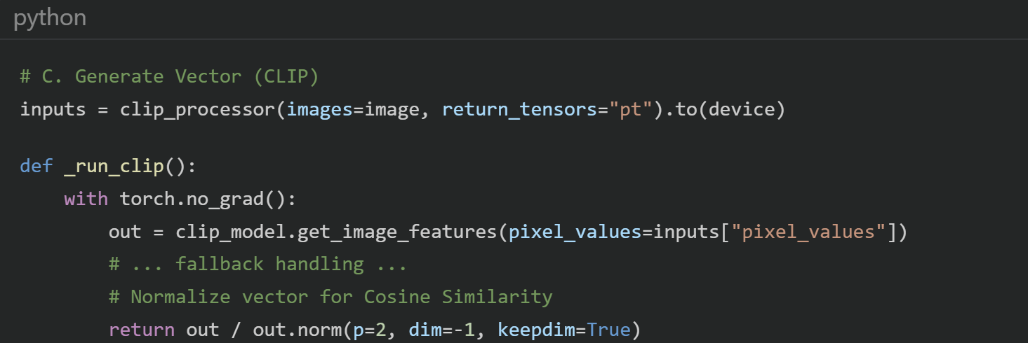

Q: Why torch.no_grad()?
Answer:
During inference (not training), we don't need to compute gradients. torch.no_grad() disables gradient tracking, which:
1. Reduces memory usage (no gradient tensors stored)
2. Speeds up computation
It's a best practice for production inference.

Q: What does normalization do? (out / out.norm(...))
Answer:
L2 normalization divides the vector by its magnitude, producing a unit vector (length = 1). This is critical because:
• With unit vectors, Inner Product = Cosine Similarity
• It makes similarity scores range from -1 to 1 instead of arbitrary magnitudes
• Two completely identical images score 1.0; completely different images score ~0
Without normalization, a brighter image might produce a longer vector, skewing results.

Embedding Handling

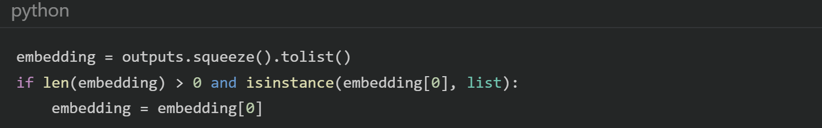
Q: What's happening with squeeze and the isinstance check?
Answer:
CLIP outputs a tensor with shape [1, 512] (batch dimension × embedding dimension). squeeze() removes the batch dimension to give [512]. Then tolist() converts the PyTorch tensor to a Python list for JSON serialization. The isinstance check is a defensive fallback — some transformer versions return nested lists like [[0.1, 0.2, ...]]. Flattening ensures Milvus always receives a flat 512-element list.

🔥 FILE 2: JWT Cookie Authentication
core-backend/src/auth/jwt.strategy.ts

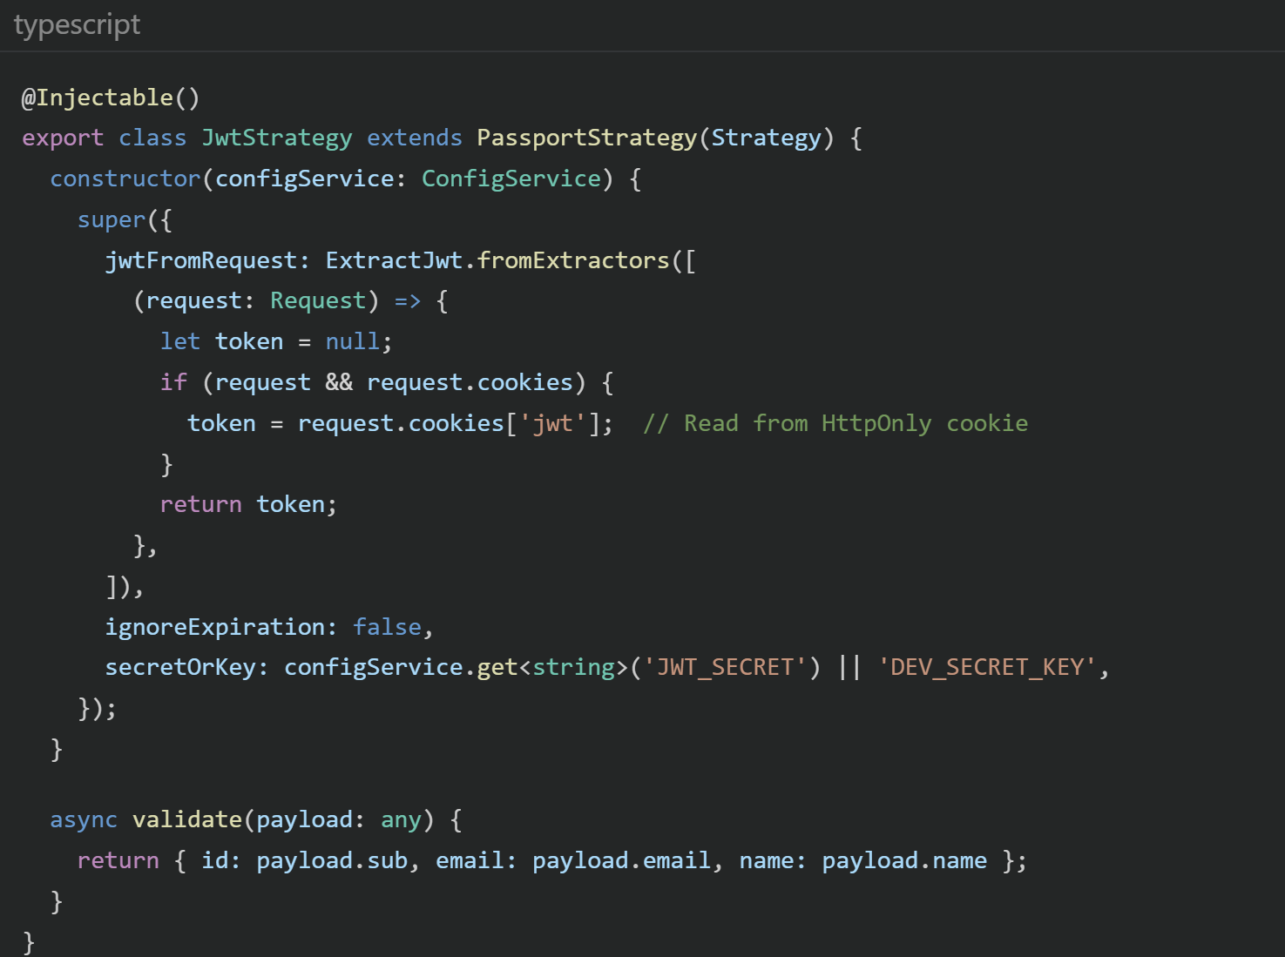
Q: Walk me through how this works.
Answer:
This is Passport.js's JWT strategy adapted for NestJS:
1. Extraction: Instead of the default Authorization: Bearer <token> header, I wrote a custom extractor that reads from request.cookies['jwt']. This is because I store the JWT in an HttpOnly cookie, not in localStorage.
2. Verification: Passport automatically verifies the signature using secretOrKey, checks the expiration (ignoreExpiration: false), and rejects tampered tokens.
3. Payload Mapping: validate() receives the decoded JWT payload and maps it to req.user. So payload.sub (the user ID I set during login()) becomes req.user.id.
4. Guard Integration: Any route with @UseGuards(AuthGuard('jwt')) triggers this strategy automatically.

Q: What's PassportStrategy(Strategy) — why the wrapping?
Answer:
It's an adapter pattern. @nestjs/passport's PassportStrategy() function takes a raw Passport.js strategy class and wraps it into a NestJS-compatible injectable provider. This lets NestJS manage it through its Dependency Injection system.

🔥 FILE 3: The Orchestration Layer
core-backend/src/items/items.service.ts
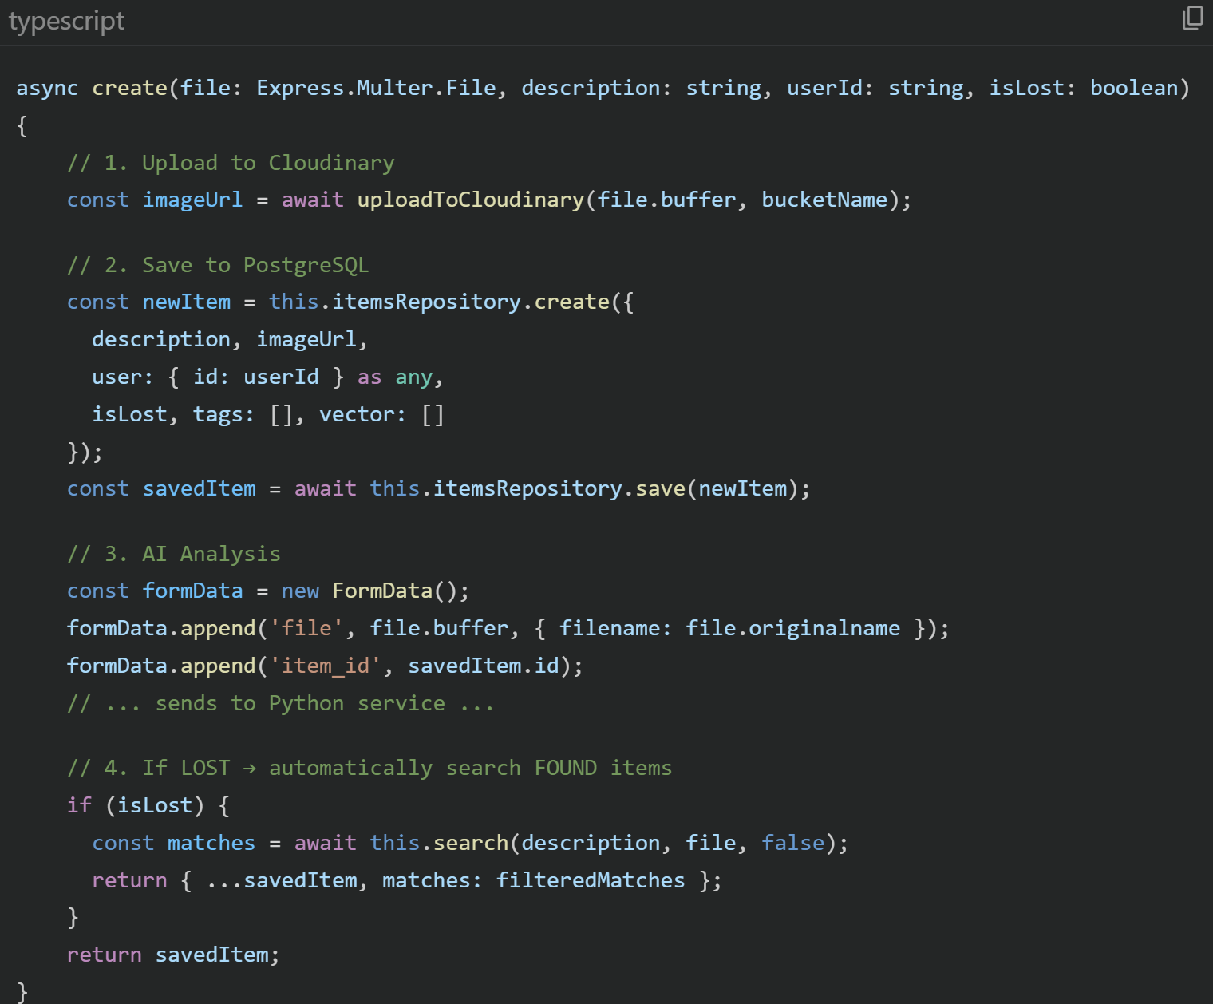

Q: What pattern is this implementing?
Answer:
This is the API Gateway / Orchestrator pattern. NestJS itself never does AI computation — it coordinates:
1. Cloudinary (storage) → 2. PostgreSQL (persistence) → 3. FastAPI (AI) → 4. Back to PostgreSQL (hydration)
Each external system is called sequentially because each step depends on the previous one's result (e.g., step 3 needs savedItem.id from step 2).

Q: What does { id: userId } as any mean? Isn't that a code smell?
Answer:
Yes, it's a shortcut. TypeORM accepts a partial entity object for relational fields — providing just { id: userId } sets the foreign key without a full database lookup. The as any bypasses TypeScript's type checker because the User type expects all fields. The proper fix would be a DeepPartial<User> type or userRepository.findOneBy({ id: userId }).

Q: What happens if step 3 (AI call) fails?
Answer:
The AI call is wrapped in a try/catch. If it fails, the item is still saved to Postgres with empty tags and vector arrays. The user doesn't see an error — they just won't get AI-powered search results for that item. I log the error for debugging. In production, I'd push this to a retry queue.

🔥 FILE 4: Cloudinary Upload
core-backend/src/cloudinary-client.ts
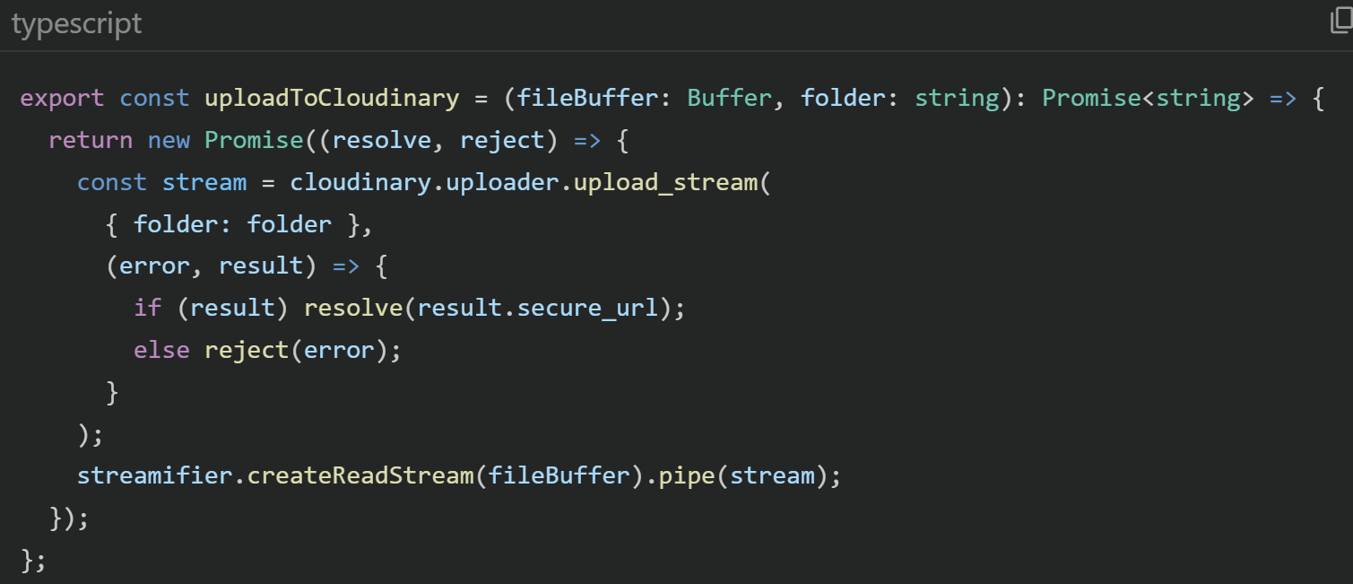

Q: Why the Promise wrapper and stream pattern?
Answer:
Cloudinary's upload_stream is a callback-based API, not Promise-based. I wrap it in a new Promise() to make it await-able. The stream pattern is necessary because we receive the file as a Buffer (from multer), but Cloudinary expects a readable stream. streamifier.createReadStream() converts the Buffer to a stream, then .pipe() sends it chunk-by-chunk to Cloudinary's upload stream. This is memory-efficient — we never hold two copies of the file in memory.

Q: What's secure_url vs url?
Answer:
secure_url is the HTTPS version. The regular url is HTTP. In production, you must always use HTTPS to prevent mixed-content warnings and man-in-the-middle attacks.

🔥 FILE 5: WebSocket Chat Gateway
core-backend/src/chat/chat.gateway.ts
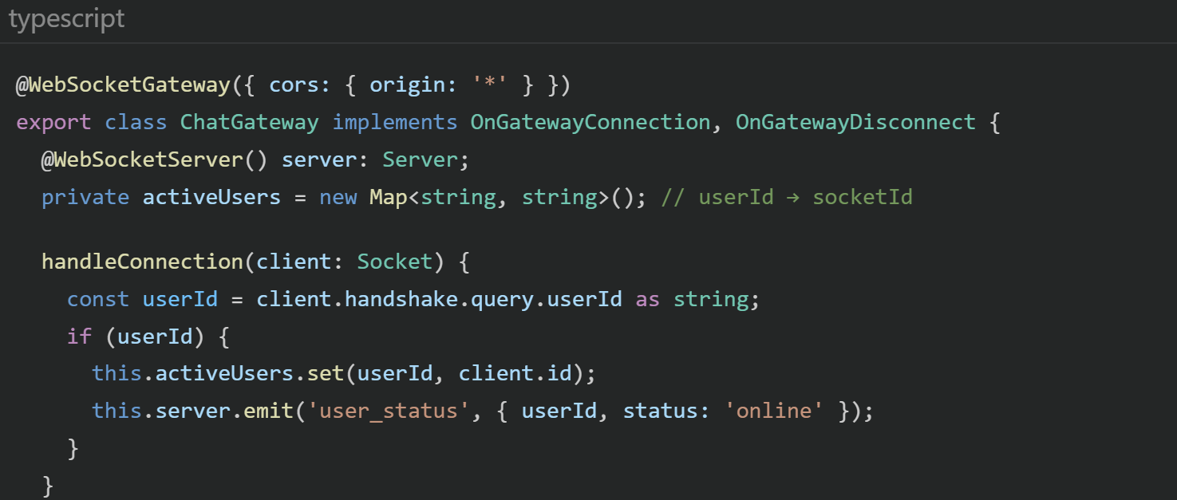

Q: How does @WebSocketGateway work in NestJS?
Answer:
It's a NestJS decorator that creates a Socket.IO server attached to the same HTTP server. It implements OnGatewayConnection and OnGatewayDisconnect interfaces, which are lifecycle hooks that fire when a client connects/disconnects. @WebSocketServer() injects the raw Socket.IO Server instance for broadcasting. @SubscribeMessage('event_name') is like an @Post() route but for WebSocket events.

Q: Your activeUsers is an in-memory Map. What happens with multiple server instances?
Answer:
It breaks — each instance has its own Map, so User A on Instance 1 can't see User B on Instance 2. The fix is a Redis Adapter (@socket.io/redis-adapter). Redis pub/sub broadcasts events across all instances, and you'd store activeUsers in Redis instead of a local Map. That's exactly what my Docker Compose's Redis service was designed for.

Room-Based Messaging
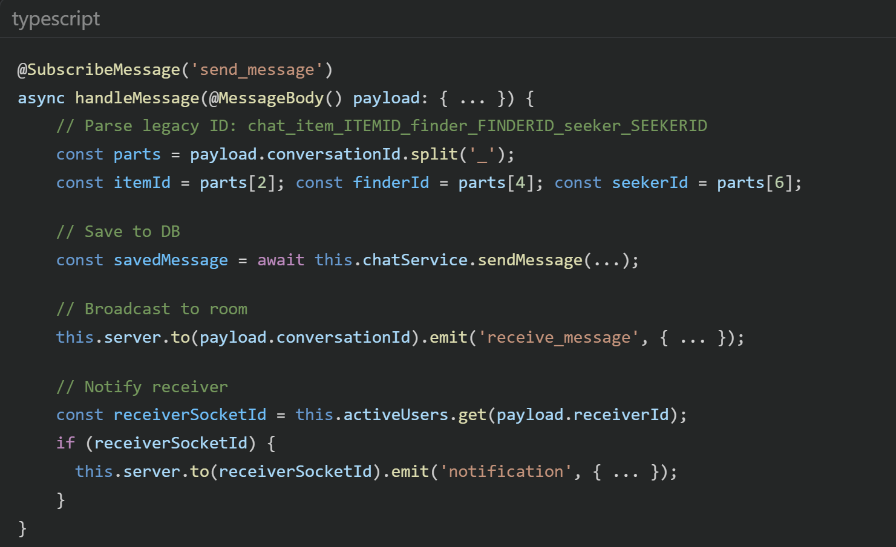

Q: Explain the room-based messaging.
Answer:
Socket.IO rooms are virtual groupings of sockets. When a client does socket.emit('join_room', roomId), the server calls client.join(roomId). Then server.to(roomId).emit(...) sends a message only to sockets in that room — not to everyone. This is how I implement private conversations: both the seeker and finder join the same room ID. The notification is sent separately to the receiver's specific socket ID.

🔥 FILE 6: React Auth Context
web-client/src/context/AuthContext.tsx

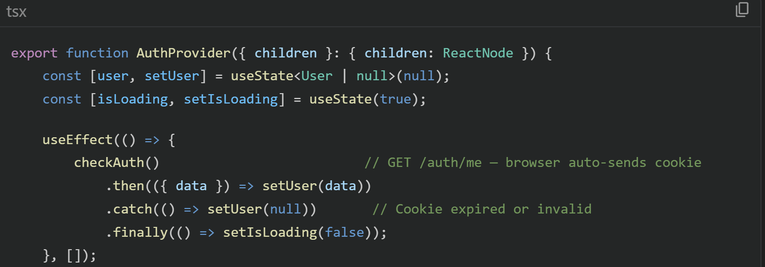
Q: How does the auth state persist on page refresh?
Answer:
The JWT is stored in an HttpOnly cookie, which the browser automatically persists. On every page load, the useEffect runs checkAuth() which calls GET /auth/me. Axios has withCredentials: true, so the browser automatically attaches the cookie. The server verifies the JWT and returns the user object. If the cookie is expired or missing, it returns 401, and we set user to null. The isLoading state prevents a flash of the login page during this check.

Q: Why useState(true) for isLoading instead of false?
Answer:
We start with true because we're immediately making the checkAuth() API call on mount. If we started with false, there'd be a split second where isLoading is false AND user is null, causing the ProtectedRoute to redirect to /login before we even check if the user has a valid session. Starting with true shows a loading spinner instead.

🔥 FILE 7: Protected Route Pattern
web-client/src/App.tsx
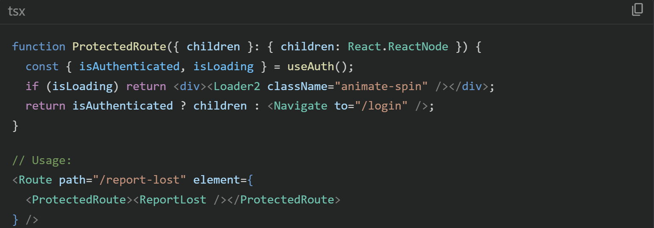

Q: Is this a Higher-Order Component (HOC) or a Render Prop?
Answer:
Neither — it's a Wrapper Component pattern. It uses children prop to conditionally render its contents or redirect. HOCs wrap at the definition level (export default withAuth(ReportLost)), render props use function-as-children. This wrapper approach is more readable and is the modern React pattern (React Router v6 encourages this over HOCs).

🔥 FILE 8: Item Entity
core-backend/src/items/entities/item.entity.ts
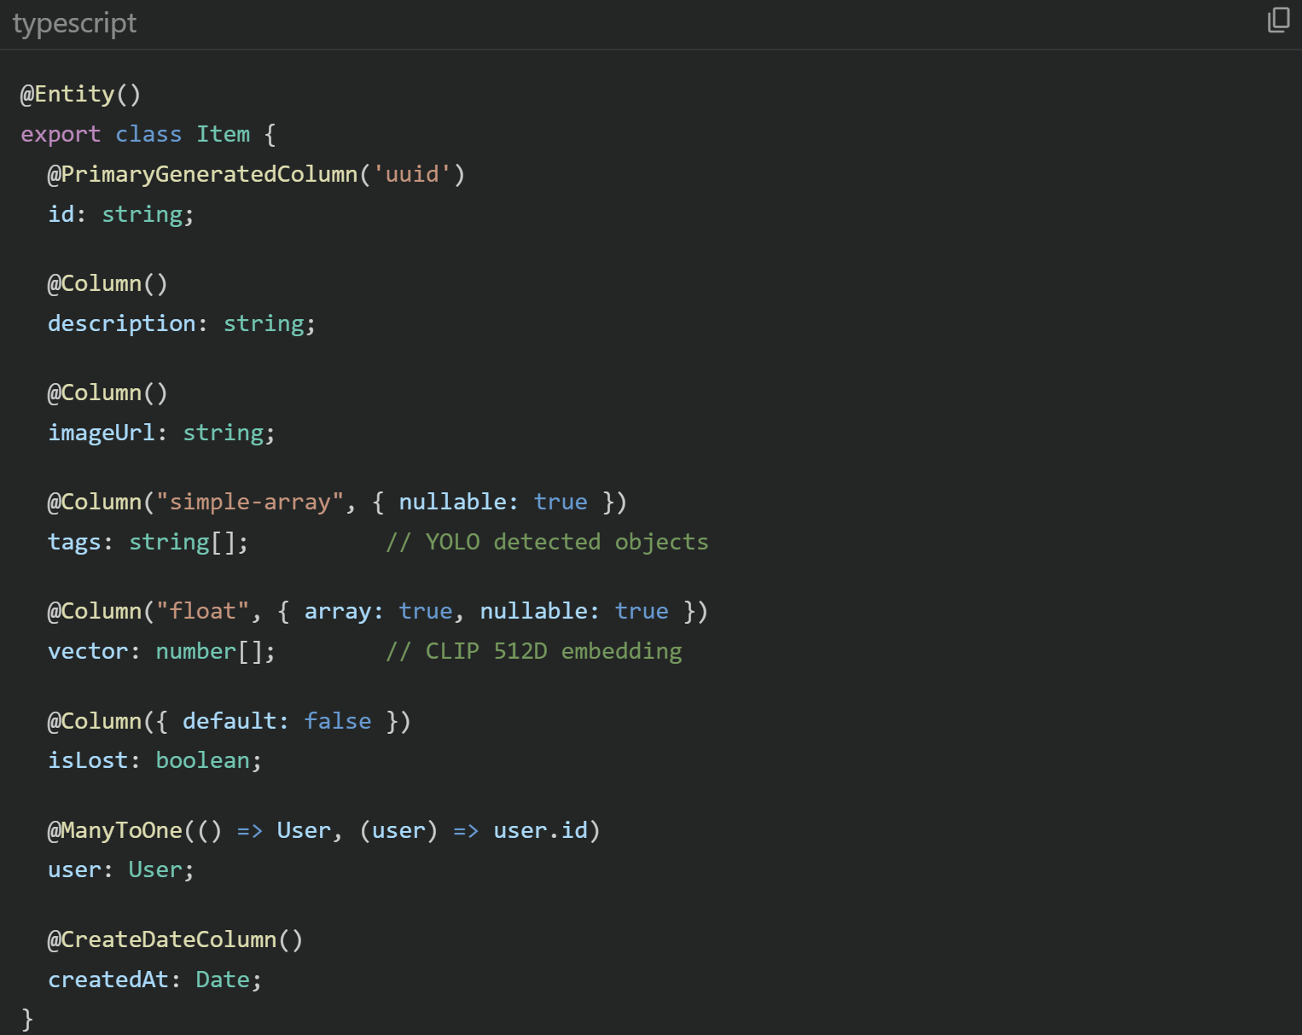

Q: Explain @ManyToOne.
Answer:
It defines a many-to-one relationship: many Items belong to one User. TypeORM automatically creates a userId foreign key column in the item table. The inverse would be @OneToMany(() => Item, (item) => item.user) on the User entity. The (user) => user.id is a callback that tells TypeORM which property to use as the join column.

Q: Why store the vector in Postgres if you also have Milvus?
Answer:
It's a backup and debugging aid. Postgres stores the raw vector so I can inspect values, verify they're 512D, and potentially re-index Milvus without re-running CLIP inference. In production, I'd likely remove it from Postgres to save storage (512 floats × 4 bytes = 2KB per item).

Q: What's the difference between simple-array and array: true?
Answer:
simple-array stores as a comma-separated string in a single VARCHAR column (e.g., 'backpack,red,black'). array: true with float uses PostgreSQL's native array type (float[]), which supports indexing and array operations. I used simple-array for tags (simple text list) and native arrays for vectors (need numeric operations).

⚡ Section 2: Live Coding Challenges
"Can you write X from scratch on the whiteboard?"

Interviewers might say: "Can you write X from scratch on the whiteboard?" These are realistic challenges based on your project's patterns.

Challenge 1: Write a NestJS Guard from Scratch
📋 PROMPT: Create a custom guard that checks if the user has an admin role.
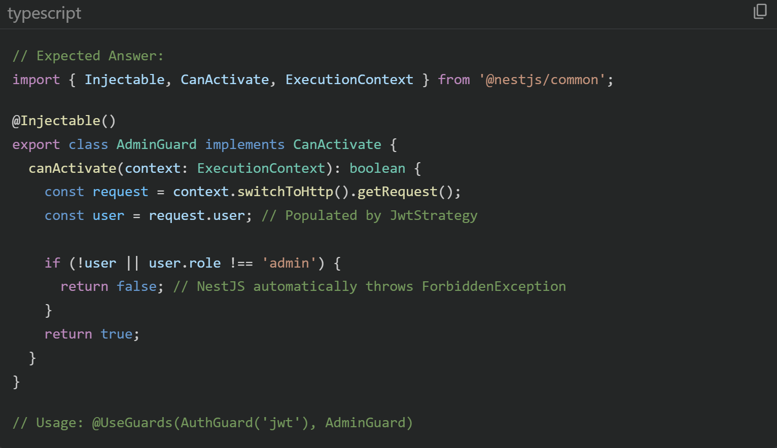
Key Points to Explain:
- Guards implement CanActivate, return boolean
- Guards run AFTER middleware but BEFORE interceptors
- You can stack guards — JWT guard first (authentication), then Admin guard (authorization)

Challenge 2: Write the Axios Interceptor for Handling 401 Errors
📋 PROMPT: How would you handle token expiration globally in React?
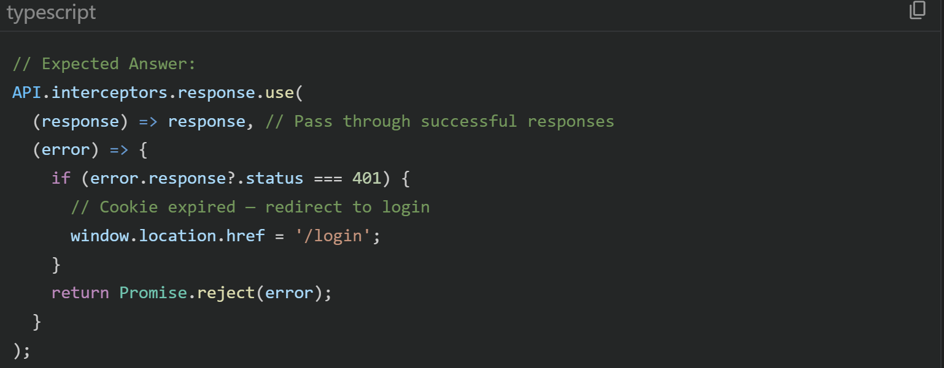

Key Points:
- Interceptors are middleware for HTTP clients
- Response interceptors catch errors globally instead of try/catch in every component
- With HttpOnly cookies, there's no token to "refresh" client-side — the server decides

Challenge 3: Write a Custom React Hook for Debounced Search
📋 PROMPT: Your search hits the AI service, which is expensive. Add debouncing.
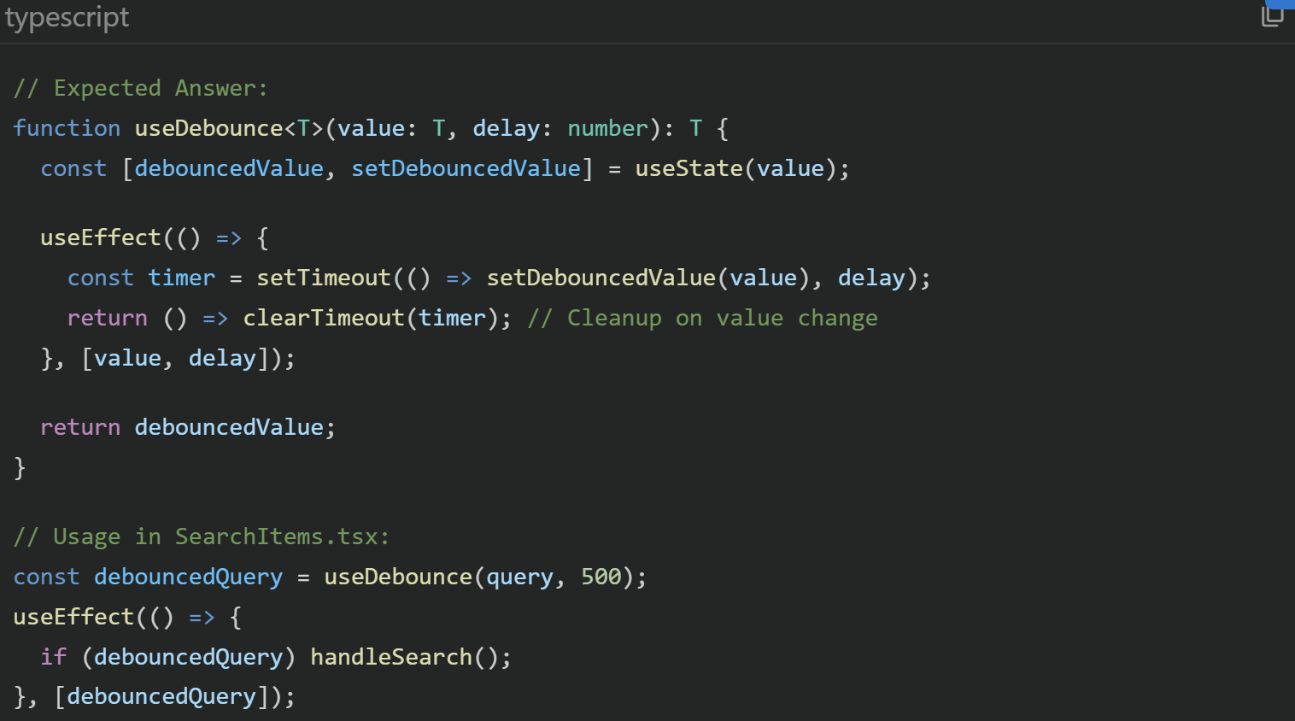

Key Points:
- The cleanup function (clearTimeout) is crucial — without it, every keystroke would still trigger a search after the delay. The cleanup cancels the previous timer before starting a new one.

Challenge 4: Write Cosine Similarity from Scratch in Python
📋 PROMPT: Implement cosine similarity without using a library.
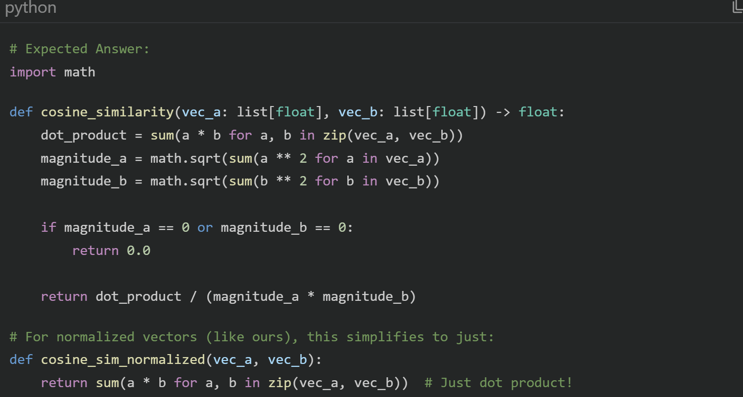

Key Points:
- Cosine similarity = dot product / (magnitude A × magnitude B)
- For L2-normalized vectors (magnitude = 1), it reduces to just the dot product
- That's why we normalize in CLIP and use Inner Product (IP) in Milvus

Challenge 5: Write the TypeORM Entity for Conversation
📋 PROMPT: Design the database entity for a chat conversation.

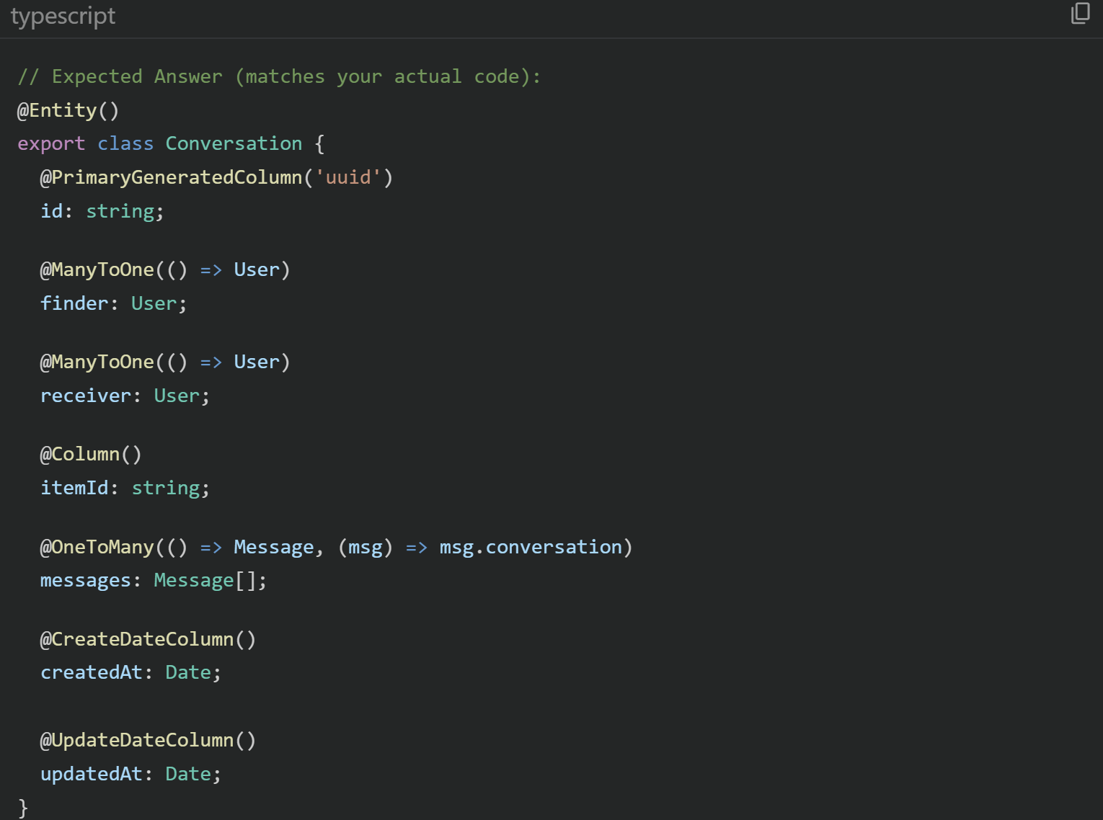
Key Points:
- Two @ManyToOne to User (finder + receiver), one @OneToMany to Message
- @UpdateDateColumn auto-updates on every save — useful for sorting inbox by most recent activity

Challenge 6: Write a NestJS Pipe for File Validation
📋 PROMPT: Validate that uploaded files are images and under 10MB.

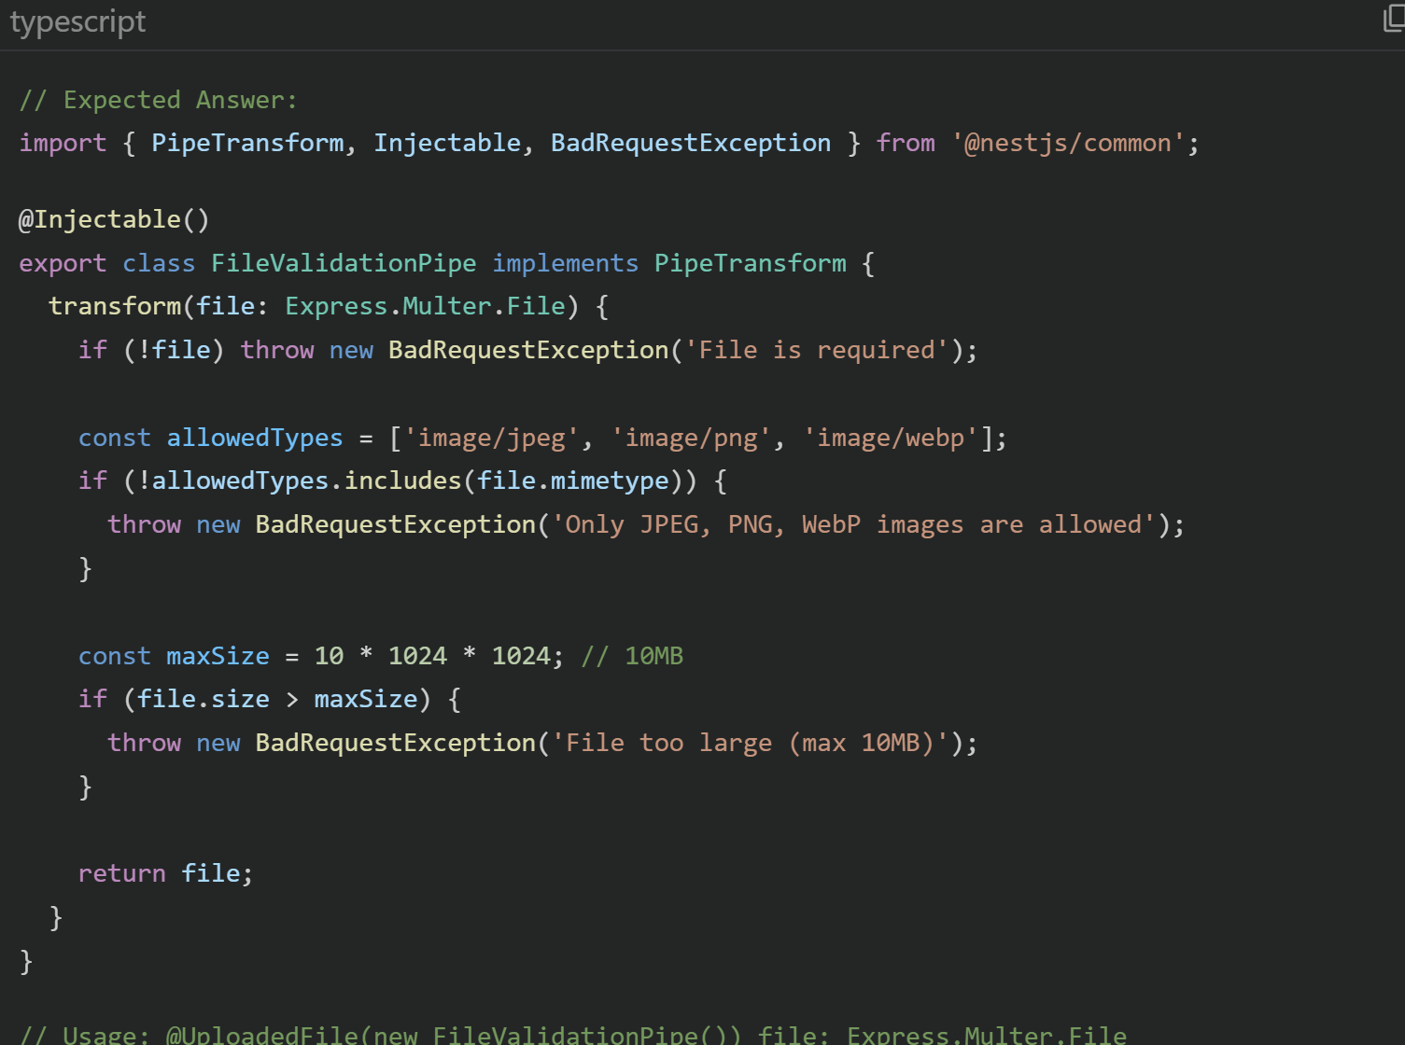

Challenge 7: Write the Image Proxy Without Looking at Your Code
📋 PROMPT: Build an endpoint that proxies images from Cloudinary.
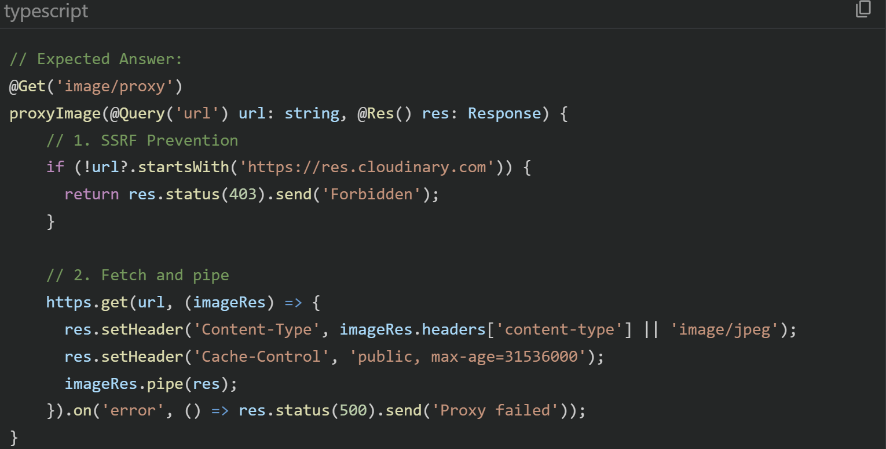

Key Points:
- Whitelist check (SSRF prevention), stream piping (memory efficient — never loads full image into RAM), aggressive cache headers (CDN behavior).

Challenge 8: Write a FastAPI Endpoint for Text-to-Vector Search
📋 PROMPT: Convert text query to a CLIP vector and search Milvus.
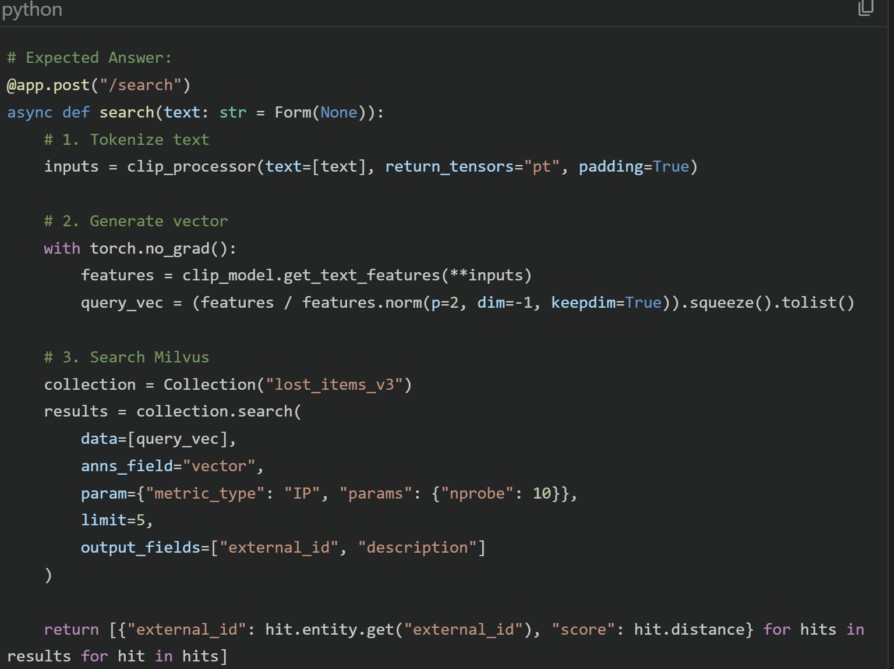

Challenge 9: Implement Soft Delete for Messages
📋 PROMPT: How would you delete messages without losing chat history?
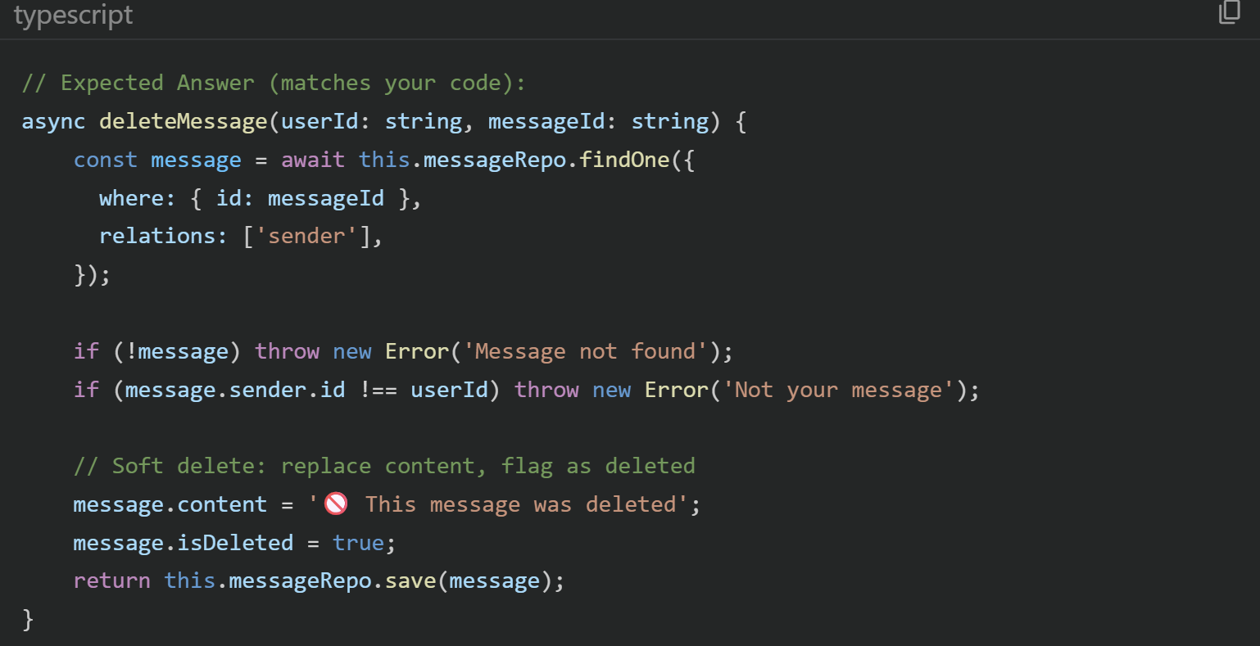

Key Points:
- Authorization check — only sender can delete
- Soft delete preserves the message row for audit trails
- The UI checks isDeleted for styling

Challenge 10: Write bcrypt Password Hashing
📋 PROMPT: How do you securely store passwords?
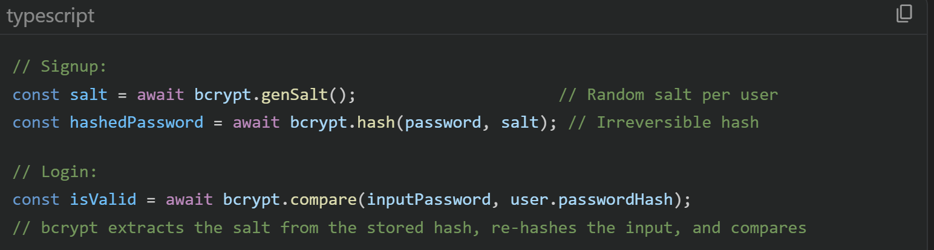
Key Points:
- Each user gets a unique salt — prevents rainbow table attacks
- bcrypt.compare doesn't decrypt — it re-hashes and compares
- bcrypt is intentionally slow (configurable cost factor) to resist brute force

🔬 Section 3: Tech Stack Deep-Dive Q&A
For each technology: what it is, why you chose it, how you used it, and alternatives.

🟦 React 19 + TypeScript
Q: What is React's Virtual DOM and how does it improve performance?
Answer:
The Virtual DOM is a lightweight JavaScript representation of the actual DOM. When state changes, React creates a new virtual tree, diffs it against the previous one (reconciliation), and applies only the minimal changes to the real DOM. Direct DOM manipulation is expensive — this batching approach avoids unnecessary reflows/repaints.

Q: Explain the React component lifecycle with hooks.
Answer:
With hooks: useState initializes state, useEffect handles side effects (mount = empty deps [], update = with deps, cleanup = return function). useContext consumes context values. useRef persists values across renders without causing re-renders (I use it for bottomRef to auto-scroll chat).

Q: Why TypeScript over JavaScript?
Answer:
Type safety catches bugs at compile time. In this project, TypeScript prevents issues like passing a string where an Item object is expected. The interface User { id: string; email: string } definitions serve as living documentation. IDE autocomplete also becomes incredibly accurate.

Q: What's import.meta.env.VITE_API_URL?
Answer:
Vite exposes environment variables prefixed with VITE_ through import.meta.env. Unlike process.env (Node.js), this is replaced at build time — the value is baked into the JavaScript bundle. That's why it works in the browser.

Q: How does withCredentials: true work in Axios?
Answer:
It tells the browser to include cookies in cross-origin requests. Without it, the browser strips cookies from requests to a different domain (e.g., frontend on web-client.onrender.com, backend on core-backend.onrender.com). The server must also respond with Access-Control-Allow-Credentials: true.

🟩 NestJS
Q: What are NestJS Modules, and why are they important?
Answer:
Modules are organizational units. Each module encapsulates a set of controllers, providers (services), and imports. AuthModule contains AuthController, AuthService, JwtStrategy, and imports UsersModule for database access. This enforces separation of concerns and prevents circular dependencies. The @Module() decorator defines the dependency graph.

Q: Explain NestJS Dependency Injection.
Answer:
When I write constructor(private itemsService: ItemsService) in a controller, NestJS automatically creates an instance of ItemsService and injects it. The @Injectable() decorator marks a class as a provider. NestJS manages the entire lifecycle — creating singletons by default. This makes testing easy: I can inject mock services.

Q: What are Guards, Interceptors, and Pipes in NestJS?
Answer:
The request pipeline order:
1. Guards (DebugAuthGuard): decide if a request is allowed (authentication/authorization)
2. Interceptors: transform the response or add logic before/after the handler (logging, caching)
3. Pipes (FileValidationPipe): transform/validate input data before the handler receives it
4. Filters: catch exceptions and format error responses

Order: Middleware → Guards → Interceptors (before) → Pipes → Handler → Interceptors (after) → Filters

Q: What's the difference between @Req() and @Body()?
Answer:
@Req() gives you the raw Express Request object (access to req.user, req.cookies, req.headers). @Body() extracts and validates just the request body. @Body('description') extracts a specific field. Using @Body() is preferred because it's cleaner and works with DTOs for validation.

Q: How does @UseInterceptors(FileInterceptor('file')) work?
Answer:
FileInterceptor is a NestJS wrapper around multer. It intercepts multipart form data, extracts the file from field 'file', stores it in memory (as a Buffer), and makes it available via @UploadedFile(). I chose memory storage (not disk) because I immediately pipe the buffer to Cloudinary — no need to write to disk.

🐍 FastAPI + PyTorch
Q: Why FastAPI over Flask or Django?
Answer:
FastAPI is async-native (uses asyncio), auto-generates OpenAPI/Swagger docs, has built-in request validation with Pydantic, and handles file uploads elegantly. Flask is synchronous and would block during CLIP inference. Django is too heavy for a single-purpose AI service. FastAPI's run_in_threadpool perfectly handles CPU-bound ML code in an async context.

Q: What is PyTorch and why not TensorFlow?
Answer:
PyTorch is Facebook's deep learning framework. I chose it because the Hugging Face transformers library defaults to PyTorch, the CLIP model is natively a PyTorch model, and PyTorch's eager execution makes debugging easier (vs TensorFlow's graph mode). The research community primarily uses PyTorch.

Q: What is clip_processor vs clip_model?
Answer:
clip_processor handles pre-processing: resizing images to 224×224, normalizing pixel values, tokenizing text. clip_model is the actual neural network that produces embeddings. The separation follows the HuggingFace pattern: processor prepares input → model generates output.

Q: What YOLO version did you use and what does it do?
Answer:
YOLOv8-nano (yolov8n.pt), the smallest YOLO variant at 6.5MB. YOLO (You Only Look Once) is a real-time object detection model. It draws bounding boxes around objects and labels them (e.g., 'backpack', 'person'). I use it to extract text tags that enrich the item's description, not for the vector search itself.

🐘 PostgreSQL + TypeORM
Q: What is an ORM and why use one?
Answer:
An ORM (Object-Relational Mapper) maps database tables to code classes. My Item class maps to the item table. Instead of writing SELECT * FROM item WHERE user_id = $1, I write this.itemsRepository.find({ where: { user: { id: userId } } }). Benefits: type safety, query building, migration support, database-agnostic code.

Q: Explain the relationships in your schema.
Answer:
• User 1→N Item (A user can have many items)
• User 1→N Conversation as finder or receiver
• Conversation 1→N Message
• Message N→1 User (sender)

These are defined with @ManyToOne, @OneToMany decorators. TypeORM auto-creates foreign key columns and handles JOINs with the relations option.

Q: What's autoLoadEntities: true?
Answer:
It automatically registers every entity class that's imported via TypeOrmModule.forFeature() in any module. Without it, you'd have to manually list every entity in the root module. It's a convenience feature for NestJS integration.

Q: What's the difference between .create() and .save() in TypeORM?
Answer:
.create() instantiates a new entity object in memory — no database call. .save() actually persists it to the database. If the entity has an ID that already exists, .save() performs an UPDATE; otherwise, it INSERTs. Always .create() first, then .save().

📐 Milvus / Zilliz Cloud
Q: What is a vector database and why can't Postgres do it?
Answer:
A vector database is optimized for similarity search on high-dimensional vectors. Postgres CAN do vector operations (with pgvector), but it uses brute-force scanning for nearest neighbors. Milvus uses specialized indexes (IVF, HNSW) that partition the vector space for sub-linear search times. At 1M vectors, Milvus finds nearest neighbors in milliseconds; Postgres would take seconds.

Q: Explain IVF_FLAT index.
Answer:
IVF (Inverted File Index) partitions vectors into nlist clusters using K-Means. During search, instead of comparing against all vectors, it only searches the nprobe closest clusters. FLAT means vectors within each cluster are stored uncompressed (no quantization). My config: nlist=128 clusters, nprobe=10 during search. Tradeoff: higher nprobe = better recall but slower.

Q: What's the difference between Milvus and Zilliz?
Answer:
Milvus is the open-source vector database. Zilliz Cloud is the managed, serverless version by the same company (like the difference between PostgreSQL and Amazon RDS). I used local Milvus in Docker for development, then migrated to Zilliz Cloud for production because it handles persistence, scaling, and backups automatically.

🔌 Socket.IO / WebSockets
Q: What's the difference between WebSocket and HTTP?
Answer:
HTTP is request-response: the client always initiates. WebSocket is full-duplex: after an initial HTTP handshake (upgrade), both client and server can send messages at any time. I use WebSocket for real-time chat because HTTP polling would waste resources — the server pushes messages instantly when they arrive.

Q: What are Socket.IO rooms?
Answer:
Rooms are server-side groupings of socket connections. You can join a room and emit to a room. In my chat, both the seeker and finder join the same room ID. When either sends a message, server.to(roomId).emit(...) delivers it to everyone in that room. The server manages rooms — clients never directly see other clients' socket IDs.

Q: Why Socket.IO instead of raw WebSockets?
Answer:
Socket.IO adds: automatic reconnection, fallback to HTTP long-polling if WebSocket fails, room/namespace support, acknowledgement callbacks (my get_messages with callback), and binary data support. Raw WebSockets don't have any of these features built-in.

☁️ Cloudinary
Q: What is Cloudinary?
Answer:
Cloudinary is a cloud-based media management platform. It stores images/videos and serves them via a global CDN. It also supports on-the-fly transformations (resize, crop, format conversion) via URL parameters. I use it purely for storage and CDN delivery.

Q: How does the upload work in your project?
Answer:
NestJS receives the file buffer from the client via multer → wraps it in a readable stream with streamifier → pipes it to Cloudinary's upload_stream API → Cloudinary returns a secure_url (HTTPS CDN link) → NestJS saves this URL to PostgreSQL.

🐳 Docker + Docker Compose
Q: What is Docker and why use it?
Answer:
Docker packages an application with ALL its dependencies into a portable container. My vision service needs Python 3.10, PyTorch, CLIP, YOLO, system libs (libgl1) — Docker ensures this exact environment is reproduced anywhere. Without Docker, installing these on different machines would be a nightmare.

Q: Explain your docker-compose.yml.
Answer:
Docker Compose defines multi-container applications. Mine runs 4 services:
1. PostgreSQL (postgres:15-alpine): Relational database, data persisted in postgres_data volume
2. Redis (redis:7-alpine): Cache and Socket.IO pub/sub
3. MinIO (minio/minio): Local S3-compatible object storage (swapped for Cloudinary in prod)
4. Milvus (milvusdb/milvus:v2.3.0): Vector database in standalone mode

Each has published ports for local access and named volumes for data persistence across restarts.

Q: What is a Docker volume?
Answer:
Volumes persist data outside the container's filesystem. When a container is destroyed and recreated, data in volumes survives. Without postgres_data volume, every docker-compose down would delete my database. Volumes are managed by Docker, not by the host OS.

Q: What does docker-compose down vs docker-compose stop do?
Answer:
stop pauses containers but keeps them. down removes containers AND networks (but NOT volumes unless you add -v). down -v removes everything including data. I use stop during development and down for clean resets.

🔐 Passport.js + JWT + bcrypt
Q: What is JWT and how is it structured?
Answer:
JWT (JSON Web Token) has three Base64-encoded parts separated by dots:
1. Header: algorithm (HS256) and token type
2. Payload: claims — my payload has sub (user ID), email, name, exp (expiration)
3. Signature: HMAC(header + payload, JWT_SECRET) — proves the token wasn't tampered with

The server never stores JWTs — it verifies the signature using the secret key. This is stateless authentication.

Q: What is bcrypt's salt and why is it important?
Answer:
A salt is random data added to the password before hashing. Without salt, identical passwords produce identical hashes — an attacker with a rainbow table (pre-computed hash→password mappings) could crack millions of passwords instantly. bcrypt generates a unique salt per user and embeds it in the hash string itself (so compare() can extract it later).

Q: What is Passport.js?
Answer:
Passport.js is Node.js authentication middleware with 500+ strategies (Google OAuth, Facebook, JWT, Local, etc.). Each strategy defines how to authenticate. My JwtStrategy extracts the JWT from cookies, verifies it, and populates req.user. NestJS wraps Passport with @nestjs/passport for decorator-based integration.

⚡ Vite
Q: How is Vite different from Webpack?
Answer:
Key differences:
1. Dev server: Vite serves files as native ES modules — no bundling during development. Webpack bundles everything on each change. Result: Vite dev server starts in <500ms vs Webpack's 10+ seconds.
2. HMR (Hot Module Replacement): Vite replaces only the changed module. Webpack often re-bundles chunks.
3. Build: Vite uses Rollup (optimized for ES modules). Webpack is more flexible but slower.
4. Config: Vite needs minimal config. Webpack needs extensive loader/plugin configuration.

Q: What is import.meta in Vite?
Answer:
import.meta is a standard ES module feature. Vite extends it with import.meta.env for environment variables and import.meta.hot for HMR. During build, import.meta.env.VITE_API_URL is statically replaced with the actual value — it's a compile-time substitution, not a runtime lookup.

🎨 TailwindCSS v4
Q: What is TailwindCSS and how does it differ from traditional CSS?
Answer:
Tailwind is a utility-first CSS framework. Instead of writing .card { border-radius: 1rem; padding: 1rem; }, you apply classes directly: className='rounded-2xl p-4'. Benefits: no switching between files, no naming classes, automatic tree-shaking (unused styles are removed). The tradeoff is longer class lists, but readability improves with practice.

Q: What changed in v4?
Answer:
Tailwind v4 uses a new CSS-native engine (Lightning CSS), removes the need for tailwind.config.js in most cases, and supports CSS cascade layers. Configuration moves into CSS @theme blocks. It's significantly faster to build.

📋 Quick Reference: "Why This Tech?" Card
One-liner justification for every technology in your stack.

Technology | One-Line Why
React | Component-based UI with hooks for state + effects
TypeScript | Catch bugs at compile-time, self-documenting code
Vite | 20x faster than Webpack, native ES module dev server
TailwindCSS | Utility-first = no context switching, automatic tree-shaking
NestJS | Enterprise-grade Node.js framework with DI, Guards, Modules
TypeORM | Decorator-based ORM that integrates natively with NestJS
PostgreSQL | Industry-standard relational DB with UUID, array, and JSON support
Passport.js | Battle-tested auth middleware, 500+ strategies including JWT
FastAPI | Async Python with auto-docs, perfect for ML serving
PyTorch | De facto standard for ML research, HuggingFace native
CLIP | Maps images + text to same vector space for cross-modal search
YOLOv8 | Real-time object detection for extracting item tags
Milvus/Zilliz | Purpose-built for billion-scale vector similarity search
Cloudinary | Managed image CDN with on-the-fly transformations
Docker | Reproducible environments, easy multi-service orchestration
Socket.IO | Real-time bidirectional communication with auto-reconnect

💡 PRO TIP: Formula for Answering Any Tech Question
- What it is (1 sentence)
- Why you chose it over alternatives (1-2 sentences)
- How you specifically used it (reference your code)
- What you'd change (shows growth mindset)

