**CAUSAL INFERENCE: UNDERSTANDING EFFECTS OF GUN USAGE ON CRIME RATE**

The right-to-carry laws, or **shall-issue** laws, is one of the most hotly debated laws in America. A Shall-issue law is one that requires that governments issue concealed carry-handgun permits to any applicant who meets the following necessary criteria:

* The applicant must be an adult
* Applicant must have no significant criminal record and no history of mental illness
* Applicant must successfully complete a course in firearms safety training (if required by law)

If the above criteria are met, the applicant is eligible to be issued a handgun permit and is not required to demonstrate ‘good cause’. This has sparked off a debate with some claiming that the move would make citizens better equipped to handle crime/ attacks and fend off potential attackers, while others feel that the move would make it easier for potential criminals to access weapons or that it may raise the number of accidental crimes.

**Guns** is a balanced panel of data on 50 US states, plus the District of Columbia (for a total of 51 “states”), by year for 1977 – 1999. Each observation is a given state in a given year. There is a total of 51 states × 23 years = 1173 observations.

***Objective: To analyze historical data on crime in the U.S to answer the questions:***

* ***“Do shall-issues law reduce crime-or not?”***
* ***“Does incarceration policy reduce crime-or not?”***

|  |  |
| --- | --- |
| **Variable** | **Definition** |
| *vio* | violent crime rate (incidents per 100,000 members of the population) |
| *rob* | robbery rate (incidents per 100,000) |
| *mur* | murder rate (incidents per 100,000) |
| *shall* | = 1 if the state has a shall-carry law in effect in that year  = 0 otherwise |
| *incarc_rate* | incarceration rate in the state in the previous year (sentenced  prisoners per 100,000 residents; value for the previous year) |
| *density* | population per square mile of land area, divided by 1000 |
| *avginc* | real per capita personal income in the state, in thousands of dollars |
| *pop* | state population, in millions of people |
| *pm1029* | percent of state population that is male, ages 10 to 29 |
| *pw1064* | percent of state population that is white, ages 10 to 64 |
| *pb1064* | percent of state population that is black, ages 10 to 64 |
| *stateid* | ID number of states (Alabama = 1, Alaska = 2, etc.) |
| *year* | Year (1977-1999) |

Before proceeding to answer the above question, it is important to do a quick exploratory data analysis to realize any trends or correlations that exist in the data.

* Graph 1 shows the crime-trend over the years. Murder rates and robbery rates follow a similar pattern over the years (relatively flat-trended), while violent-crime rate shows an upward trend.
* Of the 51 states, 29 adopted the shall-issue laws, while 22 never adopted them. (Graph 2)
* The incarceration rate shows a steady increase over the years. (Graph 2)

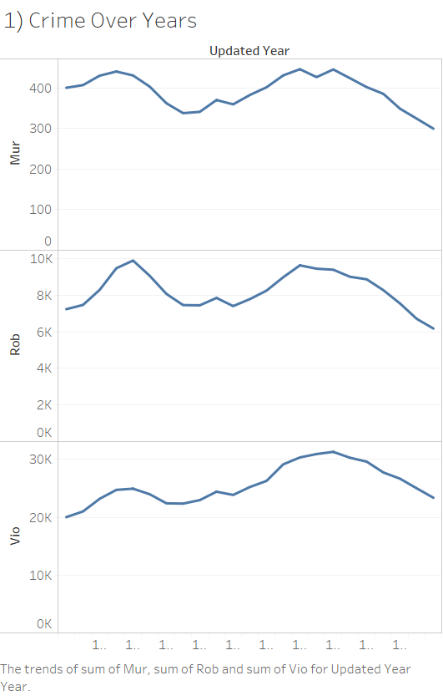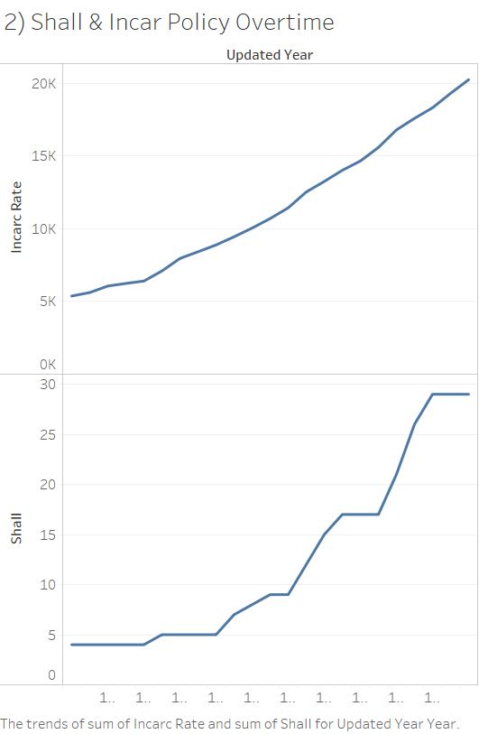

**GRAPH 2**

**GRAPH 2**

**GRAPH 1**

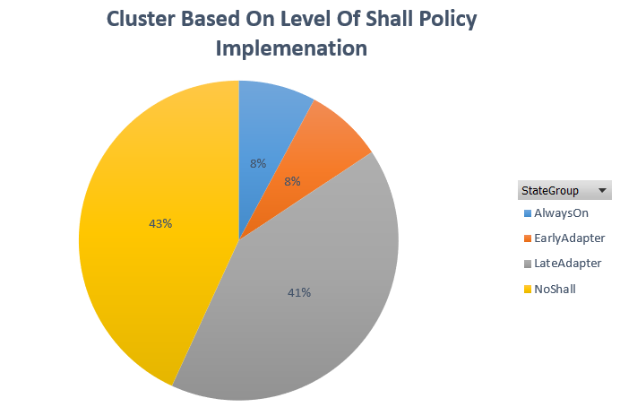To better understand the trends within panel data, 50 States were clustered into 4 distinct groups based on the level of shall-policy implementations. The 4 clusters were:

1. No-Shall: 22 out of 51 states that never allowed the carry of concealed handgun.
2. Early-Adopter: 4 out of 51 states that decided to implement shall policy anytime between 1978 to 1999
3. Late- Adopter: 21 out of 5 states that decided to implement shall policy after 1989
4. Always-On: 4 out of 51 states that always allow the carry of concealed handgun

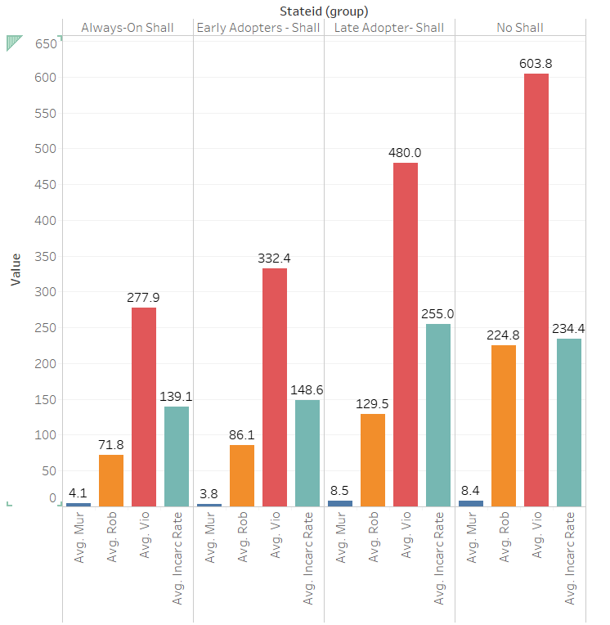Among the 4 clusters:

* No-Shall and Late-Adopter states had much higher crime incidents (across violence, murder, and robbery) compared to Early-Adopter and Always-On states. However, the difference between number of crimes in Always-On and Early-Adopter was not significantly (For example: an average of 4.1 vs 3.8 for murder). Same trend appeared between Late-Adopter and No-Shall. Therefore, it was implied that there were individual differences among 50 States that caused the variation in crime levels.
* No-Shall and Later-Adopter states also had higher incarceration rate compared to Early-Adopter and Always-On states. Implementing incarceration policy was expected to deter people from committing crimes. However, at the same time, higher incarceration might also be the result of increased crime. A simultaneous causality bias might be possible in this circumstance. As a result, the panel data might be inflicted with unobserved heterogeneity.

Trends in other demographic variables were also studied to get a better insight into the panel data. Specifically:

* Graph 3 showed in No-Shall and Late-Adopter states where crime level was high, demographic variables such as: “income level, density, and population” also tended to be upward. Therefore, it was speculated that the mentioned variables would have some effects on the crime level.
* Graph 4 showed that in No-Shall and Late-Adopter states where crime level was high, there was also a high percent male population. The high percent of black population and white population were just indication of high population. As a result, it was speculated that high level of male population would have some effects on the number of crime incidents.

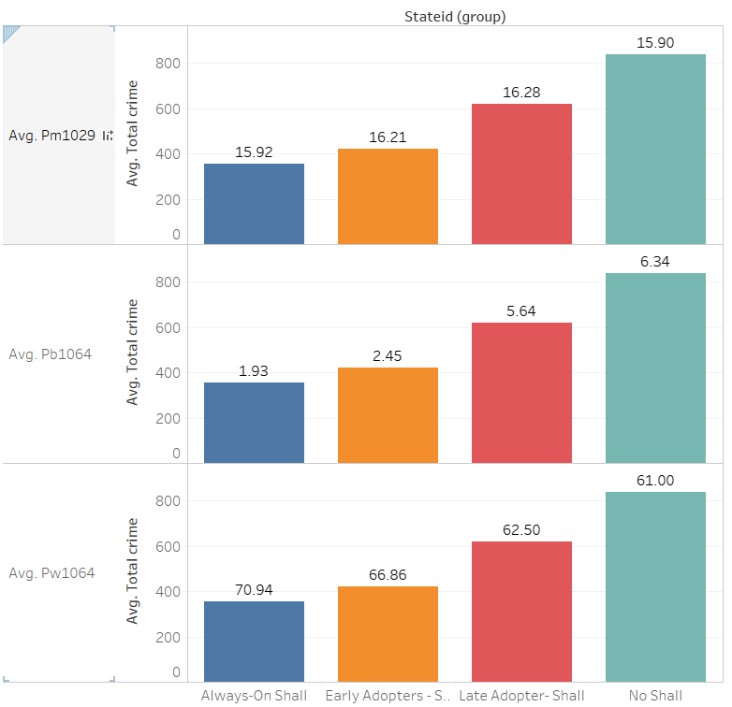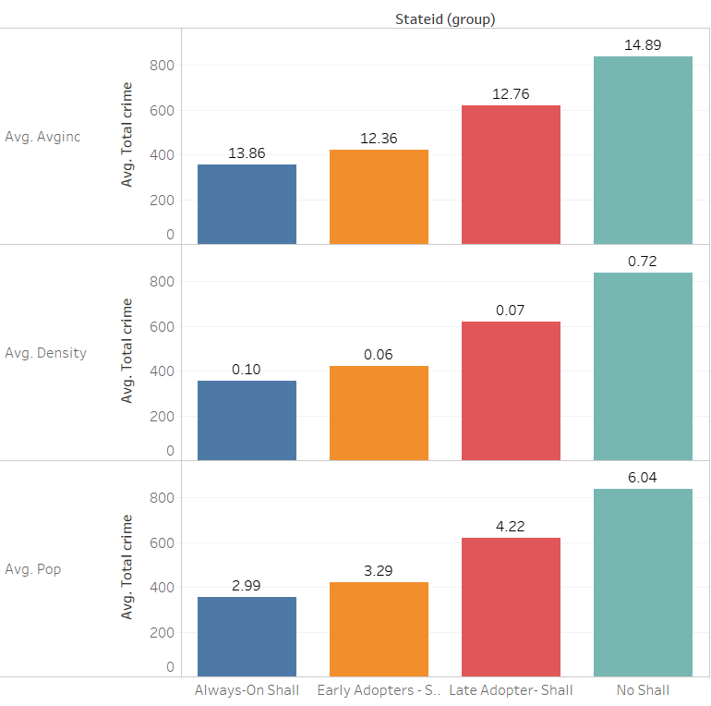

*Note: Avg. Total Crime = Avg. (Violence crime + Murder crime + Robbery crime)*

**GRAPH 4**

**GRAPH 3**

The following histogram plots helped reveal the distributions of the variables and the possible effects of outliers. Accordingly, certain variables were log-transformed to reduce their skewness and to make them more interpretable.

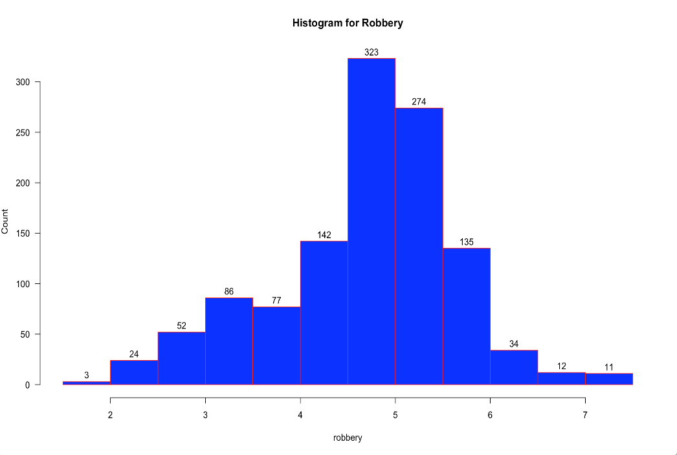

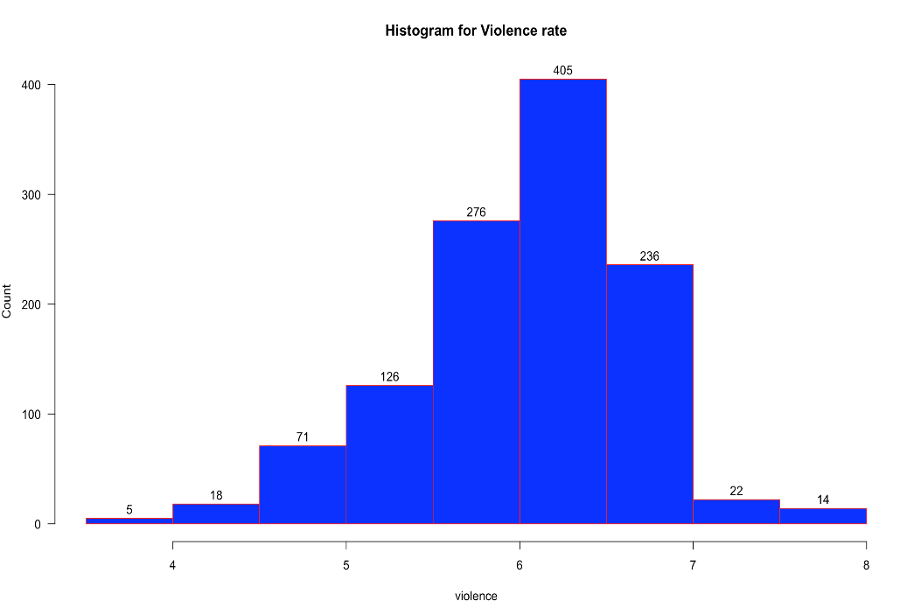

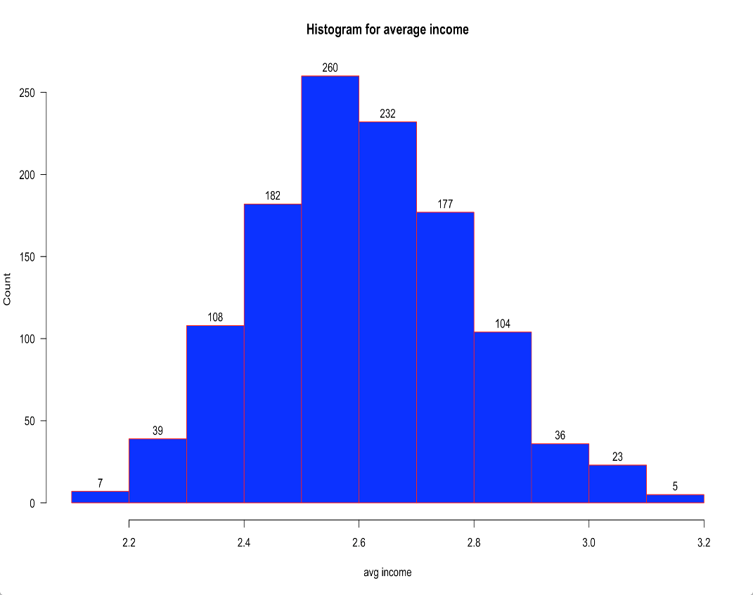

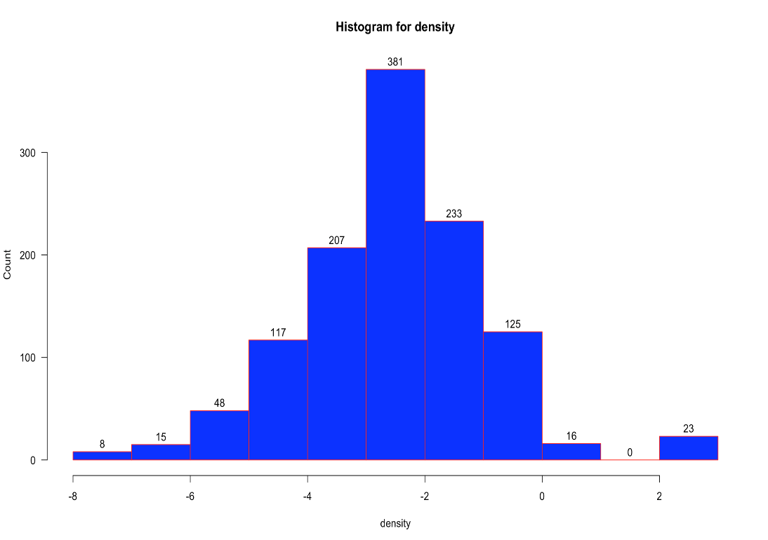

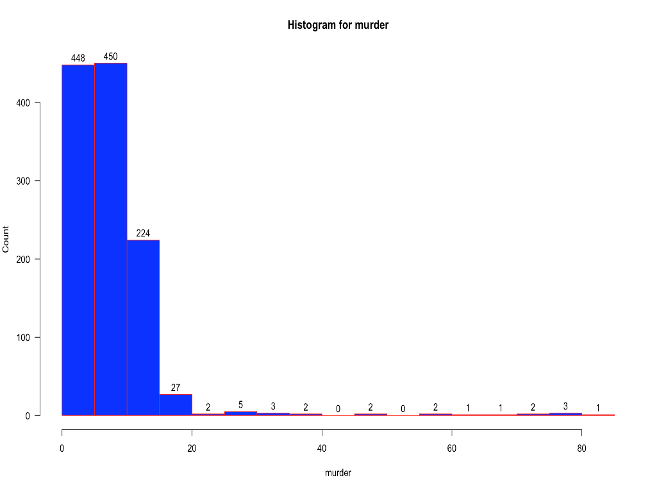

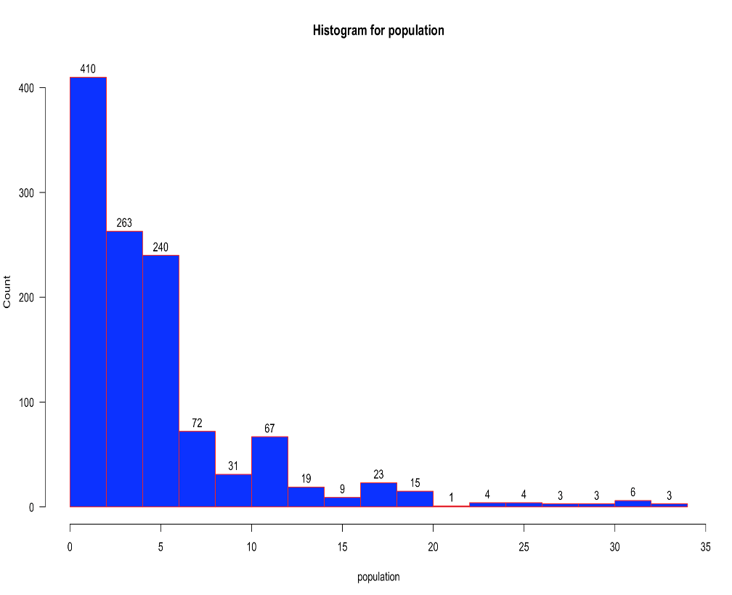

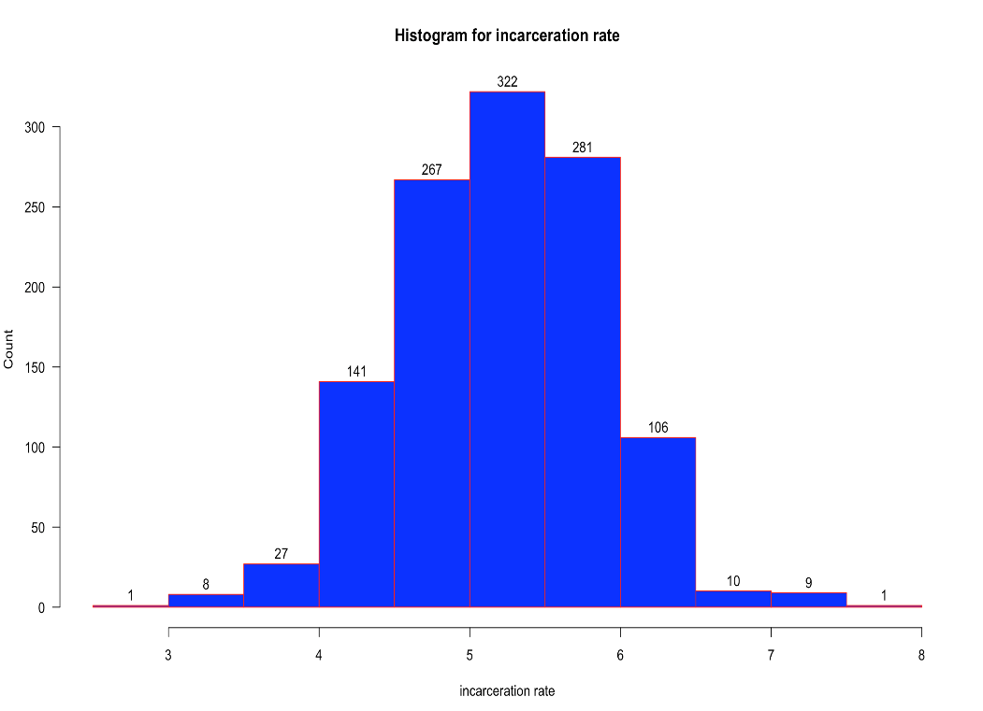

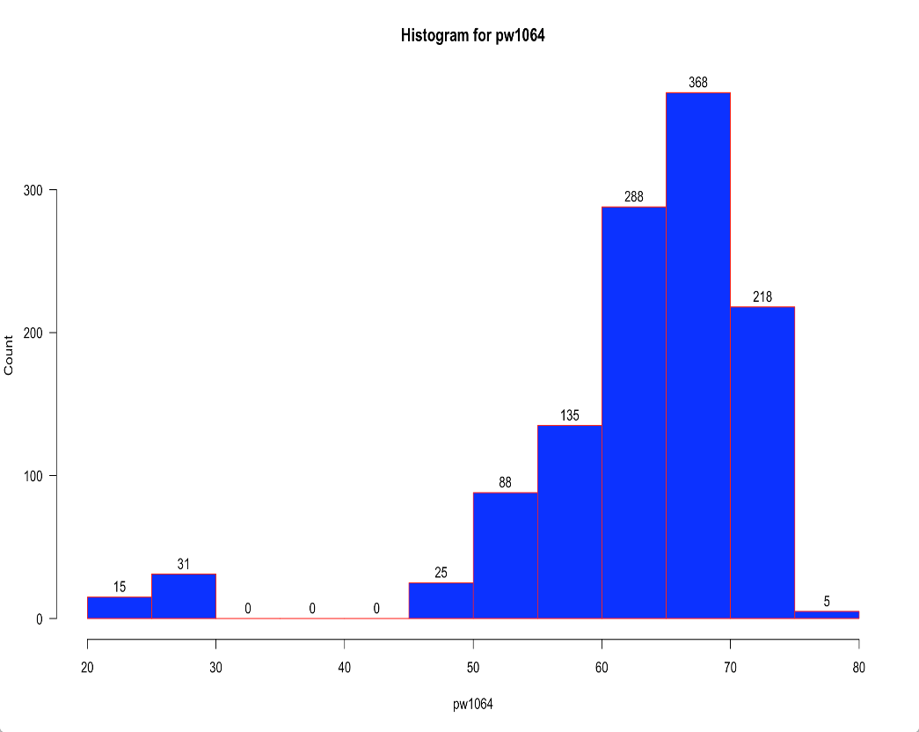

We have also looked at the correlation matrix to be aware of highly correlated variables, if any. This will be an easy reference to investigate, if a collinearity problem were to be detected.

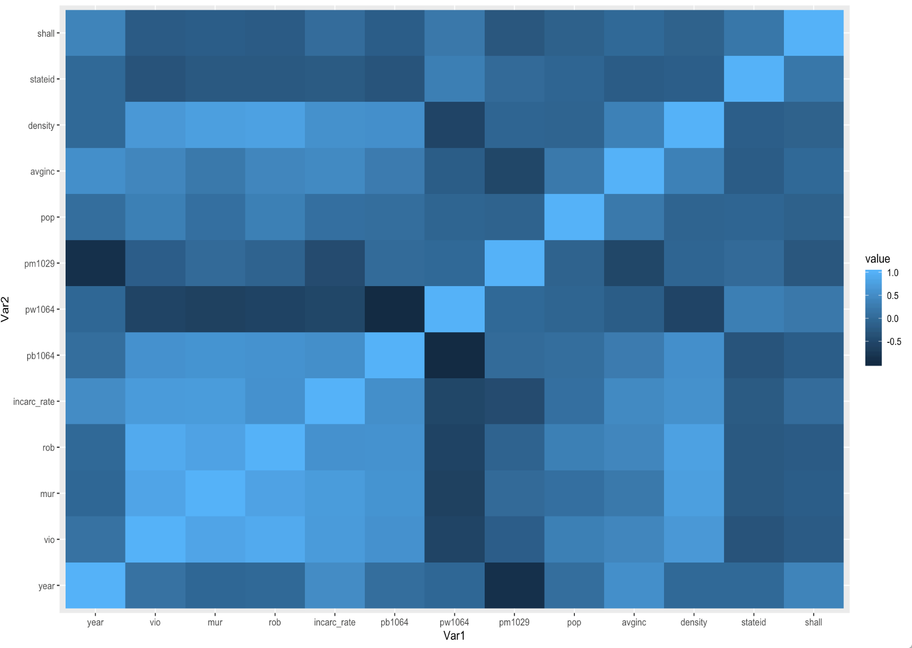



We shall now proceed with detailed analysis of our panel dataset, to fulfill the stated objective. We have conducted Entity Fixed effects modeling and Time-fixed effects modeling for violent-crime rate, murder rate and robbery-rates as dependent variables separately.

Hausmann Tests were conducted in each case to check the presence of endogeneity and to conclude the requirement/ non-requirement of random-effects model for each analysis.

The models, their analysis, and conclusions have been elaborated below:

**METHODOLOGY**

* Run Pooled OLS model, Entity- Fixed Effect model, Time-Effect-FE model for 3 dependent variables: Violence, Murder, Robbery Crime
* Perform log transformation on the following variables to improve model accuracy: Violence, Murder, Robber, Incarceration Rate, Population, Average Income, and Density.

**RESULTS**

* **Findings on Violence Crime**

1. **Pooled OLS Model**

* The result showed that States with active shall-policy would witness a decrease in violence crime by 25%. The effect was significant at 99% confidence level.
* We initially expected incarceration policy would help decrease violence crime in local areas. However, the Pooled OLS model showed contradicting outcome. Implementing incarceration policy would lead to a surge in violence crime by 66% compared to when the policy was not enforced.
* The assumption of Pooled OLS Model where there would be no unobserved heterogeneity across all 51 entities was violated, since the huge effect of shall policy from the model did not align with real-life observation. Therefore, Pooled OLS was not recommended to use.
* The unreliable results might be influenced by difference between the States in terms of other government policies, cultural practices, or unemployment rate. The mentioned factors could be omitted from the model leading to upward bias. As a result, it was necessary for the model to consider unobserved heterogeneity.

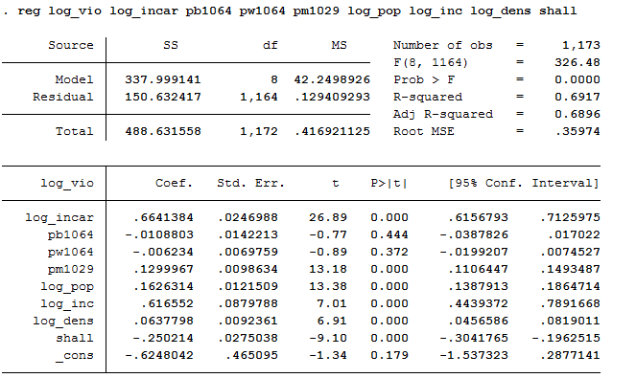

1. **Entity Fixed Effect Model**

* In Entity Fixed Effect model, States which implemented shall policy were able to decrease violence crime by 3.9%
* The effect of incarceration policy on violence crime was minimal at 0.07%, which did not show significant impact.
* Variables such as: population, income, and density showed insignificant influence on violence crime since their p-values were much higher than significance level at 5%.
* Even though, Entity-Fixed Effect did solve unobserved heterogeneity problem in Pooled OLS, the model still ignored the potential changes in violence crime across the years.

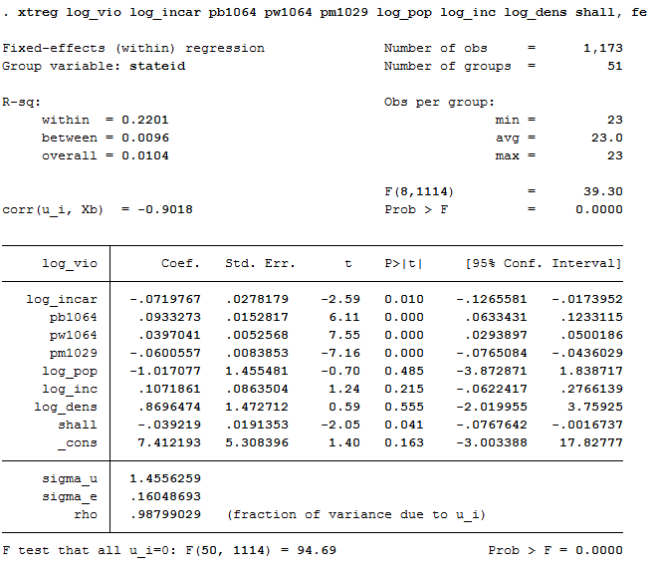

1. **Time Fixed Effect Model**

* An F-test was conducted to determine whether violence crime was influenced over the years. The test result showed significant effect results at 99% confidence level.

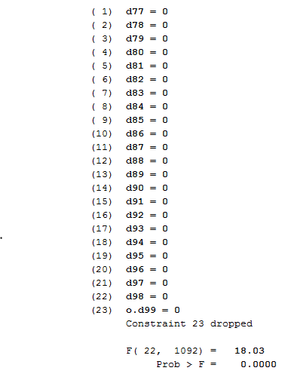

* In Time-Fixed Effect Model, shall-policy implementation decreased violence crime by 2.3%. However, its effect was insignificant at 5% significance level.
* The impact of incarceration policy on violence crime (at 0.097% reduction rate) was also minimal.
* According to the model result, demographic variable “pm1029” had great effect on violence crime. Specifically, when pm1029 increased by 1%, violence crime would go up by 7.5%.

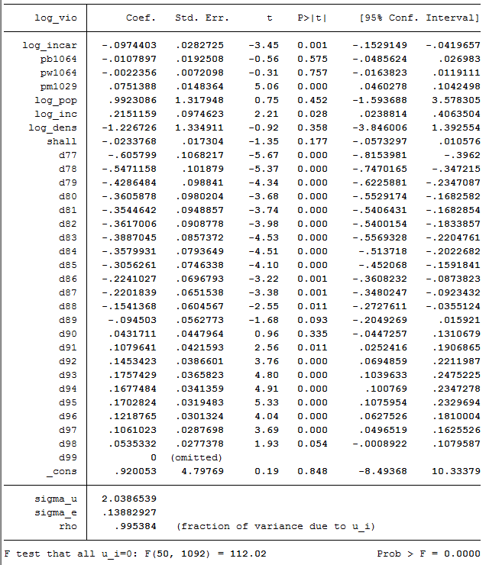

1. **Hausmann Test - Endogeneity Problem Detection**

* The Hausmann Test revealed that the null hypothesis would be rejected. As a result, it was concluded that the assumption of no endogeneity was incorrect.
* From the findings, Random-Effect Model would not be suitable due to endogeneity problem. In addition, the panel data comprised of information across all 50 States, not random samples. As a result, running Random-Effect Model would not be recommended.

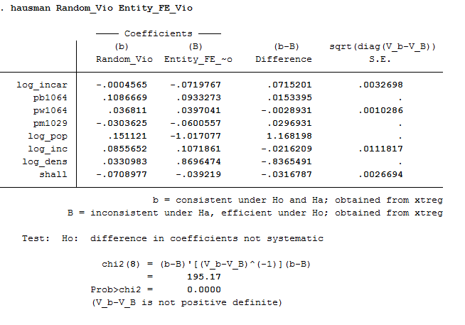

1. **Model Comparison**

* In summary, Pooled OLS Model’s result was unreliable as it did not capture within-state differences. *Due to this fatal flaws, Pooled OLS Model would not be conducted to study the effect of shall policy and incarceration policy on Robbery & Murder Crime*
* Time Fixed-Effect Model was more accurate than Entity Fixed-Effect Model as it captured the trend of violence crimes over the years.

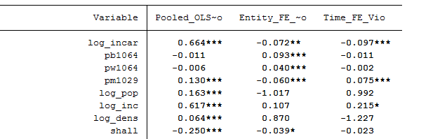

* **Findings on Robbery Crime**

1. **Entity Fixed-Effect Model**

* The model showed that shall policy had insignificant effect on robbery. As a result, it was concluded that allowing the carry of concealed handgun did not deter robbery crime.
* However, implementing incarceration policy revealed to decrease level of robbery. 1% increase in incarceration would lead to 0.129% decrease in robbery incidents
* Other demographic factors such as: *pb1064, pw1064, pop, and density* also made a significant impact in reducing robbery.

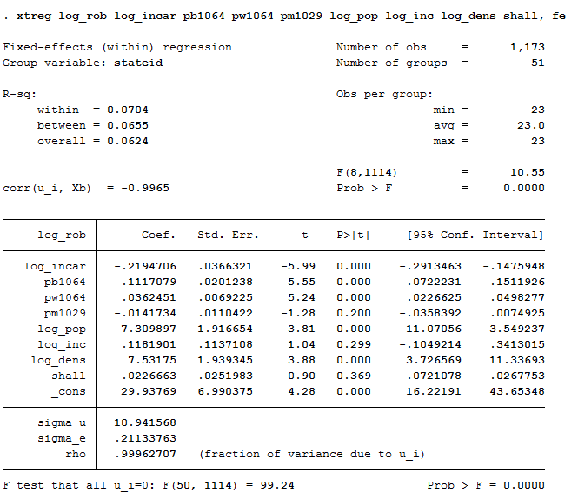

1. **Time Fixed Effect Model**

* An F-test was conducted to determine whether there was a significant change of robbery level over the years. The result confirmed the notion. There was time effect on the variation of robbery

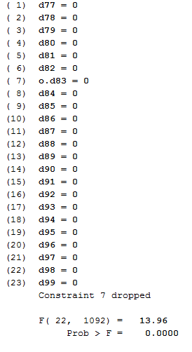

* In Time Fixed Effect model, shall policy again showed no significant impact on robbery.
* An 1% increase in incarceration would lead to a 0.215% decrease in robbery
* *Male population* revealed to affected robbery level significantly. Specially, a 1% decrease in male population age 10-26 would reduce robbery by almost 10%.
* Robbery crimes tended to increase over time, especially from 1983 onwards. Especially, robbery peaked from 1996 to 1999.

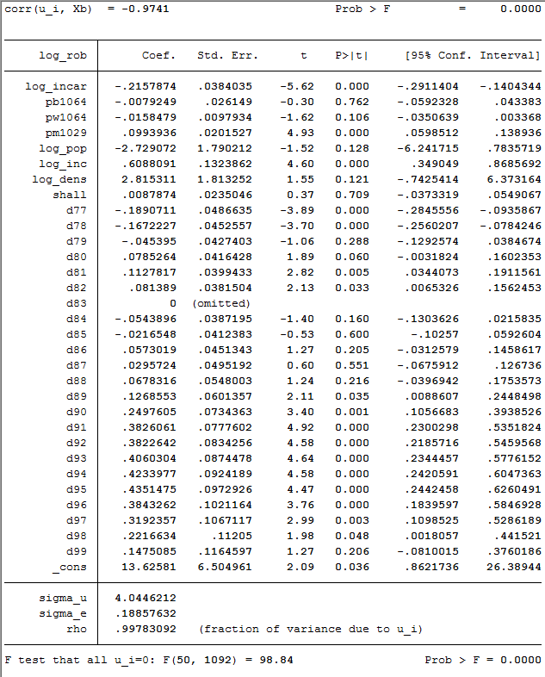

1. **Hausman Test – Endogeneity Problem Detection**

* Based on Hausman test, there was endogeneity in one of the variables at 10% significance level. The finding was alarming, thus running Random-Effect Model would not be suggested.

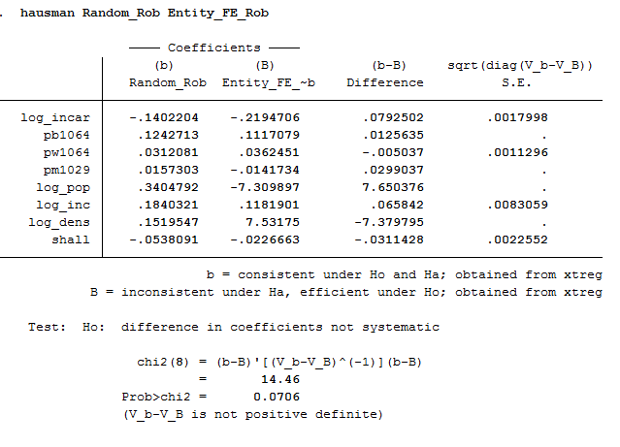

1. **Model Comparison**

* In both Entity Fixed-Effect and Time Fixed-Effect model, allowing the carry of concealed handgun did not reduce robbery rate.
* As Time Fixed Effect were able to capture the changes of robbery over time, it was the preferred model.
* In Time Fixed Effect mode, factors that could diminish robbery incidents were to: incarceration rate, male population within the age of 10-29, and average income level.

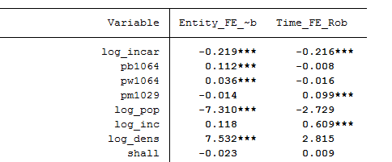

* **Findings on Murder rate**

1. **Entity Fixed-Effect Model**

* Both shall and incarceration rate had significant impact on murder rate.
* Specifically, implementing shall-policy would lead to a reduction in murder incidents by at least 7%. Additionally, an 1% increase in incarceration would reduce murder by 0.16%
* *Income and density* also showed to affect the murder rate considerably. The more crowded, the more likelihood that murder rate would increase. Same went for the effect of income on murder rate.

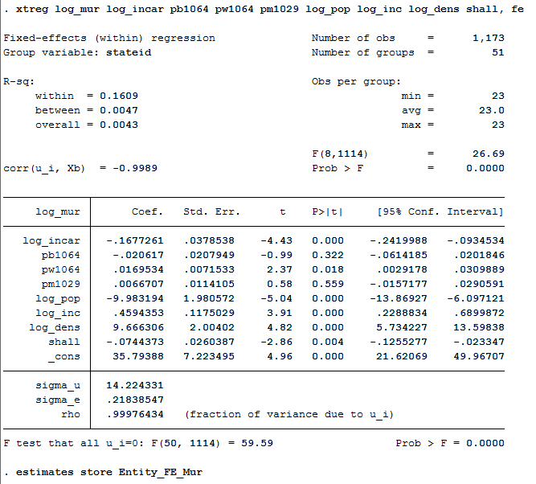

1. **Time Fixed-Effect Model**

* An F-test was conducted to determine whether there was a significant change of murder rate over the years.

The result confirmed the notion. There was time effect on the variation of murder incidents.

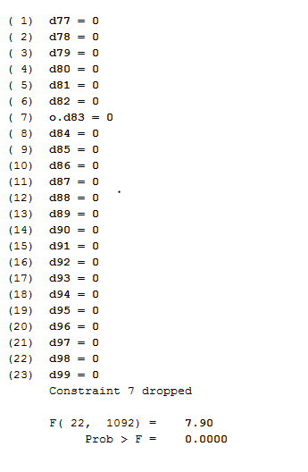

* In Time Fixed Effect model, at 5% significant level shall policy did not affect murder rate
* On the other hand, a 1% increase in incarceration would reduce murder incidents by 0.1%
* *Density and male population* could make positive contribution in murder rate deduction.
* The result showed that 1% increase in the male population within age 10-20 would increase murder level by 0.066%. Additionally, 1% increase in density unit would also lead to a surge of 6.22% in murder rate.
* In terms of time effect, murder rate slowly increased with its peak in 1993. After that, it consistently declined onward.

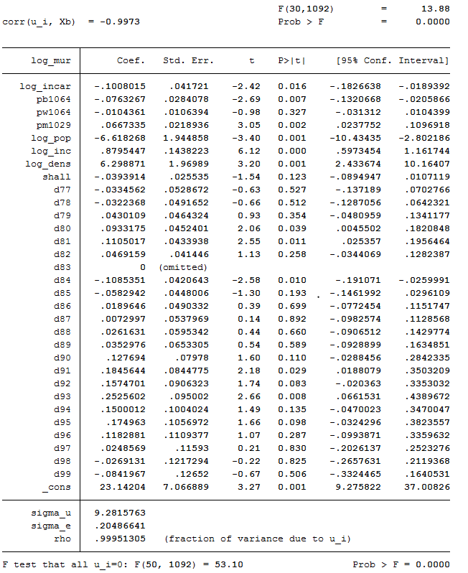

1. **Hausman Test – Endogeneity Problem Detection**

* Based on Hausman test, there was endogeneity in one of the variables. As a result, running Random-Effect Model would not be suggested.

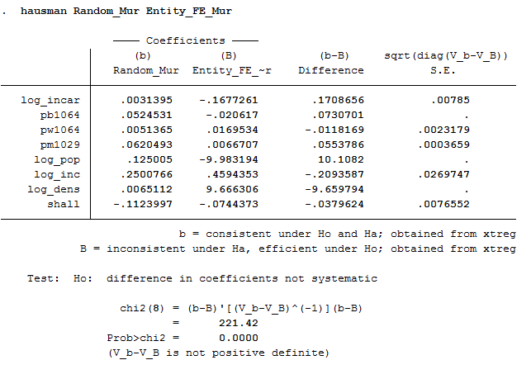

1. **Model Comparison**

* Both models showed that implementing incarceration would reduce murder rate significantly.
* Besides that, demographic variables such as: income and density would also affect murder incidents across 50 States.
* Among the 2 models, Time Fixed Effect was more preferred as it was able to capture the effect of time on murder rate variation across the panel data.

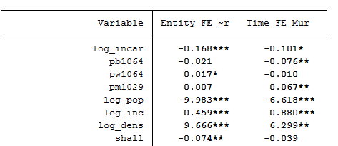

**CONCLUSIONS & IMPLICATIONS**

We were able to conclude the following from our analysis:

* Both shall-issues and incarceration policy can reduce violent crime rates, but very minimally.
* Neither the implementation of shall-issue laws nor enforcing increased incarceration seemed to have any effect on robbery rates. However, the percentage of male population aged 10-29 did.
* Shall-issue laws had no significant effect on murder rates but implementing increased incarceration did reduce murder rates in the succeeding year.

**LIMITATIONS**

The main limitation of our analysis is that we have assumed a linear relationship between the dependent and the regressors. It is indeed possible that better estimates may have been possible by including quadratic terms or even interaction terms.