ANKIT BAJAJ

8622588

**ASSIGNMENT 2**

**Part1:**

1. using the order_details table, find the revenue (price * quantity) earned on each order.

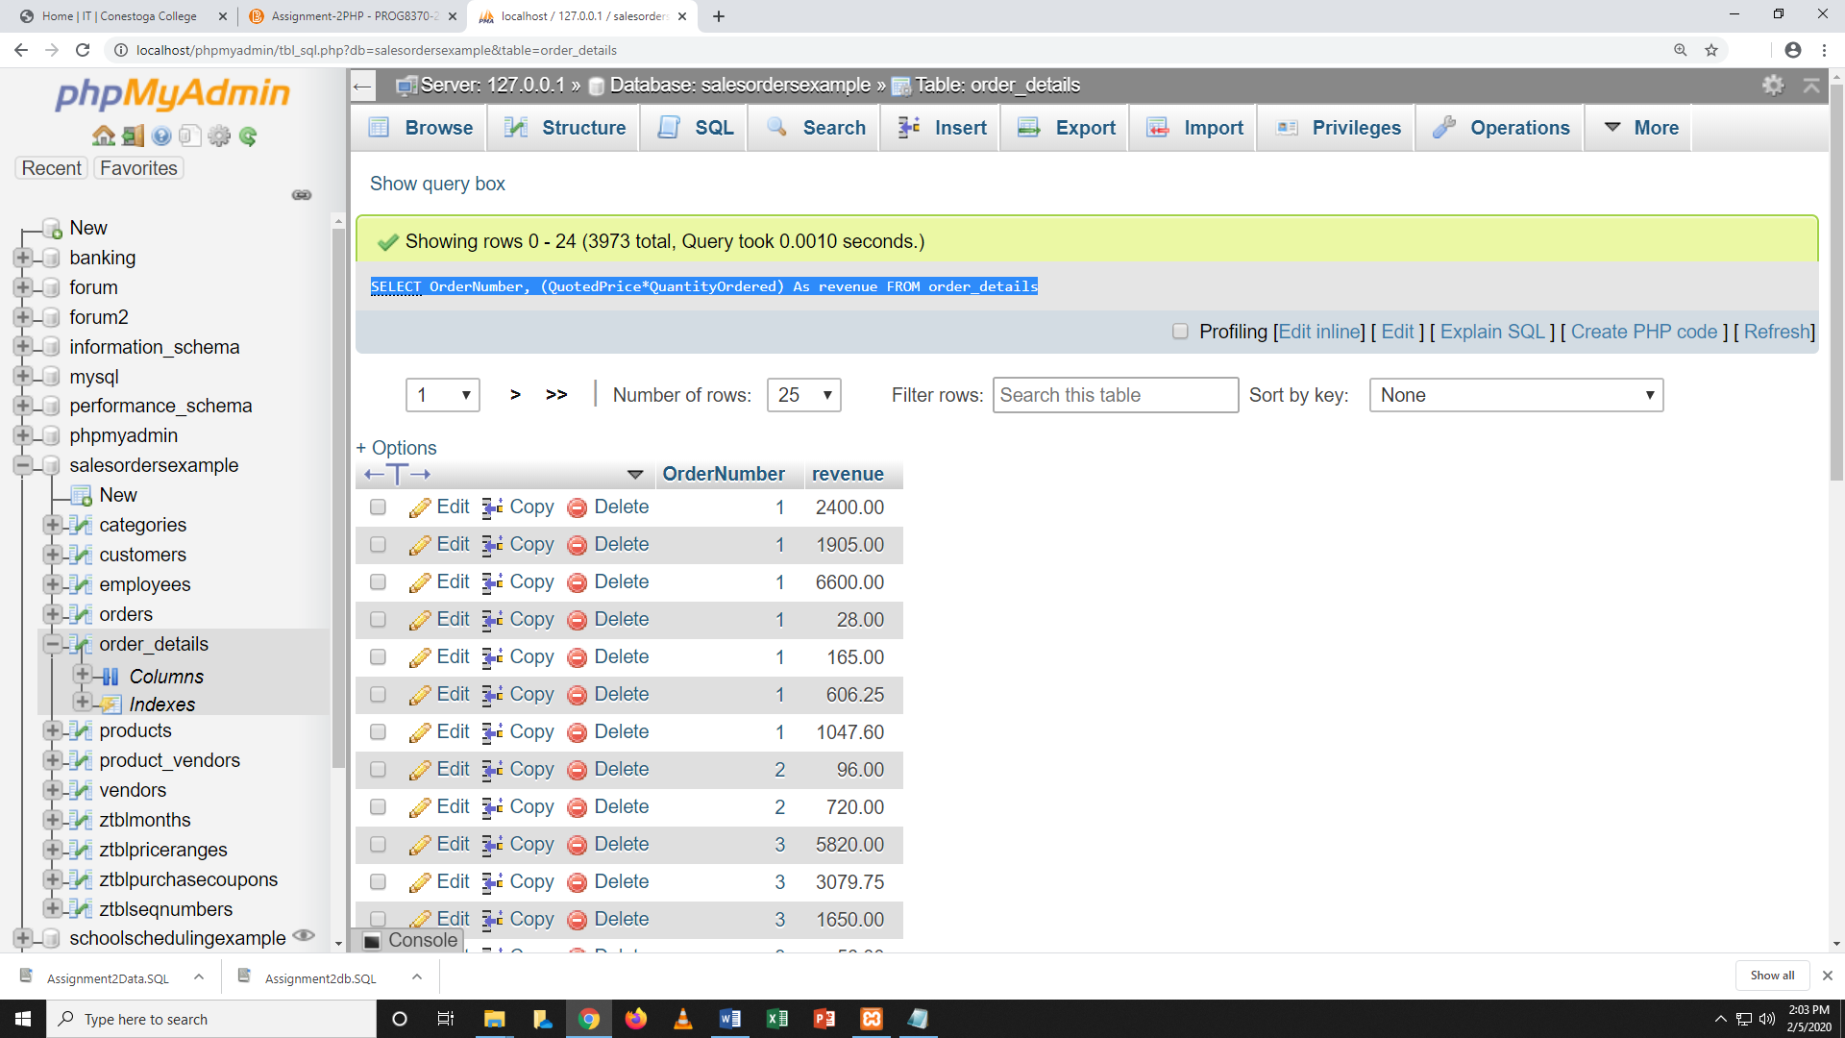

1. Using the employees table, find the age of each employee in years and order from youngest to oldest.

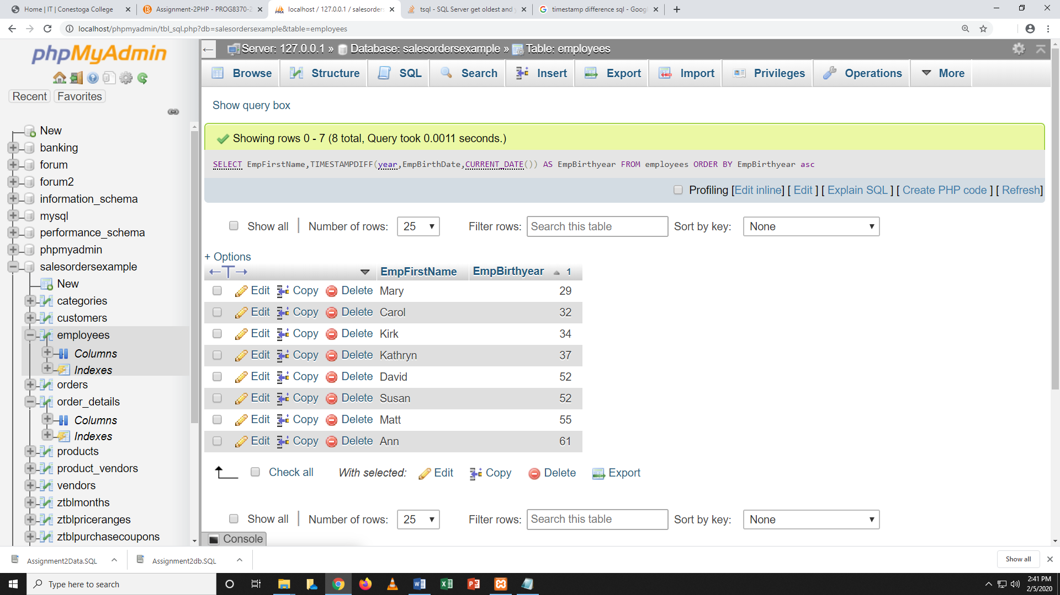

Part 2: conditional queries.

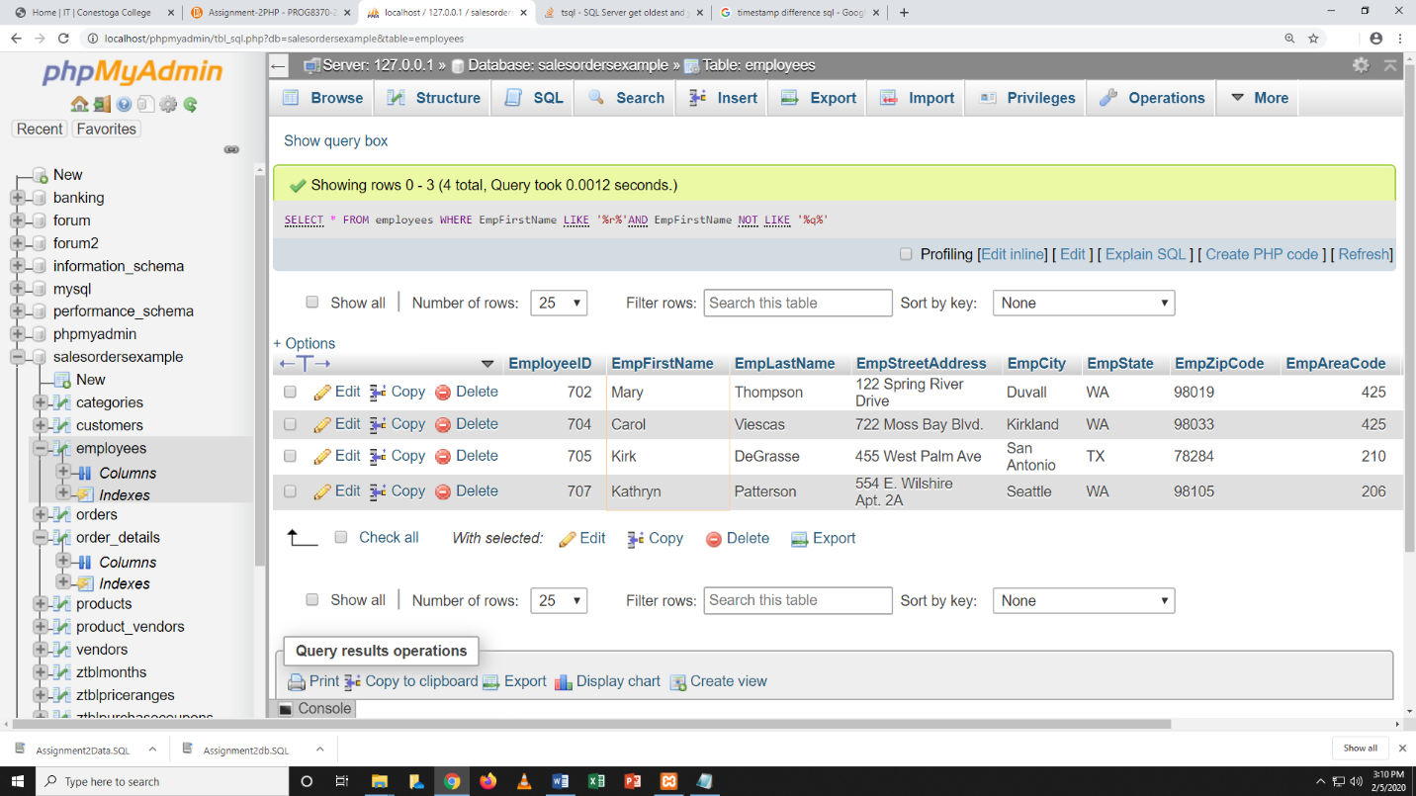1. Using the employees table, find all employees with a first name that contains an 'r' and a last name that does not contain a 'q’.

Part 3:

1.Explain what is wrong with the following table and how you would fix.

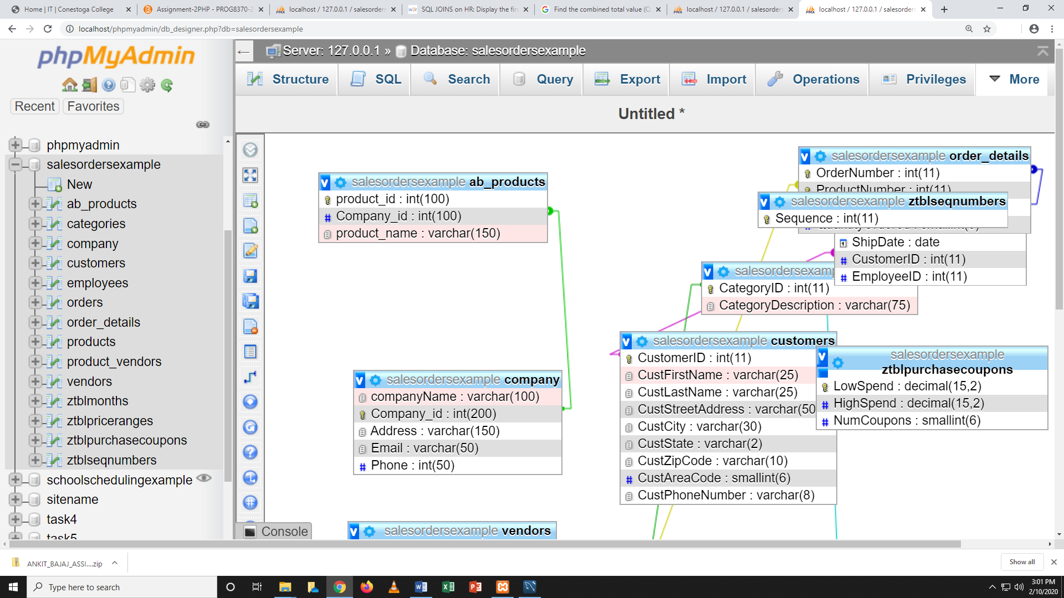

Part 4:

1. Find the first name and phone number of all customers who have ever ordered a helmet. HINT: Use the keyword DISTINCT.

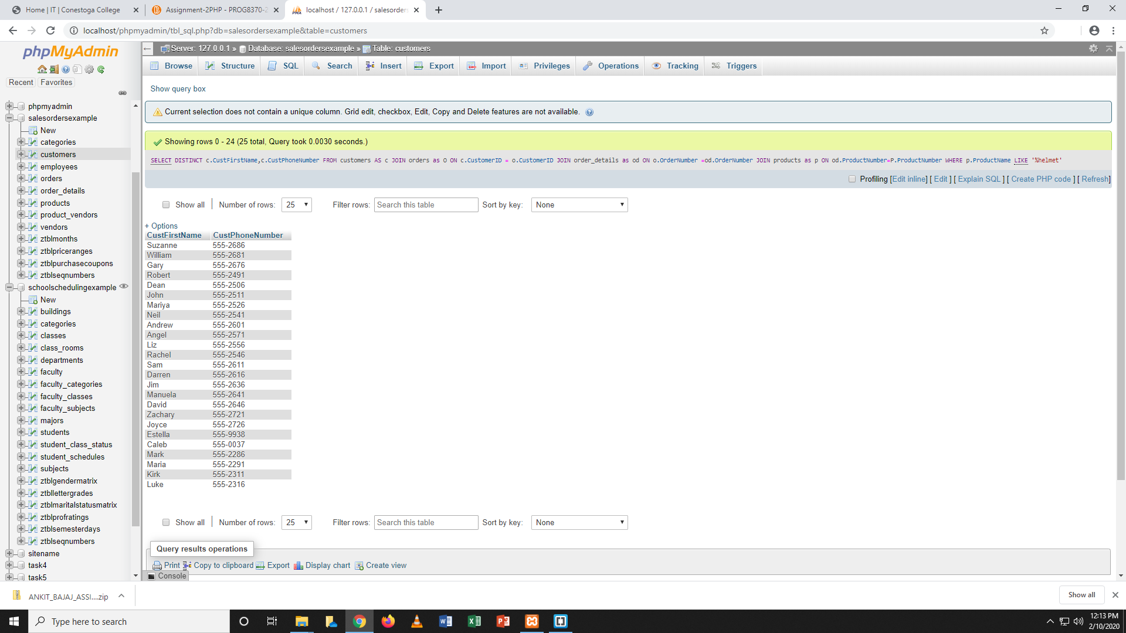

1. Display the first name of all customers who have the same first name as an employee.

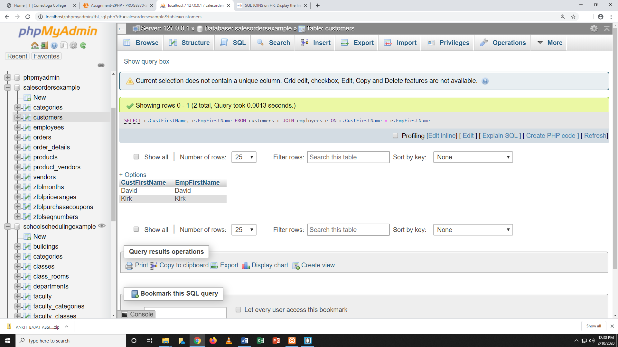

Part 5:

1 Find the combined total value (QuantityOrdered*QuotedPrice*2) of all orders made by customers from the state of 'OR

