Baliyan, Ankit

Installation Guide

Table of Contents

1. Project Link in GitHub 2

2. Unzip Folder 2

3. Application Release 3

4. Pre-Check 3

## Project Link in GitHub

<https://github.com/ankit-baliyan/Grid_Beyond_Task.git>

Goto the link above and download the project.

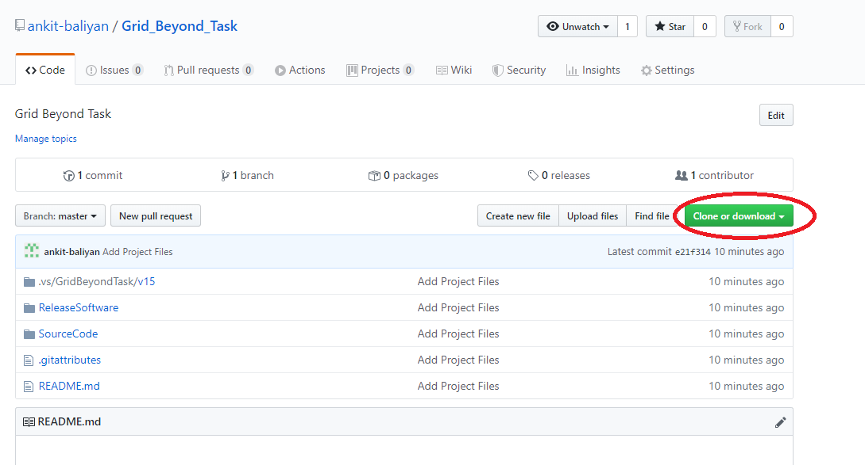

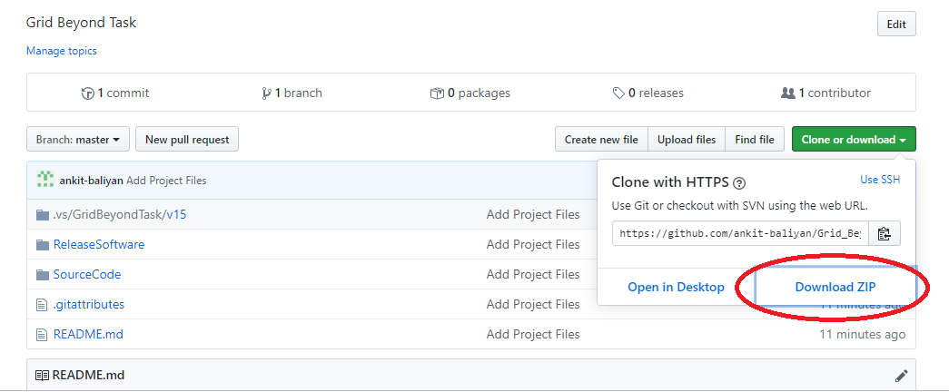

## Unzip Folder

After download, unzip the folder. There is Source Code, Documentation & Release Software folder in the package.

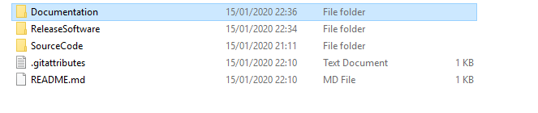

## Application Release

To run the software, open the “ReleaseSoftware” folder then open “GridBeyondTaskApplication” folder.

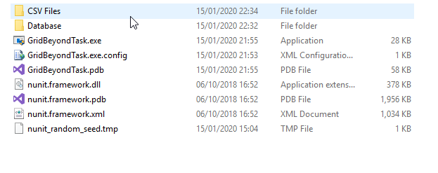

## Pre-Check

* Check if there is file exist in the “CSV Files” folder. If not copy file which need to be processed.
* Check if database file “SampleDatabase.mdf” exist in the “Database” folder.
* If database server is different than “.\SQLEXPRESS”, change it in “GridBeyondTask.exe.config” file.

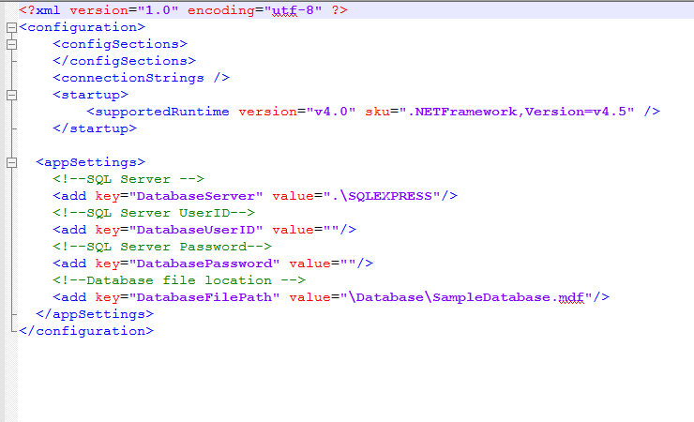

Software is ready to run.