Baliyan, Ankit

User guide for GRID BEYOND TASK Application

Table of Contents

1. Application Run 2

2. Source Code 3

3. Testing – Nunit 4

## Application Run

Application should be “Run as Administrator”

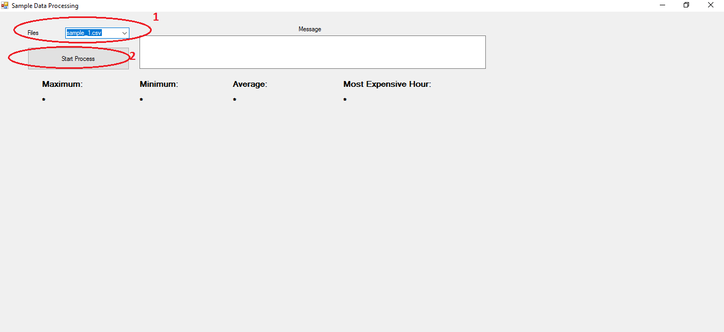

After running application, 1 (Files Dropdown List) will be populated with existing files. Select the file you wanted to process.

After selecting file, 2 click on the “Start Process” button.

After process finished, message box will show successful message.

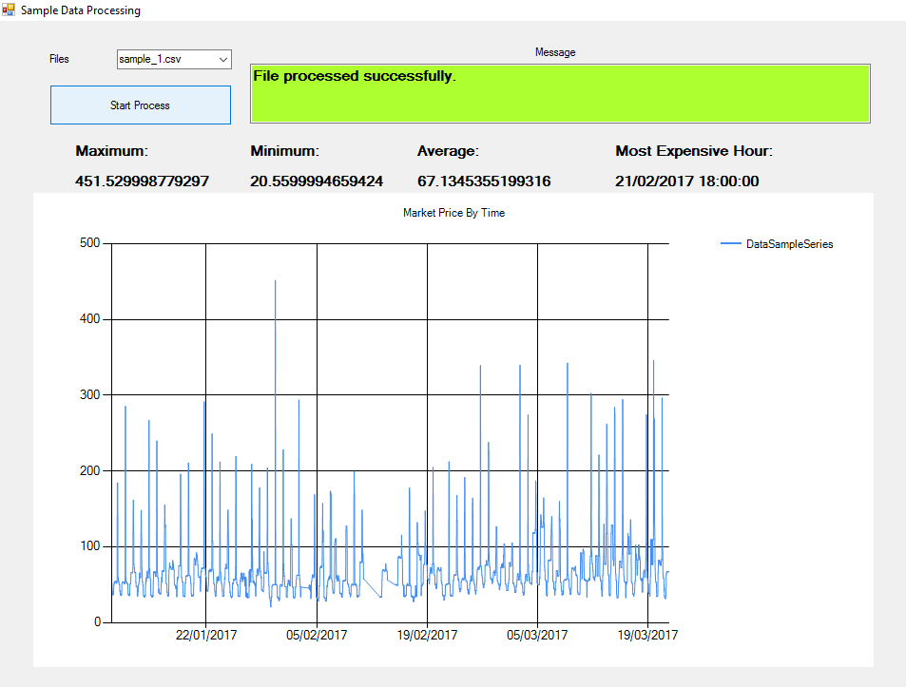

## Source Code

Source Code can be open in Visual Studio 2017/2019.

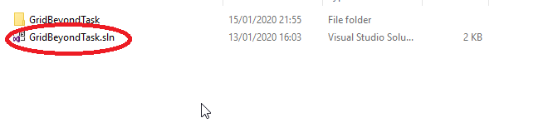

If Source Code not open in Visual Studio, open “GridBeyondTask” folder, open “GridBeyondTask.csproj” in Visual Studio.

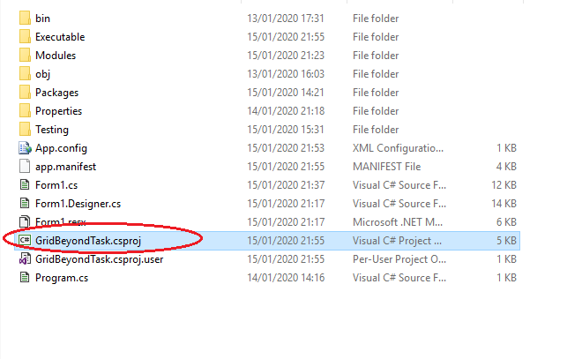

## Testing – Nunit

Automated Testing Screenshot below.

