An Internship Report
Of
Java Full Stack Developer Virtual Internship

Submitted
To

School of Computer Science and Engineering
IILM University, Greater Noida, U.P.

In partial fulfilment of the requirement of degree of
B.Tech (Computer Science and Engineering)

By

Roll Number of Student: 2410031066
Name of Student: ANKIT KUMAR
Batch: 2024-2028

CANDIDATE'S DECLARATION
I, ANKIT KUMAR, do hereby declare that the internship report titled "Java Full Stack Developer Virtual Internship" has been completed by me to fulfil the requirement for the award of the degree of Bachelor of Technology in Computer Science and Engineering. All the references have been quoted and I have not taken as such any material from any other source. I affirm that this report is my own and has not been submitted to any other institute for any degree/diploma requirement, and further I shall be solely responsible for any kind of copyright violation in this regard.

Signature:-
Student Name: ANKIT KUMAR
Roll No.: 2410031066

ACKNOWLEDGEMENT
I am using this opportunity to express my gratitude to everyone who supported me throughout the Internship Program. I am thankful for their aspiring guidance, invaluably constructive criticism and friendly advice during this work. I am sincerely grateful to them for sharing their truthful and illuminating views on a number of issues related to this work.
I would like to thank the AICTE – EduSkills Virtual Internship Program team and EduSkills Academy for providing me the opportunity and the structured platform to learn and gain hands-on exposure in the domain of Java Full Stack Development. I am also thankful to my institute, IILM University, Greater Noida, and the faculty of the School of Computer Science and Engineering for their continuous support and encouragement.
I express my gratitude to my parents for their blessings.

Signature:-
Student Name: ANKIT KUMAR
Roll No.: 2410031066

TABLE OF CONTENTS
1. | Candidate's Declaration | i
2. | Acknowledgement | ii
3. | Internship Completion Certificate | -
4. | Project Description | 1
 | 4.1 Introduction | 1
 | 4.2 Organization Profile | 1
 | 4.3 Problem Statement | 1
 | 4.4 Project Objectives | 2
 | 4.5 Scope of the Project | 2
 | 4.6 Technologies and Tools Used | 2
 | 4.7 System Architecture | 3
 | 4.8 Methodology | 3
 | 4.9 Expected Outcomes | 4
 | 4.10 Certificates of Completion and Communication Proof | 4
5. | Bibliography/References | 5

3. INTERNSHIP COMPLETION CERTIFICATE
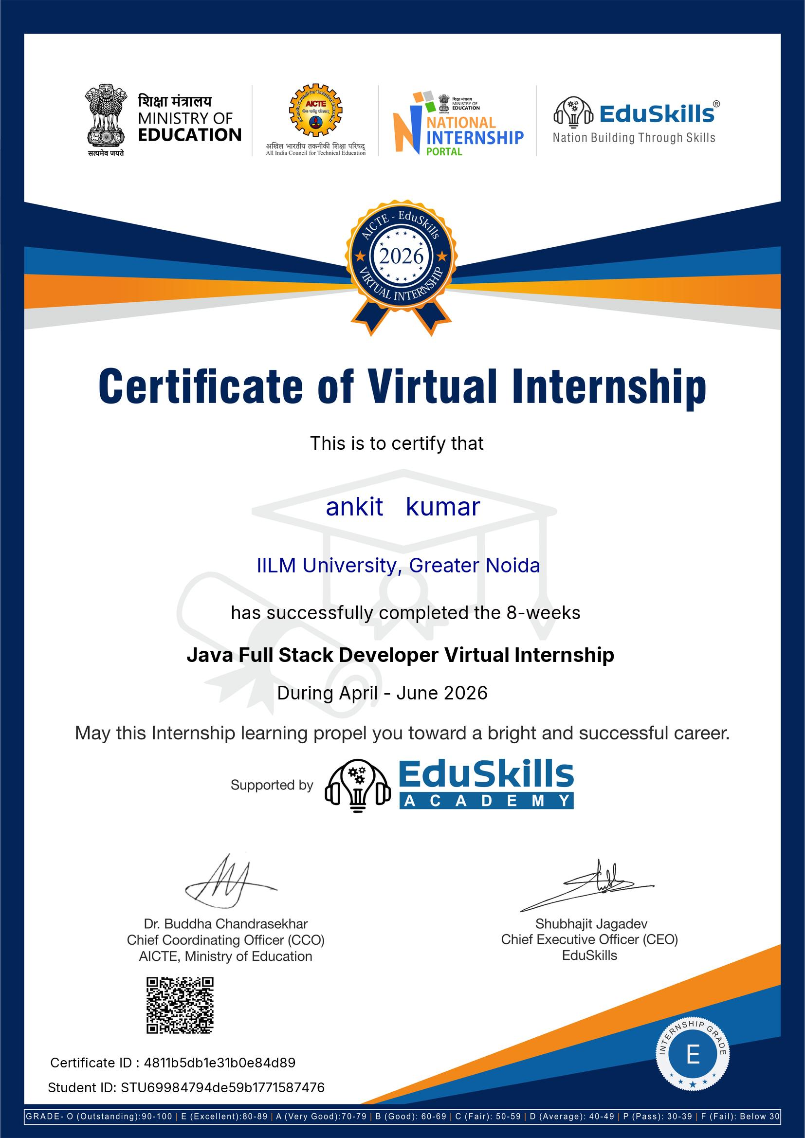

4. PROJECT DESCRIPTION
4.1 Introduction
This report presents a detailed account of the 8-week Virtual Internship undertaken under the AICTE – EduSkills Virtual Internship Program, in the domain of “Java Full Stack Developer”, supported by EduSkills Academy. The internship was carried out from April 2026 to June 2026 as part of the requirement of the Bachelor of Technology (Computer Science and Engineering) programme at IILM University, Greater Noida. The primary aim of this internship was to build a strong practical foundation in Java-based full stack web development, covering front-end design, back-end programming, database connectivity, and deployment of a complete web application.
The internship followed a structured, week-wise curriculum combining conceptual learning with hands-on assignments, quizzes and a final credential validation. On successful completion of all the requirements, including the Internship Grade Point Assessment, a Virtual Internship Certificate with an “Excellent” grade was awarded by EduSkills Academy under the patronage of AICTE and the National Internship Portal.
4.2 Organization Profile
EduSkills Academy is an ISO 9001:2015 and ISO/IEC 20000-1:2018 certified organization working under the theme “Nation Building Through Skills”. EduSkills partners with the All India Council for Technical Education (AICTE) to run the AICTE – EduSkills Virtual Internship Program under the patronage of the AICTE National Internship Portal. For the Java Full Stack Developer track, EduSkills has designed an industry-aligned curriculum that helps engineering students build practical, job-ready skills in end-to-end web application development.
4.3 Problem Statement
Although a large number of engineering students learn the theoretical foundations of programming and object-oriented concepts during their academic coursework, very few get structured, hands-on exposure to building a complete web application that integrates front-end, back-end, and database layers using an industry-standard technology stack such as Java, Spring Boot, and MySQL. Concepts such as RESTful API design, server-side programming, and database connectivity are often understood only at a theoretical level, with little practice in building and integrating a working full stack application. The problem addressed by this internship was to practically learn and apply the Java full stack development workflow – from core Java programming to front-end design, server-side logic, database integration, and final application deployment.
4.4 Project Objectives
- To strengthen core Java programming and object-oriented programming (OOP) concepts.
- To learn front-end web development using HTML5, CSS3 and JavaScript.
- To understand server-side programming using Servlets and JSP, and the MVC design pattern.
- To learn the fundamentals of the Spring Framework, including Dependency Injection and Inversion of Control.
- To build and test RESTful web services using Spring Boot.
- To design relational database schemas and integrate them using JDBC/MySQL.
- To integrate front-end, back-end and database components into a single, working full stack application.
- To successfully clear the Final Assessment / Internship Grade Point Assessment.
4.5 Scope of the Project
The scope of this internship spans the complete Java-based full stack development workflow – starting from core Java and object-oriented fundamentals, moving through front-end web development, server-side programming with Servlets/JSP and the Spring Framework, and extending into REST API development and MySQL database integration using JDBC. It further covers combining these components into a single deployable full stack web application. The internship was limited to a virtual, simulation/lab-based learning environment provided by EduSkills Academy, and did not involve deployment on any live organizational production system.
4.6 Technologies and Tools Used
- Programming Language: Java (Core Java, Object-Oriented Programming)
- Front-End: HTML5, CSS3, JavaScript
- Back-End Frameworks: Servlets, JSP, Spring, Spring Boot
- Database: MySQL, JDBC
- Development Tools: Eclipse / IntelliJ IDEA, Postman, Git/GitHub
- Learning Platform: AICTE – EduSkills Virtual Internship Portal, learning modules and quizzes
4.7 System Architecture
The general architecture followed during the internship for the Java Full Stack Developer track can be summarized in the following layers:
- Presentation Layer: The user interface built using HTML5, CSS3 and JavaScript, responsible for displaying content to the user.
- Application/Business Layer: Server-side logic implemented using Servlets, JSP and the Spring Framework, handling requests and business rules.
- API Layer: RESTful web services built using Spring Boot that expose application functionality to the front-end.
- Data Access Layer: Database connectivity and CRUD operations implemented using JDBC against a MySQL database.
- Database Layer: A MySQL relational database that stores and manages application data.
- Assessment Layer: Weekly quizzes, assignments and a Final Assessment/Internship Grade Point Assessment that track progress and final grading.
4.8 Methodology
The internship followed a structured, week-wise methodology combining conceptual learning, hands-on practice, and quiz-based assessments, culminating in a Final Assessment, as summarized in the table below.
Week | Module | Description
1 | Core Java & OOP Concepts | Fundamentals of Java programming – classes, objects, inheritance, polymorphism, and exception handling.
2 | Front-End Web Basics | Building web page structure and styling using HTML5, CSS3 and JavaScript fundamentals.
3 | Advanced Java & JDBC | Collections framework, multithreading basics, and database connectivity using JDBC.
4 | Servlets & JSP | Building dynamic, server-side web pages and understanding the MVC design pattern.
5 | Spring Framework | Core concepts of the Spring Framework, Dependency Injection and Inversion of Control.
6 | Spring Boot & REST APIs | Developing and testing RESTful web services using Spring Boot.
7 | Database Design & Integration | Designing MySQL schemas and implementing CRUD operations for the application.
8 | Full Stack Project Integration | Integrating the front-end, back-end and database layers into a working full stack application.
Final | Final Assessment / Credential Validation | Final Assessment and Internship Grade Point evaluation based on weekly performance.

Note: There was no stipend associated with this internship. Each week concluded with quiz-based assessments to evaluate conceptual understanding. In the final phase, a Final Assessment / Internship Grade Point Assessment was conducted, and the overall grade was based on performance across the weekly modules and this final assessment.
4.9 Expected Outcomes
- Ability to apply core Java and object-oriented programming concepts to real development tasks.
- Practical understanding of front-end web development using HTML, CSS and JavaScript.
- Hands-on exposure to server-side programming using Servlets, JSP and the Spring Framework.
- Capability to design and develop RESTful APIs using Spring Boot.
- Skill to design MySQL database schemas and connect them to a Java application using JDBC.
- Ability to integrate front-end, back-end and database layers into a complete full stack web application.
- Successful completion of the Final Assessment / Internship Grade Point Assessment, resulting in an “Excellent” grade.
4.10 Certificates of Completion and Communication Proof
The Internship Completion Certificate issued by EduSkills Academy, confirming successful completion of the 8-week AICTE – EduSkills Virtual Internship Program in Java Full Stack Development with an “Excellent” grade, is attached in Chapter 3 of this report.

5. BIBLIOGRAPHY/REFERENCES
1. EduSkills Academy, “Certificate of Virtual Internship – Java Full Stack Developer,” Certificate ID: 4811b5db1e31b0e84d89, Student ID: STU69984794de59b1771587476, 2026.
2. AICTE National Internship Portal, https://internship.aicte-india.org/
3. EduSkills Foundation / EduSkills Academy, https://eduskillsfoundation.org/
4. Oracle Java Documentation, https://docs.oracle.com/en/java/
5. Spring Framework Documentation, https://spring.io/
6. MySQL Documentation, https://dev.mysql.com/doc/

