**INDIAN INSTITUTE OF INFORMATION TECHNOLOGY SURAT**



# LAB REPORT

### on

**ADVANCE DATABASE MANAGEMENT (CS 604)**

**Submitted by**

### [KALPAN BARIYA] (UI21CS28)

**Course Faculty MR. RISHI SHARMA DR. REEMA PATEL**

**Department of Computer Science and Engineering Indian Institute of Information Technology Surat Gujarat-394190, India**

**APRIL - 2024**

# Table of Contents

| **Exp. No** | **Name of the Experiments** | **Page number** | **Date of Experiment** | **Date of Submission** | **Sign** |
| --- | --- | --- | --- | --- | --- |
| **1** | Implement Basic commands of SQL | 03-13 | 21-01-2024 | 29-01-2024 |  |
| **2** | Implement PL/SQL commands | 14-19 | 21-01-2024 | 29-01-2024 |  |
| **3** | Write PL/SQL code as specified in tasks | 20-29 | 30-01-2024 | 5-02-2024 |  |
| **4** | Create TRIGGERS and implement given task | 30-33 | 06-02-2024 | 06-02-2024 |  |
| **5** | Analyze ecommerce Inventory | 34-37 | 13-02-2024 | 22-02-2024 |  |
| **6** | Object Oriented PL/SQL | 38-44 | 20-03-2024 | 16-04-2024 |  |
| **7** | PostgreSQL Practice | 45-47 | 10-04-2024 | 16-04-2024 |  |

**Assignment 1**

### Aim:

Create a Database for an Organization and create the following tables in the Organization Database:

Employee(EMP_ID(PK), FIRST_NAME, LAST_NAME, SALARY, JOINING_DATE, EPARTMENT)

Bonus (EMP_REF_ID(FK EMP_ID), BONUS_AMOUNT, BONUS_DATE) Title (EMP_REF_ID(FKEMP_ID), EMP_TITLE, AFFECTED_FROM)

Insert a minimum of 50 records in each table.

Retrieve the following information from the Organization database:

1. SQL query to print all Employee details from the Employee table order by FIRST_NAME Ascending and DEPARTMENT Descending.
2. SQL query to fetch the count of employees working in the department ‘Admin’.
3. SQL query to fetch Employee names with salaries >= 50000 and <= 100000.
4. SQL query to print details of the Workers who are also Managers.
5. SQL query to fetch duplicate records having matching data in some fields of a table.
6. SQL query to show only even rows from a table.
7. SQL query to show records from one table that another table does not have. Find employees in employee table that do not exist in bonus table (i.e. who did not get bonus)
8. SQL query to show the to pn(say10) records of a table.
9. Find people who have the same salary
10. SQL query to fetch the first 50% records from a table.
11. Find the highest 2 salaries without LIMIT or TOP.
12. Create a trigger to ensure that no employee of age less than 18 can be inserted in the database.
13. Create a trigger which will work before deletion in employee table and create a duplicate copy of the record in another table employee_backup.
14. Create a trigger to count number of new tupples inserted using each insert statement.

### MySQL Queries & Output :

CREATE DATABASE IF NOT EXISTS kp1;

USE kp1;

CREATE TABLE IF NOT EXISTS Employee (

    EMP_ID INTEGER PRIMARY KEY,

    FIRST_NAME VARCHAR(20),

    LAST_NAME VARCHAR(20),

    SALARY INTEGER,

    JOINING_DATE DATE,

    DEPARTMENT VARCHAR(50)

);

CREATE TABLE IF NOT EXISTS bonus(

    BONUS_AMOUNT INTEGER,

    BONUS_DATE DATE,

    EMP_REF_ID INTEGER,

    FOREIGN KEY (EMP_REF_ID) REFERENCES Employee(EMP_ID)

);

CREATE TABLE IF NOT EXISTS title(

    EMP_TITLE VARCHAR(50),

    AFFECTED_FROM DATE,

    EMP_REF_ID INTEGER,

    FOREIGN KEY (EMP_REF_ID) REFERENCES Employee(EMP_ID)

);

INSERT INTO Employee (EMP_ID, FIRST_NAME, LAST_NAME, SALARY, JOINING_DATE, DEPARTMENT)

VALUES

  (1, 'John', 'Doe', 50000, '2022-01-01', 'HR'),

  (2, 'Jane', 'Smith', 60000, '2022-02-01', 'IT'),

  (3, 'Alice', 'Johnson', 55000, '2022-03-01', 'Finance'),

  (4, 'Bob', 'Williams', 70000, '2022-04-01', 'Marketing'),

  (5, 'Eva', 'Jones', 48000, '2022-05-01', 'Sales'),

  (6, 'Mike', 'Brown', 52000, '2022-06-01', 'IT'),

  (7, 'Sara', 'Miller', 63000, '2022-07-01', 'Finance'),

  (8, 'Tom', 'Anderson', 55000, '2022-08-01', 'HR'),

  (9, 'Emily', 'Davis', 58000, '2022-09-01', 'Marketing'),

  (10, 'Chris', 'Taylor', 67000, '2022-10-01', 'Sales'),

  (11, 'David', 'Johnson', 59000, '2022-11-01', 'IT'),

  (12, 'Laura', 'White', 72000, '2022-12-01', 'HR'),

  (13, 'Alex', 'Turner', 60000, '2023-01-01', 'Sales'),

  (14, 'Grace', 'Smith', 55000, '2023-02-01', 'IT'),

  (15, 'Ryan', 'Williams', 68000, '2023-03-01', 'Finance'),

  (16, 'Jessica', 'Miller', 50000, '2023-04-01', 'Marketing'),

  (17, 'Eric', 'Brown', 75000, '2023-05-01', 'Sales'),

  (18, 'Olivia', 'Jones', 47000, '2023-06-01', 'IT'),

  (19, 'Michael', 'Anderson', 61000, '2023-07-01', 'HR'),

  (20, 'Sophia', 'Davis', 53000, '2023-08-01', 'Marketing'),

  (51, 'Laura', 'Adams', 58000, '2022-01-01', 'Marketing'),

  (52, 'Daniel', 'Perez', 70000, '2022-02-01', 'IT'),

  (53, 'Rachel', 'Smith', 52000, '2022-03-01', 'Sales'),

  (54, 'Mark', 'Johnson', 60000, '2022-04-01', 'Finance'),

  (55, 'Sophie', 'White', 48000, '2022-05-01', 'HR'),

  (56, 'Edward', 'Martinez', 67000, '2022-06-01', 'IT'),

  (57, 'Chloe', 'Turner', 55000, '2022-07-01', 'Finance'),

  (58, 'Oliver', 'Davis', 72000, '2022-08-01', 'HR'),

  (59, 'Mia', 'Walker', 63000, '2022-09-01', 'Marketing'),

  (60, 'Ethan', 'Hill', 59000, '2022-10-01', 'Sales'),

  (61, 'Emma', 'Garcia', 55000, '2022-11-01', 'IT'),

  (62, 'Liam', 'Clark', 60000, '2022-12-01', 'HR'),

  (63, 'Ava', 'Baker', 52000, '2023-01-01', 'Marketing'),

  (64, 'Noah', 'Ward', 65000, '2023-02-01', 'Finance'),

  (65, 'Isabella', 'Fisher', 53000, '2023-03-01', 'IT'),

  (66, 'Lucas', 'Harrison', 70000, '2023-04-01', 'Sales'),

  (67, 'Aria', 'Gomez', 48000, '2023-05-01', 'HR'),

  (68, 'Liam', 'Clark', 55000, '2023-06-01', 'Finance'),

  (69, 'Mila', 'Russell', 63000, '2023-07-01', 'Marketing'),

  (70, 'James', 'Gordon', 59000, '2023-08-01', 'Sales'),

  (71, 'Sophie', 'Thomas', 58000, '2023-01-01', 'Marketing'),

  (72, 'William', 'Moore', 70000, '2023-02-01', 'IT'),

  (73, 'Ava', 'Parker', 52000, '2023-03-01', 'Sales'),

  (74, 'Daniel', 'Barnes', 60000, '2023-04-01', 'Finance'),

  (75, 'Mia', 'Brown', 48000, '2023-05-01', 'HR'),

  (76, 'Liam', 'Ward', 67000, '2023-06-01', 'IT'),

  (77, 'Emma', 'Baker', 55000, '2023-07-01', 'Finance'),

  (78, 'Oliver', 'Taylor', 72000, '2023-08-01', 'HR'),

  (79, 'Isabella', 'Russell', 63000, '2023-09-01', 'Marketing'),

  (80, 'Lucas', 'Gomez', 59000, '2023-10-01', 'Sales');

INSERT INTO bonus (BONUS_AMOUNT, BONUS_DATE, EMP_REF_ID)

VALUES

  (1000, '2022-02-15', 1),

  (1500, '2022-03-01', 2),

  (1200, '2022-04-01', 3),

  (800, '2022-05-01', 4),

  (1300, '2022-06-01', 5),

  (900, '2022-07-01', 6),

  (1100, '2022-08-01', 7),

  (1000, '2022-09-01', 8),

  (1200, '2022-10-01', 9),

  (1400, '2022-11-01', 10),

  (950, '2022-12-01', 11),

  (1050, '2023-01-01', 12),

  (1150, '2023-02-01', 13),

  (1250, '2023-03-01', 14),

  (1350, '2023-04-01', 15),

  (1450, '2023-05-01', 16),

  (950, '2023-06-01', 17),

  (1050, '2023-07-01', 18),

  (1150, '2023-08-01', 19),

  (1250, '2023-09-01', 20),

  (1100, '2022-02-15', 51),

  (950, '2022-03-01', 52),

  (1200, '2022-04-01', 53),

  (850, '2022-05-01', 54),

  (1300, '2022-06-01', 55),

  (900, '2022-07-01', 56),

  (1000, '2022-08-01', 57),

  (1150, '2022-09-01', 58),

  (1050, '2022-10-01', 59),

  (1400, '2022-11-01', 60),

  (1200, '2022-12-01', 61),

  (1300, '2023-01-01', 62),

  (1000, '2023-02-01', 63),

  (1100, '2023-03-01', 64),

  (900, '2023-04-01', 65),

  (1250, '2023-05-01', 66),

  (850, '2023-06-01', 67),

  (950, '2023-07-01', 68),

  (1150, '2023-08-01', 69),

  (1050, '2023-09-01', 70),

  (1100, '2023-02-15', 71),

  (950, '2023-03-01', 72),

  (1200, '2023-04-01', 73),

  (850, '2023-05-01', 74),

  (1300, '2023-06-01', 75),

  (900, '2023-07-01', 76),

  (1000, '2023-08-01', 77),

  (1150, '2023-09-01', 78),

  (1050, '2023-10-01', 79),

  (1400, '2023-11-01', 80);

INSERT INTO title (EMP_TITLE, AFFECTED_FROM, EMP_REF_ID)

VALUES

  ('Manager', '2022-02-01', 1),

  ('Developer', '2022-03-01', 2),

  ('Analyst', '2022-04-01', 3),

  ('Coordinator', '2022-05-01', 4),

  ('Sales Representative', '2022-06-01', 5),

  ('Database Administrator', '2022-07-01', 6),

  ('Financial Analyst', '2022-08-01', 7),

  ('HR Specialist', '2022-09-01', 8),

  ('Marketing Manager', '2022-10-01', 9),

  ('Sales Manager', '2022-11-01', 10),

  ('IT Specialist', '2022-12-01', 11),

  ('Financial Planner', '2023-01-01', 12),

  ('Sales Analyst', '2023-02-01', 13),

  ('Software Engineer', '2023-03-01', 14),

  ('Marketing Coordinator', '2023-04-01', 15),

  ('HR Manager', '2023-05-01', 16),

  ('Sales Coordinator', '2023-06-01', 17),

  ('Database Analyst', '2023-07-01', 18),

  ('Financial Manager', '2023-08-01', 19),

  ('Marketing Analyst', '2023-09-01', 20),

  ('Manager', '2022-02-01', 51),

  ('Developer', '2022-03-01', 52),

  ('Analyst', '2022-04-01', 53),

  ('Coordinator', '2022-05-01', 54),

  ('Sales Representative', '2022-06-01', 55),

  ('Database Administrator', '2022-07-01', 56),

  ('Financial Analyst', '2022-08-01', 57),

  ('HR Specialist', '2022-09-01', 58),

  ('Marketing Manager', '2022-10-01', 59),

  ('Sales Manager', '2022-11-01', 60),

  ('IT Specialist', '2022-12-01', 61),

  ('Financial Planner', '2023-01-01', 62),

  ('Sales Analyst', '2023-02-01', 63),

  ('Software Engineer', '2023-03-01', 64),

  ('Marketing Coordinator', '2023-04-01', 65),

  ('HR Manager', '2023-05-01', 66),

  ('Sales Coordinator', '2023-06-01', 67),

  ('Database Analyst', '2023-07-01', 68),

  ('Financial Manager', '2023-08-01', 69),

  ('Marketing Analyst', '2023-09-01', 70),

  ('Manager', '2023-03-01', 71),

  ('Developer', '2023-04-01', 72),

  ('Analyst', '2023-05-01', 73),

  ('Coordinator', '2023-06-01', 74),

  ('Sales Representative', '2023-07-01', 75),

  ('Database Administrator', '2023-08-01', 76),

  ('Financial Analyst', '2023-09-01', 77),

  ('HR Specialist', '2023-10-01', 78),

  ('Marketing Manager', '2023-11-01', 79),

  ('Sales Manager', '2023-12-01', 80);

SELECT * FROM Employee ORDER BY FIRST_NAME;

SELECT * FROM Employee ORDER BY FIRST_NAME DESC;

SELECT COUNT(*) AS C FROM EMPLOYEE WHERE DEPARTMENT='IT';

SELECT FIRST_NAME, LAST_NAME FROM Employee WHERE SALARY BETWEEN 50000 AND 100000;

SELECT FIRST_NAME, LAST_NAME, COUNT(*) FROM Employee GROUP BY FIRST_NAME, LAST_NAME HAVING COUNT(*) > 1;

SELECT * FROM Employee WHERE MOD(EMP_ID, 2) = 0;

SELECT Employee.* FROM Employee LEFT JOIN bonus ON Employee.EMP_ID = bonus.EMP_REF_ID WHERE bonus.EMP_REF_ID IS NULL;

SELECT * FROM Employee ORDER BY EMP_ID LIMIT 10;

SELECT FIRST_NAME, LAST_NAME, SALARY FROM Employee GROUP BY FIRST_NAME, LAST_NAME,SALARY HAVING COUNT(*) > 1;

SELECT * FROM Employee WHERE EMP_ID <= (SELECT COUNT(*) / 2 FROM Employee);

SELECT EMP_ID, FIRST_NAME, LAST_NAME, SALARY

FROM (

    SELECT EMP_ID, FIRST_NAME, LAST_NAME, SALARY,

           DENSE_RANK() OVER (ORDER BY SALARY DESC) AS salary_rank

    FROM Employee

) ranked_salaries

WHERE salary_rank <= 2;

DELIMITER //

CREATE TRIGGER check_age BEFORE INSERT ON Employee

FOR EACH ROW

BEGIN

    IF (YEAR(CURRENT_DATE) - YEAR(NEW.JOINING_DATE)) < 18 THEN

        SIGNAL SQLSTATE '45000' SET MESSAGE_TEXT = 'Employee must be at least 18 years old';

    END IF;

END;

//

DELIMITER ;

DELIMITER //

CREATE TRIGGER backup_employee BEFORE DELETE ON Employee

FOR EACH ROW

BEGIN

    INSERT INTO employee_backup (EMP_ID, FIRST_NAME, LAST_NAME, SALARY, JOINING_DATE, DEPARTMENT)

    VALUES (OLD.EMP_ID, OLD.FIRST_NAME, OLD.LAST_NAME, OLD.SALARY, OLD.JOINING_DATE, OLD.DEPARTMENT);

END;

//

DELIMITER ;

DELIMITER //

CREATE TRIGGER count_inserted_tuples

BEFORE INSERT ON Employee

FOR EACH ROW

BEGIN

    -- Increment the counter for each new tuple insertion

    SET @inserted_tuples_count = @inserted_tuples_count + 1 ;

END;

SET @inserted_tuples_count = 0;

//

DELIMITER ;

**-- 1. SQL query to print all Employee details from the Employee table order by FIRST_NAME Ascending and DEPARTMENT Descending.**

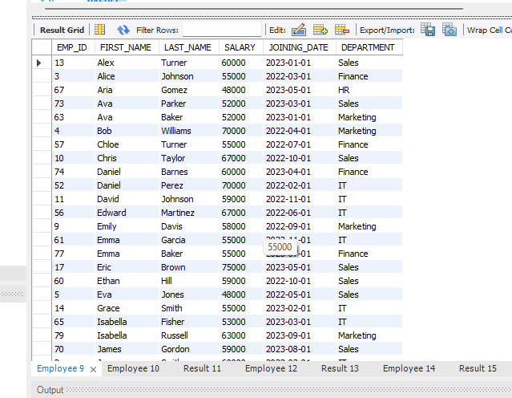SELECT * FROM Employee ORDER BY FIRST_NAME ASC, DEPARTMENT DESC;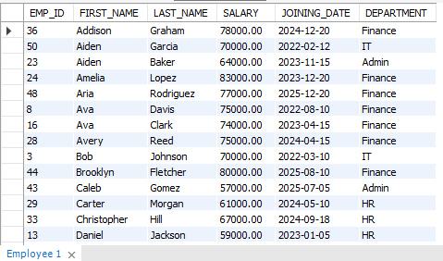

**-- 2 SQL query to fetch the count of employees working in the department ‘Admin’.**

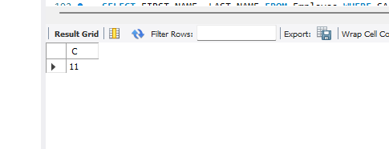

SELECT COUNT(*) FROM Employee WHERE DEPARTMENT = 'Admin';

**-- 3. SQL query to fetch Employee names with salaries >= 50000 and <= 100000.**

SELECT FIRST_NAME, LAST_NAME FROM Employee WHERE SALARY BETWEEN 50000 AND 100000;

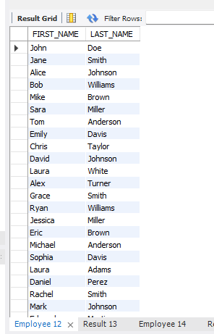

**-- 4. SQL query to print details of the Workers who are also Managers.**

SELECT E.* FROM Employee E

JOIN Title T ON E.EMP_ID = T.EMP_REF_ID AND T.EMP_TITLE = 'Manager

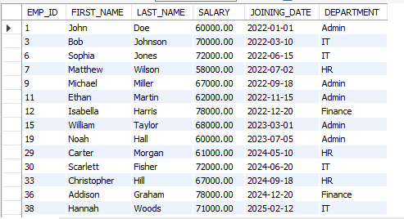

**-- 5. SQL query to fetch duplicate records having matching data in some fields of a table.**

SELECT EMP_ID, COUNT(*) FROM Employee GROUP BY EMP_ID HAVING COUNT(*) > 1;

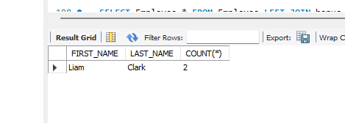

**-- 6. SQL query to show only even rows from a table.**

SELECT * FROM Employee WHERE MOD(EMP_ID, 2) = 0;

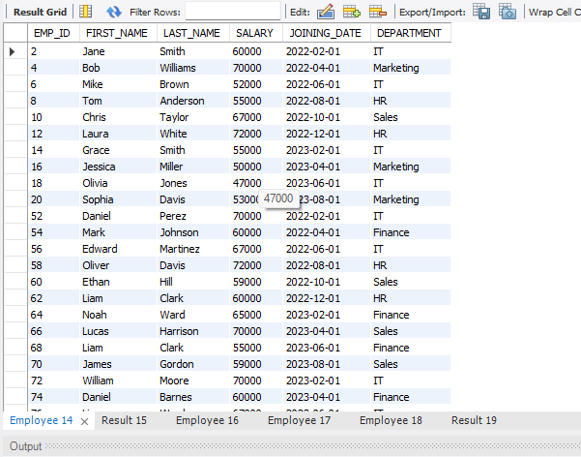

**-- 7. SQL query to show records from one table that another table does not have. Find employees in employee table that do not exist in bonus table.**

DELETE FROM Bonus WHERE EMP_REF_ID = 50;

SELECT * FROM Employee WHERE EMP_ID NOT IN (SELECT EMP_REF_ID FROM Bonus);

**-- 8. SQL query to show the top n (say 10) records of a table.**

SELECT * FROM Employee LIMIT 10;

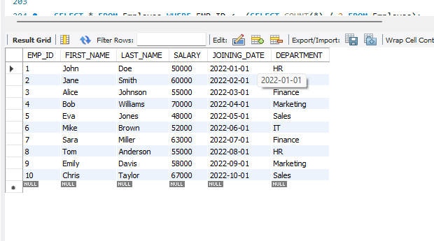

**-- 9. Find people who have the same salary.**

SELECT SALARY, COUNT(*) FROM Employee GROUP BY SALARY HAVING COUNT(*) > 1;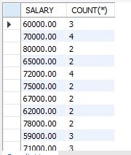

**-- 10. SQL query to fetch the first 50% records from a table.**

SELECT * FROM ( SELECT *,

ROW_NUMBER() OVER (ORDER BY EMP_ID) AS rn

FROM Employee

) AS subquery

WHERE rn <= (SELECT COUNT(*)/2 FROM Employee);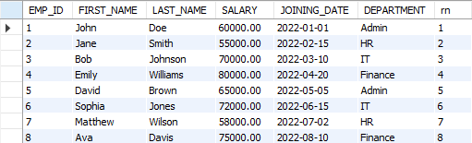

**-- 11. Find the highest 2 salaries without LIMIT or TOP.**

SELECT DISTINCT SALARY FROM Employee ORDER BY SALARY DESC LIMIT 2;

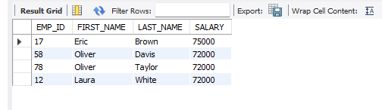

**-- 12. Create a trigger to ensure that no employee joining date less than current date can be inserted in the database.**

DELIMITER //

CREATE TRIGGER before_insert_employee BEFORE INSERT ON Employee

FOR EACH ROW BEGIN

IF NEW.JOINING_DATE >= CURDATE() THEN SIGNAL SQLSTATE '45000'

SET MESSAGE_TEXT = 'Joining date must be less than the current date.'; END IF;

END;

// DELIMITER ;

-- TSETING 12

INSERT INTO Employee VALUES (51, 'PATEL', 'Fletcher', 80000.00, '2025-08-10', 'Finance');

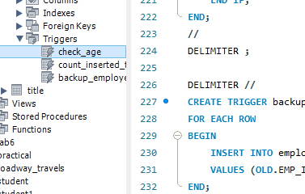

**-- 13. Create a trigger which will work before deletion in employee table and create a duplicate copy of the record in another table employee_backup.**

DELIMITER //

CREATE TRIGGER before_delete_employee BEFORE DELETE ON Employee

FOR EACH ROW BEGIN

INSERT INTO employee_backup (EMP_ID, FIRST_NAME, LAST_NAME, SALARY, JOINING_DATE, DEPARTMENT)

VALUES (OLD.EMP_ID, OLD.FIRST_NAME, OLD.LAST_NAME, OLD.SALARY, OLD.JOINING_DATE, OLD.DEPARTMENT);

END;

// DELIMITER ;

-- TESING 13

DELETE FROM Title WHERE EMP_REF_ID = 50; DELETE FROM Bonus WHERE EMP_REF_ID = 50; DELETE FROM Employee WHERE EMP_ID = 50;

select * FROM employee_backup;

**-- 14. Create a trigger to count the number of new tuples inserted using each insert statement.**

DELIMITER //

CREATE TRIGGER after_insert_employee AFTER INSERT ON Employee

FOR EACH ROW BEGIN

INSERT INTO insert_count (table_name, count) VALUES ('Employee', 1)

ON DUPLICATE KEY UPDATE count = count + 1; END;

// DELIMITER ;

-- TESTING 14

INSERT INTO Employee VALUES (52, 'PATELboss', 'Fletcher', 80000.00, '2021-08-10', 'Finance');

select * from insert_count;

### Conclusion:

Here I learned different basic MySQL queries form this assignment. Below attached database

images

# Assignment 2

### Aim:

Write a PL/SQL code block to find total and average of 6 subjects and display the grade.

### Queries & Output :

-- Create the database

CREATE DATABASE studentdata;

-- Use the studentdata database USE studentdata;

-- Create the student table CREATE TABLE student (

serial_number INT PRIMARY KEY, student_name VARCHAR(50), subject1 INT,

subject2 INT, subject3 INT, subject4 INT, subject5 INT, subject6 INT

);

-- Insert 10 sample student records

INSERT INTO student (serial_number, student_name, subject1, subject2, subject3, subject4, subject5, subject6)

##### VALUES

(1, 'John Doe', 85, 92, 78, 88, 94, 90),

(2, 'Jane Smith', 75, 80, 82, 88, 79, 85),

(3, 'Bob Johnson', 92, 88, 90, 87, 95, 91),

(4, 'Alice Brown', 78, 85, 76, 80, 82, 89),

(5, 'Charlie Davis', 93, 91, 89, 96, 87, 84),

(6, 'Eva White', 86, 92, 88, 75, 80, 92),

(7, 'David Lee', 77, 83, 79, 81, 75, 88),

(8, 'Grace Miller', 89, 90, 85, 92, 88, 91),

(9, 'Samuel Wilson', 94, 88, 87, 90, 91, 95),

(10, 'Olivia Turner', 82, 79, 80, 78, 84, 87);

-- Select all records from the student table SELECT * FROM student;

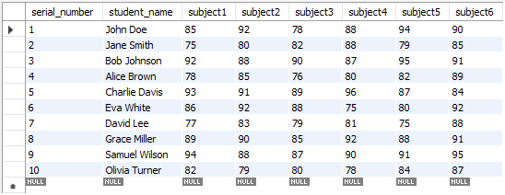

#### -- Create a stored procedure to print "Hello World"

##### DELIMITER //

CREATE PROCEDURE temp() BEGIN

SELECT "Hello World"; END;

##### // DELIMITER ;

-- Call the temp stored procedure CALL temp();



#### -- Create a stored procedure to calculate factorial

##### DELIMITER //

CREATE PROCEDURE facto(IN n INT) BEGIN

DECLARE i INT DEFAULT 1; DECLARE fact INT DEFAULT 1;

factorial: LOOP SET fact = fact * i; SET i = i + 1;

IF i <= n THEN

ITERATE factorial;

##### END IF;

LEAVE factorial;

##### END LOOP;

SELECT i, fact, n;

##### END;

// DELIMITER ;

call studentdata.facto(5);



#### -- Create a stored function to calculate the average grade for 6 subjects

##### DELIMITER //

CREATE PROCEDURE calculate_average_grade(IN score1 INT, IN score2 INT, IN score3 INT, IN score4 INT, IN score5 INT, IN score6 INT)

##### BEGIN

DECLARE average_score INT; DECLARE total_score INT; DECLARE avg_grade VARCHAR(10);

-- Calculate total score

SET total_score = score1 + score2 + score3 + score4 + score5 + score6;

-- Calculate average score

SET average_score = total_score / 6;

-- Calculate the average grade based on the average score IF average_score >= 90 THEN

SET avg_grade = 'A';

ELSEIF average_score >= 70 THEN SET avg_grade = 'B';

ELSEIF average_score >= 60 THEN SET avg_grade = 'C';

ELSEIF average_score >= 50 THEN SET avg_grade = 'D';

##### ELSE

SET avg_grade = 'E'; END IF;

-- Return the average grade SELECT avg_grade, average_score; END;

// DELIMITER ;

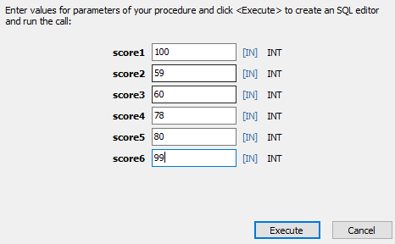



#### -- Create a stored procedure to calculate average grade from student table

##### DELIMITER //

CREATE PROCEDURE calculate_student_average_grade(IN student_id INT) BEGIN

DECLARE score1 INT; DECLARE score2 INT; DECLARE score3 INT; DECLARE score4 INT; DECLARE score5 INT; DECLARE score6 INT;

DECLARE average_score INT; DECLARE avg_grade VARCHAR(10);

-- Fetch scores for the specified student_id from the student table SELECT subject1, subject2, subject3, subject4, subject5, subject6 INTO score1, score2, score3, score4, score5, score6

FROM student

WHERE serial_number = student_id;

-- Calculate total score

SET average_score = (score1 + score2 + score3 + score4 + score5 + score6) / 6;

-- Calculate the average grade based on the average score IF average_score >= 90 THEN

SET avg_grade = 'A';

ELSEIF average_score >= 70 THEN SET avg_grade = 'B';

ELSEIF average_score >= 60 THEN SET avg_grade = 'C';

ELSEIF average_score >= 50 THEN SET avg_grade = 'D';

##### ELSE

SET avg_grade = 'E'; END IF;

-- Return the average grade and average score

SELECT avg_grade AS grade, average_score AS avg_score; END;

##### // DELIMITER ;

call studentdata.calculate_student_average_grade(2);



### Conclusion :

Here I learned about how to do a coding in PL/SQL and create procedure and alter it as well as find factorial, average grade from student database with MySQL query.

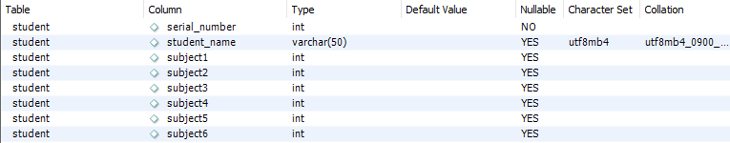

Figure - Database of student table

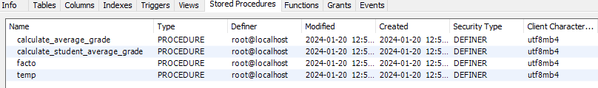

Figure - Procedure using PL/SQL

# Assignment 3

### Aim:

Consider the following table to write PL/SQL code as specified under

Teacher (t_no, f_name, l_name, salary, supervisor, joining_date, birth_date, title) Class (class_no, t_no, room_no)

Pay_scale (Min_limit, Max_limit, grade)

1. Accept a range of salary and print the details of teachers from teacher table.
2. By using cursor - Calculate the bonus amount to be given to a teacher depending on the following conditions:
   1. if salary< 10000 then bonus is 10% of the salary.
   2. if salary is between 10000 and 20000 then bonus is 20% of the salary.
   3. if salary is between 20000 and 25000 then bonus is 25% of the salary.
   4. if salary exceeds 25000 then bonus is 30% of the salary.
3. Using a simple LOOP structure, list the first 10 records of the ‘teachers’ table.
4. Accept the room number and display the teacher details like t_no, f_name, l_name, birth_date, title from table Teacher.

### Queries & Output :

create DATABASE Teachers; use Teachers;

-- Creating Teacher table CREATE TABLE Teacher (

t_no INT PRIMARY KEY,

f_name VARCHAR(255), l_name VARCHAR(255), salary DECIMAL(10, 2), supervisor INT, joining_date DATE, birth_date DATE,

title VARCHAR(50)

);

-- Creating Class table CREATE TABLE Class (

class_no INT PRIMARY KEY, t_no INT,

room_no INT,

FOREIGN KEY (t_no) REFERENCES Teacher(t_no)

);

-- Creating Pay_scale table CREATE TABLE Pay_scale (

Min_limit DECIMAL(10, 2),

Max_limit DECIMAL(10, 2), grade VARCHAR(10),

PRIMARY KEY (Min_limit, Max_limit)

);

-- Inserting data into Teacher table

INSERT INTO Teacher (t_no, f_name, l_name, salary, supervisor, joining_date, birth_date, title) VALUES

(1, 'John', 'Doe', 50000.00, NULL, '2020-01-15', '1980-05-20', 'Professor'),

(2, 'Jane', 'Smith', 60000.00, 1, '2018-03-10', '1985-09-12', 'Associate Professor'),

(3, 'Mark', 'Johnson', 45000.00, 1, '2019-07-22', '1990-11-30', 'Assistant Professor'),

(4, 'Alice', 'Williams', 55000.00, NULL, '2021-02-05', '1982-08-18', 'Professor'),

(5, 'Bob', 'Jones', 70000.00, 2, '2017-06-08', '1975-04-25', 'Professor'),

(6, 'Emily', 'Davis', 48000.00, 3, '2022-09-14', '1988-12-07', 'Assistant Professor'),

(7, 'Michael', 'Brown', 62000.00, 1, '2016-04-30', '1972-03-15', 'Professor'),

(8, 'Samantha', 'Miller', 58000.00, NULL, '2023-11-02', '1983-07-10', 'Associate Professor'),

(9, 'David', 'Anderson', 52000.00, 5, '2020-08-18', '1978-09-28', 'Assistant Professor'),

(10, 'Sophia', 'Garcia', 53000.00, 2, '2019-01-07', '1987-06-03', 'Associate Professor'),

(11, 'Laura', 'Martinez', 8000.00, 1, '2020-04-12', '1982-09-22', 'Assistant Professor'),

(12, 'Daniel', 'Wilson', 15000.00, 3, '2019-08-25', '1975-11-10', 'Associate Professor'),

(13, 'Ella', 'Taylor', 12000.00, 1, '2022-02-18', '1988-05-05', 'Assistant Professor'),

(14, 'Christopher', 'Moore', 25000.00, 2, '2018-06-30', '1980-12-15', 'Professor'),

(15, 'Sophie', 'Lee', 18000.00, NULL, '2021-11-08', '1990-03-28', 'Associate Professor'),

(16, 'Connor', 'Hill', 10000.00, 5, '2017-03-02', '1985-07-18', 'Assistant Professor'),

(17, 'Olivia', 'Allen', 30000.00, 7, '2016-09-14', '1972-10-30', 'Professor'),

(18, 'Jackson', 'Ward', 7000.00, 8, '2023-04-30', '1983-03-25', 'Assistant Professor'),

(19, 'Aria', 'Clark', 11000.00, NULL, '2020-08-18', '1978-05-20', 'Associate Professor'),

(20, 'Logan', 'Evans', 6000.00, 5, '2019-01-07', '1987-11-03', 'Assistant Professor');

-- Inserting data into Class table with different room numbers INSERT INTO Class (class_no, t_no, room_no)

##### VALUES

(101, 1, 201),

(102, 2, 202),

(103, 3, 203),

(104, 4, 204),

(105, 5, 205),

(106, 6, 206),

(107, 7, 207),

(108, 8, 208),

(109, 9, 209),

(110, 10, 210),

(111, 11, 211),

(112, 12, 212),

(113, 13, 213),

(114, 14, 214),

(115, 15, 215),

(116, 16, 216),

(117, 17, 217),

(118, 18, 218),

(119, 19, 219),

(120, 20, 220);

-- Inserting data into Pay_scale table

INSERT INTO Pay_scale (Min_limit, Max_limit, grade) VALUES

(0.00, 9999.99, 'Grade A'),

(10000.00, 19999.99, 'Grade B'),

(20000.00, 39999.99, 'Grade C'),

(40000.00, 49999.99, 'Grade D'),

(50000.00, 69999.99, 'Grade E'),

(70000.00, 99999.99, 'Grade F');

-- Task 1: Accept a range of salary and print details of teachers from the teacher table. DELIMITER //

CREATE PROCEDURE TEACHER_RANGE(IN min_sal INT, IN max_sal INT) BEGIN

IF min_sal <= max_sal THEN

SELECT * FROM Teacher WHERE salary BETWEEN min_sal AND max_sal;

ELSE

SELECT "PLZ ENTER IN PROPER MANNER MIN_SAL < MAX_SAL";

END IF;

END;

// DELIMITER ;

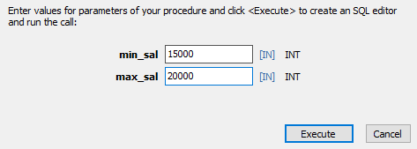

Figure shows a Procedure of 1 output and input

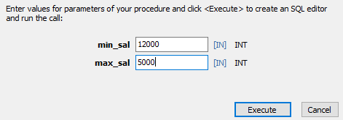

Figure shows a Procedure of 1 output and input wrong input

-- Task 2: Calculate the bonus amount using a cursor DELIMITER //

##### CREATE PROCEDURE TEACHER_BONUS() BEGIN

-- Declare variables to store fetched data DECLARE v_teacher_id INT; DECLARE v_f_name VARCHAR(250); DECLARE v_l_name VARCHAR(250); DECLARE v_salary DECIMAL(10, 2); DECLARE v_bonus DECIMAL(10, 2);

-- Declare cursor

DECLARE Teach_Bonus CURSOR FOR SELECT t_no, f_name, l_name, salary FROM teacher;

-- Declare handler for NOT FOUND condition DECLARE CONTINUE HANDLER FOR NOT FOUND

SET v_teacher_id = NULL;

-- Create a new table to store bonus values CREATE TABLE IF NOT EXISTS teacher_bonus (

teacher_id INT PRIMARY KEY, f_name VARCHAR(250), l_name VARCHAR(250),

bonus DECIMAL(10, 2)

);

-- Open the cursor OPEN Teach_Bonus;

-- Fetch and process data from the cursor

FETCH Teach_Bonus INTO v_teacher_id, v_f_name, v_l_name, v_salary;

-- Loop through the cursor results WHILE v_teacher_id IS NOT NULL DO

-- Calculate bonus based on salary conditions IF v_salary < 10000 THEN

SET v_bonus = 0.10 * v_salary;

ELSEIF v_salary BETWEEN 10000 AND 20000 THEN

SET v_bonus = 0.20 * v_salary;

ELSEIF v_salary BETWEEN 20000 AND 25000 THEN

SET v_bonus = 0.25 * v_salary; ELSE

SET v_bonus = 0.30 * v_salary; END IF;

-- Insert the calculated bonus into the new table

INSERT INTO teacher_bonus (teacher_id, f_name, l_name, bonus)

VALUES (v_teacher_id, v_f_name, v_l_name, v_bonus);

-- Fetch the next row

FETCH Teach_Bonus INTO v_teacher_id, v_f_name, v_l_name, v_salary; END WHILE;

-- Close the cursor CLOSE Teach_Bonus;

##### END // DELIMITER ;

CALL TEACHER_BONUS();

SELECT * FROM teacher_bonus;

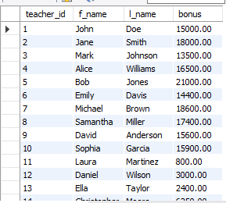

Figure shows a Procedure of 2 output

-- Task 3: Using a simple LOOP structure, list the first 10 records of the ‘teachers’ table. DELIMITER //

CREATE PROCEDURE TEACHER_RECORD(IN n INT) BEGIN

DECLARE v_t_no INT;

DECLARE v_f_name VARCHAR(250); DECLARE v_l_name VARCHAR(250); DECLARE v_salary DECIMAL(10, 2);

DECLARE v_supervisor BOOL;

DECLARE v_joining_date DATE; DECLARE v_birth_date DATE; DECLARE v_title VARCHAR(50); DECLARE c INTEGER;

DECLARE Teach_REC CURSOR FOR

SELECT t_no, f_name, l_name, salary, supervisor, joining_date, birth_date, title FROM teacher;

##### DECLARE CONTINUE HANDLER FOR NOT FOUND

SET v_t_no = NULL; SET c = 1;

##### CREATE TABLE IF NOT EXISTS TRECORDS (

t_no int primary key,

f_name varchar(255), l_name varchar(255), salary DECIMAL(10,2), supervisor INT, joining_date date, birth_date date,

title varchar(50)

);

OPEN Teach_REC;

FETCH Teach_REC INTO

v_t_no,v_f_name,v_l_name,v_salary,v_supervisor,v_joining_date,v_birth_date,v_title;

WHILE c <= n DO

INSERT TRECORDS (t_no, f_name, l_name, salary, supervisor, joining_date, birth_date, title)

##### VALUES

(v_t_no,v_f_name,v_l_name,v_salary,v_supervisor,v_joining_date,v_birth_date,v_title);

FETCH Teach_REC INTO

v_t_no,v_f_name,v_l_name,v_salary,v_supervisor,v_joining_date,v_birth_date,v_title; SET c = c + 1;

##### END WHILE;

CLOSE Teach_REC;

END //

DELIMITER ;

SELECT * FROM TRECORDS;

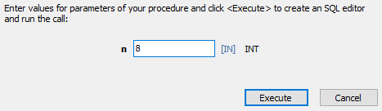

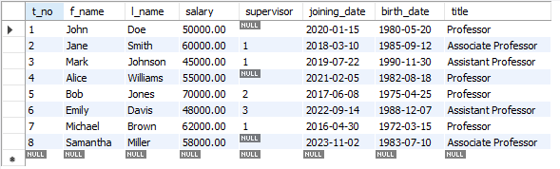

Figure shows a Procedure of 3 input output

-- Task 4: Accept the room number and display teacher details. DELIMITER //

CREATE PROCEDURE TEACHER_ROOMNO(IN room_number INT ) BEGIN

IF room_number >= 201 AND room_number <= 220 then

select Teacher.t_no, Teacher.f_name, Teacher.l_name, Teacher.birth_date, Teacher.title from Teacher join Class on Teacher.t_no = Class.t_no where room_number = Class.room_no ;

##### ELSE

END;

//

select "Enter room number between 201 and 220"; END IF;

##### DELIMITER ;

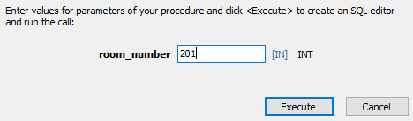



Figure shows a Procedure of 4 input output

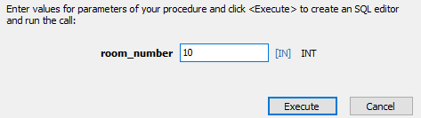



Figure shows a Procedure of 4 output when user enter wrong input

### Conclusion :

In this experiment, I acquired the skills to create a producer using PL/SQL and gained knowledge in utilizing cursors within a program. Specifically, I developed a teacher database as part of the assignment, successfully completing the task. This experience allowed me to familiarize myself with various PL/SQL commands.

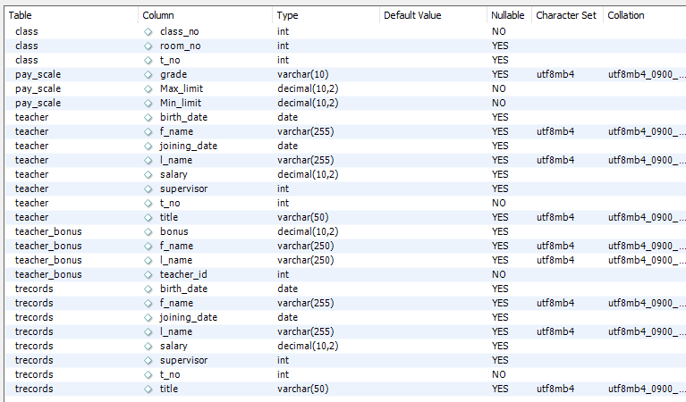

Figure shows a database table for given task

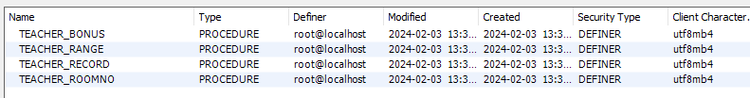

Figure shows all 4 Procedure for given task

# Assignment 4

### Aim:

Design and develop a suitable Student Database application. One of the attributes to me maintained is the attendance of a student in each subject for which he/she has enrolled.

Using TRIGGERS, we write active rules to do the following:

1. Whenever attendance is updated, check if the attendance is less than 85%; if so notify the Head of Department concerned.
2. Whenever the marks in the Internal Assessment Test are entered, check if the marks are less than 40%; if so, notify the Head of the Department concerned.

### Queries & Output :

CREATE DATABASE students; USE students;

CREATE TABLE Student ( student_id INT PRIMARY KEY, student_name VARCHAR(50),

adm43_marks INT CHECK (adm43_marks >= 0 AND adm43_marks <= 100), adm43_attendance INT CHECK (adm43_attendance >= 0 AND adm43_attendance <= 100)

);

CREATE TABLE chagnes_table (

notification_id INT AUTO_INCREMENT PRIMARY KEY, stud_id INT,

message VARCHAR(255), stud_name VARCHAR(50)

);

##### DELIMITER //

CREATE TRIGGER attend_mark_check AFTER UPDATE ON Student

##### FOR EACH ROW BEGIN

IF NEW.adm43_attendance < 85 THEN

INSERT INTO chagnes_table (stud_id, message, stud_name)

VALUES (NEW.student_id , 'Low attendance for student ' , NEW.student_name);

##### END IF;

IF NEW.adm43_marks < 40 THEN

INSERT INTO chagnes_table (stud_id, message, stud_name)

VALUES (NEW.student_id ,'Low marks for student ' , NEW.student_name ); END IF;

END;

// DELIMITER ;

DELIMITER //

CREATE TRIGGER attend_mark_check_inst AFTER INSERT ON Student

##### FOR EACH ROW BEGIN

IF NEW.adm43_attendance < 85 THEN

INSERT INTO chagnes_table (stud_id, message, stud_name)

VALUES (NEW.student_id, 'Low attendance for student ' , NEW.student_name); END IF;

IF NEW.adm43_marks < 40 THEN

INSERT INTO chagnes_table (stud_id, message, stud_name)

VALUES (NEW.student_id, 'Low marks for student ' , NEW.student_name ); END IF;

##### END;

// DELIMITER ;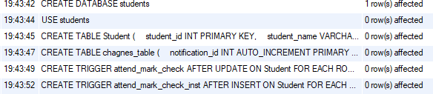

Figure 4.1 shows above queries are successfully executed select * from chagnes_table;



Figure 4.2 null table

INSERT INTO Student (student_id, student_name, adm43_marks, adm43_attendance) VALUES

(1, 'John Doe', 85, 76),

(2, 'Jane Smith', 78, 82),

(3, 'Alice Johnson', 90, 85),

(4, 'Bob Williams', 82, 79),

(5, 'Emily Brown', 88, 92),

(6, 'Michael Davis', 76, 84),

(7, 'Sophia Wilson', 85, 91),

(8, 'William Martinez', 92, 88),

(9, 'Olivia Anderson', 79, 91),

(10, 'Daniel Taylor', 91, 88); select * from chagnes_table;

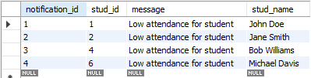

Figure 4.3 Table has changes by insertion trigger

select * from student;

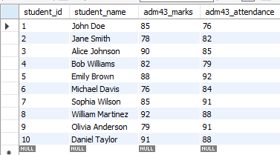

Figure 4.4 student table

UPDATE students.Student SET adm43_attendance = 75 WHERE student_id = 1;

UPDATE students.Student SET adm43_marks = 25 WHERE student_id = 1;

select * from chagnes_table;

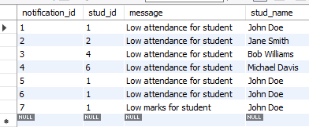

Figure 4.5 changes in table as updation happen as compare to fig 4.3 select * from student;

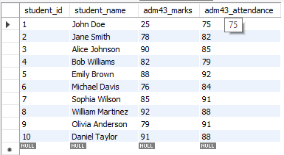

Figure 4.6 changes in student table as updation happen as compare to fig 4.4 and also value updated in table as well as in changes table.

### Conclusion:

In this experiment I learned how to create triggers and also update values in the database with triggers.

# Assignment 5

### Aim:

How to analyze ecommerce Inventory

* 1. What are the top 5 products with the highest inventory levels on the most recent inventory date ?
  2. What is the total inventory level for each product category on the most recent inventory date ?
  3. What is the average inventory level for each product category for the month of January 2022 ?
  4. Which products had a decrease in inventory level from the previous inventory date to the current inventory date ?
  5. What is the overall trend in inventory levels for each product category over the month of January 2022 ?

### Queries & Output :

CREATE DATABASE ecommerce; USE ecommerce;

CREATE TABLE products ( product_id SERIAL PRIMARY KEY, product_name VARCHAR(50), product_category VARCHAR(20), product_price NUMERIC(10,2)

);

INSERT INTO products (product_name, product_category, product_price) VALUES ('Product A', 'Category 1', 19.99),

('Product B', 'Category 2', 29.99),

('Product C', 'Category 1', 39.99),

('Product D', 'Category 3', 49.99),

('Product E', 'Category 2', 59.99);

CREATE TABLE inventory ( product_id INT, inventory_date DATE, inventory_level INT

);

INSERT INTO inventory (product_id, inventory_date, inventory_level) VALUES (1, '2022-01-01', 100),

(2, '2022-01-01', 200),

(3, '2022-01-01', 150),

(4, '2022-01-01', 75),

(5, '2022-01-01', 250),

(1, '2022-01-02', 80),

(2, '2022-01-02', 180),

(3, '2022-01-02', 100),

(4, '2022-01-02', 60),

(5, '2022-01-02', 220),

(1, '2022-01-03', 50),

(2, '2022-01-03', 150),

(3, '2022-01-03', 75),

(4, '2022-01-03', 80),

(5, '2022-01-03', 200);

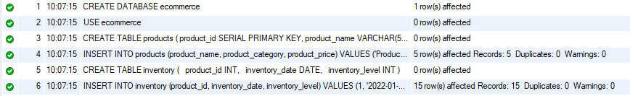

* + 1. What are the top 5 products with the highest inventory levels on the most recent inventory date ?

SELECT p.product_name, i.inventory_level FROM products p

JOIN inventory i ON p.product_id = i.product_id

WHERE i.inventory_date = (SELECT MAX(inventory_date) FROM inventory) ORDER BY i.inventory_level DESC

##### LIMIT 5;

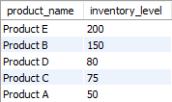

* + 1. What is the total inventory level for each product category on the most recent inventory date ?

SELECT p.product_category, SUM(i.inventory_level) AS total_inventory_level FROM products p

JOIN inventory i ON p.product_id = i.product_id

WHERE i.inventory_date = (SELECT MAX(inventory_date) FROM inventory) GROUP BY p.product_category;

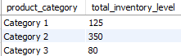

* + 1. What is the average inventory level for each product category for the month of January 2022 ?

SELECT p.product_category, AVG(i.inventory_level) AS avg_inventory_level FROM products p

JOIN inventory i ON p.product_id = i.product_id

WHERE i.inventory_date >= '2022-01-01' AND i.inventory_date < '2022-02-01' GROUP BY p.product_category;

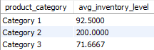

* + 1. Which products had a decrease in inventory level from the previous inventory date to the current inventory date ?

SELECT i1.product_id, p.product_name, i1.inventory_level - i2.inventory_level AS inventory_diff

FROM inventory i1

JOIN inventory i2 ON i1.product_id = i2.product_id

AND i1.inventory_date = i2.inventory_date + INTERVAL 1 day JOIN products p ON i1.product_id = p.product_id

WHERE i1.inventory_level < i2.inventory_level;

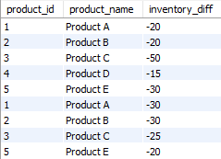

* + 1. What is the overall trend in inventory levels for each product category over the month of January 2022 ?

SELECT p.product_category, i.inventory_date, AVG(i.inventory_level) AS avg_inventory_level FROM products p

JOIN inventory i ON p.product_id = i.product_id

WHERE i.inventory_date >= '2022-01-01' AND i.inventory_date < '2022-02-01' GROUP BY p.product_category, i.inventory_date

ORDER BY p.product_category, i.inventory_date;

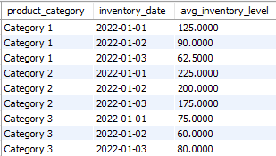

**Conclusion:** In analyzing ecommerce inventory using MySQL queries, insights were gained on top products by inventory, total inventory per category, and average levels for January 2022. Identification of products with decreased inventory highlighted management areas. Trend analysis for January 2022 revealed patterns, aiding in proactive adjustments. Leveraging MySQL for ecommerce inventory analysis enabled actionable insights for optimizing stock levels and improving business performance.

# Assignment 6

### Aim:

(Object Oriented)

1. Write a PL/SQL code to create a class for a "Person" with attributes such as name, age, and address.
2. Write a PL/SQL code to Implement methods in the "Person" class to display the details and update the age.
3. Write a PL/SQL code to implement a method to calculate the annual bonus based on the salary in the "Employee" class.
4. Write a PL/SQL code to create a "Manager" subclass inheriting from the "Employee" class, and add an attribute to store the number of employees managed.

**Queries & Output :**

## A)

### s1:

CREATE TYPE Person AS OBJECT ( name VARCHAR2(50),

age NUMBER,

address VARCHAR2(100)

);

#### Output:

Type created.

### s2:

##### DECLARE

p1 Person;

##### BEGIN

p1 := Person('Kalpan Bariya', 21, 'IIIT SURAT');

DBMS_OUTPUT.PUT_LINE('Name: ' || p1.name); DBMS_OUTPUT.PUT_LINE('Age: ' || p1.age);

DBMS_OUTPUT.PUT_LINE('Address: ' || p1.address); END;

#### Output:

Statement processed. Name: Kalpan Bariya

Age: 30

Address: IIIT SURAT

## B)

### s1:

CREATE OR REPLACE TYPE Person AS OBJECT ( id NUMBER,

name VARCHAR2(100), age NUMBER,

-- displayDetails member function

MEMBER FUNCTION displayDetails RETURN VARCHAR2, MEMBER PROCEDURE updateAge(newAge NUMBER)

);

#### Output:

Type created.

### s2:

CREATE OR REPLACE TYPE BODY Person AS

MEMBER FUNCTION displayDetails RETURN VARCHAR2 IS BEGIN

RETURN 'Person ID: ' || id || ', Name: ' || name || ', Age: ' || age; END;

MEMBER PROCEDURE updateAge(newAge NUMBER) IS BEGIN

age := newAge;

END;

END;

#### Output:

Type created.

### s3:

##### DECLARE

p1 Person := Person(1, 'Kalpan', 20); p2 Person := Person(2, 'KP', 28);

##### BEGIN

DBMS_OUTPUT.PUT_LINE(p1.displayDetails()); DBMS_OUTPUT.PUT_LINE(p2.displayDetails());

p1.updateAge(25);

DBMS_OUTPUT.PUT_LINE('Updated age:'); DBMS_OUTPUT.PUT_LINE(p1.displayDetails()); DBMS_OUTPUT.PUT_LINE(p2.displayDetails()); END;

#### Output:

Statement processed.

Person ID: 1, Name: Kalpan, Age: 20 Person ID: 2, Name: KP, Age: 28

Updated age:

Person ID: 1, Name: Kalpan, Age: 25 Person ID: 2, Name: KP, Age: 28

## C)

### s1:

CREATE TYPE Employee AS OBJECT (

emp_id NUMBER, emp_name VARCHAR2(100), salary NUMBER,

MEMBER FUNCTION calculate_bonus RETURN NUMBER

);

#### Output:

Type created.

### s2:

CREATE TYPE BODY Employee AS

MEMBER FUNCTION calculate_bonus RETURN NUMBER IS bonus_percentage NUMBER;

bonus_amount NUMBER; BEGIN

IF self.salary< 20000 THEN bonus_percentage := 0.15;

ELSIF self.salary< 100000 THEN bonus_percentage := 0.20;

##### ELSE

bonus_percentage := 0.25; END IF;

bonus_amount := self.salary * bonus_percentage;

RETURN bonus_amount; END;

END;

#### Output:

Type created.

### s3:

##### DECLARE

emp_obj Employee; -- an instance of the Employee class emp_bonus NUMBER; -- a variable to store the bonus amount BEGIN

emp_obj := Employee(1, 'Kalpan', 5000); emp_bonus := emp_obj.calculate_bonus;

DBMS_OUTPUT.PUT_LINE('Employee Bonus: ' || emp_bonus); END;

#### Output:

Statement processed.

Employee Bonus: 750

## D)

### s1:

CREATE OR REPLACE TYPE Employee AS OBJECT (

emp_id NUMBER, emp_name VARCHAR2(90), salary NUMBER,

MEMBER FUNCTION calculate_bonus RETURN NUMBER

);

#### Output:

Type created.

### s2:

CREATE OR REPLACE TYPE BODY Employee AS

MEMBER FUNCTION calculate_bonus RETURN NUMBER IS bonus_percentage NUMBER;

bonus_amount NUMBER; BEGIN

IF self.salary< 20000THEN bonus_percentage := 0.15;

ELSIF self.salary< 100000 THEN bonus_percentage := 0.20;

##### ELSE

bonus_percentage := 0.25; END IF;

bonus_amount := self.salary * bonus_percentage; RETURN bonus_amount;

END;

END;

#### Output:

Type created.

### s3:

CREATE OR REPLACE TYPE Manager AS OBJECT (

emp_id NUMBER, emp_name VARCHAR2(90), salary NUMBER,

employees_managed NUMBER, -- Additional

CONSTRUCTOR FUNCTION Manager(

emp_id NUMBER, emp_name VARCHAR2, salary NUMBER,

employees_managed NUMBER

##### ) RETURN SELF AS RESULT,

MEMBER FUNCTION calculate_bonus RETURN NUMBER

);

#### Output:

Type created.

### s4:

CREATE OR REPLACE TYPE BODY Manager AS

CONSTRUCTOR FUNCTION Manager(

emp_id NUMBER, emp_name VARCHAR2, salary NUMBER,

employees_managed NUMBER

##### ) RETURN SELF AS RESULT IS BEGIN

SELF.emp_id := emp_id; SELF.emp_name := emp_name; SELF.salary := salary;

SELF.employees_managed := employees_managed; RETURN;

##### END;

MEMBER FUNCTION calculate_bonus RETURN NUMBER IS bonus_percentage NUMBER;

bonus_amount NUMBER; BEGIN

IF self.salary< 50000 THEN bonus_percentage := 0.05;

ELSIF self.salary< 100000 THEN bonus_percentage := 0.155;

##### ELSE

bonus_percentage := 0.25; END IF;

bonus_amount := (self.salary + self.employees_managed * 1000) * bonus_percentage; RETURN bonus_amount;

END;

END;

#### Output:

Type created.

### s5:

##### DECLARE

emp_obj Employee; emp_bonus NUMBER; BEGIN

emp_obj := Employee(1, 'Kalpan', 20000); emp_bonus := emp_obj.calculate_bonus;

DBMS_OUTPUT.PUT_LINE('Employee Bonus: ' || emp_bonus); END;

#### Output:

Statement processed.

Employee Bonus: 4000

### s6:

##### DECLARE

manager_obj Manager; manager_bonus NUMBER; BEGIN

manager_obj := Manager(2, 'Kalpan', 90000, 15); manager_bonus := manager_obj.calculate_bonus;

DBMS_OUTPUT.PUT_LINE('Manager Bonus: ' || manager_bonus); END;

#### Output:

Statement processed.

Manager Bonus: 16275

**Conclusion:** In this experiment, I learned how to create and execute an object in Oracle, along with exploring inheritance implementation within this assignment. Additionally, I delved into the implementation of if-else statements, member functions, and member procedures in PL/SQL.

# Assignment 7

### Aim:

1. Write a SQL statement to create a simple table countries including columns country_id,country_name and region_id.
2. Write a SQL statement to create a simple table countries including columns country_id,country_name and region_id which already exist.
3. Write a SQL statement to create the structure of a table dup_countries similar to countries.
4. Write a SQL statement to create a duplicate copy of countries table including structure and data by name dup_countries.
5. Write a SQL statement to create a table countries set a constraint NULL.
6. Write a SQL statement to create a table named jobs including columns job_id, job_title, min_salary, max_salary and check whether the max_salary amount exceeding the upper limit 25000.
7. Write a SQL statement to create a table named countries including columns country_id, country_name and region_id and make sure that no countries except Italy, India and China will be entered in the table.
8. Write a SQL statement to create a table named countries including columns country_id,country_name and region_id and make sure that no duplicate data against column country_id will be allowed at the time of insertion.
9. Write a SQL statement to create a table named jobs including columns job_id, job_title, min_salary and max_salary, and make sure that, the default value for job_title is blank and min_salary is 8000 and max_salary is NULL will be entered automatically at the time of insertion if no value assigned for the specified columns.
10. Write a SQL statement to create a table named countries including columns country_id, country_name and region_id and make sure that the country_id column will be a key field which will not contain any duplicate data at the time of insertion.
11. Write a SQL statement to create a table countries including columns country_id, country_name and region_id and make sure that the column country_id will be unique and store an auto-incremented value.

Click me to see the solution

1. Write a SQL statement to create a table countries including columns country_id, country_name and region_id and make sure that the combination of columns country_id and region_id will be unique.

### Queries & Output :

CREATE DATABASE AS7; USE AS7;

-- 1. Create a simple table countries CREATE TABLE AS7.countries (

country_id INT,

country_name VARCHAR(50), region_id INT

);

-- 2. Create a table countries if not exists

CREATE TABLE IF NOT EXISTS AS7.countries (

country_id INT,

country_name VARCHAR(50), region_id INT

);

-- 3. Create the structure of table dup_countries similar to countries CREATE TABLE AS7.dup_countries LIKE AS7.countries;

-- 4. Create a duplicate copy of countries table including structure and data CREATE TABLE AS7.dup_countries AS SELECT * FROM AS7.countries;

-- 5. Create a table countries with a constraint allowing NULL values CREATE TABLE AS7.countries (

country_id INT,

country_name VARCHAR(50), region_id INT,

CONSTRAINT country_name_null CHECK (country_name IS NULL)

);

-- 6. Create a table jobs with max_salary check constraint CREATE TABLE AS7.jobs (

job_id INT,

job_title VARCHAR(50), min_salary DECIMAL(10,2), max_salary DECIMAL(10,2),

CONSTRAINT max_salary_check CHECK (max_salary <= 25000)

);

-- 7. Create a table countries with specific allowed country entries CREATE TABLE AS7.countries (

country_id INT,

country_name VARCHAR(50), region_id INT,

CONSTRAINT country_name_check CHECK (country_name IN ('Italy', 'India', 'China'))

);

-- 8. Create a table countries with no duplicate country_id allowed CREATE TABLE AS7.countries (

country_id INT PRIMARY KEY, country_name VARCHAR(50), region_id INT

);

-- 9. Create a table jobs with default values for specified columns CREATE TABLE AS7.jobs (

job_id INT,

job_title VARCHAR(50) DEFAULT '', min_salary DECIMAL(10,2) DEFAULT 8000,

max_salary DECIMAL(10,2)

);

-- 10. Create a table countries with country_id as a key field CREATE TABLE AS7.countries (

country_id INT UNIQUE, country_name VARCHAR(50), region_id INT

);

-- 11. Create a table countries with auto-incremented country_id and unique constraint CREATE TABLE AS7.countries (

country_id INT AUTO_INCREMENT PRIMARY KEY,

country_name VARCHAR(50), region_id INT, UNIQUE(country_id)

);

-- 12. Create a table countries with unique combination of country_id and region_id CREATE TABLE AS7.countries (

country_id INT,

country_name VARCHAR(50), region_id INT, UNIQUE(country_id, region_id)

)