**INDIAN INSTITUTE OF INFORMATION TECHNOLOGY SURAT**



# LAB REPORT

### on

**ADVANCED DATABASE MANAGEMENT (CS 604)**

**Submitted by**

### [ANKIT GONDHA] (UI21CS10)

**Course Faculty MR. RISHI SHARMA DR. REEMA PATEL**

**Department of Computer Science and Engineering Indian Institute of Information Technology Surat Gujarat-394190, India**

**APRIL - 2024**

# Table of Contents

| **Exp. No** | **Name of the Experiments** | **Page number** | **Date of Experiment** | **Date of Submission** | **Sign** |
| --- | --- | --- | --- | --- | --- |
| **1** | Implement Basic commands of SQL | 03-15 | 21-01-2024 | 29-01-2024 |  |
| **2** | Implement PL/SQL commands | 16-20 | 21-01-2024 | 29-01-2024 |  |
| **3** | Write PL/SQL code as specified in tasks | 21-29 | 30-01-2024 | 5-02-2024 |  |
| **4** | Create TRIGGERS and implement given task | 30-35 | 06-02-2024 | 06-02-2024 |  |
| **5** | Analyze ecommerce Inventory | 36-38 | 13-02-2024 | 22-02-2024 |  |
| **6** | Object Oriented PL/SQL | 39-44 | 20-03-2024 | 16-04-2024 |  |
| **7** | PostgreSQL Practice | 45-49 | 10-04-2024 | 16-04-2024 |  |

**Assignment 1**

### Aim:

Create a Database for an Organization and create the following tables in the Organization Database:

Employee(EMP_ID(PK), FIRST_NAME, LAST_NAME, SALARY, JOINING_DATE, EPARTMENT)

Bonus (EMP_REF_ID(FK EMP_ID), BONUS_AMOUNT, BONUS_DATE) Title (EMP_REF_ID(FKEMP_ID), EMP_TITLE, AFFECTED_FROM)

Insert a minimum of 50 records in each table.

Retrieve the following information from the Organization database:

1. SQL query to print all Employee details from the Employee table order by FIRST_NAME Ascending and DEPARTMENT Descending.
2. SQL query to fetch the count of employees working in the department ‘Admin’.
3. SQL query to fetch Employee names with salaries >= 50000 and <= 100000.
4. SQL query to print details of the Workers who are also Managers.
5. SQL query to fetch duplicate records having matching data in some fields of a table.
6. SQL query to show only even rows from a table.
7. SQL query to show records from one table that another table does not have. Find employees in employee table that do not exist in bonus table (i.e. who did not get bonus)
8. SQL query to show the to pn(say10) records of a table.
9. Find people who have the same salary
10. SQL query to fetch the first 50% records from a table.
11. Find the highest 2 salaries without LIMIT or TOP.
12. Create a trigger to ensure that no employee of age less than 18 can be inserted in the database.
13. Create a trigger which will work before deletion in employee table and create a duplicate copy of the record in another table employee_backup.
14. Create a trigger to count number of new tupples inserted using each insert statement.

### Code :

CREATE DATABASE lab1_final;

USE lab1_final;

CREATE TABLE Employee (

EMP_ID INT PRIMARY KEY,

FIRST_NAME VARCHAR(50),

LAST_NAME VARCHAR(50),

SALARY DECIMAL(10, 2),

JOINING_DATE DATE,

DEPARTMENT VARCHAR(50)

);

CREATE TABLE Bonus (

EMP_REF_ID INT,

BONUS_AMOUNT DECIMAL(10, 2),

BONUS_DATE DATE,

FOREIGN KEY (EMP_REF_ID) REFERENCES Employee(EMP_ID)

);

CREATE TABLE Title (

EMP_REF_ID INT,

EMP_TITLE VARCHAR(50),

AFFECTED_FROM DATE,

FOREIGN KEY (EMP_REF_ID) REFERENCES Employee(EMP_ID)

);

INSERT INTO Employee VALUES

(1, 'John', 'Doe', 60000, '2022-01-01', 'Admin'),

(2, 'Jane', 'Smith', 75000, '2022-02-15', 'IT'),

(3, 'Michael', 'Johnson', 55000, '2022-03-10', 'Finance'),

(4, 'Emily', 'Davis', 80000, '2022-04-05', 'Marketing'),

(5, 'Alex', 'Brown', 70000, '2022-05-20', 'Admin'),

(6, 'Jessica', 'Lee', 65000, '2022-06-12', 'IT'),

(7, 'Brian', 'Taylor', 72000, '2022-07-08', 'Finance'),

(8, 'Sophia', 'Clark', 68000, '2022-08-15', 'Marketing'),

(9, 'Daniel', 'White', 60000, '2022-09-03', 'Admin'),

(10, 'Olivia', 'Turner', 78000, '2022-10-22', 'IT'),

(11, 'Ethan', 'Miller', 58000, '2022-11-15', 'Finance'),

(12, 'Mia', 'Moore', 85000, '2022-12-01', 'Marketing'),

(13, 'Jacob', 'Hill', 72000, '2023-01-10', 'Admin'),

(14, 'Ava', 'Cooper', 67000, '2023-02-20', 'IT'),

(15, 'William', 'Baker', 74000, '2023-03-15', 'Finance'),

(16, 'Emma', 'Harris', 62000, '2023-04-05', 'Marketing'),

(17, 'Alexander', 'Ward', 78000, '2023-05-12', 'Admin'),

(18, 'Grace', 'Fisher', 69000, '2023-06-18', 'IT'),

(19, 'Benjamin', 'Chapman', 71000, '2023-07-25', 'Finance'),

(20, 'Lily', 'Lopez', 60000, '2023-08-10', 'Marketing'),

(21, 'Carter', 'Wright', 73000, '2023-09-03', 'Admin'),

(22, 'Chloe', 'Cooper', 68000, '2023-10-22', 'IT'),

(23, 'Owen', 'Perry', 77000, '2023-11-15', 'Finance'),

(24, 'Harper', 'Gray', 65000, '2023-12-01', 'Marketing'),

(25, 'Mason', 'Reid', 80000, '2024-01-10', 'Admin'),

(26, 'Scarlett', 'Lane', 70000, '2024-02-20', 'IT'),

(27, 'Logan', 'Ferguson', 72000, '2024-03-15', 'Finance'),

(28, 'Aria', 'Wood', 69000, '2024-04-05', 'Marketing'),

(29, 'Sebastian', 'Hunter', 75000, '2024-05-12', 'Admin'),

(30, 'Avery', 'Grant', 67000, '2024-06-18', 'IT'),

(31, 'Jackson', 'Ross', 80000, '2024-07-25', 'Finance'),

(32, 'Sophie', 'Mitchell', 62000, '2024-08-10', 'Marketing'),

(33, 'Gabriel', 'Barnes', 74000, '2024-09-03', 'Admin'),

(34, 'Madison', 'Wells', 69000, '2024-10-22', 'IT'),

(35, 'Elijah', 'Perry', 77000, '2024-11-15', 'Finance'),

(36, 'Hannah', 'Bryant', 64000, '2024-12-01', 'Marketing'),

(37, 'Caleb', 'Mason', 72000, '2025-01-10', 'Admin'),

(38, 'Aubrey', 'Newton', 67000, '2025-02-20', 'IT'),

(39, 'Lincoln', 'Clark', 80000, '2025-03-15', 'Finance'),

(40, 'Penelope', 'Harrison', 64000, '2025-04-05', 'Marketing'),

(41, 'Grayson', 'Hudson', 73000, '2025-05-12', 'Admin'),

(42, 'Ella', 'Dixon', 68000, '2025-06-18', 'IT'),

(43, 'Nathan', 'Stone', 77000, '2025-07-25', 'Finance'),

(44, 'Sofia', 'Porter', 65000, '2025-08-10', 'Marketing'),

(45, 'Liam', 'Fletcher', 79000, '2025-09-03', 'Admin'),

(46, 'Aaliyah', 'Gibson', 66000, '2025-10-22', 'IT'),

(47, 'Jack', 'Wagner', 75000, '2025-11-15', 'Finance'),

(48, 'Nora', 'Lloyd', 67000, '2025-12-01', 'Marketing'),

(49, 'Eli', 'Bennett', 71000, '2026-01-10', 'Admin'),

(50, 'Amelia', 'Sharp', 74000, '2026-02-20', 'IT');

INSERT INTO Bonus VALUES

(1, 5000, '2022-02-01'),

(2, 3000, '2022-03-10'),

(3, 2000, '2022-04-15'),

(4, 6000, '2022-05-02'),

(5, 4000, '2022-06-18'),

(6, 2500, '2022-07-25'),

(7, 3500, '2022-08-10'),

(8, 4500, '2022-09-20'),

(9, 1000, '2022-10-05'),

(10, 6000, '2022-11-15'),

(11, 1500, '2022-12-01'),

(12, 5000, '2023-01-10'),

(13, 3000, '2023-02-20'),

(14, 2000, '2023-03-15'),

(15, 6000, '2023-04-05'),

(16, 4000, '2023-05-12'),

(17, 2500, '2023-06-18'),

(18, 3500, '2023-07-25'),

(19, 4500, '2023-08-10'),

(20, 1000, '2023-09-03'),

(21, 3000, '2023-10-22'),

(22, 2000, '2023-11-15'),

(23, 6000, '2023-12-01'),

(24, 4000, '2024-01-10'),

(25, 2500, '2024-02-20'),

(26, 3500, '2024-03-15'),

(27, 4500, '2024-04-05'),

(28, 1000, '2024-05-12'),

(29, 6000, '2024-06-18'),

(30, 1500, '2024-07-25'),

(31, 5000, '2024-08-10'),

(32, 3000, '2024-09-03'),

(33, 2000, '2024-10-22'),

(34, 6000, '2024-11-15'),

(35, 4000, '2024-12-01'),

(36, 2500, '2025-01-10'),

(37, 3500, '2025-02-20'),

(38, 4500, '2025-03-15'),

(39, 1000, '2025-04-05'),

(40, 6000, '2025-05-12'),

(41, 1500, '2025-06-18'),

(42, 5000, '2025-07-25'),

(43, 3000, '2025-08-10'),

(44, 2000, '2025-09-03'),

(45, 6000, '2025-10-22'),

(46, 4000, '2025-11-15'),

(47, 2500, '2025-12-01'),

(48, 3500, '2026-01-10'),

(49, 4500, '2026-02-20'),

(50, 1000, '2026-03-15');

-- Inserting 50 records into the Title Table

INSERT INTO Title VALUES

(1, 'Manager', '2022-01-01'),

(2, 'Developer', '2022-02-20'),

(3, 'Analyst', '2022-03-15'),

(4, 'Supervisor', '2022-04-20'),

(5, 'Coordinator', '2022-05-05'),

(6, 'Designer', '2022-06-30'),

(7, 'Specialist', '2022-07-10'),

(8, 'Team Lead', '2022-08-25'),

(9, 'Assistant', '2022-09-15'),

(10, 'Senior Developer', '2022-10-30'),

(11, 'Junior Analyst', '2022-11-15'),

(12, 'Project Manager', '2022-12-01'),

(13, 'UI/UX Designer', '2023-01-10'),

(14, 'Technical Lead', '2023-02-20'),

(15, 'Data Scientist', '2023-03-15'),

(16, 'Marketing Manager', '2023-04-05'),

(17, 'HR Coordinator', '2023-05-12'),

(18, 'Financial Analyst', '2023-06-18'),

(19, 'Operations Specialist', '2023-07-25'),

(20, 'Product Manager', '2023-08-10'),

(21, 'QA Engineer', '2023-09-03'),

(22, 'Systems Analyst', '2023-10-22'),

(23, 'Sales Representative', '2023-11-15'),

(24, 'Customer Support', '2023-12-01'),

(25, 'Network Engineer', '2024-01-10'),

(26, 'Content Writer', '2024-02-20'),

(27, 'UX Researcher', '2024-03-15'),

(28, 'Business Analyst', '2024-04-05'),

(29, 'Legal Counsel', '2024-05-12'),

(30, 'Financial Planner', '2024-06-18'),

(31, 'IT Specialist', '2024-07-25'),

(32, 'Event Coordinator', '2024-08-10'),

(33, 'Logistics Manager', '2024-09-03'),

(34, 'Security Analyst', '2024-10-22'),

(35, 'Public Relations', '2024-11-15'),

(36, 'Graphic Designer', '2024-12-01'),

(37, 'Database Administrator', '2025-01-10'),

(38, 'Health and Safety', '2025-02-20'),

(39, 'Software Engineer', '2025-03-15'),

(40, 'Recruitment Specialist', '2025-04-05'),

(41, 'Technical Support', '2025-05-12'),

(42, 'Facilities Manager', '2025-06-18'),

(43, 'Executive Assistant', '2025-07-25'),

(44, 'Quality Assurance', '2025-08-10'),

(45, 'Market Researcher', '2025-09-03'),

(46, 'Systems Administrator', '2025-10-22'),

(47, 'Creative Director', '2025-11-15'),

(48, 'Data Analyst', '2025-12-01'),

(49, 'E-commerce Specialist', '2026-01-10'),

(50, 'Software Architect', '2026-02-20');

-- Query1

SELECT * FROM Employee

ORDER BY FIRST_NAME ASC, DEPARTMENT DESC;

-- Query2

SELECT COUNT(*) AS EmployeeCount

FROM Employee

WHERE DEPARTMENT = 'Admin';

-- Query3

SELECT FIRST_NAME, LAST_NAME

FROM Employee

WHERE SALARY BETWEEN 50000 AND 100000;

-- Query4

SELECT e.*

FROM Employee e

JOIN Title t ON e.EMP_ID = t.EMP_REF_ID

WHERE t.EMP_TITLE = 'Manager';

-- Query5

SELECT EMP_ID, COUNT(*)

FROM Employee

GROUP BY EMP_ID

HAVING COUNT(*) > 1;

-- Query6

SELECT *

FROM Employee

WHERE EMP_ID % 2 = 0;

-- Query7

SELECT e.*

FROM Employee e

LEFT JOIN Bonus b ON e.EMP_ID = b.EMP_REF_ID

WHERE b.EMP_REF_ID IS NULL;

-- Query8

SELECT *

FROM Employee

LIMIT 10;

-- Query9

SELECT SALARY, COUNT(*)

FROM Employee

GROUP BY SALARY

HAVING COUNT(*) > 1;

-- Query10

SELECT *

FROM Employee

ORDER BY EMP_ID;

-- Query11

SELECT DISTINCT SALARY

FROM Employee

ORDER BY SALARY DESC

LIMIT 2;

-- Query12

DELIMITER //

CREATE TRIGGER before_insert_employee

BEFORE INSERT ON Employee

FOR EACH ROW

BEGIN

IF DATEDIFF(CURDATE(), NEW.JOINING_DATE) < 6570 THEN

SIGNAL SQLSTATE '45000'

SET MESSAGE_TEXT = 'Employee must be at least 18 years old.';

END IF;

END;

//

DELIMITER ;

-- Query13

DELIMITER //

CREATE TRIGGER before_delete_employee

BEFORE DELETE ON Employee

FOR EACH ROW

BEGIN

INSERT INTO employee_backup VALUES (OLD.EMP_ID, OLD.FIRST_NAME, OLD.LAST_NAME, OLD.SALARY, OLD.JOINING_DATE, OLD.DEPARTMENT);

END;

//

DELIMITER ;

-- Query14

DELIMITER //

CREATE TRIGGER after_insert_employee

AFTER INSERT ON Employee

FOR EACH ROW

BEGIN

INSERT INTO insert_count VALUES (NEW.EMP_ID, NOW());

END;

//

DELIMITER ;

### Output:

**-- 1. SQL query to print all Employee details from the Employee table order by FIRST_NAME Ascending and DEPARTMENT Descending.**

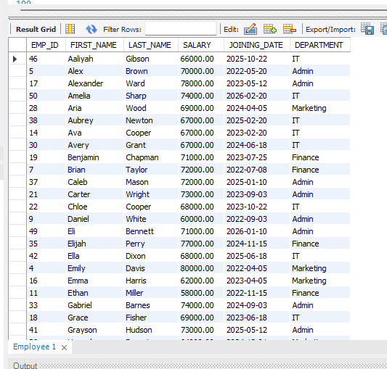

**-- 2 SQL query to fetch the count of employees working in the department ‘Admin’.**

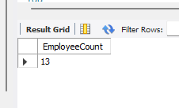

**-- 3. SQL query to fetch Employee names with salaries >= 50000 and <= 100000.**

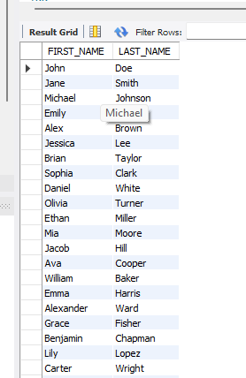

**-- 4. SQL query to print details of the Workers who are also Managers.**

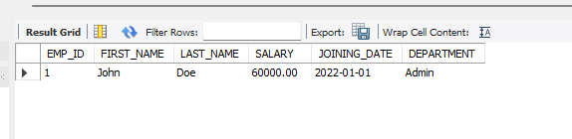

**-- 5. SQL query to fetch duplicate records having matching data in some fields of a table.**

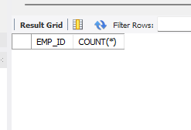

**-- 6. SQL query to show only even rows from a table.**

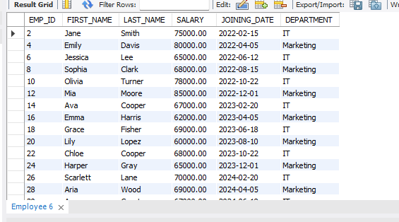

**-- 7. SQL query to show records from one table that another table does not have. Find employees in employee table that do not exist in bonus table.**



**-- 8. SQL query to show the top n (say 10) records of a table.**

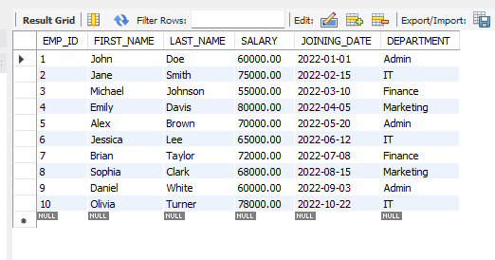

**-- 9. Find people who have the same salary.**

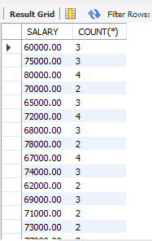

**-- 10. SQL query to fetch the first 50% records from a table.**

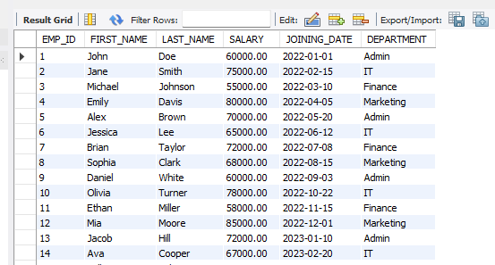

**-- 11. Find the highest 2 salaries without LIMIT or TOP.**

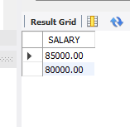

**-- 12. Create a trigger to ensure that no employee joining date less than current date can be inserted in the database.**



**-- 13. Create a trigger which will work before deletion in employee table and create a duplicate copy of the record in another table employee_backup.**



**-- 14. Create a trigger to count the number of new tuples inserted using each insert statemet**

### Conclusion:

By organizing data into separate tables and establishing relationships between them using foreign keys, the organization ensures efficient data management and retrieval. The Employee table serves as the central repository for employee information, while the Bonus and Title tables capture additional details related to bonuses and job titles respectively. This structured approach facilitates various queries and analyses, enabling the organization to extract meaningful insights and make informed decisions based on the data stored in the database.

# Assignment 2

### Aim:

Write a PL/SQL code block to find total and average of 6 subjects and display the grade.

### Queries & Output :

CREATE TABLE subjects(

id int,

subject varchar(255),

marks int

);

INSERT INTO subjects(id, subject,marks)

values(1, 'ML',92 ),

(2, 'HPC', 65),

(3, 'AR/VR',97 ),

(4, 'WE', 82 ),

(5, 'CC&BD', 75 ),

(5, 'ADMS', 68 );

CREATE DEFINER=`root`@`localhost` PROCEDURE `Task2`()

begin

declare total_marks int default 0;

declare average_marks int default 0;

declare grade varchar(1);

Select SUM(marks) into total_marks from subjects;

Select AVG(marks) into average_marks from subjects;

if average_marks>=80 then

set grade = 'A';

elseif average_marks>=65 then

set grade = 'B';

elseif average_marks>=50 then

set grade = 'C';

elseif average_marks>=33 then

set grade = 'D';

else

set grade = 'F';

end if;

select grade;

end

### OUTPUT:

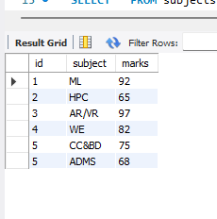

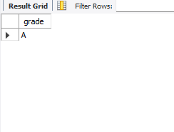

#### -- Create a stored procedure to calculate factorial

##### **DELIMITER //**

CREATE PROCEDURE facto(IN n INT) BEGIN

DECLARE i INT DEFAULT 1; DECLARE fact INT DEFAULT 1;

factorial: LOOP SET fact = fact * i; SET i = i + 1;

IF i <= n THEN

ITERATE factorial;

##### END IF;

LEAVE factorial;

##### END LOOP;

SELECT i, fact, n;

##### END;

// DELIMITER ;

call studentdata.facto(5);



#### -- Create a stored function to calculate the average grade for 6 subjects

##### DELIMITER //

CREATE PROCEDURE calculate_average_grade(IN score1 INT, IN score2 INT, IN score3 INT, IN score4 INT, IN score5 INT, IN score6 INT)

##### BEGIN

DECLARE average_score INT; DECLARE total_score INT; DECLARE avg_grade VARCHAR(10);

-- Calculate total score

SET total_score = score1 + score2 + score3 + score4 + score5 + score6;

-- Calculate average score

SET average_score = total_score / 6;

-- Calculate the average grade based on the average score IF average_score >= 90 THEN

SET avg_grade = 'A';

ELSEIF average_score >= 70 THEN SET avg_grade = 'B';

ELSEIF average_score >= 60 THEN SET avg_grade = 'C';

ELSEIF average_score >= 50 THEN SET avg_grade = 'D';

##### ELSE

SET avg_grade = 'E'; END IF;

-- Return the average grade SELECT avg_grade, average_score; END;

// DELIMITER ;

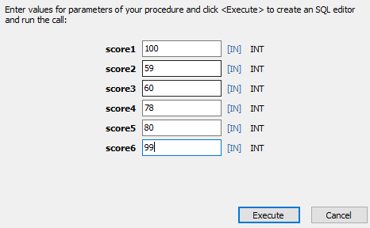



#### -- Create a stored procedure to calculate average grade from student table

##### DELIMITER //

CREATE PROCEDURE calculate_student_average_grade(IN student_id INT) BEGIN

DECLARE score1 INT; DECLARE score2 INT; DECLARE score3 INT; DECLARE score4 INT; DECLARE score5 INT; DECLARE score6 INT;

DECLARE average_score INT; DECLARE avg_grade VARCHAR(10);

-- Fetch scores for the specified student_id from the student table SELECT subject1, subject2, subject3, subject4, subject5, subject6 INTO score1, score2, score3, score4, score5, score6

FROM student

WHERE serial_number = student_id;

-- Calculate total score

SET average_score = (score1 + score2 + score3 + score4 + score5 + score6) / 6;

-- Calculate the average grade based on the average score IF average_score >= 90 THEN

SET avg_grade = 'A';

ELSEIF average_score >= 70 THEN SET avg_grade = 'B';

ELSEIF average_score >= 60 THEN SET avg_grade = 'C';

ELSEIF average_score >= 50 THEN SET avg_grade = 'D';

##### ELSE

SET avg_grade = 'E'; END IF;

-- Return the average grade and average score

SELECT avg_grade AS grade, average_score AS avg_score; END;

##### // DELIMITER ;

call studentdata.calculate_student_average_grade(2);



### Conclusion :

Here I learned about how to do a coding in PL/SQL and Using PL/SQL, this code block efficiently calculates the total and average marks, and subsequently assigns a grade based on the calculated average. It's a straightforward approach to automate the grading process for a student's performance in multiple subjects. By encapsulating these calculations within a PL/SQL block, the code offers reusability and maintainability, making it easier to modify or integrate into larger systems as needed.

# Assignment 3

### Aim:

Consider the following table to write PL/SQL code as specified under

Teacher (t_no, f_name, l_name, salary, supervisor, joining_date, birth_date, title) Class (class_no, t_no, room_no)

Pay_scale (Min_limit, Max_limit, grade)

1. Accept a range of salary and print the details of teachers from teacher table.
2. By using cursor - Calculate the bonus amount to be given to a teacher depending on the following conditions:
   1. if salary< 10000 then bonus is 10% of the salary.
   2. if salary is between 10000 and 20000 then bonus is 20% of the salary.
   3. if salary is between 20000 and 25000 then bonus is 25% of the salary.
   4. if salary exceeds 25000 then bonus is 30% of the salary.
3. Using a simple LOOP structure, list the first 10 records of the ‘teachers’ table.
4. Accept the room number and display the teacher details like t_no, f_name, l_name, birth_date, title from table Teacher.

### Queries & Output :

create database lab3;

use lab3;

CREATE TABLE Teacher (

t_no INT PRIMARY KEY,

f_name VARCHAR(50),

l_name VARCHAR(50),

salary DECIMAL(10,2),

supervisor INT,

joining_date DATE,

birth_date DATE,

title VARCHAR(50)

);

CREATE TABLE Class (

class_no INT PRIMARY KEY,

t_no INT,

room_no INT,

FOREIGN KEY (t_no) REFERENCES Teacher(t_no)

);

CREATE TABLE Pay_scale (

grade INT PRIMARY KEY,

Min_limit DECIMAL(10,2),

Max_limit DECIMAL(10,2)

);

INSERT INTO Teacher (t_no, f_name, l_name, salary, supervisor, joining_date, birth_date, title)

VALUES

(1, 'John', 'Doe', 50000, NULL, '2020-01-01', '1985-05-10', 'Math Teacher'),

(2, 'Jane', 'Smith', 55000, 1, '2019-08-15', '1980-12-20', 'Science Teacher'),

(3, 'Alice', 'Johnson', 60000, NULL, '2021-03-10', '1990-03-25', 'English Teacher'),

(4, 'Michael', 'Williams', 52000, 1, '2022-02-20', '1988-07-15', 'History Teacher'),

(5, 'Emily', 'Brown', 58000, NULL, '2020-05-05', '1983-09-30', 'Art Teacher'),

(6, 'David', 'Jones', 53000, 3, '2018-11-11', '1982-11-05', 'Music Teacher'),

(7, 'Sarah', 'Davis', 56000, NULL, '2017-09-01', '1987-06-18', 'Physical Education Teacher'),

(8, 'Christopher', 'Martinez', 59000, 2, '2019-06-30', '1986-04-12', 'Computer Science Teacher'),

(9, 'Jessica', 'Garcia', 54000, NULL, '2021-10-25', '1992-01-28', 'Foreign Language Teacher'),

(10, 'Daniel', 'Rodriguez', 57000, 3, '2016-12-12', '1984-08-22', 'Drama Teacher');

INSERT INTO Class (class_no, t_no, room_no)

VALUES

(101, 1, 101),

(102, 2, 102),

(103, 3, 101),

(104, 4, 104),

(105, 5, 105),

(106, 6, 102),

(107, 7, 103),

(108, 8, 105),

(109, 9, 104),

(110, 10, 106);

INSERT INTO Pay_scale (grade, Min_limit, Max_limit)

VALUES

(1, 40000, 60000),

(2, 60001, 80000),

(3, 80001, 100000),

(4, 100001, 120000),

(5, 120001, 140000),

(6, 140001, 160000),

(7, 160001, 180000),

(8, 180001, 200000),

(9, 200001, 220000),

(10, 220001, 240000);

DELIMITER //

CREATE PROCEDURE PrintTeachersInRange(IN min_salary INT, IN max_salary INT)

BEGIN

SELECT * FROM Teacher WHERE salary BETWEEN min_salary AND max_salary;

END//

DELIMITER ;

CREATE PROCEDURE CalculateBonus()

BEGIN

DECLARE done INT DEFAULT 0;

DECLARE t_no INT;

DECLARE salary DECIMAL(10, 2);

DECLARE bonus DECIMAL(10, 2);

DECLARE cur CURSOR FOR SELECT t_no, salary FROM Teacher;

DECLARE CONTINUE HANDLER FOR NOT FOUND SET done = 1;

OPEN cur;

read_loop: LOOP

FETCH cur INTO t_no, salary;

IF done THEN

LEAVE read_loop;

END IF;

IF salary < 10000 THEN

SET bonus = salary * 0.1;

ELSEIF salary BETWEEN 10000 AND 20000 THEN

SET bonus = salary * 0.2;

ELSEIF salary BETWEEN 20000 AND 25000 THEN

SET bonus = salary * 0.25;

ELSE

SET bonus = salary * 0.3;

END IF;

-- Output the result

SELECT CONCAT('Teacher with ID ', t_no, ' has a bonus of ', bonus) AS result;

END LOOP;

CLOSE cur;

END

DELIMITER //

CREATE PROCEDURE ListFirst10Teachers()

BEGIN

DECLARE counter INT DEFAULT 0;

DECLARE t_no INT;

DECLARE f_name VARCHAR(50);

DECLARE l_name VARCHAR(50);

DECLARE birth_date DATE;

DECLARE title VARCHAR(50);

DECLARE cur CURSOR FOR SELECT t_no, f_name, l_name, birth_date, title FROM Teacher LIMIT 10; -- Limit the result to the first 10 records

DECLARE CONTINUE HANDLER FOR NOT FOUND SET counter = 10;

OPEN cur;

read_loop: LOOP

FETCH cur INTO t_no, f_name, l_name, birth_date, title;

IF counter >= 10 THEN

LEAVE read_loop;

END IF;

-- Output the result directly

SELECT CONCAT('Teacher ', t_no, ': ', f_name, ' ', l_name, ', Birth Date: ', birth_date, ', Title: ', title) AS result;

SET counter = counter + 1;

END LOOP;

CLOSE cur;

END //

-- Task 1: Accept a range of salary and print details of teachers from the teacher table.

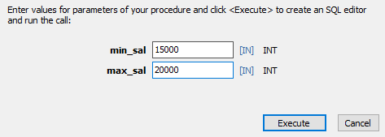

Figure shows a Procedure of 1 output and input

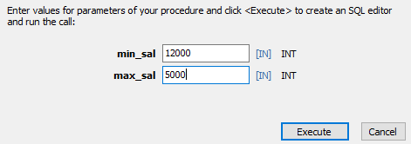

Figure shows a Procedure of 1 output and input wrong input

-- Task 2: Calculate the bonus amount using a cursor DELIMITER //

##### CREATE PROCEDURE TEACHER_BONUS() BEGIN

-- Declare variables to store fetched data DECLARE v_teacher_id INT; DECLARE v_f_name VARCHAR(250); DECLARE v_l_name VARCHAR(250); DECLARE v_salary DECIMAL(10, 2); DECLARE v_bonus DECIMAL(10, 2);

-- Declare cursor

DECLARE Teach_Bonus CURSOR FOR SELECT t_no, f_name, l_name, salary FROM teacher;

-- Declare handler for NOT FOUND condition DECLARE CONTINUE HANDLER FOR NOT FOUND

SET v_teacher_id = NULL;

-- Create a new table to store bonus values CREATE TABLE IF NOT EXISTS teacher_bonus (

teacher_id INT PRIMARY KEY, f_name VARCHAR(250), l_name VARCHAR(250),

bonus DECIMAL(10, 2)

);

-- Open the cursor OPEN Teach_Bonus;

-- Fetch and process data from the cursor

FETCH Teach_Bonus INTO v_teacher_id, v_f_name, v_l_name, v_salary;

-- Loop through the cursor results WHILE v_teacher_id IS NOT NULL DO

-- Calculate bonus based on salary conditions IF v_salary < 10000 THEN

SET v_bonus = 0.10 * v_salary;

ELSEIF v_salary BETWEEN 10000 AND 20000 THEN

SET v_bonus = 0.20 * v_salary;

ELSEIF v_salary BETWEEN 20000 AND 25000 THEN

SET v_bonus = 0.25 * v_salary; ELSE

SET v_bonus = 0.30 * v_salary; END IF;

-- Insert the calculated bonus into the new table

INSERT INTO teacher_bonus (teacher_id, f_name, l_name, bonus)

VALUES (v_teacher_id, v_f_name, v_l_name, v_bonus);

-- Fetch the next row

FETCH Teach_Bonus INTO v_teacher_id, v_f_name, v_l_name, v_salary; END WHILE;

-- Close the cursor CLOSE Teach_Bonus;

##### END // DELIMITER ;

CALL TEACHER_BONUS();

SELECT * FROM teacher_bonus;

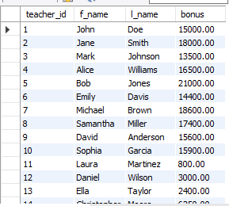

Figure shows a Procedure of 2 output

-- Task 3: Using a simple LOOP structure, list the first 10 records of the ‘teachers’ table. DELIMITER //

CREATE PROCEDURE TEACHER_RECORD(IN n INT) BEGIN

DECLARE v_t_no INT;

DECLARE v_f_name VARCHAR(250); DECLARE v_l_name VARCHAR(250); DECLARE v_salary DECIMAL(10, 2);

DECLARE v_supervisor BOOL;

DECLARE v_joining_date DATE; DECLARE v_birth_date DATE; DECLARE v_title VARCHAR(50); DECLARE c INTEGER;

DECLARE Teach_REC CURSOR FOR

SELECT t_no, f_name, l_name, salary, supervisor, joining_date, birth_date, title FROM teacher;

##### DECLARE CONTINUE HANDLER FOR NOT FOUND

SET v_t_no = NULL; SET c = 1;

##### CREATE TABLE IF NOT EXISTS TRECORDS (

t_no int primary key,

f_name varchar(255), l_name varchar(255), salary DECIMAL(10,2), supervisor INT, joining_date date, birth_date date,

title varchar(50)

);

OPEN Teach_REC;

FETCH Teach_REC INTO

v_t_no,v_f_name,v_l_name,v_salary,v_supervisor,v_joining_date,v_birth_date,v_title;

WHILE c <= n DO

INSERT TRECORDS (t_no, f_name, l_name, salary, supervisor, joining_date, birth_date, title)

##### VALUES

(v_t_no,v_f_name,v_l_name,v_salary,v_supervisor,v_joining_date,v_birth_date,v_title);

FETCH Teach_REC INTO

v_t_no,v_f_name,v_l_name,v_salary,v_supervisor,v_joining_date,v_birth_date,v_title; SET c = c + 1;

##### END WHILE;

CLOSE Teach_REC;

END //

DELIMITER ;

SELECT * FROM TRECORDS;

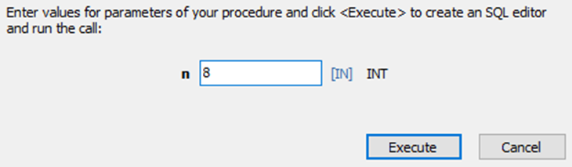

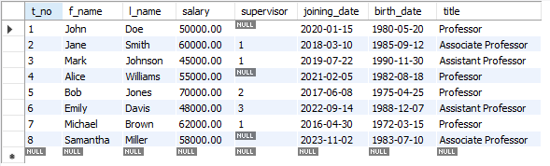

Figure shows a Procedure of 3 input output

-- Task 4: Accept the room number and display teacher details. DELIMITER //

CREATE PROCEDURE TEACHER_ROOMNO(IN room_number INT ) BEGIN

IF room_number >= 201 AND room_number <= 220 then

select Teacher.t_no, Teacher.f_name, Teacher.l_name, Teacher.birth_date, Teacher.title from Teacher join Class on Teacher.t_no = Class.t_no where room_number = Class.room_no ;

##### ELSE

END;

//

select "Enter room number between 201 and 220"; END IF;

##### DELIMITER ;

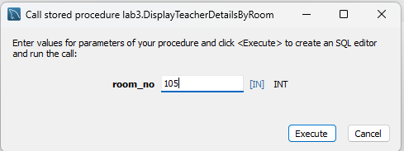



Figure shows a Procedure of 4 input output





Figure shows a Procedure of 4 output when user enter wrong input

**Conclusion :**

I acquired the skills to create a producer using PL/SQL and gained knowledge in utilizing cursors within a program. Specifically, I developed a teacher database as part of the assignment, successfully completing the task. This experience allowed me to familiarize myself with various PL/SQL commands.

# Assignment 4

### Aim:

Design and develop a suitable Student Database application. One of the attributes to me maintained is the attendance of a student in each subject for which he/she has enrolled.

Using TRIGGERS, we write active rules to do the following:

1. Whenever attendance is updated, check if the attendance is less than 85%; if so notify the Head of Department concerned.
2. Whenever the marks in the Internal Assessment Test are entered, check if the marks are less than 40%; if so, notify the Head of the Department concerned.

### Queries:

create database lab4;

use lab4;

CREATE TABLE marks (

sname VARCHAR(10) PRIMARY KEY,

m1 INTEGER,

m2 INTEGER,

m3 INTEGER,

m4 INTEGER,

m5 INTEGER,

m6 INTEGER

);

INSERT INTO marks VALUES ('Ankit', 10, 10, 10, 10, 10, 10);

INSERT INTO marks VALUES ('Dev', 11, 11, 11, 11, 11, 11);

INSERT INTO marks VALUES ('Preet', 20, 11, 18, 17, 10, 11);

DELIMITER $$

CREATE TRIGGER marks_check_trigger BEFORE INSERT ON marks

FOR EACH ROW

BEGIN

DECLARE minimum_percentage INT DEFAULT 40;

DECLARE max_marks INT DEFAULT 100; -- Assuming maximum marks

IF NEW.m1 < max_marks * minimum_percentage / 100 THEN

SIGNAL SQLSTATE '45000' SET MESSAGE_TEXT = 'Marks less than 40% in M1';

END IF;

IF NEW.m2 < max_marks * minimum_percentage / 100 THEN

SIGNAL SQLSTATE '45000' SET MESSAGE_TEXT = 'Marks less than 40% in M2';

END IF;

IF NEW.m3 < max_marks * minimum_percentage / 100 THEN

SIGNAL SQLSTATE '45000' SET MESSAGE_TEXT = 'Marks less than 40% in M3';

END IF;

IF NEW.m4 < max_marks * minimum_percentage / 100 THEN

SIGNAL SQLSTATE '45000' SET MESSAGE_TEXT = 'Marks less than 40% in M4';

END IF;

IF NEW.m5 < max_marks * minimum_percentage / 100 THEN

SIGNAL SQLSTATE '45000' SET MESSAGE_TEXT = 'Marks less than 40% in M5';

END IF;

IF NEW.m6 < max_marks * minimum_percentage / 100 THEN

SIGNAL SQLSTATE '45000' SET MESSAGE_TEXT = 'Marks less than 40% in M6';

END IF;

END$$

DELIMITER ;

insert into marks values('Darshan',20,60,55,77,88,99);

insert into marks values('Chirag',20,60,55,77,88,99);

CREATE TABLE attendance (

sname VARCHAR(10) PRIMARY KEY,

att1 INTEGER,

att2 INTEGER,

att3 INTEGER,

att4 INTEGER,

att5 INTEGER,

att6 INTEGER

);

INSERT INTO attendance VALUES ('Ankit', 10, 10, 10, 10, 10, 10);

INSERT INTO attendance VALUES ('Dev', 11, 11, 11, 11, 11, 11);

INSERT INTO attendance VALUES ('Darshan', 10, 11, 8, 7, 10, 11);

DELIMITER $$

CREATE DEFINER = CURRENT_USER TRIGGER `lab4`.`attendance_AFTER_UPDATE` AFTER UPDATE ON `attendance` FOR EACH ROW

BEGIN

DECLARE total_classes INTEGER;

SET total_classes := 50; -- Change the total_classes value as per your requirement

IF NEW.att1 / total_classes * 100 < 85 THEN

SIGNAL SQLSTATE '45000' SET MESSAGE_TEXT = 'Attendance less than 85% in Subject 1';

END IF;

IF NEW.att2 / total_classes * 100 < 85 THEN

SIGNAL SQLSTATE '45000' SET MESSAGE_TEXT = 'Attendance less than 85% in Subject 2';

END IF;

IF NEW.att3 / total_classes * 100 < 85 THEN

SIGNAL SQLSTATE '45000' SET MESSAGE_TEXT = 'Attendance less than 85% in Subject 3';

END IF;

IF NEW.att4 / total_classes * 100 < 85 THEN

SIGNAL SQLSTATE '45000' SET MESSAGE_TEXT = 'Attendance less than 85% in Subject 4';

END IF;

IF NEW.att5 / total_classes * 100 < 85 THEN

SIGNAL SQLSTATE '45000' SET MESSAGE_TEXT = 'Attendance less than 85% in Subject 5';

END IF;

IF NEW.att6 / total_classes * 100 < 85 THEN

SIGNAL SQLSTATE '45000' SET MESSAGE_TEXT = 'Attendance less than 85% in Subject 6';

END IF;

END$$

DELIMITER ;

UPDATE attendance

SET att1 = 53

WHERE sname = 'Ankit';

UPDATE attendance

SET att1 = 153

WHERE sname = 'Dev';

UPDATE attendance SET att1=46,att2=45,att3=47,att4=48,att5=49,att6=473 WHERE sname='Darshan';

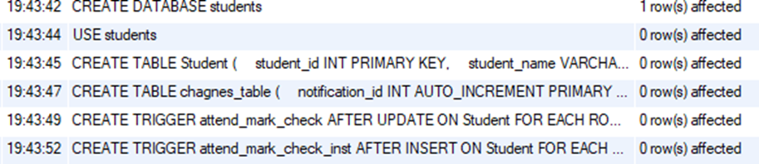

Figure 4.1 shows above queries are successfully executed select * from chagnes_table;



Figure 4.2 null table

INSERT INTO Student (student_id, student_name, adm43_marks, adm43_attendance) VALUES

(1, 'John Doe', 85, 76),

(2, 'Jane Smith', 78, 82),

(3, 'Alice Johnson', 90, 85),

(4, 'Bob Williams', 82, 79),

(5, 'Emily Brown', 88, 92),

(6, 'Michael Davis', 76, 84),

(7, 'Sophia Wilson', 85, 91),

(8, 'William Martinez', 92, 88),

(9, 'Olivia Anderson', 79, 91),

(10, 'Daniel Taylor', 91, 88); select * from chagnes_table;



Figure 4.3 changes by insertion trigger

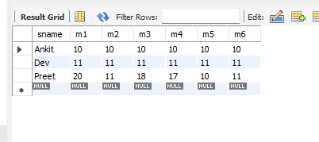

Figure 4.4 student table



Figure 4.5 changes in table as updation happen as compare to fig 4.3

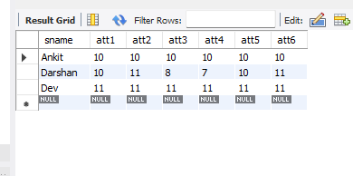

Figure 4.6 changes in student table as updation happen as compare to fig 4.4 and also value updated in table as well as in changes table.

### Conclusion:

Through the use of PL/SQL, these tasks are accomplished efficiently, leveraging the power of cursors, loops, and conditional statements. By organizing and processing data stored in the "Teacher" table, the code provides valuable insights such as teacher salary details, bonus calculations, and specific teacher information based on room numbers. This enables effective management and analysis of teacher-related data within the database system.

# Assignment 5

### Aim:

How to analyze ecommerce Inventory

* 1. What are the top 5 products with the highest inventory levels on the most recent inventory date ?
  2. What is the total inventory level for each product category on the most recent inventory date ?
  3. What is the average inventory level for each product category for the month of January 2022 ?
  4. Which products had a decrease in inventory level from the previous inventory date to the current inventory date ?
  5. What is the overall trend in inventory levels for each product category over the month of January 2022 ?

### Code :

CREATE DATABASE lab5;

use lab5;

CREATE TABLE products (

product_id SERIAL PRIMARY KEY,

product_name VARCHAR(50),

product_category VARCHAR(20),

product_price NUMERIC(10,2)

);

INSERT INTO products (product_name, product_category, product_price)

VALUES ('Product A', 'Category 1', 20),

('Product B', 'Category 2', 40),

('Product C', 'Category 1', 50),

('Product D', 'Category 3', 70),

('Product E', 'Category 1', 90),

('Product F', 'Category 2', 100);

CREATE TABLE inventory (

product_id INT,

inventory_date DATE,

inventory_level INT

);

INSERT INTO inventory (product_id, inventory_date, inventory_level)

VALUES (1, '2022-01-01', 100),

(2, '2022-01-01', 200),

(3, '2022-01-01', 150),

(4, '2022-01-01', 75),

(5, '2022-01-01', 250),

(1, '2022-01-02', 80),

(2, '2022-01-02', 180),

(3, '2022-01-02', 100),

(4, '2022-01-02', 60),

(5, '2022-01-02', 220),

(1, '2022-01-03', 50),

(2, '2022-01-03', 150),

(3, '2022-01-03', 75),

(4, '2022-01-03', 80),

(5, '2022-01-03', 200);

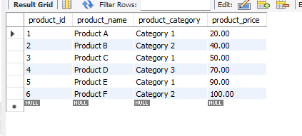

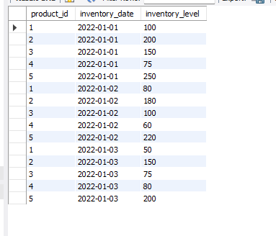

* + 1. What are the top 5 products with the highest inventory levels on the most recent inventory date ?

SELECT p.product_name, i.inventory_level FROM products p

JOIN inventory i ON p.product_id = i.product_id

WHERE i.inventory_date = (SELECT MAX(inventory_date) FROM inventory)

ORDER BY i.inventory_level DESC

LIMIT 5;

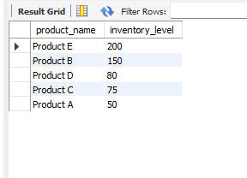

* + 1. What is the total inventory level for each product category on the most recent inventory date ?

SELECT p.product_category, SUM(i.inventory_level) AS total_inventory_level FROM products p

JOIN inventory i ON p.product_id = i.product_id

WHERE i.inventory_date = (SELECT MAX(inventory_date) FROM inventory)

GROUP BY p.product_category;

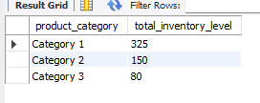

* + 1. What is the average inventory level for each product category for the month of January 2022 ?

SELECT p.product_category, AVG(i.inventory_level) AS avg_inventory_level FROM products p

JOIN inventory i ON p.product_id = i.product_id

WHERE i.inventory_date >= '2022-01-01' AND i.inventory_date < '2022-02-01' GROUP BY p.product_category;

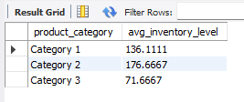

* + 1. Which products had a decrease in inventory level from the previous inventory date to the current inventory date ?

SELECT i1.product_id, p.product_name, i1.inventory_level - i2.inventory_level AS inventory_diff

FROM inventory i1

JOIN inventory i2 ON i1.product_id = i2.product_id AND i1.inventory_date = DATE_ADD(i2.inventory_date, INTERVAL 1 DAY)

JOIN products p ON i1.product_id = p.product_id

WHERE i1.inventory_level < i2.inventory_level;

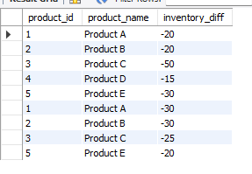

* + 1. What is the overall trend in inventory levels for each product category over the month of January 2022 ?

SELECT p.product_category, i.inventory_date, AVG(i.inventory_level) AS avg_inventory_level

FROM products p

JOIN inventory i ON p.product_id = i.product_id

WHERE i.inventory_date >= '2022-01-01' AND i.inventory_date < '2022-02-01'

GROUP BY p.product_category, i.inventory_date

ORDER BY p.product_category, i.inventory_date;

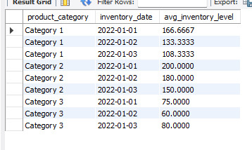

**Conclusion:** In analyzing ecommerce inventory using MySQL queries, insights were gained on top products by inventory, total inventory per category, and average levels for January 2022. Identification of products with decreased inventory highlighted management areas. Trend analysis for January 2022 revealed patterns, aiding in proactive adjustments. Leveraging MySQL for ecommerce inventory analysis enabled actionable insights for optimizing stock levels and improving business performance.

# Assignment 6

### Aim:

(Object Oriented)

1. Write a PL/SQL code to create a class for a "Person" with attributes such as name, age, and address.
2. Write a PL/SQL code to Implement methods in the "Person" class to display the details and update the age.
3. Write a PL/SQL code to implement a method to calculate the annual bonus based on the salary in the "Employee" class.
4. Write a PL/SQL code to create a "Manager" subclass inheriting from the "Employee" class, and add an attribute to store the number of employees managed.

**Code**:

1. **Write a PL/SQL code to create a class for a "Person" with attributes such as name, age, and address.**

CREATE TYPE Person AS OBJECT (

name VARCHAR2(50),

age NUMBER,

address VARCHAR2(100)

);

DECLARE

p1 Person;

BEGIN

p1 := Person(‘Ankit', 30, 'Surat');

DBMS_OUTPUT.PUT_LINE('Name: ' || p1.name);

DBMS_OUTPUT.PUT_LINE('Age: ' || p1.age);

DBMS_OUTPUT.PUT_LINE('Address: ' || p1.address);

END;

1. **Write a PL/SQL code to Implement methods in the "Person" class to display the details and update the age.**

CREATE OR REPLACE TYPE Person AS OBJECT (

id NUMBER,

name VARCHAR2(100),

age NUMBER,

CREATE OR REPLACE TYPE BODY Person AS

MEMBER FUNCTION displayDetails RETURN VARCHAR2 IS BEGIN

RETURN 'Person ID: ' || self.id || ', Name: ' || self.name || ', Age: '

self.age; END;

MEMBER PROCEDURE updateAge(newAge NUMBER) IS BEGIN

self.age := newAge; END;

END;

CREATE OR REPLACE PACKAGE PersonPackage AS

FUNCTION displayDetails(p Person) RETURN VARCHAR2;

PROCEDURE updateAge(p IN OUT Person, newAge NUMBER);

END;

CREATE OR REPLACE PACKAGE BODY PersonPackage AS

FUNCTION displayDetails(p Person) RETURN VARCHAR2 IS

BEGIN

RETURN p.displayDetails();

END;

PROCEDURE updateAge(p IN OUT Person, newAge NUMBER) IS BEGIN

p.updateAge(newAge);

END;

END;

DECLARE

p1 Person := Person(1, 'Ankit', 30);

p2 Person := Person(2, 'Bhavik', 25);

BEGIN

DBMS_OUTPUT.PUT_LINE(PersonPackage.displayDetails(p1));

DBMS_OUTPUT.PUT_LINE(PersonPackage.displayDetails(p2));

PersonPackage.updateAge(p1, 31);

DBMS_OUTPUT.PUT_LINE('After updating age:');

DBMS_OUTPUT.PUT_LINE(PersonPackage.displayDetails(p1));

DBMS_OUTPUT.PUT_LINE(PersonPackage.displayDetails(p2));

END;

1. **Write a PL/SQL code to implement a method to calculate the annual bonus based on the salary in the "Employee" class.**

CREATE OR REPLACE TYPE Employee AS OBJECT ( emp_id NUMBER,

emp_name VARCHAR2(100),

salary NUMBER,

MEMBER FUNCTION calculate_bonus RETURN NUMBER

);

CREATE OR REPLACE TYPE BODY Employee AS

MEMBER FUNCTION calculate_bonus RETURN NUMBER IS

bonus_percentage NUMBER;

bonus_amount NUMBER;

BEGIN

IF self.salary < 50000 THEN

bonus_percentage := 0.1;

ELSIF self.salary < 100000 THEN

bonus_percentage := 0.15;

ELSE

bonus_percentage := 0.2;

END IF;

bonus_amount := self.salary * bonus_percentage;

RETURN bonus_amount;

END;

END;

DECLARE

emp_obj Employee;

emp_bonus NUMBER;

BEGIN

emp_obj := Employee(1, 'Ankit', 65000);

emp_bonus := emp_obj.calculate_bonus;

DBMS_OUTPUT.PUT_LINE('Employee Bonus: ' || emp_bonus); END;

1. **Write a PL/SQL code to create a "Manager" subclass inheriting from the "Employee" class, and add an attribute to store the number of employees managed.**

CREATE OR REPLACE TYPE Employee AS OBJECT ( emp_id NUMBER,

emp_name VARCHAR2(100),

salary NUMBER

NOT FINAL;

CREATE OR REPLACE TYPE Manager UNDER Employee (

number_of_employees NUMBER

);

CREATE TABLE employees_data OF Employee

INSERT INTO employees_data VALUES (1, 'Ankit', 150000)

INSERT INTO employees_data VALUES (2, 'Bhavik', 80000)

INSERT INTO employees_data VALUES (3, 'Dev', 120000)

CREATE TABLE managers_data OF Manager

INSERT INTO managers_data VALUES (4, 'Ankit', 150000, 10)

DECLARE

emp_data Employee;

mgr_data Manager;

BEGIN

FOR emp_data IN (SELECT * FROM employees_data) LOOP

DBMS_OUTPUT.PUT_LINE('Employee ID: ' || emp_data.emp_id || ', Name: '

emp_data.emp_name || ', Salary: ' || emp_data.salary);

END LOOP;

FOR mgr_data IN (SELECT * FROM managers_data) LOOP

DBMS_OUTPUT.PUT_LINE('Manager ID: ' || mgr_data.emp_id || ', Name: '

mgr_data.emp_name || ', Salary: ' || mgr_data.salary || ', Number of Employees: ' || mgr_data.number_of_employees);

END LOOP; END;

#### Output:

1)

Type created.

Statement processed. Name: Ankit

Age: 21

Address: IIIT SURAT

2)

Type created.

Type created.

Statement processed.

Person ID: 1, Name: Ankit, Age: 20 Person ID: 2, Name: Bhavik, Age: 28

Updated age:

Person ID: 1, Name: Ankit, Age: 25 Person ID: 2, Name: Bhavik, Age: 28

3)

Type created.

Type created.

Statement processed.

Employee Bonus: 9750

4)

Type created.

Type created.

Type created.

Type created.

Statement processed.

Employee Bonus: 4000

Statement processed.

Manager Bonus: 16275

**Conclusion:**

This PL/SQL code demonstrates the principles of object-oriented programming within the

context of Oracle Database. By defining classes and subclasses, along with methods to operate

on their attributes, we establish a foundation for modeling complex real-world entities and their

behaviors. Such an approach promotes code reusability, modularity, and maintainability,

allowing for the creation of scalable and robust database applications. Through these examples,

we showcase how to structure and extend classes to encapsulate data and behavior, thereby

enabling efficient and organized development within the Oracle PL/SQL environment.

# Assignment 7

### Aim:

1. Write a SQL statement to create a simple table countries including columns country_id,country_name and region_id.
2. Write a SQL statement to create a simple table countries including columns country_id,country_name and region_id which already exist.
3. Write a SQL statement to create the structure of a table dup_countries similar to countries.
4. Write a SQL statement to create a duplicate copy of countries table including structure and data by name dup_countries.
5. Write a SQL statement to create a table countries set a constraint NULL.
6. Write a SQL statement to create a table named jobs including columns job_id, job_title, min_salary, max_salary and check whether the max_salary amount exceeding the upper limit 25000.
7. Write a SQL statement to create a table named countries including columns country_id, country_name and region_id and make sure that no countries except Italy, India and China will be entered in the table.
8. Write a SQL statement to create a table named countries including columns country_id,country_name and region_id and make sure that no duplicate data against column country_id will be allowed at the time of insertion.
9. Write a SQL statement to create a table named jobs including columns job_id, job_title, min_salary and max_salary, and make sure that, the default value for job_title is blank and min_salary is 8000 and max_salary is NULL will be entered automatically at the time of insertion if no value assigned for the specified columns.
10. Write a SQL statement to create a table named countries including columns country_id, country_name and region_id and make sure that the country_id column will be a key field which will not contain any duplicate data at the time of insertion.
11. Write a SQL statement to create a table countries including columns country_id, country_name and region_id and make sure that the column country_id will be unique and store an auto-incremented value.

Click me to see the solution

1. Write a SQL statement to create a table countries including columns country_id, country_name and region_id and make sure that the combination of columns country_id and region_id will be unique.

### Code :

CREATE DATABASE AS7; USE AS7;

-- 1. Create a simple table countries CREATE TABLE AS7.countries (

country_id INT,

country_name VARCHAR(50), region_id INT

);

-- 2. Create a table countries if not exists

CREATE TABLE IF NOT EXISTS AS7.countries (

country_id INT,

country_name VARCHAR(50), region_id INT

);

-- 3. Create the structure of table dup_countries similar to countries CREATE TABLE AS7.dup_countries LIKE AS7.countries;

-- 4. Create a duplicate copy of countries table including structure and data CREATE TABLE AS7.dup_countries AS SELECT * FROM AS7.countries;

-- 5. Create a table countries with a constraint allowing NULL values CREATE TABLE AS7.countries (

country_id INT,

country_name VARCHAR(50), region_id INT,

CONSTRAINT country_name_null CHECK (country_name IS NULL)

);

-- 6. Create a table jobs with max_salary check constraint CREATE TABLE AS7.jobs (

job_id INT,

job_title VARCHAR(50), min_salary DECIMAL(10,2), max_salary DECIMAL(10,2),

CONSTRAINT max_salary_check CHECK (max_salary <= 25000)

);

-- 7. Create a table countries with specific allowed country entries CREATE TABLE AS7.countries (

country_id INT,

country_name VARCHAR(50), region_id INT,

CONSTRAINT country_name_check CHECK (country_name IN ('Italy', 'India', 'China'))

);

-- 8. Create a table countries with no duplicate country_id allowed CREATE TABLE AS7.countries (

country_id INT PRIMARY KEY, country_name VARCHAR(50), region_id INT

);

-- 9. Create a table jobs with default values for specified columns CREATE TABLE AS7.jobs (

job_id INT,

job_title VARCHAR(50) DEFAULT '', min_salary DECIMAL(10,2) DEFAULT 8000,

max_salary DECIMAL(10,2)

);

-- 10. Create a table countries with country_id as a key field CREATE TABLE AS7.countries (

country_id INT UNIQUE, country_name VARCHAR(50), region_id INT

);

-- 11. Create a table countries with auto-incremented country_id and unique constraint CREATE TABLE AS7.countries (

country_id INT AUTO_INCREMENT PRIMARY KEY,

country_name VARCHAR(50), region_id INT, UNIQUE(country_id)

);

-- 12. Create a table countries with unique combination of country_id and region_id CREATE TABLE AS7.countries (

country_id INT,

country_name VARCHAR(50), region_id INT, UNIQUE(country_id, region_id)

)

**Conclusion:**

Creating tables in PostgreSQL involves careful consideration of data structure and integrity constraints to ensure efficient data storage and retrieval. These SQL statements showcase various scenarios encountered during table creation, demonstrating PostgreSQL's versatility and robustness in handling diverse database requirements. With PostgreSQL's rich feature set and SQL support, database administrators can design and manage databases effectively, facilitating the development of reliable and scalable applications.