lakehuron.R
AUTHOR:- ANKIT GHOSH:
2026-01-22
data("LakeHuron")
head(LakeHuron)
## Time Series:
## Start = 1875
## End = 1880
## Frequency = 1
## [1] 580.38 581.86 580.97 580.80 579.79 580.39
summary(LakeHuron)
## Min. 1st Qu. Median Mean 3rd Qu. Max.
## 576.0 578.1 579.1 579.0 579.9 581.9
class(LakeHuron)
## [1] "ts"
print(dim(data.frame(LakeHuron)))
## [1] 98 1
plot(LakeHuron,main='lakehuron water level',ylab='feet',col="blue",lwd= 2)
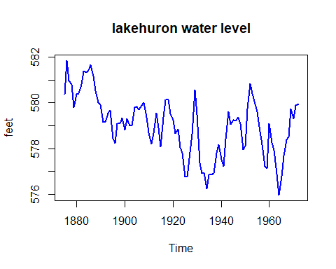
lake_train=window(LakeHuron,start=1875,end=1950)
lake_test=window(LakeHuron,start=1951,end=1972)
# stationary checking
library(tseries)
adf_test=adf.test(lake_train)
adf_test
##
## Augmented Dickey-Fuller Test
##
## data: lake_train
## Dickey-Fuller = -3.1114, Lag order = 4, p-value = 0.1219
## alternative hypothesis: stationary
#making the data stationary
diff_lake=diff(lake_train)
plot(diff_lake,main="difference lake huron series",ylab='difference water level',col='red')
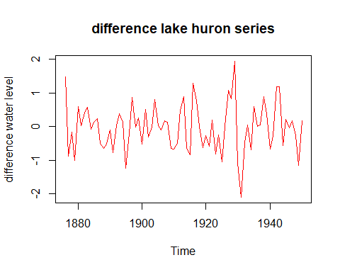
#removing trend
adf_diff_test=adf.test(diff_lake)
## Warning in adf.test(diff_lake): p-value smaller than printed p-value
adf_diff_test
##
## Augmented Dickey-Fuller Test
##
## data: diff_lake
## Dickey-Fuller = -4.753, Lag order = 4, p-value = 0.01
## alternative hypothesis: stationary
#acf and pacf plot
par(mfrow=c(1,2))
acf(diff_lake,main="acf")
pacf(diff_lake,main="pacf")
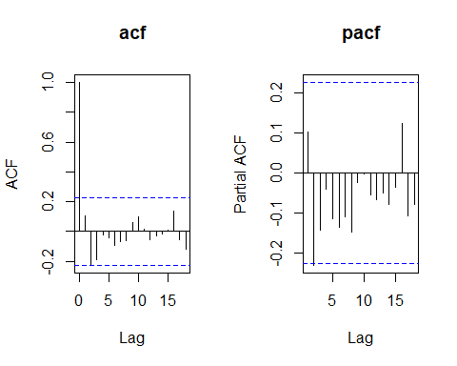
par(mfrow=c(1,1))
# arima model manual parameter selection using acf pacf
#arima(1,1,2)
#library(forecast)
manual=arima(lake_train,order =c(1,1,2))
print(manual)
##
## Call:
## arima(x = lake_train, order = c(1, 1, 2))
##
## Coefficients:
## ar1 ma1 ma2
## 0.5681 -0.5228 -0.3327
## s.e. 0.1707 0.1749 0.1226
##
## sigma^2 estimated as 0.4259: log likelihood = -74.68, aic = 157.36
#arima(1,1,1)
manual_1=arima(lake_train,order =c(1,1,1))
print(manual_1)
##
## Call:
## arima(x = lake_train, order = c(1, 1, 1))
##
## Coefficients:
## ar1 ma1
## -0.3441 0.5207
## s.e. 0.4160 0.3809
##
## sigma^2 estimated as 0.4761: log likelihood = -78.62, aic = 163.23
#arima(1,1,0)
manual_2=arima(lake_train,order =c(1,1,0))
print(manual_2)
##
## Call:
## arima(x = lake_train, order = c(1, 1, 0))
##
## Coefficients:
## ar1
## 0.1105
## s.e. 0.1175
##
## sigma^2 estimated as 0.4855: log likelihood = -79.33, aic = 162.65
#using autoarima
library(forecast)
model=auto.arima(lake_train)
print(model)
## Series: lake_train
## ARIMA(0,1,0)
##
## sigma^2 = 0.4958: log likelihood = -79.77
## AIC=161.53 AICc=161.59 BIC=163.85
manual_3=arima(lake_train,order =c(0,1,0))
print(manual_3)
##
## Call:
## arima(x = lake_train, order = c(0, 1, 0))
##
##
## sigma^2 estimated as 0.4913: log likelihood = -79.77, aic = 161.53
checkresiduals(manual)
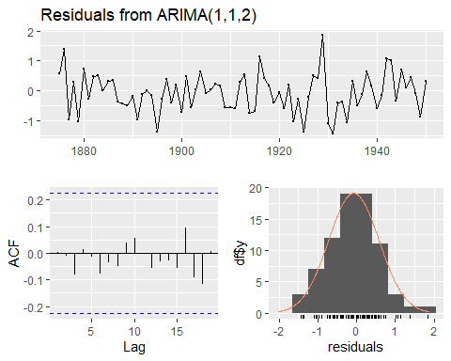
##
## Ljung-Box test
##
## data: Residuals from ARIMA(1,1,2)
## Q* = 1.8823, df = 7, p-value = 0.9661
##
## Model df: 3. Total lags used: 10
checkresiduals(manual_3)
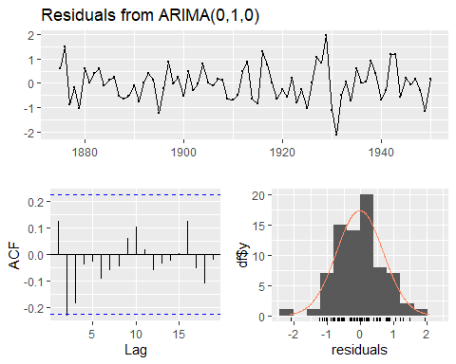
##
## Ljung-Box test
##
## data: Residuals from ARIMA(0,1,0)
## Q* = 11.047, df = 10, p-value = 0.3538
##
## Model df: 0. Total lags used: 10
#actual vs fitted plot
plot(fitted(manual_3),col='red',main='arima(0,1,0) fitted vs actual')
lines(lake_train,col='blue')
legend("topright",legend = c('fitted','actual'),fill=c('red','blue'))
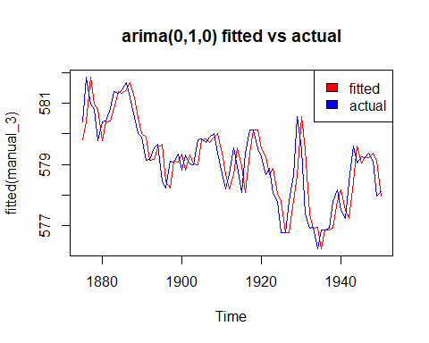
#forecast plot
forecast_lake=forecast(manual_3,h=22,level=c(85,95))
autoplot(forecast_lake,main='arima(0,1,0)forecast')
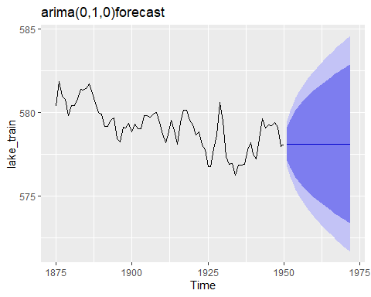
plot
## function (x, y, ...)
## UseMethod("plot")
## <bytecode: 0x000001cfbbf62cc8>
## <environment: namespace:base>
plot(lake_test,col='black',main='forecast vs test data in arima(0,1,0)')
lines(forecast_lake$mean,col='red')
legend('topright',legend = c('forecast','actual'),fill=c('red','black'))
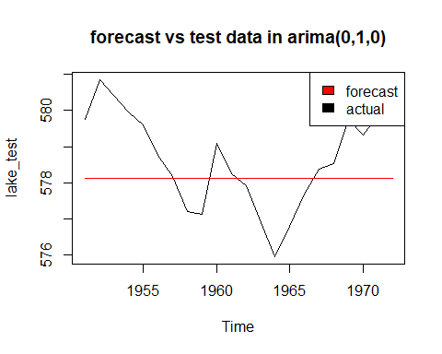
#model comaparison
accuracy=forecast_lake$mean-lake_test
cat("test error n 22 data points",sum(accuracy^2),'\n')
## test error n 22 data points 43.1035
cat('train_error',manual_3$sigma2)
## train_error 0.491264
forecast_lake_1=forecast(manual,h=22,level=c(85,95))
accuracy_1=forecast_lake_1$mean-lake_test
cat("test error n 22 data points",sum(accuracy_1^2),'\n')
## test error n 22 data points 38.78347
cat('train_error',manual$sigma2)
## train_error 0.4258698

