loan_approval_analysis
ANKIT
2025-09-07
# TITLE= LOAN APPROVAL ANALYSIS
#AUTHOR- ANKIT GHOSH
#import libraries
library(tidyr)
library(dplyr)
library(ggplot2)
#data import
setwd("D:/r_project/r_islr_work/LOAN_APPROVAL_ANALYSIS")
getwd()
## [1] "D:/r_project/r_islr_work/LOAN_APPROVAL_ANALYSIS"
df=read.csv("Loan_Train.csv")
dim(df)
## [1] 614 13
#data cleaning
df[df==""]=NA
df1=drop_na(df)
dim(df1)
## [1] 480 13
str(df1)
## 'data.frame': 480 obs. of 13 variables:
## $ Loan_ID : chr "LP001003" "LP001005" "LP001006" "LP001008" ...
## $ Gender : chr "Male" "Male" "Male" "Male" ...
## $ Married : chr "Yes" "Yes" "Yes" "No" ...
## $ Dependents : chr "1" "0" "0" "0" ...
## $ Education : chr "Graduate" "Graduate" "Not Graduate" "Graduate" ...
## $ Self_Employed : chr "No" "Yes" "No" "No" ...
## $ ApplicantIncome : int 4583 3000 2583 6000 5417 2333 3036 4006 12841 3200 ...
## $ CoapplicantIncome: num 1508 0 2358 0 4196 ...
## $ LoanAmount : int 128 66 120 141 267 95 158 168 349 70 ...
## $ Loan_Amount_Term : int 360 360 360 360 360 360 360 360 360 360 ...
## $ Credit_History : int 1 1 1 1 1 1 0 1 1 1 ...
## $ Property_Area : chr "Rural" "Urban" "Urban" "Urban" ...
## $ Loan_Status : chr "N" "Y" "Y" "Y" ...
Total_Income=df1$ApplicantIncome+df1$CoapplicantIncome
log_total_income=log(Total_Income,base = exp(1))
hist(log_total_income,col="blue",xlim = c(7.5,11.5),breaks = 20)
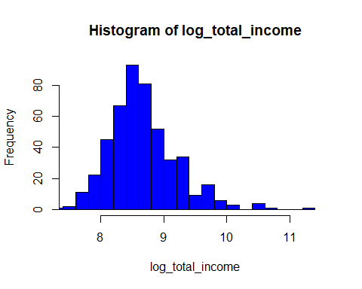
#removing oulier for applicant income
quantile(df1$ApplicantIncome)
## 0% 25% 50% 75% 100%
## 150.00 2898.75 3859.00 5852.50 81000.00
u=IQR(df1$ApplicantIncome)
u
## [1] 2953.75
u_b=5852.50+1.5*u
l_b=2898.75 -1.5*u
df2=subset(df1,df1$ApplicantIncome>l_b & df1$ApplicantIncome<u_b)
#PERFORMING SOME SORTS OF EDA RELATED TO DATA
#number of people who take loan group by gender
loan_gender=data.frame(df1$Gender)
gender_count=loan_gender%>%count(df1$Gender)
print(gender_count)
## df1$Gender n
## 1 Female 86
## 2 Male 394
ggplot(data = loan_gender,aes(x=df1$Gender))+geom_bar(aes(fill = df1.Gender))+labs(title=" gender counts",x="Gender")+theme()
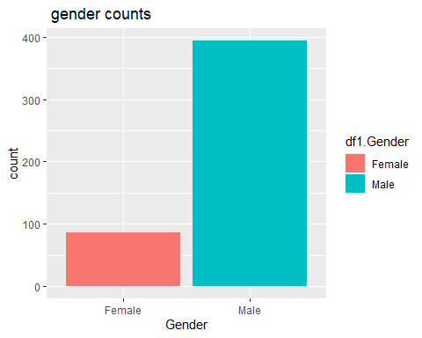
#number of people who take loan group by martial status
loan_married=data.frame(df1$Married)
married_count=loan_married%>%count(df1$Married)
print(married_count)
## df1$Married n
## 1 No 169
## 2 Yes 311
ggplot(data = loan_married,aes(x=df1.Married))+geom_bar(aes(fill=df1$Married))+labs(title=" loan based on martial status",x="married")+theme()
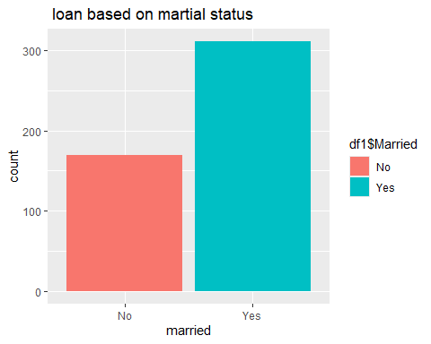
#number of people who take loan group by dependents
loan_dependents=data.frame(df1$Dependents)
dependents_count=loan_dependents%>%count(df1$Dependents)
print(dependents_count)
## df1$Dependents n
## 1 0 274
## 2 1 80
## 3 2 85
## 4 3+ 41
ggplot(data = loan_dependents,aes(x=df1.Dependents))+geom_bar(aes(fill=df1$Dependents))+labs(title=" dependents counts",x="dependentts")+theme()
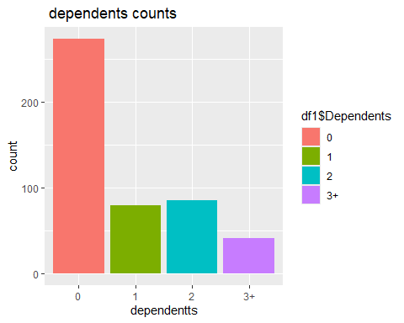
#number of people who take loan group by self employed
loan_employed=data.frame(df1$Self_Employed)
employed_count=loan_employed%>%count(df1$Self_Employed)
print(employed_count)
## df1$Self_Employed n
## 1 No 414
## 2 Yes 66
ggplot(data = loan_employed,aes(x=df1.Self_Employed))+geom_bar(aes(fill=df1$Self_Employed))+labs(title=" employed counts",x="self employed")+theme()
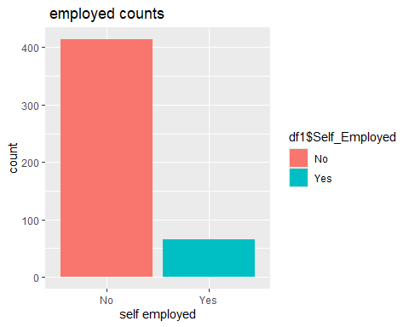
#proportion of loan approved by demographic analysis
#loan approved proportion by gender
ggplot(df1,aes(x=Gender,fill=Loan_Status))+geom_bar(position = "fill")+labs(title = "loan approved proprtion by Gender",y="proportion")
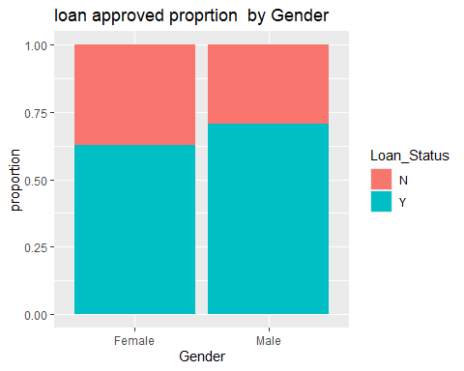
#loan approved proportion by martial status
ggplot(df1,aes(x=Married,fill=Loan_Status))+geom_bar(position = "fill")+labs(title = "loan approved proportion by martial status",y="proportion")
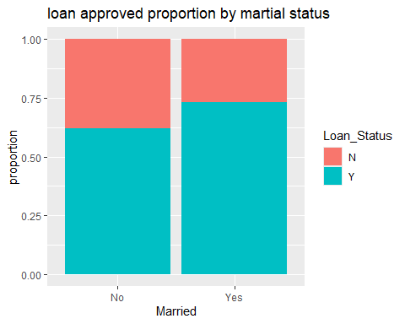
#loan approved proportion by educational status
ggplot(df1,aes(x=Education,fill=Loan_Status))+geom_bar(position = "fill")+labs(title = "loan approved proportion by educational status",y="proportion")
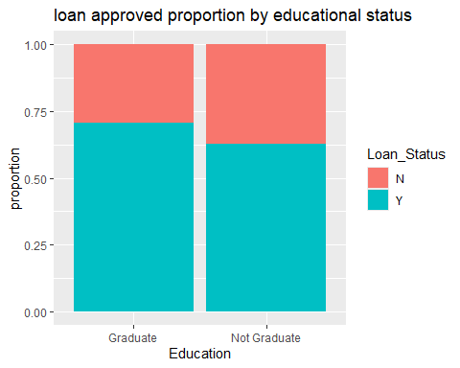
#loan approved proportion by dependent status
ggplot(df1,aes(x=factor(Dependents),fill=Loan_Status))+geom_bar(position = "fill")+labs(title = "loan approved proportion by dependent status",y="proportion")
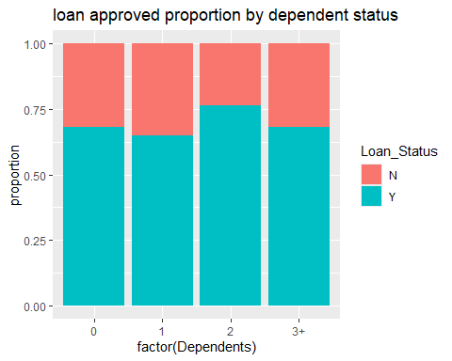
#income and loan analysis
#income distribution
ggplot(df1,aes(x=ApplicantIncome))+geom_histogram(bins = 30,fill="steelblue",color="black")+labs(title = "distribution of applicant income")
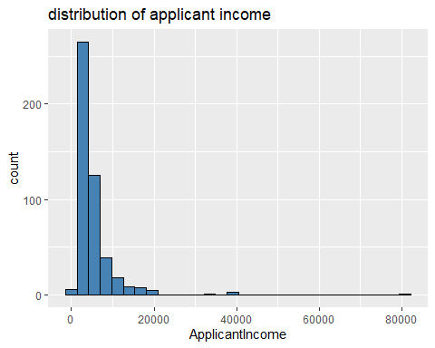
#income distribution after removing outlier
ggplot(df2,aes(x=ApplicantIncome))+geom_histogram(bins = 30,fill="steelblue",color="black")+labs(title = "distribution of applicant income without outlier")
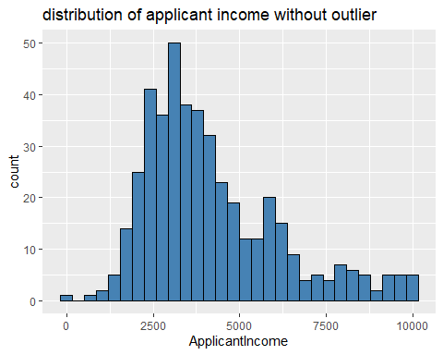
#loan amount distribution
ggplot(df1,aes(x=LoanAmount))+geom_histogram(bins = 30,fill="green",color="black")+labs(title = "distribution of loan amount")
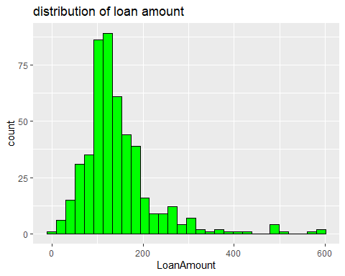
#income vs loanstatus
ggplot(df1,aes(x=Loan_Status,y=ApplicantIncome))+geom_boxplot()+labs(title = " applicant income vs loan status")
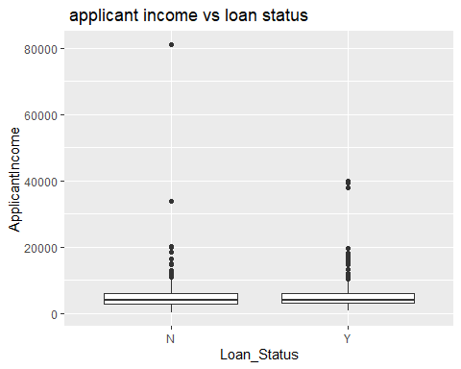
#income vs loanstatus after removing outlier
ggplot(df2,aes(x=Loan_Status,y=ApplicantIncome))+geom_boxplot()+labs(title = " applicant income vs loan status")
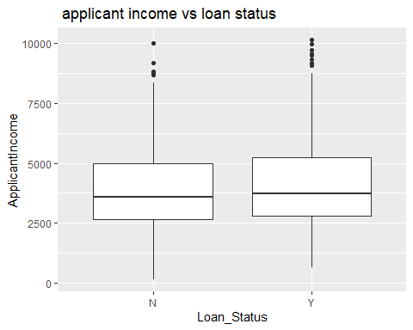
#total income vs loan amount
ggplot(df1,aes(x=Total_Income,y=LoanAmount,color=Loan_Status))+geom_point(aes(size=LoanAmount),alpha=0.6)+labs(title = "total income vs loan amount")+theme_minimal()
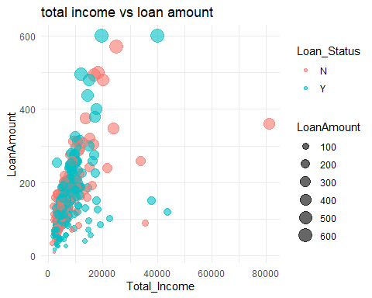
#total income vs loan amount after removing outlier
Total_Income2=df2$ApplicantIncome+df2$CoapplicantIncome
ggplot(df2,aes(x=Total_Income2,y=LoanAmount,color=Loan_Status))+geom_point(aes(size=LoanAmount),alpha=0.6)+labs(title = "total income vs loan amount (without outlier)")+theme_minimal()
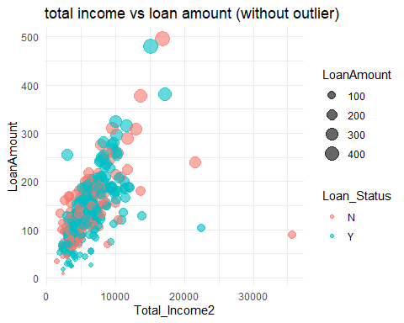
#CREDIT HISTORY AND LOAN APPROVAL
ggplot(df1,aes(x=factor(Credit_History),fill = Loan_Status))+geom_bar(position = "fill")+labs(title = "loan approved proportion by credit history",x="credit history(0=NO,1=YES)",y="proportion")
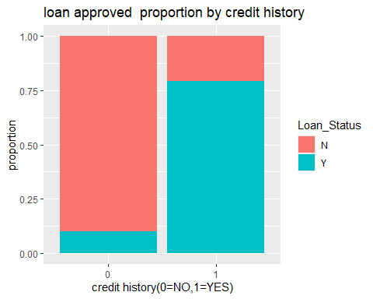
#LOAN APPROVAL RATE OVERALL
approv_rate =mean(df1$Loan_Status=="Y")*100
cat("overall loan approval rate:",round(approv_rate,2),"%\n")
## overall loan approval rate: 69.17 %
#Approval rate by gender
gen_approv=df1%>%group_by(Gender)%>%summarise(approvalrate=mean(Loan_Status=="Y",na.rm=TRUE)*100)
print(gen_approv)
## # A tibble: 2 × 2
## Gender approvalrate
## <chr> <dbl>
## 1 Female 62.8
## 2 Male 70.6
ggplot(gen_approv,aes(x=Gender,fill =approvalrate ))+geom_bar(position = "fill")+labs(title = "loan approved rate by gender")
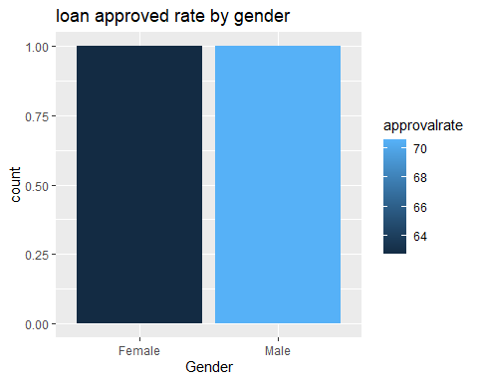
#approval rate by martial status
married_approval=df1%>%group_by(Married)%>%summarise(approvalrate=mean(Loan_Status=="Y",na.rm=TRUE)*100)
print(married_approval)
## # A tibble: 2 × 2
## Married approvalrate
## <chr> <dbl>
## 1 No 62.1
## 2 Yes 73.0
ggplot(married_approval,aes(x=Married,fill =approvalrate ))+geom_bar(position = "fill")+labs(title = "loan approved rate by martial ")
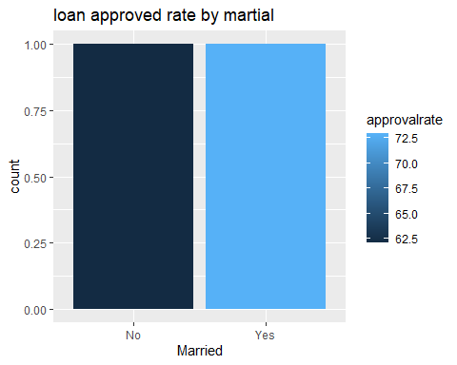
#approval rate by educational status
edu_approval=df1%>%group_by(Education)%>%summarise(approvalrate=mean(Loan_Status=="Y",na.rm=TRUE)*100)
print(edu_approval)
## # A tibble: 2 × 2
## Education approvalrate
## <chr> <dbl>
## 1 Graduate 70.8
## 2 Not Graduate 62.9
ggplot(edu_approval,aes(x=Education,fill =approvalrate ))+geom_bar(position = "fill")+labs(title = "loan approved rate by education")
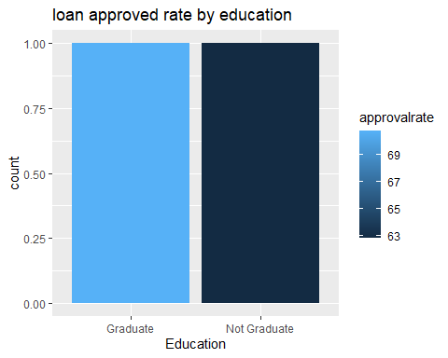
#approval rate by Dependents status
dep_approval=df1%>%group_by(Dependents)%>%summarise(approvalrate=mean(Loan_Status=="Y",na.rm=TRUE)*100)
print(dep_approval)
## # A tibble: 4 × 2
## Dependents approvalrate
## <chr> <dbl>
## 1 0 68.2
## 2 1 65
## 3 2 76.5
## 4 3+ 68.3
ggplot(dep_approval,aes(x=Dependents,fill =approvalrate ))+geom_bar(position = "fill")+labs(title = "loan approved rate by dependents")
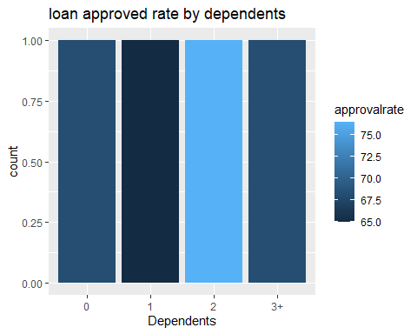
#approval rate by credit status
cred_approval=df1%>%group_by(Credit_History)%>%summarise(approvalrate=mean(Loan_Status=="Y",na.rm=TRUE)*100)
print(cred_approval)
## # A tibble: 2 × 2
## Credit_History approvalrate
## <int> <dbl>
## 1 0 10
## 2 1 79.3
ggplot(cred_approval,aes(x=factor(Credit_History),fill = approvalrate ))+geom_bar(position = "fill")+labs(title = "loan approved rate by credit status")
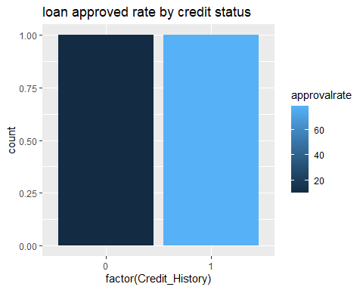
#approval rate by property area
p_approval=df1%>%group_by(Property_Area)%>%summarise(approvalrate=mean(Loan_Status=="Y",na.rm=TRUE)*100)
print(p_approval)
## # A tibble: 3 × 2
## Property_Area approvalrate
## <chr> <dbl>
## 1 Rural 61.2
## 2 Semiurban 78.0
## 3 Urban 65.3
ggplot(p_approval,aes(x=Property_Area,fill =approvalrate ))+geom_bar(position = "fill")
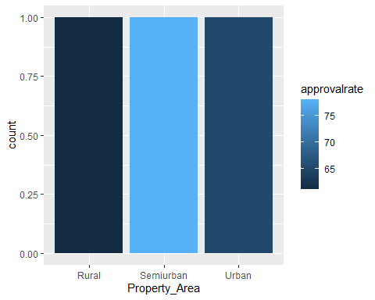
#average loan amount by loan status
avg_loan=df1%>%group_by(Loan_Status)%>%summarise(AverageLoan=mean(LoanAmount,na.rm=TRUE))
print(avg_loan)
## # A tibble: 2 × 2
## Loan_Status AverageLoan
## <chr> <dbl>
## 1 N 153.
## 2 Y 141.
ggplot(avg_loan,aes(x=Loan_Status,fill =AverageLoan ))+geom_bar(position = "fill")+labs(title = "average loan vs loan status")
