BlackImg - Multi-Page Visual Discovery Website
Minor Assignment
Submited for the award of BCA of
CAREER POINT UNIVERSITY

By Ankit Kumar Maurya
KID :- K27562

Subject:- CAL557 – Web Technology I
Under the supervision of
Prof. (Dr.) Abid Hussain


School of computer application & technology
CAREER POINT UNIVERSITY KOTA, RAJATHAN

S. No. | Topic | Page No.
1 | Introduction | 3
2 | Development Requirements | 3
3 | Modules of the Website | 4-5
4 | Code Snippets | 5
5 | User Interface (UI) / Screenshots | 6
6 | Conclusion
7 | Future Scope | 7

1. Introduction
BlackImg is a multi-page front-end website built using HTML, CSS, and JavaScript. The project is designed as a visual discovery platform where users can access structured pages such as Home, Dashboard, About, Services, Gallery, Explore, and Contact. The main objective is to demonstrate modular web design, smooth navigation, and practical implementation of core web technologies.

2. Development Requirements
2.1 Hardware
- Laptop/Desktop system
- Stable internet connection for testing and deployment

2.2 Software
- Operating System: Windows 11
- Code Editor: Visual Studio Code
- Browser: Google Chrome / Microsoft Edge
- Hosting Platform: Netlify

2.3 Technologies Used
- HTML5 for page structure
- CSS3 for styling and responsive layouts
- JavaScript for interactivity and validation
- Font Awesome for icons

3. Modules of the BlackImg Website
- `index.html`
Main entry page using frame-based layout to load header and content sections.

- `header.html`
Top navigation module with links to all major pages (`mainFrame` target).

- `dashboard.html`
Overview page displaying quick highlights and stats cards.

- `main.html`
Home module introducing BlackImg and key actions.

- `about.html`
Describes project purpose, vision, and background.

- `services.html`
Lists offerings and support features of the platform.

- `gallery.html`
Image gallery with filter-based visual browsing.

- `explore.html`
Extended discovery section with visual cards/content browsing.

- `contact.html`
User communication form with input validation behavior.

- `Signup.html`
User registration interface module.

4. Code Snippets
4.1 Navigation in `header.html`
<nav class="top-nav" id="topNav" aria-label="Main navigation">
<a href="dashboard.html" target="mainFrame">Dashboard</a>
<a href="main.html" target="mainFrame">Home</a>
<a href="about.html" target="mainFrame">About</a>
<a href="services.html" target="mainFrame">Services</a>
<a href="gallery.html" target="mainFrame">Photo Gallery</a>
<a href="explore.html" target="mainFrame">Explore</a>
<a href="contact.html" target="mainFrame">Contact</a>
</nav>

4.2 Frameset in `index.html`
<frameset rows="80,*" border="0" frameborder="0" framespacing="0">
<frame src="header.html" name="topFrame" scrolling="no" noresize />
<frame src="dashboard.html" name="mainFrame" />
</frameset>

4.3 Gallery Filter Logic
function applyFilter(filter) {
photos.forEach((photo) => {
const show = filter === "all" || photo.dataset.category === filter;
photo.classList.toggle("hidden", !show);
});
}

5. User Interface (UI) Summary

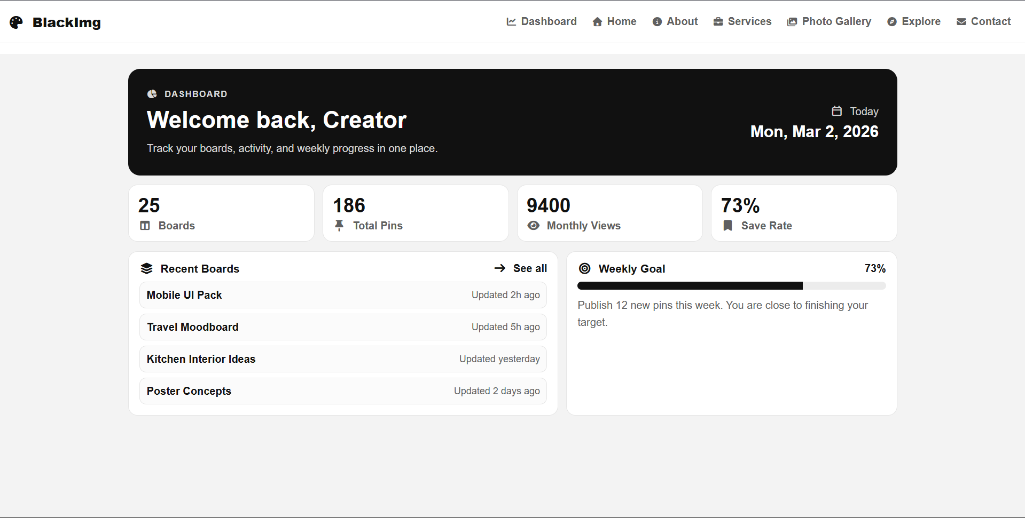
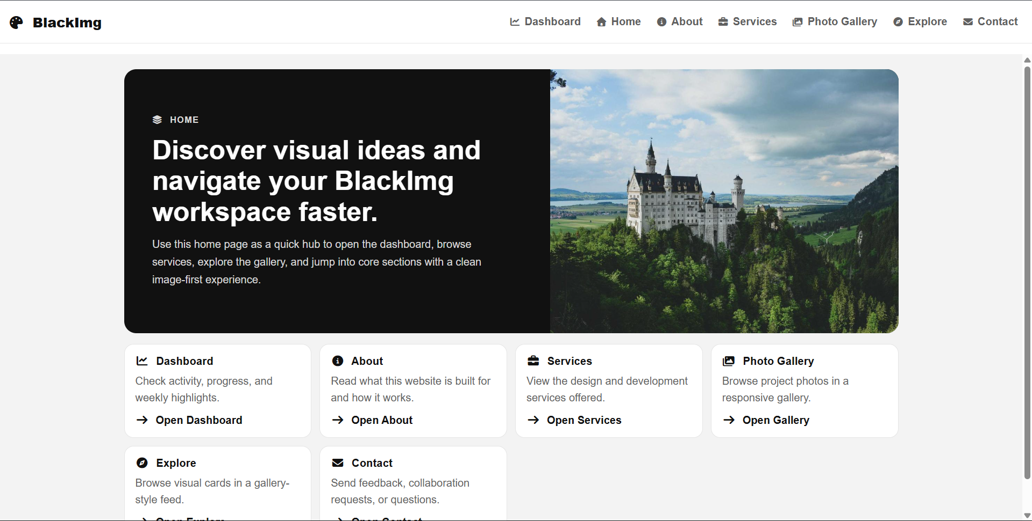
Dashboard Page
Home Page
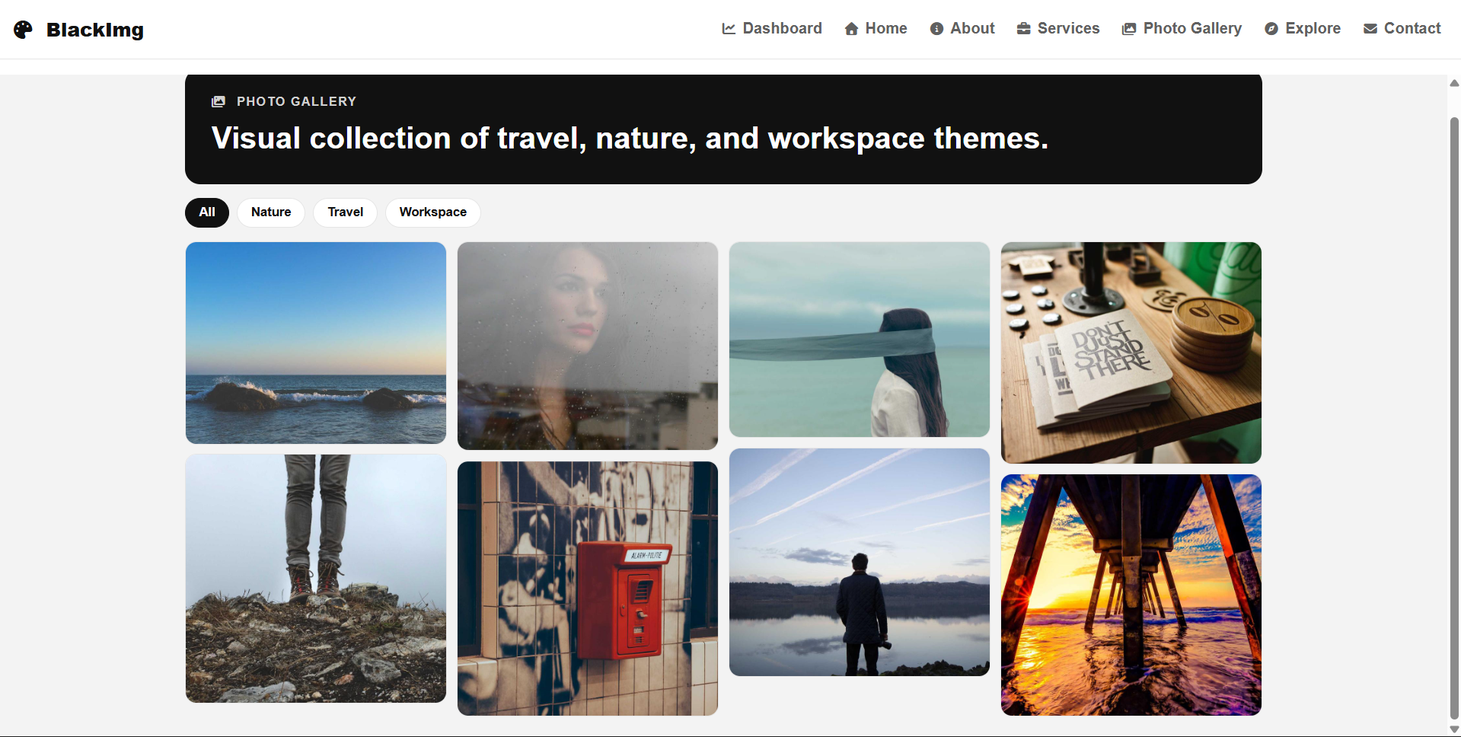
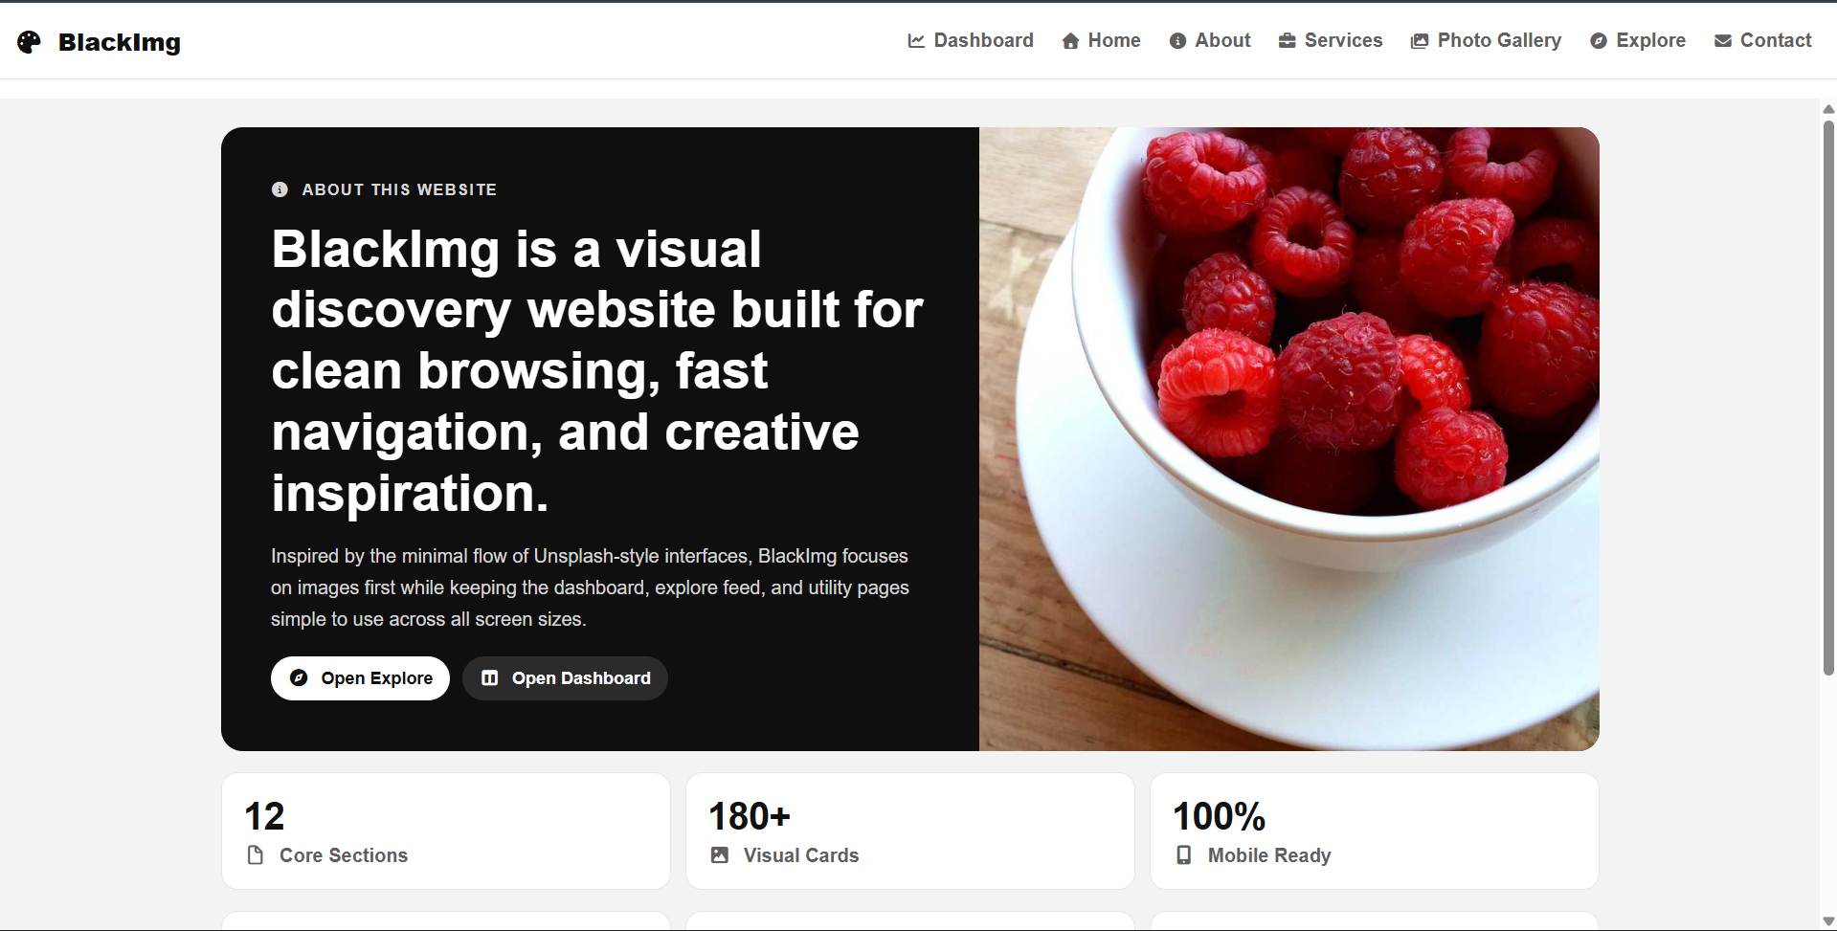
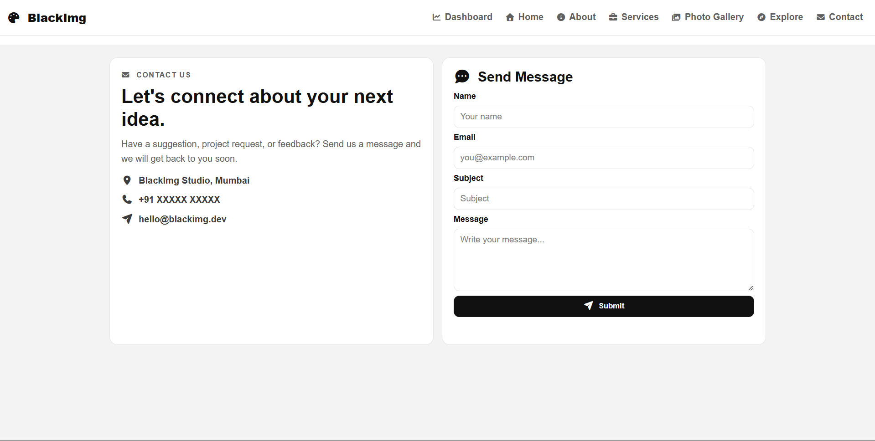
6. Conclusion
Contact Page
Photo Gallery Page
About Page
BlackImg successfully demonstrates a functional multi-page website for the CAL557 minor assignment. The project applies HTML structuring, CSS styling, and JavaScript interactivity in a practical and organized way. It reflects a clear understanding of modular web development and user-focused UI design.

7. Future Scope
- Add backend integration for user and gallery data storage.
- Implement authentication and role-based access.
- Add advanced gallery search/sort features.
- Improve accessibility compliance and keyboard navigation.
- Deploy production version with CI/CD workflow.

