CUSTOMER RETENTION &
CHURN ANALYTICS

End-to-End Telecom Churn Analysis Project
A comprehensive analytics solution covering data exploration, cleaning, SQL modelling,
PostgreSQL database integration, and Tableau dashboard development.
Dataset: IBM Telco Customer Churn (Kaggle) • 7,032 Customers • 23 Features
Tools: Python • PostgreSQL • SQLAlchemy • Tableau

- Ankit Verma

Table of Contents
1. Executive Summary 4
1.1 Key Performance Indicators 4
1.2 Critical Findings 4
2. Project Overview 5
2.1 Business Problem 5
2.2 Project Objectives 5
2.3 Tools and Technologies 5
3. Dataset Description 6
3.1 Source 6
3.2 Dataset Schema 6
3.3 Dataset Statistics 7
4. Methodology & Project Workflow 8
Phase 1 — Data Understanding 8
Phase 2 — Data Cleaning 8
Phase 3 — Exploratory Data Analysis (EDA) 8
Univariate Analysis 8
Bivariate Analysis 9
Multivariate Analysis 9
Phase 4 — Feature Engineering 9
Phase 5 — Statistical Hypothesis Testing 9
Phase 6 — Database Integration 10
5. SQL Database Views 11
5.1 Views Summary 11
5.2 View Definitions 11
View 1: churn_summary 11
View 2: churn_by_contract 11
View 3: churn_by_internet 12
View 4: churn_by_payment 12
View 5: revenue_by_contract 12
View 6: customer_segments 12
6. Tableau Dashboard 13
6.1 Dashboard 1 — Executive Summary 13
6.2 Dashboard 2 — Churn Drivers Analysis 14
Churn by Payment Method 14
Churn by Contract Type 14
Churn by Internet Service 15
Churn by Tenure Group 15
6.3 Dashboard 3 — Scatter Plot Explorer 15
7. Key Findings & Business Recommendations 16
7.1 Finding 1 — Contract Type is the Strongest Retention Lever 16
Recommendations 16
7.2 Finding 2 — New Customers Are the Highest-Risk Cohort 16
Recommendations 17
7.3 Finding 3 — Electronic Check Users Are Disproportionately at Risk 17
Recommendations 17
7.4 Finding 4 — Fiber Optic Subscribers Exhibit Unexpectedly High Churn 17
Recommendations 17
7.5 Finding 5 — Loyal Customers Generate Disproportionate Revenue 17
Recommendations 17
8. Project Architecture 18
9. Limitations & Future Scope 19
9.1 Limitations 19
9.2 Future Scope 19
10. Conclusion 20
Appendix 21
A. Python Libraries Used 21
B. PostgreSQL Configuration 21
C. Tableau Dashboard Pages 21
D. Dataset Source 21

1. Executive Summary

This project presents a comprehensive end-to-end churn analytics solution developed for a subscription-based telecom company. The study analyses customer behaviour, identifies high-risk segments, quantifies revenue loss, and delivers actionable retention recommendations backed by statistical evidence.

The analysis is built on a dataset of 7,032 telecom customers sourced from IBM's Telco Customer Churn dataset (Kaggle). The dataset was cleaned and enriched using Python, loaded into a PostgreSQL relational database via SQLAlchemy, and subsequently queried through five analytical SQL views. The resulting insights were visualised in a Tableau dashboard spanning executive KPIs, churn drivers, customer segmentation, and a scatter-plot explorer.

1.1 Key Performance Indicators
Total Customers | Churn Rate | Monthly Revenue | Revenue Lost (Monthly)
7,032 | 26.58% | $455,661 | $139,131

1.2 Critical Findings
- Overall churn rate stands at 26.58%, representing approximately one in four customers lost every month.
- Month-to-month contract holders churn at 42.71% — nearly 15 times the rate of two-year contract customers (2.85%).
- New customers (tenure 0–12 months) exhibit the highest churn rate at 47.68%, signalling a critical early-lifecycle vulnerability.
- Electronic check users churn at 45.29%, the highest of any payment method — nearly triple the rate of automatic payment users.
- Fiber optic internet subscribers experience 41.89% churn, despite being a premium tier, indicating a service-quality or pricing concern.
- A small cohort of long-tenure, high-value customers (Loyal group) accounts for a disproportionate share of total revenue.

2. Project Overview

2.1 Business Problem
A subscription-based telecom company has been observing increasing customer churn and seeks to understand the root causes in order to intervene proactively. Customer acquisition is significantly more expensive than retention; therefore, even marginal improvements in retention can translate into material revenue gains. Management specifically requires answers to the following questions:
- Which customers are most likely to churn?
- Which subscription plans and contract types experience the highest churn?
- How much recurring revenue is lost to churn?
- Which customer segments should be targeted for retention campaigns?

2.2 Project Objectives
The project builds an end-to-end analytics solution with the following goals:
- Identify churn patterns across demographics, service types, and contract terms.
- Segment customers by behaviour, tenure, and risk profile.
- Measure retention performance across cohorts and tenure groups.
- Quantify business impact in terms of monthly revenue and projected lifetime value.
- Provide strategic recommendations for retention campaign targeting.

2.3 Tools and Technologies
The project employs the following stack:
- Python (Pandas, NumPy, Matplotlib, Seaborn, SciPy): data loading, exploration, cleaning, feature engineering, and statistical hypothesis testing.
- PostgreSQL: relational database for structured storage and SQL-based analytical querying.
- SQLAlchemy: ORM and database connectivity layer used to push the cleaned dataset from Python into PostgreSQL.
- Tableau: interactive dashboard development for visualisation and stakeholder communication.
- GitHub: version control and project documentation repository.

3. Dataset Description

3.1 Source
The dataset is the IBM Telco Customer Churn dataset, publicly available on Kaggle (blastchar/telco-customer-churn). It is a widely used benchmark dataset for churn prediction and customer analytics, containing 7,043 records across 21 original fields. After data cleaning, 11 records with missing TotalCharges values were removed, yielding a final analytical dataset of 7,032 rows. Two additional features were engineered during the EDA phase, resulting in 23 total columns.

3.2 Dataset Schema
The table below describes each column in the cleaned analytical dataset, including the two engineered features added during preprocessing.

Column Name | Data Type | Description
customerID | String | Unique customer identifier
gender | String | Customer gender (Male/Female)
SeniorCitizen | Integer | Binary flag — 1 if senior citizen, 0 otherwise
Partner | String | Whether the customer has a partner (Yes/No)
Dependents | String | Whether the customer has dependents (Yes/No)
tenure | Integer | Number of months the customer has been with the company
PhoneService | String | Whether the customer has phone service (Yes/No)
MultipleLines | String | Whether the customer has multiple phone lines
InternetService | String | Type of internet service (DSL / Fiber optic / No)
OnlineSecurity | String | Whether online security add-on is subscribed
OnlineBackup | String | Whether online backup add-on is subscribed
DeviceProtection | String | Whether device protection add-on is subscribed
TechSupport | String | Whether tech support add-on is subscribed
StreamingTV | String | Whether TV streaming service is subscribed
StreamingMovies | String | Whether movie streaming service is subscribed
Contract | String | Contract term (Month-to-month / One year / Two year)
PaperlessBilling | String | Whether billing is paperless (Yes/No)
PaymentMethod | String | Payment method used by the customer
MonthlyCharges | Float | Monthly amount charged to the customer
TotalCharges | Float | Total charges accumulated over tenure
Churn | String | Target variable — whether the customer churned (Yes/No)
TenureGroup | String | Engineered feature — New / Growing / Established / Loyal
TotalSubsCharge | Float | Engineered feature — MonthlyCharges × tenure

3.3 Dataset Statistics
- Total records: 7,032 customers
- Churned: 1,869 customers (26.58%)
- Retained: 5,163 customers (73.42%)
- Average monthly charge: $64.80 (range: $18.25 to $118.75)
- Contract distribution: Month-to-month 55.1% | Two year 24.0% | One year 20.9%
- Internet service mix: Fiber optic 44.0% | DSL 34.4% | No service 21.6%

4. Methodology & Project Workflow

The project follows a structured six-phase analytics workflow, moving from raw data ingestion through to interactive dashboard delivery. Each phase is described in detail below.

Phase 1 — Data Understanding
The initial phase involved loading the raw CSV dataset into a Pandas DataFrame and conducting a structural review. Key activities included:
- Examining dataset shape, column names, and data types using df.info() and df.head().
- Reviewing the distribution of the target variable (Churn) to assess class balance — approximately a 73:27 split.
- Studying domain context: understanding what fields like InternetService, Contract, and PaymentMethod represent in a telecom subscription context.
- Confirming the operational definition of a churned customer — any customer with Churn == 'Yes'.

Phase 2 — Data Cleaning
Several data quality issues were identified and resolved:
- Missing values: TotalCharges was stored as a string object type. Blank string entries (' ') existed for 11 customers with zero tenure (newly joined, no charges accrued). These were converted to numeric via pd.to_numeric(errors='coerce') and the 11 resulting NaN rows were dropped.
- Duplicate check: no duplicate customerID records were found.
- Type validation: all remaining numerical columns were confirmed to hold valid, non-negative values.
- Categorical standardisation: all categorical fields used consistent string labels with no mixed-case inconsistencies.
The cleaned dataset (7,032 rows) was exported to a CSV file (Updated_Churn_Analysis_Dataset.csv) and also pushed to PostgreSQL.

Phase 3 — Exploratory Data Analysis (EDA)
EDA was conducted across three levels of increasing complexity:

Univariate Analysis
- Histogram of tenure revealed a bimodal distribution: a spike of new customers and a spike of long-tenure loyal customers.
- Count plot of Contract showed month-to-month as the dominant contract type.
- Churn distribution confirmed the approximate 73:27 split.

Bivariate Analysis
- Box plot of MonthlyCharges vs Churn showed churned customers pay higher monthly charges.
- Cross-tabulation of Contract vs Churn confirmed month-to-month contracts have dramatically higher churn rates.
- Count plot of TechSupport vs Churn indicated customers without tech support churn more frequently.
- Box plot of tenure vs Churn confirmed churned customers have shorter tenure on average.

Multivariate Analysis
- Correlation heatmap (numeric columns) revealed that tenure and TotalCharges are strongly positively correlated — long-tenure customers accumulate higher total spend.
- MonthlyCharges showed a moderate positive correlation with TotalCharges.

Phase 4 — Feature Engineering
Two engineered features were added to the dataset to improve analytical utility:
- TenureGroup: a binned categorical variable segmenting customers by tenure length into four groups — New (0–12 months), Growing (13–24 months), Established (25–48 months), and Loyal (49–72 months). This was created using pd.cut() with bins [0, 12, 24, 48, 72].
- TotalSubsCharge: a continuous feature computed as MonthlyCharges × tenure, representing the total subscription revenue a customer has generated. This served as a proxy for customer lifetime value within the observed window.

Phase 5 — Statistical Hypothesis Testing
Formal statistical tests were applied to validate the significance of key relationships observed during EDA. Results are summarised below.

Variable | Test Used | p-value | Business Insight
Contract | Chi-Square | < 0.001 | Contract type significantly affects churn probability
PaymentMethod | Chi-Square | < 0.001 | Payment method is a significant predictor of churn
Tenure | Independent T-Test | < 0.001 | Churned customers have significantly shorter tenure
MonthlyCharges | Independent T-Test | < 0.001 | Churned customers incur higher monthly charges

All four tests rejected the null hypothesis at p < 0.001, confirming that contract type, payment method, tenure length, and monthly charge level are all statistically significant drivers of churn. These findings provide empirical justification for the business recommendations in Section 7.

Phase 6 — Database Integration
The cleaned and feature-engineered DataFrame was pushed to a locally hosted PostgreSQL database (telco_db) using SQLAlchemy's create_engine() and Pandas' to_sql() method. The table telco_churn was created with 7,032 rows and 23 columns, replacing any prior version on each run. A verification query confirmed the upload. Five analytical SQL views were subsequently created to power the Tableau dashboard.

5. SQL Database Views

Five analytical views were created in the telco_db PostgreSQL database. These views abstract the raw telco_churn table behind pre-computed, optimised aggregates, enabling the Tableau dashboard to connect directly to cleaned, analysis-ready result sets without performing row-level computation at query time.

5.1 Views Summary
View Name | Purpose
churn_summary | Computes overall KPIs: total customers, churn rate, monthly revenue, and revenue lost due to churn.
churn_by_contract | Aggregates churn rate grouped by contract type (Month-to-month, One year, Two year).
churn_by_internet | Aggregates churn rate grouped by internet service type (Fiber optic, DSL, No service).
churn_by_payment | Aggregates churn rate grouped by payment method, ordered by highest churn first.
revenue_by_contract | Computes total revenue aggregated by contract type, ordered by revenue descending.
customer_segments | Segments customers by TenureGroup with avg monthly charge, customer count, and total revenue.

5.2 View Definitions

View 1: churn_summary
Provides a single-row executive summary of overall business performance.
CREATE OR REPLACE VIEW churn_summary AS
SELECT
COUNT(*) AS total_customers,
ROUND(100 * SUM(CASE WHEN "Churn" = 'Yes' THEN 1 ELSE 0 END)::NUMERIC / COUNT(*), 2) AS churn_rate,
ROUND(SUM("MonthlyCharges")::NUMERIC, 2) AS monthly_revenue,
ROUND(SUM(CASE WHEN "Churn" = 'Yes' THEN "MonthlyCharges" ELSE 0 END)::NUMERIC, 2) AS revenue_lost
FROM telco_churn;

View 2: churn_by_contract
Aggregates churn rate grouped by contract type to identify which contract terms retain customers most effectively.
CREATE OR REPLACE VIEW churn_by_contract AS
SELECT "Contract", COUNT(*) AS customers,
ROUND(100.0 * SUM(CASE WHEN "Churn" = 'Yes' THEN 1 ELSE 0 END) / COUNT(*), 2) AS churn_rate
FROM telco_churn GROUP BY "Contract";

View 3: churn_by_internet
Aggregates churn rate by internet service type to surface any service-tier-related churn patterns.
CREATE OR REPLACE VIEW churn_by_internet AS
SELECT "InternetService", COUNT(*) AS customers,
ROUND(100.0 * SUM(CASE WHEN "Churn" = 'Yes' THEN 1 ELSE 0 END) / COUNT(*), 2) AS churn_rate
FROM telco_churn GROUP BY "InternetService";

View 4: churn_by_payment
Ranks payment methods by churn rate to identify whether friction in the payment experience drives attrition.
CREATE OR REPLACE VIEW churn_by_payment AS
SELECT "PaymentMethod", COUNT(*) AS customers,
ROUND(100.0 * SUM(CASE WHEN "Churn" = 'Yes' THEN 1 ELSE 0 END) / COUNT(*), 2) AS churn_rate
FROM telco_churn GROUP BY "PaymentMethod" ORDER BY churn_rate DESC;

View 5: revenue_by_contract
Computes total accumulated revenue aggregated by contract type, enabling comparison of the revenue contribution of each contract tier.
CREATE OR REPLACE VIEW revenue_by_contract AS
SELECT "Contract",
ROUND(SUM("TotalCharges")::NUMERIC, 2) AS revenue
FROM telco_churn GROUP BY "Contract" ORDER BY revenue DESC;

View 6: customer_segments
Segments customers by TenureGroup and returns average monthly charge, customer count, and total accumulated revenue per segment, supporting cohort-level revenue analysis.
CREATE OR REPLACE VIEW customer_segments AS
SELECT "TenureGroup", COUNT(*) AS customers,
ROUND(AVG("MonthlyCharges")::NUMERIC, 2) AS avg_monthly_charge,
ROUND(SUM("TotalCharges")::NUMERIC, 2) AS revenue
FROM telco_churn GROUP BY "TenureGroup";

6. Tableau Dashboard

The Tableau workbook connected to the PostgreSQL views and the cleaned CSV dataset to build an interactive multi-page dashboard. The dashboard is designed for non-technical business stakeholders and covers four analytical perspectives.

6.1 Dashboard 1 — Executive Summary
The dashboard presents four headline KPIs in a summary card layout at the top: Total Customers (7,032), Churn Rate (26.58%), Monthly Revenue ($455.7K), and Revenue Lost ($139.1K). A pie chart on the right illustrates the churn split — 73.42% retained versus 26.58% churned — accompanied by a callout noting that improving retention by even a small percentage could substantially increase profitability. The central visualisation is a grouped bar chart — Revenue by Contract and Tenure Group — which plots Total Charges on the Y-axis, broken down by Tenure Group (New, Growing, Established, Loyal) on the X-axis, with bars grouped by contract type (Month-to-month, One year, Two year). This chart clearly shows that Two-year contract customers in the Loyal group generate the highest total revenue.

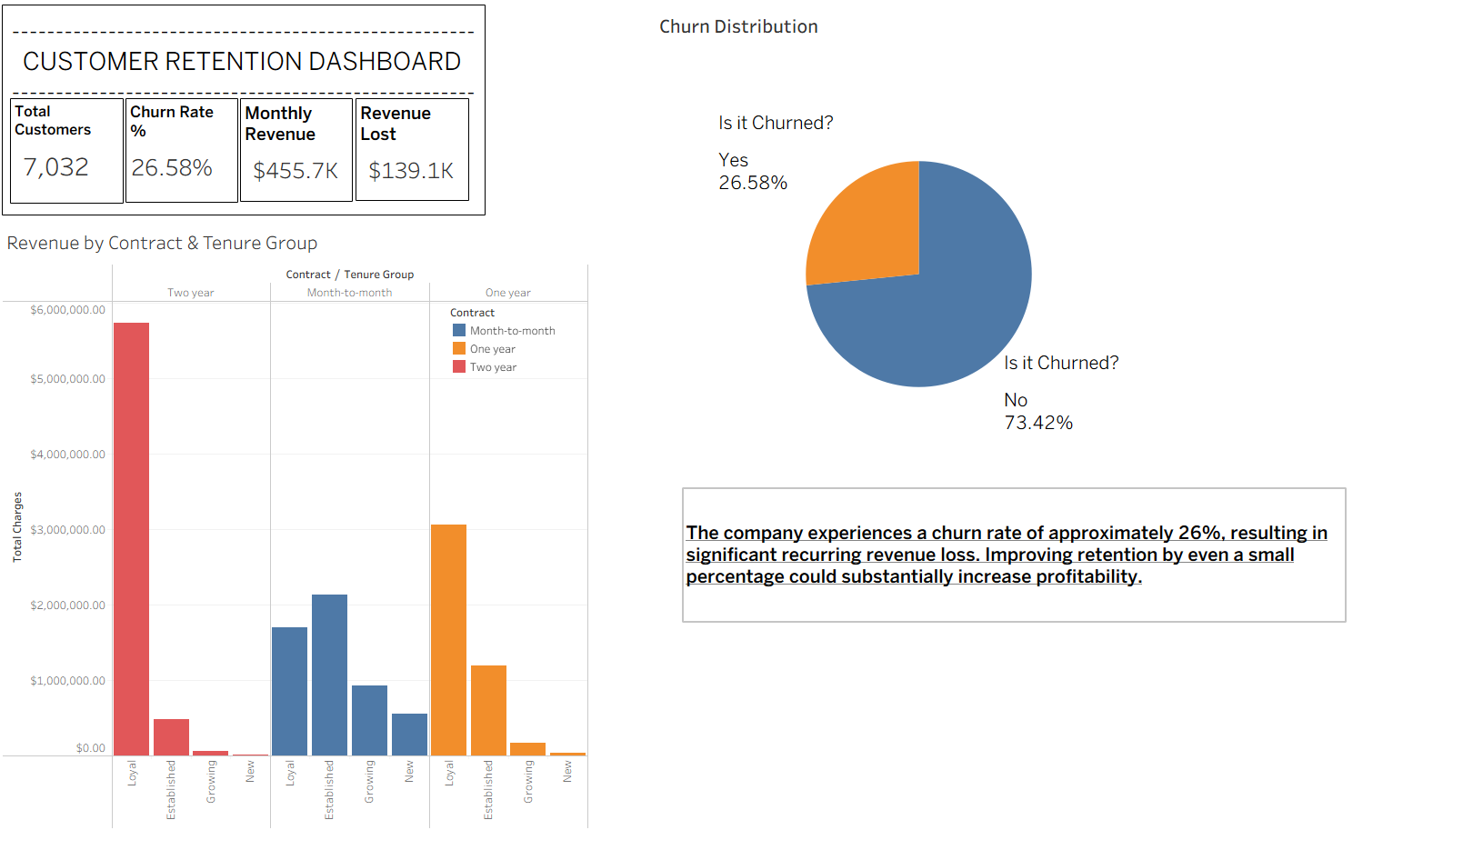

6.2 Dashboard 2 — Churn Drivers Analysis
This page contains four horizontal bar charts presenting churn rates across key dimensions:
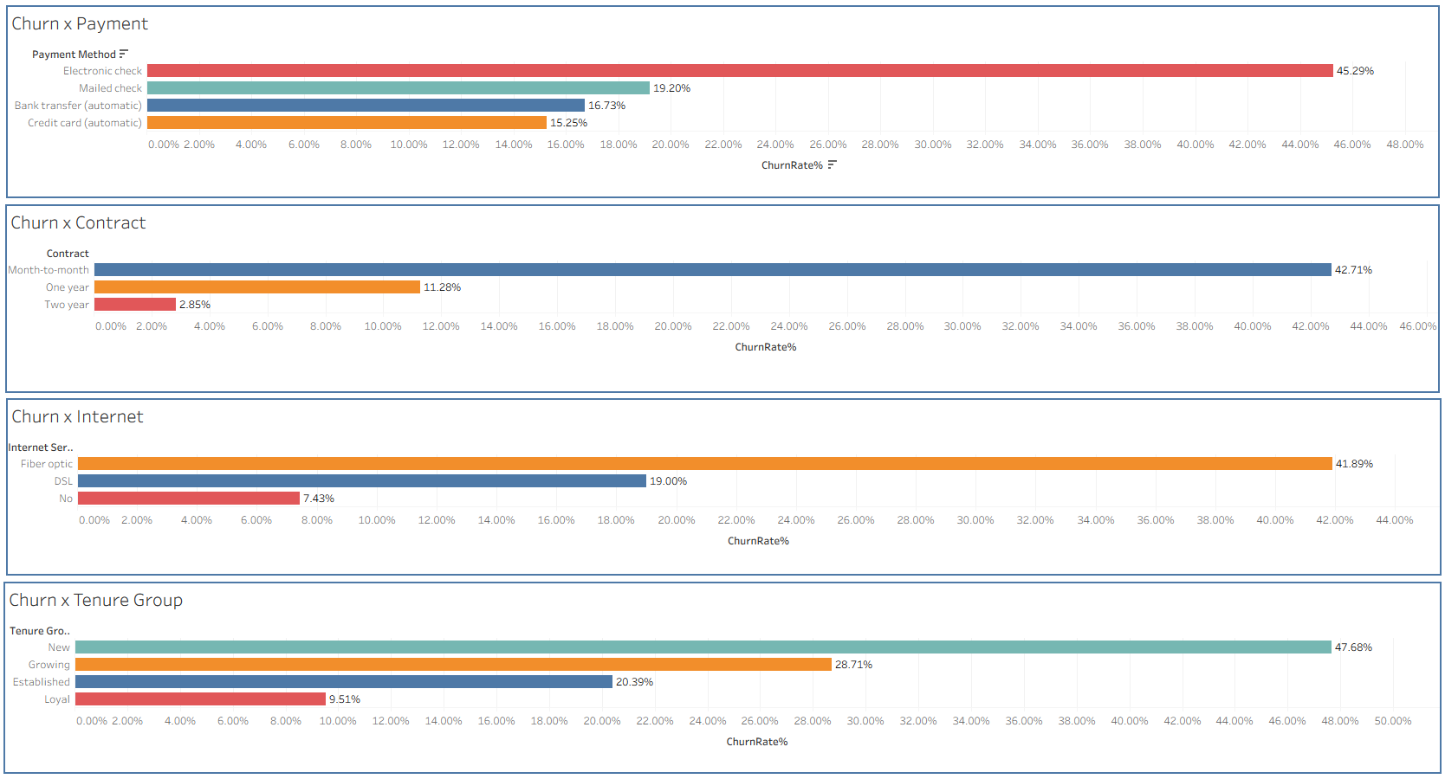

Churn by Payment Method
Payment Method | Churn Rate
Electronic check | 45.29%
Mailed check | 19.20%
Bank transfer (automatic) | 16.73%
Credit card (automatic) | 15.25%

Electronic check users show churn nearly three times higher than automatic payment users, suggesting that manual payment friction or a less engaged customer profile correlates strongly with attrition.

Churn by Contract Type
Contract Type | Customers | Churn Rate
Month-to-month | 3,875 | 42.71%
One year | 1,472 | 11.28%
Two year | 1,685 | 2.85%

The gradient from month-to-month (42.71%) to two-year (2.85%) is the single strongest churn signal in the dataset. Customers on longer contracts demonstrate substantially higher loyalty.

Churn by Internet Service
Internet Service | Churn Rate
Fiber optic | 41.89%
DSL | 19.00%
No internet service | 7.43%

Fiber optic subscribers churn at a rate more than five times higher than customers with no internet service, despite fibre being the premium product tier. This warrants investigation into pricing competitiveness and service quality perception for fibre customers.

Churn by Tenure Group
Tenure Group | Tenure Range | Customers | Churn Rate
New | 0–12 months | 2,175 | 47.68%
Growing | 13–24 months | 1,024 | 28.71%
Established | 25–48 months | 1,594 | 20.39%
Loyal | 49–72 months | 2,239 | 9.51%

Nearly half of all new customers (0–12 months) churn, compared to fewer than 1 in 10 loyal customers (49–72 months). This confirms that early-lifecycle intervention is the highest-leverage retention opportunity.

6.3 Dashboard 3 — Scatter Plot Explorer
The third dashboard features an interactive scatter plot with Monthly Charges on the X-axis and Tenure on the Y-axis, with points coloured by churn status (blue: retained, orange: churned). The plot supports multi-dimensional filtering via four control panels — Payment Method, Tenure Group, Internet Service, and Contract — allowing users to isolate specific customer cohorts. Key patterns visible in the scatter plot include:
- Churned customers (orange dots) are densely concentrated in the low-tenure, high-monthly-charge quadrant, confirming that new customers on expensive plans are at the highest risk.
- Long-tenure customers (tenure > 48 months) are predominantly blue regardless of monthly charge level, indicating that survival past the first two years is a strong loyalty signal.
- Month-to-month contract customers exhibit a diffuse scatter across all charge levels at low tenure, while two-year customers cluster at high tenure.
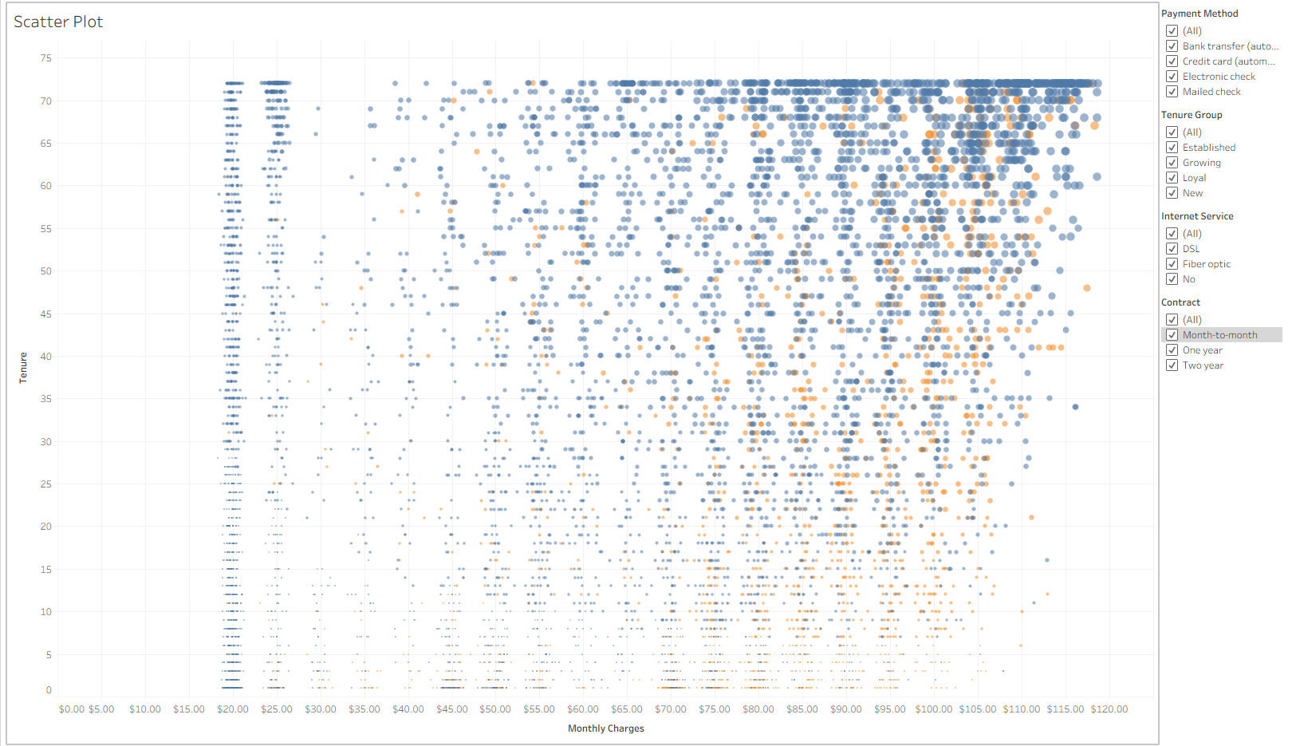

7. Key Findings & Business Recommendations

7.1 Finding 1 — Contract Type is the Strongest Retention Lever
Month-to-month customers churn at 42.71% versus 2.85% for two-year customers — a 15-fold difference. This is the single most actionable finding in the dataset.

Recommendations
- Design an early contract upgrade incentive programme. Offer month-to-month customers a discounted first three months if they commit to a one-year or two-year contract during months 1–3.
- For high-value month-to-month customers (MonthlyCharges > $70), deploy proactive outreach from an account manager within the first 60 days.
- Reframe contract upgrade messaging around service continuity and price lock, rather than obligation.

7.2 Finding 2 — New Customers Are the Highest-Risk Cohort
Customers in the New tenure group (0–12 months) churn at 47.68%, suggesting a critical onboarding and early-experience problem. The first year is the most vulnerable period.

Recommendations
- Implement a structured 90-day onboarding journey including automated check-in touchpoints at Day 7, Day 30, and Day 90.
- Introduce a customer health score for new accounts combining product usage signals and support ticket frequency to trigger early retention interventions.
- Offer a service satisfaction guarantee for the first 90 days to reduce the perceived risk of staying.

7.3 Finding 3 — Electronic Check Users Are Disproportionately at Risk
Customers paying by electronic check churn at 45.29% — nearly three times the rate of automatic payment users. This may reflect a less engaged, more transactional relationship with the service.

Recommendations
- Incentivise migration to automatic payment methods (bank transfer or credit card) through a modest monthly discount or bill credit.
- Use electronic check status as a flag in the churn risk model to prioritise outreach.
- Simplify the process for switching payment methods within the customer portal.

7.4 Finding 4 — Fiber Optic Subscribers Exhibit Unexpectedly High Churn
Despite being the premium internet tier, fiber optic subscribers churn at 41.89%, compared to 19.00% for DSL and only 7.43% for customers with no internet. This is counterintuitive and suggests a pricing, service quality, or competitive substitution issue.

Recommendations
- Conduct a targeted NPS survey among fiber optic customers to identify specific dissatisfaction drivers.
- Review pricing benchmarks against local fibre competitors. Consider whether price is competitive relative to perceived quality.
- Bundle fiber optic with complementary services (streaming, cloud storage, device protection) to increase switching costs and perceived value.

7.5 Finding 5 — Loyal Customers Generate Disproportionate Revenue
The Loyal tenure group (49–72 months) has the lowest churn rate at 9.51% and generates the highest revenue per segment. This group represents the revenue backbone of the business.

Recommendations
- Introduce a formal loyalty reward programme for customers approaching and exceeding the 4-year mark — special pricing, priority support, or service upgrades.
- Identify the characteristics of customers who reach Loyal status and use them to build a predictive profile for identifying high-potential new customers early.

8. Project Architecture

The overall data pipeline flows as follows:

- Raw Data Source: IBM Telco Customer Churn CSV dataset (Kaggle).
- Python EDA Layer (Jupyter Notebook): data loading, missing value handling, type conversion, feature engineering (TenureGroup, TotalSubsCharge), statistical testing, and export of the cleaned CSV.
- SQLAlchemy Bridge: the cleaned DataFrame is pushed to PostgreSQL using engine.to_sql(), replacing the prior table on each run.
- PostgreSQL Database (telco_db): hosts the primary table (telco_churn) and five analytical views (churn_summary, churn_by_contract, churn_by_internet, churn_by_payment, revenue_by_contract, customer_segments).
- Tableau: connects to PostgreSQL views and the cleaned CSV for dashboard development. Four dashboard pages cover executive KPIs, churn drivers, customer segmentation, and the scatter-plot explorer.
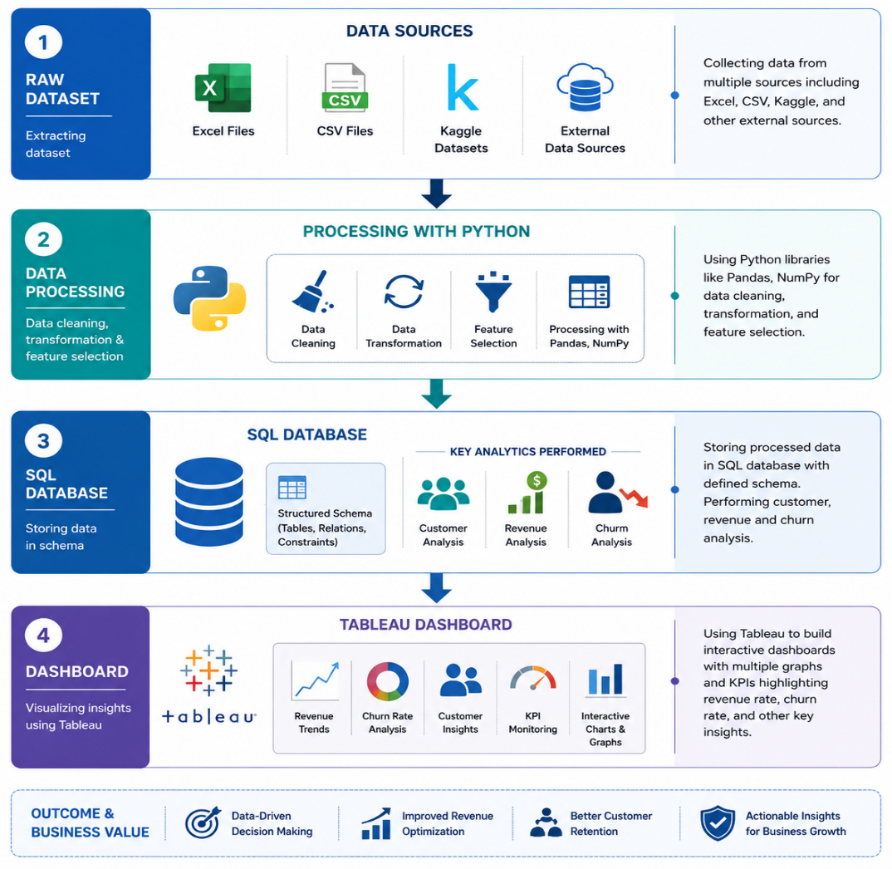
This architecture separates concerns cleanly: data preparation happens in Python, structured querying and aggregation happen in SQL, and presentation happens in Tableau. Each layer is independently reusable and maintainable.

9. Limitations & Future Scope

9.1 Limitations
- Cross-sectional data only: the dataset represents a single point-in-time snapshot. No time-series cohort retention analysis was possible without monthly subscription records.
- No geographic dimension: the dataset lacks regional or market information, preventing spatial analysis of churn patterns.
- No reason-for-churn data: the dataset records whether a customer churned but not why, limiting root-cause analysis.

9.2 Future Scope
- Predictive Modelling: build a binary churn classifier using logistic regression or XGBoost, evaluated on precision, recall, and AUC-ROC.
- CLV Analysis: integrate customer lifetime value (CLV) estimation to prioritise retention spend toward the highest-value at-risk customers.
- Cohort Retention Heatmap: if monthly subscription start-dates become available, build a month-over-month cohort retention matrix.
- Automated Alerting: deploy the SQL views as a live connection in Tableau Server or Power BI to enable real-time churn monitoring dashboards.
- A/B Testing Framework: design-controlled experiments for the retention interventions recommended in Section 7 to measure incremental retention lift.

10. Conclusion

This project set out to understand why customers leave, and more importantly, what a business can actually do about it. Working through the full pipeline — from a raw CSV file to interactive dashboards — the study shows that churn is not something that just happens randomly. There are clear, consistent patterns behind it, and those patterns are measurable.

The most important takeaway is straightforward: customers who are on month-to-month contracts, are still in their first year, pay manually via electronic check, and use fiber optic internet are the ones most likely to leave. These are not guesses based on intuition — they were confirmed through statistical testing, which gave the findings a solid enough foundation to act on with confidence.

What makes the revenue impact particularly concerning is the imbalance it reveals. Churned customers make up about 27% of the customer base, yet they account for nearly 30% of monthly revenue lost — roughly $139,100 every month. That gap exists because customers who leave tend to be on higher monthly charges. In other words, the business is disproportionately losing its higher-paying customers, which makes retention far more urgent than the headline churn rate alone might suggest.

The recommendations that follow from this are practical ones: focus on the first year of a customer's journey, give month-to-month customers a genuine reason to switch to longer contracts, make automatic payments easier and more attractive, and take a closer look at what fiber optic customers are experiencing that is pushing them toward the exit.

Appendix

A. Python Libraries Used
- pandas: data loading, wrangling, and transformation
- numpy: numerical operations
- matplotlib & seaborn: EDA visualisations
- scipy.stats: chi2_contingency and ttest_ind for hypothesis testing
- sqlalchemy: PostgreSQL connection and DataFrame upload via create_engine() and to_sql()
- warnings: suppression of non-critical output during EDA

B. PostgreSQL Configuration
- Database: telco_db
- Host: 127.0.0.1 (localhost)
- Port: 5432 (default PostgreSQL port)
- Primary table: telco_churn (7,032 rows, 23 columns)
- Connection driver: psycopg2 via SQLAlchemy

C. Tableau Dashboard Pages
- Page 1: Executive Summary — KPI cards, churn distribution pie chart, revenue by contract and tenure group bar chart.
- Page 2: Churn Drivers — Horizontal bar charts for churn by payment method, contract type, internet service, and tenure group.
- Page 3: Scatter Plot Explorer — Interactive Monthly Charges vs Tenure scatter plot with multi-dimensional filters.

D. Dataset Source
IBM Telco Customer Churn Dataset — available at: https://www.kaggle.com/datasets/blastchar/telco-customer-churn

