Assignment 3: Data Visualization in Excel/Google Sheets
Screenshots of all six tasks

Screenshot 1: Bar Chart – Monthly Sales
Bar chart showing Sales for each Month (X-axis: Month, Y-axis: Sales).
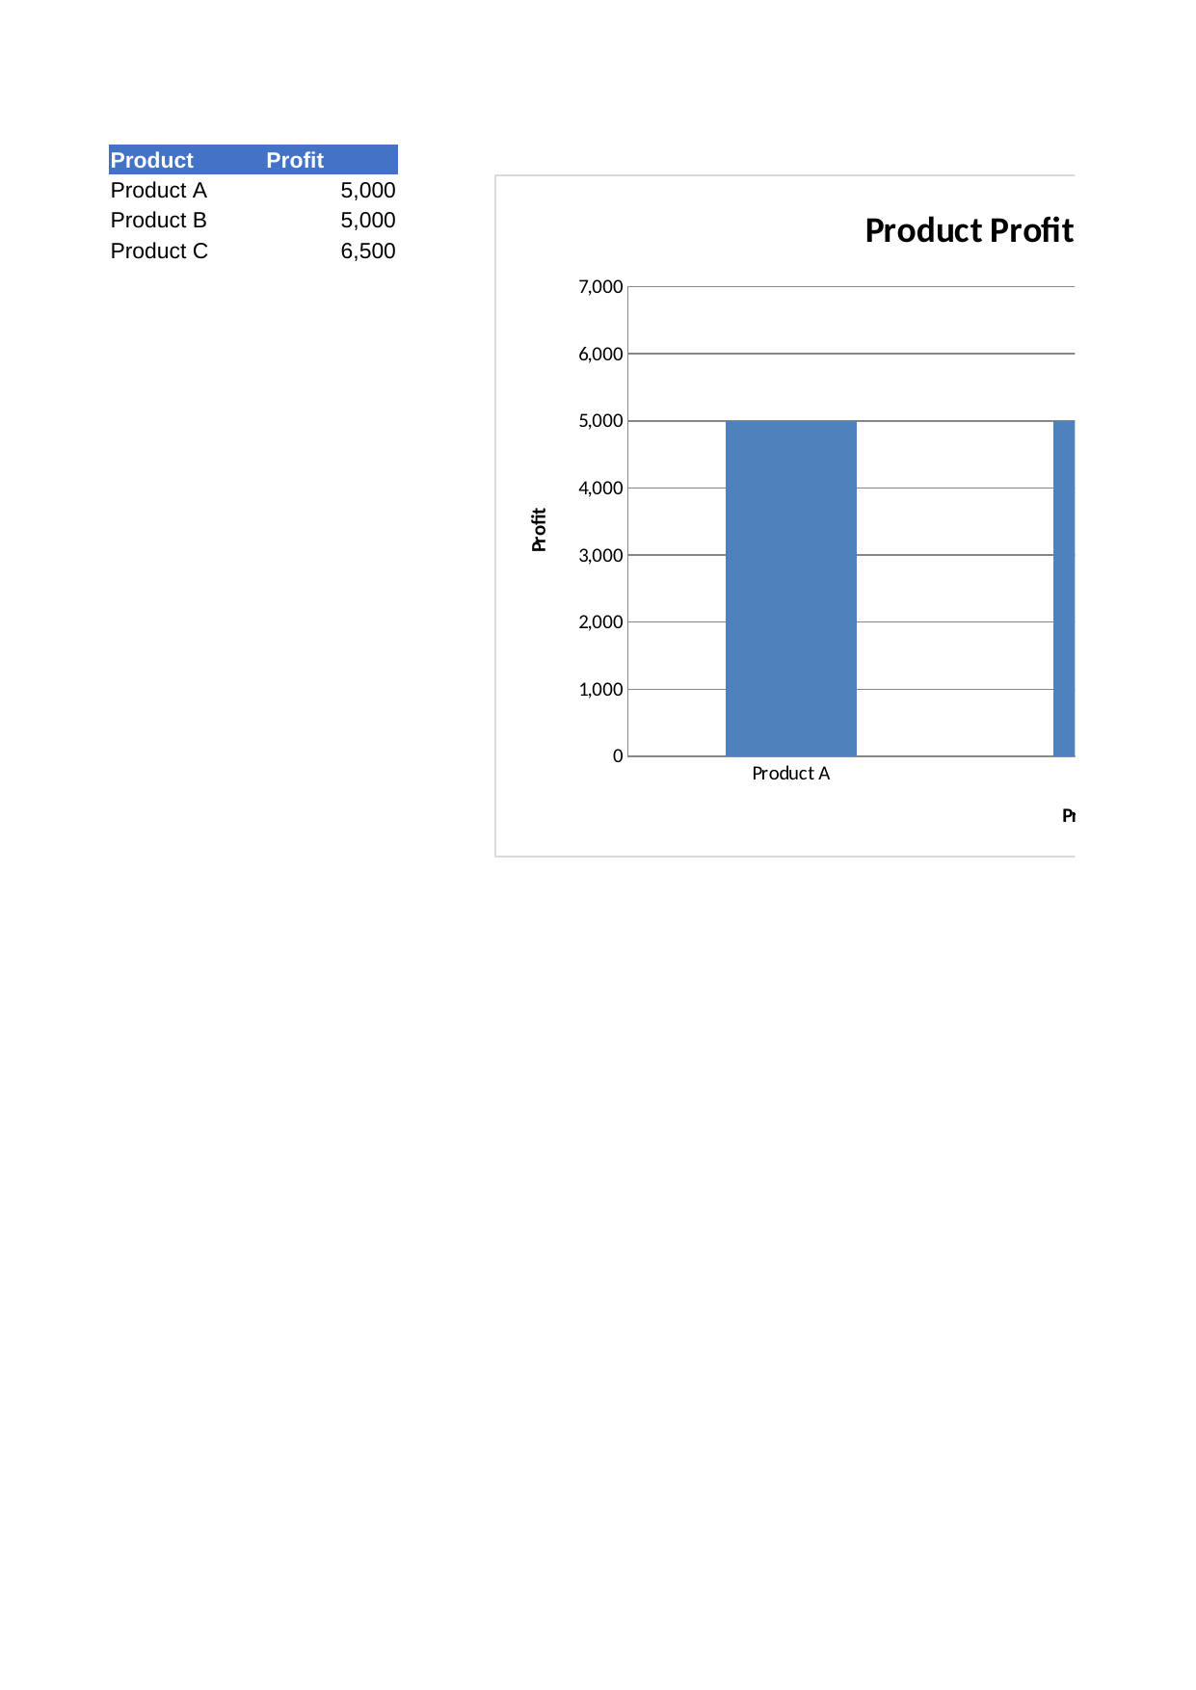

Screenshot 2: Column Chart – Product Profit Comparison
Column chart comparing Profit across Products (X-axis: Product, Y-axis: Profit).
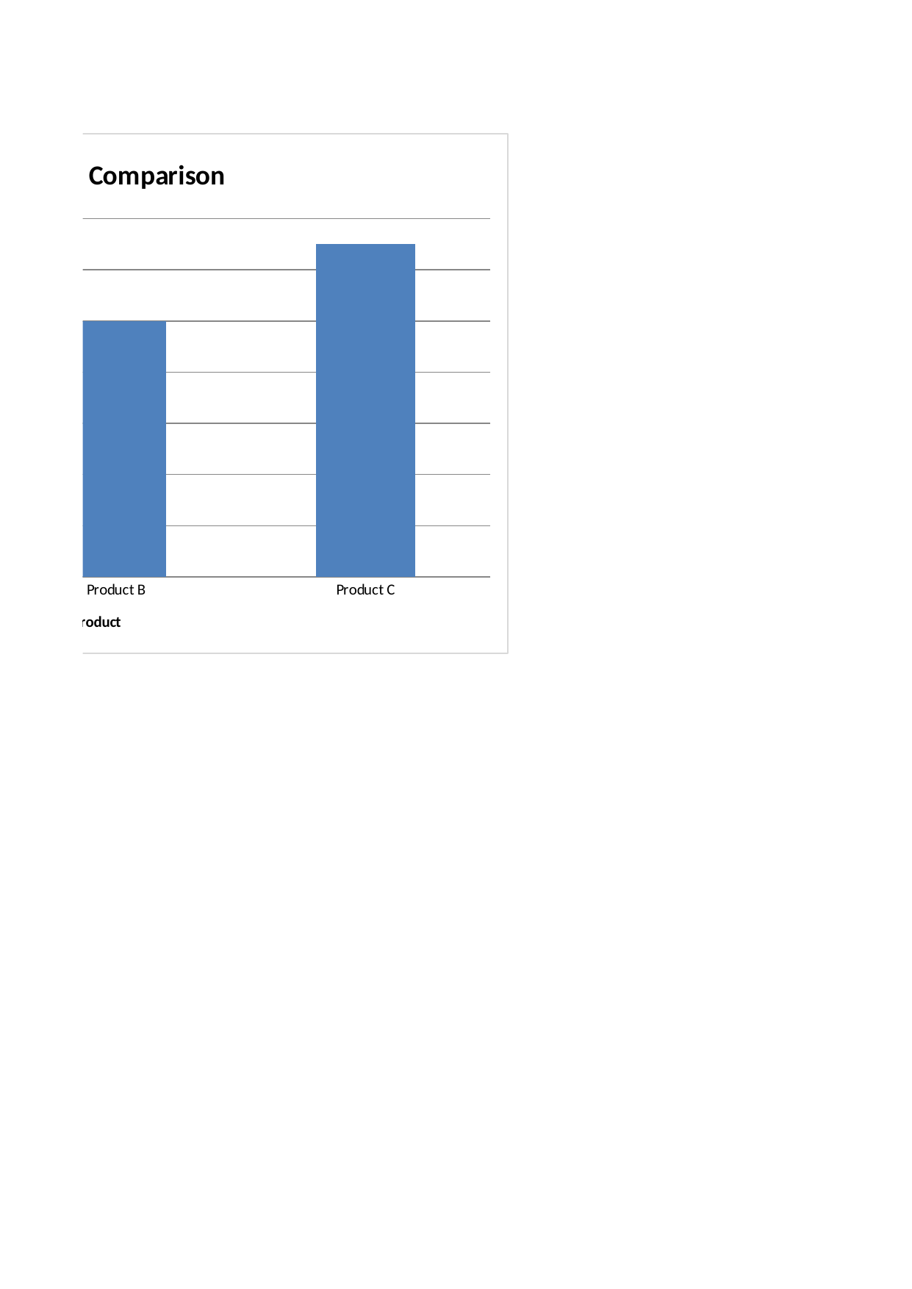

Screenshot 3: Pie Chart – Sales by Region
Pie chart displaying the percentage of total Sales contributed by each Region, with data labels showing percentage values.
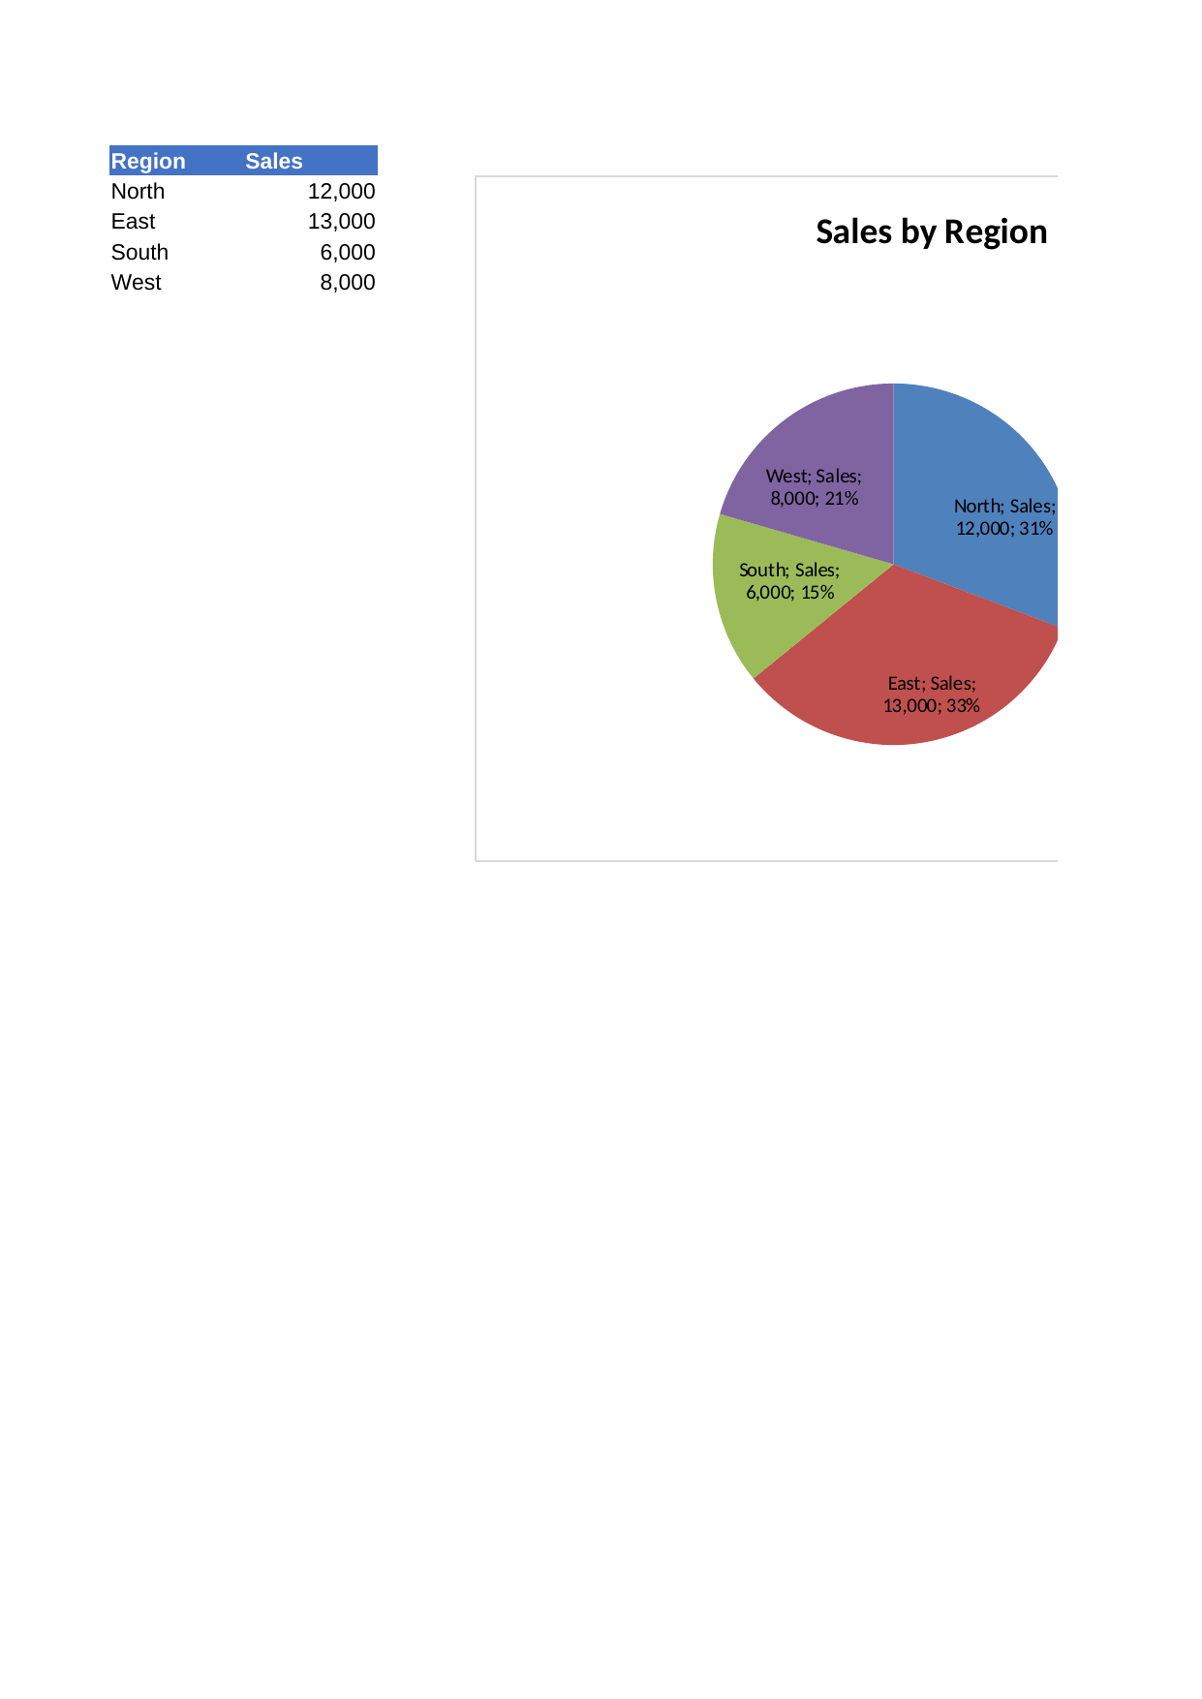

Screenshot 4: Line Chart – Monthly Sales Trend
Line chart illustrating the trend of Sales over the six months.
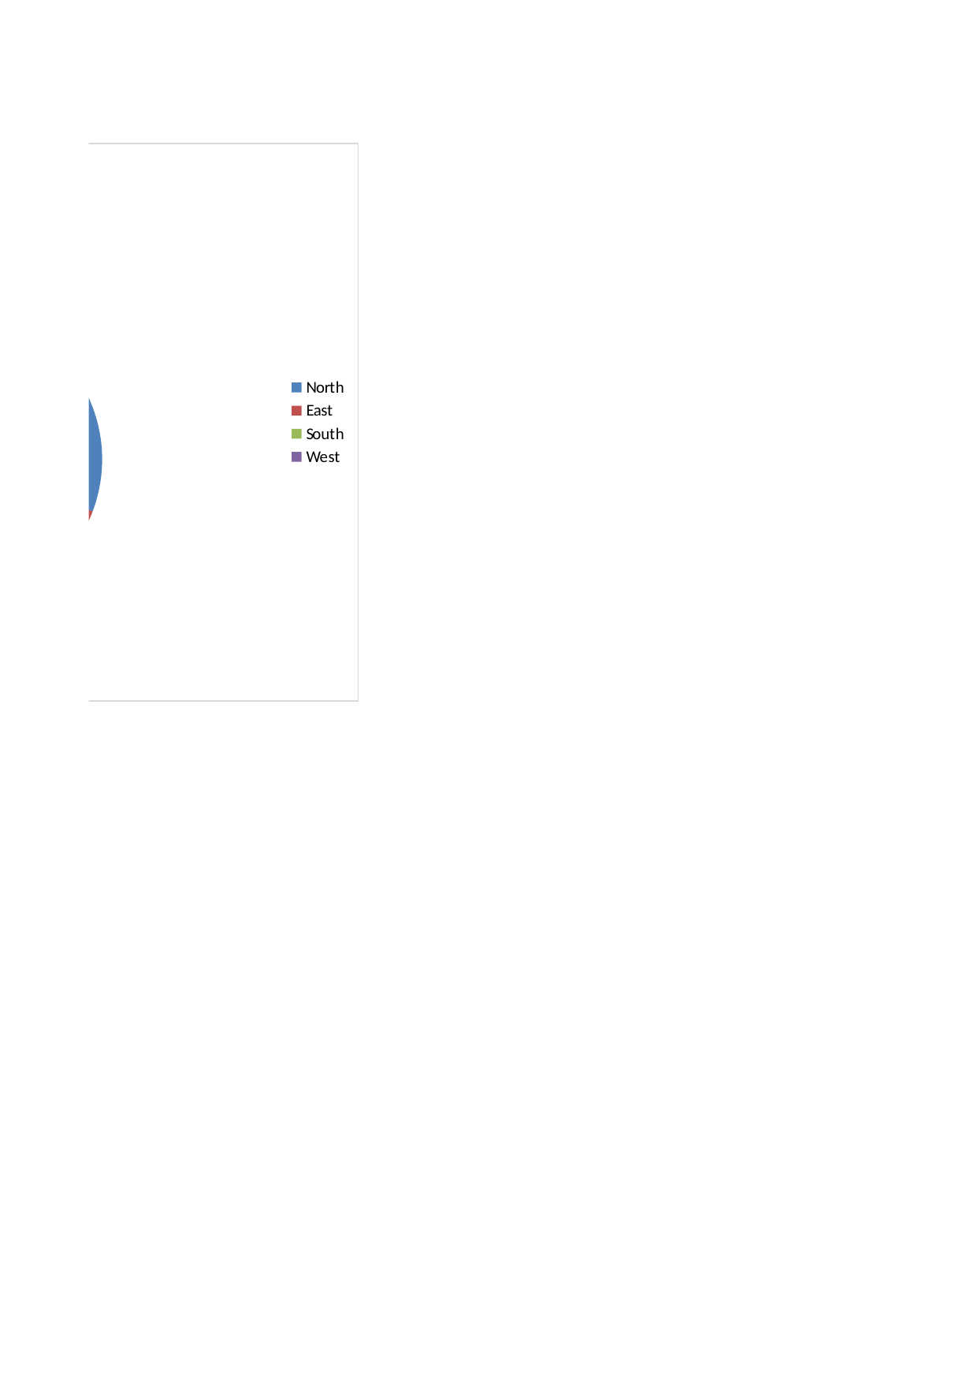

Screenshot 5: Scatter Plot – Sales vs Profit
Scatter plot exploring the relationship between Sales and Profit.
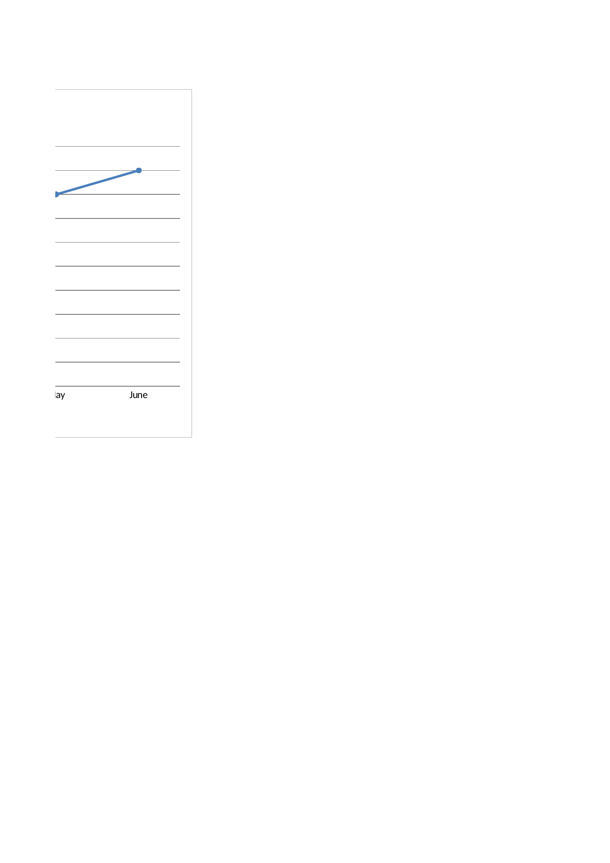

Screenshot 6: Pivot Table – Total Sales by Region
Pivot table summarizing Total Sales per Region (Region in Rows, Sales in Values).
