**Assignment 1**

BY

**Ravisanker E**

**2017AAPS0433H**

**S Ankit**

**2017A7PS0297H**

Table of Contents

**1.** **Fisher’s Linear Discriminant Analysis** 3

**1.1** **Results – Dataset 1 (a1_d1)** 3

**1.2** **Results – Dataset 2 (a2_d2)** 4

# **Fisher’s Linear Discriminant Analysis**

## **Results – Dataset 1 (a1_d1)**

Let,

tp = True Positives (Positive points classified as positive)

fp = False Positives (Negative points classified as positive)

tn = True Negatives (Negative points classified as negative)

fn = False Negatives (Positive points classified as negative)

Precision = tp/(tp+fp)

Accuracy = (tp+tn)/(tp+tn+fp+fn)

Recall = tp/(tp+fn)

F-score = 2*Precision*Recall/(Precision+Recall)

|  |  |  |  |  |  |  |  |
| --- | --- | --- | --- | --- | --- | --- | --- |
| TP | FP | TN | FN | Accuracy | Precision | Recall | F-Score |
| 496 | 3 | 497 | 4 | 0.993 | 0.993988 | 0.992 | 0.992993 |

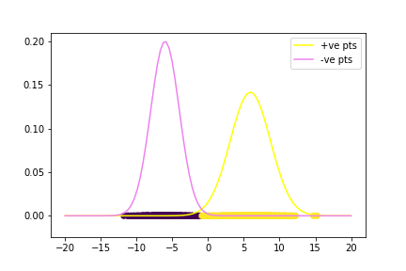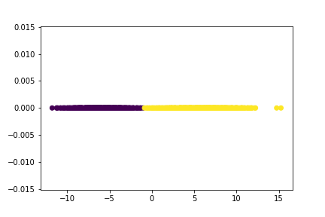

From these plot we observed that the classification threshold is -0.915.

## **Results – Dataset 2 (a2_d2)**

Let,

tp = True Positives (Positive points classified as positive)

fp = False Positives (Negative points classified as positive)

tn = True Negatives (Negative points classified as negative)

fn = False Negatives (Positive points classified as negative)

Precision = tp/(tp+fp)

Accuracy = (tp+tn)/(tp+tn+fp+fn)

Recall = tp/(tp+fn)

F-score = 2*Precision*Recall/(Precision+Recall)

|  |  |  |  |  |  |  |  |
| --- | --- | --- | --- | --- | --- | --- | --- |
| TP | FP | TN | FN | Accuracy | Precision | Recall | F-Score |
| 500 | 0 | 500 | 0 | 1 | 1 | 1 | 1 |

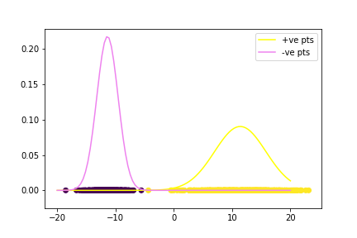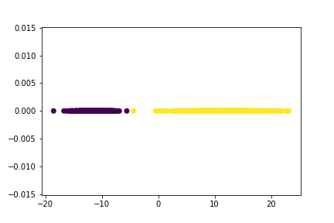

From these plot we observed that the classification threshold is -4.4.