***ARTIFICIAL INTELLIGENCE PROJECT***

***Question Answering System for Automated Customer Relationship Management***

SUBMITTED BY:

NAME: ANKIT SHUKLA

REGISTRATION NO.:11801840

SECTION: K18KK / GROUP-2

ROLL NO: 63

In partial fulfilment for the requirements of award of the degree “B.Tech CSE(Hons.)”

SCHOOL OF COMPUTER SCIENCE AND ENGINEERING

**LOVELY PROFESSIONAL UNIVERSITY**

**PHAGWARA, PUNJAB**

***INTRODUCTION***

“Our intelligence is what makes us human, and AI is an extension of that quality.”

**AIM**

The major aim of the project is to create an intelligent system which resembles with a customer service operator i.e. a program which can have a conversation with the customer of the company similar to what a human can do.

**MOTIVATION**

The major cost of a company is maintaining their customer relationship for which they have to hire several operators and those operators have to be ready 24 X 7 answering the customer’s queries.

If a machine can do the same thing then this will result in major cost curtailment for the companies as well as the answers will be more systematic for the customers.

**OBJECTIVES**

* The program should be able to greet the customer properly when starting a conversation.
* The program should produce appropriate responses for the queries.
* The program should be able to understand the queries of the customer.
* If the program cannot answer the question properly, it should apologise for the same and inform the customer about it.

**SCOPE**

The program can be used by many companies for answering there customer queries, they will just have to modify the dataset according to their requirement. The websites which have a lot of visitors and are not able to reply to their customers can use it efficiently.

**ABSTRACT**

From the start of human civilisation, communication has been the most vital action that has contributed in the development of humanity. As technology is enhancing with every passing second, the number of companies and their users are increasing in proportion. The companies spend a lot of money on maintain the proper interactive environment with their customers. They have to spend a lot of money on call centres and various other ventures which help them in maintaining communication with their customer. A Chatbot is something which resembles a human when it converses with a human being. It can be used for various purposes and maintaining proper interaction with the customer can be one of them. As the size of data in today’s scenario is abundant, that data can easily be used to create such chatbots which can give proper answer to every question of the customer. These can resemble the interaction with a customer support operator and if trained with large data optimally, in some cases it can be more efficient than a human being. These chatbots will help will cost curtailment for the company as well as better service for the customer.

**Related Work(Existing Work Analysis)**

Many big multinational corporations are already using chatbots for their customer service management. These chatbots are generally used for text chatting; only a few chatbots are there which can converse with the customer using audio.

These chatbots use the existing data that is there with the company to satisfactorily answer the queries of the customers, and they also learn from whatever new conversations take place with the customers.

**Implementation**

* The bot that is created in this project for automated customer reply is specifically designed for a company like Udemy.
* The speaking function of the bot is created using the pyttsx3 library.
* The voice that is used for the bot is already provided by Microsoft in Windows 10.
* The bot greets the user and provides the user a chance to greet the bot.
* Then it asks the user about the problem, and provides different categories in which the problem can lie.
* Once user enters the category of problem, it asks for further subcategory of problem.
* And as soon as the user enters the subcategory, it prints the related answer or opens an article related to the topic.
* The user is again asked if there is any query and if there is no query, he/she can quit.

**Code Snippet**

(Since the code is of aroud 600 lines so it might take up unnecessary space, that’s why did not include the code. Rather included some of it’s snippets(not all). The code can be checked in the github link at the end of file)

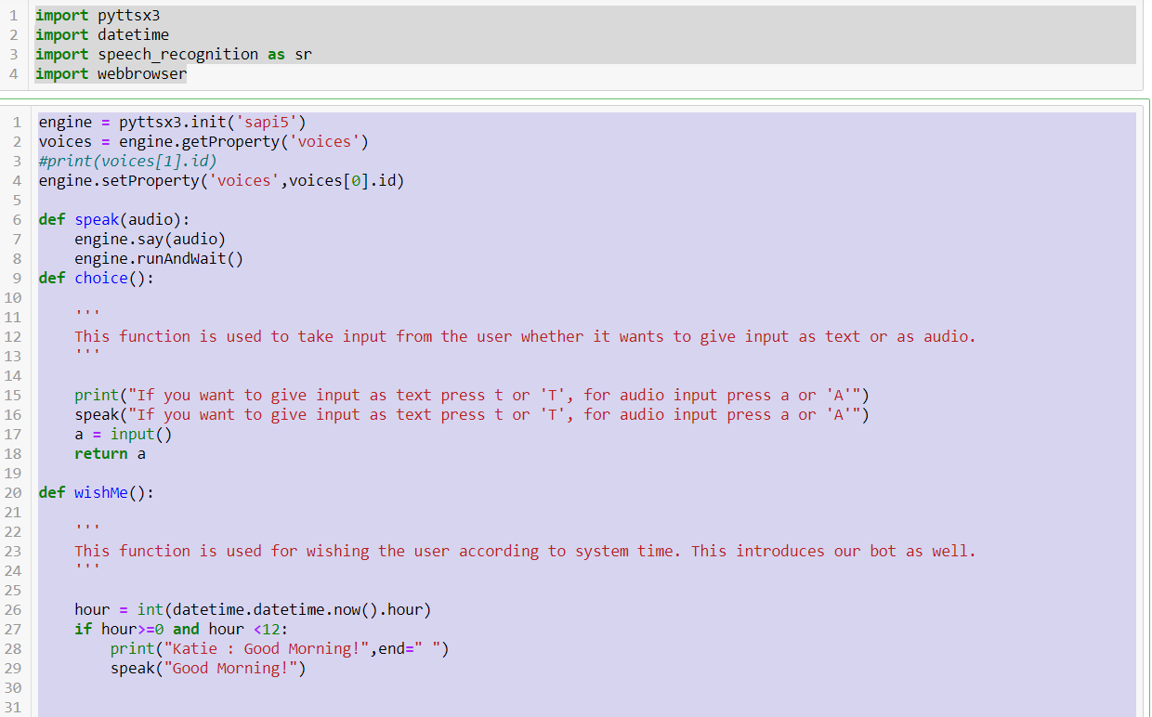

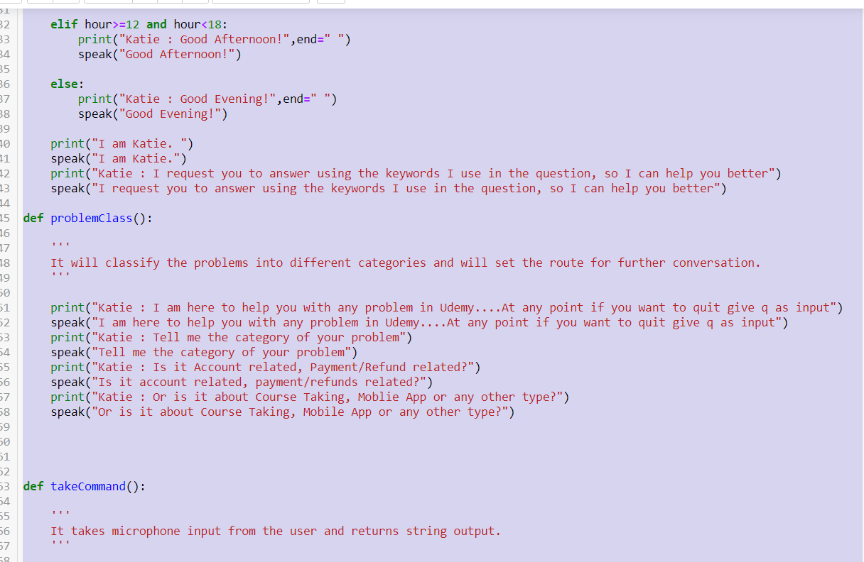

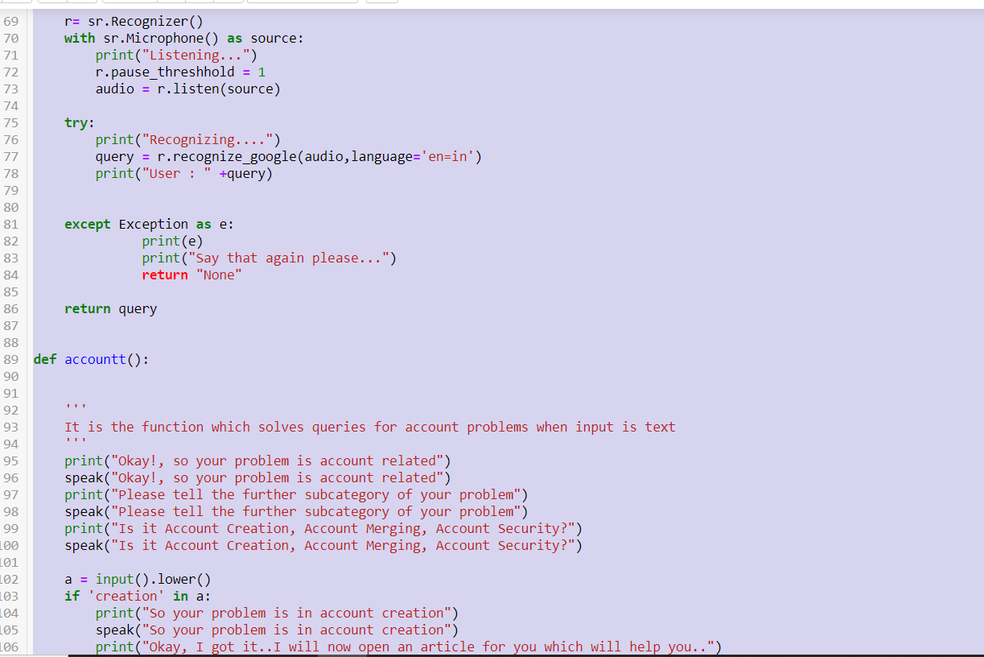

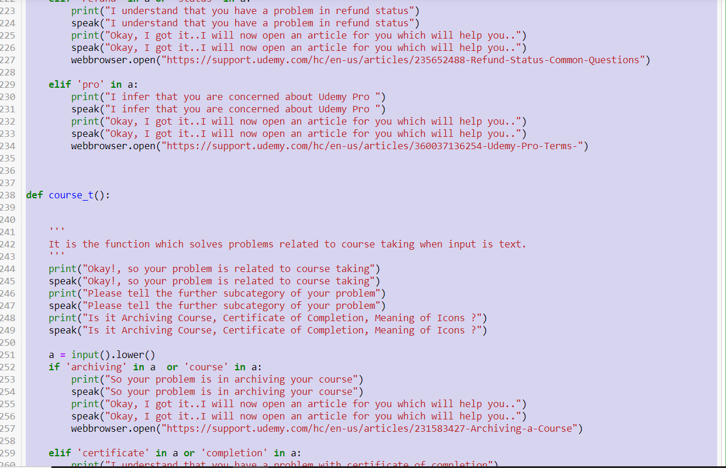

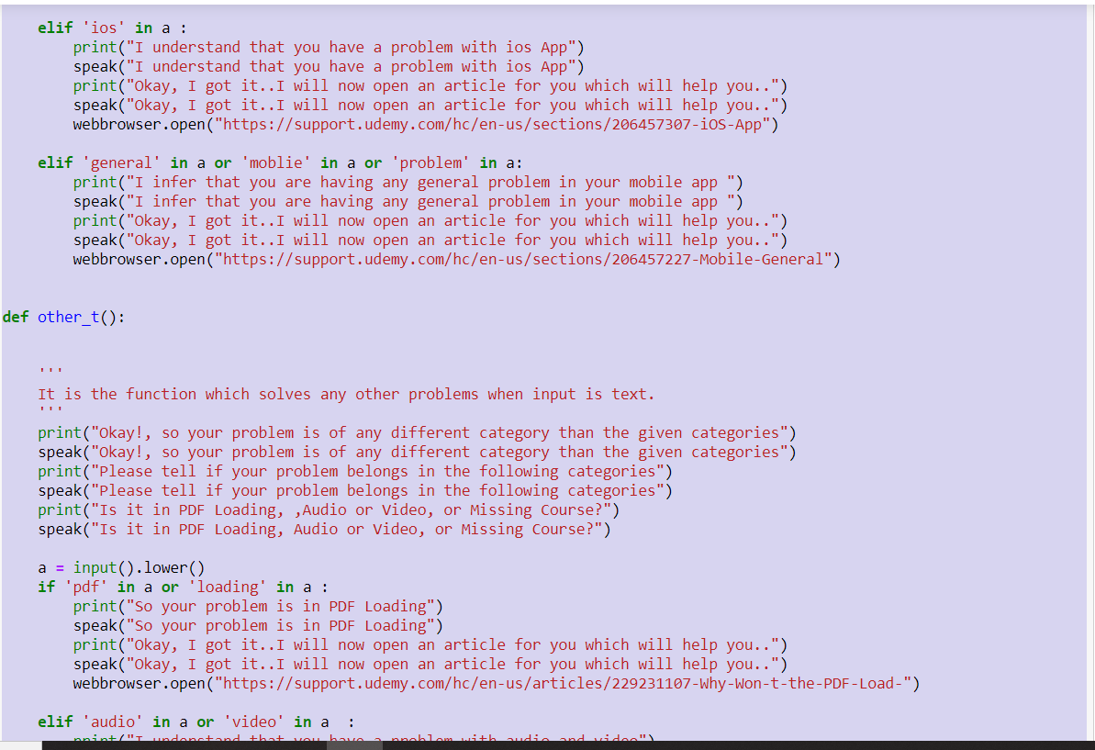

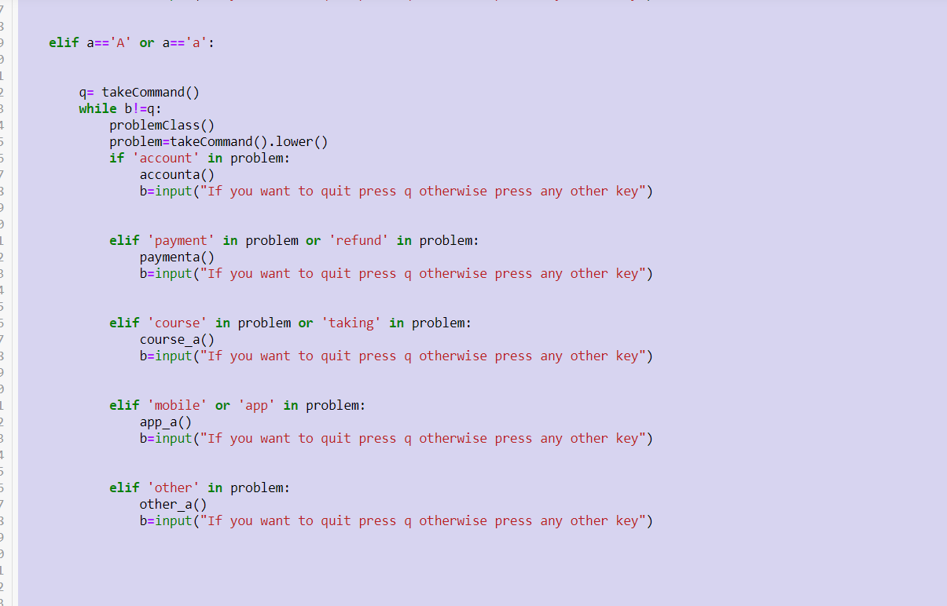

**OUTPUT**

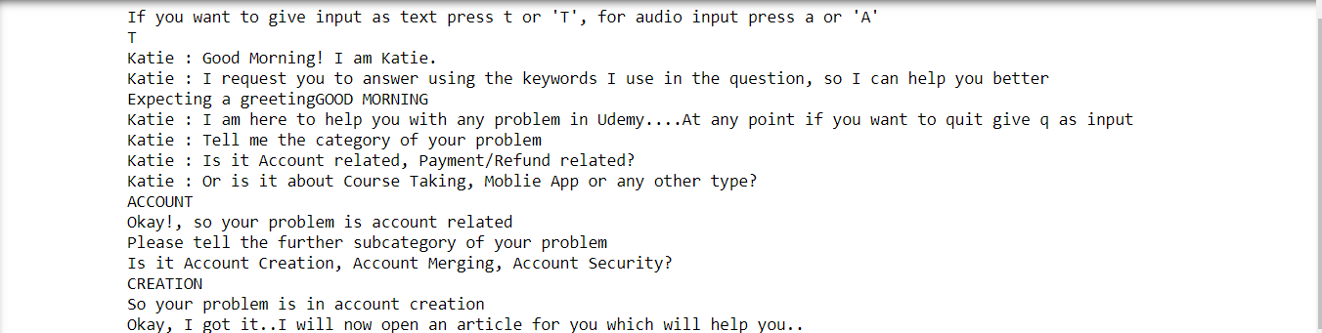

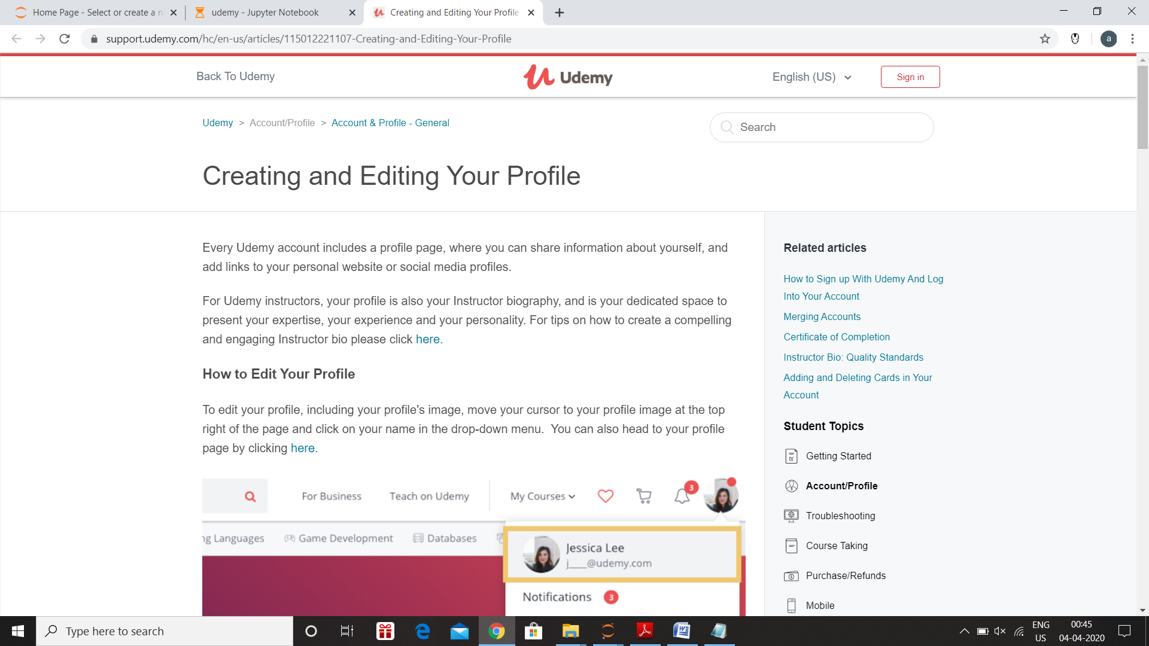

**LIBRARIES USED**

* PYTTSX3 (FOR THE SPEAK FUNCTION)
* SPEECH RECOGNISER (FOR GETTING AUDIO INPUT FROM USER AND CONVERTING IT INTO TEXT)
* DATE TIME (FOR GETTING THE DATE TIME)
* WEB BROWSER (FOR OPENING RELATED ARTICLES)

**REFERENCES**

* <https://chatbotslife.com/how-to-create-an-intelligent-chatbot-in-python-c655eb39d6b1>
* <https://www.youtube.com/watch?v=QpMsT0WuIuI&list=LLsDlc3JINct-nNkC3L0qg3A&index=2&t=0s>

( A video that describes the code for creating a basic chatbot)

**GITHUB LINK**

<https://github.com/ankit-shukla1/Customer_Service_Chatbot>