1) write a basic NFT contract made by using solidity, Remix IDE, and openZeppelin.

Ans.NFT and digital collectibles are growing popular as web3 space continues

tomakesignificantadvancement in the blockchain arena.

The enormous popularity of NFTs like crytokitties and BoredAPE pushed investors to purchase ERC721- compatible digital collectibles.

In this artical, we will guide you through the procedure of creating your firstErc721(NFT)contractonsolidity with open Zepplin.

Developing asmartcontractwithsolidityanddeployingitontheblockchain might sound

dauting at first: solidity,gas optimisation, developer environment, and gas fee, are only some of the

things you'll need to go through to host your code on the blockchain.

Tools like the openZepplin wizard that offers developers click and write functionlities

to create composable and secure smart contracts in no time, used with web3 developer

tools like Alchemy, make theexperience of writing a deploying code on the blockchain easy.fast, andreliable like never before.In this tutorial, you're going to learn how to develop and deploy an ERC721(NFT) smart contract.

Tech stack

. openZeppelin

.Remix

1.open Zeppelin:-

first of all, lets's go to open Zepplin then on the wizard tab, click on ERC721All NFTs are ERC721 tokens.we want our tokens to be Mintable, have Enumerable and URI storage as features Name your

token as per your wish and also enter the disired symbol;

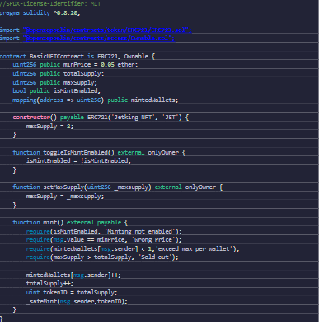

2.Remix IDE:-

Now,click on the open in Remix button in the upper right hand side corner.it will open the Remix IDE and will have the code written. you can changethe compiler version to 0.8.4Here, is the updated code, be sure to change it in Remix. we need to remove

the Ownable part of the solidity program as we want the people other than

ownable can also mint our NFTs. Also, we have added MAX_Supply as

5000 so that the NFTs are limited.