MDM 9.0.1 Development Environment Setup

Overview
A scripted process was written to speed up the time taken to setup a development environment for MDM 9.0.1 at Aviva, this document outlines common activities and process a new or existing developer might want to follow in order to setup a new environment, uninstall or reinstall parts of an existing environment.

Requirements
- Approximately 10.5 GB space (any local drive) for the scripts and approximately 8GB for the final installation (which will be on the C drive)
- It is required that you copy the entire MDM_WB_Env directory to your local machine. It must not be copied to a virtualized folder (i.e. not in any folder under “Libraries”, “Program Files”, etc). A good place would be something like C:\MDM_Setup\MDM_WB_Env but the actual location is not critical so long as the name isn’t too long and the above rule is adhered to. The folder can be on a different local drive (i.e D:\MDM\MDM_WB_Env etc). Ideally avoid spaces in the path but the script has been tested and works with spaces.
- This has been tested on Windows 7 only
- The user must be able to run the script with “Administrative” permissions
- The user should be connected to the Aviva network during install (either via VPN or directly)
- The following folders should not exist:
  - C:\IBM\DB2
  - C:\IBM\IBMIMShared
  - C:\IBM\InstallationManager
  - C:\IBM\InstallationManagerData
  - C:\IBM\SDP
  - C:\IBM\WebSphere
  - C:\IBM\workspace

Installation/Configuration

These steps assume you’ve copied the MDM_WB_Env folder to your local machine with a directory of the same name.
- Within MDM_WB_Env\Scripts edit installMDMEnvironment.bat
- Edit the logging levels as desired. These lines are something like (and recommended values are shown):
SET CONSOLE_LOG_LEVEL=%INFO%
SET FILE_LOG_LEVEL=%DEBUG%
The two loggers are:
CONSOLE_LOG_LEVEL – information printed to the console window
FILE_LOG_LEVEL – information printed to various files in a log directory
Valid log levels are:
%FATAL%
%WARNING%
%INFO%
%DEBUG%
- Edit the components you wish to install. This section looks like:
:: IBM Installation Manager
SET IBMIM_INSTALL_STATUS=%INSTALLED%
:: Rational Software Architect + WebSphere Test Environment
SET RSA_WAS_INSTALL_STATUS=%INSTALLED%
:: MDM Workbench
SET MDMWB_INSTALL_STATUS=%INSTALLED%
:: IBM DB2
SET DB2_INSTALL_STATUS=%INSTALLED%
Each value has a comment above saying what it controls the installation of, invalid combinations should be picked up but common sense is suggested anyway. Valid values are:
%TO_INSTALL% - Install the product
%INSTALLED% - You are confirming that this product is installed already installed. This script does not check and makes no guarantees around its behaviour if the product isn't installed as expected
%SKIP% - This product should have no actions done on it, but the script should error if it's a prerequisite for something we intend to do
- Edit the components you wish to configure. These typically depend on the components installed/to be installed as per the previous step. Invalid combinations should be picked up but common sense is suggested anyway. The section looks like:
:: Configure a DB2 instance, create a DB and populate with vanilla MDM 9.0.1
SET DB2_CONFIG_STATUS=%TO_CONFIGURE%
:: Configure a new WAS profile (AppSrv01) for, and then install, vanilla MDM 9.0.1
SET WAS_PROFILE_CONFIG_STATUS=%CONFIGURED%
:: Setup an MDM 9.0.1 workspace at C:\IBM\workspace
:: Note: If WAS_PROFILE_CONFIG_STATUS is set to TO_CONFIGURE then this will also set the server classpath to include
:: the properties files in the workspace
SET RSA_WORKSPACE_CONFIG_STATUS=%CONFIGURED%
Valid values are:
%TO_CONFIGURE% - You know the application is installed at the correct place or is being installed and want it configured
%CONFIGURED% - You are confirming that this product is installed and configured already. This script does not check and makes no guarantees around it
%SKIP% - This product should have no actions done on it, but the script should error if it's a prerequisite for something we intend to do
- Once complete open the start menu and type “cmd”. Right-click “cmd.exe” and select “Run as administrator”:
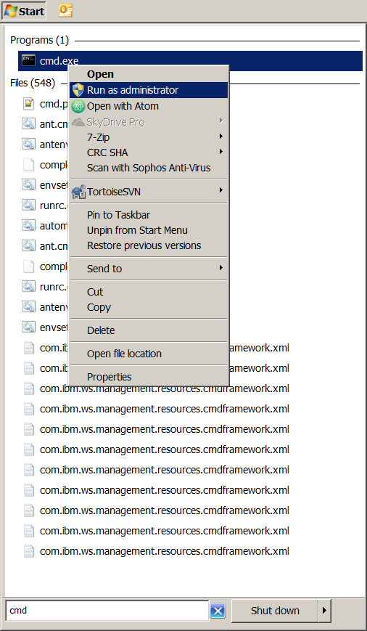
- Navigate to the MDM_WB_Env\Scripts directory (reminder: if it’s on another drive you might need to do “cd /D D:\Path\To\MDM_WB_Env\Scripts”)
- Run installMDMEnvironment.bat
- When prompted at the start for your password, first review the printed status that those are the actions you intended to do. If they’re not then stop the script by either entering a blank password or pressing Ctrl-C.
- If you are happy with the actions enter your normal Active Directory password and press Enter. The installation will proceed without further prompt until it completes successfully or fails.
- If you have selected to configure the RSA workspace then after installation successfully completes you must:
  - Start RSA and load the workspace. It’ll default to pointed at the configured workspace, just press enter if prompted
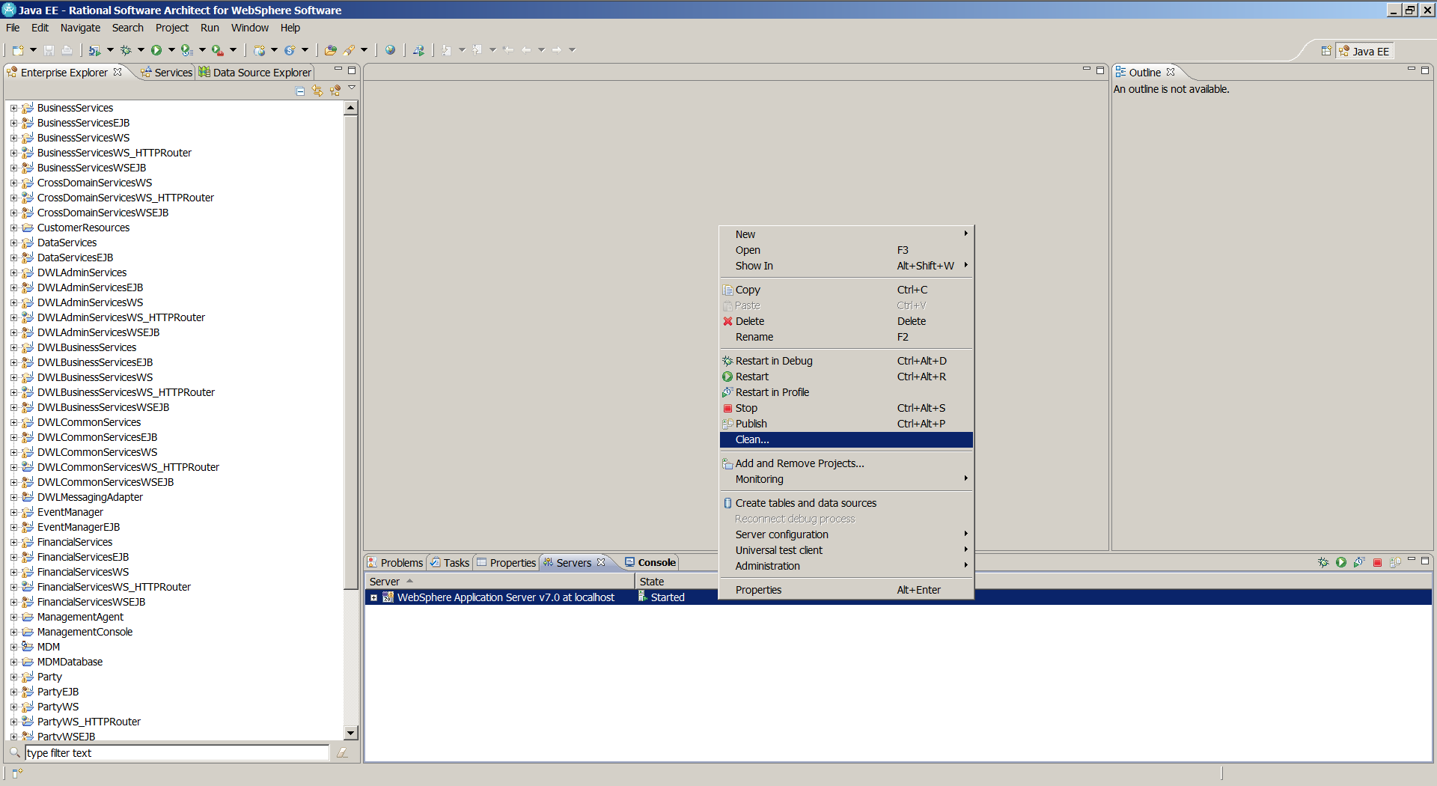
  - Open the servers view at the bottom and right-click the server. Click “Clean”:
This will deploy the workspace built EAR to the server.
  - Restart the application server, using “Stop” and then “Start” – avoid using “Restart” as this has a bad habit of causing issues (particularly in later versions of MDM so it’s a good habit to avoid using it).

Uninstallation/unconfiguration

The procedure for uninstalling or unconfiguring components is similar to installation/configuration but uses the uninstallMDMEnvironment.bat script and the following flags to choose what to uninstall/unconfigure:

SET IBMIM_ACTION=%UNINSTALL%
SET RSA_ACTION=%UNINSTALL%
SET MDMWB_ACTION=%UNINSTALL%
SET DB2_ACTION=%UNINSTALL%

SET MDMDB_ACTION=%UNCONFIGURE%
SET WAS_PROFILE_ACTION=%UNCONFIGURE%
SET WORKSPACE_ACTION=%UNCONFIGURE%

Which have valid values of:

%UNINSTALL% - Remove configured instances and uninstall the product
%UNINSTALLED% - You are indicating that this product has been wholly uninstalled already
%UNCONFIGURE% - Remove configured instances but leave the core installation so a new instances can be instantiated and configured without the need to reinstall the product
%UNCONFIGURED% - You are indicating that this product has already been unconfigured
%SKIP% - Do not touch this product or its configured instances

