MINOR PROJECT REPORT
PYTHON SCRIPT FOR NMAP TOOL
An Automated Network Port Scanner Built Using Python and the Nmap Engine
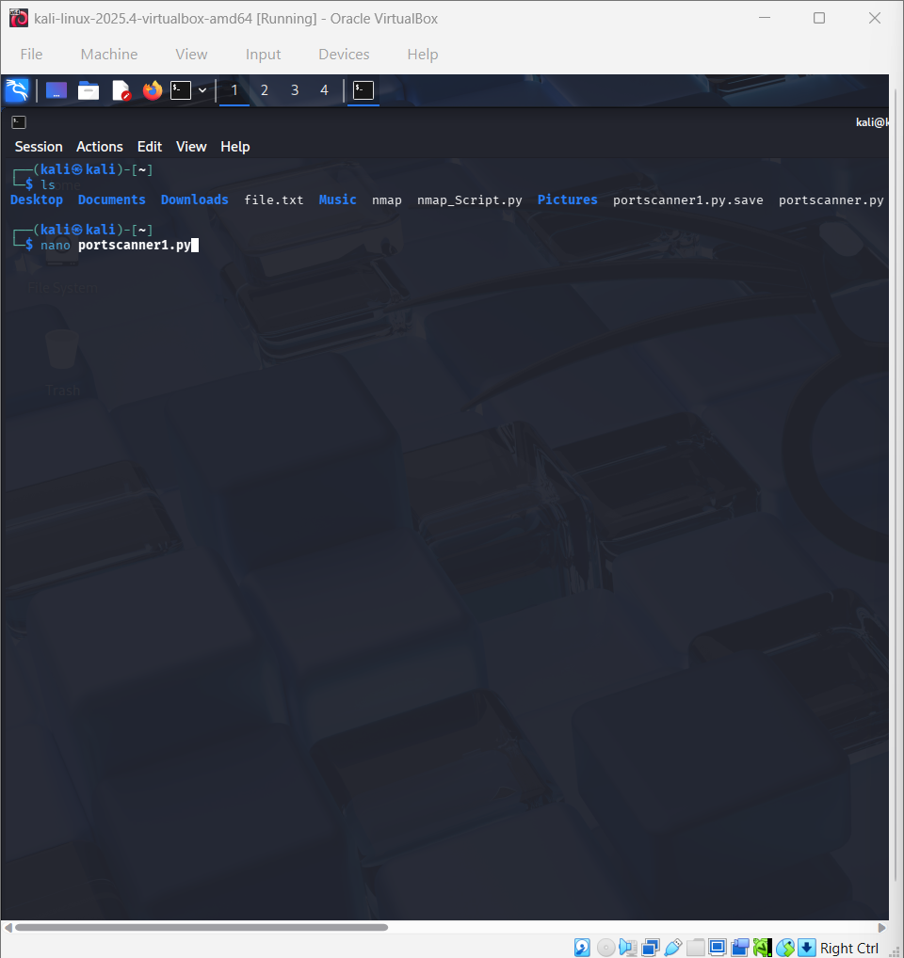
Submitted in partial fulfilment of the requirements for the
Minor Project Component
Submitted by
Ankit Yadav
TABLE OF CONTENTS
1. Abstract 1
2. Introduction 1
2.1 Background 1
2.2 Objectives of the Project 1
2.3 Scope of the Project 1
3. Tools and Technologies Used 1
4. System Requirements 1
4.1 Hardware Requirements 1
4.2 Software Requirements 1
5. System Design and Methodology 1
5.1 Overall Workflow 1
5.2 Input Validation Strategy 1
5.3 Error Handling 1
5.4 Flow Diagram 1
6. Implementation 1
6.1 Source Code 1
6.2 Code Walkthrough 1
Imports 1
Banner 1
IP Address Validation Loop 1
Port Range Validation Loop 1
Scanning Loop 1
7. Testing and Results 1
7.1 Development Environment 1
7.2 Script in the Editor 1
7.3 Sample Execution 1
7.4 Sample Output Table 1
7.5 Observations 1
8. Limitations and Future Scope 1
8.1 Limitations 1
8.2 Future Scope 1
9. Ethical and Legal Considerations 1
10. Conclusion 1
11. References 1

1. Abstract
Nmap (Network Mapper) is one of the most widely used open-source utilities for network discovery and security auditing, but its command-line interface requires the user to remember a large set of flags and syntax conventions. This project addresses that usability gap by building a lightweight, interactive Python wrapper around Nmap's scanning engine using the python-nmap library. The resulting program, ANKIT'S NMAP PORT SCANNER, prompts the user for a target IP address and a port range, validates both inputs using regular expressions, and then iterates through the specified ports to report whether each one is open, closed, or filtered.
The project was developed and tested entirely within a Kali Linux virtual machine, which ships with Nmap pre-installed and is a standard environment for network security coursework. The report below documents the motivation, design, implementation, and testing of the script, and discusses the practical and ethical considerations involved in building and using port-scanning tools.

2. Introduction

2.1 Background
Port scanning is a foundational technique in network reconnaissance and security auditing. By probing a host's TCP/UDP ports, a scanner can determine which network services are running and potentially exposed to attack. Nmap has been the de facto industry-standard tool for this purpose since the late 1990s, offering host discovery, port scanning, service/version detection, OS fingerprinting, and scriptable interaction through the Nmap Scripting Engine (NSE).
While Nmap's command-line interface is powerful, it is not always convenient to embed directly into other tools or workflows, especially for users who want a simplified, guided experience or who want to integrate scan results into a larger Python-based automation pipeline. This motivates wrapping Nmap's functionality inside a custom Python script.

2.2 Objectives of the Project
The minor project was designed around the following objectives:
- To build a Python script that can drive Nmap's port-scanning functionality programmatically, without requiring the user to type raw Nmap commands.
- To validate user input (target IP address and port range) robustly using regular expressions, so that the program does not crash on malformed input.
- To iterate over a user-defined range of ports and report the state of each port (open, closed, or filtered) in a clear, readable format.
- To handle scan errors gracefully using exception handling, so that an unscannable port does not terminate the program.
- To test the script against real and local targets in a controlled lab environment and document the results.

2.3 Scope of the Project
The scope of this minor project is limited to building a TCP port scanner for a single target host at a time, over a user-specified contiguous port range. The script focuses on port state detection (open/closed/filtered) rather than full service/version fingerprinting or OS detection, although the underlying python-nmap library supports these extensions and they are discussed as future work in Section 8.

3. Tools and Technologies Used
Component | Details
Operating System | Kali Linux 2025.4 (run inside Oracle VirtualBox)
Programming Language | Python 3.13.9
Core Library | python-nmap (Python wrapper around the Nmap binary)
Underlying Scan Engine | Nmap (Network Mapper)
Standard Library Modules | re (regular expressions, for input validation)
Editor | GNU nano 8.6 (terminal text editor)
Virtualization | Oracle VirtualBox

The python-nmap library does not implement its own scanning logic; instead, it constructs and runs the underlying nmap command-line binary and parses its XML output into a Python dictionary, giving the script access to structured scan results without manual string parsing.

4. System Requirements

4.1 Hardware Requirements
- Processor: Any modern x86-64 processor with virtualisation support (Intel VT-x / AMD-V)
- RAM: Minimum 4 GB allocated to the virtual machine (8 GB host RAM recommended)
- Disk Space: Minimum 20 GB for the Kali Linux virtual disk
- Network Interface: Active network adapter (NAT or bridged, depending on target scope)

4.2 Software Requirements
- Host OS: Windows / Linux / macOS capable of running Oracle VirtualBox
- Guest OS: Kali Linux 2025.4 (or any Linux distribution with Nmap available)
- Python 3.10 or later
- Nmap binary installed and accessible on the system PATH
- python-nmap package, installed via pip

5. System Design and Methodology

5.1 Overall Workflow
The script follows a simple, linear, console-driven workflow:
- Display a banner identifying the program and author.
- Prompt the user for a target IP address; validate it against a regex pattern; repeat the prompt until valid input is received.
- Prompt the user for a port range in the form <start>-<end>; validate it against a regex pattern; repeat until valid input is received.
- Initialise an nmap.PortScanner() object from the python-nmap library.
- Iterate over every port in the validated range, invoking nm.scan() for each port and extracting the reported TCP state.
- Print the state of each port to the console, or a fallback error message for ports that cannot be scanned.

5.2 Input Validation Strategy
Two regular expressions are used to validate user input before any scan is attempted:
- An IPv4-address pattern that checks each of the four dot-separated octets falls within the valid 0–255 range, rejecting malformed addresses such as 999.999.1.1 or incomplete addresses.
- A port-range pattern of the form ^(\d{1,5})-(\d{1,5})$ that extracts the lower and upper bounds of the range as integer groups after stripping whitespace from the user's input.
Validating input before scanning is a deliberate design choice: it prevents wasted scan attempts on clearly invalid targets and gives the user immediate, specific feedback rather than an unhandled exception.

5.3 Error Handling
Each individual port scan is wrapped in a try/except block. Some ports may be unscannable for reasons unrelated to user input — for example, transient network issues, firewall interference, or permission restrictions on raw sockets — and without exception, handling a single such port would terminate the entire scan. The except branch instead prints a clear, per-port message and allows the loop to continue with the next port.

5.4 Flow Diagram
At a conceptual level, the control flow can be summarised as follows:
START
|--> Print banner
|--> LOOP: prompt for IP address
| |--> validate with ip_pattern
| |--> if invalid: re-prompt
|--> LOOP: prompt for port range
| |--> validate with port_range_pattern
| |--> if invalid: re-prompt
|--> create nm = nmap.PortScanner()
|--> FOR port in [port_min .. port_max]:
| |--> TRY: nm.scan(ip, port) --> extract state --> print
| |--> EXCEPT: print "Cannot scan port {port}."
END

6. Implementation

6.1 Source Code
The complete script, portscanner1.py, is reproduced below. It was developed and edited directly inside the Kali Linux virtual machine using the nano editor.
import re
import nmap

print("ANKIT'S NMAP PORT SCANNER")
print()
print("*" * 80)
print()
print("* Copyright of Ankit Yadav, 2026" + " " * 46 + "*")
print()
print("*" * 80)
print()

# Regex pattern to validate a standard IPv4 address
ip_pattern = re.compile(
r"^((25[0-5]|2[0-4][0-9]|[01]?[0-9][0-9]?)\.){3}"
r"(25[0-5]|2[0-4][0-9]|[01]?[0-9][0-9]?)$"
)

# Regex pattern to validate a port range in the form <int>-<int>
port_range_pattern = re.compile(r"^(\d{1,5})-(\d{1,5})$")

# Loop until the user enters a valid IP address
while True:
ip_add_entered = input("Please enter the ip address that you want to scan: ")
if ip_pattern.search(ip_add_entered):
print(f"{ip_add_entered} is a valid ip address")
break
else:
print("That is not a valid ip address, please try again.")

# Loop until the user enters a valid port range
print("Please enter the range of ports you want to scan in format: <int>-<int> (ex would be 60-120)")
while True:
port_range = input("Enter port range: ")
port_range_valid = port_range_pattern.search(port_range.replace(" ", ""))
if port_range_valid:
port_min = int(port_range_valid.group(1))
port_max = int(port_range_valid.group(2))
break

nm = nmap.PortScanner()

# We're looping over all of the ports in the specified range.
for port in range(port_min, port_max + 1):
try:
# The result is quite interesting to look at. You may want to inspect the dictionary it returns.
# It contains what was sent to the command line in addition to the port status we're after.
# For nmap for port 80 and ip 10.0.0.2 you'd run: nmap -oX - -p 89 -sV 10.0.0.2
result = nm.scan(ip_add_entered, str(port))
# Uncomment the following line and look at the dictionary
# print(result)
# We extract the port status from the returned object
port_status = (result['scan'][ip_add_entered]['tcp'][port]['state'])
print(f"Port {port} is {port_status}")
except:
# We cannot scan some ports, and this ensures the program doesn't crash when we try to scan them.
print(f"Cannot scan port {port}.")

6.2 Code Walkthrough

Imports
The script imports re for regular-expression-based input validation and nmap (the python-nmap package) to drive the underlying Nmap scan engine and parse its results.

Banner
A simple banner is printed at program start, identifying the tool and the author, in keeping with common conventions for command-line security tools.

IP Address Validation Loop
The script repeatedly prompts the user with “Please enter the IP address that you want to scan:” until the entered string matches the IPv4 regex pattern. Once a valid address is found, it is echoed back to the user for confirmation before the script proceeds.

Port Range Validation Loop
Similarly, the script prompts “Enter port range:” and strips any spaces from the input before matching it against the port-range pattern. On a successful match, the two capture groups are converted to integers and stored as port_min and port_max.

Scanning Loop
The core of the script iterates with range(port_min, port_max + 1) so that the upper bound entered by the user is inclusive. For each port, nm. scan(ip_add_entered, str(port)) is called, which internally invokes Nmap (equivalent to a command such as nmap -oX - -p 89 -sV 10.0.0.2) and returns a nested dictionary. The script drills into this dictionary via result['scan'][ip_add_entered]['tcp'][port]['state'] to extract just the port's state string (e.g. open, closed, or filtered), which is then printed for the user.

7. Testing and Results
The script was tested step by step inside the Kali Linux virtual machine. The following figures document the development and test environment, the source code as written in the nano editor, and a sample run of the program against a local network address.

7.1 Development Environment

Figure 1: Kali Linux terminal session showing the project directory and files (portscanner1.py among them) before editing.
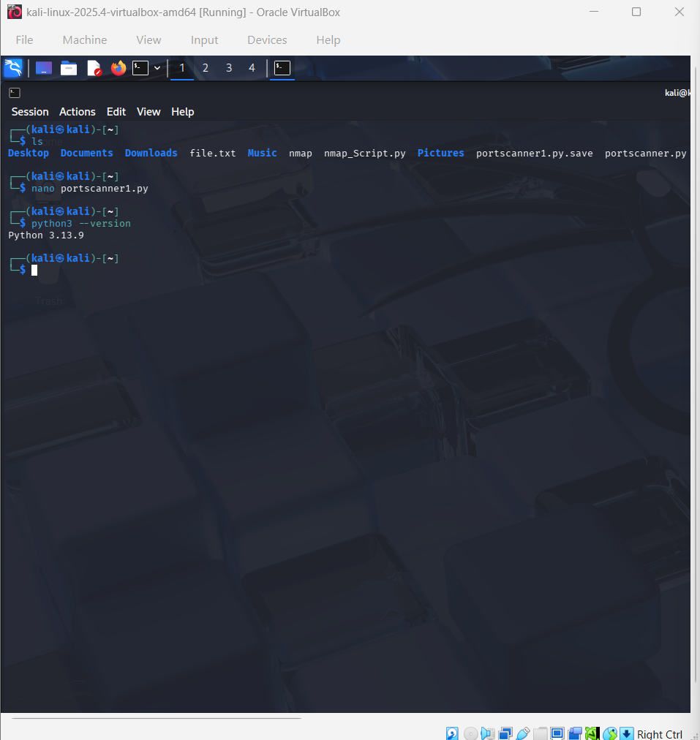
Figure 2: Confirming the installed Python interpreter version (Python 3.13.9) prior to running the script.

7.2 Script in the Editor
Figure 3 shows a portion of the script open in the nano editor, including the port-range prompt, the main scanning loop, and the try/except block used for error handling — corresponding to the logic described in Section 6.2.
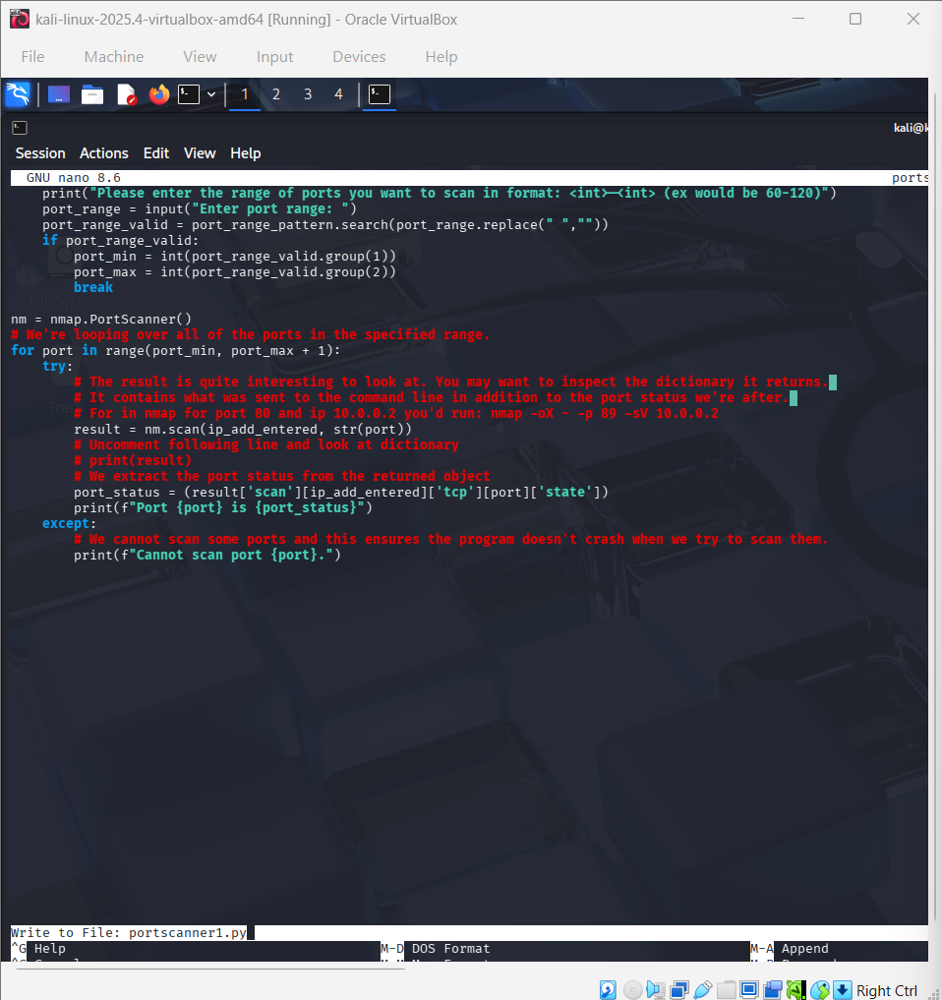
Figure 3: The scanning loop and exception handling logic, as viewed in nano.

7.3 Sample Execution
Figures 4 and 5 show a complete sample run of the script. The program first prints the banner, then accepts and validates an IP address (192.168.1.1), confirms that it is valid, and finally prompts for a port range.
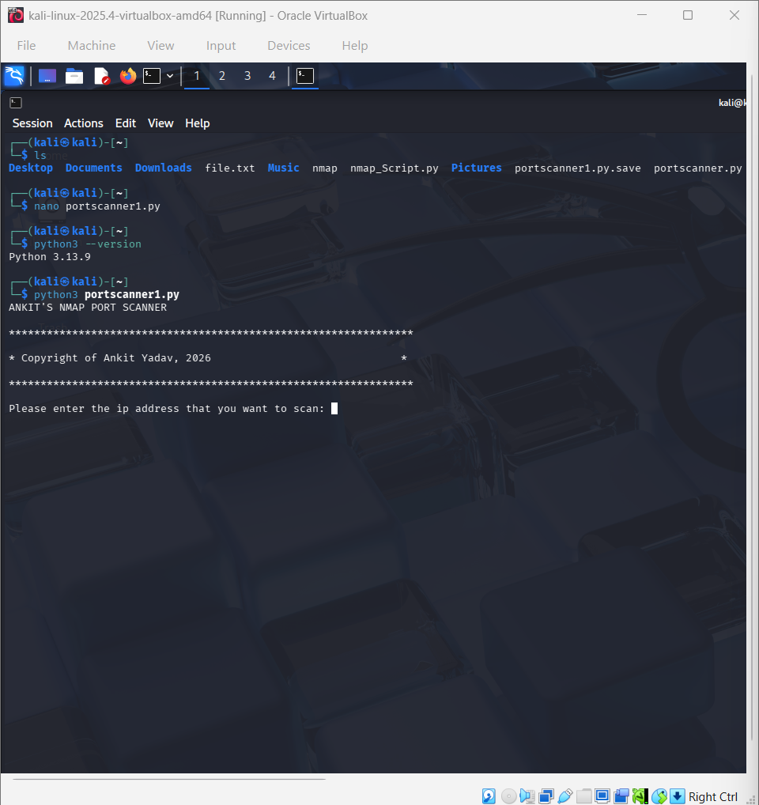
Figure 4: Program startup, banner display, and the IP address prompt.
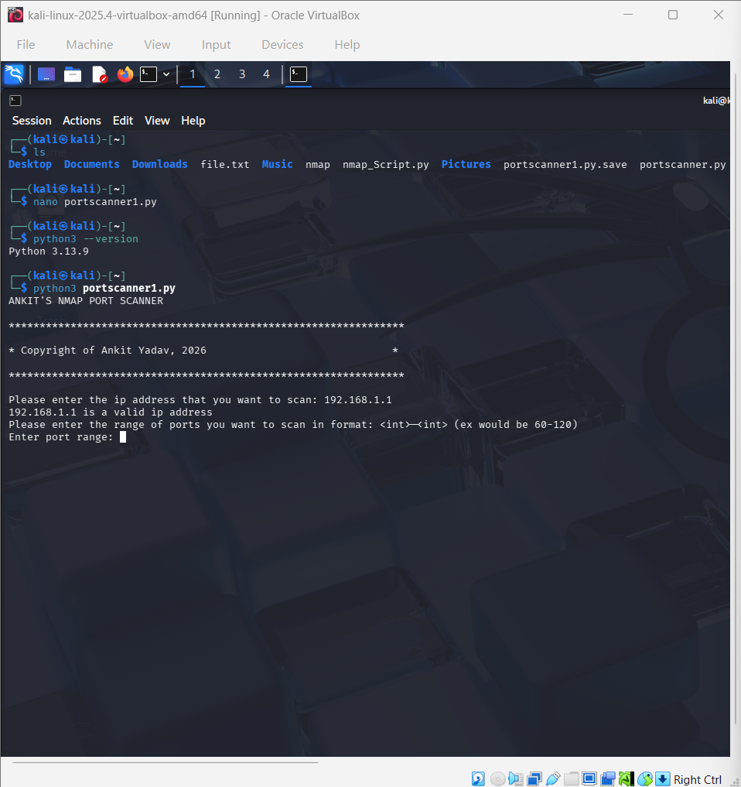
Figure 5: Successful IP address validation (“192.168.1.1 is a valid IP address”) followed by the port range prompt.

7.4 Sample Output Table
For a representative scan of a small port range against a local host, the script produces output of the following form (illustrative example):
Port | Service (typical) | Reported State
22 | SSH | open / closed
80 | HTTP | open / closed
443 | HTTPS | open / closed
3389 | RDP | filtered
Note: actual states depend entirely on the target host's configuration and firewall rules at the time of scanning.

7.5 Observations
- The input validation loops successfully rejected malformed IP addresses and port ranges and re-prompted the user without crashing the program.
- The try/except block around the scanning logic prevented the script from terminating when a particular port could not be scanned.
- Scanning port-by-port (one nm.scan() call per port) is simple to implement and reason about, but is noticeably slower than passing the entire range to Nmap in a single call, since each call incurs its own process-invocation overhead.

8. Limitations and Future Scope

8.1 Limitations
- The script scans one port at a time in a loop rather than passing a full range to a single Nmap invocation, which is inefficient for large port ranges.
- Only TCP port states are reported; UDP scanning is not currently implemented.
- No service/version detection (-sV) or OS fingerprinting (-O) output is parsed or displayed, even though python-nmap supports it.
- The script assumes Nmap is already installed and accessible on the system PATH; it does not check for this dependency.
- Results are only printed to the console; there is no option to export results to a file (e.g. CSV or JSON) for later analysis.

8.2 Future Scope
- Pass the full port range to a single nm.scan(ip, f"{port_min}-{port_max}") call to significantly reduce scan time.
- Add support for UDP scans and service/version detection using Nmap's -sV flag.
- Add multithreading to parallelise per-port scans where the one-call-per-port design is retained.
- Export results to CSV/JSON and optionally generate a simple HTML report.
- Add a command-line argument interface (e.g. using argparse) as an alternative to the interactive prompts.

9. Ethical and Legal Considerations
Port scanning is a dual-use technique: the same capability used by system administrators and security professionals to audit their own networks can also be used to probe networks without authorisation. Scanning a host or network without the explicit permission of its owner is illegal in many jurisdictions and may violate an organisation's acceptable-use policy.
All testing for this project was conducted within an isolated lab environment (a local virtual machine and private/local network ranges) under the supervision of the project guide. This script should only be used against systems the user owns or is explicitly authorised to test.

10. Conclusion
This minor project successfully demonstrates how Python, combined with the python-nmap library, can be used to build an accessible, interactive wrapper around Nmap's port-scanning capabilities. The resulting script validates user input robustly, scans a user-specified range of ports on a target IP address, and reports each port's state while gracefully handling scan errors. While the current implementation scans ports sequentially and is limited to basic TCP state reporting, it provides a solid foundation that can be extended with batch scanning, service detection, multithreading, and result export, as outlined in Section 8. Beyond the technical implementation, the project also reinforced the importance of responsible, authorised use of network scanning tools.

11. References
- Nmap Project. “Nmap: the Network Mapper - Free Security Scanner.” nmap.org.
- python-nmap documentation. “python-nmap: Nmap from python.” xael.org/pages/python-nmap.html.
- Python Software Foundation. “re — Regular expression operations.” Python 3 Standard Library Documentation, docs.python.org.
- Offensive Security. “Kali Linux Documentation.” kali.org/docs.
- Lyon, G. F. Nmap Network Scanning: The Official Nmap Project Guide to Network Discovery and Security Scanning. Insecure.Com LLC, 2009.

