Newman’s Coin Symmetry:

Newman is a shopkeper he has many coins avialable for change in
his shop . One day an Indian mathematician Ankit comes to his shop and asks him to solve a puzzle he takes few coins and arranges them in a particular manner as shown in figure and asks him to arrange these coins into minimum possible manner so as to
form a particular geometrical shape. Help out Newman in doing so
for larger number of coins using your program.

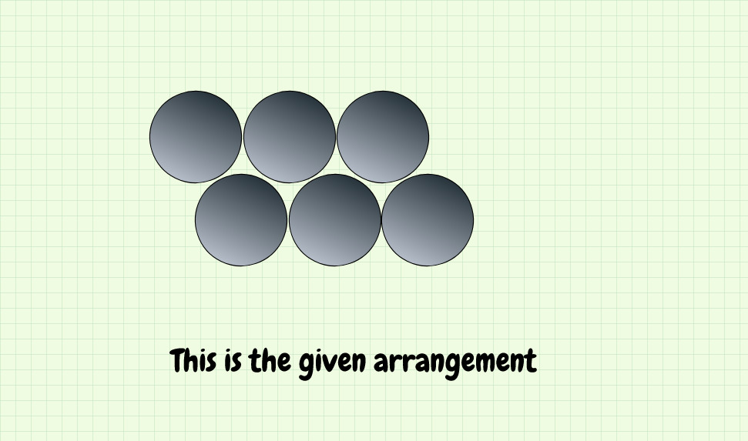

The required shape should be something like this as shown here:
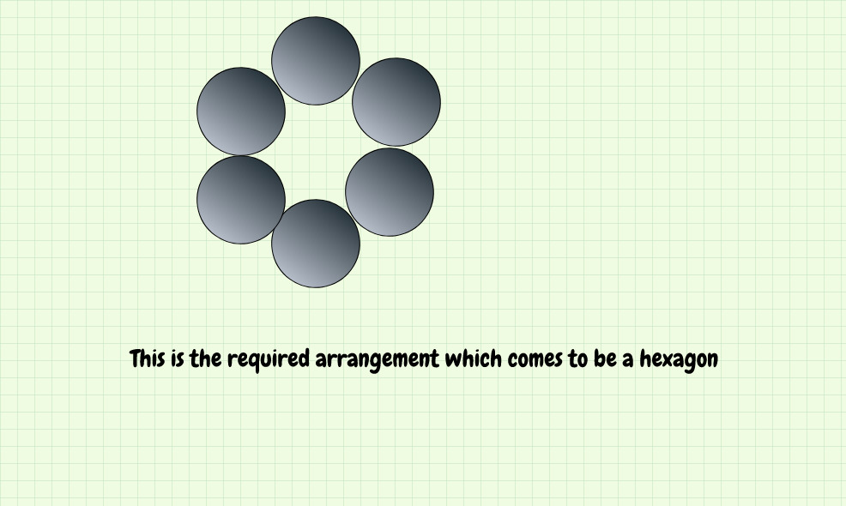

Conditions for sliding the coins:-
- The User must pick one coin at a time for sliding.
- The Coin which is to be slided must not be blocked by other coins or the coin which is to be removed can only be removed/slided if it is not disturbing the arrangment of other coins.
- The Coin which is slided must be placed between circumference of two coins as shown

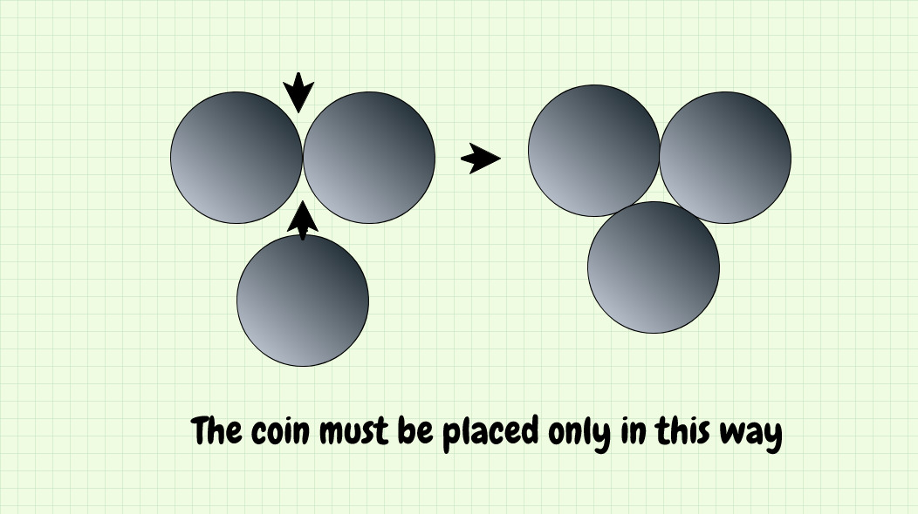

Input:-
N 2*n+4>N>6 , where n belong to +ve Integers 1,2,3,4---10^6
Number of Coins user enters.

Output:-
X 10^6>X>1
This is the Number of way to do the task.

Tip: The resultant shape may be a regular polygon or irregular polygon depending upon N.

