GOVERNMENT OF INDIA
Ministry of Health & Family Welfare · Directorate General of Health Services
Central Drugs Standard Control Organization (CDSCO)

DIGITAL DRUGS REGULATORY SYSTEM (DDRS)
SOFTWARE ARCHITECTURE DOCUMENT (SAD)
Knowledge Transfer & Technical Reference

Document Version 1.0
Date: 31 May 2026
Classification: Internal — For Knowledge Transfer

Document Control

Revision History
Version | Date | Author | Description
0.1 | — | Architecture Team | Initial skeleton and outline
0.5 | — | Architecture Team | Draft with logical & data views
0.9 | — | Architecture Team | Module deep-dives, API & data dictionary
1.0 | 31 May 2026 | Architecture Team | Baseline release for knowledge transfer

Document Purpose
This Software Architecture Document (SAD) describes the architecture of the Digital Drugs Regulatory System (DDRS) built for the Central Drugs Standard Control Organization (CDSCO). It is intended as the definitive technical reference for knowledge transfer to engineering, operations, security and governance teams. It captures the business context, requirements, multiple architectural views, the complete data model and API surface, module-level design, security, deployment, non-functional characteristics, and operational runbooks.

Intended Audience
- Solution & enterprise architects
- Backend and frontend engineers
- DevOps / SRE and cloud operations
- Security and compliance (CERT-In, ISO 27001, DPDP)
- QA and UAT teams
- CDSCO programme governance and product owners
- Future maintenance / transition vendors

How to Read This Document
Section 2 gives the executive summary and orientation. Sections 3–4 cover the business context and requirements. Section 5 presents the architecture using the 4+1 view model with diagrams. Sections 6–7 detail the data architecture and the complete REST API. Section 8 provides per-module deep-dives. Sections 9–14 cover workflows, security, integrations, non-functional requirements, deployment and testing. Sections 15+ provide operational runbooks, the glossary and appendices (including the full data dictionary).

Table of Contents
Right-click and "Update Field" to build the Table of Contents.

2. Executive Summary
The Digital Drugs Regulatory System (DDRS) is a unified, API-first digital public infrastructure for India’s drug regulatory ecosystem. It digitises the complete regulatory lifecycle — registration, licensing, clinical trials, inspections, enforcement, vigilance, laboratory testing, supply-chain traceability, payments, returns, grievances and analytics — across CDSCO, the State Licensing Authorities, testing laboratories, regulated industry and the public.
DDRS is implemented as a modular monolith that is microservices-ready: each regulatory domain is an independent module behind a documented OpenAPI surface, so any module can later be extracted to its own service without changing its public contract. The platform is built entirely on open-source technologies and runs as a single deployable service (API + web) for operational simplicity.
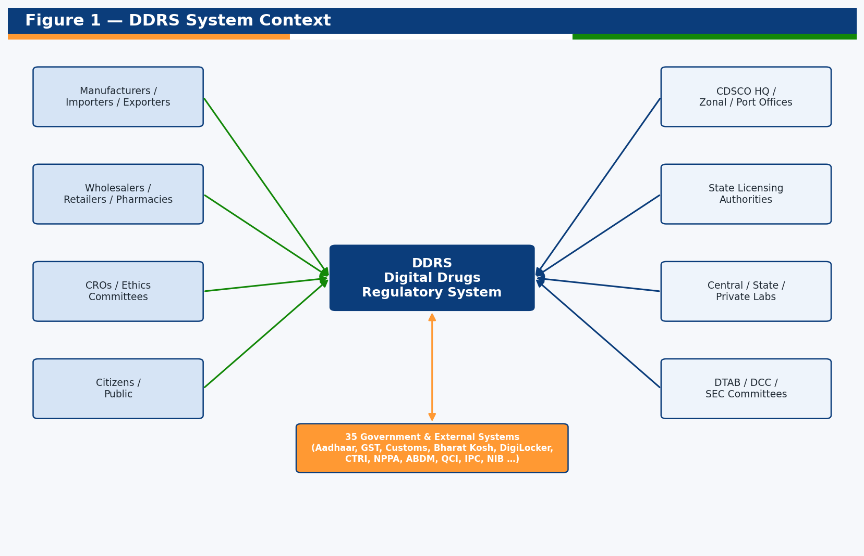
Figure 1 — DDRS system context: actors and external systems.

2.1 Solution Highlights
- Unified portal for all regulated product categories (drugs, biologicals, medical devices, IVDs, cosmetics, veterinary, blood products).
- Generic workflow engine driving every application type with full audit and a Timeline Review System (TRS) for SLA ageing.
- Role-based access control across 19 stakeholder roles and five portals.
- QR-enabled licences/certificates with public, no-login verification.
- Laboratory Information Management (LIMS), pharmaco/materio/haemovigilance, enforcement (NSQ/spurious/recall), and supply-chain track & trace.
- A hub of 35 government/external integrations (Aadhaar, GST, Customs, Bharat Kosh, DigiLocker, CTRI, NPPA, ABDM, QCI, IPC, NIB and more).
- Executive dashboards, the SHRESTH state-benchmarking index, and a custom report builder.
- Portable persistence: SQLite for zero-setup development, PostgreSQL for production.

2.2 Technology Stack
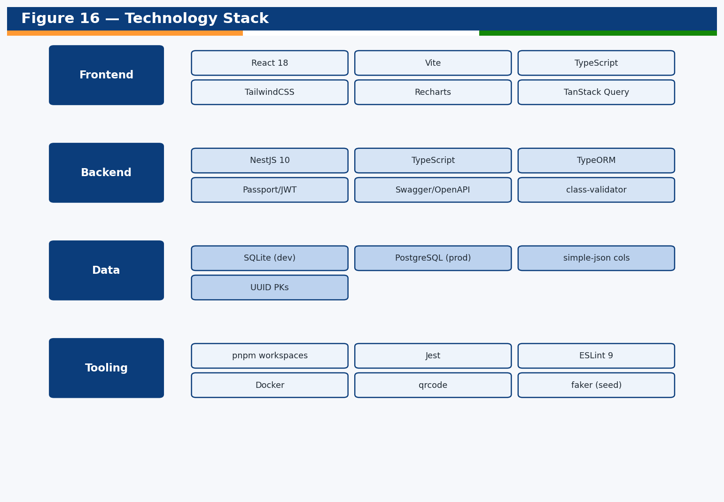
Figure 16 — Technology stack overview.
Layer | Technologies
Frontend | React 18, Vite, TypeScript, TailwindCSS, Recharts, TanStack Query, Axios
Backend | NestJS 10, TypeScript, TypeORM, Passport/JWT, Swagger/OpenAPI, class-validator
Database | SQLite (development) ↔ PostgreSQL (production), UUID keys, simple-json columns
Auth | JWT, OTP, simulated Aadhaar/DigiLocker e-KYC, RBAC guards
Build/Test | pnpm workspaces, Jest, ESLint 9, Docker, qrcode, faker (seed)

2.3 Key Metrics
Metric | Value
Backend feature modules | 20+
Domain entities (tables) | 37
Entity columns (data points) | 564
REST API endpoints | 117
RBAC roles | 19
Portals | 5 (Public, Industry, CDSCO, State, Lab/Admin)
External integrations | 35
Seeded demonstration records | 60,000+ (500+ per flow)

3. Business Context

3.1 About CDSCO
The Central Drugs Standard Control Organization (CDSCO) is the National Drugs Regulatory Authority of India under the Directorate General of Health Services, Ministry of Health & Family Welfare. CDSCO lays down standards for drugs, approves clinical trials and new drugs, controls the quality of imported drugs, coordinates the activities of State Drug Control Organizations, and grants/renews licences for critical categories such as blood products, vaccines & sera, r-DNA products and medical devices.
CDSCO operates a headquarters in New Delhi, 16 zonal/sub-zonal offices, 12 port offices and a network of central testing laboratories (CDL/CDTL/RDTL, IPC, NIB). Under the Drugs & Cosmetics Act, Class A/B products are licensed by State Licensing Authorities while Class C/D products are approved by the Central Licensing Authority.

3.2 Vision for DDRS
DDRS is envisioned as India’s Digital Public Infrastructure (DPI) for regulatory systems — a comprehensive, connected, paperless ecosystem that enables supply-chain track & trace to combat spurious products, improves monitoring for decision makers, supports return filing for manufacturing and consumption data, and provides automated alerting. The platform follows API-first and microservices methodologies and adheres to open standards.

3.3 Stakeholders
Stakeholder | Role in DDRS
CDSCO (Central) | Central licensing, clinical trial approval, import control, enforcement, vigilance oversight, analytics
State Licensing Authorities | Class A/B licensing, state inspections and enforcement, state labs
Testing Laboratories | Sample receipt, testing, batch release, reference standards (Central/State/Private)
Manufacturers/Importers/Exporters | Applications, registrations, returns, vigilance reporting
Wholesalers/Retailers/Pharmacies | Sale licences, supply-chain participation
CROs / Ethics Committees / BA-BE | Clinical trial conduct and oversight
Citizens / Public | Verification, alerts, grievances, public registries

3.4 Regulated Product Categories
- Drugs (FDC, IND, New Drugs, Subsequent New Drugs, large-volume parenterals)
- Biologicals (vaccines, antisera, blood products, r-DNA, stem-cell)
- Medical Devices and In-Vitro Diagnostics (IVD)
- Cosmetics
- Veterinary products
- AYUSH / emerging therapies
- Blood centres
- Testing laboratories

3.5 Business Objectives
- Single window for the end-to-end lifecycle of all regulated categories.
- Paperless, time-bound, auditable approvals with SLA monitoring.
- Traceability from sourcing to consumption to detect spurious/NSQ products.
- Seamless integration with central and state government platforms.
- Evidence-based decision making via dashboards and the SHRESTH index.
- Transparency and citizen services (verification, alerts, grievances).

4. Requirements Overview

4.1 Functional Scope (summary)
The functional scope spans the full regulatory lifecycle. The table below maps the principal functional areas to the implementing DDRS modules.
Functional Area | Implementing Module(s)
User & entity registration; RBAC | auth, users, registry
Pre-screening, market authorisation, licensing, renewal | applications, licensing
Endorsement, post-approval change, suspension, surrender, correction, appeal | applications
NOC and certificate issuance (COPP/FSC/MSC/NCC/WC/GMP) | licensing
Clinical trials (CT/GCT/BA-BE/PMS/academic/veterinary) | clinical-trials
Inspections (joint, geo-tagged, Form-35/MD-11/COS-11) | inspections
Enforcement (sampling, NSQ/spurious, recall, court cases) | enforcement
Vigilance (SAE/AEFI/PvPI/MvPI/HvPI, PSUR, compensation) | vigilance
Laboratory QMS/LIMS, batch release, reference standards | laboratory
Supply-chain track & trace, invoices | supply-chain
Periodic return filing | returns
Payments (Bharat Kosh / State Treasury) | payments
Grievance redressal & helpdesk | grievances
Notifications & alerts | notifications
Document management & e-sign | documents
Audit trail & version history | audit
External integrations (35 systems) | integrations
Dashboards, MIS, SHRESTH, reports | analytics

4.2 Non-Functional Requirements (summary)
Category | Requirement
Scalability | Horizontal scale to ~1,000 concurrent users; stateless API
Availability | High availability via stateless services behind a load balancer
Security | ISO 27001-aligned, CERT-In audit, encryption, RBAC, full audit trail
Privacy | DPDP-aligned conditional/minimal data access; access logging
Interoperability | Open APIs, standard formats (E2B/ICSR, CSV/JSON), versioned
Performance | Paginated, indexed queries; efficient list endpoints
Maintainability | Modular design, typed code, lint/tests, documentation
Portability | DB-agnostic schema (SQLite/PostgreSQL); containerised
Accessibility | GIGW-aligned, responsive, PWA-friendly
Auditability | Immutable logs with user, timestamp, IP, outcome

5. Architecture (4+1 Views)
The architecture is described using the 4+1 view model: Logical, Process, Development, Physical, plus Scenarios that tie them together.
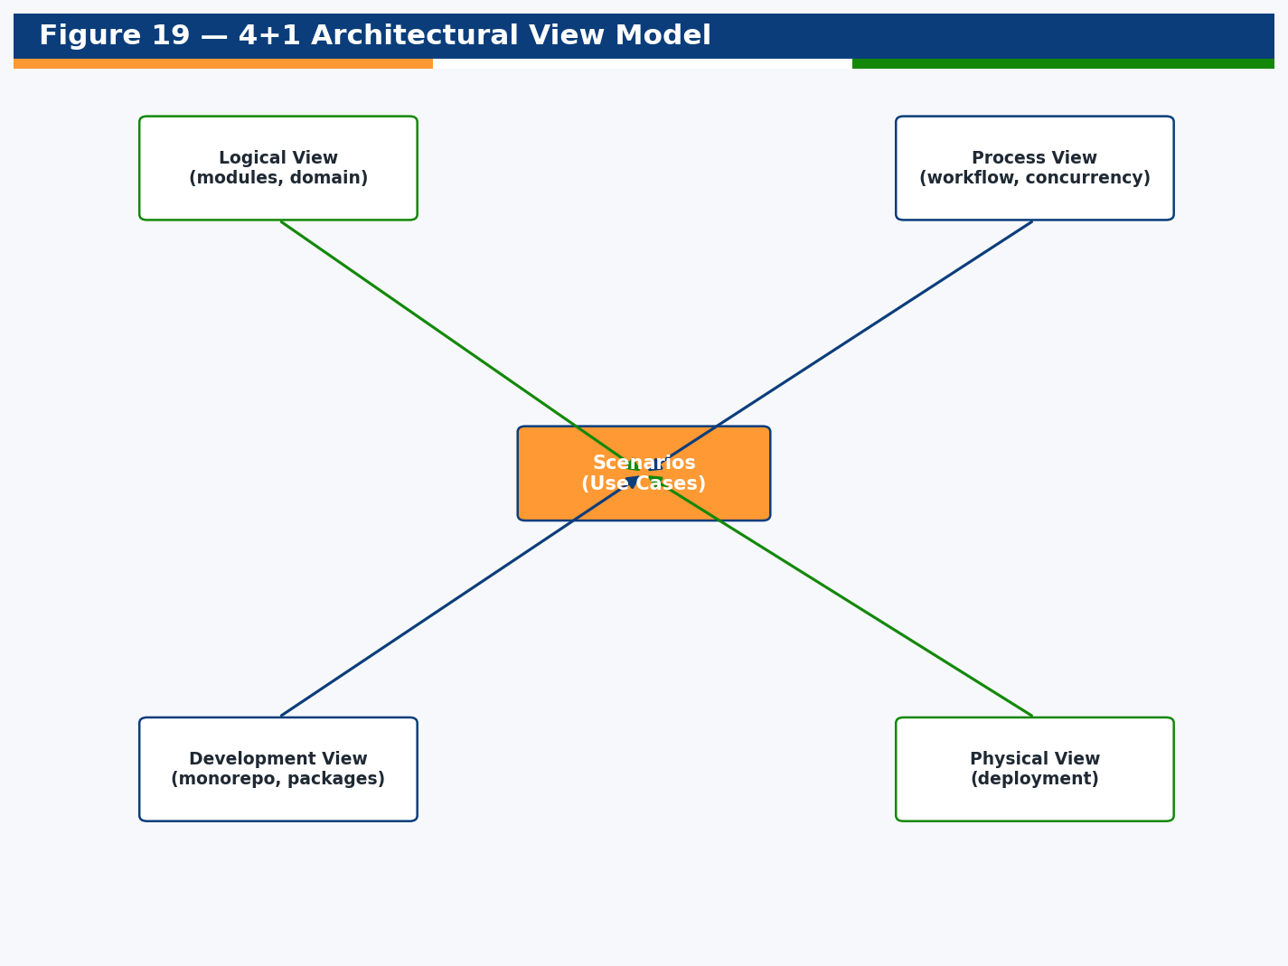
Figure 19 — 4+1 architectural view model.

5.1 Logical View
The logical view organises the system into presentation, API, domain/service, data-access and persistence layers, with cross-cutting concerns applied globally.
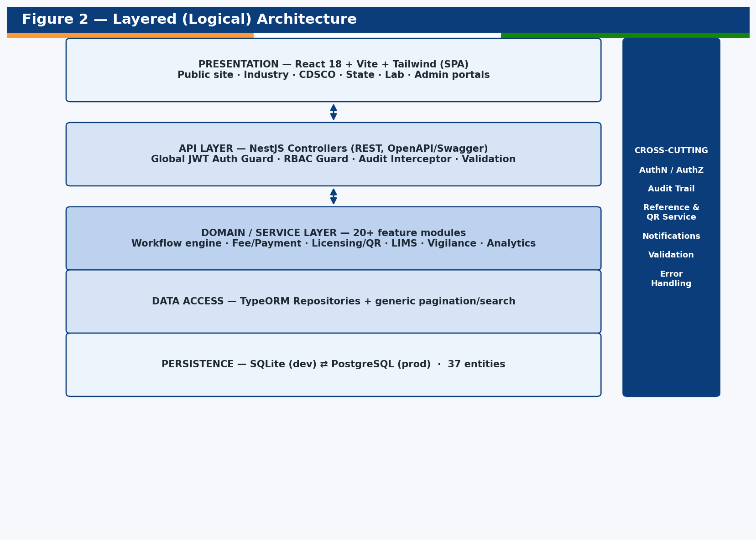
Figure 2 — Layered (logical) architecture.
Cross-cutting concerns — authentication, authorization (RBAC), the audit interceptor, the reference/QR service, notifications, validation and centralised error handling — are implemented once and applied across all modules via NestJS guards, interceptors and dependency injection.

5.2 Development View (Component / Module Map)
The codebase is a pnpm monorepo with two packages — backend (NestJS) and frontend (React) — plus shared documentation and seed tooling. The backend is decomposed into platform-core, registry, regulatory and platform-service module groups.
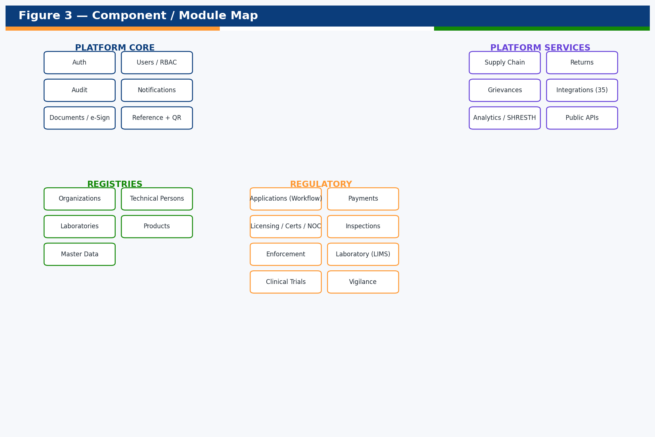
Figure 3 — Component / module map.

5.3 Process View (Workflow & Concurrency)
The dominant runtime process is the application workflow state machine, which governs every regulatory application type. Requests are stateless and authenticated per call via JWT; long-running human steps are modelled as explicit workflow states with audited transitions.
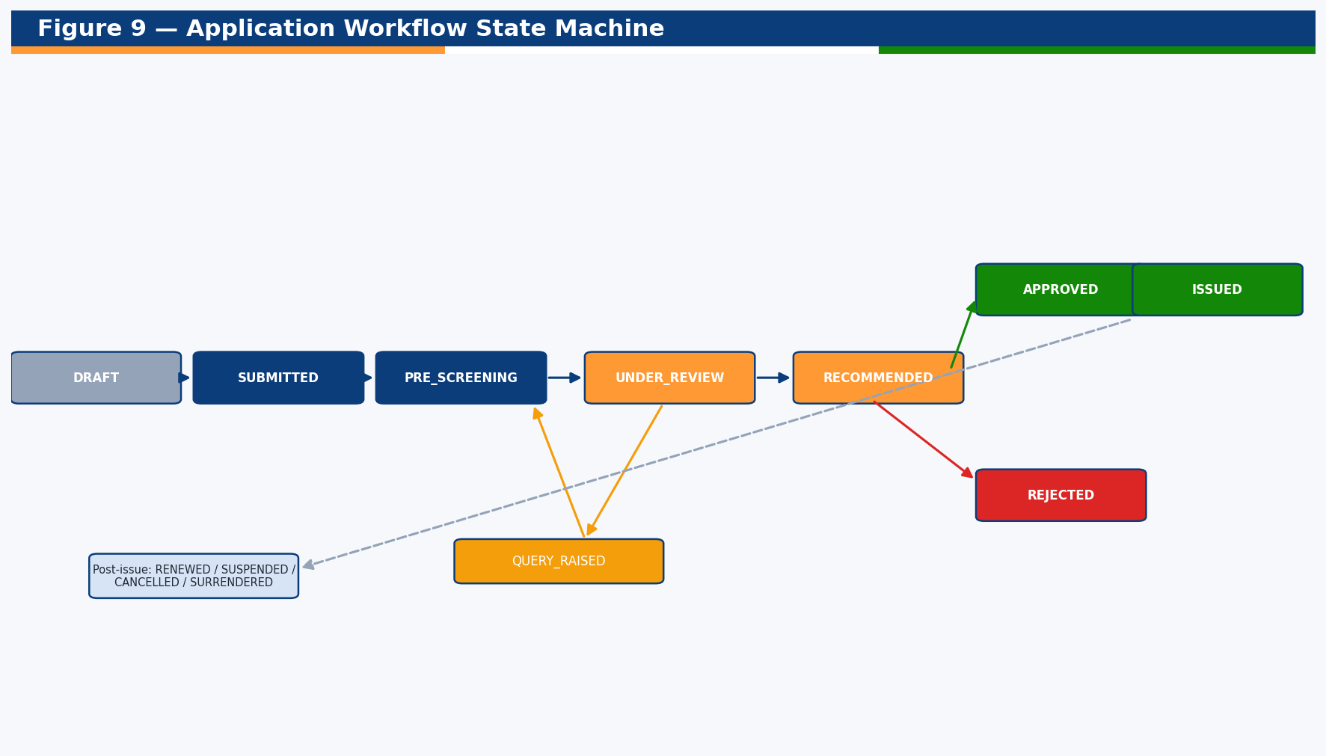
Figure 9 — Application workflow state machine.

5.4 Physical View (Deployment)
DDRS deploys as a single service that serves both the REST API and the built SPA. Three supported topologies are shown below.
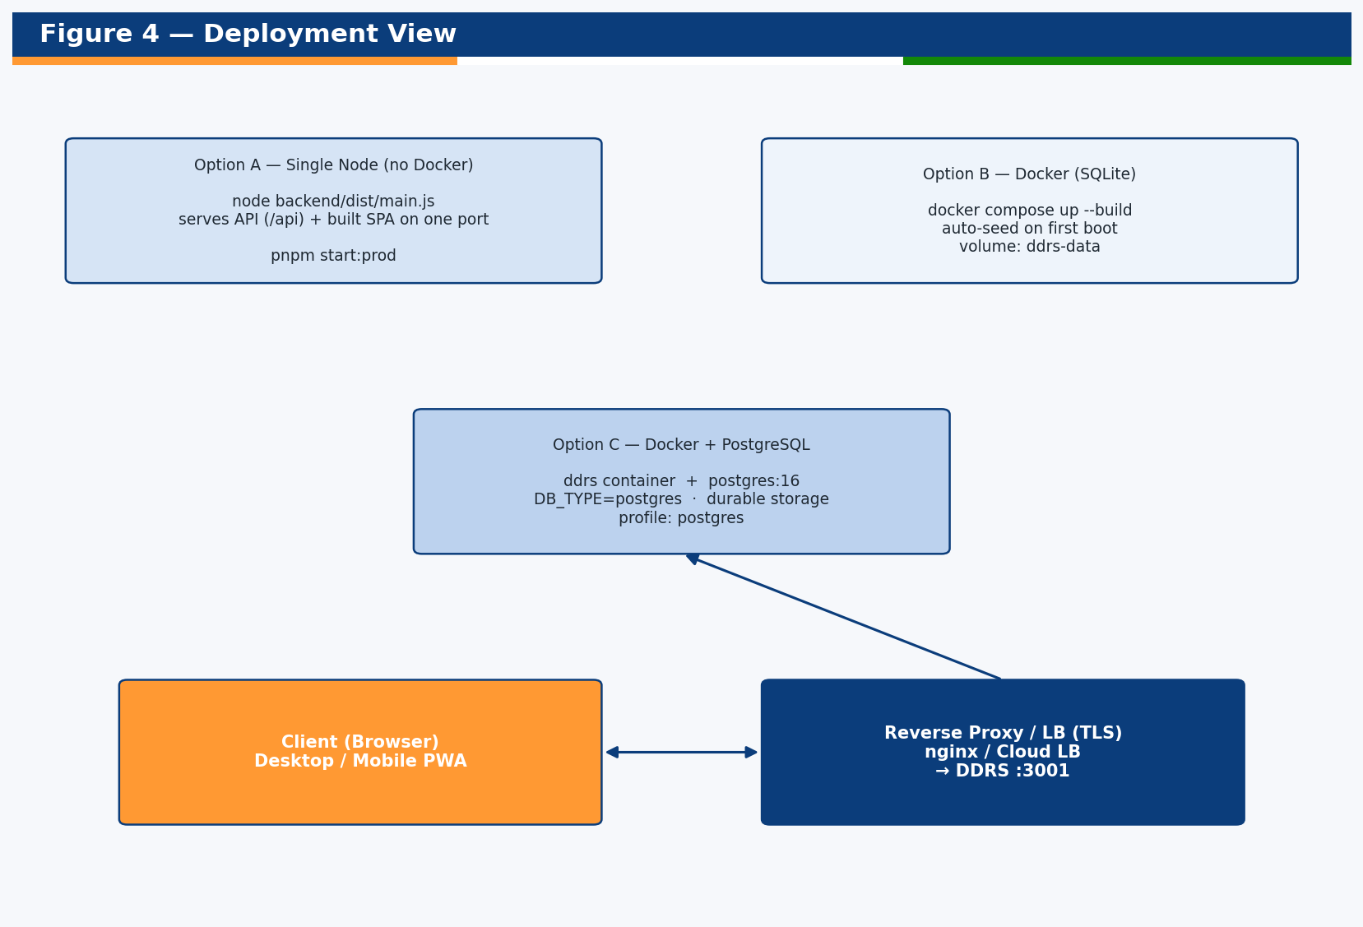
Figure 4 — Deployment view.

5.5 Scenarios (Navigation Map)
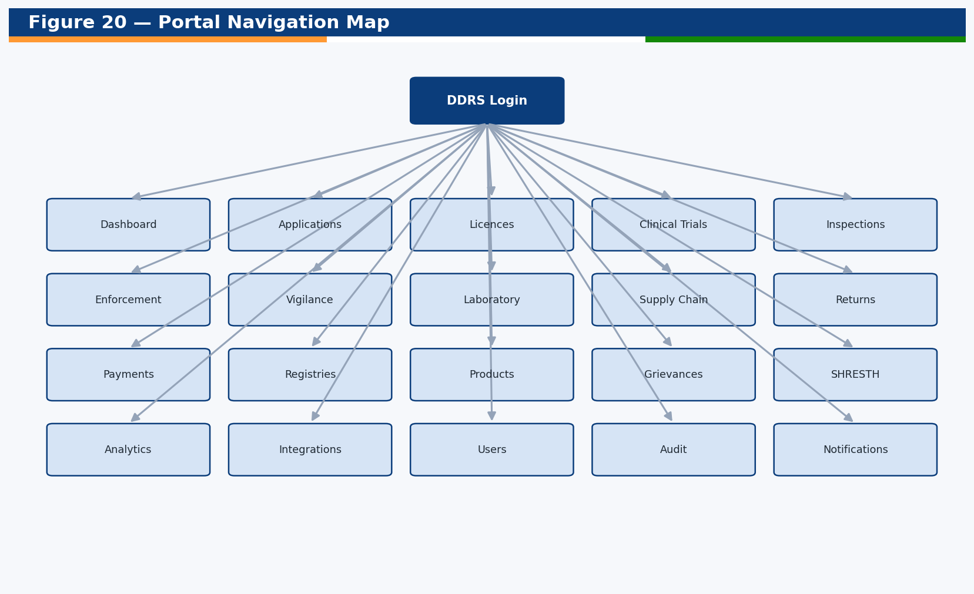
Figure 20 — Portal navigation map (role-filtered).

6. Data Architecture
All entities share a common base providing a UUID primary key and created/updated timestamps. The schema deliberately avoids database-specific features — it uses string-based enumerations and simple-json columns — so it runs unchanged on SQLite (development) and PostgreSQL (production). Lists are paginated, searchable, sortable and filterable through a shared data-access helper.

6.1 Core Domain ER
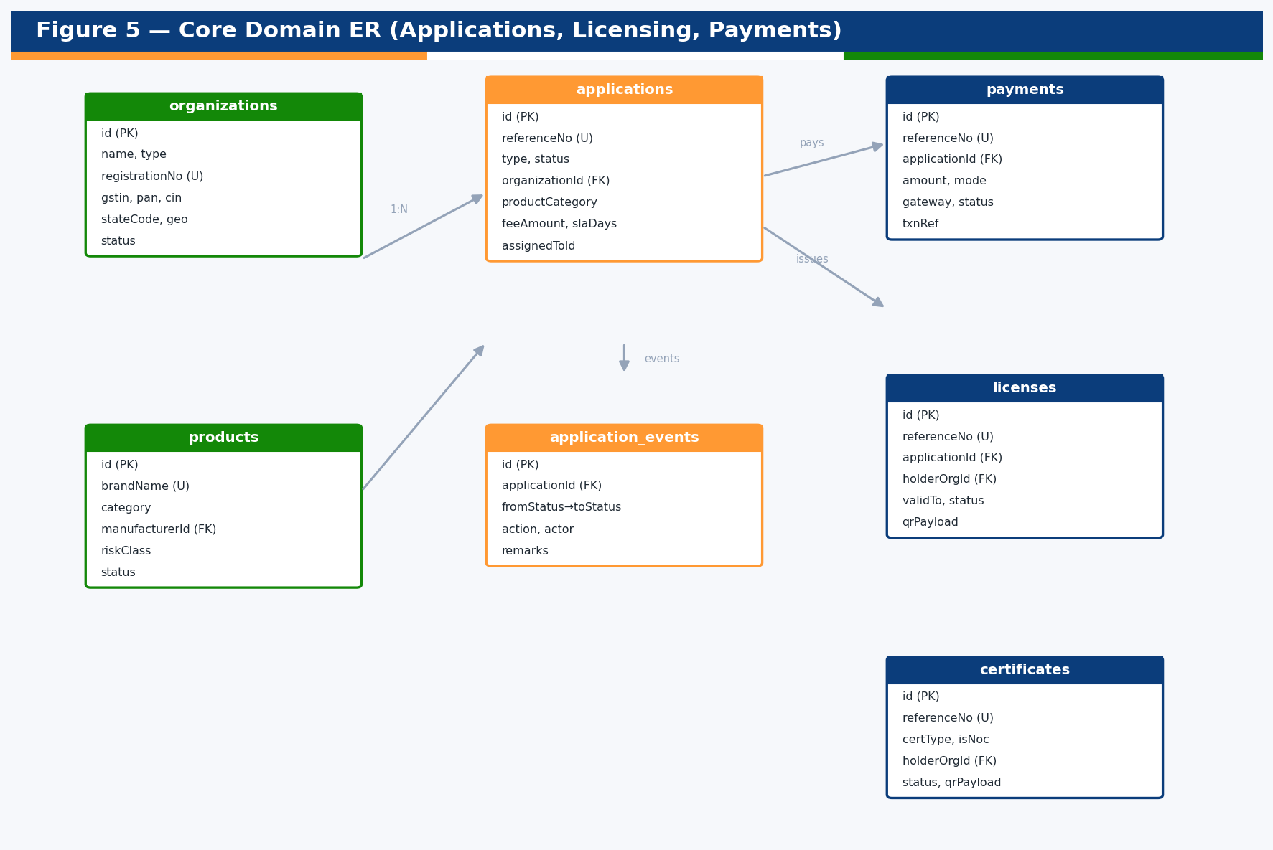
Figure 5 — Core domain ER (applications, licensing, payments).

6.2 Regulatory Operations ER
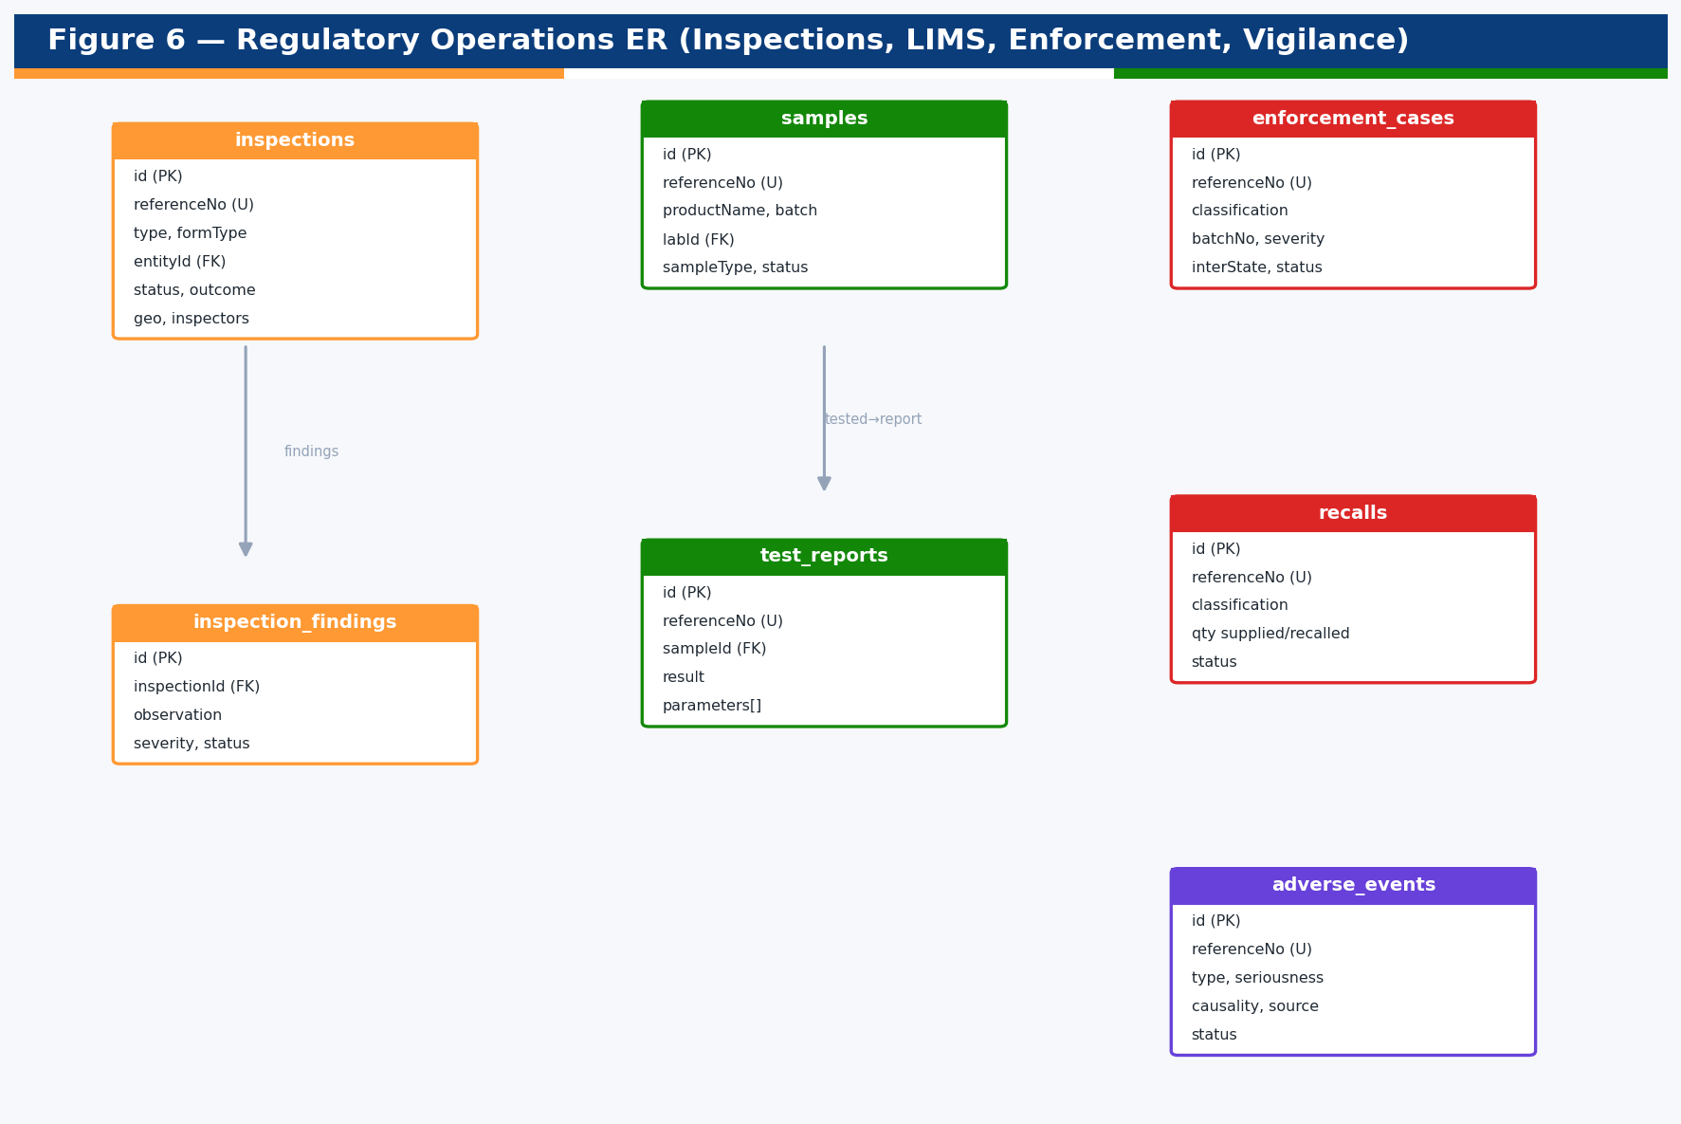
Figure 6 — Operations ER (inspections, LIMS, enforcement, vigilance).

6.3 Entity Catalogue
The system comprises 37 entities (564 columns in total). The following catalogue summarises each entity; the full field-level data dictionary is in Appendix A.
# | Table | Class | Module | Cols
1 | adverse_events | AdverseEvent | vigilance | 17
2 | application_events | ApplicationEvent | applications | 11
3 | applications | Application | applications | 31
4 | audit_logs | AuditLog | audit | 14
5 | batch_release_certs | BatchReleaseCertificate | laboratory | 12
6 | certificates | Certificate | licensing | 17
7 | clinical_trials | ClinicalTrial | clinical-trials | 18
8 | compensation_claims | CompensationClaim | vigilance | 11
9 | court_cases | CourtCase | enforcement | 13
10 | documents | Document | documents | 15
11 | enforcement_cases | EnforcementCase | enforcement | 18
12 | esignatures | ESignature | documents | 12
13 | fee_rules | FeeRule | payments | 9
14 | grievances | Grievance | grievances | 19
15 | inspection_findings | InspectionFinding | inspections | 10
16 | inspections | Inspection | inspections | 22
17 | integration_logs | IntegrationLog | integrations | 11
18 | invoices | Invoice | supply-chain | 11
19 | laboratories | Laboratory | registry | 20
20 | licenses | License | licensing | 20
21 | master_data | MasterData | master-data | 8
22 | notifications | Notification | notifications | 12
23 | organizations | Organization | registry | 27
24 | payments | Payment | payments | 18
25 | products | Product | products | 21
26 | psur | Psur | vigilance | 11
27 | recalls | Recall | enforcement | 16
28 | reference_standards | ReferenceStandard | laboratory | 10
29 | returns_filings | ReturnFiling | returns | 14
30 | samples | Sample | laboratory | 15
31 | supply_chain_batches | SupplyChainBatch | supply-chain | 15
32 | supply_chain_movements | SupplyChainMovement | supply-chain | 13
33 | technical_persons | TechnicalPerson | registry | 15
34 | test_reports | TestReport | laboratory | 15
35 | trial_sites | TrialSite | clinical-trials | 12
36 | users | User | users | 18
37 | work_allocations | WorkAllocation | applications | 13

6.4 Data Portability & Conventions
- UUID primary keys on every table for global uniqueness and merge-safety.
- String enums (not native DB enums) for portability and forward-compatibility.
- simple-json columns for arrays/objects (e.g., inspectors, parameters, conditions).
- Indexed reference numbers and foreign keys for fast lookups.
- Standardised reference numbers: CDSCO/<TYPE>/<YEAR>/<SEQ> with QR encoding.
- Timestamps on all rows; immutable audit_logs capture every mutation.

7. API Architecture
DDRS exposes a versioned REST API under the /api prefix, fully documented with Swagger/OpenAPI at /api/docs. There are 117 endpoints. All mutating requests are authenticated (JWT) and authorised (RBAC) unless explicitly marked public (verification, alerts, public registries, grievance filing).

7.1 API Conventions
- Authentication: Authorization: Bearer <JWT> (12-hour expiry).
- Authorization: @Roles(...) on handlers; SUPER_ADMIN bypass; @Public() for open reads.
- Pagination: ?page, ?limit, ?search, ?sortBy, ?sortOrder on all list endpoints.
- Responses: { data: [...], meta: { total, page, limit, totalPages } } for lists.
- Errors: standard HTTP status codes with a JSON message payload.
- Auditing: every non-GET request is recorded with user, IP, status and latency.

7.2 Endpoint Catalogue (by domain)

7.2 · analytics (4 endpoints)
Method | Path | Handler
GET | /api/analytics/dashboard | dashboard
GET | /api/analytics/report | report
GET | /api/analytics/shresth | shresth
GET | /api/analytics/summary | summary

7.2 · applications (11 endpoints)
Method | Path | Handler
GET | /api/applications | list
POST | /api/applications | create
GET | /api/applications/:id | getOne
POST | /api/applications/:id/allocate | allocate
POST | /api/applications/:id/confirm-payment | confirmPayment
POST | /api/applications/:id/submit | submit
POST | /api/applications/:id/transition | transition
GET | /api/applications/allocations | allocations
GET | /api/applications/overdue | overdue
GET | /api/applications/stats | stats
GET | /api/applications/trs | trs

7.2 · audit (2 endpoints)
Method | Path | Handler
GET | /api/audit | findAll
GET | /api/audit/stats | stats

7.2 · auth (6 endpoints)
Method | Path | Handler
POST | /api/auth/aadhaar | aadhaar
POST | /api/auth/login | login
GET | /api/auth/me | me
POST | /api/auth/otp/request | requestOtp
POST | /api/auth/otp/verify | verifyOtp
POST | /api/auth/register | register

7.2 · clinical-trials (4 endpoints)
Method | Path | Handler
GET | /api/clinical-trials | list
POST | /api/clinical-trials | create
GET | /api/clinical-trials/:id | findOne
GET | /api/clinical-trials/stats | stats

7.2 · documents (4 endpoints)
Method | Path | Handler
GET | /api/documents | list
POST | /api/documents | upload
GET | /api/documents/:id | findOne
POST | /api/documents/:id/sign | sign

7.2 · enforcement (7 endpoints)
Method | Path | Handler
GET | /api/enforcement/cases | listCases
POST | /api/enforcement/cases | createCase
GET | /api/enforcement/court-cases | listCourt
GET | /api/enforcement/recalls | listRecalls
POST | /api/enforcement/recalls | createRecall
GET | /api/enforcement/stats | stats
GET | /api/public/alerts | publicAlerts

7.2 · grievances (6 endpoints)
Method | Path | Handler
GET | /api/grievances | list
POST | /api/grievances | create
PATCH | /api/grievances/:id | update
POST | /api/grievances/public | filePublic
GET | /api/grievances/stats | stats
GET | /api/grievances/track/:ticketNo | track

7.2 · inspections (5 endpoints)
Method | Path | Handler
GET | /api/inspections | list
POST | /api/inspections | schedule
GET | /api/inspections/:id | findOne
POST | /api/inspections/:id/complete | complete
GET | /api/inspections/stats | stats

7.2 · integrations (4 endpoints)
Method | Path | Handler
GET | /api/integrations/catalog | catalog
POST | /api/integrations/invoke | invoke
GET | /api/integrations/logs | logs
GET | /api/integrations/stats | stats

7.2 · laboratory (7 endpoints)
Method | Path | Handler
GET | /api/laboratory/batch-release | listBrcs
GET | /api/laboratory/reference-standards | listStandards
GET | /api/laboratory/reports | listReports
GET | /api/laboratory/samples | listSamples
POST | /api/laboratory/samples | registerSample
POST | /api/laboratory/samples/:id/test | testSample
GET | /api/laboratory/stats | stats

7.2 · licensing (7 endpoints)
Method | Path | Handler
GET | /api/certificates | listCerts
GET | /api/certificates/:id | getCert
GET | /api/licenses | listLicenses
GET | /api/licenses/:id | getLicense
PATCH | /api/licenses/:id/status | setStatus
GET | /api/licensing/stats | stats
GET | /api/verify/:referenceNo | verify

7.2 · notifications (4 endpoints)
Method | Path | Handler
GET | /api/notifications | list
PATCH | /api/notifications/:id/read | markRead
PATCH | /api/notifications/read-all | markAll
GET | /api/notifications/unread-count | unread

7.2 · payments (6 endpoints)
Method | Path | Handler
GET | /api/payments | list
GET | /api/payments/:id | findOne
POST | /api/payments/:id/pay | pay
POST | /api/payments/:id/refund | refund
GET | /api/payments/calc | calc
GET | /api/payments/stats | stats

7.2 · products (5 endpoints)
Method | Path | Handler
GET | /api/products | list
POST | /api/products | create
GET | /api/products/:id | findOne
GET | /api/products/check-brand | checkBrand
GET | /api/products/stats | stats

7.2 · registry (15 endpoints)
Method | Path | Handler
GET | /api/registry/laboratories | listLabs
POST | /api/registry/laboratories | createLab
GET | /api/registry/laboratories/:id | lab
GET | /api/registry/laboratories/stats | labStats
GET | /api/registry/organizations | listOrgs
POST | /api/registry/organizations | createOrg
GET | /api/registry/organizations/:id | org
PATCH | /api/registry/organizations/:id/status | setOrgStatus
GET | /api/registry/organizations/stats | orgStats
GET | /api/registry/technical-persons | listTps
POST | /api/registry/technical-persons | createTp
GET | /api/registry/technical-persons/:id | tp
PATCH | /api/registry/technical-persons/:id/assign | assignTp
PATCH | /api/registry/technical-persons/:id/release | releaseTp
GET | /api/registry/technical-persons/duplicates | tpDuplicates

7.2 · returns (3 endpoints)
Method | Path | Handler
GET | /api/returns | list
POST | /api/returns | file
GET | /api/returns/stats | stats

7.2 · supply-chain (4 endpoints)
Method | Path | Handler
GET | /api/supply-chain/batches | listBatches
GET | /api/supply-chain/invoices | listInvoices
GET | /api/supply-chain/stats | stats
GET | /api/supply-chain/trace/:batchNo | trace

7.2 · system (2 endpoints)
Method | Path | Handler
GET | /api | apiRoot
GET | /api/health | health

7.2 · users (5 endpoints)
Method | Path | Handler
GET | /api/users | findAll
GET | /api/users/:id | findOne
PATCH | /api/users/:id/status | updateStatus
GET | /api/users/me | me
GET | /api/users/stats | stats

7.2 · vigilance (6 endpoints)
Method | Path | Handler
GET | /api/vigilance/compensation | listClaims
GET | /api/vigilance/events | listEvents
POST | /api/vigilance/events | createEvent
POST | /api/vigilance/events/import-icsr | importIcsr
GET | /api/vigilance/psur | listPsur
GET | /api/vigilance/stats | stats

8. Module Deep-Dives
This section provides a detailed design reference for each backend module: its purpose, responsibilities, domain entities, API endpoints, business rules and knowledge-transfer notes. Module names match the source folders under backend/src/modules.

8.1 Authentication (auth)

Overview
The auth module issues and validates JSON Web Tokens and supports three sign-in methods: password, one-time password (OTP), and a simulated Aadhaar/DigiLocker e-KYC flow. Tokens carry the user identity, roles, organization and state scope, and expire after 12 hours. The module is the single entry point for establishing an authenticated session used by every other module via the global JWT guard.

Responsibilities
- Password login with bcrypt verification and account-status checks.
- OTP request/verify (demo OTP surfaced for demonstration; production uses SMS/email gateways).
- Simulated Aadhaar/DigiLocker login that links or provisions a public user.
- Self-registration for external stakeholders.
- JWT signing with role and scope claims.

API Endpoints
Method | Path | Handler
POST | /api/auth/aadhaar | aadhaar
POST | /api/auth/login | login
GET | /api/auth/me | me
POST | /api/auth/otp/request | requestOtp
POST | /api/auth/otp/verify | verifyOtp
POST | /api/auth/register | register

Business Rules
- Suspended accounts cannot authenticate.
- OTPs expire after five minutes and are single-use.
- Aadhaar must be 12 digits (format-validated; verification simulated).
- Last-login timestamp and IP are recorded on every successful sign-in.

Knowledge-Transfer Notes
- JWT secret is configured via JWT_SECRET; rotate in production.
- Swap the OTP store for Redis and wire a real SMS/email provider for production.

Sequence & Interactions
At runtime, requests to this module pass through the global JWT authentication guard and the RBAC guard before reaching the controller. The controller delegates to the service, which applies business rules, persists changes via TypeORM repositories, emits notifications/audit entries where relevant, and returns a typed response. List endpoints use the shared pagination helper for consistent search, sort and filter semantics.

Error Handling & Edge Cases
Validation errors return HTTP 400 with an explanatory message; unauthenticated access returns 401 and insufficient privileges 403. Not-found lookups return 404. Conflicts (e.g., duplicate unique keys) return 409. The module fails safe — no partial state is persisted on a rejected operation — and all failures are audited.

Extensibility
New fields are added via TypeORM entity columns (portable types only); new sub-types or statuses are added as string values without schema-breaking changes; new endpoints follow the controller/service/DTO pattern. Because the module is isolated behind its OpenAPI contract, it can be extracted into an independent microservice without affecting callers.

Operational & Monitoring Notes
Operationally, monitor request latency and error rates on this module’s endpoints, watch the audit stream for anomalous activity, and review domain statistics on the dashboards. Data growth is linear with regulatory volume and is addressed by PostgreSQL indexing and read replicas in production.

8.2 Users & RBAC (users)

Overview
The users module is the registry of all internal and external user accounts and the source of truth for role assignment. It exposes profile retrieval, administrative listing/search, status management and aggregate statistics. Passwords are stored as bcrypt hashes and never serialised in API responses.

Responsibilities
- Maintain user records with primary role, role set, organization and state scope.
- Expose /users/me for the authenticated profile.
- Administrative search/list with role and status filters.
- Activate/suspend accounts; record last-login metadata.

Domain Entities
User (table: users) — Domain entity.
Column | Type | Attributes
id | uuid | PK
createdAt | Date | —
updatedAt | Date | —
email | string | unique, indexed
passwordHash | string | —
fullName | string | —
phone | string | nullable
primaryRole | Role | default=Role.PUBLIC_USER
roles | Role[] | —
status | UserStatus | default=ACTIVE
organizationId | string | indexed, nullable
stateCode | string | nullable
office | string | nullable
designation | string | nullable
aadhaarMasked | string | nullable
aadhaarVerified | boolean | default=false
lastLoginAt | Date | nullable
lastLoginIp | string | nullable

API Endpoints
Method | Path | Handler
GET | /api/users | findAll
GET | /api/users/:id | findOne
PATCH | /api/users/:id/status | updateStatus
GET | /api/users/me | me
GET | /api/users/stats | stats

Business Rules
- Email is unique and lower-cased.
- passwordHash is excluded from all serialised output.
- Only privileged roles may list or change other users.

Knowledge-Transfer Notes
- Roles are defined in the Role enum; nineteen roles map to five portal groups.
- Conditional access is enforced by route-level @Roles and the global RolesGuard.

Sequence & Interactions
At runtime, requests to this module pass through the global JWT authentication guard and the RBAC guard before reaching the controller. The controller delegates to the service, which applies business rules, persists changes via TypeORM repositories, emits notifications/audit entries where relevant, and returns a typed response. List endpoints use the shared pagination helper for consistent search, sort and filter semantics.

Error Handling & Edge Cases
Validation errors return HTTP 400 with an explanatory message; unauthenticated access returns 401 and insufficient privileges 403. Not-found lookups return 404. Conflicts (e.g., duplicate unique keys) return 409. The module fails safe — no partial state is persisted on a rejected operation — and all failures are audited.

Extensibility
New fields are added via TypeORM entity columns (portable types only); new sub-types or statuses are added as string values without schema-breaking changes; new endpoints follow the controller/service/DTO pattern. Because the module is isolated behind its OpenAPI contract, it can be extracted into an independent microservice without affecting callers.

Operational & Monitoring Notes
Operationally, monitor request latency and error rates on this module’s endpoints, watch the audit stream for anomalous activity, and review domain statistics on the dashboards. Data growth is linear with regulatory volume and is addressed by PostgreSQL indexing and read replicas in production.

8.3 Registries (registry)

Overview
The registry module manages the regulated-entity registry (manufacturers, importers, exporters, wholesalers, retailers, CROs, ethics committees, blood centres, BA/BE centres, consultants, marketers), the technical-person registry and the testing-laboratory registry. It is the master-data backbone for licensing, inspections and supply-chain.

Responsibilities
- CRUD and search for organizations with GSTIN/PAN/CIN and geo-tag.
- Technical-person registry with engagement lifecycle.
- Laboratory onboarding for Central/State/Private labs (no code change required).
- Statistics by type and by state for dashboards.

Domain Entities
Laboratory (table: laboratories) — Testing Laboratory registry — Central (CDL/CDTL/RDTL/IPC/NIB), State and Private labs. Onboardable without code changes (RFP requirement).
Column | Type | Attributes
id | uuid | PK
createdAt | Date | —
updatedAt | Date | —
name | string | indexed
type | LabType | indexed
registrationNo | string | unique, indexed
stateCode | string | nullable
stateName | string | nullable
city | string | nullable
address | string | nullable
latitude | number | nullable
longitude | number | nullable
nablAccreditationNo | string | nullable
nablAccredited | boolean | default=false
testingScope | string[] | nullable
contactPerson | string | nullable
email | string | nullable
phone | string | nullable
status | EntityStatus | default=EntityStatus.ACTIVE
capacityPerMonth | number | default=0
Organization (table: organizations) — Regulated entity registry — manufacturers, importers, exporters, wholesalers/retailers, CROs, ethics committees, blood centres, BA/BE centres, consultants, marketers. Acts as a source-of-truth registry.
Column | Type | Attributes
id | uuid | PK
createdAt | Date | —
updatedAt | Date | —
name | string | indexed
type | OrganizationType | indexed
registrationNo | string | unique, indexed
gstin | string | nullable
pan | string | nullable
cin | string | nullable
address | string | nullable
city | string | nullable
stateCode | string | indexed, nullable
stateName | string | nullable
pincode | string | nullable
latitude | number | nullable
longitude | number | nullable
contactPerson | string | nullable
email | string | nullable
phone | string | nullable
website | string | nullable
status | EntityStatus | default=EntityStatus.ACTIVE
jurisdiction | Jurisdiction | default=Jurisdiction.STATE
riskClass | RiskClass | nullable
productCategories | string[] | nullable
establishedYear | number | nullable
productCount | number | default=0
ownerUserId | string | nullable
TechnicalPerson (table: technical_persons) — Technical Person registry. Business rule (RFP): a technical person can be associated with only ONE manufacturer / laboratory / blood bank / wholesaler / retailer at a time. Enforced via a unique registrationNo and single organizationId, wi
Column | Type | Attributes
id | uuid | PK
createdAt | Date | —
updatedAt | Date | —
name | string | —
registrationNo | string | unique, indexed
qualification | string | nullable
designation | string | nullable
email | string | nullable
phone | string | nullable
aadhaarMasked | string | nullable
organizationId | string | indexed, nullable
organizationName | string | nullable
organizationType | string | nullable
status | 'ENGAGED' | 'AVAILABLE' | 'BLACKLI | default=ENGAGED
experienceYears | number | nullable

API Endpoints
Method | Path | Handler
GET | /api/registry/laboratories | listLabs
POST | /api/registry/laboratories | createLab
GET | /api/registry/laboratories/:id | lab
GET | /api/registry/laboratories/stats | labStats
GET | /api/registry/organizations | listOrgs
POST | /api/registry/organizations | createOrg
GET | /api/registry/organizations/:id | org
PATCH | /api/registry/organizations/:id/status | setOrgStatus
GET | /api/registry/organizations/stats | orgStats
GET | /api/registry/technical-persons | listTps
POST | /api/registry/technical-persons | createTp
GET | /api/registry/technical-persons/:id | tp
PATCH | /api/registry/technical-persons/:id/assign | assignTp
PATCH | /api/registry/technical-persons/:id/release | releaseTp
GET | /api/registry/technical-persons/duplicates | tpDuplicates

Business Rules
- Registration numbers are unique per registry.
- A technical person may be engaged with only ONE entity at a time; reassigning an already-engaged person is rejected.
- Lab onboarding is data-driven so the notified-lab list changes without redeployment.

Knowledge-Transfer Notes
- The uniqueness rule is enforced in TechnicalPersonsService.assign().
- Geo-tag (latitude/longitude) supports premises mapping and inspection routing.

Sequence & Interactions
At runtime, requests to this module pass through the global JWT authentication guard and the RBAC guard before reaching the controller. The controller delegates to the service, which applies business rules, persists changes via TypeORM repositories, emits notifications/audit entries where relevant, and returns a typed response. List endpoints use the shared pagination helper for consistent search, sort and filter semantics.

Error Handling & Edge Cases
Validation errors return HTTP 400 with an explanatory message; unauthenticated access returns 401 and insufficient privileges 403. Not-found lookups return 404. Conflicts (e.g., duplicate unique keys) return 409. The module fails safe — no partial state is persisted on a rejected operation — and all failures are audited.

Extensibility
New fields are added via TypeORM entity columns (portable types only); new sub-types or statuses are added as string values without schema-breaking changes; new endpoints follow the controller/service/DTO pattern. Because the module is isolated behind its OpenAPI contract, it can be extracted into an independent microservice without affecting callers.

Operational & Monitoring Notes
Operationally, monitor request latency and error rates on this module’s endpoints, watch the audit stream for anomalous activity, and review domain statistics on the dashboards. Data growth is linear with regulatory volume and is addressed by PostgreSQL indexing and read replicas in production.

8.4 Product Registry (products)

Overview
The products module catalogues every regulated product across all categories with brand, generic, dosage form, strength, composition, schedule, risk class and manufacturer linkage. It includes a brand-name duplication guard to prevent confusingly similar brands.

Responsibilities
- Product CRUD and category-filtered search.
- Brand-name duplication check endpoint.
- Category-wise statistics.

Domain Entities
Product (table: products) — Product registry across all regulated categories (drugs, biologicals, medical devices, IVDs, cosmetics, veterinary, AYUSH, blood products).
Column | Type | Attributes
id | uuid | PK
createdAt | Date | —
updatedAt | Date | —
name | string | indexed
brandName | string | indexed, nullable
category | ProductCategory | indexed
genericName | string | nullable
dosageForm | string | nullable
strength | string | nullable
composition | string | nullable
registrationNo | string | unique, indexed
riskClass | RiskClass | nullable
schedule | string | nullable
therapeuticArea | string | nullable
hsnCode | string | nullable
packSize | string | nullable
manufacturerId | string | indexed, nullable
manufacturerName | string | nullable
status | string | default=ACTIVE
isImported | boolean | default=false
approvalDate | Date | nullable

API Endpoints
Method | Path | Handler
GET | /api/products | list
POST | /api/products | create
GET | /api/products/:id | findOne
GET | /api/products/check-brand | checkBrand
GET | /api/products/stats | stats

Business Rules
- Registration number is unique.
- Creating a product with an existing brand name is rejected (duplication guard).

Knowledge-Transfer Notes
- Risk class drives fee calculation and licensing jurisdiction for devices/IVDs.

Sequence & Interactions
At runtime, requests to this module pass through the global JWT authentication guard and the RBAC guard before reaching the controller. The controller delegates to the service, which applies business rules, persists changes via TypeORM repositories, emits notifications/audit entries where relevant, and returns a typed response. List endpoints use the shared pagination helper for consistent search, sort and filter semantics.

Error Handling & Edge Cases
Validation errors return HTTP 400 with an explanatory message; unauthenticated access returns 401 and insufficient privileges 403. Not-found lookups return 404. Conflicts (e.g., duplicate unique keys) return 409. The module fails safe — no partial state is persisted on a rejected operation — and all failures are audited.

Extensibility
New fields are added via TypeORM entity columns (portable types only); new sub-types or statuses are added as string values without schema-breaking changes; new endpoints follow the controller/service/DTO pattern. Because the module is isolated behind its OpenAPI contract, it can be extracted into an independent microservice without affecting callers.

Operational & Monitoring Notes
Operationally, monitor request latency and error rates on this module’s endpoints, watch the audit stream for anomalous activity, and review domain statistics on the dashboards. Data growth is linear with regulatory volume and is addressed by PostgreSQL indexing and read replicas in production.

8.5 Applications & Workflow Engine (applications)

Overview
The applications module is the heart of DDRS. A generic workflow engine drives every regulatory application type (registration, market authorisation, licensing, renewal, endorsement, post-approval change, suspension, surrender, correction, appeal and NOC) through a validated state machine. It manages fee creation, masked auto-allocation to officers, the Timeline Review System (TRS) and automatic issuance of the resulting licence or certificate on approval.

Responsibilities
- Create, submit and progress applications through validated state transitions.
- Compute fees and create payment records on submission.
- Auto/random/manual allocation of work to officers (masked assignment).
- Maintain an immutable per-application event history.
- Provide TRS ageing buckets and overdue lists.
- Trigger licence/certificate/NOC issuance on approval.

Domain Entities
ApplicationEvent (table: application_events) — Immutable workflow history entry for an application.
Column | Type | Attributes
id | uuid | PK
createdAt | Date | —
updatedAt | Date | —
applicationId | string | indexed
fromStatus | string | nullable
toStatus | string | nullable
action | string | —
actorId | string | nullable
actorName | string | nullable
actorRole | string | nullable
remarks | string | nullable
Application (table: applications) — Central application object driven by the generic workflow engine. Covers the full regulatory lifecycle: registration, market authorisation, licensing, renewal, endorsement, post-approval change, suspension, surrender, appeal, NOC, clinical
Column | Type | Attributes
id | uuid | PK
createdAt | Date | —
updatedAt | Date | —
referenceNo | string | unique, indexed
type | ApplicationType | indexed
title | string | —
productCategory | ProductCategory | indexed, nullable
riskClass | RiskClass | nullable
jurisdiction | Jurisdiction | indexed, default=Jurisdiction.CENTRE
stateCode | string | nullable
applicantUserId | string | nullable
applicantName | string | nullable
organizationId | string | indexed, nullable
organizationName | string | nullable
status | ApplicationStatus | indexed, default=ApplicationStatus.DRAFT
currentStage | string | default=Submission
assignedToId | string | indexed, nullable
assignedToName | string | nullable
priority | string | default=NORMAL
feeAmount | number | default=0
feePaid | boolean | default=false
paymentId | string | nullable
submittedAt | Date | nullable
slaDays | number | default=30
dueDate | Date | indexed, nullable
decisionDate | Date | nullable
decisionRemarks | string | nullable
productId | string | nullable
relatedLicenseId | string | nullable
issuedLicenseId | string | nullable
formData | Record<string, any> | nullable
WorkAllocation (table: work_allocations) — Records random/auto/manual allocation of work (applications, inspections, sample testing) to officers — supports masked assignment and manual override.
Column | Type | Attributes
id | uuid | PK
createdAt | Date | —
updatedAt | Date | —
itemType | string | indexed
itemId | string | indexed
itemRef | string | nullable
assignedToId | string | —
assignedToName | string | —
assignedToRole | string | nullable
mode | AllocationMode | default=AllocationMode.AUTO
masked | boolean | default=false
allocatedById | string | nullable
status | 'ASSIGNED' | 'COMPLETED' | 'REASSI | default=ASSIGNED

API Endpoints
Method | Path | Handler
GET | /api/applications | list
POST | /api/applications | create
GET | /api/applications/:id | getOne
POST | /api/applications/:id/allocate | allocate
POST | /api/applications/:id/confirm-payment | confirmPayment
POST | /api/applications/:id/submit | submit
POST | /api/applications/:id/transition | transition
GET | /api/applications/allocations | allocations
GET | /api/applications/overdue | overdue
GET | /api/applications/stats | stats
GET | /api/applications/trs | trs

Business Rules
- Transitions are validated against an allowed-transition map (SUPER_ADMIN may override).
- Fee payment is required before pre-screening proceeds.
- Due date = submission date + SLA days; breaches surface in TRS.
- Issuance is automatic and idempotent on entering APPROVED.

Knowledge-Transfer Notes
- Allowed transitions live in the TRANSITIONS map in applications.service.ts.
- Reference numbers use a runtime base of 900000 to avoid collisions with seeded data.
- Officer identity is masked on allocation to reduce bias, with manual override available.

Sequence & Interactions
At runtime, requests to this module pass through the global JWT authentication guard and the RBAC guard before reaching the controller. The controller delegates to the service, which applies business rules, persists changes via TypeORM repositories, emits notifications/audit entries where relevant, and returns a typed response. List endpoints use the shared pagination helper for consistent search, sort and filter semantics.

Error Handling & Edge Cases
Validation errors return HTTP 400 with an explanatory message; unauthenticated access returns 401 and insufficient privileges 403. Not-found lookups return 404. Conflicts (e.g., duplicate unique keys) return 409. The module fails safe — no partial state is persisted on a rejected operation — and all failures are audited.

Extensibility
New fields are added via TypeORM entity columns (portable types only); new sub-types or statuses are added as string values without schema-breaking changes; new endpoints follow the controller/service/DTO pattern. Because the module is isolated behind its OpenAPI contract, it can be extracted into an independent microservice without affecting callers.

Operational & Monitoring Notes
Operationally, monitor request latency and error rates on this module’s endpoints, watch the audit stream for anomalous activity, and review domain statistics on the dashboards. Data growth is linear with regulatory volume and is addressed by PostgreSQL indexing and read replicas in production.

8.6 Payments (payments)

Overview
The payments module auto-calculates regulatory fees from configurable rules and simulates remittance through Bharat Kosh (Consolidated Fund of India) and State Treasuries. It supports refunds, transaction history and collection statistics.

Responsibilities
- Fee calculation by application type, product category, risk class and jurisdiction.
- Create, pay (simulated gateway) and refund transactions.
- Collection and status statistics for dashboards.

Domain Entities
FeeRule (table: fee_rules) — Configurable fee rule used to auto-calculate application fees.
Column | Type | Attributes
id | uuid | PK
createdAt | Date | —
updatedAt | Date | —
applicationType | string | indexed
productCategory | string | nullable
riskClass | string | nullable
jurisdiction | string | nullable
amount | number | —
description | string | nullable
Payment (table: payments) — Fee payment record (Bharat Kosh / State Treasury — simulated gateway).
Column | Type | Attributes
id | uuid | PK
createdAt | Date | —
updatedAt | Date | —
referenceNo | string | unique, indexed
applicationId | string | nullable
applicationRef | string | nullable
payerId | string | nullable
payerName | string | nullable
amount | number | —
currency | string | default=INR
mode | PaymentMode | default=PaymentMode.UPI
gateway | string | default=BHARAT_KOSH
status | PaymentStatus | indexed, default=PaymentStatus.PENDING
txnRef | string | nullable
paidAt | Date | nullable
breakup | { head: string | nullable
refundRef | string | nullable
refundedAt | Date | nullable

API Endpoints
Method | Path | Handler
GET | /api/payments | list
GET | /api/payments/:id | findOne
POST | /api/payments/:id/pay | pay
POST | /api/payments/:id/refund | refund
GET | /api/payments/calc | calc
GET | /api/payments/stats | stats

Business Rules
- Fee = base (rule-matched) + 18% GST + portal charge.
- Only PAID transactions can be refunded.
- State applications route to State Treasury; central to Bharat Kosh.

Knowledge-Transfer Notes
- Replace the simulated gateway with the real Bharat Kosh (pay.gov.in) and treasury APIs in production.

Sequence & Interactions
At runtime, requests to this module pass through the global JWT authentication guard and the RBAC guard before reaching the controller. The controller delegates to the service, which applies business rules, persists changes via TypeORM repositories, emits notifications/audit entries where relevant, and returns a typed response. List endpoints use the shared pagination helper for consistent search, sort and filter semantics.

Error Handling & Edge Cases
Validation errors return HTTP 400 with an explanatory message; unauthenticated access returns 401 and insufficient privileges 403. Not-found lookups return 404. Conflicts (e.g., duplicate unique keys) return 409. The module fails safe — no partial state is persisted on a rejected operation — and all failures are audited.

Extensibility
New fields are added via TypeORM entity columns (portable types only); new sub-types or statuses are added as string values without schema-breaking changes; new endpoints follow the controller/service/DTO pattern. Because the module is isolated behind its OpenAPI contract, it can be extracted into an independent microservice without affecting callers.

Operational & Monitoring Notes
Operationally, monitor request latency and error rates on this module’s endpoints, watch the audit stream for anomalous activity, and review domain statistics on the dashboards. Data growth is linear with regulatory volume and is addressed by PostgreSQL indexing and read replicas in production.

8.7 Licensing, Certificates & NOC (licensing)

Overview
The licensing module issues licences and certificates/NOCs (COPP, FSC, MSC, NCC, WC, WHO-GMP, neutral codes and various NOCs), each with a standardised reference number and a QR payload. It provides public, no-login verification of any issued artefact by reference number or QR scan.

Responsibilities
- Issue licences with form numbers, validity and conditions.
- Issue certificates and NOCs with type-specific fields.
- Generate QR codes for public verification.
- Public /verify endpoint returning validity, details and QR.

Domain Entities
Certificate (table: certificates) — Issued certificate or NOC (COPP, FSC, MSC, NCC, WC, GMP, NOCs, codes).
Column | Type | Attributes
id | uuid | PK
createdAt | Date | —
updatedAt | Date | —
referenceNo | string | unique, indexed
certType | CertificateType | indexed
isNoc | boolean | default=false
applicationId | string | nullable
holderOrgId | string | indexed, nullable
holderName | string | nullable
productId | string | nullable
productName | string | nullable
issueDate | Date | nullable
validTo | Date | nullable
status | string | default=ACTIVE
qrPayload | string | nullable
issuedByName | string | nullable
fields | Record<string, any> | nullable
License (table: licenses) — Issued licence (manufacturing, import, sale, test, loan, etc.).
Column | Type | Attributes
id | uuid | PK
createdAt | Date | —
updatedAt | Date | —
referenceNo | string | unique, indexed
licenceType | string | —
formNumber | string | nullable
applicationId | string | nullable
holderOrgId | string | indexed, nullable
holderName | string | nullable
productCategory | ProductCategory | nullable
jurisdiction | Jurisdiction | default=Jurisdiction.CENTRE
stateCode | string | nullable
status | LicenseStatus | indexed, default=LicenseStatus.ISSUED
issueDate | Date | nullable
validFrom | Date | nullable
validTo | Date | indexed, nullable
productCount | number | default=0
conditions | string[] | nullable
qrPayload | string | nullable
issuedByName | string | nullable

API Endpoints
Method | Path | Handler
GET | /api/certificates | listCerts
GET | /api/certificates/:id | getCert
GET | /api/licenses | listLicenses
GET | /api/licenses/:id | getLicense
PATCH | /api/licenses/:id/status | setStatus
GET | /api/licensing/stats | stats
GET | /api/verify/:referenceNo | verify

Business Rules
- Reference numbers are unique and embedded in the QR payload.
- Verification reflects current status (e.g., cancelled licences show as invalid).

Knowledge-Transfer Notes
- QR generation uses the shared ReferenceService.qrDataUrl().
- Certificates and NOCs share one table distinguished by certType/isNoc.

Sequence & Interactions
At runtime, requests to this module pass through the global JWT authentication guard and the RBAC guard before reaching the controller. The controller delegates to the service, which applies business rules, persists changes via TypeORM repositories, emits notifications/audit entries where relevant, and returns a typed response. List endpoints use the shared pagination helper for consistent search, sort and filter semantics.

Error Handling & Edge Cases
Validation errors return HTTP 400 with an explanatory message; unauthenticated access returns 401 and insufficient privileges 403. Not-found lookups return 404. Conflicts (e.g., duplicate unique keys) return 409. The module fails safe — no partial state is persisted on a rejected operation — and all failures are audited.

Extensibility
New fields are added via TypeORM entity columns (portable types only); new sub-types or statuses are added as string values without schema-breaking changes; new endpoints follow the controller/service/DTO pattern. Because the module is isolated behind its OpenAPI contract, it can be extracted into an independent microservice without affecting callers.

Operational & Monitoring Notes
Operationally, monitor request latency and error rates on this module’s endpoints, watch the audit stream for anomalous activity, and review domain statistics on the dashboards. Data growth is linear with regulatory volume and is addressed by PostgreSQL indexing and read replicas in production.

8.8 Inspections (inspections)

Overview
The inspections module schedules and records site inspections — manufacturing, joint (Centre+State), BA/BE, CRO, blood centre, retail, written-confirmation and medical-device — with geo-tagging, masked inspector assignment and digital forms (Form-35, MD-11, COS-11). Findings are captured with severity and resolution status.

Responsibilities
- Schedule inspections with form type and masked inspectors.
- Capture outcome (compliant/non-compliant/critical) and findings.
- Support joint consolidated reporting.
- Statistics by status and outcome.

Domain Entities
InspectionFinding (table: inspection_findings) — Domain entity.
Column | Type | Attributes
id | uuid | PK
createdAt | Date | —
updatedAt | Date | —
inspectionId | string | indexed
code | string | nullable
observation | string | —
severity | string | default=MINOR
category | string | nullable
response | string | nullable
status | string | default=OPEN
Inspection (table: inspections) — Site inspection — manufacturing, joint (Centre+State), BA/BE, CRO, blood centre, retail, WC, medical device, etc. Captures geo-tag and form data (Form-35 / MD-11 / COS-11). Supports joint consolidated reporting.
Column | Type | Attributes
id | uuid | PK
createdAt | Date | —
updatedAt | Date | —
referenceNo | string | unique, indexed
type | string | indexed
entityId | string | nullable
entityName | string | nullable
stateCode | string | nullable
jurisdiction | Jurisdiction | default=Jurisdiction.STATE
isJoint | boolean | default=false
formType | string | nullable
scheduledDate | Date | nullable
conductedDate | Date | nullable
inspectors | { id?: string | nullable
masked | boolean | default=false
status | string | indexed, default=SCHEDULED
outcome | string | nullable
latitude | number | nullable
longitude | number | nullable
observationsCount | number | default=0
applicationId | string | nullable
consolidatedReport | Record<string, any> | nullable

API Endpoints
Method | Path | Handler
GET | /api/inspections | list
POST | /api/inspections | schedule
GET | /api/inspections/:id | findOne
POST | /api/inspections/:id/complete | complete
GET | /api/inspections/stats | stats

Business Rules
- Inspectors are masked until the inspection is completed.
- Findings carry severity (critical/major/minor) and an open/resolved state.

Knowledge-Transfer Notes
- Geo-coordinates support premises verification and routing.
- Detail view fetches findings via /inspections/:id.

Sequence & Interactions
At runtime, requests to this module pass through the global JWT authentication guard and the RBAC guard before reaching the controller. The controller delegates to the service, which applies business rules, persists changes via TypeORM repositories, emits notifications/audit entries where relevant, and returns a typed response. List endpoints use the shared pagination helper for consistent search, sort and filter semantics.

Error Handling & Edge Cases
Validation errors return HTTP 400 with an explanatory message; unauthenticated access returns 401 and insufficient privileges 403. Not-found lookups return 404. Conflicts (e.g., duplicate unique keys) return 409. The module fails safe — no partial state is persisted on a rejected operation — and all failures are audited.

Extensibility
New fields are added via TypeORM entity columns (portable types only); new sub-types or statuses are added as string values without schema-breaking changes; new endpoints follow the controller/service/DTO pattern. Because the module is isolated behind its OpenAPI contract, it can be extracted into an independent microservice without affecting callers.

Operational & Monitoring Notes
Operationally, monitor request latency and error rates on this module’s endpoints, watch the audit stream for anomalous activity, and review domain statistics on the dashboards. Data growth is linear with regulatory volume and is addressed by PostgreSQL indexing and read replicas in production.

8.9 Enforcement (enforcement)

Overview
The enforcement module manages quality monitoring, sampling, NSQ/spurious detection, product recalls, court cases and a public alerts feed. It supports inter-state coordination and tracks corrective/punitive outcomes.

Responsibilities
- Record enforcement cases with classification and severity.
- Manage recalls with supplied-vs-recalled quantity tracking.
- Track prosecution/court cases and action-taken reports.
- Expose a public NSQ/spurious/recall alerts feed.

Domain Entities
CourtCase (table: court_cases) — Prosecution / court case + Action Taken Report tracking.
Column | Type | Attributes
id | uuid | PK
createdAt | Date | —
updatedAt | Date | —
caseNo | string | unique, indexed
court | string | nullable
parties | string | nullable
type | string | default=DRUGS_COSMETICS_ACT
status | string | indexed, default=FILED
filedDate | Date | nullable
nextHearing | Date | nullable
relatedEnforcementId | string | nullable
stateCode | string | nullable
actionTakenReport | string | nullable
EnforcementCase (table: enforcement_cases) — Enforcement case — quality monitoring, sampling, NSQ/spurious detection, investigations and inter-state coordination.
Column | Type | Attributes
id | uuid | PK
createdAt | Date | —
updatedAt | Date | —
referenceNo | string | unique, indexed
type | string | indexed
productName | string | nullable
brandName | string | nullable
batchNo | string | nullable
manufacturerName | string | nullable
stateCode | string | nullable
classification | string | nullable
severity | string | default=MEDIUM
status | string | indexed, default=OPEN
detectedDate | Date | nullable
interState | boolean | default=false
actionTaken | string | nullable
sampleId | string | nullable
labReportRef | string | nullable
Recall (table: recalls) — Product recall record with supplied vs recalled quantity tracking.
Column | Type | Attributes
id | uuid | PK
createdAt | Date | —
updatedAt | Date | —
referenceNo | string | unique, indexed
productName | string | —
brandName | string | nullable
batchNo | string | nullable
manufacturerName | string | nullable
classification | string | default=CLASS_II
reason | string | nullable
quantitySupplied | number | default=0
quantityRecalled | number | default=0
status | string | indexed, default=INITIATED
initiatedDate | Date | nullable
stateCode | string | nullable
voluntary | boolean | default=false

API Endpoints
Method | Path | Handler
GET | /api/enforcement/cases | listCases
POST | /api/enforcement/cases | createCase
GET | /api/enforcement/court-cases | listCourt
GET | /api/enforcement/recalls | listRecalls
POST | /api/enforcement/recalls | createRecall
GET | /api/enforcement/stats | stats
GET | /api/public/alerts | publicAlerts

Business Rules
- Cases classified NSQ/SPURIOUS/ADULTERATED/MISBRANDED feed public alerts.
- Inter-state cases are flagged for coordination.

Knowledge-Transfer Notes
- Public alerts are served at /api/public/alerts (no authentication).

Sequence & Interactions
At runtime, requests to this module pass through the global JWT authentication guard and the RBAC guard before reaching the controller. The controller delegates to the service, which applies business rules, persists changes via TypeORM repositories, emits notifications/audit entries where relevant, and returns a typed response. List endpoints use the shared pagination helper for consistent search, sort and filter semantics.

Error Handling & Edge Cases
Validation errors return HTTP 400 with an explanatory message; unauthenticated access returns 401 and insufficient privileges 403. Not-found lookups return 404. Conflicts (e.g., duplicate unique keys) return 409. The module fails safe — no partial state is persisted on a rejected operation — and all failures are audited.

Extensibility
New fields are added via TypeORM entity columns (portable types only); new sub-types or statuses are added as string values without schema-breaking changes; new endpoints follow the controller/service/DTO pattern. Because the module is isolated behind its OpenAPI contract, it can be extracted into an independent microservice without affecting callers.

Operational & Monitoring Notes
Operationally, monitor request latency and error rates on this module’s endpoints, watch the audit stream for anomalous activity, and review domain statistics on the dashboards. Data growth is linear with regulatory volume and is addressed by PostgreSQL indexing and read replicas in production.

8.10 Laboratory (LIMS/QMS) (laboratory)

Overview
The laboratory module is the Laboratory Information & Quality Management System: sample receipt, testing, finalised test reports (with parameter-level results), batch-release certificates (including Summary Lot Protocol scrutiny for biologicals) and reference-standard management.

Responsibilities
- Register samples and move them through testing to completion.
- Capture test reports with parameters and Standard-Quality/NSQ/Spurious results.
- Issue batch-release certificates with SLP scrutiny.
- Manage validated reference standards.

Domain Entities
BatchReleaseCertificate (table: batch_release_certs) — Batch Release Certificate (BRC) for biologicals, incl. SLP scrutiny.
Column | Type | Attributes
id | uuid | PK
createdAt | Date | —
updatedAt | Date | —
referenceNo | string | unique, indexed
productName | string | —
batchNo | string | nullable
manufacturerName | string | nullable
labName | string | nullable
status | string | indexed, default=RELEASED
slpScrutinised | boolean | default=false
releasedDate | Date | nullable
potency | string | nullable
ReferenceStandard (table: reference_standards) — Reference standard validated/issued by laboratories.
Column | Type | Attributes
id | uuid | PK
createdAt | Date | —
updatedAt | Date | —
code | string | unique, indexed
name | string | —
category | string | nullable
labName | string | nullable
status | string | default=VALIDATED
validTo | Date | nullable
unitsIssued | number | default=0
Sample (table: samples) — Lab sample received for testing.
Column | Type | Attributes
id | uuid | PK
createdAt | Date | —
updatedAt | Date | —
referenceNo | string | unique, indexed
productName | string | —
category | string | nullable
batchNo | string | nullable
manufacturerName | string | nullable
drawnByName | string | nullable
drawnDate | Date | nullable
labId | string | nullable
labName | string | nullable
sampleType | string | default=SURVEY
status | string | indexed, default=RECEIVED
stateCode | string | nullable
TestReport (table: test_reports) — Laboratory test report for a sample.
Column | Type | Attributes
id | uuid | PK
createdAt | Date | —
updatedAt | Date | —
referenceNo | string | unique, indexed
sampleId | string | indexed
sampleRef | string | nullable
productName | string | nullable
labId | string | nullable
labName | string | nullable
analystName | string | nullable
result | string | indexed, default=STANDARD_QUALITY
parameters | { name: string | nullable
conclusion | string | nullable
reportDate | Date | nullable
status | string | default=FINALISED

API Endpoints
Method | Path | Handler
GET | /api/laboratory/batch-release | listBrcs
GET | /api/laboratory/reference-standards | listStandards
GET | /api/laboratory/reports | listReports
GET | /api/laboratory/samples | listSamples
POST | /api/laboratory/samples | registerSample
POST | /api/laboratory/samples/:id/test | testSample
GET | /api/laboratory/stats | stats

Business Rules
- Completing a test marks the sample COMPLETED and creates a finalised report.
- Results drive enforcement (NSQ/Spurious) and public alerts.

Knowledge-Transfer Notes
- Test parameters are stored as simple-json for flexible specifications.

Sequence & Interactions
At runtime, requests to this module pass through the global JWT authentication guard and the RBAC guard before reaching the controller. The controller delegates to the service, which applies business rules, persists changes via TypeORM repositories, emits notifications/audit entries where relevant, and returns a typed response. List endpoints use the shared pagination helper for consistent search, sort and filter semantics.

Error Handling & Edge Cases
Validation errors return HTTP 400 with an explanatory message; unauthenticated access returns 401 and insufficient privileges 403. Not-found lookups return 404. Conflicts (e.g., duplicate unique keys) return 409. The module fails safe — no partial state is persisted on a rejected operation — and all failures are audited.

Extensibility
New fields are added via TypeORM entity columns (portable types only); new sub-types or statuses are added as string values without schema-breaking changes; new endpoints follow the controller/service/DTO pattern. Because the module is isolated behind its OpenAPI contract, it can be extracted into an independent microservice without affecting callers.

Operational & Monitoring Notes
Operationally, monitor request latency and error rates on this module’s endpoints, watch the audit stream for anomalous activity, and review domain statistics on the dashboards. Data growth is linear with regulatory volume and is addressed by PostgreSQL indexing and read replicas in production.

8.11 Clinical Trials (clinical-trials)

Overview
The clinical-trials module captures clinical trials, global clinical trials, bioavailability/bioequivalence studies, post-market surveillance, academic and veterinary field trials, along with their sites, CTRI numbers and ethics-committee approvals.

Responsibilities
- Register trials with phase, sponsor, CRO and therapeutic area.
- Manage trial sites with principal investigators and enrolment.
- Statistics by status and type.

Domain Entities
ClinicalTrial (table: clinical_trials) — Clinical trial / GCT / BA-BE / PMS / academic / veterinary field trial.
Column | Type | Attributes
id | uuid | PK
createdAt | Date | —
updatedAt | Date | —
referenceNo | string | unique, indexed
title | string | —
type | string | indexed, default=CLINICAL_TRIAL
phase | string | nullable
sponsorName | string | nullable
croName | string | nullable
drugName | string | nullable
therapeuticArea | string | nullable
status | string | indexed, default=SUBMITTED
ctriNo | string | nullable
ecApprovalNo | string | nullable
subjectsPlanned | number | default=0
sitesCount | number | default=0
startDate | Date | nullable
isGlobal | boolean | default=false
TrialSite (table: trial_sites) — Clinical trial / GCT / BA-BE / PMS / academic / veterinary field trial.
Column | Type | Attributes
id | uuid | PK
createdAt | Date | —
updatedAt | Date | —
trialId | string | indexed
trialRef | string | nullable
siteName | string | —
city | string | nullable
stateCode | string | nullable
principalInvestigator | string | nullable
ethicsCommittee | string | nullable
subjectsEnrolled | number | default=0
status | string | default=ACTIVE

API Endpoints
Method | Path | Handler
GET | /api/clinical-trials | list
POST | /api/clinical-trials | create
GET | /api/clinical-trials/:id | findOne
GET | /api/clinical-trials/stats | stats

Business Rules
- Trials reference a CTRI number and ethics-committee approval.
- Site enrolment aggregates to the trial.

Knowledge-Transfer Notes
- Detail view loads sites via /clinical-trials/:id; integrates with CTRI verification.

Sequence & Interactions
At runtime, requests to this module pass through the global JWT authentication guard and the RBAC guard before reaching the controller. The controller delegates to the service, which applies business rules, persists changes via TypeORM repositories, emits notifications/audit entries where relevant, and returns a typed response. List endpoints use the shared pagination helper for consistent search, sort and filter semantics.

Error Handling & Edge Cases
Validation errors return HTTP 400 with an explanatory message; unauthenticated access returns 401 and insufficient privileges 403. Not-found lookups return 404. Conflicts (e.g., duplicate unique keys) return 409. The module fails safe — no partial state is persisted on a rejected operation — and all failures are audited.

Extensibility
New fields are added via TypeORM entity columns (portable types only); new sub-types or statuses are added as string values without schema-breaking changes; new endpoints follow the controller/service/DTO pattern. Because the module is isolated behind its OpenAPI contract, it can be extracted into an independent microservice without affecting callers.

Operational & Monitoring Notes
Operationally, monitor request latency and error rates on this module’s endpoints, watch the audit stream for anomalous activity, and review domain statistics on the dashboards. Data growth is linear with regulatory volume and is addressed by PostgreSQL indexing and read replicas in production.

8.12 Vigilance & Safety (vigilance)

Overview
The vigilance module covers pharmacovigilance (PvPI), materiovigilance (MvPI) and haemovigilance (HvPI): adverse-event reports (SAE/AEFI/ICSR), periodic safety update reports (PSUR) and compensation claims arising from serious adverse events. It supports CIOMS E2B / ICSR import.

Responsibilities
- Capture adverse events with seriousness, causality and source.
- Manage PSUR submissions and compensation claims.
- Simulated E2B/ICSR bulk import.
- Statistics by type and seriousness.

Domain Entities
AdverseEvent (table: adverse_events) — Adverse event report — SAE, AEFI, ICSR, Pharmaco/Materio/Haemovigilance.
Column | Type | Attributes
id | uuid | PK
createdAt | Date | —
updatedAt | Date | —
referenceNo | string | unique, indexed
type | string | indexed, default=SAE
productName | string | nullable
category | string | nullable
seriousness | string | nullable
reporterType | string | nullable
patientAgeGroup | string | nullable
patientGender | string | nullable
outcome | string | nullable
status | string | indexed, default=RECEIVED
causality | string | nullable
source | string | default=MANUAL
reportedDate | Date | nullable
stateCode | string | nullable
CompensationClaim (table: compensation_claims) — Compensation claim arising from a serious adverse event in a trial.
Column | Type | Attributes
id | uuid | PK
createdAt | Date | —
updatedAt | Date | —
referenceNo | string | unique, indexed
relatedAeId | string | nullable
trialRef | string | nullable
claimantName | string | nullable
amountClaimed | number | default=0
amountAwarded | number | default=0
status | string | indexed, default=FILED
filedDate | Date | nullable
Psur (table: psur) — Periodic Safety Update Report.
Column | Type | Attributes
id | uuid | PK
createdAt | Date | —
updatedAt | Date | —
referenceNo | string | unique, indexed
productName | string | —
manufacturerName | string | nullable
periodFrom | Date | nullable
periodTo | Date | nullable
status | string | indexed, default=SUBMITTED
submittedDate | Date | nullable
casesReported | number | default=0

API Endpoints
Method | Path | Handler
GET | /api/vigilance/compensation | listClaims
GET | /api/vigilance/events | listEvents
POST | /api/vigilance/events | createEvent
POST | /api/vigilance/events/import-icsr | importIcsr
GET | /api/vigilance/psur | listPsur
GET | /api/vigilance/stats | stats

Business Rules
- Serious events (death/hospitalisation/disability/life-threatening) are highlighted.
- Causality follows WHO categories (certain/probable/possible/unlikely).

Knowledge-Transfer Notes
- Import endpoint accepts ICSR records and tags source=E2B.

Sequence & Interactions
At runtime, requests to this module pass through the global JWT authentication guard and the RBAC guard before reaching the controller. The controller delegates to the service, which applies business rules, persists changes via TypeORM repositories, emits notifications/audit entries where relevant, and returns a typed response. List endpoints use the shared pagination helper for consistent search, sort and filter semantics.

Error Handling & Edge Cases
Validation errors return HTTP 400 with an explanatory message; unauthenticated access returns 401 and insufficient privileges 403. Not-found lookups return 404. Conflicts (e.g., duplicate unique keys) return 409. The module fails safe — no partial state is persisted on a rejected operation — and all failures are audited.

Extensibility
New fields are added via TypeORM entity columns (portable types only); new sub-types or statuses are added as string values without schema-breaking changes; new endpoints follow the controller/service/DTO pattern. Because the module is isolated behind its OpenAPI contract, it can be extracted into an independent microservice without affecting callers.

Operational & Monitoring Notes
Operationally, monitor request latency and error rates on this module’s endpoints, watch the audit stream for anomalous activity, and review domain statistics on the dashboards. Data growth is linear with regulatory volume and is addressed by PostgreSQL indexing and read replicas in production.

8.13 Supply Chain Track & Trace (supply-chain)

Overview
The supply-chain module provides batch-level traceability from manufacturing through distribution to consumption, with QR payloads, movement events, invoices and cold-chain/storage condition tracking. A public trace endpoint returns the full movement history for a batch.

Responsibilities
- Maintain batches with QR payloads and storage conditions.
- Record movement events between supply-chain entities.
- Capture invoices linking batches.
- Public batch trace by batch number.

Domain Entities
Invoice (table: invoices) — Supply & distribution invoice.
Column | Type | Attributes
id | uuid | PK
createdAt | Date | —
updatedAt | Date | —
invoiceNo | string | unique, indexed
sellerName | string | nullable
buyerName | string | nullable
invoiceDate | Date | nullable
amount | number | default=0
itemCount | number | default=0
batchRefs | string[] | nullable
stateCode | string | nullable
SupplyChainBatch (table: supply_chain_batches) — Batch in the supply chain (QR-traceable from source to consumption).
Column | Type | Attributes
id | uuid | PK
createdAt | Date | —
updatedAt | Date | —
batchNo | string | unique, indexed
productName | string | —
brandName | string | nullable
category | string | nullable
manufacturerName | string | nullable
manufactureDate | Date | nullable
expiryDate | Date | nullable
quantity | number | default=0
qrPayload | string | nullable
status | string | indexed, default=IN_TRANSIT
currentHolder | string | nullable
storageCondition | string | default=AMBIENT
SupplyChainMovement (table: supply_chain_movements) — A movement event of a batch between supply-chain entities.
Column | Type | Attributes
id | uuid | PK
createdAt | Date | —
updatedAt | Date | —
batchId | string | indexed
batchNo | string | indexed
fromEntity | string | nullable
fromType | string | nullable
toEntity | string | nullable
toType | string | nullable
quantity | number | default=0
movementDate | Date | nullable
invoiceNo | string | nullable
location | string | nullable

API Endpoints
Method | Path | Handler
GET | /api/supply-chain/batches | listBatches
GET | /api/supply-chain/invoices | listInvoices
GET | /api/supply-chain/stats | stats
GET | /api/supply-chain/trace/:batchNo | trace

Business Rules
- Each movement reduces available quantity along the chain.
- Batches can be flagged RECALLED, linking to enforcement.

Knowledge-Transfer Notes
- Trace endpoint /api/supply-chain/trace/:batchNo is public for consumer scanning.

Sequence & Interactions
At runtime, requests to this module pass through the global JWT authentication guard and the RBAC guard before reaching the controller. The controller delegates to the service, which applies business rules, persists changes via TypeORM repositories, emits notifications/audit entries where relevant, and returns a typed response. List endpoints use the shared pagination helper for consistent search, sort and filter semantics.

Error Handling & Edge Cases
Validation errors return HTTP 400 with an explanatory message; unauthenticated access returns 401 and insufficient privileges 403. Not-found lookups return 404. Conflicts (e.g., duplicate unique keys) return 409. The module fails safe — no partial state is persisted on a rejected operation — and all failures are audited.

Extensibility
New fields are added via TypeORM entity columns (portable types only); new sub-types or statuses are added as string values without schema-breaking changes; new endpoints follow the controller/service/DTO pattern. Because the module is isolated behind its OpenAPI contract, it can be extracted into an independent microservice without affecting callers.

Operational & Monitoring Notes
Operationally, monitor request latency and error rates on this module’s endpoints, watch the audit stream for anomalous activity, and review domain statistics on the dashboards. Data growth is linear with regulatory volume and is addressed by PostgreSQL indexing and read replicas in production.

8.14 Returns Filing (returns)

Overview
The returns module captures periodic production, sales, consumption and stock returns from regulated entities in a GST/ITR-style filing model, with predefined data points, totals and filing status.

Responsibilities
- File periodic returns by type and period.
- Track filing status (filed/accepted/late/query/draft).
- Statistics by type and status.

Domain Entities
ReturnFiling (table: returns_filings) — Periodic return filing (production/sales/consumption/stock) — GST/ITR style.
Column | Type | Attributes
id | uuid | PK
createdAt | Date | —
updatedAt | Date | —
referenceNo | string | unique, indexed
organizationId | string | nullable
organizationName | string | nullable
type | string | indexed, default=PRODUCTION
period | string | —
status | string | indexed, default=FILED
dueDate | Date | nullable
filedDate | Date | nullable
totalValue | number | default=0
dataPoints | Record<string, any> | nullable
stateCode | string | nullable

API Endpoints
Method | Path | Handler
GET | /api/returns | list
POST | /api/returns | file
GET | /api/returns/stats | stats

Business Rules
- Late filings are flagged for follow-up.
- Return data points are stored as structured JSON.

Knowledge-Transfer Notes
- Return types are extensible without schema change via the type field.

Sequence & Interactions
At runtime, requests to this module pass through the global JWT authentication guard and the RBAC guard before reaching the controller. The controller delegates to the service, which applies business rules, persists changes via TypeORM repositories, emits notifications/audit entries where relevant, and returns a typed response. List endpoints use the shared pagination helper for consistent search, sort and filter semantics.

Error Handling & Edge Cases
Validation errors return HTTP 400 with an explanatory message; unauthenticated access returns 401 and insufficient privileges 403. Not-found lookups return 404. Conflicts (e.g., duplicate unique keys) return 409. The module fails safe — no partial state is persisted on a rejected operation — and all failures are audited.

Extensibility
New fields are added via TypeORM entity columns (portable types only); new sub-types or statuses are added as string values without schema-breaking changes; new endpoints follow the controller/service/DTO pattern. Because the module is isolated behind its OpenAPI contract, it can be extracted into an independent microservice without affecting callers.

Operational & Monitoring Notes
Operationally, monitor request latency and error rates on this module’s endpoints, watch the audit stream for anomalous activity, and review domain statistics on the dashboards. Data growth is linear with regulatory volume and is addressed by PostgreSQL indexing and read replicas in production.

8.15 Grievance Redressal (grievances)

Overview
The grievances module is a multi-channel complaint ticketing system (web, IVRS, email, chatbot) with SLA tracking and escalation. Citizens can file complaints and track them publicly by ticket number; officers manage resolution.

Responsibilities
- Public complaint filing and public ticket tracking.
- Officer assignment, status and resolution management.
- SLA due-date computation and escalation.
- Statistics by status and category.

Domain Entities
Grievance (table: grievances) — Grievance / complaint ticket with SLA & escalation tracking.
Column | Type | Attributes
id | uuid | PK
createdAt | Date | —
updatedAt | Date | —
ticketNo | string | unique, indexed
category | string | —
subject | string | —
description | string | —
complainantName | string | nullable
complainantEmail | string | nullable
complainantType | string | nullable
status | string | indexed, default=OPEN
priority | string | default=NORMAL
assignedTo | string | nullable
slaDays | number | default=7
dueDate | Date | nullable
channel | string | nullable
stateCode | string | nullable
resolution | string | nullable
resolvedAt | Date | nullable

API Endpoints
Method | Path | Handler
GET | /api/grievances | list
POST | /api/grievances | create
PATCH | /api/grievances/:id | update
POST | /api/grievances/public | filePublic
GET | /api/grievances/stats | stats
GET | /api/grievances/track/:ticketNo | track

Business Rules
- Public tickets default to a 7-day SLA.
- Resolution records a timestamp and resolution note.

Knowledge-Transfer Notes
- Public filing at /api/grievances/public; tracking at /api/grievances/track/:ticketNo.

Sequence & Interactions
At runtime, requests to this module pass through the global JWT authentication guard and the RBAC guard before reaching the controller. The controller delegates to the service, which applies business rules, persists changes via TypeORM repositories, emits notifications/audit entries where relevant, and returns a typed response. List endpoints use the shared pagination helper for consistent search, sort and filter semantics.

Error Handling & Edge Cases
Validation errors return HTTP 400 with an explanatory message; unauthenticated access returns 401 and insufficient privileges 403. Not-found lookups return 404. Conflicts (e.g., duplicate unique keys) return 409. The module fails safe — no partial state is persisted on a rejected operation — and all failures are audited.

Extensibility
New fields are added via TypeORM entity columns (portable types only); new sub-types or statuses are added as string values without schema-breaking changes; new endpoints follow the controller/service/DTO pattern. Because the module is isolated behind its OpenAPI contract, it can be extracted into an independent microservice without affecting callers.

Operational & Monitoring Notes
Operationally, monitor request latency and error rates on this module’s endpoints, watch the audit stream for anomalous activity, and review domain statistics on the dashboards. Data growth is linear with regulatory volume and is addressed by PostgreSQL indexing and read replicas in production.

8.16 Integrations Hub (integrations)

Overview
The integrations module catalogues 35 government/external systems and provides a simulated adapter for each, with realistic responses, latency and an invocation log. It is the single point where DDRS exchanges data with the wider government ecosystem.

Responsibilities
- Expose the integration catalogue and per-system metadata.
- Invoke an adapter (simulated) and log the request/response/latency.
- Provide call statistics and a searchable log.

Domain Entities
IntegrationLog (table: integration_logs) — Domain entity.
Column | Type | Attributes
id | uuid | PK
createdAt | Date | —
updatedAt | Date | —
system | string | indexed
systemName | string | nullable
direction | string | nullable
operation | string | nullable
request | Record<string, any> | nullable
response | Record<string, any> | nullable
status | string | indexed, default=SUCCESS
latencyMs | number | default=0

API Endpoints
Method | Path | Handler
GET | /api/integrations/catalog | catalog
POST | /api/integrations/invoke | invoke
GET | /api/integrations/logs | logs
GET | /api/integrations/stats | stats

Business Rules
- Each invocation is logged with system, direction, status and latency.
- A small failure rate is simulated for realism.

Knowledge-Transfer Notes
- Replace mockResponse() in integrations.service.ts with real API clients per system.

Sequence & Interactions
At runtime, requests to this module pass through the global JWT authentication guard and the RBAC guard before reaching the controller. The controller delegates to the service, which applies business rules, persists changes via TypeORM repositories, emits notifications/audit entries where relevant, and returns a typed response. List endpoints use the shared pagination helper for consistent search, sort and filter semantics.

Error Handling & Edge Cases
Validation errors return HTTP 400 with an explanatory message; unauthenticated access returns 401 and insufficient privileges 403. Not-found lookups return 404. Conflicts (e.g., duplicate unique keys) return 409. The module fails safe — no partial state is persisted on a rejected operation — and all failures are audited.

Extensibility
New fields are added via TypeORM entity columns (portable types only); new sub-types or statuses are added as string values without schema-breaking changes; new endpoints follow the controller/service/DTO pattern. Because the module is isolated behind its OpenAPI contract, it can be extracted into an independent microservice without affecting callers.

Operational & Monitoring Notes
Operationally, monitor request latency and error rates on this module’s endpoints, watch the audit stream for anomalous activity, and review domain statistics on the dashboards. Data growth is linear with regulatory volume and is addressed by PostgreSQL indexing and read replicas in production.

8.17 Analytics, MIS & SHRESTH (analytics)

Overview
The analytics module powers dashboards, the SHRESTH state-benchmarking index and a custom report builder. It computes aggregates defensively across tables and exposes chart-ready series and a tabular report API with CSV export on the client.

Responsibilities
- Dashboard summary and chart series (status, type, classification, results, trend).
- SHRESTH composite scoring and ranking of 36 States/UTs.
- Custom report builder over whitelisted datasets and group-by fields.

API Endpoints
Method | Path | Handler
GET | /api/analytics/dashboard | dashboard
GET | /api/analytics/report | report
GET | /api/analytics/shresth | shresth
GET | /api/analytics/summary | summary

Business Rules
- SHRESTH weights inspection completion, disposal, grievance resolution and surveillance equally (25% each), normalised to 0–100.
- Report datasets/fields are whitelisted to prevent arbitrary queries.

Knowledge-Transfer Notes
- SHRESTH methodology is in analytics.service.ts shresth(); tune weights as policy evolves.

Sequence & Interactions
At runtime, requests to this module pass through the global JWT authentication guard and the RBAC guard before reaching the controller. The controller delegates to the service, which applies business rules, persists changes via TypeORM repositories, emits notifications/audit entries where relevant, and returns a typed response. List endpoints use the shared pagination helper for consistent search, sort and filter semantics.

Error Handling & Edge Cases
Validation errors return HTTP 400 with an explanatory message; unauthenticated access returns 401 and insufficient privileges 403. Not-found lookups return 404. Conflicts (e.g., duplicate unique keys) return 409. The module fails safe — no partial state is persisted on a rejected operation — and all failures are audited.

Extensibility
New fields are added via TypeORM entity columns (portable types only); new sub-types or statuses are added as string values without schema-breaking changes; new endpoints follow the controller/service/DTO pattern. Because the module is isolated behind its OpenAPI contract, it can be extracted into an independent microservice without affecting callers.

Operational & Monitoring Notes
Operationally, monitor request latency and error rates on this module’s endpoints, watch the audit stream for anomalous activity, and review domain statistics on the dashboards. Data growth is linear with regulatory volume and is addressed by PostgreSQL indexing and read replicas in production.

8.18 Documents & e-Sign (documents)

Overview
The documents module manages uploaded artefacts with versioning and checksums and applies simulated digital signatures (OTP/DSC/Aadhaar/DigiLocker) with certificate metadata, supporting tamper-evident regulatory records.

Responsibilities
- Register document metadata with checksum and storage reference.
- Apply simulated e-signatures with method and certificate metadata.
- List and retrieve documents with their signatures.

Domain Entities
Document (table: documents) — Domain entity.
Column | Type | Attributes
id | uuid | PK
createdAt | Date | —
updatedAt | Date | —
name | string | —
category | string | nullable
mimeType | string | default=application/pdf
sizeBytes | number | default=0
storageRef | string | —
version | number | default=1
checksum | string | nullable
relatedType | string | indexed, nullable
relatedId | string | indexed, nullable
uploadedById | string | nullable
uploadedByName | string | nullable
signed | boolean | default=false
ESignature (table: esignatures) — Domain entity.
Column | Type | Attributes
id | uuid | PK
createdAt | Date | —
updatedAt | Date | —
documentId | string | indexed
signerId | string | —
signerName | string | —
signerDesignation | string | nullable
method | ESignMethod | default=OTP
signatureHash | string | —
certificateMeta | Record<string, any> | nullable
ip | string | nullable
signedAt | Date | —

API Endpoints
Method | Path | Handler
GET | /api/documents | list
POST | /api/documents | upload
GET | /api/documents/:id | findOne
POST | /api/documents/:id/sign | sign

Business Rules
- Signing records signer, method, hash, IP and timestamp.
- Signed documents are flagged and carry an audit trail.

Knowledge-Transfer Notes
- Integrate a CDAC eSign / licensed DSC provider for legally-valid signatures in production.

Sequence & Interactions
At runtime, requests to this module pass through the global JWT authentication guard and the RBAC guard before reaching the controller. The controller delegates to the service, which applies business rules, persists changes via TypeORM repositories, emits notifications/audit entries where relevant, and returns a typed response. List endpoints use the shared pagination helper for consistent search, sort and filter semantics.

Error Handling & Edge Cases
Validation errors return HTTP 400 with an explanatory message; unauthenticated access returns 401 and insufficient privileges 403. Not-found lookups return 404. Conflicts (e.g., duplicate unique keys) return 409. The module fails safe — no partial state is persisted on a rejected operation — and all failures are audited.

Extensibility
New fields are added via TypeORM entity columns (portable types only); new sub-types or statuses are added as string values without schema-breaking changes; new endpoints follow the controller/service/DTO pattern. Because the module is isolated behind its OpenAPI contract, it can be extracted into an independent microservice without affecting callers.

Operational & Monitoring Notes
Operationally, monitor request latency and error rates on this module’s endpoints, watch the audit stream for anomalous activity, and review domain statistics on the dashboards. Data growth is linear with regulatory volume and is addressed by PostgreSQL indexing and read replicas in production.

8.19 Notifications & Alerts (notifications)

Overview
The notifications module delivers in-app notifications and simulated email/SMS messages for application status, alerts, renewals and pendency. It powers the portal notification bell and unread counts.

Responsibilities
- Create notifications across channels (in-app/email/SMS).
- Per-user inbox, unread count and mark-read operations.

Domain Entities
Notification (table: notifications) — Domain entity.
Column | Type | Attributes
id | uuid | PK
createdAt | Date | —
updatedAt | Date | —
userId | string | indexed, nullable
title | string | —
message | string | —
type | NotificationType | default=INFO
category | string | nullable
link | string | nullable
relatedId | string | nullable
channel | string | default=IN_APP
read | boolean | default=false

API Endpoints
Method | Path | Handler
GET | /api/notifications | list
PATCH | /api/notifications/:id/read | markRead
PATCH | /api/notifications/read-all | markAll
GET | /api/notifications/unread-count | unread

Business Rules
- Only in-app notifications appear in the portal bell; email/SMS are logged.

Knowledge-Transfer Notes
- Wire real SMS/email gateways for production delivery.

Sequence & Interactions
At runtime, requests to this module pass through the global JWT authentication guard and the RBAC guard before reaching the controller. The controller delegates to the service, which applies business rules, persists changes via TypeORM repositories, emits notifications/audit entries where relevant, and returns a typed response. List endpoints use the shared pagination helper for consistent search, sort and filter semantics.

Error Handling & Edge Cases
Validation errors return HTTP 400 with an explanatory message; unauthenticated access returns 401 and insufficient privileges 403. Not-found lookups return 404. Conflicts (e.g., duplicate unique keys) return 409. The module fails safe — no partial state is persisted on a rejected operation — and all failures are audited.

Extensibility
New fields are added via TypeORM entity columns (portable types only); new sub-types or statuses are added as string values without schema-breaking changes; new endpoints follow the controller/service/DTO pattern. Because the module is isolated behind its OpenAPI contract, it can be extracted into an independent microservice without affecting callers.

Operational & Monitoring Notes
Operationally, monitor request latency and error rates on this module’s endpoints, watch the audit stream for anomalous activity, and review domain statistics on the dashboards. Data growth is linear with regulatory volume and is addressed by PostgreSQL indexing and read replicas in production.

8.20 Audit Trail (audit)

Overview
The audit module records an immutable trail of every mutating request — user, role, action, path, IP, status and latency — via a global interceptor. It underpins ISO 27001 and DPDP compliance and provides an administrative query API and statistics.

Responsibilities
- Intercept and persist all non-GET requests asynchronously.
- Redact sensitive fields (passwords, OTPs, tokens).
- Administrative search and statistics.

Domain Entities
AuditLog (table: audit_logs) — Domain entity.
Column | Type | Attributes
id | uuid | PK
createdAt | Date | —
updatedAt | Date | —
userId | string | indexed, nullable
userEmail | string | nullable
userRole | string | nullable
action | string | indexed
method | string | nullable
path | string | nullable
ip | string | nullable
userAgent | string | nullable
statusCode | number | nullable
durationMs | number | nullable
metadata | Record<string, any> | nullable

API Endpoints
Method | Path | Handler
GET | /api/audit | findAll
GET | /api/audit/stats | stats

Business Rules
- Audit writes never block the request path (fire-and-forget).
- Sensitive body fields are masked before persistence.

Knowledge-Transfer Notes
- For long-term retention, ship audit_logs to off-site WORM storage.

Sequence & Interactions
At runtime, requests to this module pass through the global JWT authentication guard and the RBAC guard before reaching the controller. The controller delegates to the service, which applies business rules, persists changes via TypeORM repositories, emits notifications/audit entries where relevant, and returns a typed response. List endpoints use the shared pagination helper for consistent search, sort and filter semantics.

Error Handling & Edge Cases
Validation errors return HTTP 400 with an explanatory message; unauthenticated access returns 401 and insufficient privileges 403. Not-found lookups return 404. Conflicts (e.g., duplicate unique keys) return 409. The module fails safe — no partial state is persisted on a rejected operation — and all failures are audited.

Extensibility
New fields are added via TypeORM entity columns (portable types only); new sub-types or statuses are added as string values without schema-breaking changes; new endpoints follow the controller/service/DTO pattern. Because the module is isolated behind its OpenAPI contract, it can be extracted into an independent microservice without affecting callers.

Operational & Monitoring Notes
Operationally, monitor request latency and error rates on this module’s endpoints, watch the audit stream for anomalous activity, and review domain statistics on the dashboards. Data growth is linear with regulatory volume and is addressed by PostgreSQL indexing and read replicas in production.

9. Workflows & Data Flow

9.1 Context Data Flow (Level 0)
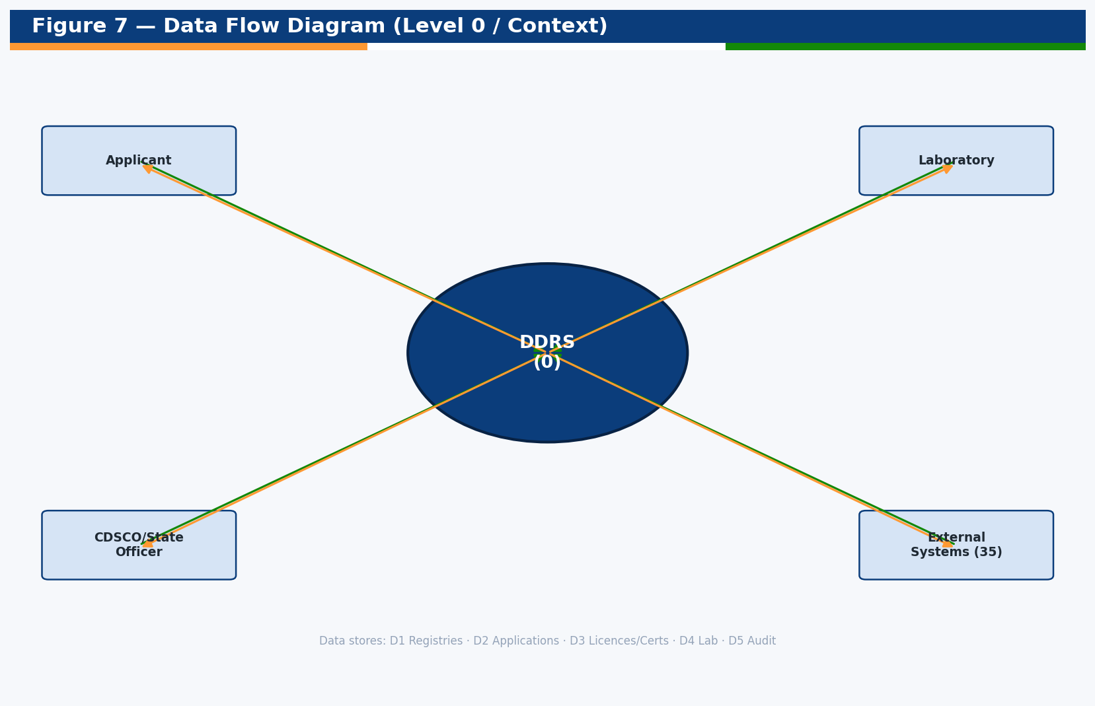
Figure 7 — Level 0 (context) data flow diagram.

9.2 Licensing & Approval (Level 1)
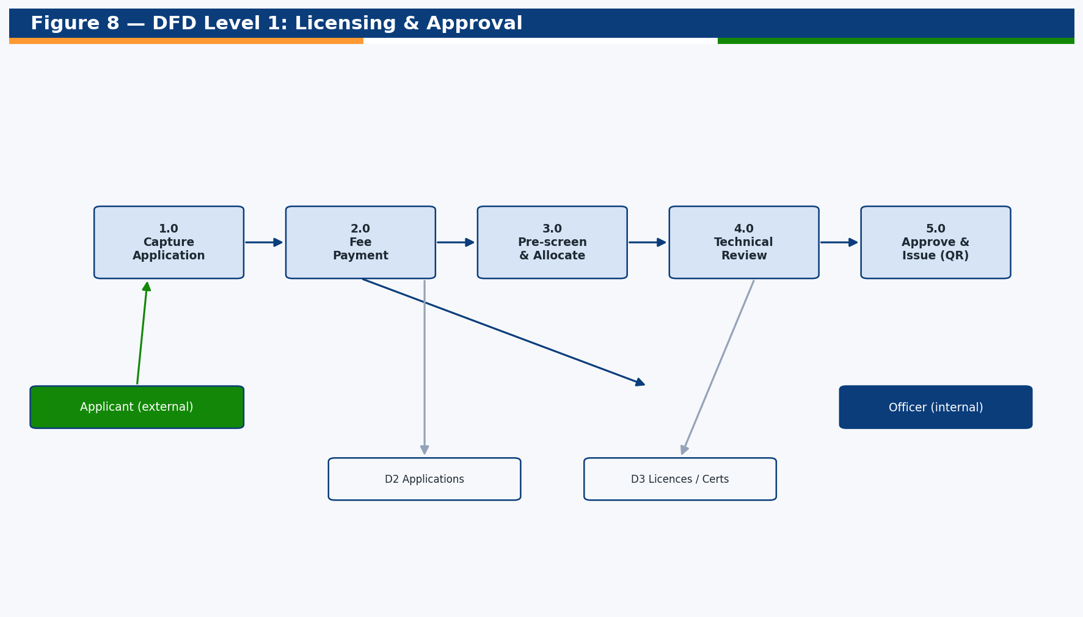
Figure 8 — Level 1 DFD: licensing & approval.

9.3 Sequence: Application Lifecycle
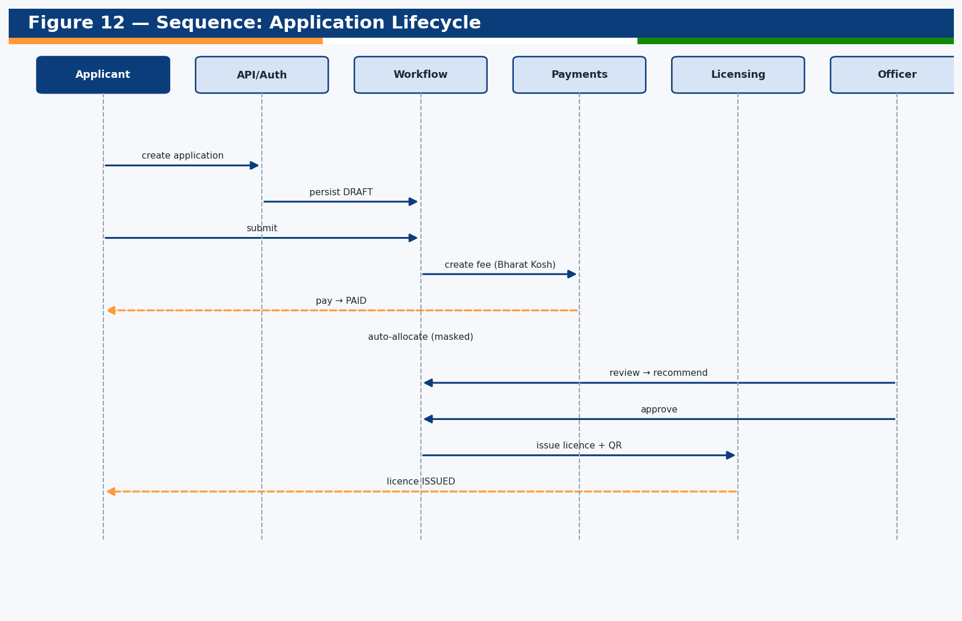
Figure 12 — Application lifecycle sequence.
The applicant creates and submits an application; the system creates a fee record and, on payment, auto-allocates the case (masked) and advances to pre-screening. Officers review, raise queries, recommend and approve; approval automatically issues the licence/certificate with a QR code and notifies the applicant.

9.4 Sequence: Authentication
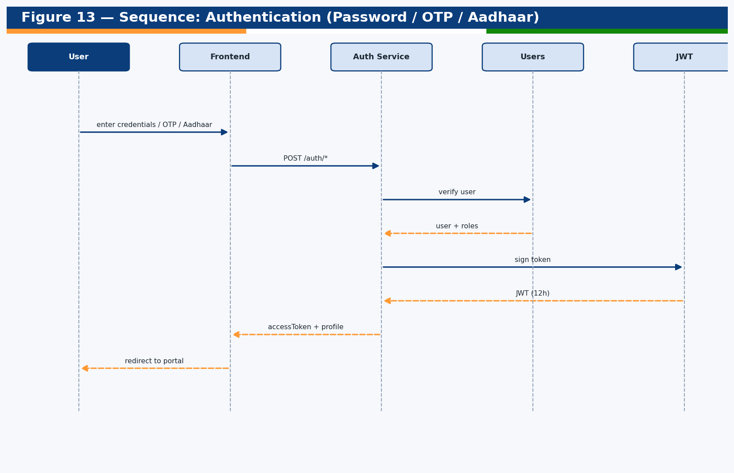
Figure 13 — Authentication sequence.

9.5 Sequence: Public Verification
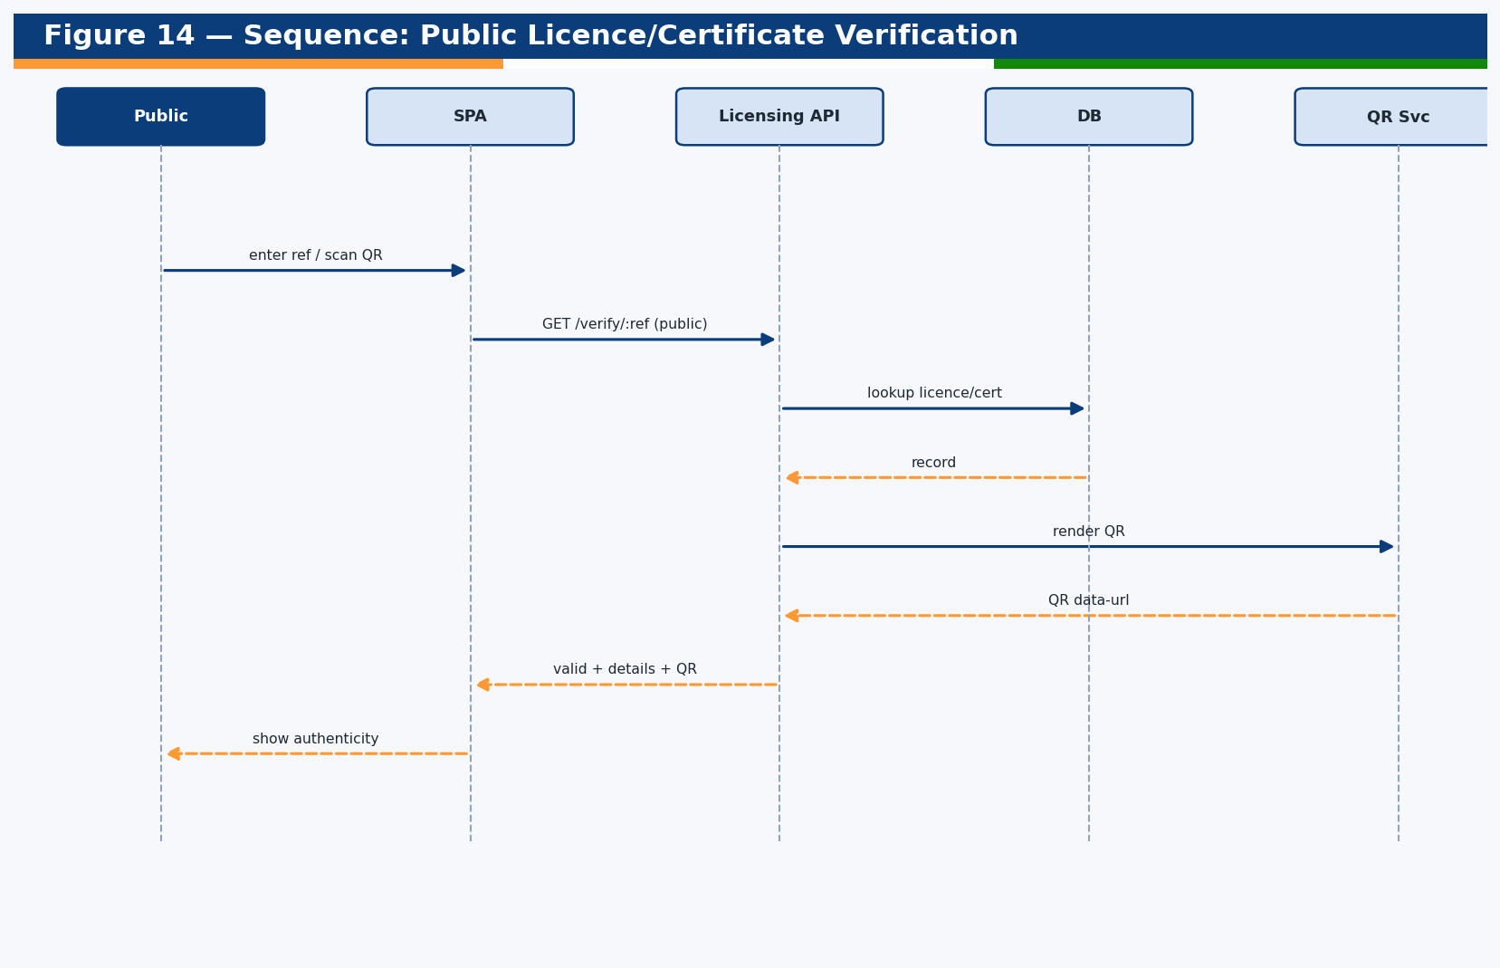
Figure 14 — Public verification sequence.

10. Security & Compliance
Security is layered (defense in depth) and applied as cross-cutting concerns so every endpoint inherits consistent protections.
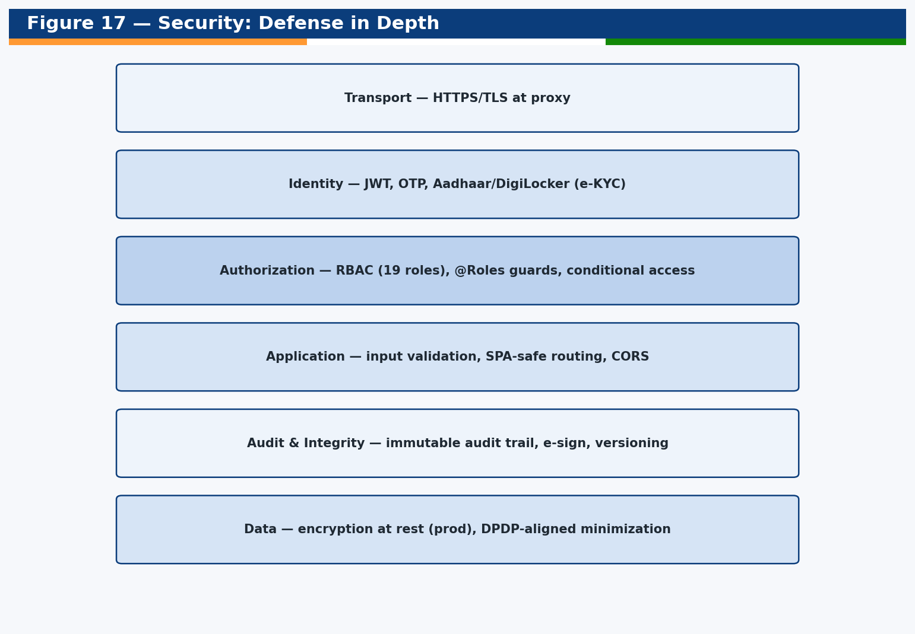
Figure 17 — Defense-in-depth security model.

10.1 Authentication & Authorization
Authentication uses signed JWTs (12-hour expiry) issued after password, OTP or Aadhaar/DigiLocker verification. Authorization is role-based: a global guard reads the @Roles metadata on each handler and permits access only to holders of an allowed role (SUPER_ADMIN bypasses). Public endpoints are explicitly annotated.
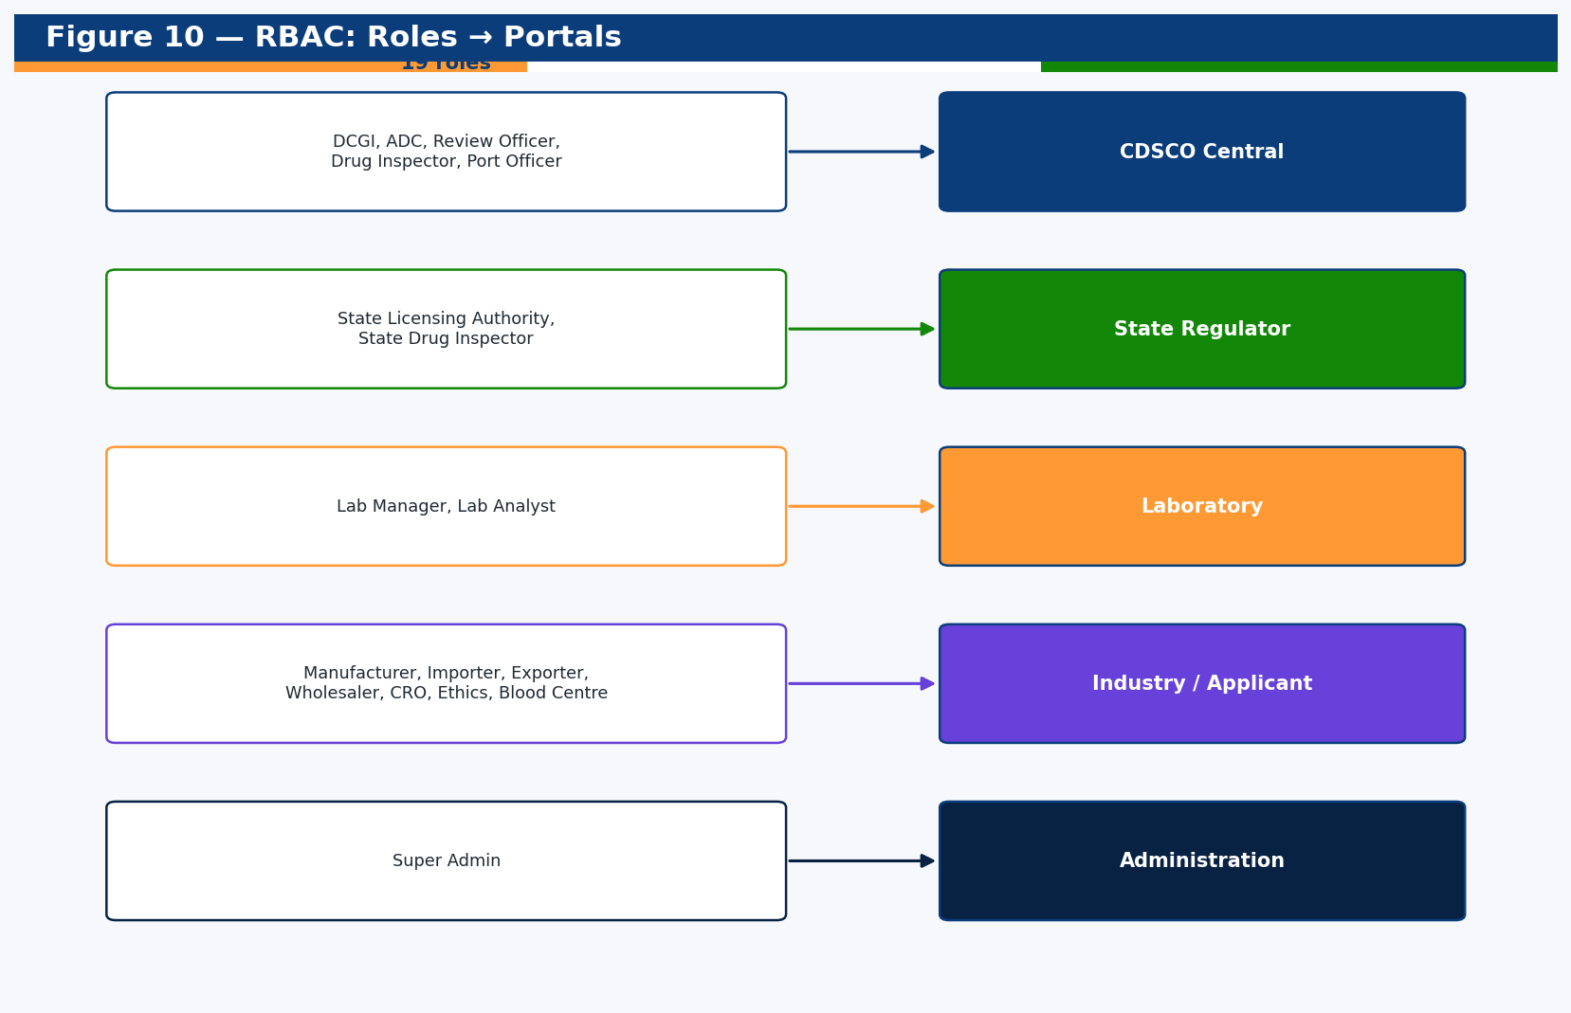
Figure 10 — RBAC: roles mapped to portals.

10.2 Role × Module Access Matrix
Role | Applications | Licensing | Inspections | Enforcement | Vigilance | Laboratory | Analytics | Users/Audit | Integrations
Super Admin | ✓ | ✓ | ✓ | ✓ | ✓ | ✓ | ✓ | ✓ | ✓
DCGI | ✓ | ✓ | ✓ | ✓ | ✓ | ✓ | ✓ | ✓ | ✓
ADC | ✓ | ✓ | ✓ | ✓ | ✓ | ✓ | ✓ | ✓ | ✓
Review Officer | ✓ | ✓ | ✓ | — | ✓ | — | ✓ | — | —
Drug Inspector | ✓ | — | ✓ | ✓ | — | — | — | — | —
Port Officer | ✓ | ✓ | — | — | — | — | — | — | —
State Licensing Auth. | ✓ | ✓ | ✓ | ✓ | — | — | ✓ | — | —
State Drug Inspector | ✓ | — | ✓ | ✓ | — | — | — | — | —
Lab Manager | — | — | — | — | — | ✓ | — | — | —
Lab Analyst | — | — | — | — | — | ✓ | — | — | —
Manufacturer | ✓ | ✓ | ✓ | — | ✓ | — | — | — | —
Importer/Exporter | ✓ | ✓ | — | — | ✓ | — | — | — | —
Wholesaler/Retailer | ✓ | ✓ | — | — | — | — | — | — | —
CRO | ✓ | — | — | — | ✓ | — | — | — | —
Ethics Committee | ✓ | — | — | — | ✓ | — | — | — | —
Blood Centre | ✓ | ✓ | ✓ | — | ✓ | — | — | — | —
Technical Person | ✓ | — | — | — | — | — | — | — | —
Public User | — | — | — | — | — | — | — | — | —

10.3 Audit, Integrity & Privacy
- Immutable audit trail of every mutation (user, role, path, IP, status, latency).
- Sensitive fields (passwords, OTPs, tokens) redacted before audit persistence.
- Document versioning + simulated e-sign (OTP/DSC/Aadhaar) for tamper-evidence.
- DPDP-aligned conditional/minimal data access; last-login and access visibility.
- ISO 27001-aligned controls; CERT-In empanelled security audit recommended pre-go-live.

11. External Integrations
DDRS integrates with 35 government and external systems. In this build each is served by a clearly-labelled simulated adapter; production swaps in real API clients and credentials without changing the calling code.
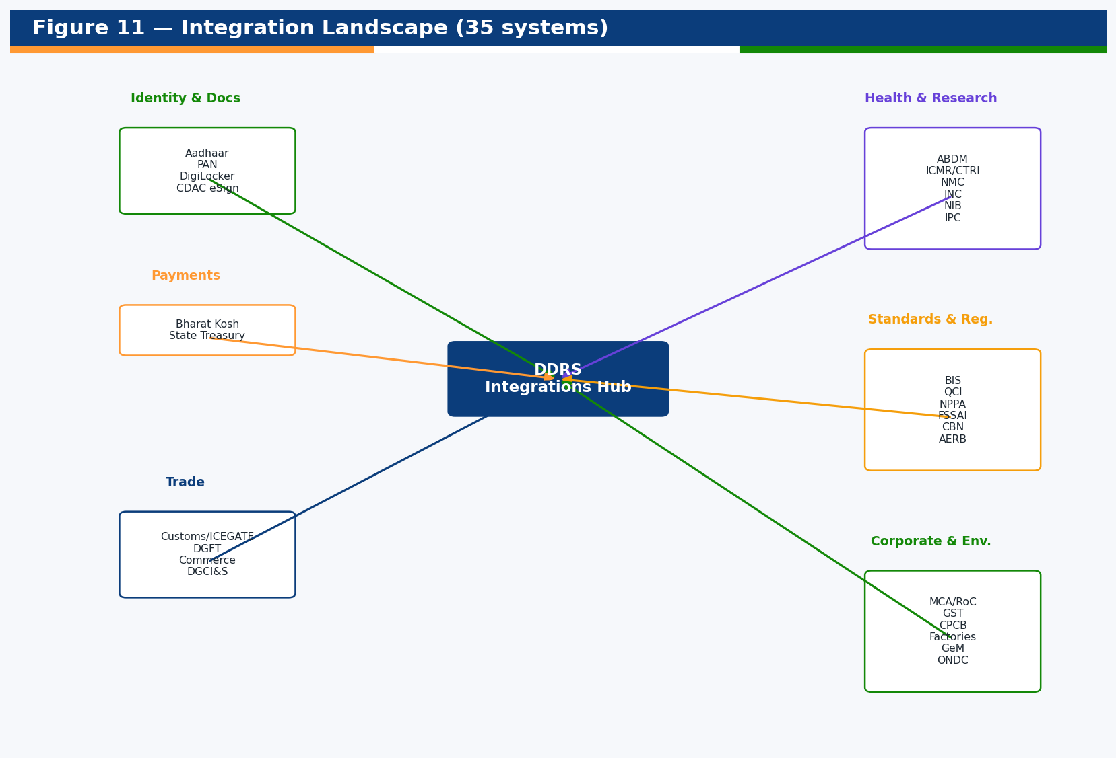
Figure 11 — Integration landscape (35 systems).
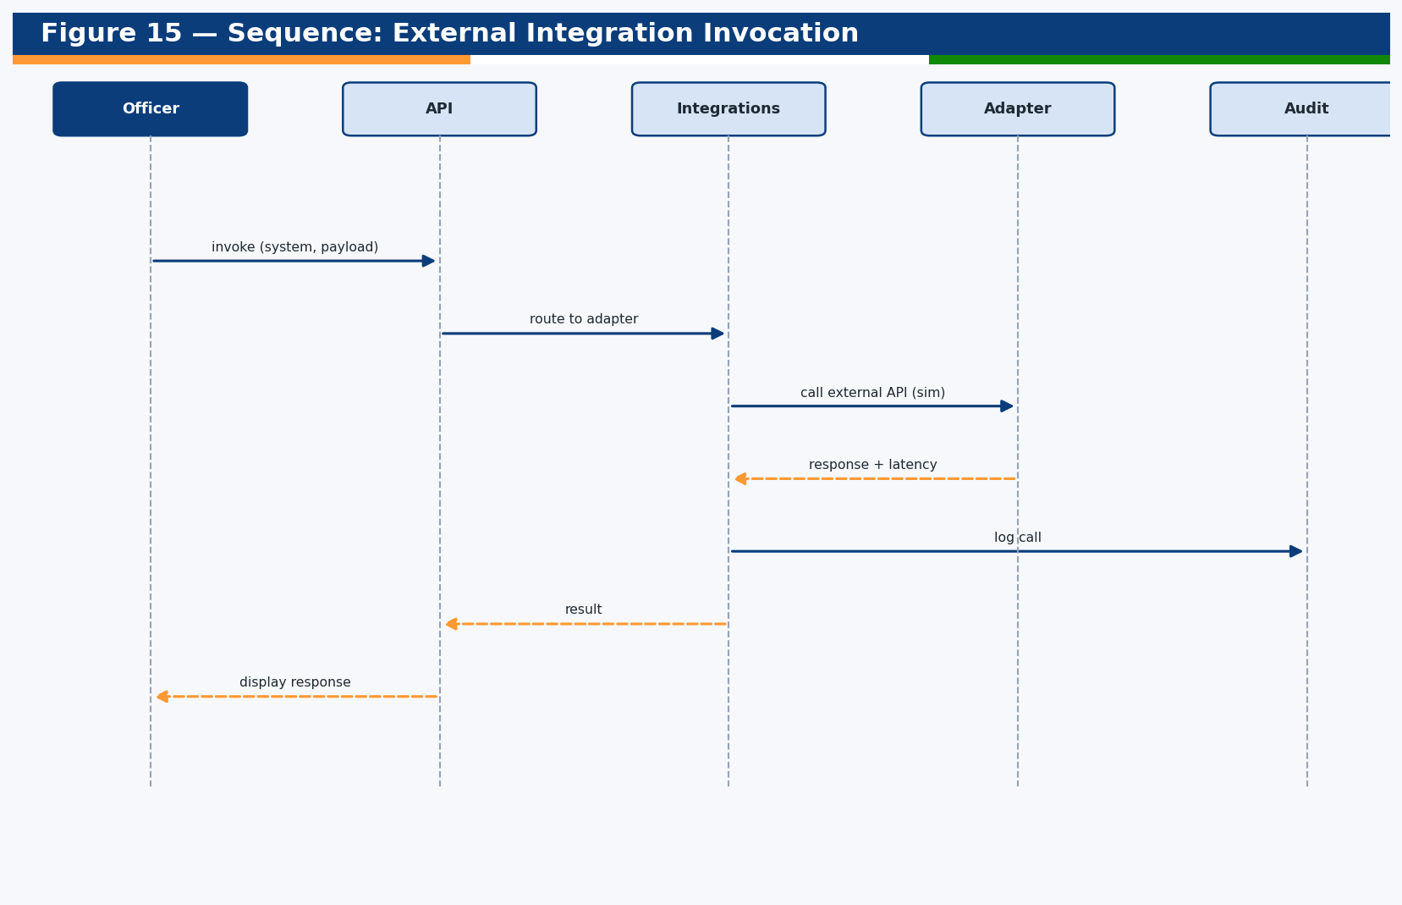
Figure 15 — Integration invocation sequence.

11.1 Integration Register
# | System | Purpose | Direction
1 | Aadhaar / UIDAI | e-KYC & authentication | Bidirectional
2 | PAN (Income Tax) | PAN verification | Incoming
3 | DigiLocker | Document issuance & e-sign | Bidirectional
4 | GST Network | GSTIN, invoices, e-waybill | Incoming
5 | Bharat Kosh (pay.gov.in) | Fee remittance to CFI | Bidirectional
6 | State Treasuries | State fee collection | Bidirectional
7 | Customs / ICEGATE | Import clearance | Bidirectional
8 | DGFT | Export, advance licence, FSC | Incoming
9 | Bureau of Indian Standards | Standards in workflows | Incoming
10 | CTRI (ICMR) | Clinical trial registration | Bidirectional
11 | ICMR | Ethics committee & IVD testing | Bidirectional
12 | NPPA / IPDMS | Drug pricing & availability | Incoming
13 | ABDM (NHA) | HFR / HPR registry | Bidirectional
14 | Quality Council of India | NABL labs & notified bodies | Bidirectional
15 | GeM | Licence verification | Outgoing
16 | FSSAI | Licence verification | Bidirectional
17 | Central Bureau of Narcotics | Narcotics quotas & NOCs | Incoming
18 | National Institute of Biologicals | Biological testing & HvPI | Incoming
19 | Indian Pharmacopoeia Commission | IP standards, PvPI/MvPI | Incoming
20 | Legal Metrology Dept | Measuring devices | Incoming
21 | Indian Nursing Council | Nurse verification | Incoming
22 | National Medical Commission | Practitioner verification | Incoming
23 | Pollution Control Board | Licence verification | Incoming
24 | Inspectorate of Factories | Licence verification | Incoming
25 | Department of Commerce | Import-Export Data Bank | Bidirectional
26 | DSIR | R&D site approval | Incoming
27 | RCGM | rDNA clearances | Incoming
28 | AERB | Radiation device NOC | Incoming
29 | MCA / Registrar of Companies | CIN verification | Incoming
30 | ONDC | Commerce signals | Bidirectional
31 | CDAC eSign / DSC | Digital signatures | Bidirectional
32 | SMS Gateway | OTP & alert SMS | Outgoing
33 | Email Gateway | Email notifications | Outgoing
34 | E-Aushadhi (State) | Lab sample reports | Bidirectional
35 | DGCI&S | Commercial intelligence | Incoming

12. Non-Functional Requirements & SLA

12.1 Quality Attributes
Attribute | Approach in DDRS
Performance | Indexed columns, server-side pagination/search, lean list payloads
Scalability | Stateless JWT API behind a load balancer; PostgreSQL for concurrency
Availability | Single-service simplicity; horizontal replicas; health endpoint for probes
Security | RBAC, audit, encryption (prod), CERT-In/ISO 27001 alignment
Maintainability | Modular monolith, typed code, lint + tests, this SAD
Portability | DB-agnostic schema; Docker images; env-driven config
Observability | Audit trail, structured logs, integration logs, health checks
Usability/Accessibility | GIGW-aligned UI, responsive, role-aware navigation

12.2 Indicative Service Levels
Severity | Description | Target Response | Target Resolution
S1 Critical | System down / data integrity risk | 15 min | 4 hours
S2 High | Major function impaired | 30 min | 8 hours
S3 Medium | Minor function impaired | 4 hours | 3 business days
S4 Low | Cosmetic / query | 1 business day | 10 business days
Application availability target: 99.5% monthly (excluding planned maintenance). These are indicative; the binding SLA is defined in the contract (RFP Appendix 5).

13. Deployment & DevOps
DDRS deploys as a single service that serves the API and the built SPA. Three topologies are supported (Node single-process, Docker+SQLite, Docker+PostgreSQL).

Figure 4 — Deployment topologies.

13.1 Configuration Reference
Variable | Default | Purpose
PORT | 3001 | HTTP listen port
JWT_SECRET | (dev value) | Token signing secret — set strong in prod
STATIC_ROOT | ../frontend/dist | Built SPA location for single-service serving
DB_TYPE | sqlite | sqlite | postgres
DB_PATH | ./ddrs.sqlite | SQLite file path
PGHOST/PGPORT/PGUSER/PGPASSWORD/PGDATABASE | — | PostgreSQL connection
SEED_ON_START | false | Seed on container boot

13.2 Build & Run
- pnpm install — install workspaces
- pnpm build — build backend (dist) and frontend (dist)
- pnpm --filter backend seed — create & seed the database
- pnpm start:prod — run single-service on PORT (API + web)
- docker compose up --build — containerised (SQLite, auto-seed)
- docker compose --profile postgres up --build — with PostgreSQL

13.3 Production Hardening Checklist
- Set a strong JWT_SECRET and rotate periodically.
- Use PostgreSQL with automated backups and PITR.
- Terminate TLS at a reverse proxy / load balancer.
- Wire real integrations, payment, DSC and SMS/email providers.
- Run a CERT-In empanelled security audit; remediate findings.
- Enable centralised logging, metrics and tracing; configure alerts.
- Establish CI/CD (lint → test → build → image → deploy).

14. Testing & Quality Assurance

14.1 Strategy
- Unit tests (Jest) for critical platform logic (reference service, RBAC guard).
- Build gates: TypeScript compilation for backend and frontend.
- Static analysis: ESLint (flat config) clean on both packages.
- Seed verification: every flow seeded with 500+ records (idempotent).
- Automated UI smoke: all portal routes load with zero page errors.
- Manual UAT against signed-off functional requirements.

14.2 UAT Acceptance Criteria (summary)
- Functional verification against signed-off requirements.
- Performance within agreed throughput/latency thresholds.
- Availability and security (authn, encryption, access control) validated.
- Documentation completeness (this SAD, manuals, source).
- Data quality of migrated/seeded data.

15. Operations & Knowledge-Transfer Runbooks

15.1 Run Locally
Prerequisites: Node ≥ 20 and pnpm ≥ 10. No Docker/DB required for development.
- pnpm install
- pnpm --filter backend seed
- pnpm dev (backend :3001 + frontend :5173)
- Swagger at http://localhost:3001/api/docs
- Login with demo accounts (password Ddrs@2026)

15.2 Re-seed / Reset
Stop the backend (it holds the SQLite file), then run pnpm --filter backend seed. The seed is idempotent (drops and recreates the schema). Delete ddrs.sqlite for a full wipe.

15.3 Common Operational Tasks
Task | Action
Add a new role | Extend the Role enum; assign in users; reference in @Roles
Onboard a laboratory | POST /api/registry/laboratories (no code change)
Add a fee rule | Insert a FeeRule row (type/category/risk/jurisdiction → amount)
Wire a real integration | Replace mockResponse() for the system in integrations.service.ts
Switch to PostgreSQL | Set DB_TYPE=postgres + PG* env; re-seed
Investigate an action | Query /api/audit (admin) by user/path/time
Tune SHRESTH weights | Edit shresth() in analytics.service.ts

15.4 Troubleshooting
Symptom | Resolution
Port in use | lsof -ti:3001 | xargs kill
sqlite3 build error | pnpm rebuild sqlite3
"database is locked" on seed | Stop the backend before seeding
401 on protected route | Ensure Authorization: Bearer <token> header

16. Glossary of Abbreviations
Abbreviation | Expansion
ADC | Assistant Drugs Controller
AEFI | Adverse Event Following Immunisation
API | Application Programming Interface
BA/BE | Bioavailability / Bioequivalence
BRC | Batch Release Certificate
CDSCO | Central Drugs Standard Control Organization
CLAA | Central Licensing Approving Authority
COPP | Certificate of Pharmaceutical Product
CRO | Contract Research Organization
CT | Clinical Trial
CTRI | Clinical Trials Registry – India
DCGI | Drugs Controller General of India
DDRS | Digital Drugs Regulatory System
DFD | Data Flow Diagram
DPDP | Digital Personal Data Protection Act
DPI | Digital Public Infrastructure
DSC | Digital Signature Certificate
ER | Entity Relationship
FSC | Free Sales Certificate
GCT | Global Clinical Trial
GMP | Good Manufacturing Practices
HvPI | Haemovigilance Programme of India
ICSR | Individual Case Safety Report
IVD | In-Vitro Diagnostic
JWT | JSON Web Token
KPI | Key Performance Indicator
LIMS | Laboratory Information Management System
MSC | Market Standing Certificate
MvPI | Materiovigilance Programme of India
NCC | Non-Conviction Certificate
NOC | No Objection Certificate
NPPA | National Pharmaceutical Pricing Authority
NSQ | Not of Standard Quality
PMS | Post-Market Surveillance
PSUR | Periodic Safety Update Report
PvPI | Pharmacovigilance Programme of India
QCBS | Quality Cost-Based Selection
RBAC | Role-Based Access Control
SAD | Software Architecture Document
SAE | Serious Adverse Event
SLA | Service Level Agreement / State Licensing Authority
SLP | Summary Lot Protocol
SPA | Single Page Application
TRS | Timeline Review System
UAT | User Acceptance Testing
WC | Written Confirmation
WHO | World Health Organization

17. Appendix A — Full Data Dictionary
The complete field-level data dictionary for all 37 entities (564 columns).

AdverseEvent (adverse_events)
Adverse event report — SAE, AEFI, ICSR, Pharmaco/Materio/Haemovigilance.
Column | Type | Attributes | Description
id | uuid | PK | Primary key (UUID) uniquely identifying the record.
createdAt | Date | — | Timestamp when the record was created (audit).
updatedAt | Date | — | Timestamp when the record was last updated (audit).
referenceNo | string | unique, idx | Standardised unique reference number used for citation and QR verification.
type | string | idx, def=SAE | Categorical type/classification of the record.
productName | string | nullable | Name of the associated product.
category | string | nullable | Attribute capturing category for the record.
seriousness | string | nullable | Attribute capturing seriousness for the record.
reporterType | string | nullable | Attribute capturing reporterType for the record.
patientAgeGroup | string | nullable | Attribute capturing patientAgeGroup for the record.
patientGender | string | nullable | Attribute capturing patientGender for the record.
outcome | string | nullable | Attribute capturing outcome for the record.
status | string | idx, def=RECEIVED | Lifecycle status driving workflow and UI badges.
causality | string | nullable | Attribute capturing causality for the record.
source | string | def=MANUAL | Attribute capturing source for the record.
reportedDate | Date | nullable | Date/time relevant to the record lifecycle.
stateCode | string | nullable | State/UT code scoping the record for jurisdiction and filtering.

ApplicationEvent (application_events)
Immutable workflow history entry for an application.
Column | Type | Attributes | Description
id | uuid | PK | Primary key (UUID) uniquely identifying the record.
createdAt | Date | — | Timestamp when the record was created (audit).
updatedAt | Date | — | Timestamp when the record was last updated (audit).
applicationId | string | idx | Foreign-key reference to a related application record.
fromStatus | string | nullable | Attribute capturing fromStatus for the record.
toStatus | string | nullable | Attribute capturing toStatus for the record.
action | string | — | Attribute capturing action for the record.
actorId | string | nullable | Foreign-key reference to a related actor record.
actorName | string | nullable | Name of the associated actor.
actorRole | string | nullable | Attribute capturing actorRole for the record.
remarks | string | nullable | Attribute capturing remarks for the record.

Application (applications)
Central application object driven by the generic workflow engine. Covers the full regulatory lifecycle: registration, market authorisation, licensing, renewal, endorsement, post-approval change, suspension, surrender, appeal, NOC, clinical trial, etc.
Column | Type | Attributes | Description
id | uuid | PK | Primary key (UUID) uniquely identifying the record.
createdAt | Date | — | Timestamp when the record was created (audit).
updatedAt | Date | — | Timestamp when the record was last updated (audit).
referenceNo | string | unique, idx | Standardised unique reference number used for citation and QR verification.
type | ApplicationType | idx | Categorical type/classification of the record.
title | string | — | Attribute capturing title for the record.
productCategory | ProductCategory | idx, nullable | Attribute capturing productCategory for the record.
riskClass | RiskClass | nullable | Attribute capturing riskClass for the record.
jurisdiction | Jurisdiction | idx, def=Jurisdiction.CENTRE | Attribute capturing jurisdiction for the record.
stateCode | string | nullable | State/UT code scoping the record for jurisdiction and filtering.
applicantUserId | string | nullable | Foreign-key reference to a related applicantuser record.
applicantName | string | nullable | Name of the associated applicant.
organizationId | string | idx, nullable | Foreign-key reference to a related organization record.
organizationName | string | nullable | Name of the associated organization.
status | ApplicationStatus | idx, def=ApplicationStatus.DRAFT | Lifecycle status driving workflow and UI badges.
currentStage | string | def=Submission | Attribute capturing currentStage for the record.
assignedToId | string | idx, nullable | Foreign-key reference to a related assignedto record.
assignedToName | string | nullable | Name of the associated assignedto.
priority | string | def=NORMAL | Attribute capturing priority for the record.
feeAmount | number | def=0 | Numeric value/quantity.
feePaid | boolean | def=false | Foreign-key reference to a related feepa record.
paymentId | string | nullable | Foreign-key reference to a related payment record.
submittedAt | Date | nullable | Date/time relevant to the record lifecycle.
slaDays | number | def=30 | Numeric value/quantity.
dueDate | Date | idx, nullable | Date/time relevant to the record lifecycle.
decisionDate | Date | nullable | Date/time relevant to the record lifecycle.
decisionRemarks | string | nullable | Attribute capturing decisionRemarks for the record.
productId | string | nullable | Foreign-key reference to a related product record.
relatedLicenseId | string | nullable | Foreign-key reference to a related relatedlicense record.
issuedLicenseId | string | nullable | Foreign-key reference to a related issuedlicense record.
formData | Record<string, any> | nullable | Structured JSON payload (array/object).

AuditLog (audit_logs)
Column | Type | Attributes | Description
id | uuid | PK | Primary key (UUID) uniquely identifying the record.
createdAt | Date | — | Timestamp when the record was created (audit).
updatedAt | Date | — | Timestamp when the record was last updated (audit).
userId | string | idx, nullable | Foreign-key reference to a related user record.
userEmail | string | nullable | Attribute capturing userEmail for the record.
userRole | string | nullable | Attribute capturing userRole for the record.
action | string | idx | Attribute capturing action for the record.
method | string | nullable | Attribute capturing method for the record.
path | string | nullable | Attribute capturing path for the record.
ip | string | nullable | Attribute capturing ip for the record.
userAgent | string | nullable | Attribute capturing userAgent for the record.
statusCode | number | nullable | Numeric value/quantity.
durationMs | number | nullable | Numeric value/quantity.
metadata | Record<string, any> | nullable | Structured JSON payload (array/object).

BatchReleaseCertificate (batch_release_certs)
Batch Release Certificate (BRC) for biologicals, incl. SLP scrutiny.
Column | Type | Attributes | Description
id | uuid | PK | Primary key (UUID) uniquely identifying the record.
createdAt | Date | — | Timestamp when the record was created (audit).
updatedAt | Date | — | Timestamp when the record was last updated (audit).
referenceNo | string | unique, idx | Standardised unique reference number used for citation and QR verification.
productName | string | — | Name of the associated product.
batchNo | string | nullable | Attribute capturing batchNo for the record.
manufacturerName | string | nullable | Name of the associated manufacturer.
labName | string | nullable | Name of the associated lab.
status | string | idx, def=RELEASED | Lifecycle status driving workflow and UI badges.
slpScrutinised | boolean | def=false | Boolean flag controlling behaviour or state.
releasedDate | Date | nullable | Date/time relevant to the record lifecycle.
potency | string | nullable | Attribute capturing potency for the record.

Certificate (certificates)
Issued certificate or NOC (COPP, FSC, MSC, NCC, WC, GMP, NOCs, codes).
Column | Type | Attributes | Description
id | uuid | PK | Primary key (UUID) uniquely identifying the record.
createdAt | Date | — | Timestamp when the record was created (audit).
updatedAt | Date | — | Timestamp when the record was last updated (audit).
referenceNo | string | unique, idx | Standardised unique reference number used for citation and QR verification.
certType | CertificateType | idx | Attribute capturing certType for the record.
isNoc | boolean | def=false | Boolean flag controlling behaviour or state.
applicationId | string | nullable | Foreign-key reference to a related application record.
holderOrgId | string | idx, nullable | Foreign-key reference to a related holderorg record.
holderName | string | nullable | Name of the associated holder.
productId | string | nullable | Foreign-key reference to a related product record.
productName | string | nullable | Name of the associated product.
issueDate | Date | nullable | Date/time relevant to the record lifecycle.
validTo | Date | nullable | Attribute capturing validTo for the record.
status | string | def=ACTIVE | Lifecycle status driving workflow and UI badges.
qrPayload | string | nullable | Encoded payload embedded in the QR code for public verification.
issuedByName | string | nullable | Name of the associated issuedby.
fields | Record<string, any> | nullable | Structured JSON payload (array/object).

ClinicalTrial (clinical_trials)
Clinical trial / GCT / BA-BE / PMS / academic / veterinary field trial.
Column | Type | Attributes | Description
id | uuid | PK | Primary key (UUID) uniquely identifying the record.
createdAt | Date | — | Timestamp when the record was created (audit).
updatedAt | Date | — | Timestamp when the record was last updated (audit).
referenceNo | string | unique, idx | Standardised unique reference number used for citation and QR verification.
title | string | — | Attribute capturing title for the record.
type | string | idx, def=CLINICAL_TRIAL | Categorical type/classification of the record.
phase | string | nullable | Attribute capturing phase for the record.
sponsorName | string | nullable | Name of the associated sponsor.
croName | string | nullable | Name of the associated cro.
drugName | string | nullable | Name of the associated drug.
therapeuticArea | string | nullable | Attribute capturing therapeuticArea for the record.
status | string | idx, def=SUBMITTED | Lifecycle status driving workflow and UI badges.
ctriNo | string | nullable | Attribute capturing ctriNo for the record.
ecApprovalNo | string | nullable | Attribute capturing ecApprovalNo for the record.
subjectsPlanned | number | def=0 | Numeric value/quantity.
sitesCount | number | def=0 | Numeric value/quantity.
startDate | Date | nullable | Date/time relevant to the record lifecycle.
isGlobal | boolean | def=false | Boolean flag controlling behaviour or state.

CompensationClaim (compensation_claims)
Compensation claim arising from a serious adverse event in a trial.
Column | Type | Attributes | Description
id | uuid | PK | Primary key (UUID) uniquely identifying the record.
createdAt | Date | — | Timestamp when the record was created (audit).
updatedAt | Date | — | Timestamp when the record was last updated (audit).
referenceNo | string | unique, idx | Standardised unique reference number used for citation and QR verification.
relatedAeId | string | nullable | Foreign-key reference to a related relatedae record.
trialRef | string | nullable | Attribute capturing trialRef for the record.
claimantName | string | nullable | Name of the associated claimant.
amountClaimed | number | def=0 | Numeric value/quantity.
amountAwarded | number | def=0 | Numeric value/quantity.
status | string | idx, def=FILED | Lifecycle status driving workflow and UI badges.
filedDate | Date | nullable | Date/time relevant to the record lifecycle.

CourtCase (court_cases)
Prosecution / court case + Action Taken Report tracking.
Column | Type | Attributes | Description
id | uuid | PK | Primary key (UUID) uniquely identifying the record.
createdAt | Date | — | Timestamp when the record was created (audit).
updatedAt | Date | — | Timestamp when the record was last updated (audit).
caseNo | string | unique, idx | Attribute capturing caseNo for the record.
court | string | nullable | Attribute capturing court for the record.
parties | string | nullable | Attribute capturing parties for the record.
type | string | def=DRUGS_COSMETICS_ACT | Categorical type/classification of the record.
status | string | idx, def=FILED | Lifecycle status driving workflow and UI badges.
filedDate | Date | nullable | Date/time relevant to the record lifecycle.
nextHearing | Date | nullable | Attribute capturing nextHearing for the record.
relatedEnforcementId | string | nullable | Foreign-key reference to a related relatedenforcement record.
stateCode | string | nullable | State/UT code scoping the record for jurisdiction and filtering.
actionTakenReport | string | nullable | Attribute capturing actionTakenReport for the record.

Document (documents)
Column | Type | Attributes | Description
id | uuid | PK | Primary key (UUID) uniquely identifying the record.
createdAt | Date | — | Timestamp when the record was created (audit).
updatedAt | Date | — | Timestamp when the record was last updated (audit).
name | string | — | Human-readable name/title of the record.
category | string | nullable | Attribute capturing category for the record.
mimeType | string | def=application/pdf | Attribute capturing mimeType for the record.
sizeBytes | number | def=0 | Numeric value/quantity.
storageRef | string | — | Attribute capturing storageRef for the record.
version | number | def=1 | Numeric value/quantity.
checksum | string | nullable | Attribute capturing checksum for the record.
relatedType | string | idx, nullable | Attribute capturing relatedType for the record.
relatedId | string | idx, nullable | Foreign-key reference to a related related record.
uploadedById | string | nullable | Foreign-key reference to a related uploadedby record.
uploadedByName | string | nullable | Name of the associated uploadedby.
signed | boolean | def=false | Boolean flag controlling behaviour or state.

EnforcementCase (enforcement_cases)
Enforcement case — quality monitoring, sampling, NSQ/spurious detection, investigations and inter-state coordination.
Column | Type | Attributes | Description
id | uuid | PK | Primary key (UUID) uniquely identifying the record.
createdAt | Date | — | Timestamp when the record was created (audit).
updatedAt | Date | — | Timestamp when the record was last updated (audit).
referenceNo | string | unique, idx | Standardised unique reference number used for citation and QR verification.
type | string | idx | Categorical type/classification of the record.
productName | string | nullable | Name of the associated product.
brandName | string | nullable | Name of the associated brand.
batchNo | string | nullable | Attribute capturing batchNo for the record.
manufacturerName | string | nullable | Name of the associated manufacturer.
stateCode | string | nullable | State/UT code scoping the record for jurisdiction and filtering.
classification | string | nullable | Attribute capturing classification for the record.
severity | string | def=MEDIUM | Attribute capturing severity for the record.
status | string | idx, def=OPEN | Lifecycle status driving workflow and UI badges.
detectedDate | Date | nullable | Date/time relevant to the record lifecycle.
interState | boolean | def=false | Boolean flag controlling behaviour or state.
actionTaken | string | nullable | Attribute capturing actionTaken for the record.
sampleId | string | nullable | Foreign-key reference to a related sample record.
labReportRef | string | nullable | Attribute capturing labReportRef for the record.

ESignature (esignatures)
Column | Type | Attributes | Description
id | uuid | PK | Primary key (UUID) uniquely identifying the record.
createdAt | Date | — | Timestamp when the record was created (audit).
updatedAt | Date | — | Timestamp when the record was last updated (audit).
documentId | string | idx | Foreign-key reference to a related document record.
signerId | string | — | Foreign-key reference to a related signer record.
signerName | string | — | Name of the associated signer.
signerDesignation | string | nullable | Attribute capturing signerDesignation for the record.
method | ESignMethod | def=OTP | Attribute capturing method for the record.
signatureHash | string | — | Attribute capturing signatureHash for the record.
certificateMeta | Record<string, any> | nullable | Structured JSON payload (array/object).
ip | string | nullable | Attribute capturing ip for the record.
signedAt | Date | — | Date/time relevant to the record lifecycle.

FeeRule (fee_rules)
Configurable fee rule used to auto-calculate application fees.
Column | Type | Attributes | Description
id | uuid | PK | Primary key (UUID) uniquely identifying the record.
createdAt | Date | — | Timestamp when the record was created (audit).
updatedAt | Date | — | Timestamp when the record was last updated (audit).
applicationType | string | idx | Attribute capturing applicationType for the record.
productCategory | string | nullable | Attribute capturing productCategory for the record.
riskClass | string | nullable | Attribute capturing riskClass for the record.
jurisdiction | string | nullable | Attribute capturing jurisdiction for the record.
amount | number | — | Monetary amount in INR.
description | string | nullable | Attribute capturing description for the record.

Grievance (grievances)
Grievance / complaint ticket with SLA & escalation tracking.
Column | Type | Attributes | Description
id | uuid | PK | Primary key (UUID) uniquely identifying the record.
createdAt | Date | — | Timestamp when the record was created (audit).
updatedAt | Date | — | Timestamp when the record was last updated (audit).
ticketNo | string | unique, idx | Attribute capturing ticketNo for the record.
category | string | — | Attribute capturing category for the record.
subject | string | — | Attribute capturing subject for the record.
description | string | — | Attribute capturing description for the record.
complainantName | string | nullable | Name of the associated complainant.
complainantEmail | string | nullable | Attribute capturing complainantEmail for the record.
complainantType | string | nullable | Attribute capturing complainantType for the record.
status | string | idx, def=OPEN | Lifecycle status driving workflow and UI badges.
priority | string | def=NORMAL | Attribute capturing priority for the record.
assignedTo | string | nullable | Attribute capturing assignedTo for the record.
slaDays | number | def=7 | Numeric value/quantity.
dueDate | Date | nullable | Date/time relevant to the record lifecycle.
channel | string | nullable | Attribute capturing channel for the record.
stateCode | string | nullable | State/UT code scoping the record for jurisdiction and filtering.
resolution | string | nullable | Attribute capturing resolution for the record.
resolvedAt | Date | nullable | Date/time relevant to the record lifecycle.

InspectionFinding (inspection_findings)
Column | Type | Attributes | Description
id | uuid | PK | Primary key (UUID) uniquely identifying the record.
createdAt | Date | — | Timestamp when the record was created (audit).
updatedAt | Date | — | Timestamp when the record was last updated (audit).
inspectionId | string | idx | Foreign-key reference to a related inspection record.
code | string | nullable | Attribute capturing code for the record.
observation | string | — | Attribute capturing observation for the record.
severity | string | def=MINOR | Attribute capturing severity for the record.
category | string | nullable | Attribute capturing category for the record.
response | string | nullable | Attribute capturing response for the record.
status | string | def=OPEN | Lifecycle status driving workflow and UI badges.

Inspection (inspections)
Site inspection — manufacturing, joint (Centre+State), BA/BE, CRO, blood centre, retail, WC, medical device, etc. Captures geo-tag and form data (Form-35 / MD-11 / COS-11). Supports joint consolidated reporting.
Column | Type | Attributes | Description
id | uuid | PK | Primary key (UUID) uniquely identifying the record.
createdAt | Date | — | Timestamp when the record was created (audit).
updatedAt | Date | — | Timestamp when the record was last updated (audit).
referenceNo | string | unique, idx | Standardised unique reference number used for citation and QR verification.
type | string | idx | Categorical type/classification of the record.
entityId | string | nullable | Foreign-key reference to a related entity record.
entityName | string | nullable | Name of the associated entity.
stateCode | string | nullable | State/UT code scoping the record for jurisdiction and filtering.
jurisdiction | Jurisdiction | def=Jurisdiction.STATE | Attribute capturing jurisdiction for the record.
isJoint | boolean | def=false | Boolean flag controlling behaviour or state.
formType | string | nullable | Attribute capturing formType for the record.
scheduledDate | Date | nullable | Date/time relevant to the record lifecycle.
conductedDate | Date | nullable | Date/time relevant to the record lifecycle.
inspectors | { id?: string | nullable | Attribute capturing inspectors for the record.
masked | boolean | def=false | Boolean flag controlling behaviour or state.
status | string | idx, def=SCHEDULED | Lifecycle status driving workflow and UI badges.
outcome | string | nullable | Attribute capturing outcome for the record.
latitude | number | nullable | Geo-tag latitude of the premises.
longitude | number | nullable | Geo-tag longitude of the premises.
observationsCount | number | def=0 | Numeric value/quantity.
applicationId | string | nullable | Foreign-key reference to a related application record.
consolidatedReport | Record<string, any> | nullable | Structured JSON payload (array/object).

IntegrationLog (integration_logs)
Column | Type | Attributes | Description
id | uuid | PK | Primary key (UUID) uniquely identifying the record.
createdAt | Date | — | Timestamp when the record was created (audit).
updatedAt | Date | — | Timestamp when the record was last updated (audit).
system | string | idx | Attribute capturing system for the record.
systemName | string | nullable | Name of the associated system.
direction | string | nullable | Attribute capturing direction for the record.
operation | string | nullable | Attribute capturing operation for the record.
request | Record<string, any> | nullable | Structured JSON payload (array/object).
response | Record<string, any> | nullable | Structured JSON payload (array/object).
status | string | idx, def=SUCCESS | Lifecycle status driving workflow and UI badges.
latencyMs | number | def=0 | Numeric value/quantity.

Invoice (invoices)
Supply & distribution invoice.
Column | Type | Attributes | Description
id | uuid | PK | Primary key (UUID) uniquely identifying the record.
createdAt | Date | — | Timestamp when the record was created (audit).
updatedAt | Date | — | Timestamp when the record was last updated (audit).
invoiceNo | string | unique, idx | Attribute capturing invoiceNo for the record.
sellerName | string | nullable | Name of the associated seller.
buyerName | string | nullable | Name of the associated buyer.
invoiceDate | Date | nullable | Date/time relevant to the record lifecycle.
amount | number | def=0 | Monetary amount in INR.
itemCount | number | def=0 | Numeric value/quantity.
batchRefs | string[] | nullable | Structured JSON payload (array/object).
stateCode | string | nullable | State/UT code scoping the record for jurisdiction and filtering.

Laboratory (laboratories)
Testing Laboratory registry — Central (CDL/CDTL/RDTL/IPC/NIB), State and Private labs. Onboardable without code changes (RFP requirement).
Column | Type | Attributes | Description
id | uuid | PK | Primary key (UUID) uniquely identifying the record.
createdAt | Date | — | Timestamp when the record was created (audit).
updatedAt | Date | — | Timestamp when the record was last updated (audit).
name | string | idx | Human-readable name/title of the record.
type | LabType | idx | Categorical type/classification of the record.
registrationNo | string | unique, idx | Attribute capturing registrationNo for the record.
stateCode | string | nullable | State/UT code scoping the record for jurisdiction and filtering.
stateName | string | nullable | Name of the associated state.
city | string | nullable | Attribute capturing city for the record.
address | string | nullable | Attribute capturing address for the record.
latitude | number | nullable | Geo-tag latitude of the premises.
longitude | number | nullable | Geo-tag longitude of the premises.
nablAccreditationNo | string | nullable | Attribute capturing nablAccreditationNo for the record.
nablAccredited | boolean | def=false | Boolean flag controlling behaviour or state.
testingScope | string[] | nullable | Structured JSON payload (array/object).
contactPerson | string | nullable | Attribute capturing contactPerson for the record.
email | string | nullable | Contact email address.
phone | string | nullable | Contact phone number (Indian format).
status | EntityStatus | def=EntityStatus.ACTIVE | Lifecycle status driving workflow and UI badges.
capacityPerMonth | number | def=0 | Numeric value/quantity.

License (licenses)
Issued licence (manufacturing, import, sale, test, loan, etc.).
Column | Type | Attributes | Description
id | uuid | PK | Primary key (UUID) uniquely identifying the record.
createdAt | Date | — | Timestamp when the record was created (audit).
updatedAt | Date | — | Timestamp when the record was last updated (audit).
referenceNo | string | unique, idx | Standardised unique reference number used for citation and QR verification.
licenceType | string | — | Attribute capturing licenceType for the record.
formNumber | string | nullable | Attribute capturing formNumber for the record.
applicationId | string | nullable | Foreign-key reference to a related application record.
holderOrgId | string | idx, nullable | Foreign-key reference to a related holderorg record.
holderName | string | nullable | Name of the associated holder.
productCategory | ProductCategory | nullable | Attribute capturing productCategory for the record.
jurisdiction | Jurisdiction | def=Jurisdiction.CENTRE | Attribute capturing jurisdiction for the record.
stateCode | string | nullable | State/UT code scoping the record for jurisdiction and filtering.
status | LicenseStatus | idx, def=LicenseStatus.ISSUED | Lifecycle status driving workflow and UI badges.
issueDate | Date | nullable | Date/time relevant to the record lifecycle.
validFrom | Date | nullable | Attribute capturing validFrom for the record.
validTo | Date | idx, nullable | Attribute capturing validTo for the record.
productCount | number | def=0 | Numeric value/quantity.
conditions | string[] | nullable | Structured JSON payload (array/object).
qrPayload | string | nullable | Encoded payload embedded in the QR code for public verification.
issuedByName | string | nullable | Name of the associated issuedby.

MasterData (master_data)
Generic reference master-data registry (drug categories, dosage forms, blood types, states, zones, etc.). Extensible without code changes.
Column | Type | Attributes | Description
id | uuid | PK | Primary key (UUID) uniquely identifying the record.
createdAt | Date | — | Timestamp when the record was created (audit).
updatedAt | Date | — | Timestamp when the record was last updated (audit).
type | string | idx | Categorical type/classification of the record.
code | string | — | Attribute capturing code for the record.
name | string | — | Human-readable name/title of the record.
meta | Record<string, any> | nullable | Structured JSON payload (array/object).
active | boolean | def=true | Boolean flag controlling behaviour or state.

Notification (notifications)
Column | Type | Attributes | Description
id | uuid | PK | Primary key (UUID) uniquely identifying the record.
createdAt | Date | — | Timestamp when the record was created (audit).
updatedAt | Date | — | Timestamp when the record was last updated (audit).
userId | string | idx, nullable | Foreign-key reference to a related user record.
title | string | — | Attribute capturing title for the record.
message | string | — | Attribute capturing message for the record.
type | NotificationType | def=INFO | Categorical type/classification of the record.
category | string | nullable | Attribute capturing category for the record.
link | string | nullable | Attribute capturing link for the record.
relatedId | string | nullable | Foreign-key reference to a related related record.
channel | string | def=IN_APP | Attribute capturing channel for the record.
read | boolean | def=false | Boolean flag controlling behaviour or state.

Organization (organizations)
Regulated entity registry — manufacturers, importers, exporters, wholesalers/retailers, CROs, ethics committees, blood centres, BA/BE centres, consultants, marketers. Acts as a source-of-truth registry.
Column | Type | Attributes | Description
id | uuid | PK | Primary key (UUID) uniquely identifying the record.
createdAt | Date | — | Timestamp when the record was created (audit).
updatedAt | Date | — | Timestamp when the record was last updated (audit).
name | string | idx | Human-readable name/title of the record.
type | OrganizationType | idx | Categorical type/classification of the record.
registrationNo | string | unique, idx | Attribute capturing registrationNo for the record.
gstin | string | nullable | GST identification number.
pan | string | nullable | Permanent Account Number.
cin | string | nullable | Corporate identity number (MCA).
address | string | nullable | Attribute capturing address for the record.
city | string | nullable | Attribute capturing city for the record.
stateCode | string | idx, nullable | State/UT code scoping the record for jurisdiction and filtering.
stateName | string | nullable | Name of the associated state.
pincode | string | nullable | Attribute capturing pincode for the record.
latitude | number | nullable | Geo-tag latitude of the premises.
longitude | number | nullable | Geo-tag longitude of the premises.
contactPerson | string | nullable | Attribute capturing contactPerson for the record.
email | string | nullable | Contact email address.
phone | string | nullable | Contact phone number (Indian format).
website | string | nullable | Attribute capturing website for the record.
status | EntityStatus | def=EntityStatus.ACTIVE | Lifecycle status driving workflow and UI badges.
jurisdiction | Jurisdiction | def=Jurisdiction.STATE | Attribute capturing jurisdiction for the record.
riskClass | RiskClass | nullable | Attribute capturing riskClass for the record.
productCategories | string[] | nullable | Structured JSON payload (array/object).
establishedYear | number | nullable | Numeric value/quantity.
productCount | number | def=0 | Numeric value/quantity.
ownerUserId | string | nullable | Foreign-key reference to a related owneruser record.

Payment (payments)
Fee payment record (Bharat Kosh / State Treasury — simulated gateway).
Column | Type | Attributes | Description
id | uuid | PK | Primary key (UUID) uniquely identifying the record.
createdAt | Date | — | Timestamp when the record was created (audit).
updatedAt | Date | — | Timestamp when the record was last updated (audit).
referenceNo | string | unique, idx | Standardised unique reference number used for citation and QR verification.
applicationId | string | nullable | Foreign-key reference to a related application record.
applicationRef | string | nullable | Attribute capturing applicationRef for the record.
payerId | string | nullable | Foreign-key reference to a related payer record.
payerName | string | nullable | Name of the associated payer.
amount | number | — | Monetary amount in INR.
currency | string | def=INR | Attribute capturing currency for the record.
mode | PaymentMode | def=PaymentMode.UPI | Attribute capturing mode for the record.
gateway | string | def=BHARAT_KOSH | Attribute capturing gateway for the record.
status | PaymentStatus | idx, def=PaymentStatus.PENDING | Lifecycle status driving workflow and UI badges.
txnRef | string | nullable | Attribute capturing txnRef for the record.
paidAt | Date | nullable | Date/time relevant to the record lifecycle.
breakup | { head: string | nullable | Attribute capturing breakup for the record.
refundRef | string | nullable | Attribute capturing refundRef for the record.
refundedAt | Date | nullable | Date/time relevant to the record lifecycle.

Product (products)
Product registry across all regulated categories (drugs, biologicals, medical devices, IVDs, cosmetics, veterinary, AYUSH, blood products).
Column | Type | Attributes | Description
id | uuid | PK | Primary key (UUID) uniquely identifying the record.
createdAt | Date | — | Timestamp when the record was created (audit).
updatedAt | Date | — | Timestamp when the record was last updated (audit).
name | string | idx | Human-readable name/title of the record.
brandName | string | idx, nullable | Name of the associated brand.
category | ProductCategory | idx | Attribute capturing category for the record.
genericName | string | nullable | Name of the associated generic.
dosageForm | string | nullable | Attribute capturing dosageForm for the record.
strength | string | nullable | Attribute capturing strength for the record.
composition | string | nullable | Attribute capturing composition for the record.
registrationNo | string | unique, idx | Attribute capturing registrationNo for the record.
riskClass | RiskClass | nullable | Attribute capturing riskClass for the record.
schedule | string | nullable | Attribute capturing schedule for the record.
therapeuticArea | string | nullable | Attribute capturing therapeuticArea for the record.
hsnCode | string | nullable | Attribute capturing hsnCode for the record.
packSize | string | nullable | Attribute capturing packSize for the record.
manufacturerId | string | idx, nullable | Foreign-key reference to a related manufacturer record.
manufacturerName | string | nullable | Name of the associated manufacturer.
status | string | def=ACTIVE | Lifecycle status driving workflow and UI badges.
isImported | boolean | def=false | Boolean flag controlling behaviour or state.
approvalDate | Date | nullable | Date/time relevant to the record lifecycle.

Psur (psur)
Periodic Safety Update Report.
Column | Type | Attributes | Description
id | uuid | PK | Primary key (UUID) uniquely identifying the record.
createdAt | Date | — | Timestamp when the record was created (audit).
updatedAt | Date | — | Timestamp when the record was last updated (audit).
referenceNo | string | unique, idx | Standardised unique reference number used for citation and QR verification.
productName | string | — | Name of the associated product.
manufacturerName | string | nullable | Name of the associated manufacturer.
periodFrom | Date | nullable | Attribute capturing periodFrom for the record.
periodTo | Date | nullable | Attribute capturing periodTo for the record.
status | string | idx, def=SUBMITTED | Lifecycle status driving workflow and UI badges.
submittedDate | Date | nullable | Date/time relevant to the record lifecycle.
casesReported | number | def=0 | Numeric value/quantity.

Recall (recalls)
Product recall record with supplied vs recalled quantity tracking.
Column | Type | Attributes | Description
id | uuid | PK | Primary key (UUID) uniquely identifying the record.
createdAt | Date | — | Timestamp when the record was created (audit).
updatedAt | Date | — | Timestamp when the record was last updated (audit).
referenceNo | string | unique, idx | Standardised unique reference number used for citation and QR verification.
productName | string | — | Name of the associated product.
brandName | string | nullable | Name of the associated brand.
batchNo | string | nullable | Attribute capturing batchNo for the record.
manufacturerName | string | nullable | Name of the associated manufacturer.
classification | string | def=CLASS_II | Attribute capturing classification for the record.
reason | string | nullable | Attribute capturing reason for the record.
quantitySupplied | number | def=0 | Numeric value/quantity.
quantityRecalled | number | def=0 | Numeric value/quantity.
status | string | idx, def=INITIATED | Lifecycle status driving workflow and UI badges.
initiatedDate | Date | nullable | Date/time relevant to the record lifecycle.
stateCode | string | nullable | State/UT code scoping the record for jurisdiction and filtering.
voluntary | boolean | def=false | Boolean flag controlling behaviour or state.

ReferenceStandard (reference_standards)
Reference standard validated/issued by laboratories.
Column | Type | Attributes | Description
id | uuid | PK | Primary key (UUID) uniquely identifying the record.
createdAt | Date | — | Timestamp when the record was created (audit).
updatedAt | Date | — | Timestamp when the record was last updated (audit).
code | string | unique, idx | Attribute capturing code for the record.
name | string | — | Human-readable name/title of the record.
category | string | nullable | Attribute capturing category for the record.
labName | string | nullable | Name of the associated lab.
status | string | def=VALIDATED | Lifecycle status driving workflow and UI badges.
validTo | Date | nullable | Attribute capturing validTo for the record.
unitsIssued | number | def=0 | Numeric value/quantity.

ReturnFiling (returns_filings)
Periodic return filing (production/sales/consumption/stock) — GST/ITR style.
Column | Type | Attributes | Description
id | uuid | PK | Primary key (UUID) uniquely identifying the record.
createdAt | Date | — | Timestamp when the record was created (audit).
updatedAt | Date | — | Timestamp when the record was last updated (audit).
referenceNo | string | unique, idx | Standardised unique reference number used for citation and QR verification.
organizationId | string | nullable | Foreign-key reference to a related organization record.
organizationName | string | nullable | Name of the associated organization.
type | string | idx, def=PRODUCTION | Categorical type/classification of the record.
period | string | — | Attribute capturing period for the record.
status | string | idx, def=FILED | Lifecycle status driving workflow and UI badges.
dueDate | Date | nullable | Date/time relevant to the record lifecycle.
filedDate | Date | nullable | Date/time relevant to the record lifecycle.
totalValue | number | def=0 | Numeric value/quantity.
dataPoints | Record<string, any> | nullable | Structured JSON payload (array/object).
stateCode | string | nullable | State/UT code scoping the record for jurisdiction and filtering.

Sample (samples)
Lab sample received for testing.
Column | Type | Attributes | Description
id | uuid | PK | Primary key (UUID) uniquely identifying the record.
createdAt | Date | — | Timestamp when the record was created (audit).
updatedAt | Date | — | Timestamp when the record was last updated (audit).
referenceNo | string | unique, idx | Standardised unique reference number used for citation and QR verification.
productName | string | — | Name of the associated product.
category | string | nullable | Attribute capturing category for the record.
batchNo | string | nullable | Attribute capturing batchNo for the record.
manufacturerName | string | nullable | Name of the associated manufacturer.
drawnByName | string | nullable | Name of the associated drawnby.
drawnDate | Date | nullable | Date/time relevant to the record lifecycle.
labId | string | nullable | Foreign-key reference to a related lab record.
labName | string | nullable | Name of the associated lab.
sampleType | string | def=SURVEY | Attribute capturing sampleType for the record.
status | string | idx, def=RECEIVED | Lifecycle status driving workflow and UI badges.
stateCode | string | nullable | State/UT code scoping the record for jurisdiction and filtering.

SupplyChainBatch (supply_chain_batches)
Batch in the supply chain (QR-traceable from source to consumption).
Column | Type | Attributes | Description
id | uuid | PK | Primary key (UUID) uniquely identifying the record.
createdAt | Date | — | Timestamp when the record was created (audit).
updatedAt | Date | — | Timestamp when the record was last updated (audit).
batchNo | string | unique, idx | Attribute capturing batchNo for the record.
productName | string | — | Name of the associated product.
brandName | string | nullable | Name of the associated brand.
category | string | nullable | Attribute capturing category for the record.
manufacturerName | string | nullable | Name of the associated manufacturer.
manufactureDate | Date | nullable | Date/time relevant to the record lifecycle.
expiryDate | Date | nullable | Date/time relevant to the record lifecycle.
quantity | number | def=0 | Numeric value/quantity.
qrPayload | string | nullable | Encoded payload embedded in the QR code for public verification.
status | string | idx, def=IN_TRANSIT | Lifecycle status driving workflow and UI badges.
currentHolder | string | nullable | Attribute capturing currentHolder for the record.
storageCondition | string | def=AMBIENT | Attribute capturing storageCondition for the record.

SupplyChainMovement (supply_chain_movements)
A movement event of a batch between supply-chain entities.
Column | Type | Attributes | Description
id | uuid | PK | Primary key (UUID) uniquely identifying the record.
createdAt | Date | — | Timestamp when the record was created (audit).
updatedAt | Date | — | Timestamp when the record was last updated (audit).
batchId | string | idx | Foreign-key reference to a related batch record.
batchNo | string | idx | Attribute capturing batchNo for the record.
fromEntity | string | nullable | Attribute capturing fromEntity for the record.
fromType | string | nullable | Attribute capturing fromType for the record.
toEntity | string | nullable | Attribute capturing toEntity for the record.
toType | string | nullable | Attribute capturing toType for the record.
quantity | number | def=0 | Numeric value/quantity.
movementDate | Date | nullable | Date/time relevant to the record lifecycle.
invoiceNo | string | nullable | Attribute capturing invoiceNo for the record.
location | string | nullable | Attribute capturing location for the record.

TechnicalPerson (technical_persons)
Technical Person registry. Business rule (RFP): a technical person can be associated with only ONE manufacturer / laboratory / blood bank / wholesaler / retailer at a time. Enforced via a unique registrationNo and single organizationId, with the service rejecting attempts to attach an already-engag
Column | Type | Attributes | Description
id | uuid | PK | Primary key (UUID) uniquely identifying the record.
createdAt | Date | — | Timestamp when the record was created (audit).
updatedAt | Date | — | Timestamp when the record was last updated (audit).
name | string | — | Human-readable name/title of the record.
registrationNo | string | unique, idx | Attribute capturing registrationNo for the record.
qualification | string | nullable | Attribute capturing qualification for the record.
designation | string | nullable | Attribute capturing designation for the record.
email | string | nullable | Contact email address.
phone | string | nullable | Contact phone number (Indian format).
aadhaarMasked | string | nullable | Attribute capturing aadhaarMasked for the record.
organizationId | string | idx, nullable | Foreign-key reference to a related organization record.
organizationName | string | nullable | Name of the associated organization.
organizationType | string | nullable | Attribute capturing organizationType for the record.
status | 'ENGAGED' | 'AVAILABLE' | 'B | def=ENGAGED | Lifecycle status driving workflow and UI badges.
experienceYears | number | nullable | Numeric value/quantity.

TestReport (test_reports)
Laboratory test report for a sample.
Column | Type | Attributes | Description
id | uuid | PK | Primary key (UUID) uniquely identifying the record.
createdAt | Date | — | Timestamp when the record was created (audit).
updatedAt | Date | — | Timestamp when the record was last updated (audit).
referenceNo | string | unique, idx | Standardised unique reference number used for citation and QR verification.
sampleId | string | idx | Foreign-key reference to a related sample record.
sampleRef | string | nullable | Attribute capturing sampleRef for the record.
productName | string | nullable | Name of the associated product.
labId | string | nullable | Foreign-key reference to a related lab record.
labName | string | nullable | Name of the associated lab.
analystName | string | nullable | Name of the associated analyst.
result | string | idx, def=STANDARD_QUALITY | Attribute capturing result for the record.
parameters | { name: string | nullable | Attribute capturing parameters for the record.
conclusion | string | nullable | Attribute capturing conclusion for the record.
reportDate | Date | nullable | Date/time relevant to the record lifecycle.
status | string | def=FINALISED | Lifecycle status driving workflow and UI badges.

TrialSite (trial_sites)
Clinical trial / GCT / BA-BE / PMS / academic / veterinary field trial.
Column | Type | Attributes | Description
id | uuid | PK | Primary key (UUID) uniquely identifying the record.
createdAt | Date | — | Timestamp when the record was created (audit).
updatedAt | Date | — | Timestamp when the record was last updated (audit).
trialId | string | idx | Foreign-key reference to a related trial record.
trialRef | string | nullable | Attribute capturing trialRef for the record.
siteName | string | — | Name of the associated site.
city | string | nullable | Attribute capturing city for the record.
stateCode | string | nullable | State/UT code scoping the record for jurisdiction and filtering.
principalInvestigator | string | nullable | Attribute capturing principalInvestigator for the record.
ethicsCommittee | string | nullable | Attribute capturing ethicsCommittee for the record.
subjectsEnrolled | number | def=0 | Numeric value/quantity.
status | string | def=ACTIVE | Lifecycle status driving workflow and UI badges.

User (users)
Column | Type | Attributes | Description
id | uuid | PK | Primary key (UUID) uniquely identifying the record.
createdAt | Date | — | Timestamp when the record was created (audit).
updatedAt | Date | — | Timestamp when the record was last updated (audit).
email | string | unique, idx | Contact email address.
passwordHash | string | — | Attribute capturing passwordHash for the record.
fullName | string | — | Name of the associated full.
phone | string | nullable | Contact phone number (Indian format).
primaryRole | Role | def=Role.PUBLIC_USER | Attribute capturing primaryRole for the record.
roles | Role[] | — | Structured JSON payload (array/object).
status | UserStatus | def=ACTIVE | Lifecycle status driving workflow and UI badges.
organizationId | string | idx, nullable | Foreign-key reference to a related organization record.
stateCode | string | nullable | State/UT code scoping the record for jurisdiction and filtering.
office | string | nullable | Attribute capturing office for the record.
designation | string | nullable | Attribute capturing designation for the record.
aadhaarMasked | string | nullable | Attribute capturing aadhaarMasked for the record.
aadhaarVerified | boolean | def=false | Boolean flag controlling behaviour or state.
lastLoginAt | Date | nullable | Date/time relevant to the record lifecycle.
lastLoginIp | string | nullable | Attribute capturing lastLoginIp for the record.

WorkAllocation (work_allocations)
Records random/auto/manual allocation of work (applications, inspections, sample testing) to officers — supports masked assignment and manual override.
Column | Type | Attributes | Description
id | uuid | PK | Primary key (UUID) uniquely identifying the record.
createdAt | Date | — | Timestamp when the record was created (audit).
updatedAt | Date | — | Timestamp when the record was last updated (audit).
itemType | string | idx | Attribute capturing itemType for the record.
itemId | string | idx | Foreign-key reference to a related item record.
itemRef | string | nullable | Attribute capturing itemRef for the record.
assignedToId | string | — | Foreign-key reference to a related assignedto record.
assignedToName | string | — | Name of the associated assignedto.
assignedToRole | string | nullable | Attribute capturing assignedToRole for the record.
mode | AllocationMode | def=AllocationMode.AUTO | Attribute capturing mode for the record.
masked | boolean | def=false | Boolean flag controlling behaviour or state.
allocatedById | string | nullable | Foreign-key reference to a related allocatedby record.
status | 'ASSIGNED' | 'COMPLETED' | ' | def=ASSIGNED | Lifecycle status driving workflow and UI badges.

18. Appendix B — Seed Data Volumes
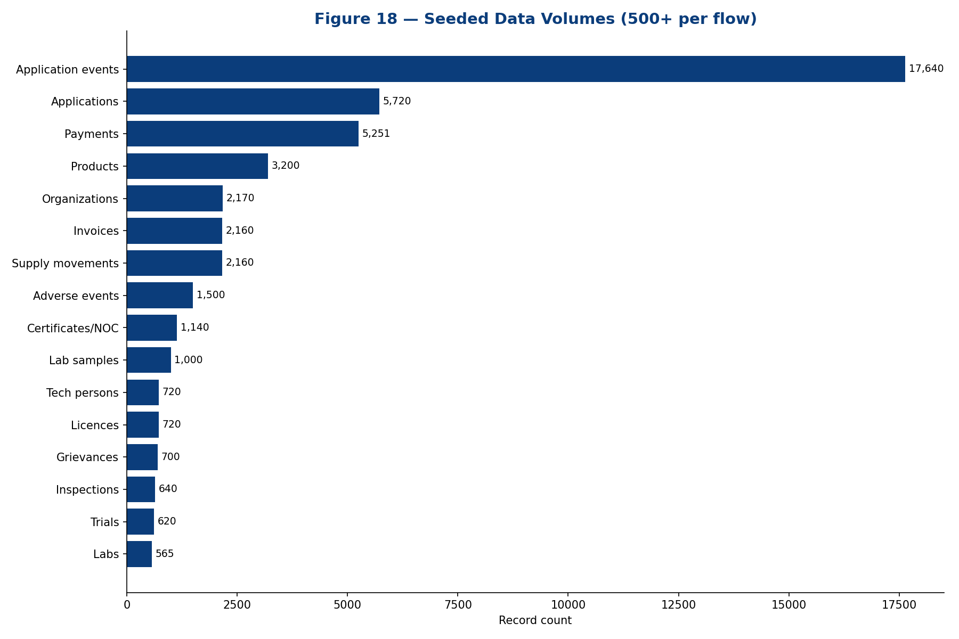
Figure 18 — Seeded data volumes (500+ per flow).
Every functional flow is seeded with at least 500 realistic, India-contextualised records (deterministic faker seed), demonstrating the platform at representative scale.

19. Appendix C — Complete API Index
Method | Path | Domain | Handler
GET | /api/analytics/dashboard | analytics | dashboard
GET | /api/analytics/report | analytics | report
GET | /api/analytics/shresth | analytics | shresth
GET | /api/analytics/summary | analytics | summary
GET | /api/applications | applications | list
POST | /api/applications | applications | create
GET | /api/applications/:id | applications | getOne
POST | /api/applications/:id/allocate | applications | allocate
POST | /api/applications/:id/confirm-payment | applications | confirmPayment
POST | /api/applications/:id/submit | applications | submit
POST | /api/applications/:id/transition | applications | transition
GET | /api/applications/allocations | applications | allocations
GET | /api/applications/overdue | applications | overdue
GET | /api/applications/stats | applications | stats
GET | /api/applications/trs | applications | trs
GET | /api/audit | audit | findAll
GET | /api/audit/stats | audit | stats
POST | /api/auth/aadhaar | auth | aadhaar
POST | /api/auth/login | auth | login
GET | /api/auth/me | auth | me
POST | /api/auth/otp/request | auth | requestOtp
POST | /api/auth/otp/verify | auth | verifyOtp
POST | /api/auth/register | auth | register
GET | /api/clinical-trials | clinical-trials | list
POST | /api/clinical-trials | clinical-trials | create
GET | /api/clinical-trials/:id | clinical-trials | findOne
GET | /api/clinical-trials/stats | clinical-trials | stats
GET | /api/documents | documents | list
POST | /api/documents | documents | upload
GET | /api/documents/:id | documents | findOne
POST | /api/documents/:id/sign | documents | sign
GET | /api/enforcement/cases | enforcement | listCases
POST | /api/enforcement/cases | enforcement | createCase
GET | /api/enforcement/court-cases | enforcement | listCourt
GET | /api/enforcement/recalls | enforcement | listRecalls
POST | /api/enforcement/recalls | enforcement | createRecall
GET | /api/enforcement/stats | enforcement | stats
GET | /api/public/alerts | enforcement | publicAlerts
GET | /api/grievances | grievances | list
POST | /api/grievances | grievances | create
PATCH | /api/grievances/:id | grievances | update
POST | /api/grievances/public | grievances | filePublic
GET | /api/grievances/stats | grievances | stats
GET | /api/grievances/track/:ticketNo | grievances | track
GET | /api/inspections | inspections | list
POST | /api/inspections | inspections | schedule
GET | /api/inspections/:id | inspections | findOne
POST | /api/inspections/:id/complete | inspections | complete
GET | /api/inspections/stats | inspections | stats
GET | /api/integrations/catalog | integrations | catalog
POST | /api/integrations/invoke | integrations | invoke
GET | /api/integrations/logs | integrations | logs
GET | /api/integrations/stats | integrations | stats
GET | /api/laboratory/batch-release | laboratory | listBrcs
GET | /api/laboratory/reference-standards | laboratory | listStandards
GET | /api/laboratory/reports | laboratory | listReports
GET | /api/laboratory/samples | laboratory | listSamples
POST | /api/laboratory/samples | laboratory | registerSample
POST | /api/laboratory/samples/:id/test | laboratory | testSample
GET | /api/laboratory/stats | laboratory | stats
GET | /api/certificates | licensing | listCerts
GET | /api/certificates/:id | licensing | getCert
GET | /api/licenses | licensing | listLicenses
GET | /api/licenses/:id | licensing | getLicense
PATCH | /api/licenses/:id/status | licensing | setStatus
GET | /api/licensing/stats | licensing | stats
GET | /api/verify/:referenceNo | licensing | verify
GET | /api/notifications | notifications | list
PATCH | /api/notifications/:id/read | notifications | markRead
PATCH | /api/notifications/read-all | notifications | markAll
GET | /api/notifications/unread-count | notifications | unread
GET | /api/payments | payments | list
GET | /api/payments/:id | payments | findOne
POST | /api/payments/:id/pay | payments | pay
POST | /api/payments/:id/refund | payments | refund
GET | /api/payments/calc | payments | calc
GET | /api/payments/stats | payments | stats
GET | /api/products | products | list
POST | /api/products | products | create
GET | /api/products/:id | products | findOne
GET | /api/products/check-brand | products | checkBrand
GET | /api/products/stats | products | stats
GET | /api/registry/laboratories | registry | listLabs
POST | /api/registry/laboratories | registry | createLab
GET | /api/registry/laboratories/:id | registry | lab
GET | /api/registry/laboratories/stats | registry | labStats
GET | /api/registry/organizations | registry | listOrgs
POST | /api/registry/organizations | registry | createOrg
GET | /api/registry/organizations/:id | registry | org
PATCH | /api/registry/organizations/:id/status | registry | setOrgStatus
GET | /api/registry/organizations/stats | registry | orgStats
GET | /api/registry/technical-persons | registry | listTps
POST | /api/registry/technical-persons | registry | createTp
GET | /api/registry/technical-persons/:id | registry | tp
PATCH | /api/registry/technical-persons/:id/assign | registry | assignTp
PATCH | /api/registry/technical-persons/:id/release | registry | releaseTp
GET | /api/registry/technical-persons/duplicates | registry | tpDuplicates
GET | /api/returns | returns | list
POST | /api/returns | returns | file
GET | /api/returns/stats | returns | stats
GET | /api/supply-chain/batches | supply-chain | listBatches
GET | /api/supply-chain/invoices | supply-chain | listInvoices
GET | /api/supply-chain/stats | supply-chain | stats
GET | /api/supply-chain/trace/:batchNo | supply-chain | trace
GET | /api | system | apiRoot
GET | /api/health | system | health
GET | /api/users | users | findAll
GET | /api/users/:id | users | findOne
PATCH | /api/users/:id/status | users | updateStatus
GET | /api/users/me | users | me
GET | /api/users/stats | users | stats
GET | /api/vigilance/compensation | vigilance | listClaims
GET | /api/vigilance/events | vigilance | listEvents
POST | /api/vigilance/events | vigilance | createEvent
POST | /api/vigilance/events/import-icsr | vigilance | importIcsr
GET | /api/vigilance/psur | vigilance | listPsur
GET | /api/vigilance/stats | vigilance | stats

20. Appendix D — Functional Requirement Traceability
Functional Requirement | Module(s) | Status
User & entity registration | users, registry, auth | Implemented
Pre-screening of applications | applications | Implemented
Market authorisation | applications, licensing | Implemented
Licensing & renewal | applications, licensing | Implemented
Endorsement | applications | Implemented
Post-approval change | applications | Implemented
Suspension | applications | Implemented
Surrender / cancellation | applications | Implemented
Withdrawal | applications | Implemented
Correction | applications | Implemented
Appeal | applications | Implemented
NOC issuance | licensing | Implemented
Certificates (COPP/FSC/MSC/NCC/WC/GMP) | licensing | Implemented
Clinical trials (CT/GCT/BA-BE/PMS) | clinical-trials | Implemented
Inspections (joint, geo-tag, forms) | inspections | Implemented
Sampling & quality monitoring | enforcement, laboratory | Implemented
NSQ / spurious detection | enforcement, laboratory | Implemented
Recall management | enforcement | Implemented
Court cases / ATR | enforcement | Implemented
Pharmacovigilance (PvPI) | vigilance | Implemented
Materiovigilance (MvPI) | vigilance | Implemented
Haemovigilance (HvPI) | vigilance | Implemented
SAE & compensation | vigilance | Implemented
PSUR | vigilance | Implemented
LIMS & batch release | laboratory | Implemented
Reference standards | laboratory | Implemented
Supply-chain track & trace | supply-chain | Implemented
Return filing | returns | Implemented
Payments (Bharat Kosh/Treasury) | payments | Implemented
Work allocation (random/auto/masked) | applications | Implemented
Timeline Review System (TRS) | applications, analytics | Implemented
QR generation & verification | licensing | Implemented
e-Sign (OTP/DSC/Aadhaar) | documents | Implemented (simulated)
Grievance redressal | grievances | Implemented
Notifications & alerts | notifications | Implemented
Audit trail & version history | audit, documents | Implemented
Dashboards & MIS | analytics | Implemented
SHRESTH state index | analytics | Implemented
Custom reporting & export | analytics | Implemented
Technical-person uniqueness | registry | Implemented
External integrations (35) | integrations | Implemented (simulated)
Public registries & verification | public APIs | Implemented

21. Appendix E — Detailed Endpoint Reference
Per-endpoint reference for all 117 API operations, grouped by domain. Each entry states the HTTP method, path, handler, access control and a description. Request and response shapes follow the conventions in Section 7.

21.1 Domain: analytics

GET /api/analytics/dashboard
Property | Value
Method | GET
Path | /api/analytics/dashboard
Handler | dashboard
Domain | analytics
Access | Authenticated (RBAC)
Pagination | N/A
Auth header | Authorization: Bearer <JWT>
Description | Retrieves the resource via the dashboard() handler. Requires JWT; role-restricted where applicable.
Notes: request/response bodies follow the conventions in Section 7; list responses are wrapped in { data, meta }. All non-GET calls are audited.

GET /api/analytics/report
Property | Value
Method | GET
Path | /api/analytics/report
Handler | report
Domain | analytics
Access | Authenticated (RBAC)
Pagination | N/A
Auth header | Authorization: Bearer <JWT>
Description | Retrieves the resource via the report() handler. Requires JWT; role-restricted where applicable.
Notes: request/response bodies follow the conventions in Section 7; list responses are wrapped in { data, meta }. All non-GET calls are audited.

GET /api/analytics/shresth
Property | Value
Method | GET
Path | /api/analytics/shresth
Handler | shresth
Domain | analytics
Access | Authenticated (RBAC)
Pagination | N/A
Auth header | Authorization: Bearer <JWT>
Description | Retrieves the resource via the shresth() handler. Requires JWT; role-restricted where applicable.
Notes: request/response bodies follow the conventions in Section 7; list responses are wrapped in { data, meta }. All non-GET calls are audited.

GET /api/analytics/summary
Property | Value
Method | GET
Path | /api/analytics/summary
Handler | summary
Domain | analytics
Access | Authenticated (RBAC)
Pagination | N/A
Auth header | Authorization: Bearer <JWT>
Description | Retrieves the resource via the summary() handler. Requires JWT; role-restricted where applicable.
Notes: request/response bodies follow the conventions in Section 7; list responses are wrapped in { data, meta }. All non-GET calls are audited.

21.2 Domain: applications

GET /api/applications
Property | Value
Method | GET
Path | /api/applications
Handler | list
Domain | applications
Access | Authenticated (RBAC)
Pagination | Yes (page/limit/search/sortBy/sortOrder)
Auth header | Authorization: Bearer <JWT>
Description | Retrieves the resource via the list() handler. Requires JWT; role-restricted where applicable.
Notes: request/response bodies follow the conventions in Section 7; list responses are wrapped in { data, meta }. All non-GET calls are audited.

POST /api/applications
Property | Value
Method | POST
Path | /api/applications
Handler | create
Domain | applications
Access | Authenticated (RBAC)
Pagination | N/A
Auth header | Authorization: Bearer <JWT>
Description | Creates or performs the resource via the create() handler. Requires JWT; role-restricted where applicable.
Notes: request/response bodies follow the conventions in Section 7; list responses are wrapped in { data, meta }. All non-GET calls are audited.

GET /api/applications/:id
Property | Value
Method | GET
Path | /api/applications/:id
Handler | getOne
Domain | applications
Access | Authenticated (RBAC)
Pagination | N/A
Auth header | Authorization: Bearer <JWT>
Description | Retrieves the resource via the getOne() handler. Requires JWT; role-restricted where applicable.
Notes: request/response bodies follow the conventions in Section 7; list responses are wrapped in { data, meta }. All non-GET calls are audited.

POST /api/applications/:id/allocate
Property | Value
Method | POST
Path | /api/applications/:id/allocate
Handler | allocate
Domain | applications
Access | Authenticated (RBAC)
Pagination | N/A
Auth header | Authorization: Bearer <JWT>
Description | Creates or performs the resource via the allocate() handler. Requires JWT; role-restricted where applicable.
Notes: request/response bodies follow the conventions in Section 7; list responses are wrapped in { data, meta }. All non-GET calls are audited.

POST /api/applications/:id/confirm-payment
Property | Value
Method | POST
Path | /api/applications/:id/confirm-payment
Handler | confirmPayment
Domain | applications
Access | Authenticated (RBAC)
Pagination | N/A
Auth header | Authorization: Bearer <JWT>
Description | Creates or performs the resource via the confirmPayment() handler. Requires JWT; role-restricted where applicable.
Notes: request/response bodies follow the conventions in Section 7; list responses are wrapped in { data, meta }. All non-GET calls are audited.

POST /api/applications/:id/submit
Property | Value
Method | POST
Path | /api/applications/:id/submit
Handler | submit
Domain | applications
Access | Authenticated (RBAC)
Pagination | N/A
Auth header | Authorization: Bearer <JWT>
Description | Creates or performs the resource via the submit() handler. Requires JWT; role-restricted where applicable.
Notes: request/response bodies follow the conventions in Section 7; list responses are wrapped in { data, meta }. All non-GET calls are audited.

POST /api/applications/:id/transition
Property | Value
Method | POST
Path | /api/applications/:id/transition
Handler | transition
Domain | applications
Access | Authenticated (RBAC)
Pagination | N/A
Auth header | Authorization: Bearer <JWT>
Description | Creates or performs the resource via the transition() handler. Requires JWT; role-restricted where applicable.
Notes: request/response bodies follow the conventions in Section 7; list responses are wrapped in { data, meta }. All non-GET calls are audited.

GET /api/applications/allocations
Property | Value
Method | GET
Path | /api/applications/allocations
Handler | allocations
Domain | applications
Access | Authenticated (RBAC)
Pagination | N/A
Auth header | Authorization: Bearer <JWT>
Description | Retrieves the resource via the allocations() handler. Requires JWT; role-restricted where applicable.
Notes: request/response bodies follow the conventions in Section 7; list responses are wrapped in { data, meta }. All non-GET calls are audited.

GET /api/applications/overdue
Property | Value
Method | GET
Path | /api/applications/overdue
Handler | overdue
Domain | applications
Access | Authenticated (RBAC)
Pagination | N/A
Auth header | Authorization: Bearer <JWT>
Description | Retrieves the resource via the overdue() handler. Requires JWT; role-restricted where applicable.
Notes: request/response bodies follow the conventions in Section 7; list responses are wrapped in { data, meta }. All non-GET calls are audited.

GET /api/applications/stats
Property | Value
Method | GET
Path | /api/applications/stats
Handler | stats
Domain | applications
Access | Authenticated (RBAC)
Pagination | N/A
Auth header | Authorization: Bearer <JWT>
Description | Retrieves the resource via the stats() handler. Requires JWT; role-restricted where applicable.
Notes: request/response bodies follow the conventions in Section 7; list responses are wrapped in { data, meta }. All non-GET calls are audited.

GET /api/applications/trs
Property | Value
Method | GET
Path | /api/applications/trs
Handler | trs
Domain | applications
Access | Authenticated (RBAC)
Pagination | N/A
Auth header | Authorization: Bearer <JWT>
Description | Retrieves the resource via the trs() handler. Requires JWT; role-restricted where applicable.
Notes: request/response bodies follow the conventions in Section 7; list responses are wrapped in { data, meta }. All non-GET calls are audited.

21.3 Domain: audit

GET /api/audit
Property | Value
Method | GET
Path | /api/audit
Handler | findAll
Domain | audit
Access | Authenticated (RBAC)
Pagination | Yes (page/limit/search/sortBy/sortOrder)
Auth header | Authorization: Bearer <JWT>
Description | Retrieves the resource via the findAll() handler. Requires JWT; role-restricted where applicable.
Notes: request/response bodies follow the conventions in Section 7; list responses are wrapped in { data, meta }. All non-GET calls are audited.

GET /api/audit/stats
Property | Value
Method | GET
Path | /api/audit/stats
Handler | stats
Domain | audit
Access | Authenticated (RBAC)
Pagination | N/A
Auth header | Authorization: Bearer <JWT>
Description | Retrieves the resource via the stats() handler. Requires JWT; role-restricted where applicable.
Notes: request/response bodies follow the conventions in Section 7; list responses are wrapped in { data, meta }. All non-GET calls are audited.

21.4 Domain: auth

POST /api/auth/aadhaar
Property | Value
Method | POST
Path | /api/auth/aadhaar
Handler | aadhaar
Domain | auth
Access | Authenticated (RBAC)
Pagination | N/A
Auth header | Authorization: Bearer <JWT>
Description | Creates or performs the resource via the aadhaar() handler. Requires JWT; role-restricted where applicable.
Notes: request/response bodies follow the conventions in Section 7; list responses are wrapped in { data, meta }. All non-GET calls are audited.

POST /api/auth/login
Property | Value
Method | POST
Path | /api/auth/login
Handler | login
Domain | auth
Access | Authenticated (RBAC)
Pagination | N/A
Auth header | Authorization: Bearer <JWT>
Description | Creates or performs the resource via the login() handler. Requires JWT; role-restricted where applicable.
Notes: request/response bodies follow the conventions in Section 7; list responses are wrapped in { data, meta }. All non-GET calls are audited.

GET /api/auth/me
Property | Value
Method | GET
Path | /api/auth/me
Handler | me
Domain | auth
Access | Authenticated (RBAC)
Pagination | N/A
Auth header | Authorization: Bearer <JWT>
Description | Retrieves the resource via the me() handler. Requires JWT; role-restricted where applicable.
Notes: request/response bodies follow the conventions in Section 7; list responses are wrapped in { data, meta }. All non-GET calls are audited.

POST /api/auth/otp/request
Property | Value
Method | POST
Path | /api/auth/otp/request
Handler | requestOtp
Domain | auth
Access | Authenticated (RBAC)
Pagination | N/A
Auth header | Authorization: Bearer <JWT>
Description | Creates or performs the resource via the requestOtp() handler. Requires JWT; role-restricted where applicable.
Notes: request/response bodies follow the conventions in Section 7; list responses are wrapped in { data, meta }. All non-GET calls are audited.

POST /api/auth/otp/verify
Property | Value
Method | POST
Path | /api/auth/otp/verify
Handler | verifyOtp
Domain | auth
Access | Public
Pagination | N/A
Auth header | None
Description | Creates or performs the resource via the verifyOtp() handler. Public (no authentication).
Notes: request/response bodies follow the conventions in Section 7; list responses are wrapped in { data, meta }. All non-GET calls are audited.

POST /api/auth/register
Property | Value
Method | POST
Path | /api/auth/register
Handler | register
Domain | auth
Access | Authenticated (RBAC)
Pagination | N/A
Auth header | Authorization: Bearer <JWT>
Description | Creates or performs the resource via the register() handler. Requires JWT; role-restricted where applicable.
Notes: request/response bodies follow the conventions in Section 7; list responses are wrapped in { data, meta }. All non-GET calls are audited.

21.5 Domain: clinical-trials

GET /api/clinical-trials
Property | Value
Method | GET
Path | /api/clinical-trials
Handler | list
Domain | clinical-trials
Access | Authenticated (RBAC)
Pagination | Yes (page/limit/search/sortBy/sortOrder)
Auth header | Authorization: Bearer <JWT>
Description | Retrieves the resource via the list() handler. Requires JWT; role-restricted where applicable.
Notes: request/response bodies follow the conventions in Section 7; list responses are wrapped in { data, meta }. All non-GET calls are audited.

POST /api/clinical-trials
Property | Value
Method | POST
Path | /api/clinical-trials
Handler | create
Domain | clinical-trials
Access | Authenticated (RBAC)
Pagination | N/A
Auth header | Authorization: Bearer <JWT>
Description | Creates or performs the resource via the create() handler. Requires JWT; role-restricted where applicable.
Notes: request/response bodies follow the conventions in Section 7; list responses are wrapped in { data, meta }. All non-GET calls are audited.

GET /api/clinical-trials/:id
Property | Value
Method | GET
Path | /api/clinical-trials/:id
Handler | findOne
Domain | clinical-trials
Access | Authenticated (RBAC)
Pagination | N/A
Auth header | Authorization: Bearer <JWT>
Description | Retrieves the resource via the findOne() handler. Requires JWT; role-restricted where applicable.
Notes: request/response bodies follow the conventions in Section 7; list responses are wrapped in { data, meta }. All non-GET calls are audited.

GET /api/clinical-trials/stats
Property | Value
Method | GET
Path | /api/clinical-trials/stats
Handler | stats
Domain | clinical-trials
Access | Authenticated (RBAC)
Pagination | N/A
Auth header | Authorization: Bearer <JWT>
Description | Retrieves the resource via the stats() handler. Requires JWT; role-restricted where applicable.
Notes: request/response bodies follow the conventions in Section 7; list responses are wrapped in { data, meta }. All non-GET calls are audited.

21.6 Domain: documents

GET /api/documents
Property | Value
Method | GET
Path | /api/documents
Handler | list
Domain | documents
Access | Authenticated (RBAC)
Pagination | Yes (page/limit/search/sortBy/sortOrder)
Auth header | Authorization: Bearer <JWT>
Description | Retrieves the resource via the list() handler. Requires JWT; role-restricted where applicable.
Notes: request/response bodies follow the conventions in Section 7; list responses are wrapped in { data, meta }. All non-GET calls are audited.

POST /api/documents
Property | Value
Method | POST
Path | /api/documents
Handler | upload
Domain | documents
Access | Authenticated (RBAC)
Pagination | N/A
Auth header | Authorization: Bearer <JWT>
Description | Creates or performs the resource via the upload() handler. Requires JWT; role-restricted where applicable.
Notes: request/response bodies follow the conventions in Section 7; list responses are wrapped in { data, meta }. All non-GET calls are audited.

GET /api/documents/:id
Property | Value
Method | GET
Path | /api/documents/:id
Handler | findOne
Domain | documents
Access | Authenticated (RBAC)
Pagination | N/A
Auth header | Authorization: Bearer <JWT>
Description | Retrieves the resource via the findOne() handler. Requires JWT; role-restricted where applicable.
Notes: request/response bodies follow the conventions in Section 7; list responses are wrapped in { data, meta }. All non-GET calls are audited.

POST /api/documents/:id/sign
Property | Value
Method | POST
Path | /api/documents/:id/sign
Handler | sign
Domain | documents
Access | Authenticated (RBAC)
Pagination | N/A
Auth header | Authorization: Bearer <JWT>
Description | Creates or performs the resource via the sign() handler. Requires JWT; role-restricted where applicable.
Notes: request/response bodies follow the conventions in Section 7; list responses are wrapped in { data, meta }. All non-GET calls are audited.

21.7 Domain: enforcement

GET /api/enforcement/cases
Property | Value
Method | GET
Path | /api/enforcement/cases
Handler | listCases
Domain | enforcement
Access | Authenticated (RBAC)
Pagination | Yes (page/limit/search/sortBy/sortOrder)
Auth header | Authorization: Bearer <JWT>
Description | Retrieves the resource via the listCases() handler. Requires JWT; role-restricted where applicable.
Notes: request/response bodies follow the conventions in Section 7; list responses are wrapped in { data, meta }. All non-GET calls are audited.

POST /api/enforcement/cases
Property | Value
Method | POST
Path | /api/enforcement/cases
Handler | createCase
Domain | enforcement
Access | Authenticated (RBAC)
Pagination | N/A
Auth header | Authorization: Bearer <JWT>
Description | Creates or performs the resource via the createCase() handler. Requires JWT; role-restricted where applicable.
Notes: request/response bodies follow the conventions in Section 7; list responses are wrapped in { data, meta }. All non-GET calls are audited.

GET /api/enforcement/court-cases
Property | Value
Method | GET
Path | /api/enforcement/court-cases
Handler | listCourt
Domain | enforcement
Access | Authenticated (RBAC)
Pagination | Yes (page/limit/search/sortBy/sortOrder)
Auth header | Authorization: Bearer <JWT>
Description | Retrieves the resource via the listCourt() handler. Requires JWT; role-restricted where applicable.
Notes: request/response bodies follow the conventions in Section 7; list responses are wrapped in { data, meta }. All non-GET calls are audited.

GET /api/enforcement/recalls
Property | Value
Method | GET
Path | /api/enforcement/recalls
Handler | listRecalls
Domain | enforcement
Access | Authenticated (RBAC)
Pagination | Yes (page/limit/search/sortBy/sortOrder)
Auth header | Authorization: Bearer <JWT>
Description | Retrieves the resource via the listRecalls() handler. Requires JWT; role-restricted where applicable.
Notes: request/response bodies follow the conventions in Section 7; list responses are wrapped in { data, meta }. All non-GET calls are audited.

POST /api/enforcement/recalls
Property | Value
Method | POST
Path | /api/enforcement/recalls
Handler | createRecall
Domain | enforcement
Access | Authenticated (RBAC)
Pagination | N/A
Auth header | Authorization: Bearer <JWT>
Description | Creates or performs the resource via the createRecall() handler. Requires JWT; role-restricted where applicable.
Notes: request/response bodies follow the conventions in Section 7; list responses are wrapped in { data, meta }. All non-GET calls are audited.

GET /api/enforcement/stats
Property | Value
Method | GET
Path | /api/enforcement/stats
Handler | stats
Domain | enforcement
Access | Authenticated (RBAC)
Pagination | N/A
Auth header | Authorization: Bearer <JWT>
Description | Retrieves the resource via the stats() handler. Requires JWT; role-restricted where applicable.
Notes: request/response bodies follow the conventions in Section 7; list responses are wrapped in { data, meta }. All non-GET calls are audited.

GET /api/public/alerts
Property | Value
Method | GET
Path | /api/public/alerts
Handler | publicAlerts
Domain | enforcement
Access | Public
Pagination | N/A
Auth header | None
Description | Retrieves the resource via the publicAlerts() handler. Public (no authentication).
Notes: request/response bodies follow the conventions in Section 7; list responses are wrapped in { data, meta }. All non-GET calls are audited.

21.8 Domain: grievances

GET /api/grievances
Property | Value
Method | GET
Path | /api/grievances
Handler | list
Domain | grievances
Access | Authenticated (RBAC)
Pagination | Yes (page/limit/search/sortBy/sortOrder)
Auth header | Authorization: Bearer <JWT>
Description | Retrieves the resource via the list() handler. Requires JWT; role-restricted where applicable.
Notes: request/response bodies follow the conventions in Section 7; list responses are wrapped in { data, meta }. All non-GET calls are audited.

POST /api/grievances
Property | Value
Method | POST
Path | /api/grievances
Handler | create
Domain | grievances
Access | Authenticated (RBAC)
Pagination | N/A
Auth header | Authorization: Bearer <JWT>
Description | Creates or performs the resource via the create() handler. Requires JWT; role-restricted where applicable.
Notes: request/response bodies follow the conventions in Section 7; list responses are wrapped in { data, meta }. All non-GET calls are audited.

PATCH /api/grievances/:id
Property | Value
Method | PATCH
Path | /api/grievances/:id
Handler | update
Domain | grievances
Access | Authenticated (RBAC)
Pagination | N/A
Auth header | Authorization: Bearer <JWT>
Description | Updates the resource via the update() handler. Requires JWT; role-restricted where applicable.
Notes: request/response bodies follow the conventions in Section 7; list responses are wrapped in { data, meta }. All non-GET calls are audited.

POST /api/grievances/public
Property | Value
Method | POST
Path | /api/grievances/public
Handler | filePublic
Domain | grievances
Access | Public
Pagination | N/A
Auth header | None
Description | Creates or performs the resource via the filePublic() handler. Public (no authentication).
Notes: request/response bodies follow the conventions in Section 7; list responses are wrapped in { data, meta }. All non-GET calls are audited.

GET /api/grievances/stats
Property | Value
Method | GET
Path | /api/grievances/stats
Handler | stats
Domain | grievances
Access | Authenticated (RBAC)
Pagination | N/A
Auth header | Authorization: Bearer <JWT>
Description | Retrieves the resource via the stats() handler. Requires JWT; role-restricted where applicable.
Notes: request/response bodies follow the conventions in Section 7; list responses are wrapped in { data, meta }. All non-GET calls are audited.

GET /api/grievances/track/:ticketNo
Property | Value
Method | GET
Path | /api/grievances/track/:ticketNo
Handler | track
Domain | grievances
Access | Authenticated (RBAC)
Pagination | N/A
Auth header | Authorization: Bearer <JWT>
Description | Retrieves the resource via the track() handler. Requires JWT; role-restricted where applicable.
Notes: request/response bodies follow the conventions in Section 7; list responses are wrapped in { data, meta }. All non-GET calls are audited.

21.9 Domain: inspections

GET /api/inspections
Property | Value
Method | GET
Path | /api/inspections
Handler | list
Domain | inspections
Access | Authenticated (RBAC)
Pagination | Yes (page/limit/search/sortBy/sortOrder)
Auth header | Authorization: Bearer <JWT>
Description | Retrieves the resource via the list() handler. Requires JWT; role-restricted where applicable.
Notes: request/response bodies follow the conventions in Section 7; list responses are wrapped in { data, meta }. All non-GET calls are audited.

POST /api/inspections
Property | Value
Method | POST
Path | /api/inspections
Handler | schedule
Domain | inspections
Access | Authenticated (RBAC)
Pagination | N/A
Auth header | Authorization: Bearer <JWT>
Description | Creates or performs the resource via the schedule() handler. Requires JWT; role-restricted where applicable.
Notes: request/response bodies follow the conventions in Section 7; list responses are wrapped in { data, meta }. All non-GET calls are audited.

GET /api/inspections/:id
Property | Value
Method | GET
Path | /api/inspections/:id
Handler | findOne
Domain | inspections
Access | Authenticated (RBAC)
Pagination | N/A
Auth header | Authorization: Bearer <JWT>
Description | Retrieves the resource via the findOne() handler. Requires JWT; role-restricted where applicable.
Notes: request/response bodies follow the conventions in Section 7; list responses are wrapped in { data, meta }. All non-GET calls are audited.

POST /api/inspections/:id/complete
Property | Value
Method | POST
Path | /api/inspections/:id/complete
Handler | complete
Domain | inspections
Access | Authenticated (RBAC)
Pagination | N/A
Auth header | Authorization: Bearer <JWT>
Description | Creates or performs the resource via the complete() handler. Requires JWT; role-restricted where applicable.
Notes: request/response bodies follow the conventions in Section 7; list responses are wrapped in { data, meta }. All non-GET calls are audited.

GET /api/inspections/stats
Property | Value
Method | GET
Path | /api/inspections/stats
Handler | stats
Domain | inspections
Access | Authenticated (RBAC)
Pagination | N/A
Auth header | Authorization: Bearer <JWT>
Description | Retrieves the resource via the stats() handler. Requires JWT; role-restricted where applicable.
Notes: request/response bodies follow the conventions in Section 7; list responses are wrapped in { data, meta }. All non-GET calls are audited.

21.10 Domain: integrations

GET /api/integrations/catalog
Property | Value
Method | GET
Path | /api/integrations/catalog
Handler | catalog
Domain | integrations
Access | Authenticated (RBAC)
Pagination | N/A
Auth header | Authorization: Bearer <JWT>
Description | Retrieves the resource via the catalog() handler. Requires JWT; role-restricted where applicable.
Notes: request/response bodies follow the conventions in Section 7; list responses are wrapped in { data, meta }. All non-GET calls are audited.

POST /api/integrations/invoke
Property | Value
Method | POST
Path | /api/integrations/invoke
Handler | invoke
Domain | integrations
Access | Authenticated (RBAC)
Pagination | N/A
Auth header | Authorization: Bearer <JWT>
Description | Creates or performs the resource via the invoke() handler. Requires JWT; role-restricted where applicable.
Notes: request/response bodies follow the conventions in Section 7; list responses are wrapped in { data, meta }. All non-GET calls are audited.

GET /api/integrations/logs
Property | Value
Method | GET
Path | /api/integrations/logs
Handler | logs
Domain | integrations
Access | Authenticated (RBAC)
Pagination | Yes (page/limit/search/sortBy/sortOrder)
Auth header | Authorization: Bearer <JWT>
Description | Retrieves the resource via the logs() handler. Requires JWT; role-restricted where applicable.
Notes: request/response bodies follow the conventions in Section 7; list responses are wrapped in { data, meta }. All non-GET calls are audited.

GET /api/integrations/stats
Property | Value
Method | GET
Path | /api/integrations/stats
Handler | stats
Domain | integrations
Access | Authenticated (RBAC)
Pagination | N/A
Auth header | Authorization: Bearer <JWT>
Description | Retrieves the resource via the stats() handler. Requires JWT; role-restricted where applicable.
Notes: request/response bodies follow the conventions in Section 7; list responses are wrapped in { data, meta }. All non-GET calls are audited.

21.11 Domain: laboratory

GET /api/laboratory/batch-release
Property | Value
Method | GET
Path | /api/laboratory/batch-release
Handler | listBrcs
Domain | laboratory
Access | Authenticated (RBAC)
Pagination | Yes (page/limit/search/sortBy/sortOrder)
Auth header | Authorization: Bearer <JWT>
Description | Retrieves the resource via the listBrcs() handler. Requires JWT; role-restricted where applicable.
Notes: request/response bodies follow the conventions in Section 7; list responses are wrapped in { data, meta }. All non-GET calls are audited.

GET /api/laboratory/reference-standards
Property | Value
Method | GET
Path | /api/laboratory/reference-standards
Handler | listStandards
Domain | laboratory
Access | Authenticated (RBAC)
Pagination | Yes (page/limit/search/sortBy/sortOrder)
Auth header | Authorization: Bearer <JWT>
Description | Retrieves the resource via the listStandards() handler. Requires JWT; role-restricted where applicable.
Notes: request/response bodies follow the conventions in Section 7; list responses are wrapped in { data, meta }. All non-GET calls are audited.

GET /api/laboratory/reports
Property | Value
Method | GET
Path | /api/laboratory/reports
Handler | listReports
Domain | laboratory
Access | Authenticated (RBAC)
Pagination | Yes (page/limit/search/sortBy/sortOrder)
Auth header | Authorization: Bearer <JWT>
Description | Retrieves the resource via the listReports() handler. Requires JWT; role-restricted where applicable.
Notes: request/response bodies follow the conventions in Section 7; list responses are wrapped in { data, meta }. All non-GET calls are audited.

GET /api/laboratory/samples
Property | Value
Method | GET
Path | /api/laboratory/samples
Handler | listSamples
Domain | laboratory
Access | Authenticated (RBAC)
Pagination | Yes (page/limit/search/sortBy/sortOrder)
Auth header | Authorization: Bearer <JWT>
Description | Retrieves the resource via the listSamples() handler. Requires JWT; role-restricted where applicable.
Notes: request/response bodies follow the conventions in Section 7; list responses are wrapped in { data, meta }. All non-GET calls are audited.

POST /api/laboratory/samples
Property | Value
Method | POST
Path | /api/laboratory/samples
Handler | registerSample
Domain | laboratory
Access | Authenticated (RBAC)
Pagination | N/A
Auth header | Authorization: Bearer <JWT>
Description | Creates or performs the resource via the registerSample() handler. Requires JWT; role-restricted where applicable.
Notes: request/response bodies follow the conventions in Section 7; list responses are wrapped in { data, meta }. All non-GET calls are audited.

POST /api/laboratory/samples/:id/test
Property | Value
Method | POST
Path | /api/laboratory/samples/:id/test
Handler | testSample
Domain | laboratory
Access | Authenticated (RBAC)
Pagination | N/A
Auth header | Authorization: Bearer <JWT>
Description | Creates or performs the resource via the testSample() handler. Requires JWT; role-restricted where applicable.
Notes: request/response bodies follow the conventions in Section 7; list responses are wrapped in { data, meta }. All non-GET calls are audited.

GET /api/laboratory/stats
Property | Value
Method | GET
Path | /api/laboratory/stats
Handler | stats
Domain | laboratory
Access | Authenticated (RBAC)
Pagination | N/A
Auth header | Authorization: Bearer <JWT>
Description | Retrieves the resource via the stats() handler. Requires JWT; role-restricted where applicable.
Notes: request/response bodies follow the conventions in Section 7; list responses are wrapped in { data, meta }. All non-GET calls are audited.

21.12 Domain: licensing

GET /api/certificates
Property | Value
Method | GET
Path | /api/certificates
Handler | listCerts
Domain | licensing
Access | Authenticated (RBAC)
Pagination | Yes (page/limit/search/sortBy/sortOrder)
Auth header | Authorization: Bearer <JWT>
Description | Retrieves the resource via the listCerts() handler. Requires JWT; role-restricted where applicable.
Notes: request/response bodies follow the conventions in Section 7; list responses are wrapped in { data, meta }. All non-GET calls are audited.

GET /api/certificates/:id
Property | Value
Method | GET
Path | /api/certificates/:id
Handler | getCert
Domain | licensing
Access | Authenticated (RBAC)
Pagination | N/A
Auth header | Authorization: Bearer <JWT>
Description | Retrieves the resource via the getCert() handler. Requires JWT; role-restricted where applicable.
Notes: request/response bodies follow the conventions in Section 7; list responses are wrapped in { data, meta }. All non-GET calls are audited.

GET /api/licenses
Property | Value
Method | GET
Path | /api/licenses
Handler | listLicenses
Domain | licensing
Access | Authenticated (RBAC)
Pagination | Yes (page/limit/search/sortBy/sortOrder)
Auth header | Authorization: Bearer <JWT>
Description | Retrieves the resource via the listLicenses() handler. Requires JWT; role-restricted where applicable.
Notes: request/response bodies follow the conventions in Section 7; list responses are wrapped in { data, meta }. All non-GET calls are audited.

GET /api/licenses/:id
Property | Value
Method | GET
Path | /api/licenses/:id
Handler | getLicense
Domain | licensing
Access | Authenticated (RBAC)
Pagination | N/A
Auth header | Authorization: Bearer <JWT>
Description | Retrieves the resource via the getLicense() handler. Requires JWT; role-restricted where applicable.
Notes: request/response bodies follow the conventions in Section 7; list responses are wrapped in { data, meta }. All non-GET calls are audited.

PATCH /api/licenses/:id/status
Property | Value
Method | PATCH
Path | /api/licenses/:id/status
Handler | setStatus
Domain | licensing
Access | Authenticated (RBAC)
Pagination | N/A
Auth header | Authorization: Bearer <JWT>
Description | Updates the resource via the setStatus() handler. Requires JWT; role-restricted where applicable.
Notes: request/response bodies follow the conventions in Section 7; list responses are wrapped in { data, meta }. All non-GET calls are audited.

GET /api/licensing/stats
Property | Value
Method | GET
Path | /api/licensing/stats
Handler | stats
Domain | licensing
Access | Authenticated (RBAC)
Pagination | N/A
Auth header | Authorization: Bearer <JWT>
Description | Retrieves the resource via the stats() handler. Requires JWT; role-restricted where applicable.
Notes: request/response bodies follow the conventions in Section 7; list responses are wrapped in { data, meta }. All non-GET calls are audited.

GET /api/verify/:referenceNo
Property | Value
Method | GET
Path | /api/verify/:referenceNo
Handler | verify
Domain | licensing
Access | Public
Pagination | N/A
Auth header | None
Description | Retrieves the resource via the verify() handler. Public (no authentication).
Notes: request/response bodies follow the conventions in Section 7; list responses are wrapped in { data, meta }. All non-GET calls are audited.

21.13 Domain: notifications

GET /api/notifications
Property | Value
Method | GET
Path | /api/notifications
Handler | list
Domain | notifications
Access | Authenticated (RBAC)
Pagination | Yes (page/limit/search/sortBy/sortOrder)
Auth header | Authorization: Bearer <JWT>
Description | Retrieves the resource via the list() handler. Requires JWT; role-restricted where applicable.
Notes: request/response bodies follow the conventions in Section 7; list responses are wrapped in { data, meta }. All non-GET calls are audited.

PATCH /api/notifications/:id/read
Property | Value
Method | PATCH
Path | /api/notifications/:id/read
Handler | markRead
Domain | notifications
Access | Authenticated (RBAC)
Pagination | N/A
Auth header | Authorization: Bearer <JWT>
Description | Updates the resource via the markRead() handler. Requires JWT; role-restricted where applicable.
Notes: request/response bodies follow the conventions in Section 7; list responses are wrapped in { data, meta }. All non-GET calls are audited.

PATCH /api/notifications/read-all
Property | Value
Method | PATCH
Path | /api/notifications/read-all
Handler | markAll
Domain | notifications
Access | Authenticated (RBAC)
Pagination | N/A
Auth header | Authorization: Bearer <JWT>
Description | Updates the resource via the markAll() handler. Requires JWT; role-restricted where applicable.
Notes: request/response bodies follow the conventions in Section 7; list responses are wrapped in { data, meta }. All non-GET calls are audited.

GET /api/notifications/unread-count
Property | Value
Method | GET
Path | /api/notifications/unread-count
Handler | unread
Domain | notifications
Access | Authenticated (RBAC)
Pagination | N/A
Auth header | Authorization: Bearer <JWT>
Description | Retrieves the resource via the unread() handler. Requires JWT; role-restricted where applicable.
Notes: request/response bodies follow the conventions in Section 7; list responses are wrapped in { data, meta }. All non-GET calls are audited.

21.14 Domain: payments

GET /api/payments
Property | Value
Method | GET
Path | /api/payments
Handler | list
Domain | payments
Access | Authenticated (RBAC)
Pagination | Yes (page/limit/search/sortBy/sortOrder)
Auth header | Authorization: Bearer <JWT>
Description | Retrieves the resource via the list() handler. Requires JWT; role-restricted where applicable.
Notes: request/response bodies follow the conventions in Section 7; list responses are wrapped in { data, meta }. All non-GET calls are audited.

GET /api/payments/:id
Property | Value
Method | GET
Path | /api/payments/:id
Handler | findOne
Domain | payments
Access | Authenticated (RBAC)
Pagination | N/A
Auth header | Authorization: Bearer <JWT>
Description | Retrieves the resource via the findOne() handler. Requires JWT; role-restricted where applicable.
Notes: request/response bodies follow the conventions in Section 7; list responses are wrapped in { data, meta }. All non-GET calls are audited.

POST /api/payments/:id/pay
Property | Value
Method | POST
Path | /api/payments/:id/pay
Handler | pay
Domain | payments
Access | Authenticated (RBAC)
Pagination | N/A
Auth header | Authorization: Bearer <JWT>
Description | Creates or performs the resource via the pay() handler. Requires JWT; role-restricted where applicable.
Notes: request/response bodies follow the conventions in Section 7; list responses are wrapped in { data, meta }. All non-GET calls are audited.

POST /api/payments/:id/refund
Property | Value
Method | POST
Path | /api/payments/:id/refund
Handler | refund
Domain | payments
Access | Authenticated (RBAC)
Pagination | N/A
Auth header | Authorization: Bearer <JWT>
Description | Creates or performs the resource via the refund() handler. Requires JWT; role-restricted where applicable.
Notes: request/response bodies follow the conventions in Section 7; list responses are wrapped in { data, meta }. All non-GET calls are audited.

GET /api/payments/calc
Property | Value
Method | GET
Path | /api/payments/calc
Handler | calc
Domain | payments
Access | Authenticated (RBAC)
Pagination | N/A
Auth header | Authorization: Bearer <JWT>
Description | Retrieves the resource via the calc() handler. Requires JWT; role-restricted where applicable.
Notes: request/response bodies follow the conventions in Section 7; list responses are wrapped in { data, meta }. All non-GET calls are audited.

GET /api/payments/stats
Property | Value
Method | GET
Path | /api/payments/stats
Handler | stats
Domain | payments
Access | Authenticated (RBAC)
Pagination | N/A
Auth header | Authorization: Bearer <JWT>
Description | Retrieves the resource via the stats() handler. Requires JWT; role-restricted where applicable.
Notes: request/response bodies follow the conventions in Section 7; list responses are wrapped in { data, meta }. All non-GET calls are audited.

21.15 Domain: products

GET /api/products
Property | Value
Method | GET
Path | /api/products
Handler | list
Domain | products
Access | Authenticated (RBAC)
Pagination | Yes (page/limit/search/sortBy/sortOrder)
Auth header | Authorization: Bearer <JWT>
Description | Retrieves the resource via the list() handler. Requires JWT; role-restricted where applicable.
Notes: request/response bodies follow the conventions in Section 7; list responses are wrapped in { data, meta }. All non-GET calls are audited.

POST /api/products
Property | Value
Method | POST
Path | /api/products
Handler | create
Domain | products
Access | Authenticated (RBAC)
Pagination | N/A
Auth header | Authorization: Bearer <JWT>
Description | Creates or performs the resource via the create() handler. Requires JWT; role-restricted where applicable.
Notes: request/response bodies follow the conventions in Section 7; list responses are wrapped in { data, meta }. All non-GET calls are audited.

GET /api/products/:id
Property | Value
Method | GET
Path | /api/products/:id
Handler | findOne
Domain | products
Access | Authenticated (RBAC)
Pagination | N/A
Auth header | Authorization: Bearer <JWT>
Description | Retrieves the resource via the findOne() handler. Requires JWT; role-restricted where applicable.
Notes: request/response bodies follow the conventions in Section 7; list responses are wrapped in { data, meta }. All non-GET calls are audited.

GET /api/products/check-brand
Property | Value
Method | GET
Path | /api/products/check-brand
Handler | checkBrand
Domain | products
Access | Authenticated (RBAC)
Pagination | N/A
Auth header | Authorization: Bearer <JWT>
Description | Retrieves the resource via the checkBrand() handler. Requires JWT; role-restricted where applicable.
Notes: request/response bodies follow the conventions in Section 7; list responses are wrapped in { data, meta }. All non-GET calls are audited.

GET /api/products/stats
Property | Value
Method | GET
Path | /api/products/stats
Handler | stats
Domain | products
Access | Authenticated (RBAC)
Pagination | N/A
Auth header | Authorization: Bearer <JWT>
Description | Retrieves the resource via the stats() handler. Requires JWT; role-restricted where applicable.
Notes: request/response bodies follow the conventions in Section 7; list responses are wrapped in { data, meta }. All non-GET calls are audited.

21.16 Domain: registry

GET /api/registry/laboratories
Property | Value
Method | GET
Path | /api/registry/laboratories
Handler | listLabs
Domain | registry
Access | Authenticated (RBAC)
Pagination | Yes (page/limit/search/sortBy/sortOrder)
Auth header | Authorization: Bearer <JWT>
Description | Retrieves the resource via the listLabs() handler. Requires JWT; role-restricted where applicable.
Notes: request/response bodies follow the conventions in Section 7; list responses are wrapped in { data, meta }. All non-GET calls are audited.

POST /api/registry/laboratories
Property | Value
Method | POST
Path | /api/registry/laboratories
Handler | createLab
Domain | registry
Access | Authenticated (RBAC)
Pagination | N/A
Auth header | Authorization: Bearer <JWT>
Description | Creates or performs the resource via the createLab() handler. Requires JWT; role-restricted where applicable.
Notes: request/response bodies follow the conventions in Section 7; list responses are wrapped in { data, meta }. All non-GET calls are audited.

GET /api/registry/laboratories/:id
Property | Value
Method | GET
Path | /api/registry/laboratories/:id
Handler | lab
Domain | registry
Access | Authenticated (RBAC)
Pagination | N/A
Auth header | Authorization: Bearer <JWT>
Description | Retrieves the resource via the lab() handler. Requires JWT; role-restricted where applicable.
Notes: request/response bodies follow the conventions in Section 7; list responses are wrapped in { data, meta }. All non-GET calls are audited.

GET /api/registry/laboratories/stats
Property | Value
Method | GET
Path | /api/registry/laboratories/stats
Handler | labStats
Domain | registry
Access | Authenticated (RBAC)
Pagination | N/A
Auth header | Authorization: Bearer <JWT>
Description | Retrieves the resource via the labStats() handler. Requires JWT; role-restricted where applicable.
Notes: request/response bodies follow the conventions in Section 7; list responses are wrapped in { data, meta }. All non-GET calls are audited.

GET /api/registry/organizations
Property | Value
Method | GET
Path | /api/registry/organizations
Handler | listOrgs
Domain | registry
Access | Authenticated (RBAC)
Pagination | Yes (page/limit/search/sortBy/sortOrder)
Auth header | Authorization: Bearer <JWT>
Description | Retrieves the resource via the listOrgs() handler. Requires JWT; role-restricted where applicable.
Notes: request/response bodies follow the conventions in Section 7; list responses are wrapped in { data, meta }. All non-GET calls are audited.

POST /api/registry/organizations
Property | Value
Method | POST
Path | /api/registry/organizations
Handler | createOrg
Domain | registry
Access | Authenticated (RBAC)
Pagination | N/A
Auth header | Authorization: Bearer <JWT>
Description | Creates or performs the resource via the createOrg() handler. Requires JWT; role-restricted where applicable.
Notes: request/response bodies follow the conventions in Section 7; list responses are wrapped in { data, meta }. All non-GET calls are audited.

GET /api/registry/organizations/:id
Property | Value
Method | GET
Path | /api/registry/organizations/:id
Handler | org
Domain | registry
Access | Authenticated (RBAC)
Pagination | N/A
Auth header | Authorization: Bearer <JWT>
Description | Retrieves the resource via the org() handler. Requires JWT; role-restricted where applicable.
Notes: request/response bodies follow the conventions in Section 7; list responses are wrapped in { data, meta }. All non-GET calls are audited.

PATCH /api/registry/organizations/:id/status
Property | Value
Method | PATCH
Path | /api/registry/organizations/:id/status
Handler | setOrgStatus
Domain | registry
Access | Authenticated (RBAC)
Pagination | N/A
Auth header | Authorization: Bearer <JWT>
Description | Updates the resource via the setOrgStatus() handler. Requires JWT; role-restricted where applicable.
Notes: request/response bodies follow the conventions in Section 7; list responses are wrapped in { data, meta }. All non-GET calls are audited.

GET /api/registry/organizations/stats
Property | Value
Method | GET
Path | /api/registry/organizations/stats
Handler | orgStats
Domain | registry
Access | Authenticated (RBAC)
Pagination | N/A
Auth header | Authorization: Bearer <JWT>
Description | Retrieves the resource via the orgStats() handler. Requires JWT; role-restricted where applicable.
Notes: request/response bodies follow the conventions in Section 7; list responses are wrapped in { data, meta }. All non-GET calls are audited.

GET /api/registry/technical-persons
Property | Value
Method | GET
Path | /api/registry/technical-persons
Handler | listTps
Domain | registry
Access | Authenticated (RBAC)
Pagination | Yes (page/limit/search/sortBy/sortOrder)
Auth header | Authorization: Bearer <JWT>
Description | Retrieves the resource via the listTps() handler. Requires JWT; role-restricted where applicable.
Notes: request/response bodies follow the conventions in Section 7; list responses are wrapped in { data, meta }. All non-GET calls are audited.

POST /api/registry/technical-persons
Property | Value
Method | POST
Path | /api/registry/technical-persons
Handler | createTp
Domain | registry
Access | Authenticated (RBAC)
Pagination | N/A
Auth header | Authorization: Bearer <JWT>
Description | Creates or performs the resource via the createTp() handler. Requires JWT; role-restricted where applicable.
Notes: request/response bodies follow the conventions in Section 7; list responses are wrapped in { data, meta }. All non-GET calls are audited.

GET /api/registry/technical-persons/:id
Property | Value
Method | GET
Path | /api/registry/technical-persons/:id
Handler | tp
Domain | registry
Access | Authenticated (RBAC)
Pagination | N/A
Auth header | Authorization: Bearer <JWT>
Description | Retrieves the resource via the tp() handler. Requires JWT; role-restricted where applicable.
Notes: request/response bodies follow the conventions in Section 7; list responses are wrapped in { data, meta }. All non-GET calls are audited.

PATCH /api/registry/technical-persons/:id/assign
Property | Value
Method | PATCH
Path | /api/registry/technical-persons/:id/assign
Handler | assignTp
Domain | registry
Access | Authenticated (RBAC)
Pagination | N/A
Auth header | Authorization: Bearer <JWT>
Description | Updates the resource via the assignTp() handler. Requires JWT; role-restricted where applicable.
Notes: request/response bodies follow the conventions in Section 7; list responses are wrapped in { data, meta }. All non-GET calls are audited.

PATCH /api/registry/technical-persons/:id/release
Property | Value
Method | PATCH
Path | /api/registry/technical-persons/:id/release
Handler | releaseTp
Domain | registry
Access | Authenticated (RBAC)
Pagination | N/A
Auth header | Authorization: Bearer <JWT>
Description | Updates the resource via the releaseTp() handler. Requires JWT; role-restricted where applicable.
Notes: request/response bodies follow the conventions in Section 7; list responses are wrapped in { data, meta }. All non-GET calls are audited.

GET /api/registry/technical-persons/duplicates
Property | Value
Method | GET
Path | /api/registry/technical-persons/duplicates
Handler | tpDuplicates
Domain | registry
Access | Authenticated (RBAC)
Pagination | N/A
Auth header | Authorization: Bearer <JWT>
Description | Retrieves the resource via the tpDuplicates() handler. Requires JWT; role-restricted where applicable.
Notes: request/response bodies follow the conventions in Section 7; list responses are wrapped in { data, meta }. All non-GET calls are audited.

21.17 Domain: returns

GET /api/returns
Property | Value
Method | GET
Path | /api/returns
Handler | list
Domain | returns
Access | Authenticated (RBAC)
Pagination | Yes (page/limit/search/sortBy/sortOrder)
Auth header | Authorization: Bearer <JWT>
Description | Retrieves the resource via the list() handler. Requires JWT; role-restricted where applicable.
Notes: request/response bodies follow the conventions in Section 7; list responses are wrapped in { data, meta }. All non-GET calls are audited.

POST /api/returns
Property | Value
Method | POST
Path | /api/returns
Handler | file
Domain | returns
Access | Authenticated (RBAC)
Pagination | N/A
Auth header | Authorization: Bearer <JWT>
Description | Creates or performs the resource via the file() handler. Requires JWT; role-restricted where applicable.
Notes: request/response bodies follow the conventions in Section 7; list responses are wrapped in { data, meta }. All non-GET calls are audited.

GET /api/returns/stats
Property | Value
Method | GET
Path | /api/returns/stats
Handler | stats
Domain | returns
Access | Authenticated (RBAC)
Pagination | N/A
Auth header | Authorization: Bearer <JWT>
Description | Retrieves the resource via the stats() handler. Requires JWT; role-restricted where applicable.
Notes: request/response bodies follow the conventions in Section 7; list responses are wrapped in { data, meta }. All non-GET calls are audited.

21.18 Domain: supply-chain

GET /api/supply-chain/batches
Property | Value
Method | GET
Path | /api/supply-chain/batches
Handler | listBatches
Domain | supply-chain
Access | Authenticated (RBAC)
Pagination | Yes (page/limit/search/sortBy/sortOrder)
Auth header | Authorization: Bearer <JWT>
Description | Retrieves the resource via the listBatches() handler. Requires JWT; role-restricted where applicable.
Notes: request/response bodies follow the conventions in Section 7; list responses are wrapped in { data, meta }. All non-GET calls are audited.

GET /api/supply-chain/invoices
Property | Value
Method | GET
Path | /api/supply-chain/invoices
Handler | listInvoices
Domain | supply-chain
Access | Authenticated (RBAC)
Pagination | Yes (page/limit/search/sortBy/sortOrder)
Auth header | Authorization: Bearer <JWT>
Description | Retrieves the resource via the listInvoices() handler. Requires JWT; role-restricted where applicable.
Notes: request/response bodies follow the conventions in Section 7; list responses are wrapped in { data, meta }. All non-GET calls are audited.

GET /api/supply-chain/stats
Property | Value
Method | GET
Path | /api/supply-chain/stats
Handler | stats
Domain | supply-chain
Access | Authenticated (RBAC)
Pagination | N/A
Auth header | Authorization: Bearer <JWT>
Description | Retrieves the resource via the stats() handler. Requires JWT; role-restricted where applicable.
Notes: request/response bodies follow the conventions in Section 7; list responses are wrapped in { data, meta }. All non-GET calls are audited.

GET /api/supply-chain/trace/:batchNo
Property | Value
Method | GET
Path | /api/supply-chain/trace/:batchNo
Handler | trace
Domain | supply-chain
Access | Authenticated (RBAC)
Pagination | N/A
Auth header | Authorization: Bearer <JWT>
Description | Retrieves the resource via the trace() handler. Requires JWT; role-restricted where applicable.
Notes: request/response bodies follow the conventions in Section 7; list responses are wrapped in { data, meta }. All non-GET calls are audited.

21.19 Domain: system

GET /api
Property | Value
Method | GET
Path | /api
Handler | apiRoot
Domain | system
Access | Authenticated (RBAC)
Pagination | N/A
Auth header | Authorization: Bearer <JWT>
Description | Retrieves the resource via the apiRoot() handler. Requires JWT; role-restricted where applicable.
Notes: request/response bodies follow the conventions in Section 7; list responses are wrapped in { data, meta }. All non-GET calls are audited.

GET /api/health
Property | Value
Method | GET
Path | /api/health
Handler | health
Domain | system
Access | Authenticated (RBAC)
Pagination | N/A
Auth header | Authorization: Bearer <JWT>
Description | Retrieves the resource via the health() handler. Requires JWT; role-restricted where applicable.
Notes: request/response bodies follow the conventions in Section 7; list responses are wrapped in { data, meta }. All non-GET calls are audited.

21.20 Domain: users

GET /api/users
Property | Value
Method | GET
Path | /api/users
Handler | findAll
Domain | users
Access | Authenticated (RBAC)
Pagination | Yes (page/limit/search/sortBy/sortOrder)
Auth header | Authorization: Bearer <JWT>
Description | Retrieves the resource via the findAll() handler. Requires JWT; role-restricted where applicable.
Notes: request/response bodies follow the conventions in Section 7; list responses are wrapped in { data, meta }. All non-GET calls are audited.

GET /api/users/:id
Property | Value
Method | GET
Path | /api/users/:id
Handler | findOne
Domain | users
Access | Authenticated (RBAC)
Pagination | N/A
Auth header | Authorization: Bearer <JWT>
Description | Retrieves the resource via the findOne() handler. Requires JWT; role-restricted where applicable.
Notes: request/response bodies follow the conventions in Section 7; list responses are wrapped in { data, meta }. All non-GET calls are audited.

PATCH /api/users/:id/status
Property | Value
Method | PATCH
Path | /api/users/:id/status
Handler | updateStatus
Domain | users
Access | Authenticated (RBAC)
Pagination | N/A
Auth header | Authorization: Bearer <JWT>
Description | Updates the resource via the updateStatus() handler. Requires JWT; role-restricted where applicable.
Notes: request/response bodies follow the conventions in Section 7; list responses are wrapped in { data, meta }. All non-GET calls are audited.

GET /api/users/me
Property | Value
Method | GET
Path | /api/users/me
Handler | me
Domain | users
Access | Authenticated (RBAC)
Pagination | N/A
Auth header | Authorization: Bearer <JWT>
Description | Retrieves the resource via the me() handler. Requires JWT; role-restricted where applicable.
Notes: request/response bodies follow the conventions in Section 7; list responses are wrapped in { data, meta }. All non-GET calls are audited.

GET /api/users/stats
Property | Value
Method | GET
Path | /api/users/stats
Handler | stats
Domain | users
Access | Authenticated (RBAC)
Pagination | N/A
Auth header | Authorization: Bearer <JWT>
Description | Retrieves the resource via the stats() handler. Requires JWT; role-restricted where applicable.
Notes: request/response bodies follow the conventions in Section 7; list responses are wrapped in { data, meta }. All non-GET calls are audited.

21.21 Domain: vigilance

GET /api/vigilance/compensation
Property | Value
Method | GET
Path | /api/vigilance/compensation
Handler | listClaims
Domain | vigilance
Access | Authenticated (RBAC)
Pagination | Yes (page/limit/search/sortBy/sortOrder)
Auth header | Authorization: Bearer <JWT>
Description | Retrieves the resource via the listClaims() handler. Requires JWT; role-restricted where applicable.
Notes: request/response bodies follow the conventions in Section 7; list responses are wrapped in { data, meta }. All non-GET calls are audited.

GET /api/vigilance/events
Property | Value
Method | GET
Path | /api/vigilance/events
Handler | listEvents
Domain | vigilance
Access | Authenticated (RBAC)
Pagination | Yes (page/limit/search/sortBy/sortOrder)
Auth header | Authorization: Bearer <JWT>
Description | Retrieves the resource via the listEvents() handler. Requires JWT; role-restricted where applicable.
Notes: request/response bodies follow the conventions in Section 7; list responses are wrapped in { data, meta }. All non-GET calls are audited.

POST /api/vigilance/events
Property | Value
Method | POST
Path | /api/vigilance/events
Handler | createEvent
Domain | vigilance
Access | Authenticated (RBAC)
Pagination | N/A
Auth header | Authorization: Bearer <JWT>
Description | Creates or performs the resource via the createEvent() handler. Requires JWT; role-restricted where applicable.
Notes: request/response bodies follow the conventions in Section 7; list responses are wrapped in { data, meta }. All non-GET calls are audited.

POST /api/vigilance/events/import-icsr
Property | Value
Method | POST
Path | /api/vigilance/events/import-icsr
Handler | importIcsr
Domain | vigilance
Access | Authenticated (RBAC)
Pagination | N/A
Auth header | Authorization: Bearer <JWT>
Description | Creates or performs the resource via the importIcsr() handler. Requires JWT; role-restricted where applicable.
Notes: request/response bodies follow the conventions in Section 7; list responses are wrapped in { data, meta }. All non-GET calls are audited.

GET /api/vigilance/psur
Property | Value
Method | GET
Path | /api/vigilance/psur
Handler | listPsur
Domain | vigilance
Access | Authenticated (RBAC)
Pagination | Yes (page/limit/search/sortBy/sortOrder)
Auth header | Authorization: Bearer <JWT>
Description | Retrieves the resource via the listPsur() handler. Requires JWT; role-restricted where applicable.
Notes: request/response bodies follow the conventions in Section 7; list responses are wrapped in { data, meta }. All non-GET calls are audited.

GET /api/vigilance/stats
Property | Value
Method | GET
Path | /api/vigilance/stats
Handler | stats
Domain | vigilance
Access | Authenticated (RBAC)
Pagination | N/A
Auth header | Authorization: Bearer <JWT>
Description | Retrieves the resource via the stats() handler. Requires JWT; role-restricted where applicable.
Notes: request/response bodies follow the conventions in Section 7; list responses are wrapped in { data, meta }. All non-GET calls are audited.

22. Appendix F — Integration Specifications
Detailed specification for each of the 35 integrated systems. In this build each is served by a simulated adapter; the production action replaces the adapter’s response logic with a real API client while preserving the same internal contract.

22.1 Aadhaar / UIDAI
Property | Value
System | Aadhaar / UIDAI
Purpose | e-KYC & authentication
Direction | Bidirectional
Invocation | POST /api/integrations/invoke { system, payload }
Logging | Each call recorded in integration_logs (system, direction, status, latency)
Current mode | Simulated adapter (realistic response + latency)
Production action | Replace mockResponse() branch for this system with a real API client and credentials; map fields to the internal contract.
Data exchanged: identifiers and verification payloads relevant to Aadhaar / UIDAI. Asynchronous, near-real-time exchange is preferred; where no API exists, bulk import (CSV/TSV) is supported. All calls are audited and rate-limited.

22.2 PAN (Income Tax)
Property | Value
System | PAN (Income Tax)
Purpose | PAN verification
Direction | Incoming
Invocation | POST /api/integrations/invoke { system, payload }
Logging | Each call recorded in integration_logs (system, direction, status, latency)
Current mode | Simulated adapter (realistic response + latency)
Production action | Replace mockResponse() branch for this system with a real API client and credentials; map fields to the internal contract.
Data exchanged: identifiers and verification payloads relevant to PAN (Income Tax). Asynchronous, near-real-time exchange is preferred; where no API exists, bulk import (CSV/TSV) is supported. All calls are audited and rate-limited.

22.3 DigiLocker
Property | Value
System | DigiLocker
Purpose | Document issuance & e-sign
Direction | Bidirectional
Invocation | POST /api/integrations/invoke { system, payload }
Logging | Each call recorded in integration_logs (system, direction, status, latency)
Current mode | Simulated adapter (realistic response + latency)
Production action | Replace mockResponse() branch for this system with a real API client and credentials; map fields to the internal contract.
Data exchanged: identifiers and verification payloads relevant to DigiLocker. Asynchronous, near-real-time exchange is preferred; where no API exists, bulk import (CSV/TSV) is supported. All calls are audited and rate-limited.

22.4 GST Network
Property | Value
System | GST Network
Purpose | GSTIN, invoices, e-waybill
Direction | Incoming
Invocation | POST /api/integrations/invoke { system, payload }
Logging | Each call recorded in integration_logs (system, direction, status, latency)
Current mode | Simulated adapter (realistic response + latency)
Production action | Replace mockResponse() branch for this system with a real API client and credentials; map fields to the internal contract.
Data exchanged: identifiers and verification payloads relevant to GST Network. Asynchronous, near-real-time exchange is preferred; where no API exists, bulk import (CSV/TSV) is supported. All calls are audited and rate-limited.

22.5 Bharat Kosh (pay.gov.in)
Property | Value
System | Bharat Kosh (pay.gov.in)
Purpose | Fee remittance to CFI
Direction | Bidirectional
Invocation | POST /api/integrations/invoke { system, payload }
Logging | Each call recorded in integration_logs (system, direction, status, latency)
Current mode | Simulated adapter (realistic response + latency)
Production action | Replace mockResponse() branch for this system with a real API client and credentials; map fields to the internal contract.
Data exchanged: identifiers and verification payloads relevant to Bharat Kosh (pay.gov.in). Asynchronous, near-real-time exchange is preferred; where no API exists, bulk import (CSV/TSV) is supported. All calls are audited and rate-limited.

22.6 State Treasuries
Property | Value
System | State Treasuries
Purpose | State fee collection
Direction | Bidirectional
Invocation | POST /api/integrations/invoke { system, payload }
Logging | Each call recorded in integration_logs (system, direction, status, latency)
Current mode | Simulated adapter (realistic response + latency)
Production action | Replace mockResponse() branch for this system with a real API client and credentials; map fields to the internal contract.
Data exchanged: identifiers and verification payloads relevant to State Treasuries. Asynchronous, near-real-time exchange is preferred; where no API exists, bulk import (CSV/TSV) is supported. All calls are audited and rate-limited.

22.7 Customs / ICEGATE
Property | Value
System | Customs / ICEGATE
Purpose | Import clearance
Direction | Bidirectional
Invocation | POST /api/integrations/invoke { system, payload }
Logging | Each call recorded in integration_logs (system, direction, status, latency)
Current mode | Simulated adapter (realistic response + latency)
Production action | Replace mockResponse() branch for this system with a real API client and credentials; map fields to the internal contract.
Data exchanged: identifiers and verification payloads relevant to Customs / ICEGATE. Asynchronous, near-real-time exchange is preferred; where no API exists, bulk import (CSV/TSV) is supported. All calls are audited and rate-limited.

22.8 DGFT
Property | Value
System | DGFT
Purpose | Export, advance licence, FSC
Direction | Incoming
Invocation | POST /api/integrations/invoke { system, payload }
Logging | Each call recorded in integration_logs (system, direction, status, latency)
Current mode | Simulated adapter (realistic response + latency)
Production action | Replace mockResponse() branch for this system with a real API client and credentials; map fields to the internal contract.
Data exchanged: identifiers and verification payloads relevant to DGFT. Asynchronous, near-real-time exchange is preferred; where no API exists, bulk import (CSV/TSV) is supported. All calls are audited and rate-limited.

22.9 Bureau of Indian Standards
Property | Value
System | Bureau of Indian Standards
Purpose | Standards in workflows
Direction | Incoming
Invocation | POST /api/integrations/invoke { system, payload }
Logging | Each call recorded in integration_logs (system, direction, status, latency)
Current mode | Simulated adapter (realistic response + latency)
Production action | Replace mockResponse() branch for this system with a real API client and credentials; map fields to the internal contract.
Data exchanged: identifiers and verification payloads relevant to Bureau of Indian Standards. Asynchronous, near-real-time exchange is preferred; where no API exists, bulk import (CSV/TSV) is supported. All calls are audited and rate-limited.

22.10 CTRI (ICMR)
Property | Value
System | CTRI (ICMR)
Purpose | Clinical trial registration
Direction | Bidirectional
Invocation | POST /api/integrations/invoke { system, payload }
Logging | Each call recorded in integration_logs (system, direction, status, latency)
Current mode | Simulated adapter (realistic response + latency)
Production action | Replace mockResponse() branch for this system with a real API client and credentials; map fields to the internal contract.
Data exchanged: identifiers and verification payloads relevant to CTRI (ICMR). Asynchronous, near-real-time exchange is preferred; where no API exists, bulk import (CSV/TSV) is supported. All calls are audited and rate-limited.

22.11 ICMR
Property | Value
System | ICMR
Purpose | Ethics committee & IVD testing
Direction | Bidirectional
Invocation | POST /api/integrations/invoke { system, payload }
Logging | Each call recorded in integration_logs (system, direction, status, latency)
Current mode | Simulated adapter (realistic response + latency)
Production action | Replace mockResponse() branch for this system with a real API client and credentials; map fields to the internal contract.
Data exchanged: identifiers and verification payloads relevant to ICMR. Asynchronous, near-real-time exchange is preferred; where no API exists, bulk import (CSV/TSV) is supported. All calls are audited and rate-limited.

22.12 NPPA / IPDMS
Property | Value
System | NPPA / IPDMS
Purpose | Drug pricing & availability
Direction | Incoming
Invocation | POST /api/integrations/invoke { system, payload }
Logging | Each call recorded in integration_logs (system, direction, status, latency)
Current mode | Simulated adapter (realistic response + latency)
Production action | Replace mockResponse() branch for this system with a real API client and credentials; map fields to the internal contract.
Data exchanged: identifiers and verification payloads relevant to NPPA / IPDMS. Asynchronous, near-real-time exchange is preferred; where no API exists, bulk import (CSV/TSV) is supported. All calls are audited and rate-limited.

22.13 ABDM (NHA)
Property | Value
System | ABDM (NHA)
Purpose | HFR / HPR registry
Direction | Bidirectional
Invocation | POST /api/integrations/invoke { system, payload }
Logging | Each call recorded in integration_logs (system, direction, status, latency)
Current mode | Simulated adapter (realistic response + latency)
Production action | Replace mockResponse() branch for this system with a real API client and credentials; map fields to the internal contract.
Data exchanged: identifiers and verification payloads relevant to ABDM (NHA). Asynchronous, near-real-time exchange is preferred; where no API exists, bulk import (CSV/TSV) is supported. All calls are audited and rate-limited.

22.14 Quality Council of India
Property | Value
System | Quality Council of India
Purpose | NABL labs & notified bodies
Direction | Bidirectional
Invocation | POST /api/integrations/invoke { system, payload }
Logging | Each call recorded in integration_logs (system, direction, status, latency)
Current mode | Simulated adapter (realistic response + latency)
Production action | Replace mockResponse() branch for this system with a real API client and credentials; map fields to the internal contract.
Data exchanged: identifiers and verification payloads relevant to Quality Council of India. Asynchronous, near-real-time exchange is preferred; where no API exists, bulk import (CSV/TSV) is supported. All calls are audited and rate-limited.

22.15 GeM
Property | Value
System | GeM
Purpose | Licence verification
Direction | Outgoing
Invocation | POST /api/integrations/invoke { system, payload }
Logging | Each call recorded in integration_logs (system, direction, status, latency)
Current mode | Simulated adapter (realistic response + latency)
Production action | Replace mockResponse() branch for this system with a real API client and credentials; map fields to the internal contract.
Data exchanged: identifiers and verification payloads relevant to GeM. Asynchronous, near-real-time exchange is preferred; where no API exists, bulk import (CSV/TSV) is supported. All calls are audited and rate-limited.

22.16 FSSAI
Property | Value
System | FSSAI
Purpose | Licence verification
Direction | Bidirectional
Invocation | POST /api/integrations/invoke { system, payload }
Logging | Each call recorded in integration_logs (system, direction, status, latency)
Current mode | Simulated adapter (realistic response + latency)
Production action | Replace mockResponse() branch for this system with a real API client and credentials; map fields to the internal contract.
Data exchanged: identifiers and verification payloads relevant to FSSAI. Asynchronous, near-real-time exchange is preferred; where no API exists, bulk import (CSV/TSV) is supported. All calls are audited and rate-limited.

22.17 Central Bureau of Narcotics
Property | Value
System | Central Bureau of Narcotics
Purpose | Narcotics quotas & NOCs
Direction | Incoming
Invocation | POST /api/integrations/invoke { system, payload }
Logging | Each call recorded in integration_logs (system, direction, status, latency)
Current mode | Simulated adapter (realistic response + latency)
Production action | Replace mockResponse() branch for this system with a real API client and credentials; map fields to the internal contract.
Data exchanged: identifiers and verification payloads relevant to Central Bureau of Narcotics. Asynchronous, near-real-time exchange is preferred; where no API exists, bulk import (CSV/TSV) is supported. All calls are audited and rate-limited.

22.18 National Institute of Biologicals
Property | Value
System | National Institute of Biologicals
Purpose | Biological testing & HvPI
Direction | Incoming
Invocation | POST /api/integrations/invoke { system, payload }
Logging | Each call recorded in integration_logs (system, direction, status, latency)
Current mode | Simulated adapter (realistic response + latency)
Production action | Replace mockResponse() branch for this system with a real API client and credentials; map fields to the internal contract.
Data exchanged: identifiers and verification payloads relevant to National Institute of Biologicals. Asynchronous, near-real-time exchange is preferred; where no API exists, bulk import (CSV/TSV) is supported. All calls are audited and rate-limited.

22.19 Indian Pharmacopoeia Commission
Property | Value
System | Indian Pharmacopoeia Commission
Purpose | IP standards, PvPI/MvPI
Direction | Incoming
Invocation | POST /api/integrations/invoke { system, payload }
Logging | Each call recorded in integration_logs (system, direction, status, latency)
Current mode | Simulated adapter (realistic response + latency)
Production action | Replace mockResponse() branch for this system with a real API client and credentials; map fields to the internal contract.
Data exchanged: identifiers and verification payloads relevant to Indian Pharmacopoeia Commission. Asynchronous, near-real-time exchange is preferred; where no API exists, bulk import (CSV/TSV) is supported. All calls are audited and rate-limited.

22.20 Legal Metrology Dept
Property | Value
System | Legal Metrology Dept
Purpose | Measuring devices
Direction | Incoming
Invocation | POST /api/integrations/invoke { system, payload }
Logging | Each call recorded in integration_logs (system, direction, status, latency)
Current mode | Simulated adapter (realistic response + latency)
Production action | Replace mockResponse() branch for this system with a real API client and credentials; map fields to the internal contract.
Data exchanged: identifiers and verification payloads relevant to Legal Metrology Dept. Asynchronous, near-real-time exchange is preferred; where no API exists, bulk import (CSV/TSV) is supported. All calls are audited and rate-limited.

22.21 Indian Nursing Council
Property | Value
System | Indian Nursing Council
Purpose | Nurse verification
Direction | Incoming
Invocation | POST /api/integrations/invoke { system, payload }
Logging | Each call recorded in integration_logs (system, direction, status, latency)
Current mode | Simulated adapter (realistic response + latency)
Production action | Replace mockResponse() branch for this system with a real API client and credentials; map fields to the internal contract.
Data exchanged: identifiers and verification payloads relevant to Indian Nursing Council. Asynchronous, near-real-time exchange is preferred; where no API exists, bulk import (CSV/TSV) is supported. All calls are audited and rate-limited.

22.22 National Medical Commission
Property | Value
System | National Medical Commission
Purpose | Practitioner verification
Direction | Incoming
Invocation | POST /api/integrations/invoke { system, payload }
Logging | Each call recorded in integration_logs (system, direction, status, latency)
Current mode | Simulated adapter (realistic response + latency)
Production action | Replace mockResponse() branch for this system with a real API client and credentials; map fields to the internal contract.
Data exchanged: identifiers and verification payloads relevant to National Medical Commission. Asynchronous, near-real-time exchange is preferred; where no API exists, bulk import (CSV/TSV) is supported. All calls are audited and rate-limited.

22.23 Pollution Control Board
Property | Value
System | Pollution Control Board
Purpose | Licence verification
Direction | Incoming
Invocation | POST /api/integrations/invoke { system, payload }
Logging | Each call recorded in integration_logs (system, direction, status, latency)
Current mode | Simulated adapter (realistic response + latency)
Production action | Replace mockResponse() branch for this system with a real API client and credentials; map fields to the internal contract.
Data exchanged: identifiers and verification payloads relevant to Pollution Control Board. Asynchronous, near-real-time exchange is preferred; where no API exists, bulk import (CSV/TSV) is supported. All calls are audited and rate-limited.

22.24 Inspectorate of Factories
Property | Value
System | Inspectorate of Factories
Purpose | Licence verification
Direction | Incoming
Invocation | POST /api/integrations/invoke { system, payload }
Logging | Each call recorded in integration_logs (system, direction, status, latency)
Current mode | Simulated adapter (realistic response + latency)
Production action | Replace mockResponse() branch for this system with a real API client and credentials; map fields to the internal contract.
Data exchanged: identifiers and verification payloads relevant to Inspectorate of Factories. Asynchronous, near-real-time exchange is preferred; where no API exists, bulk import (CSV/TSV) is supported. All calls are audited and rate-limited.

22.25 Department of Commerce
Property | Value
System | Department of Commerce
Purpose | Import-Export Data Bank
Direction | Bidirectional
Invocation | POST /api/integrations/invoke { system, payload }
Logging | Each call recorded in integration_logs (system, direction, status, latency)
Current mode | Simulated adapter (realistic response + latency)
Production action | Replace mockResponse() branch for this system with a real API client and credentials; map fields to the internal contract.
Data exchanged: identifiers and verification payloads relevant to Department of Commerce. Asynchronous, near-real-time exchange is preferred; where no API exists, bulk import (CSV/TSV) is supported. All calls are audited and rate-limited.

22.26 DSIR
Property | Value
System | DSIR
Purpose | R&D site approval
Direction | Incoming
Invocation | POST /api/integrations/invoke { system, payload }
Logging | Each call recorded in integration_logs (system, direction, status, latency)
Current mode | Simulated adapter (realistic response + latency)
Production action | Replace mockResponse() branch for this system with a real API client and credentials; map fields to the internal contract.
Data exchanged: identifiers and verification payloads relevant to DSIR. Asynchronous, near-real-time exchange is preferred; where no API exists, bulk import (CSV/TSV) is supported. All calls are audited and rate-limited.

22.27 RCGM
Property | Value
System | RCGM
Purpose | rDNA clearances
Direction | Incoming
Invocation | POST /api/integrations/invoke { system, payload }
Logging | Each call recorded in integration_logs (system, direction, status, latency)
Current mode | Simulated adapter (realistic response + latency)
Production action | Replace mockResponse() branch for this system with a real API client and credentials; map fields to the internal contract.
Data exchanged: identifiers and verification payloads relevant to RCGM. Asynchronous, near-real-time exchange is preferred; where no API exists, bulk import (CSV/TSV) is supported. All calls are audited and rate-limited.

22.28 AERB
Property | Value
System | AERB
Purpose | Radiation device NOC
Direction | Incoming
Invocation | POST /api/integrations/invoke { system, payload }
Logging | Each call recorded in integration_logs (system, direction, status, latency)
Current mode | Simulated adapter (realistic response + latency)
Production action | Replace mockResponse() branch for this system with a real API client and credentials; map fields to the internal contract.
Data exchanged: identifiers and verification payloads relevant to AERB. Asynchronous, near-real-time exchange is preferred; where no API exists, bulk import (CSV/TSV) is supported. All calls are audited and rate-limited.

22.29 MCA / Registrar of Companies
Property | Value
System | MCA / Registrar of Companies
Purpose | CIN verification
Direction | Incoming
Invocation | POST /api/integrations/invoke { system, payload }
Logging | Each call recorded in integration_logs (system, direction, status, latency)
Current mode | Simulated adapter (realistic response + latency)
Production action | Replace mockResponse() branch for this system with a real API client and credentials; map fields to the internal contract.
Data exchanged: identifiers and verification payloads relevant to MCA / Registrar of Companies. Asynchronous, near-real-time exchange is preferred; where no API exists, bulk import (CSV/TSV) is supported. All calls are audited and rate-limited.

22.30 ONDC
Property | Value
System | ONDC
Purpose | Commerce signals
Direction | Bidirectional
Invocation | POST /api/integrations/invoke { system, payload }
Logging | Each call recorded in integration_logs (system, direction, status, latency)
Current mode | Simulated adapter (realistic response + latency)
Production action | Replace mockResponse() branch for this system with a real API client and credentials; map fields to the internal contract.
Data exchanged: identifiers and verification payloads relevant to ONDC. Asynchronous, near-real-time exchange is preferred; where no API exists, bulk import (CSV/TSV) is supported. All calls are audited and rate-limited.

22.31 CDAC eSign / DSC
Property | Value
System | CDAC eSign / DSC
Purpose | Digital signatures
Direction | Bidirectional
Invocation | POST /api/integrations/invoke { system, payload }
Logging | Each call recorded in integration_logs (system, direction, status, latency)
Current mode | Simulated adapter (realistic response + latency)
Production action | Replace mockResponse() branch for this system with a real API client and credentials; map fields to the internal contract.
Data exchanged: identifiers and verification payloads relevant to CDAC eSign / DSC. Asynchronous, near-real-time exchange is preferred; where no API exists, bulk import (CSV/TSV) is supported. All calls are audited and rate-limited.

22.32 SMS Gateway
Property | Value
System | SMS Gateway
Purpose | OTP & alert SMS
Direction | Outgoing
Invocation | POST /api/integrations/invoke { system, payload }
Logging | Each call recorded in integration_logs (system, direction, status, latency)
Current mode | Simulated adapter (realistic response + latency)
Production action | Replace mockResponse() branch for this system with a real API client and credentials; map fields to the internal contract.
Data exchanged: identifiers and verification payloads relevant to SMS Gateway. Asynchronous, near-real-time exchange is preferred; where no API exists, bulk import (CSV/TSV) is supported. All calls are audited and rate-limited.

22.33 Email Gateway
Property | Value
System | Email Gateway
Purpose | Email notifications
Direction | Outgoing
Invocation | POST /api/integrations/invoke { system, payload }
Logging | Each call recorded in integration_logs (system, direction, status, latency)
Current mode | Simulated adapter (realistic response + latency)
Production action | Replace mockResponse() branch for this system with a real API client and credentials; map fields to the internal contract.
Data exchanged: identifiers and verification payloads relevant to Email Gateway. Asynchronous, near-real-time exchange is preferred; where no API exists, bulk import (CSV/TSV) is supported. All calls are audited and rate-limited.

22.34 E-Aushadhi (State)
Property | Value
System | E-Aushadhi (State)
Purpose | Lab sample reports
Direction | Bidirectional
Invocation | POST /api/integrations/invoke { system, payload }
Logging | Each call recorded in integration_logs (system, direction, status, latency)
Current mode | Simulated adapter (realistic response + latency)
Production action | Replace mockResponse() branch for this system with a real API client and credentials; map fields to the internal contract.
Data exchanged: identifiers and verification payloads relevant to E-Aushadhi (State). Asynchronous, near-real-time exchange is preferred; where no API exists, bulk import (CSV/TSV) is supported. All calls are audited and rate-limited.

22.35 DGCI&S
Property | Value
System | DGCI&S
Purpose | Commercial intelligence
Direction | Incoming
Invocation | POST /api/integrations/invoke { system, payload }
Logging | Each call recorded in integration_logs (system, direction, status, latency)
Current mode | Simulated adapter (realistic response + latency)
Production action | Replace mockResponse() branch for this system with a real API client and credentials; map fields to the internal contract.
Data exchanged: identifiers and verification payloads relevant to DGCI&S. Asynchronous, near-real-time exchange is preferred; where no API exists, bulk import (CSV/TSV) is supported. All calls are audited and rate-limited.

23. Appendix G — Use Case Catalogue

UC-01 — Register as external stakeholder
Field | Detail
Primary actor | Manufacturer/Importer
Preconditions | Provide entity details and credentials
Postconditions | Account created (pending/active); login enabled
Trigger | Actor initiates "Register as external stakeholder" from the relevant portal.
Main flow | Actor submits inputs → system validates → domain service applies rules → state/records updated → audit recorded → confirmation returned.
Alternate flow | Validation failure or authorization denial returns an explanatory error; no state change.
Quality attributes: the operation is authenticated and authorised per RBAC, fully audited, and validated server-side. Related endpoints and modules are cross-referenced in Sections 7, 8 and 21.

UC-02 — Sign in via password/OTP/Aadhaar
Field | Detail
Primary actor | Any user
Preconditions | Valid credentials/OTP/Aadhaar
Postconditions | Authenticated session (JWT) established
Trigger | Actor initiates "Sign in via password/OTP/Aadhaar" from the relevant portal.
Main flow | Actor submits inputs → system validates → domain service applies rules → state/records updated → audit recorded → confirmation returned.
Alternate flow | Validation failure or authorization denial returns an explanatory error; no state change.
Quality attributes: the operation is authenticated and authorised per RBAC, fully audited, and validated server-side. Related endpoints and modules are cross-referenced in Sections 7, 8 and 21.

UC-03 — Create a licensing application
Field | Detail
Primary actor | Manufacturer
Preconditions | Authenticated; entity registered
Postconditions | Draft application created with computed fee
Trigger | Actor initiates "Create a licensing application" from the relevant portal.
Main flow | Actor submits inputs → system validates → domain service applies rules → state/records updated → audit recorded → confirmation returned.
Alternate flow | Validation failure or authorization denial returns an explanatory error; no state change.
Quality attributes: the operation is authenticated and authorised per RBAC, fully audited, and validated server-side. Related endpoints and modules are cross-referenced in Sections 7, 8 and 21.

UC-04 — Submit application & pay fee
Field | Detail
Primary actor | Manufacturer
Preconditions | Draft exists
Postconditions | Application submitted; fee paid via Bharat Kosh/Treasury
Trigger | Actor initiates "Submit application & pay fee" from the relevant portal.
Main flow | Actor submits inputs → system validates → domain service applies rules → state/records updated → audit recorded → confirmation returned.
Alternate flow | Validation failure or authorization denial returns an explanatory error; no state change.
Quality attributes: the operation is authenticated and authorised per RBAC, fully audited, and validated server-side. Related endpoints and modules are cross-referenced in Sections 7, 8 and 21.

UC-05 — Auto-allocate application (masked)
Field | Detail
Primary actor | System/ADC
Preconditions | Fee paid
Postconditions | Application assigned to a review officer (masked)
Trigger | Actor initiates "Auto-allocate application (masked)" from the relevant portal.
Main flow | Actor submits inputs → system validates → domain service applies rules → state/records updated → audit recorded → confirmation returned.
Alternate flow | Validation failure or authorization denial returns an explanatory error; no state change.
Quality attributes: the operation is authenticated and authorised per RBAC, fully audited, and validated server-side. Related endpoints and modules are cross-referenced in Sections 7, 8 and 21.

UC-06 — Pre-screen application
Field | Detail
Primary actor | Review Officer
Preconditions | Application allocated
Postconditions | Accepted to review or query raised
Trigger | Actor initiates "Pre-screen application" from the relevant portal.
Main flow | Actor submits inputs → system validates → domain service applies rules → state/records updated → audit recorded → confirmation returned.
Alternate flow | Validation failure or authorization denial returns an explanatory error; no state change.
Quality attributes: the operation is authenticated and authorised per RBAC, fully audited, and validated server-side. Related endpoints and modules are cross-referenced in Sections 7, 8 and 21.

UC-07 — Technical review & raise query
Field | Detail
Primary actor | Review Officer
Preconditions | Under review
Postconditions | Query raised to applicant or recommended
Trigger | Actor initiates "Technical review & raise query" from the relevant portal.
Main flow | Actor submits inputs → system validates → domain service applies rules → state/records updated → audit recorded → confirmation returned.
Alternate flow | Validation failure or authorization denial returns an explanatory error; no state change.
Quality attributes: the operation is authenticated and authorised per RBAC, fully audited, and validated server-side. Related endpoints and modules are cross-referenced in Sections 7, 8 and 21.

UC-08 — Approve & auto-issue licence
Field | Detail
Primary actor | DCGI/ADC
Preconditions | Recommended
Postconditions | Licence/Certificate issued with QR
Trigger | Actor initiates "Approve & auto-issue licence" from the relevant portal.
Main flow | Actor submits inputs → system validates → domain service applies rules → state/records updated → audit recorded → confirmation returned.
Alternate flow | Validation failure or authorization denial returns an explanatory error; no state change.
Quality attributes: the operation is authenticated and authorised per RBAC, fully audited, and validated server-side. Related endpoints and modules are cross-referenced in Sections 7, 8 and 21.

UC-09 — Reject application
Field | Detail
Primary actor | Review Officer/ADC
Preconditions | Under review
Postconditions | Application rejected with remarks
Trigger | Actor initiates "Reject application" from the relevant portal.
Main flow | Actor submits inputs → system validates → domain service applies rules → state/records updated → audit recorded → confirmation returned.
Alternate flow | Validation failure or authorization denial returns an explanatory error; no state change.
Quality attributes: the operation is authenticated and authorised per RBAC, fully audited, and validated server-side. Related endpoints and modules are cross-referenced in Sections 7, 8 and 21.

UC-10 — Renew a licence
Field | Detail
Primary actor | Manufacturer
Preconditions | Active licence
Postconditions | Renewal application processed
Trigger | Actor initiates "Renew a licence" from the relevant portal.
Main flow | Actor submits inputs → system validates → domain service applies rules → state/records updated → audit recorded → confirmation returned.
Alternate flow | Validation failure or authorization denial returns an explanatory error; no state change.
Quality attributes: the operation is authenticated and authorised per RBAC, fully audited, and validated server-side. Related endpoints and modules are cross-referenced in Sections 7, 8 and 21.

UC-11 — Apply for endorsement
Field | Detail
Primary actor | Manufacturer
Preconditions | Active licence
Postconditions | Additional products endorsed
Trigger | Actor initiates "Apply for endorsement" from the relevant portal.
Main flow | Actor submits inputs → system validates → domain service applies rules → state/records updated → audit recorded → confirmation returned.
Alternate flow | Validation failure or authorization denial returns an explanatory error; no state change.
Quality attributes: the operation is authenticated and authorised per RBAC, fully audited, and validated server-side. Related endpoints and modules are cross-referenced in Sections 7, 8 and 21.

UC-12 — Apply for post-approval change
Field | Detail
Primary actor | Manufacturer
Preconditions | Active licence
Postconditions | Change request processed
Trigger | Actor initiates "Apply for post-approval change" from the relevant portal.
Main flow | Actor submits inputs → system validates → domain service applies rules → state/records updated → audit recorded → confirmation returned.
Alternate flow | Validation failure or authorization denial returns an explanatory error; no state change.
Quality attributes: the operation is authenticated and authorised per RBAC, fully audited, and validated server-side. Related endpoints and modules are cross-referenced in Sections 7, 8 and 21.

UC-13 — Surrender / cancel licence
Field | Detail
Primary actor | Manufacturer/Authority
Preconditions | Active licence
Postconditions | Licence surrendered/cancelled
Trigger | Actor initiates "Surrender / cancel licence" from the relevant portal.
Main flow | Actor submits inputs → system validates → domain service applies rules → state/records updated → audit recorded → confirmation returned.
Alternate flow | Validation failure or authorization denial returns an explanatory error; no state change.
Quality attributes: the operation is authenticated and authorised per RBAC, fully audited, and validated server-side. Related endpoints and modules are cross-referenced in Sections 7, 8 and 21.

UC-14 — Issue NOC
Field | Detail
Primary actor | CDSCO
Preconditions | Application approved
Postconditions | NOC issued (re-import/dual-use/export/etc.)
Trigger | Actor initiates "Issue NOC" from the relevant portal.
Main flow | Actor submits inputs → system validates → domain service applies rules → state/records updated → audit recorded → confirmation returned.
Alternate flow | Validation failure or authorization denial returns an explanatory error; no state change.
Quality attributes: the operation is authenticated and authorised per RBAC, fully audited, and validated server-side. Related endpoints and modules are cross-referenced in Sections 7, 8 and 21.

UC-15 — Issue COPP/FSC/MSC/NCC/WC
Field | Detail
Primary actor | CDSCO
Preconditions | Eligibility verified
Postconditions | Certificate issued with QR
Trigger | Actor initiates "Issue COPP/FSC/MSC/NCC/WC" from the relevant portal.
Main flow | Actor submits inputs → system validates → domain service applies rules → state/records updated → audit recorded → confirmation returned.
Alternate flow | Validation failure or authorization denial returns an explanatory error; no state change.
Quality attributes: the operation is authenticated and authorised per RBAC, fully audited, and validated server-side. Related endpoints and modules are cross-referenced in Sections 7, 8 and 21.

UC-16 — Verify licence/certificate publicly
Field | Detail
Primary actor | Citizen
Preconditions | Reference number/QR
Postconditions | Authenticity and details displayed
Trigger | Actor initiates "Verify licence/certificate publicly" from the relevant portal.
Main flow | Actor submits inputs → system validates → domain service applies rules → state/records updated → audit recorded → confirmation returned.
Alternate flow | Validation failure or authorization denial returns an explanatory error; no state change.
Quality attributes: the operation is authenticated and authorised per RBAC, fully audited, and validated server-side. Related endpoints and modules are cross-referenced in Sections 7, 8 and 21.

UC-17 — Schedule inspection
Field | Detail
Primary actor | Inspector/Authority
Preconditions | Entity exists
Postconditions | Inspection scheduled with masked inspectors
Trigger | Actor initiates "Schedule inspection" from the relevant portal.
Main flow | Actor submits inputs → system validates → domain service applies rules → state/records updated → audit recorded → confirmation returned.
Alternate flow | Validation failure or authorization denial returns an explanatory error; no state change.
Quality attributes: the operation is authenticated and authorised per RBAC, fully audited, and validated server-side. Related endpoints and modules are cross-referenced in Sections 7, 8 and 21.

UC-18 — Conduct inspection & record findings
Field | Detail
Primary actor | Drug Inspector
Preconditions | Inspection scheduled
Postconditions | Outcome and findings captured
Trigger | Actor initiates "Conduct inspection & record findings" from the relevant portal.
Main flow | Actor submits inputs → system validates → domain service applies rules → state/records updated → audit recorded → confirmation returned.
Alternate flow | Validation failure or authorization denial returns an explanatory error; no state change.
Quality attributes: the operation is authenticated and authorised per RBAC, fully audited, and validated server-side. Related endpoints and modules are cross-referenced in Sections 7, 8 and 21.

UC-19 — Conduct joint inspection
Field | Detail
Primary actor | Centre+State Inspectors
Preconditions | Joint inspection scheduled
Postconditions | Consolidated report produced
Trigger | Actor initiates "Conduct joint inspection" from the relevant portal.
Main flow | Actor submits inputs → system validates → domain service applies rules → state/records updated → audit recorded → confirmation returned.
Alternate flow | Validation failure or authorization denial returns an explanatory error; no state change.
Quality attributes: the operation is authenticated and authorised per RBAC, fully audited, and validated server-side. Related endpoints and modules are cross-referenced in Sections 7, 8 and 21.

UC-20 — Register lab sample
Field | Detail
Primary actor | Inspector/Lab
Preconditions | Sample drawn
Postconditions | Sample registered for testing
Trigger | Actor initiates "Register lab sample" from the relevant portal.
Main flow | Actor submits inputs → system validates → domain service applies rules → state/records updated → audit recorded → confirmation returned.
Alternate flow | Validation failure or authorization denial returns an explanatory error; no state change.
Quality attributes: the operation is authenticated and authorised per RBAC, fully audited, and validated server-side. Related endpoints and modules are cross-referenced in Sections 7, 8 and 21.

UC-21 — Test sample & finalise report
Field | Detail
Primary actor | Lab Analyst
Preconditions | Sample received
Postconditions | Test report finalised (SQ/NSQ/Spurious)
Trigger | Actor initiates "Test sample & finalise report" from the relevant portal.
Main flow | Actor submits inputs → system validates → domain service applies rules → state/records updated → audit recorded → confirmation returned.
Alternate flow | Validation failure or authorization denial returns an explanatory error; no state change.
Quality attributes: the operation is authenticated and authorised per RBAC, fully audited, and validated server-side. Related endpoints and modules are cross-referenced in Sections 7, 8 and 21.

UC-22 — Issue batch release certificate
Field | Detail
Primary actor | Lab Manager
Preconditions | Biological batch
Postconditions | BRC issued after SLP scrutiny
Trigger | Actor initiates "Issue batch release certificate" from the relevant portal.
Main flow | Actor submits inputs → system validates → domain service applies rules → state/records updated → audit recorded → confirmation returned.
Alternate flow | Validation failure or authorization denial returns an explanatory error; no state change.
Quality attributes: the operation is authenticated and authorised per RBAC, fully audited, and validated server-side. Related endpoints and modules are cross-referenced in Sections 7, 8 and 21.

UC-23 — Manage reference standards
Field | Detail
Primary actor | Lab Manager
Preconditions | —
Postconditions | Reference standard validated/issued
Trigger | Actor initiates "Manage reference standards" from the relevant portal.
Main flow | Actor submits inputs → system validates → domain service applies rules → state/records updated → audit recorded → confirmation returned.
Alternate flow | Validation failure or authorization denial returns an explanatory error; no state change.
Quality attributes: the operation is authenticated and authorised per RBAC, fully audited, and validated server-side. Related endpoints and modules are cross-referenced in Sections 7, 8 and 21.

UC-24 — Raise enforcement case
Field | Detail
Primary actor | Inspector
Preconditions | NSQ/complaint
Postconditions | Enforcement case opened
Trigger | Actor initiates "Raise enforcement case" from the relevant portal.
Main flow | Actor submits inputs → system validates → domain service applies rules → state/records updated → audit recorded → confirmation returned.
Alternate flow | Validation failure or authorization denial returns an explanatory error; no state change.
Quality attributes: the operation is authenticated and authorised per RBAC, fully audited, and validated server-side. Related endpoints and modules are cross-referenced in Sections 7, 8 and 21.

UC-25 — Initiate product recall
Field | Detail
Primary actor | Authority
Preconditions | Quality risk
Postconditions | Recall initiated with quantity tracking
Trigger | Actor initiates "Initiate product recall" from the relevant portal.
Main flow | Actor submits inputs → system validates → domain service applies rules → state/records updated → audit recorded → confirmation returned.
Alternate flow | Validation failure or authorization denial returns an explanatory error; no state change.
Quality attributes: the operation is authenticated and authorised per RBAC, fully audited, and validated server-side. Related endpoints and modules are cross-referenced in Sections 7, 8 and 21.

UC-26 — Track court case / ATR
Field | Detail
Primary actor | Authority
Preconditions | Prosecution filed
Postconditions | Case status and ATR tracked
Trigger | Actor initiates "Track court case / ATR" from the relevant portal.
Main flow | Actor submits inputs → system validates → domain service applies rules → state/records updated → audit recorded → confirmation returned.
Alternate flow | Validation failure or authorization denial returns an explanatory error; no state change.
Quality attributes: the operation is authenticated and authorised per RBAC, fully audited, and validated server-side. Related endpoints and modules are cross-referenced in Sections 7, 8 and 21.

UC-27 — Publish public alert
Field | Detail
Primary actor | System
Preconditions | NSQ/spurious case
Postconditions | Alert visible on public feed
Trigger | Actor initiates "Publish public alert" from the relevant portal.
Main flow | Actor submits inputs → system validates → domain service applies rules → state/records updated → audit recorded → confirmation returned.
Alternate flow | Validation failure or authorization denial returns an explanatory error; no state change.
Quality attributes: the operation is authenticated and authorised per RBAC, fully audited, and validated server-side. Related endpoints and modules are cross-referenced in Sections 7, 8 and 21.

UC-28 — Report adverse event (SAE/AEFI)
Field | Detail
Primary actor | Physician/Manufacturer
Preconditions | —
Postconditions | Adverse event recorded for assessment
Trigger | Actor initiates "Report adverse event (SAE/AEFI)" from the relevant portal.
Main flow | Actor submits inputs → system validates → domain service applies rules → state/records updated → audit recorded → confirmation returned.
Alternate flow | Validation failure or authorization denial returns an explanatory error; no state change.
Quality attributes: the operation is authenticated and authorised per RBAC, fully audited, and validated server-side. Related endpoints and modules are cross-referenced in Sections 7, 8 and 21.

UC-29 — Import ICSR/E2B
Field | Detail
Primary actor | Manufacturer
Preconditions | E2B file
Postconditions | Cases imported into vigilance
Trigger | Actor initiates "Import ICSR/E2B" from the relevant portal.
Main flow | Actor submits inputs → system validates → domain service applies rules → state/records updated → audit recorded → confirmation returned.
Alternate flow | Validation failure or authorization denial returns an explanatory error; no state change.
Quality attributes: the operation is authenticated and authorised per RBAC, fully audited, and validated server-side. Related endpoints and modules are cross-referenced in Sections 7, 8 and 21.

UC-30 — Submit PSUR
Field | Detail
Primary actor | Manufacturer
Preconditions | Reporting period
Postconditions | PSUR submitted for review
Trigger | Actor initiates "Submit PSUR" from the relevant portal.
Main flow | Actor submits inputs → system validates → domain service applies rules → state/records updated → audit recorded → confirmation returned.
Alternate flow | Validation failure or authorization denial returns an explanatory error; no state change.
Quality attributes: the operation is authenticated and authorised per RBAC, fully audited, and validated server-side. Related endpoints and modules are cross-referenced in Sections 7, 8 and 21.

UC-31 — File compensation claim
Field | Detail
Primary actor | Claimant
Preconditions | Serious adverse event
Postconditions | Claim filed and tracked
Trigger | Actor initiates "File compensation claim" from the relevant portal.
Main flow | Actor submits inputs → system validates → domain service applies rules → state/records updated → audit recorded → confirmation returned.
Alternate flow | Validation failure or authorization denial returns an explanatory error; no state change.
Quality attributes: the operation is authenticated and authorised per RBAC, fully audited, and validated server-side. Related endpoints and modules are cross-referenced in Sections 7, 8 and 21.

UC-32 — Submit clinical trial application
Field | Detail
Primary actor | CRO/Sponsor
Preconditions | —
Postconditions | Trial registered with sites and CTRI
Trigger | Actor initiates "Submit clinical trial application" from the relevant portal.
Main flow | Actor submits inputs → system validates → domain service applies rules → state/records updated → audit recorded → confirmation returned.
Alternate flow | Validation failure or authorization denial returns an explanatory error; no state change.
Quality attributes: the operation is authenticated and authorised per RBAC, fully audited, and validated server-side. Related endpoints and modules are cross-referenced in Sections 7, 8 and 21.

UC-33 — Manage trial sites
Field | Detail
Primary actor | CRO
Preconditions | Trial exists
Postconditions | Sites and PIs maintained
Trigger | Actor initiates "Manage trial sites" from the relevant portal.
Main flow | Actor submits inputs → system validates → domain service applies rules → state/records updated → audit recorded → confirmation returned.
Alternate flow | Validation failure or authorization denial returns an explanatory error; no state change.
Quality attributes: the operation is authenticated and authorised per RBAC, fully audited, and validated server-side. Related endpoints and modules are cross-referenced in Sections 7, 8 and 21.

UC-34 — Trace a batch
Field | Detail
Primary actor | Citizen/Officer
Preconditions | Batch number/QR
Postconditions | Full movement history displayed
Trigger | Actor initiates "Trace a batch" from the relevant portal.
Main flow | Actor submits inputs → system validates → domain service applies rules → state/records updated → audit recorded → confirmation returned.
Alternate flow | Validation failure or authorization denial returns an explanatory error; no state change.
Quality attributes: the operation is authenticated and authorised per RBAC, fully audited, and validated server-side. Related endpoints and modules are cross-referenced in Sections 7, 8 and 21.

UC-35 — File periodic return
Field | Detail
Primary actor | Manufacturer
Preconditions | Reporting period
Postconditions | Return filed (production/sales/etc.)
Trigger | Actor initiates "File periodic return" from the relevant portal.
Main flow | Actor submits inputs → system validates → domain service applies rules → state/records updated → audit recorded → confirmation returned.
Alternate flow | Validation failure or authorization denial returns an explanatory error; no state change.
Quality attributes: the operation is authenticated and authorised per RBAC, fully audited, and validated server-side. Related endpoints and modules are cross-referenced in Sections 7, 8 and 21.

UC-36 — File a grievance
Field | Detail
Primary actor | Citizen
Preconditions | —
Postconditions | Ticket created with tracking number
Trigger | Actor initiates "File a grievance" from the relevant portal.
Main flow | Actor submits inputs → system validates → domain service applies rules → state/records updated → audit recorded → confirmation returned.
Alternate flow | Validation failure or authorization denial returns an explanatory error; no state change.
Quality attributes: the operation is authenticated and authorised per RBAC, fully audited, and validated server-side. Related endpoints and modules are cross-referenced in Sections 7, 8 and 21.

UC-37 — Track a grievance
Field | Detail
Primary actor | Citizen
Preconditions | Ticket number
Postconditions | Status and resolution displayed
Trigger | Actor initiates "Track a grievance" from the relevant portal.
Main flow | Actor submits inputs → system validates → domain service applies rules → state/records updated → audit recorded → confirmation returned.
Alternate flow | Validation failure or authorization denial returns an explanatory error; no state change.
Quality attributes: the operation is authenticated and authorised per RBAC, fully audited, and validated server-side. Related endpoints and modules are cross-referenced in Sections 7, 8 and 21.

UC-38 — Resolve a grievance
Field | Detail
Primary actor | Officer
Preconditions | Open ticket
Postconditions | Ticket resolved with note
Trigger | Actor initiates "Resolve a grievance" from the relevant portal.
Main flow | Actor submits inputs → system validates → domain service applies rules → state/records updated → audit recorded → confirmation returned.
Alternate flow | Validation failure or authorization denial returns an explanatory error; no state change.
Quality attributes: the operation is authenticated and authorised per RBAC, fully audited, and validated server-side. Related endpoints and modules are cross-referenced in Sections 7, 8 and 21.

UC-39 — Invoke an external integration
Field | Detail
Primary actor | Officer
Preconditions | —
Postconditions | Adapter called and logged
Trigger | Actor initiates "Invoke an external integration" from the relevant portal.
Main flow | Actor submits inputs → system validates → domain service applies rules → state/records updated → audit recorded → confirmation returned.
Alternate flow | Validation failure or authorization denial returns an explanatory error; no state change.
Quality attributes: the operation is authenticated and authorised per RBAC, fully audited, and validated server-side. Related endpoints and modules are cross-referenced in Sections 7, 8 and 21.

UC-40 — View role dashboard
Field | Detail
Primary actor | Any officer
Preconditions | Authenticated
Postconditions | KPIs and charts displayed
Trigger | Actor initiates "View role dashboard" from the relevant portal.
Main flow | Actor submits inputs → system validates → domain service applies rules → state/records updated → audit recorded → confirmation returned.
Alternate flow | Validation failure or authorization denial returns an explanatory error; no state change.
Quality attributes: the operation is authenticated and authorised per RBAC, fully audited, and validated server-side. Related endpoints and modules are cross-referenced in Sections 7, 8 and 21.

UC-41 — View SHRESTH index
Field | Detail
Primary actor | Authority
Preconditions | —
Postconditions | States ranked by composite score
Trigger | Actor initiates "View SHRESTH index" from the relevant portal.
Main flow | Actor submits inputs → system validates → domain service applies rules → state/records updated → audit recorded → confirmation returned.
Alternate flow | Validation failure or authorization denial returns an explanatory error; no state change.
Quality attributes: the operation is authenticated and authorised per RBAC, fully audited, and validated server-side. Related endpoints and modules are cross-referenced in Sections 7, 8 and 21.

UC-42 — Build custom report & export
Field | Detail
Primary actor | Authority
Preconditions | —
Postconditions | Aggregated report exported to CSV
Trigger | Actor initiates "Build custom report & export" from the relevant portal.
Main flow | Actor submits inputs → system validates → domain service applies rules → state/records updated → audit recorded → confirmation returned.
Alternate flow | Validation failure or authorization denial returns an explanatory error; no state change.
Quality attributes: the operation is authenticated and authorised per RBAC, fully audited, and validated server-side. Related endpoints and modules are cross-referenced in Sections 7, 8 and 21.

UC-43 — Manage users & roles
Field | Detail
Primary actor | Admin
Preconditions | —
Postconditions | Accounts and roles administered
Trigger | Actor initiates "Manage users & roles" from the relevant portal.
Main flow | Actor submits inputs → system validates → domain service applies rules → state/records updated → audit recorded → confirmation returned.
Alternate flow | Validation failure or authorization denial returns an explanatory error; no state change.
Quality attributes: the operation is authenticated and authorised per RBAC, fully audited, and validated server-side. Related endpoints and modules are cross-referenced in Sections 7, 8 and 21.

UC-44 — Query audit trail
Field | Detail
Primary actor | Admin
Preconditions | —
Postconditions | Actions investigated by user/path/time
Trigger | Actor initiates "Query audit trail" from the relevant portal.
Main flow | Actor submits inputs → system validates → domain service applies rules → state/records updated → audit recorded → confirmation returned.
Alternate flow | Validation failure or authorization denial returns an explanatory error; no state change.
Quality attributes: the operation is authenticated and authorised per RBAC, fully audited, and validated server-side. Related endpoints and modules are cross-referenced in Sections 7, 8 and 21.

UC-45 — Onboard a laboratory
Field | Detail
Primary actor | Admin/Authority
Preconditions | —
Postconditions | Lab added without code change
Trigger | Actor initiates "Onboard a laboratory" from the relevant portal.
Main flow | Actor submits inputs → system validates → domain service applies rules → state/records updated → audit recorded → confirmation returned.
Alternate flow | Validation failure or authorization denial returns an explanatory error; no state change.
Quality attributes: the operation is authenticated and authorised per RBAC, fully audited, and validated server-side. Related endpoints and modules are cross-referenced in Sections 7, 8 and 21.

UC-46 — Sign a document (e-sign)
Field | Detail
Primary actor | Officer/Applicant
Preconditions | Document uploaded
Postconditions | Tamper-evident signature applied
Trigger | Actor initiates "Sign a document (e-sign)" from the relevant portal.
Main flow | Actor submits inputs → system validates → domain service applies rules → state/records updated → audit recorded → confirmation returned.
Alternate flow | Validation failure or authorization denial returns an explanatory error; no state change.
Quality attributes: the operation is authenticated and authorised per RBAC, fully audited, and validated server-side. Related endpoints and modules are cross-referenced in Sections 7, 8 and 21.

24. Appendix H — Entity Lifecycle & Relationships
A concise narrative for each entity describing its purpose, key relationships and lifecycle, complementing the field-level data dictionary in Appendix A.

AdverseEvent (adverse_events)
Adverse event report — SAE, AEFI, ICSR, Pharmaco/Materio/Haemovigilance.
Module: vigilance. Columns: 17. Unique keys: referenceNo. Foreign keys: none.
Lifecycle: records are created via the module API or seed, mutated through role-guarded operations, and every change is captured in the immutable audit trail. Lists are paginated, searchable and filterable.
Indexing & performance: indexed columns (reference numbers, foreign keys and status) support fast lookups and filtered list queries. JSON columns store flexible sub-structures without additional tables.

ApplicationEvent (application_events)
Immutable workflow history entry for an application.
Module: applications. Columns: 11. Unique keys: none. Foreign keys: applicationId, actorId.
Lifecycle: records are created via the module API or seed, mutated through role-guarded operations, and every change is captured in the immutable audit trail. Lists are paginated, searchable and filterable.
Indexing & performance: indexed columns (reference numbers, foreign keys and status) support fast lookups and filtered list queries. JSON columns store flexible sub-structures without additional tables.

Application (applications)
Central application object driven by the generic workflow engine. Covers the full regulatory lifecycle: registration, market authorisation, licensing, renewal, endorsement, post-approval change, suspension, surrender, appeal, NOC, clinical trial, etc.
Module: applications. Columns: 31. Unique keys: referenceNo. Foreign keys: applicantUserId, organizationId, assignedToId, paymentId, productId, relatedLicenseId, issuedLicenseId.
Lifecycle: records are created via the module API or seed, mutated through role-guarded operations, and every change is captured in the immutable audit trail. Lists are paginated, searchable and filterable.
Indexing & performance: indexed columns (reference numbers, foreign keys and status) support fast lookups and filtered list queries. JSON columns store flexible sub-structures without additional tables.

AuditLog (audit_logs)
Domain entity managed by the audit module.
Module: audit. Columns: 14. Unique keys: none. Foreign keys: userId.
Lifecycle: records are created via the module API or seed, mutated through role-guarded operations, and every change is captured in the immutable audit trail. Lists are paginated, searchable and filterable.
Indexing & performance: indexed columns (reference numbers, foreign keys and status) support fast lookups and filtered list queries. JSON columns store flexible sub-structures without additional tables.

BatchReleaseCertificate (batch_release_certs)
Batch Release Certificate (BRC) for biologicals, incl. SLP scrutiny.
Module: laboratory. Columns: 12. Unique keys: referenceNo. Foreign keys: none.
Lifecycle: records are created via the module API or seed, mutated through role-guarded operations, and every change is captured in the immutable audit trail. Lists are paginated, searchable and filterable.
Indexing & performance: indexed columns (reference numbers, foreign keys and status) support fast lookups and filtered list queries. JSON columns store flexible sub-structures without additional tables.

Certificate (certificates)
Issued certificate or NOC (COPP, FSC, MSC, NCC, WC, GMP, NOCs, codes).
Module: licensing. Columns: 17. Unique keys: referenceNo. Foreign keys: applicationId, holderOrgId, productId.
Lifecycle: records are created via the module API or seed, mutated through role-guarded operations, and every change is captured in the immutable audit trail. Lists are paginated, searchable and filterable.
Indexing & performance: indexed columns (reference numbers, foreign keys and status) support fast lookups and filtered list queries. JSON columns store flexible sub-structures without additional tables.

ClinicalTrial (clinical_trials)
Clinical trial / GCT / BA-BE / PMS / academic / veterinary field trial.
Module: clinical-trials. Columns: 18. Unique keys: referenceNo. Foreign keys: none.
Lifecycle: records are created via the module API or seed, mutated through role-guarded operations, and every change is captured in the immutable audit trail. Lists are paginated, searchable and filterable.
Indexing & performance: indexed columns (reference numbers, foreign keys and status) support fast lookups and filtered list queries. JSON columns store flexible sub-structures without additional tables.

CompensationClaim (compensation_claims)
Compensation claim arising from a serious adverse event in a trial.
Module: vigilance. Columns: 11. Unique keys: referenceNo. Foreign keys: relatedAeId.
Lifecycle: records are created via the module API or seed, mutated through role-guarded operations, and every change is captured in the immutable audit trail. Lists are paginated, searchable and filterable.
Indexing & performance: indexed columns (reference numbers, foreign keys and status) support fast lookups and filtered list queries. JSON columns store flexible sub-structures without additional tables.

CourtCase (court_cases)
Prosecution / court case + Action Taken Report tracking.
Module: enforcement. Columns: 13. Unique keys: caseNo. Foreign keys: relatedEnforcementId.
Lifecycle: records are created via the module API or seed, mutated through role-guarded operations, and every change is captured in the immutable audit trail. Lists are paginated, searchable and filterable.
Indexing & performance: indexed columns (reference numbers, foreign keys and status) support fast lookups and filtered list queries. JSON columns store flexible sub-structures without additional tables.

Document (documents)
Domain entity managed by the documents module.
Module: documents. Columns: 15. Unique keys: none. Foreign keys: relatedId, uploadedById.
Lifecycle: records are created via the module API or seed, mutated through role-guarded operations, and every change is captured in the immutable audit trail. Lists are paginated, searchable and filterable.
Indexing & performance: indexed columns (reference numbers, foreign keys and status) support fast lookups and filtered list queries. JSON columns store flexible sub-structures without additional tables.

EnforcementCase (enforcement_cases)
Enforcement case — quality monitoring, sampling, NSQ/spurious detection, investigations and inter-state coordination.
Module: enforcement. Columns: 18. Unique keys: referenceNo. Foreign keys: sampleId.
Lifecycle: records are created via the module API or seed, mutated through role-guarded operations, and every change is captured in the immutable audit trail. Lists are paginated, searchable and filterable.
Indexing & performance: indexed columns (reference numbers, foreign keys and status) support fast lookups and filtered list queries. JSON columns store flexible sub-structures without additional tables.

ESignature (esignatures)
Domain entity managed by the documents module.
Module: documents. Columns: 12. Unique keys: none. Foreign keys: documentId, signerId.
Lifecycle: records are created via the module API or seed, mutated through role-guarded operations, and every change is captured in the immutable audit trail. Lists are paginated, searchable and filterable.
Indexing & performance: indexed columns (reference numbers, foreign keys and status) support fast lookups and filtered list queries. JSON columns store flexible sub-structures without additional tables.

FeeRule (fee_rules)
Configurable fee rule used to auto-calculate application fees.
Module: payments. Columns: 9. Unique keys: none. Foreign keys: none.
Lifecycle: records are created via the module API or seed, mutated through role-guarded operations, and every change is captured in the immutable audit trail. Lists are paginated, searchable and filterable.
Indexing & performance: indexed columns (reference numbers, foreign keys and status) support fast lookups and filtered list queries. JSON columns store flexible sub-structures without additional tables.

Grievance (grievances)
Grievance / complaint ticket with SLA & escalation tracking.
Module: grievances. Columns: 19. Unique keys: ticketNo. Foreign keys: none.
Lifecycle: records are created via the module API or seed, mutated through role-guarded operations, and every change is captured in the immutable audit trail. Lists are paginated, searchable and filterable.
Indexing & performance: indexed columns (reference numbers, foreign keys and status) support fast lookups and filtered list queries. JSON columns store flexible sub-structures without additional tables.

InspectionFinding (inspection_findings)
Domain entity managed by the inspections module.
Module: inspections. Columns: 10. Unique keys: none. Foreign keys: inspectionId.
Lifecycle: records are created via the module API or seed, mutated through role-guarded operations, and every change is captured in the immutable audit trail. Lists are paginated, searchable and filterable.
Indexing & performance: indexed columns (reference numbers, foreign keys and status) support fast lookups and filtered list queries. JSON columns store flexible sub-structures without additional tables.

Inspection (inspections)
Site inspection — manufacturing, joint (Centre+State), BA/BE, CRO, blood centre, retail, WC, medical device, etc. Captures geo-tag and form data (Form-35 / MD-11 / COS-11). Supports joint consolidated reporting.
Module: inspections. Columns: 22. Unique keys: referenceNo. Foreign keys: entityId, applicationId.
Lifecycle: records are created via the module API or seed, mutated through role-guarded operations, and every change is captured in the immutable audit trail. Lists are paginated, searchable and filterable.
Indexing & performance: indexed columns (reference numbers, foreign keys and status) support fast lookups and filtered list queries. JSON columns store flexible sub-structures without additional tables.

IntegrationLog (integration_logs)
Domain entity managed by the integrations module.
Module: integrations. Columns: 11. Unique keys: none. Foreign keys: none.
Lifecycle: records are created via the module API or seed, mutated through role-guarded operations, and every change is captured in the immutable audit trail. Lists are paginated, searchable and filterable.
Indexing & performance: indexed columns (reference numbers, foreign keys and status) support fast lookups and filtered list queries. JSON columns store flexible sub-structures without additional tables.

Invoice (invoices)
Supply & distribution invoice.
Module: supply-chain. Columns: 11. Unique keys: invoiceNo. Foreign keys: none.
Lifecycle: records are created via the module API or seed, mutated through role-guarded operations, and every change is captured in the immutable audit trail. Lists are paginated, searchable and filterable.
Indexing & performance: indexed columns (reference numbers, foreign keys and status) support fast lookups and filtered list queries. JSON columns store flexible sub-structures without additional tables.

Laboratory (laboratories)
Testing Laboratory registry — Central (CDL/CDTL/RDTL/IPC/NIB), State and Private labs. Onboardable without code changes (RFP requirement).
Module: registry. Columns: 20. Unique keys: registrationNo. Foreign keys: none.
Lifecycle: records are created via the module API or seed, mutated through role-guarded operations, and every change is captured in the immutable audit trail. Lists are paginated, searchable and filterable.
Indexing & performance: indexed columns (reference numbers, foreign keys and status) support fast lookups and filtered list queries. JSON columns store flexible sub-structures without additional tables.

License (licenses)
Issued licence (manufacturing, import, sale, test, loan, etc.).
Module: licensing. Columns: 20. Unique keys: referenceNo. Foreign keys: applicationId, holderOrgId.
Lifecycle: records are created via the module API or seed, mutated through role-guarded operations, and every change is captured in the immutable audit trail. Lists are paginated, searchable and filterable.
Indexing & performance: indexed columns (reference numbers, foreign keys and status) support fast lookups and filtered list queries. JSON columns store flexible sub-structures without additional tables.

MasterData (master_data)
Generic reference master-data registry (drug categories, dosage forms, blood types, states, zones, etc.). Extensible without code changes.
Module: master-data. Columns: 8. Unique keys: none. Foreign keys: none.
Lifecycle: records are created via the module API or seed, mutated through role-guarded operations, and every change is captured in the immutable audit trail. Lists are paginated, searchable and filterable.
Indexing & performance: indexed columns (reference numbers, foreign keys and status) support fast lookups and filtered list queries. JSON columns store flexible sub-structures without additional tables.

Notification (notifications)
Domain entity managed by the notifications module.
Module: notifications. Columns: 12. Unique keys: none. Foreign keys: userId, relatedId.
Lifecycle: records are created via the module API or seed, mutated through role-guarded operations, and every change is captured in the immutable audit trail. Lists are paginated, searchable and filterable.
Indexing & performance: indexed columns (reference numbers, foreign keys and status) support fast lookups and filtered list queries. JSON columns store flexible sub-structures without additional tables.

Organization (organizations)
Regulated entity registry — manufacturers, importers, exporters, wholesalers/retailers, CROs, ethics committees, blood centres, BA/BE centres, consultants, marketers. Acts as a source-of-truth registry.
Module: registry. Columns: 27. Unique keys: registrationNo. Foreign keys: ownerUserId.
Lifecycle: records are created via the module API or seed, mutated through role-guarded operations, and every change is captured in the immutable audit trail. Lists are paginated, searchable and filterable.
Indexing & performance: indexed columns (reference numbers, foreign keys and status) support fast lookups and filtered list queries. JSON columns store flexible sub-structures without additional tables.

Payment (payments)
Fee payment record (Bharat Kosh / State Treasury — simulated gateway).
Module: payments. Columns: 18. Unique keys: referenceNo. Foreign keys: applicationId, payerId.
Lifecycle: records are created via the module API or seed, mutated through role-guarded operations, and every change is captured in the immutable audit trail. Lists are paginated, searchable and filterable.
Indexing & performance: indexed columns (reference numbers, foreign keys and status) support fast lookups and filtered list queries. JSON columns store flexible sub-structures without additional tables.

Product (products)
Product registry across all regulated categories (drugs, biologicals, medical devices, IVDs, cosmetics, veterinary, AYUSH, blood products).
Module: products. Columns: 21. Unique keys: registrationNo. Foreign keys: manufacturerId.
Lifecycle: records are created via the module API or seed, mutated through role-guarded operations, and every change is captured in the immutable audit trail. Lists are paginated, searchable and filterable.
Indexing & performance: indexed columns (reference numbers, foreign keys and status) support fast lookups and filtered list queries. JSON columns store flexible sub-structures without additional tables.

Psur (psur)
Periodic Safety Update Report.
Module: vigilance. Columns: 11. Unique keys: referenceNo. Foreign keys: none.
Lifecycle: records are created via the module API or seed, mutated through role-guarded operations, and every change is captured in the immutable audit trail. Lists are paginated, searchable and filterable.
Indexing & performance: indexed columns (reference numbers, foreign keys and status) support fast lookups and filtered list queries. JSON columns store flexible sub-structures without additional tables.

Recall (recalls)
Product recall record with supplied vs recalled quantity tracking.
Module: enforcement. Columns: 16. Unique keys: referenceNo. Foreign keys: none.
Lifecycle: records are created via the module API or seed, mutated through role-guarded operations, and every change is captured in the immutable audit trail. Lists are paginated, searchable and filterable.
Indexing & performance: indexed columns (reference numbers, foreign keys and status) support fast lookups and filtered list queries. JSON columns store flexible sub-structures without additional tables.

ReferenceStandard (reference_standards)
Reference standard validated/issued by laboratories.
Module: laboratory. Columns: 10. Unique keys: code. Foreign keys: none.
Lifecycle: records are created via the module API or seed, mutated through role-guarded operations, and every change is captured in the immutable audit trail. Lists are paginated, searchable and filterable.
Indexing & performance: indexed columns (reference numbers, foreign keys and status) support fast lookups and filtered list queries. JSON columns store flexible sub-structures without additional tables.

ReturnFiling (returns_filings)
Periodic return filing (production/sales/consumption/stock) — GST/ITR style.
Module: returns. Columns: 14. Unique keys: referenceNo. Foreign keys: organizationId.
Lifecycle: records are created via the module API or seed, mutated through role-guarded operations, and every change is captured in the immutable audit trail. Lists are paginated, searchable and filterable.
Indexing & performance: indexed columns (reference numbers, foreign keys and status) support fast lookups and filtered list queries. JSON columns store flexible sub-structures without additional tables.

Sample (samples)
Lab sample received for testing.
Module: laboratory. Columns: 15. Unique keys: referenceNo. Foreign keys: labId.
Lifecycle: records are created via the module API or seed, mutated through role-guarded operations, and every change is captured in the immutable audit trail. Lists are paginated, searchable and filterable.
Indexing & performance: indexed columns (reference numbers, foreign keys and status) support fast lookups and filtered list queries. JSON columns store flexible sub-structures without additional tables.

SupplyChainBatch (supply_chain_batches)
Batch in the supply chain (QR-traceable from source to consumption).
Module: supply-chain. Columns: 15. Unique keys: batchNo. Foreign keys: none.
Lifecycle: records are created via the module API or seed, mutated through role-guarded operations, and every change is captured in the immutable audit trail. Lists are paginated, searchable and filterable.
Indexing & performance: indexed columns (reference numbers, foreign keys and status) support fast lookups and filtered list queries. JSON columns store flexible sub-structures without additional tables.

SupplyChainMovement (supply_chain_movements)
A movement event of a batch between supply-chain entities.
Module: supply-chain. Columns: 13. Unique keys: none. Foreign keys: batchId.
Lifecycle: records are created via the module API or seed, mutated through role-guarded operations, and every change is captured in the immutable audit trail. Lists are paginated, searchable and filterable.
Indexing & performance: indexed columns (reference numbers, foreign keys and status) support fast lookups and filtered list queries. JSON columns store flexible sub-structures without additional tables.

TechnicalPerson (technical_persons)
Technical Person registry. Business rule (RFP): a technical person can be associated with only ONE manufacturer / laboratory / blood bank / wholesaler / retailer at a time. Enforced via a unique registrationNo and single organizationId, with the service rejecting attempts to att
Module: registry. Columns: 15. Unique keys: registrationNo. Foreign keys: organizationId.
Lifecycle: records are created via the module API or seed, mutated through role-guarded operations, and every change is captured in the immutable audit trail. Lists are paginated, searchable and filterable.
Indexing & performance: indexed columns (reference numbers, foreign keys and status) support fast lookups and filtered list queries. JSON columns store flexible sub-structures without additional tables.

TestReport (test_reports)
Laboratory test report for a sample.
Module: laboratory. Columns: 15. Unique keys: referenceNo. Foreign keys: sampleId, labId.
Lifecycle: records are created via the module API or seed, mutated through role-guarded operations, and every change is captured in the immutable audit trail. Lists are paginated, searchable and filterable.
Indexing & performance: indexed columns (reference numbers, foreign keys and status) support fast lookups and filtered list queries. JSON columns store flexible sub-structures without additional tables.

TrialSite (trial_sites)
Clinical trial / GCT / BA-BE / PMS / academic / veterinary field trial.
Module: clinical-trials. Columns: 12. Unique keys: none. Foreign keys: trialId.
Lifecycle: records are created via the module API or seed, mutated through role-guarded operations, and every change is captured in the immutable audit trail. Lists are paginated, searchable and filterable.
Indexing & performance: indexed columns (reference numbers, foreign keys and status) support fast lookups and filtered list queries. JSON columns store flexible sub-structures without additional tables.

User (users)
Domain entity managed by the users module.
Module: users. Columns: 18. Unique keys: email. Foreign keys: organizationId.
Lifecycle: records are created via the module API or seed, mutated through role-guarded operations, and every change is captured in the immutable audit trail. Lists are paginated, searchable and filterable.
Indexing & performance: indexed columns (reference numbers, foreign keys and status) support fast lookups and filtered list queries. JSON columns store flexible sub-structures without additional tables.

WorkAllocation (work_allocations)
Records random/auto/manual allocation of work (applications, inspections, sample testing) to officers — supports masked assignment and manual override.
Module: applications. Columns: 13. Unique keys: none. Foreign keys: itemId, assignedToId, allocatedById.
Lifecycle: records are created via the module API or seed, mutated through role-guarded operations, and every change is captured in the immutable audit trail. Lists are paginated, searchable and filterable.
Indexing & performance: indexed columns (reference numbers, foreign keys and status) support fast lookups and filtered list queries. JSON columns store flexible sub-structures without additional tables.

— End of Document —

