GOVERNMENT OF INDIA
Ministry of Health & Family Welfare · Directorate General of Health Services
Central Drugs Standard Control Organization (CDSCO)

DIGITAL DRUGS REGULATORY SYSTEM (DDRS)
Data Migration Plan
Migrating Existing CDSCO Portals to the DDRS Portal

Document Version 1.0
Date: 31 May 2026

Table of Contents
Right-click and "Update Field" to build the Table of Contents.

1. Introduction

1.1 Purpose
This document defines the strategy, methodology, mapping, governance and acceptance approach for migrating data from the existing CDSCO portals into the new Digital Drugs Regulatory System (DDRS). It ensures accuracy, completeness and integrity of migrated data while minimising downtime and disruption to ongoing regulatory activities.

1.2 Scope
- Identification, extraction, cleansing, transformation, loading, validation and reconciliation of legacy data.
- Source systems: SUGAM, MD Online, SUGAM LABS, ONDLS and State portals.
- Master data (entities, products, technical persons, labs), transactional data (applications, licences, certificates), and documents.
- Incremental, phased migration aligned to the DDRS rollout.

1.3 Objectives & Principles
- Zero data loss and full traceability (every source record accounted for).
- Cleansed, de-duplicated, standardised data in DDRS.
- Reversible (rollback) and reconciled at each wave.
- Minimal downtime via parallel run and phased cutover.
- Security and confidentiality of sensitive data throughout.

2. Source Systems Inventory
The legacy estate comprises the following CDSCO and State systems. Exact volumes and schemas are confirmed during the assessment phase with each system owner.
Source System | Primary Content | Typical Formats | Target DDRS Area
SUGAM (cdscoonline.gov.in) | Central licensing/permissions, registrations, CT | RDBMS, PDF, scans | applications, licensing, clinical-trials
MD Online (cdscomdonline.gov.in) | Medical device & IVD manufacturing/import licences | RDBMS, PDF | applications, licensing, products
SUGAM LABS (sugamlabs.gov.in) | Central lab LIMS: samples, tests, reports | RDBMS, instrument files | laboratory (samples, reports, BRC)
ONDLS (statedrugs.gov.in) | State sales/manufacturing licences, COPP/GMP/MSC | RDBMS, PDF | applications, licensing, registry
State portals (various) | State-specific licences & registrations | RDBMS/CSV/XLS | applications, registry, licensing
Documents & scans | Supporting documents across portals | PDF/JPEG/TIFF | documents (with checksum/version)
Reference data volume: existing portal utilisation is approximately 24.3 TB (as of March 2026), dominated by uploaded documents and scanned artefacts.

3. Migration Strategy

3.1 Approach
Migration is incremental and wave-based, synchronised with the DDRS state-rollout plan. Each wave migrates a coherent slice (a portal/State and its dependent data) into a staging area, validates and reconciles it, then promotes it to production. A parallel-run window allows verification against the legacy system before cutover.
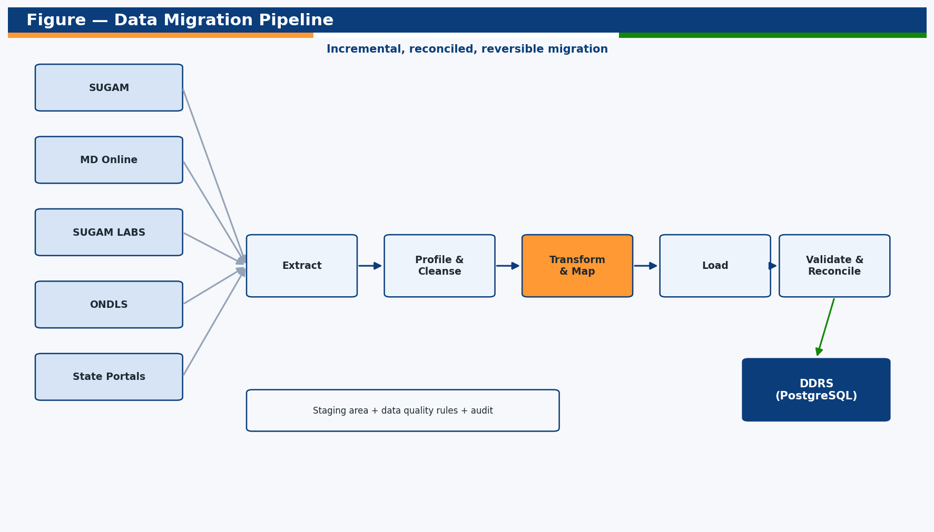
Figure — DDRS data-migration pipeline.

3.2 Migration Types
Type | Use
Big-bang (per slice) | Small, self-contained reference datasets
Phased / incremental | Primary approach — by portal/State and entity group
Parallel run | Critical transactional data verified against legacy before cutover
Delta / catch-up | Capture records created in legacy during the migration window

4. Migration Methodology

4.1 Assessment & Profiling
Inventory sources, profile data quality, define scope, volumes and risks per system.

4.2 Extraction
Extract from source RDBMS/exports (API/DB/CSV); land in a secure staging area.

4.3 Cleansing & De-duplication
Standardise formats, fix anomalies, de-duplicate entities/products, resolve orphan references.

4.4 Transformation & Mapping
Map source schemas to DDRS entities/fields; derive reference numbers; normalise enums.

4.5 Loading
Bulk-load into DDRS via repositories/ETL with referential integrity and batching.

4.6 Validation
Row counts, checksums, business-rule and referential checks; sample audits.

4.7 Reconciliation
Reconcile source vs target per entity; sign-off; record exceptions.

4.8 Cutover & Hypercare
Switch users to DDRS; monitor; apply deltas; support.

5. Data Mapping (Source → DDRS)

5.1 Entity-Level Mapping
Legacy Concept | Source | DDRS Entity | Notes
Firm / Company | SUGAM/ONDLS/MD | organizations | De-dup by PAN/GSTIN/CIN
Product / Brand | SUGAM/MD | products | Brand-name de-duplication applied
Technical/competent person | ONDLS/SUGAM | technical_persons | Enforce one-entity engagement
Testing laboratory | SUGAM LABS/ONDLS | laboratories | Central/State/Private typing
Application / permission | SUGAM/MD/ONDLS | applications (+events) | Map status to DDRS state machine
Licence / permission grant | SUGAM/MD/ONDLS | licenses | Preserve number; regenerate QR
Certificate / NOC (COPP/FSC/MSC/NCC) | SUGAM/ONDLS | certificates | Map certType; set validity
Sample / test report | SUGAM LABS | samples, test_reports | Map result to SQ/NSQ/Spurious
Clinical trial | SUGAM | clinical_trials (+sites) | Link CTRI / EC approvals
Payment / challan | SUGAM/ONDLS | payments | Status PAID; map gateway
Uploaded document | All | documents | Store ref + checksum + version

5.2 Sample Field Mapping — Application
Source Field (legacy) | DDRS Field | Transformation
file_no / app_no | referenceNo | Preserve or re-key to CDSCO/<TYPE>/<YEAR>/<SEQ>
applicant_id | organizationId | Resolve to migrated organization UUID
form_type | type | Map to ApplicationType enum
status_code | status | Map to ApplicationStatus (DRAFT…ISSUED)
submitted_on | submittedAt | Parse to ISO datetime
fee_amount | feeAmount | Validate against fee rules
product_category | productCategory | Map to ProductCategory enum
state | stateCode | Map to 2-letter code

6. Data Quality, Validation & Reconciliation

6.1 Data Quality Dimensions
Dimension | Check
Completeness | Mandatory fields present; no truncation
Accuracy | Values match source / reference data
Consistency | Enums, codes and references normalised
Uniqueness | No duplicates (entities, products, persons)
Integrity | All foreign keys resolve; no orphans
Validity | Conforms to DDRS validation rules

6.2 Reconciliation
- Per-entity source vs target row counts with variance log.
- Checksum/hash comparison for documents.
- Business-rule validation (e.g., licence validity, status legality).
- Statistical and sample-based manual audits with sign-off.

6.3 Acceptance Criteria
- 100% of in-scope records migrated or formally exception-listed.
- Reconciliation variance within agreed tolerance (target 0 for critical data).
- No unresolved referential-integrity errors.
- CDSCO sign-off per wave before production promotion.

7. Cutover, Rollback & Tools

7.1 Cutover & Parallel Run
Each wave runs DDRS in parallel with the legacy system for a defined window; delta records are captured and applied; users are switched at cutover with hypercare support.

7.2 Rollback
Every load is reversible: staging snapshots and pre-load backups allow a wave to be rolled back without affecting previously migrated, signed-off data.

7.3 Tooling
Concern | Approach
Extraction | Source DB connectors / API exports / CSV-TSV
Staging | Isolated schema with data-quality rules and audit
Transform/Load | Scripted ETL into DDRS (TypeORM/SQL), batched
Validation | Automated reconciliation reports + dashboards
Documents | Object storage with checksum + version capture

8. Governance, RACI, Risks & Schedule

8.1 RACI
Activity | CDSCO | SSP | Source Owner | DBA
Source access & schemas | A | C | R | C
Profiling & mapping | A | R | C | C
Cleansing rules | A | R | C | I
ETL build & load | I | R | I | C
Validation & reconciliation | A | R | C | C
Cutover sign-off | A | C | C | I

8.2 Risks & Mitigations
Risk | Mitigation
Poor legacy data quality | Early profiling; cleansing rules; exception handling
Schema ambiguity | Workshops with system owners; iterative mapping
Large document volume (24.3 TB) | Phased document migration; checksum verification
Downtime risk | Parallel run + delta capture + scheduled cutover windows
Referential gaps | Dependency-ordered loading; orphan resolution
Sensitive data exposure | Encryption, access control, masked non-prod data

8.3 Indicative Schedule
Wave | Scope | Window
W0 | Assessment, profiling, mapping, tooling | Months 1–2
W1 | Central master + SUGAM/MD core | Months 2–4
W2 | SUGAM LABS + high-volume States (ONDLS) | Months 4–7
W3 | Remaining States/UTs + documents | Months 7–10
W4 | Delta, reconciliation close-out, archive | Months 10–12

Appendix A — Reconciliation Report Template
Entity | Source count | Target count | Variance | Exceptions | Status
organizations | — | — | — | — | —
products | — | — | — | — | —
applications | — | — | — | — | —
licenses | — | — | — | — | —
samples | — | — | — | — | —

Appendix B — Mapping Specification Template
Source field | Type | DDRS field | Type | Rule | Default
— | — | — | — | — | —

— End of Document —

