GOVERNMENT OF INDIA
Ministry of Health & Family Welfare · Directorate General of Health Services
Central Drugs Standard Control Organization (CDSCO)

DIGITAL DRUGS REGULATORY SYSTEM (DDRS)
Intelligent Systems Architecture & Regulatory Use Cases
AI-Ready Design and Applied AI for Drug Regulation

Document Version 1.0
Date: 31 May 2026

Table of Contents
Right-click and "Update Field" to build the Table of Contents.

1. Introduction
AI-enabled capabilities are envisaged to enhance the efficiency, accuracy and responsiveness of DDRS. Per the programme’s provisional AI scope, AI models and agentic capabilities are developed separately; DDRS’s responsibility is to be architected as AI-ready so externally developed AI can be integrated without re-engineering the core. This document describes that intelligent-systems architecture and the regulatory AI use cases it enables.
- All platform services exposed via standardised, versioned, documented APIs.
- Architecture supports plug-in integration of external AI microservices and agents.
- Infrastructure accounts for future AI inference and orchestration workloads.
- Data models, schemas and workflows documented for AI training and agent onboarding.

2. AI-Ready Reference Architecture
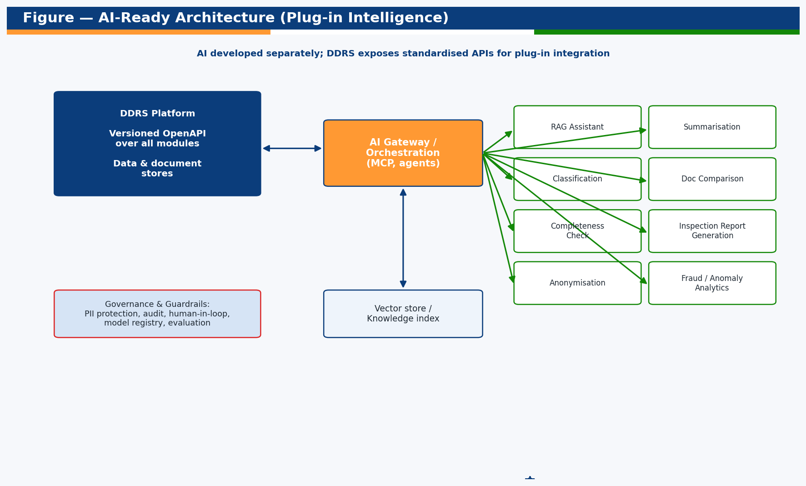
Figure — AI-ready architecture (plug-in intelligence).
Component | Role
DDRS OpenAPI surface | Single, versioned contract over all modules and data
AI Gateway / Orchestration | Routes requests to AI services; hosts agents (Model Context Protocol)
AI microservices | RAG assistant, summarisation, classification, comparison, etc.
Vector store / knowledge index | Embeddings of guidelines, dossiers, SOPs for retrieval
Model registry & MLOps | Versioning, deployment, monitoring, evaluation of models
Governance & guardrails | PII protection, human-in-loop, audit, policy enforcement

2.1 Integration Principles
- Loose coupling: AI services consume DDRS APIs; no direct DB coupling.
- Asynchronous, event-driven where suitable; idempotent operations.
- Standard protocols (REST/JSON, Model Context Protocol for agents).
- Versioned contracts and feature flags for safe rollout.
- Every AI action audited; human-in-the-loop for regulatory decisions.

3. Regulatory AI Use-Case Map
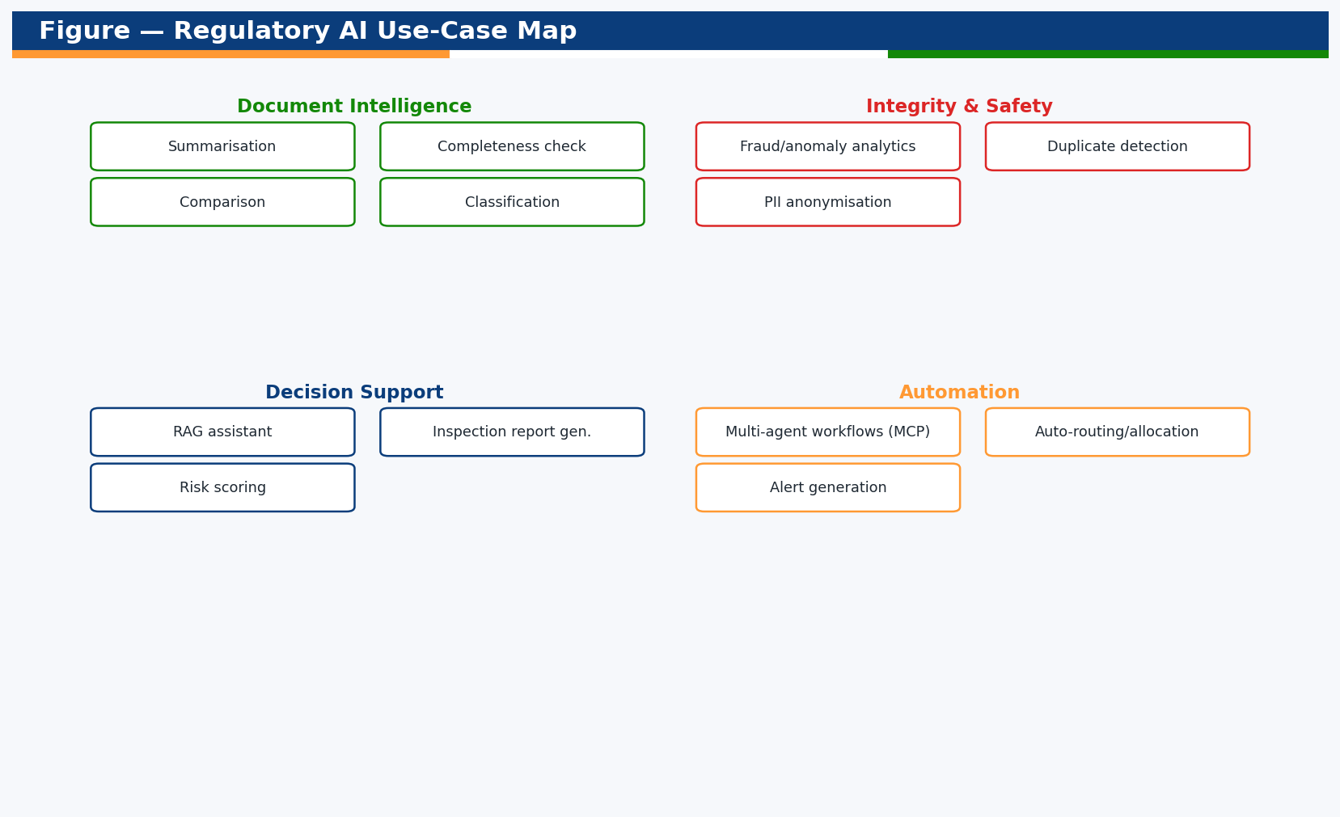
Figure — Regulatory AI use-case map.

3.1 Use-Case Catalogue
Use case | Description | Inputs | Outputs | Technique | Benefit
RAG conversational assistant | Answer applicant/officer queries grounded in CDSCO guidelines, Acts & SOPs | Query + knowledge index | Cited answer | RAG over vector store | Faster, consistent guidance
Document summarisation | Summarise dossiers, reports, PSURs | Document | Structured summary | LLM summarisation | Reviewer time saved
Completeness assessment | Check application/dossier completeness vs checklist | Application + rules | Gap report | Classification + rules | Fewer query cycles
Classification & routing | Auto-classify applications/complaints and route | Application/complaint | Category + route | Text classification | Faster allocation
Document comparison | Compare versions/labels/specifications | Two documents | Diff & risk flags | Semantic diff | Detect discrepancies
Inspection report generation | Draft inspection reports from findings | Findings + template | Draft report | LLM generation | Inspector time saved
AI anonymisation | Redact PII for sharing/analytics | Records/documents | Anonymised data | PII detection | DPDP-safe sharing
Fraud / anomaly analytics | Detect duplicate brands, suspicious patterns, NSQ risk | Transactions/registries | Risk scores/alerts | Anomaly detection | Proactive surveillance
Duplicate detection | Detect duplicate licences/brand names/batches | Registry data | Duplicate clusters | Similarity/embeddings | Data integrity
Risk-based inspection scoring | Prioritise inspections by risk | History + signals | Risk ranking | Predictive model | Efficient enforcement
Multi-agent workflows (MCP) | Orchestrate multi-step regulatory tasks | Task + tools/APIs | Completed actions | Agentic orchestration | Automation at scale
Alert generation | Draft drug/cosmetic alerts from signals | Enforcement/lab data | Draft alert | LLM + rules | Timely public safety

4. Data Readiness & MLOps
- Documented schemas (37 entities) and workflows enable supervised learning and retrieval.
- Document & knowledge stores feed the vector index for RAG.
- MLOps: model registry, versioned deployment, monitoring, drift detection, evaluation.
- Feedback loops capture human corrections to improve models.

5. Governance, Ethics & Guardrails
Concern | Control
Accuracy / hallucination | Retrieval grounding + citations + confidence thresholds
Human oversight | Human-in-the-loop for all regulatory decisions; AI assists, not decides
Privacy (DPDP) | PII minimisation/anonymisation; access control; purpose limitation
Auditability | All AI invocations logged with inputs/outputs/version
Bias & fairness | Evaluation datasets; monitoring; review
Security | Prompt-injection defences; sandboxed tools; least privilege

6. Roadmap & Maturity
Stage | Capability
Foundation (now) | AI-ready APIs, documented data, dashboards & rule-based automation
Assistive | RAG assistant, summarisation, completeness checks
Augmented | Classification, anomaly/fraud analytics, risk-based inspection
Autonomous (governed) | Multi-agent workflows via MCP with human-in-loop

7. Risks & Mitigations
Risk | Mitigation
Over-reliance on AI | Human-in-loop; AI as decision support only
Data quality | Validation, cleansing, monitoring
Model drift | Continuous evaluation and retraining
Privacy exposure | Anonymisation, access control, DPDP compliance
Integration risk | Versioned APIs, contract tests, feature flags

Appendix A — Sample Agent Workflow (MCP)
- User asks: "Is application CDSCO/ML/2026/000123 ready for approval?"
- Agent retrieves the application + checklist via DDRS APIs.
- Completeness service flags missing documents; RAG cites the relevant rule.
- Agent drafts a query letter (human reviews and sends).
- All steps and tool calls are logged to the audit trail.

— End of Document —

