GOVERNMENT OF INDIA
Ministry of Health & Family Welfare · Directorate General of Health Services
Central Drugs Standard Control Organization (CDSCO)

DIGITAL DRUGS REGULATORY SYSTEM (DDRS)
Transition, Refactoring, Migration, Upgradation & Maintenance Plan
Operating and Evolving the DDRS Portal Post Go-Live

Document Version 1.0
Date: 31 May 2026

Table of Contents
Right-click and "Update Field" to build the Table of Contents.

1. Introduction & Objectives
This plan describes how the DDRS portal will be transitioned, refactored, migrated, upgraded and maintained after Go-Live, ensuring continuous, secure and high-quality service over the operations period and a clean eventual exit/handover.
- Sustain agreed service levels (availability, performance, security).
- Continuously improve the platform without disrupting operations.
- Keep the codebase clean, modular and microservices-ready.
- Maintain complete, current documentation and transferable knowledge.
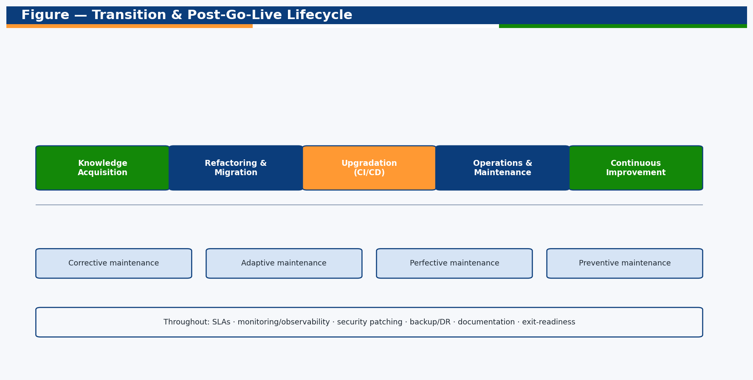
Figure — Transition & post-Go-Live lifecycle.

2. Transition & Knowledge Acquisition
- Structured knowledge acquisition: architecture, code, data, runbooks.
- Shadowing and reverse-KT with outgoing teams (where applicable).
- Environment, repository, CI/CD and credentials handover with inventory.
- Baseline of SLAs, backlog, known issues and technical debt.

3. Refactoring Strategy
DDRS is a modular monolith that is microservices-ready: each domain is isolated behind a documented OpenAPI contract. Refactoring is continuous and contract-safe.
Theme | Approach
Tech-debt management | Debt register; allocate capacity each iteration
Modular boundaries | Keep domains decoupled; extract to services when load demands
Code quality | Typed code, lint gates, tests, peer review
API versioning | Backward-compatible changes; deprecation policy
Performance | Profiling, indexing, query/pagination tuning
Reusability | Shared utilities (pagination, reference/QR, audit)

4. Migration (Environment & Data)
- Development SQLite → production PostgreSQL via DB_TYPE config (portable schema).
- Schema evolution via controlled migrations; no destructive changes in prod.
- Data migration/backfills run in maintenance windows with backups and rollback.
- Zero/low-downtime techniques (expand-contract schema changes).

5. Upgradation & Release Management
Aspect | Practice
Source control | Trunk-based with protected main; PR review
CI/CD | Lint → test → build → image → deploy pipeline
Deployment | Blue-green / canary; health checks; instant rollback
Feature flags | Decouple deploy from release; controlled exposure
Versioning | Semantic versioning; documented release notes
Change windows | Scheduled, communicated; emergency-change path

6. Maintenance Services
Type | Definition | Examples
Corrective | Fix defects | Bug fixes, hotfixes
Adaptive | Adapt to change | Rule/Act updates, new integrations, OS/lib updates
Perfective | Improve | Performance, UX, new reports
Preventive | Prevent issues | Refactoring, patching, capacity tuning

6.1 Support Model
Tier | Scope
L1 Helpdesk | IVRS/ticket intake, triage, FAQs, password/access
L2 Application | Functional issues, configuration, data fixes
L3 Engineering | Code defects, performance, integrations, DB
Vendor/3rd-party | Cloud, gateways, external systems

6.2 Indicative SLAs
Severity | Response | Resolution
S1 Critical | 15 min | 4 h
S2 High | 30 min | 8 h
S3 Medium | 4 h | 3 business days
S4 Low | 1 business day | 10 business days

7. Operations: Monitoring, Security, Backup & DR

7.1 Monitoring & Observability
- Health endpoint probes; uptime and latency monitoring.
- Structured logs, metrics and tracing; alerting on thresholds.
- Audit-trail and integration-log review for anomalies.

7.2 Security Operations
- Regular CERT-In empanelled audits; vulnerability scanning and patching.
- Secret rotation (JWT, DB, gateway keys); least-privilege access.
- Incident response plan with defined severities and comms.

7.3 Backup, DR & BCP
Control | Target
Backup frequency | Daily full + frequent incrementals (PostgreSQL)
RPO | ≤ 15 minutes (PITR)
RTO | ≤ 1 hour
DR | Cross-zone/region restore drills; runbook-tested
Retention | Per policy; audit logs archived off-site

8. Change Management, Documentation & Governance
- Change Control Board reviews significant changes (CCB).
- Living documentation: SAD, runbooks, API docs, change logs kept current.
- Periodic reviews (Tech Ops, Architecture Review) and reporting.

8.1 Governance RACI
Activity | CDSCO | SSP | CCB
Roadmap & priorities | A | C | C
Releases | A | R | C
Emergency changes | A | R | I
SLA reporting | A | R | I

9. Exit / Transition Management
On contract end or transition to a new provider, the SSP ensures a clean, complete handover with no service disruption.
- Updated transition plan and complete documentation handover.
- Full source code, configuration, infrastructure-as-code and data export.
- Inventory of assets, credentials and access; knowledge-transfer sessions.
- Walk-throughs/demos; defined acceptance of handover by CDSCO/new vendor.

10. Risks & KPIs
Risk | Mitigation
Knowledge loss | Documentation + cross-training + recorded KT
Regression on change | Automated tests + canary + rollback
Security drift | Continuous scanning + patch cadence + audits
Scope creep | CCB-governed change control
KPI | Target
Availability | ≥ 99.5% monthly
S1 resolution within SLA | ≥ 95%
Change success rate | ≥ 98%
Mean time to recover | ≤ 1 h
Documentation currency | 100% per release

— End of Document —

