GOVERNMENT OF INDIA
Ministry of Health & Family Welfare · Directorate General of Health Services
Central Drugs Standard Control Organization (CDSCO)

DIGITAL DRUGS REGULATORY SYSTEM (DDRS)
CAPACITY BUILDING & TRAINING PLAN

Document Version 1.0
Date: 31 May 2026

Document Control
Version | Date | Author | Description
0.5 | — | Training & Change Mgmt | Draft plan
1.0 | 31 May 2026 | Training & Change Mgmt | Baseline release

Purpose
This Capacity Building & Training Plan defines the strategy, curricula, schedules, delivery methods, materials, assessment and governance for equipping all DDRS stakeholders — CDSCO officers, State Licensing Authorities, testing laboratories, industry and the public — with the knowledge and skills to use the platform effectively. It covers a phased rollout across all 36 States/UTs and the full three-year operations period.

Scope
- Role-based training for all 19 DDRS user roles across five portals.
- Train-the-trainer (ToT) and master-trainer cadre development.
- E-learning, instructor-led, hands-on lab, webinars and on-site sessions.
- Training materials: manuals, quick-reference guides, videos, simulations.
- State onboarding programme and phased rollout schedule.
- Assessment, certification, feedback and continuous improvement.
- Helpdesk, knowledge base and post-go-live support.

Table of Contents
Right-click and "Update Field" to build the Table of Contents.

1. Training Strategy & Approach
The capacity-building programme follows a blended, role-based, competency-driven approach designed for a geographically distributed, multi-stakeholder audience. It uses the ADDIE instructional design model (Analyse, Design, Develop, Implement, Evaluate) and a train-the-trainer multiplier model to scale across 36 States/UTs.

1.1 Objectives
- Enable every user role to perform its DDRS tasks confidently and correctly.
- Reduce support tickets and processing errors through proficiency.
- Build a self-sustaining master-trainer cadre within CDSCO and the States.
- Drive adoption, data quality and timely (SLA-compliant) processing.
- Institutionalise continuous learning and knowledge management.

1.2 Guiding Principles
- Role-based: curricula tailored to each role’s portal and tasks.
- Blended: e-learning + instructor-led + hands-on sandbox practice.
- Hands-on first: practice on a seeded training environment, not slides alone.
- Multilingual: English and Hindi, with regional language support where needed.
- Accessible: GIGW-aligned materials; self-paced options for flexibility.
- Measured: assessments, certification and Kirkpatrick-level evaluation.

1.3 Blended Learning Model
Mode | Use | Share
E-learning (self-paced) | Foundation, refreshers, just-in-time micro-modules | 40%
Instructor-led (virtual) | Role tracks, Q&A, scenario walkthroughs | 30%
Hands-on lab (sandbox) | Guided practice on seeded environment | 20%
Webinars / workshops | Updates, advanced topics, communities of practice | 10%

2. Stakeholder & Training-Needs Analysis
Training needs are mapped to the 19 DDRS roles and the five portals. The matrix below shows the target proficiency per role across the principal modules (F=Foundation, I=Intermediate, A=Advanced).
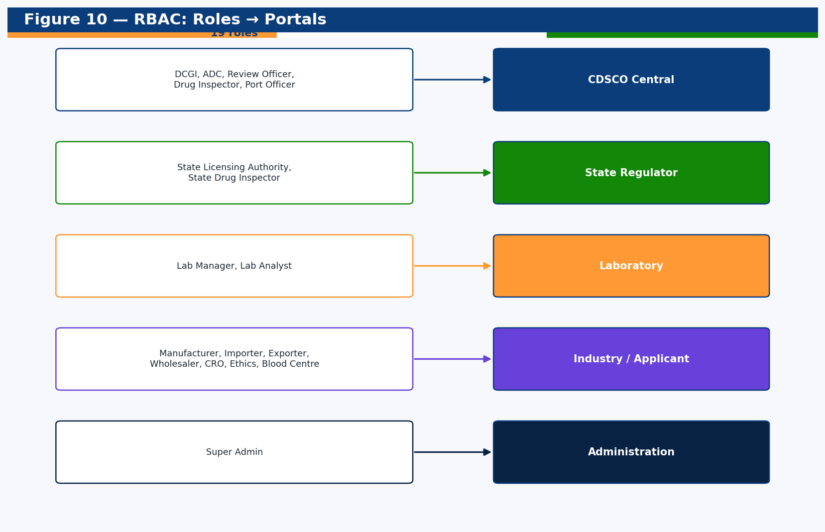
Roles mapped to portals (drives the role-based curricula).
Role | Portal | Applications | Inspections/Enf. | Lab | Vigilance | Analytics | Admin
DCGI / ADC | CDSCO | A | A | I | A | A | I
Review Officer | CDSCO | A | I | F | I | I | -
Drug Inspector | CDSCO | I | A | I | F | F | -
Port Officer | CDSCO | A | F | - | - | F | -
State Licensing Authority | State | A | A | I | F | A | -
State Drug Inspector | State | I | A | I | F | F | -
Lab Manager | Lab | - | F | A | F | F | -
Lab Analyst | Lab | - | - | A | - | - | -
Manufacturer/Importer | Industry | A | F | F | I | F | -
Wholesaler/Retailer | Industry | I | - | - | - | - | -
CRO / Ethics Committee | Industry | I | - | - | I | - | -
Blood Centre | Industry | I | F | I | I | - | -
Technical Person | Industry | F | - | - | - | - | -
Super Admin | Admin | I | I | I | I | A | A
Public User | Public | F | - | - | - | - | -
Approximate audience sizing: ~6,500 internal users (CDSCO + States + labs) and a large external base (~10 lakh stakeholders) trained primarily through self-paced e-learning, webinars and the public knowledge base.

3. Curriculum & Course Catalogue
The curriculum is organised into a common Foundation track, role-specific tracks mapped to portals, and specialised Administration, Integration and Security tracks.

3.1 Curriculum Structure
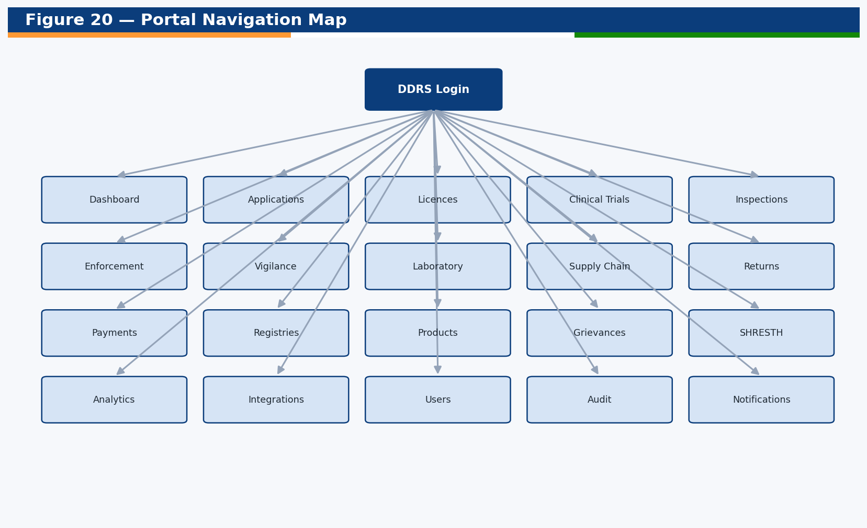
Module/portal map underpinning the role tracks.

3.2 Course Catalogue
Code | Course | Audience | Duration | Mode | Prereq
DDRS-F01 | DDRS Overview & Navigation | All roles | 1.5 h | E-learning | None
DDRS-F02 | Login, MFA (OTP/Aadhaar) & Profile | All roles | 0.5 h | E-learning | None
DDRS-F03 | Dashboards, Search, Filters & Notifications | All roles | 1 h | E-learning | F01
DDRS-F04 | Data Protection, Audit & Responsible Use (DPDP) | All roles | 1 h | E-learning | F01
DDRS-IND01 | Creating & Submitting Applications | Industry | 2 h | ILT + Lab | F01-F03
DDRS-IND02 | Fee Payment (Bharat Kosh/Treasury) & Receipts | Industry | 1 h | Lab | IND01
DDRS-IND03 | Licences, Certificates, NOCs & QR Verification | Industry | 1.5 h | ILT | IND01
DDRS-IND04 | Renewals, Endorsements & Post-Approval Changes | Industry | 1.5 h | ILT + Lab | IND01
DDRS-IND05 | Clinical Trials & Site Management | CRO/Sponsor | 2 h | ILT | IND01
DDRS-IND06 | Vigilance Reporting (SAE/AEFI) & E2B/ICSR Import | Industry/PV | 2 h | ILT + Lab | F01
DDRS-IND07 | Returns Filing & Supply-Chain Batch/QR | Industry | 1.5 h | Lab | IND01
DDRS-CEN01 | Work Queue, Allocation & Timeline Review (TRS) | CDSCO/State | 2 h | ILT + Lab | F03
DDRS-CEN02 | Application Review, Queries & Decisions | CDSCO/State | 2.5 h | ILT + Lab | CEN01
DDRS-CEN03 | Issuing Licences, Certificates & NOCs | CDSCO/State | 1.5 h | Lab | CEN02
DDRS-CEN04 | Inspections: Scheduling, Forms & Joint Reports | Inspectors | 2.5 h | ILT + Lab | F03
DDRS-CEN05 | Enforcement: Sampling, NSQ/Spurious, Recalls, Court | CDSCO/State | 2.5 h | ILT | F03
DDRS-CEN06 | Vigilance Assessment & PSUR Review | CDSCO | 2 h | ILT | F03
DDRS-LAB01 | Sample Receipt & Workflow (LIMS) | Lab | 2 h | ILT + Lab | F03
DDRS-LAB02 | Testing, Reports & Result Capture | Lab Analyst | 2.5 h | Lab | LAB01
DDRS-LAB03 | Batch Release (BRC), SLP Scrutiny & Reference Standards | Lab Manager | 2 h | ILT | LAB01
DDRS-ANA01 | MIS Dashboards & Custom Reports (CSV) | CDSCO/State | 1.5 h | ILT | F03
DDRS-ANA02 | SHRESTH State Benchmarking Index | Authorities | 1 h | Webinar | ANA01
DDRS-ADM01 | User & Role Administration (RBAC) | Admin | 2 h | ILT + Lab | F04
DDRS-ADM02 | Entity/Lab Onboarding & Master Data | Admin | 1.5 h | Lab | ADM01
DDRS-ADM03 | Audit Trail & Investigations | Admin/CDSCO | 1.5 h | ILT | F04
DDRS-INT01 | Integrations Hub & External Systems (35) | Admin/CDSCO | 2 h | ILT | ADM01
DDRS-SEC01 | Security, Access Control & Incident Response | Admin/IT | 2 h | ILT | F04
DDRS-TOT01 | Train-the-Trainer: Facilitation & Tools | Master Trainers | 8 h | Workshop | Role track
DDRS-PUB01 | Public Services: Verify, Alerts, Grievances | Public/Helpdesk | 0.5 h | E-learning | None

3.3 Role-Based Learning Paths
Audience | Recommended Path
Industry / Applicant | F01→F02→F03→F04→IND01→IND02→IND03→IND04 (+IND05/06/07 as applicable)
CDSCO Officer (Review) | F01-F04→CEN01→CEN02→CEN03→ANA01
Drug Inspector | F01-F04→CEN01→CEN04→CEN05
State Licensing Authority | F01-F04→CEN01→CEN02→CEN03→CEN04→CEN05→ANA01→ANA02
Laboratory | F01-F04→LAB01→LAB02→LAB03
Administrator | F01-F04→ADM01→ADM02→ADM03→INT01→SEC01
Master Trainer | Relevant role track + TOT01

4. Delivery Methods & Materials

4.1 Delivery Channels
- Self-paced e-learning (LMS-hosted modules, micro-videos, simulations).
- Virtual instructor-led training (VILT) over webinar platform.
- On-site instructor-led training at CDSCO HQ, zonal/port offices and State capitals.
- Hands-on labs on a dedicated, seeded training (sandbox) environment.
- Webinars, workshops and communities of practice for ongoing learning.

4.2 Training Materials
Artefact | Description | Format
User Manuals (per role) | Step-by-step task guides with screenshots | PDF/online
Quick Reference Guides | One-page job aids per key task | PDF/printable
E-learning Modules | Narrated, interactive, assessed | SCORM/HTML5
Tutorial Videos | Short how-to clips per feature | MP4
Hands-on Lab Guides | Guided exercises on the sandbox | PDF/online
Knowledge Base / FAQs | Searchable self-service articles | Web
Trainer Kits | Slides, facilitator notes, exercise data | PPTX/PDF
Release Notes & Change Bulletins | What changed each release | Web/email

4.3 Training (Sandbox) Environment
A dedicated training environment mirrors production and is pre-seeded with realistic, India-contextualised demonstration data (500+ records per flow). It allows risk-free practice of every workflow (application lifecycle, inspections, lab testing, enforcement, vigilance) without affecting live data, and is reset on a schedule between cohorts.

5. Train-the-Trainer (ToT) & Master Trainers
A multiplier model develops a cadre of master trainers who then deliver training in their States/zones, ensuring scalable, sustainable capacity beyond the SSP team.

5.1 Cadre Structure
Tier | Who | Responsibility
Lead Trainers (SSP) | SSP training specialists | Design curricula, train master trainers, quality assurance
Master Trainers | Nominated CDSCO & State officers | Deliver role training in their region; first-line mentoring
Departmental Champions | Power users per office/lab | Peer support, adoption, feedback collection

5.2 ToT Programme
- Selection of master trainers (2–4 per State/zone, per portal).
- Intensive role-track training + facilitation skills (DDRS-TOT01).
- Certification of master trainers via assessment + teach-back.
- Trainer kits, sandbox access and ongoing trainer community.

6. State Onboarding & Phased Rollout
Onboarding and training are rolled out in waves across all 36 States/UTs. Each wave includes readiness checks, master-trainer certification, role-based training, hands-on labs, go-live support and a stabilisation review. State onboarding progress is a tracked parameter linked to O&M performance.

6.1 Per-State Onboarding Steps
- Stakeholder mapping and user/role enrolment.
- Master-trainer nomination and ToT certification.
- Role-based training (e-learning + VILT + labs).
- Data readiness and (where applicable) migration validation.
- Go-live with on-site/virtual hypercare support.
- Post-go-live review, adoption metrics and refresher scheduling.

6.2 Indicative Rollout Waves
Wave | Timeframe | Coverage | Focus
Wave 0 – Pilot | Months 1–2 | CDSCO HQ + 2 zonal offices + 1 lab | Internal core, ToT seed, feedback
Wave 1 | Months 2–4 | High-volume States (e.g., MH, GJ, TN, KA, TG, UP) | SLA, licensing, inspections
Wave 2 | Months 4–7 | Next 10–12 States/UTs | Full role tracks, labs
Wave 3 | Months 7–10 | Remaining States/UTs | Complete national coverage
Wave 4 – Deepening | Months 10–36 | All + industry/public at scale | Advanced topics, refreshers, new releases

6.3 Indicative Training Calendar (per wave)
Week | Activity
W1 | Readiness check, enrolment, master-trainer ToT
W2 | Foundation e-learning (all users) + role-track VILT begins
W3 | Hands-on labs (sandbox) per role; assessments
W4 | Go-live + hypercare; daily clinics; feedback capture
W5–6 | Stabilisation, refresher clinics, certification close-out

7. Assessment, Certification & Competency

7.1 Assessment Methods
- Pre-assessment (baseline) and post-assessment (knowledge gain).
- Hands-on task-based assessment on the sandbox (can the user do the task?).
- Module quizzes within e-learning (auto-graded, pass mark 70%).
- Trainer teach-back for master-trainer certification.

7.2 Certification Levels
Certificate | Criteria
DDRS Certified User (role) | Complete role path + pass assessment (≥70%)
DDRS Certified Power User | Advanced track + task assessment
DDRS Certified Master Trainer | Role track + ToT + teach-back evaluation

7.3 Competency Framework
Level | Definition
Foundation (F) | Can navigate and perform basic, guided tasks
Intermediate (I) | Performs core role tasks independently
Advanced (A) | Handles exceptions, mentors others, configures where permitted

8. Evaluation, KPIs & Continuous Improvement

8.1 Kirkpatrick Evaluation
Level | Measures | Method
1 Reaction | Satisfaction, relevance | Post-session survey
2 Learning | Knowledge/skill gain | Pre/post assessment
3 Behaviour | On-the-job application | Usage analytics, supervisor review
4 Results | SLA, error/ticket reduction, adoption | DDRS dashboards & audit

8.2 Training KPIs
KPI | Target
Users trained (per wave) | ≥ 95% of enrolled
Assessment pass rate | ≥ 85%
Master trainers certified | ≥ 2 per State/portal
Post-training satisfaction (CSAT) | ≥ 4.2 / 5
Support tickets per user (30 days post-go-live) | Declining trend
SLA-compliant processing post-training | Improving trend

8.3 Continuous Improvement
Feedback, assessment data and support trends are reviewed each wave; materials and sessions are updated accordingly. New releases trigger change bulletins, refreshed micro-modules and targeted webinars.

9. Helpdesk, Knowledge Management & Post-Go-Live Support
- IVRS-enabled, multilingual helpdesk with ticketing, escalation and SLAs.
- Searchable knowledge base, FAQs and how-to videos (in-product and public).
- Hypercare during go-live: daily clinics and rapid-response support.
- Communities of practice and periodic webinars for ongoing learning.
- Quarterly refreshers and onboarding for new joiners.

10. Governance, Roles & Responsibilities

10.1 Training Governance
A Training Steering Group (CDSCO + SSP) owns the plan, approves curricula and schedules, and reviews KPIs at each wave. A Training PMO coordinates logistics, enrolment, materials and reporting.

10.2 RACI
Activity | CDSCO | SSP Training | Master Trainers | State PMO
Curriculum design | A | R | C | I
Material development | A | R | C | I
ToT delivery | A | R | C | I
Role training delivery | I | C | R | A
Sandbox environment | A | R | I | I
Enrolment & logistics | C | C | I | R
Assessment & certification | A | R | C | I
Evaluation & reporting | A | R | C | C

11. Training Risk Management
Risk | Mitigation
Low attendance / adoption | Mandated role certification; leadership sponsorship; incentives
Geographic dispersion | Blended/VILT + master-trainer multiplier model
Language barriers | Bilingual materials; regional-language support
Skill variance | Pre-assessment + adaptive paths; foundation track
Release churn | Change bulletins + micro-module refreshers
Trainer attrition | Larger master-trainer pool; recorded sessions; trainer kits

12. Indicative Budget Heads
Training costs are part of the SSP’s operational scope. The indicative heads below support planning; actual figures are governed by the contract.
Head | Notes
Content development | E-learning, videos, manuals, trainer kits
LMS & sandbox hosting | Platform, environment refresh, access management
Delivery (VILT/on-site) | Trainer effort, travel for on-site waves
Master-trainer programme | ToT workshops, certification
Helpdesk & support | IVRS, agents, knowledge base upkeep
Evaluation & reporting | Assessment tooling, analytics

Appendix A — Sample Course Outline (DDRS-CEN02)
Course: Application Review, Queries & Decisions — audience: CDSCO/State review officers — duration: 2.5 h — mode: ILT + hands-on lab.
Time | Segment | Activity
00:00 | Orientation | Objectives, the work queue and masked allocation
00:20 | Review workflow | Walkthrough of states: pre-screening → review → recommend
00:50 | Raising queries | Query types, applicant response loop
01:20 | Hands-on lab | Process 3 seeded applications end-to-end
02:00 | Decisions & issuance | Approve/reject; auto-issuance & QR
02:20 | Assessment | Task-based assessment + Q&A

Appendix B — Sample Assessment Items
- Demonstrate creating, submitting and paying for an application (task).
- Identify the correct action when a query response is received (MCQ).
- Locate an entity’s licence and verify it via QR (task).
- Explain the masked-allocation rule and manual override (short answer).
- Record an inspection finding with correct severity (task).

Appendix C — Attendance & Feedback Templates
Field | Example
Course / Code | DDRS-CEN02
Date / Wave | —
Trainer | —
Attendee / Role / Office | —
Pre-score / Post-score | —
Result (Pass/Fail) | —
CSAT (1–5) | —
Comments | —

Appendix D — Glossary
Term | Meaning
ADDIE | Analyse, Design, Develop, Implement, Evaluate (ID model)
VILT | Virtual Instructor-Led Training
ILT | Instructor-Led Training
ToT | Train-the-Trainer
LMS | Learning Management System
CSAT | Customer/Trainee Satisfaction score
Sandbox | Seeded non-production training environment
Hypercare | Intensive post-go-live support period
SHRESTH | State regulatory performance benchmarking index
SLA | Service Level Agreement

— End of Document —

