Admissions Workflow Automation
Requirements & Solution Design Document
Take-home exercise — Senior Frontend Engineer (Full-Stack)
Prepared for: Toddle
Prepared by: Ankit Meena
Date: 24 August 2026 · Revision 2 (updated to reflect the implemented system)
Reference: workflow-14.netlify.app (Admissions workflows — example task brief)

Table of Contents

Executive Summary
The admissions team needs to run a handful of high-value, time-bound flows around an application — reminding families to pay a fee, guiding an accepted applicant through enrolment, routing a new application to a reviewer, and reviewing scholarship applications — without depending on engineering for every change or every wording tweak. This document describes the admissions workflow builder as it has now been implemented: nine step types — the seven already available (Trigger, Delay, Branches, Communicate, Set status, Go to action, Goal) plus two additions, Request Document and Assign to Staff / Create Task, that close the two biggest gaps in the original step set. Four workflows are built from this palette and run live end-to-end: the three examples in the task brief plus a Scholarship Application Review flow that exercises all nine step types in a single flow.
This revision folds in everything added during implementation beyond the original proposal — most notably a derived auto-layout canvas (a workflow is a pure graph; node positions are computed, never stored), undo/redo, a pre-publish validation layer that blocks publishing a broken workflow, drag-to-reorder, and full workflow lifecycle management (create, rename, delete, publish and unpublish). It also records the as-built stack for this exercise (Webpack, RTK Query, SQLite, an in-process durable scheduler) alongside the production target originally proposed.
Part A sets out the requirements. Part B sketches the four implemented workflows, each with a step-by-step "what it does and why it belongs here". Part C is the solution design, with the frontend architecture (C.6) as the primary focus — the step type registry, how a workflow's JSON becomes the canvas, the derived-layout model, the draft/publish save flow, undo/redo, and validation — plus enough of the data model, execution engine and backend stack to place that frontend in its whole-system context. Part D lists open questions worth raising on the call.

Part A — Requirements

A.1 Problem Statement
Admissions is a time-bound, multi-party process: an applicant moves through stages — submitted, under review, offered, accepted, enrolled — and at each stage the school needs to nudge people (fee reminders, enrolment reminders), inform staff (assign a reviewer, escalate a stalled case), and keep the application's status in sync with what has actually happened. Today this kind of thing is typically done by hand or via one-off scripts that only engineering can change. The product's promise is that an admissions officer can configure flows like these visually, publish them, and trust that they keep running correctly for every application — including waits that span days — without a developer in the loop.

A.2 Goals
- Let admissions staff build, edit and publish workflows without writing code.
- Guarantee that a published workflow executes reliably for every application that matches its trigger, including multi-day waits, server restarts, and deploys.
- Keep each flow legible to a non-engineer reading it on the canvas — which is why the reasoning behind each step matters as much as the step itself.
- Provide enough building blocks to express retries, escalation, document collection and staff assignment using step types in the builder, rather than needing a developer to add a new step type for every new scenario.
- Let Communicate messages pull in structured data (applicant name, deadline, programme, assignee, etc.) as merge-field variables, scoped to who the message is actually being sent to.
- Lay the canvas out automatically from the graph, so a non-engineer never has to arrange boxes for a flow to stay readable as it grows.
- Catch structural mistakes (an unreachable step, an uncapped loop, a missing required field) before a flow goes live, rather than after it has emailed a family.

Non-goals for this document
- Payment processing itself — a separate fee/payment system is assumed to exist and to expose a fee status the workflow can read.
- The admissions record system's full field schema.
- Pixel-level visual design of the canvas — the provided demo already establishes this.

A.3 Users & Personas
- Admissions Officer / Workflow Builder — builds and publishes flows on the canvas. Not a developer; needs confidence a published flow will simply keep working.
- Reviewing Staff / Faculty — receives internal notifications a workflow assigns to them; acts outside the tool, in their inbox or the student system.
- Applicant / Parent or Guardian — receives communications from the workflow; never opens the builder.
- School Admin (super-user) — manages who can build vs. only view, and looks at run history across workflows.

A.4 Functional Requirements
ID | Requirement | Rationale
FR-1 | Visually build, edit and publish workflows on a canvas, using the step types below, with no code. | Core promise of the product for non-technical admissions staff.
FR-2 | Support the seven step types: Trigger, Delay, Branches, Communicate, Set status, Go to action, Goal. | These are the atomic building blocks every workflow in Part B is composed from.
FR-3 | A Trigger fires once per matching event per application, and each firing starts an independent run. | Hundreds of applicants can be mid-flow at once without their runs interfering with each other.
FR-4 | Delay steps resume automatically after the wait, even across days and server restarts. | Fee and enrolment reminders depend on multi-day waits; a missed resume is a missed reminder.
FR-5 | Branches can test the application's current status, a date/time comparison, a run-scoped counter, a document's upload status, and a task's completion status. | Every workflow in Part B needs at least one of these to decide "remind again" vs. "escalate".
FR-6 | Go to action can jump to another step in the same run, with a built-in cap on repeat count and an explicit target chosen by visible step number. | Reminder loops must repeat a bounded number of times, then fall through to escalation.
FR-7 | Communicate supports merge-field variables (e.g. {{applicant_name}}, {{deadline_date}}) and can address the applicant, guardian, both, or internal staff — the variables on offer adapt to who is selected. | The same step type drives both applicant-facing reminders and internal staff notifications, without risking a staff-only field leaking into a family-facing email.
FR-8 | Set status writes back to the application's status field, readable by the rest of the school's system. | Staff dashboards and other workflows depend on status being a single source of truth.
FR-9 | Goal ends a run and records a label for why it ended (e.g. "Fee collected" vs. "Escalated"). | Without a labelled end state, staff can't tell a healthy completion from a stalled one in run history.
FR-10 | Every run keeps a visible history of which steps executed, when, and with what result, per application. | Staff need to answer "what happened to this applicant's reminders" without reading raw logs.
FR-11 | Workflows distinguish draft vs. published; edits don't affect runs already in progress until published, and a published workflow can be unpublished to stop it firing new runs. | Staff will iterate on wording and timing; in-flight applicants shouldn't be moved onto a half-edited flow.
FR-12 | Role-based permissions distinguish who can edit/publish a workflow from who can only view its run history. | Non-technical staff should see status without being able to break a live, applicant-facing flow.
FR-13 | A Request Document step lets a workflow ask an applicant/guardian to upload one or more files against a checklist, and exposes an upload status Branches can read. | Today "documents submitted?" has to be inferred from a field some other system sets; a first-class step makes Workflow 2 fully self-serve (see C.4).
FR-14 | An Assign to Staff / Create Task step assigns an application to a person and creates a tracked task with its own due date and completion state, which Branches can read. | Lets "reviewed?" be answered by task completion rather than elapsed time alone, and makes reassignment/escalation trackable (see C.4, Workflow 3).
FR-15 | Full workflow lifecycle management from the builder: create a new workflow, rename it, delete it (cascading its runs, tasks and history), and toggle publish / unpublish. | Staff manage a growing library of flows themselves, without engineering or direct database access.
FR-16 | Undo and redo of canvas edits, by button and keyboard, scoped to the workflow being edited. | Editing a graph is exploratory; a mis-drag or wrong delete must be one keystroke to reverse.
FR-17 | Validate a workflow's structure and surface issues before it can be published — an unreachable step, an unwired branch, a loop with no exit, a step missing required config — blocking publish on errors. | A structural mistake here is public-facing (it emails real families); it should be caught in the builder, not in production.

A.5 Non-Functional Requirements
ID | Requirement | Why it matters
NFR-1 | Durability — a scheduled Delay survives a server restart or deploy. | Multi-day waits are central to every workflow here; losing state mid-wait silently breaks a live reminder.
NFR-2 | Idempotency — retrying a failed step never sends a duplicate email or double-applies a status change. | A duplicate "your fee is overdue" email erodes trust in the school's communication.
NFR-3 | Scale — thousands of applications can be mid-flow concurrently, each independently scheduled. | A single admissions cycle can involve thousands of applicants triggering the same workflow.
NFR-4 | Auditability — every step execution, email sent, and status change is logged with a timestamp. | Needed to answer support questions ("why didn't this family get a reminder") and for compliance.
NFR-5 | Privacy — student/guardian PII is handled per the applicable education-data regulation. | This is student data; both the vendor and the school carry compliance obligations (see A.6 and Part D).
NFR-6 | Usability — a non-engineer can read a published flow and understand it without documentation. | This is the entire value proposition of a visual builder over a script.
NFR-7 | new step types can be added without redesigning existing flows or touching frontend code in the common case. | Section C.9 proposes several; today's seven step types should not be assumed final.

A.6 Assumptions & Out of Scope
- The admissions system already models an "Application" with a status field the workflow engine can read and write.
- Fee collection lives in a separate payment system; the workflow only reads/writes a fee status, it does not process payments itself.
- Email is the only communication channel in the builder today; SMS/WhatsApp are proposed as future work (C.9), not assumed here.
- This document does not re-specify the canvas's visual design, which the provided demo already establishes.

Part B — Admission Workflows
All four workflows below are implemented, published, and run live end-to-end. Workflows 2 and 3 use the two step-type additions from C.4 — Request Document and Assign to Staff / Create Task — and Workflow 4 (Scholarship Application Review) exercises all nine step types in one flow. In the running system, delays are compressed to seconds rather than days, so a full run — including its reminder/escalation loop — is demoable in a minute or two. Dashed arrows are loop-backs (Go to action).

B.1 Workflow 1 — Admission Fee Payment Reminder
Reminds an accepted applicant's family to pay the admission fee, escalating to a human after a bounded number of automated reminders instead of nagging indefinitely.
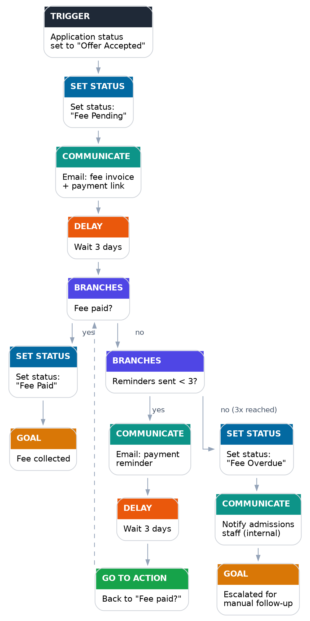
Figure B.1 — Admission fee payment reminder
# | Type | Action | Why it belongs here
1 | Trigger | Fires when an application's status becomes "Offer Accepted". | This is the earliest point a fee is actually owed — triggering any earlier would ask for money before there's an offer to pay for.
2 | Set status | Set status to "Fee Pending". | Gives staff and other workflows one source of truth that a fee is now outstanding, without waiting for the first email to go out.
3 | Communicate | Email the fee invoice and payment link to the applicant and guardian, using {{applicant_name}}, {{fee_amount}} and {{due_date}}. | The actual ask — must happen before any wait, so the Delay below measures "time since we asked", not something else.
4 | Delay | Wait 3 days. | Gives the family a reasonable window to pay before being chased.
5 | Branches | "Fee paid?" | Re-checks reality before doing anything else — if it's already paid, the flow should stop, not blindly send the next reminder.
6 | Set status (yes) | Set status to "Fee Paid". | Closes the loop on status so the rest of the system knows, without anyone re-reading emails.
7 | Goal (yes) | "Fee collected". | A clearly labelled, successful completion in the run history.
8 | Branches (no) | "Reminders sent < 3?" | Bounds the loop — without this the flow nags indefinitely and never escalates.
9 | Communicate (yes) | Send a reminder email. | The actual nudge.
10 | Delay | Wait 3 days. | Same reasoning as step 4, repeated per reminder.
11 | Go to action | Jump back to "Fee paid?". | Re-checks payment status before deciding to send yet another reminder or stop.
12 | Set status (no, 3x reached) | Set status to "Fee Overdue". | Signals to staff — and any downstream workflow, e.g. an enrolment hold — that this case is now stuck.
13 | Communicate | Notify admissions staff internally, using {{applicant_name}} and {{application_id}}. | Automated reminders have run their course; a human should decide the next step (e.g. call the family).
14 | Goal | "Escalated for manual follow-up". | A distinct end state from "Fee collected", so staff scanning run history can immediately see who needs a human touch.

B.2 Workflow 2 — Post-Offer → Enrolment
Carries an applicant from receiving an offer through accepting it and completing enrolment, with a bounded reminder loop at the accept-offer stage and a first-class Request Document step (see C.4) at the document-collection stage.
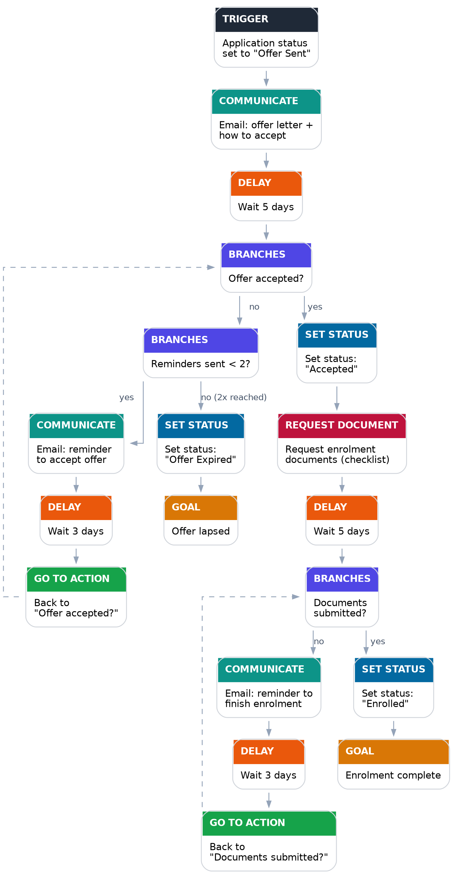
Figure B.2 — Post-offer to enrolment
# | Type | Action | Why it belongs here
1 | Trigger | Fires when an application's status becomes "Offer Sent". | Starts the flow at the moment there is actually an offer to respond to.
2 | Communicate | Email the offer letter and instructions to accept, using {{applicant_name}} and {{programme}}. | The applicant needs to know an offer exists before any reminder makes sense.
3 | Delay | Wait 5 days. | A realistic window to read an offer and respond, before following up.
4 | Branches | "Offer accepted?" | Re-checks reality — an applicant who already accepted shouldn't get a "please accept" reminder.
5 | Branches (no) | "Reminders sent < 2?" | Bounds the accept-offer reminder loop so it doesn't run forever.
6 | Communicate (yes) | Email a reminder to accept the offer. | The nudge itself.
7 | Delay | Wait 3 days. | Gives the reminder time to land before checking again.
8 | Go to action | Jump back to "Offer accepted?". | Re-checks before sending another reminder or giving up.
9 | Set status (no, 2x reached) | Set status to "Offer Expired". | An offer that goes unanswered after two reminders shouldn't sit open indefinitely — this frees the seat/decision for the school.
10 | Goal | "Offer lapsed". | A distinct, clearly labelled non-completion — different from a successful enrolment.
11 | Set status (yes) | Set status to "Accepted". | Records the acceptance as soon as it happens, independent of anything that follows.
12 | Request Document | Request enrolment documents — ID proof, previous school records, immunisation record — from the parent/guardian. | A first-class request, not just an email, creates a trackable record of exactly what was asked for and what's been uploaded, so the next step can check reality instead of inferring it from a field some other system sets.
13 | Delay | Wait 5 days. | A reasonable window to gather and submit documents.
14 | Branches | "Documents submitted?" | Reads the Request Document step's own status directly — the same "re-check reality" pattern used everywhere else in this flow, now backed by a real record instead of an inferred field.
15 | Communicate (no) | Email a reminder to finish enrolment. | The nudge itself, mirroring the fee-reminder pattern in Workflow 1.
16 | Delay | Wait 3 days. | Time for the reminder to take effect.
17 | Go to action | Jump back to "Documents submitted?". | Re-checks before sending another reminder.
18 | Set status (yes) | Set status to "Enrolled". | The authoritative record that this applicant is now a confirmed student.
19 | Goal | "Enrolment complete". | The successful end state for this flow.

B.3 Workflow 3 — Application Review & Staff Assignment
Attaches every new application to a reviewer via a tracked task and keeps it on track against an internal SLA, escalating once — by reassigning the task — if the review is late rather than letting an application sit unreviewed indefinitely.
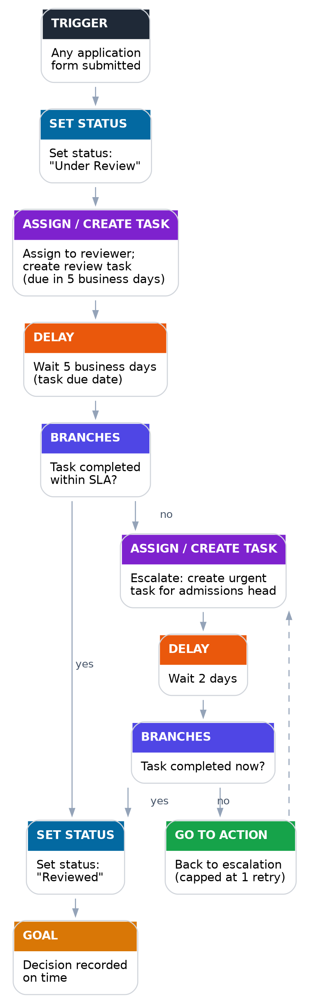
Figure B.3 — Application review & staff assignment
# | Type | Action | Why it belongs here
1 | Trigger | Fires when any application form is submitted. | This is the earliest point a review can start — matches the trigger already shown in the demo's example flow.
2 | Set status | Set status to "Under Review". | Immediately signals to the applicant-facing side of the system that the application has been received and is active, not sitting untouched.
3 | Assign to Staff / Create Task | Assign the application to a reviewer and create a review task, due in 5 business days. | Someone needs to actually pick this up. A dedicated, owned task with a due date is trackable and reassignable in a way a one-off notification email isn't.
4 | Delay | Wait 5 business days (the task's own due date). | Mirrors the task's due date exactly, so the wait the workflow observes and the SLA staff see are always the same number.
5 | Branches | "Task completed within SLA?" | Checks the task's own completion status rather than assuming silence means nothing happened — the same "read reality" principle as every other Branches condition (C.1).
6 | Set status (yes) | Set status to "Reviewed". | Marks the review as done and on time.
7 | Goal (yes) | "Decision recorded on time". | A clean, on-time completion, distinguishable from an escalated one.
8 | Assign to Staff / Create Task (no) | Escalate: create an urgent task for the admissions head. | The original task missed its due date; reassigning via the same step type keeps escalation trackable and reassignable too, instead of dropping back to a plain notification email.
9 | Delay | Wait 2 days. | A shorter grace window appropriate to an already-late, now-escalated case.
10 | Branches | "Task completed now?" | Re-checks the (new) task's completion status before escalating again or accepting the case is done.
11 | Set status (yes) | Set status to "Reviewed" (same as step 6). | One consistent status regardless of which path got the application there.
12 | Go to action (no) | Jump back to the escalation step, capped at one retry. | Bounds the escalation loop — an application should not be re-escalated forever without any human limit.

B.4 Workflow 4 — Scholarship Application Review
Not one of the three examples in the brief — added to show the same nine step types generalising to a distinct situation, and the only one of the four flows to exercise all nine step types in a single flow. Its Trigger is scoped to the Scholarship form specifically (an application-form or enquiry-form submission does not start it). It chases missing financial-aid documents with a bounded Request Document reminder loop (mirroring Workflow 2's document pattern), then gets a committee decision via Assign to Staff / Create Task with one escalation if the review runs late (mirroring Workflow 3's task-SLA pattern), rather than inventing a third pattern.
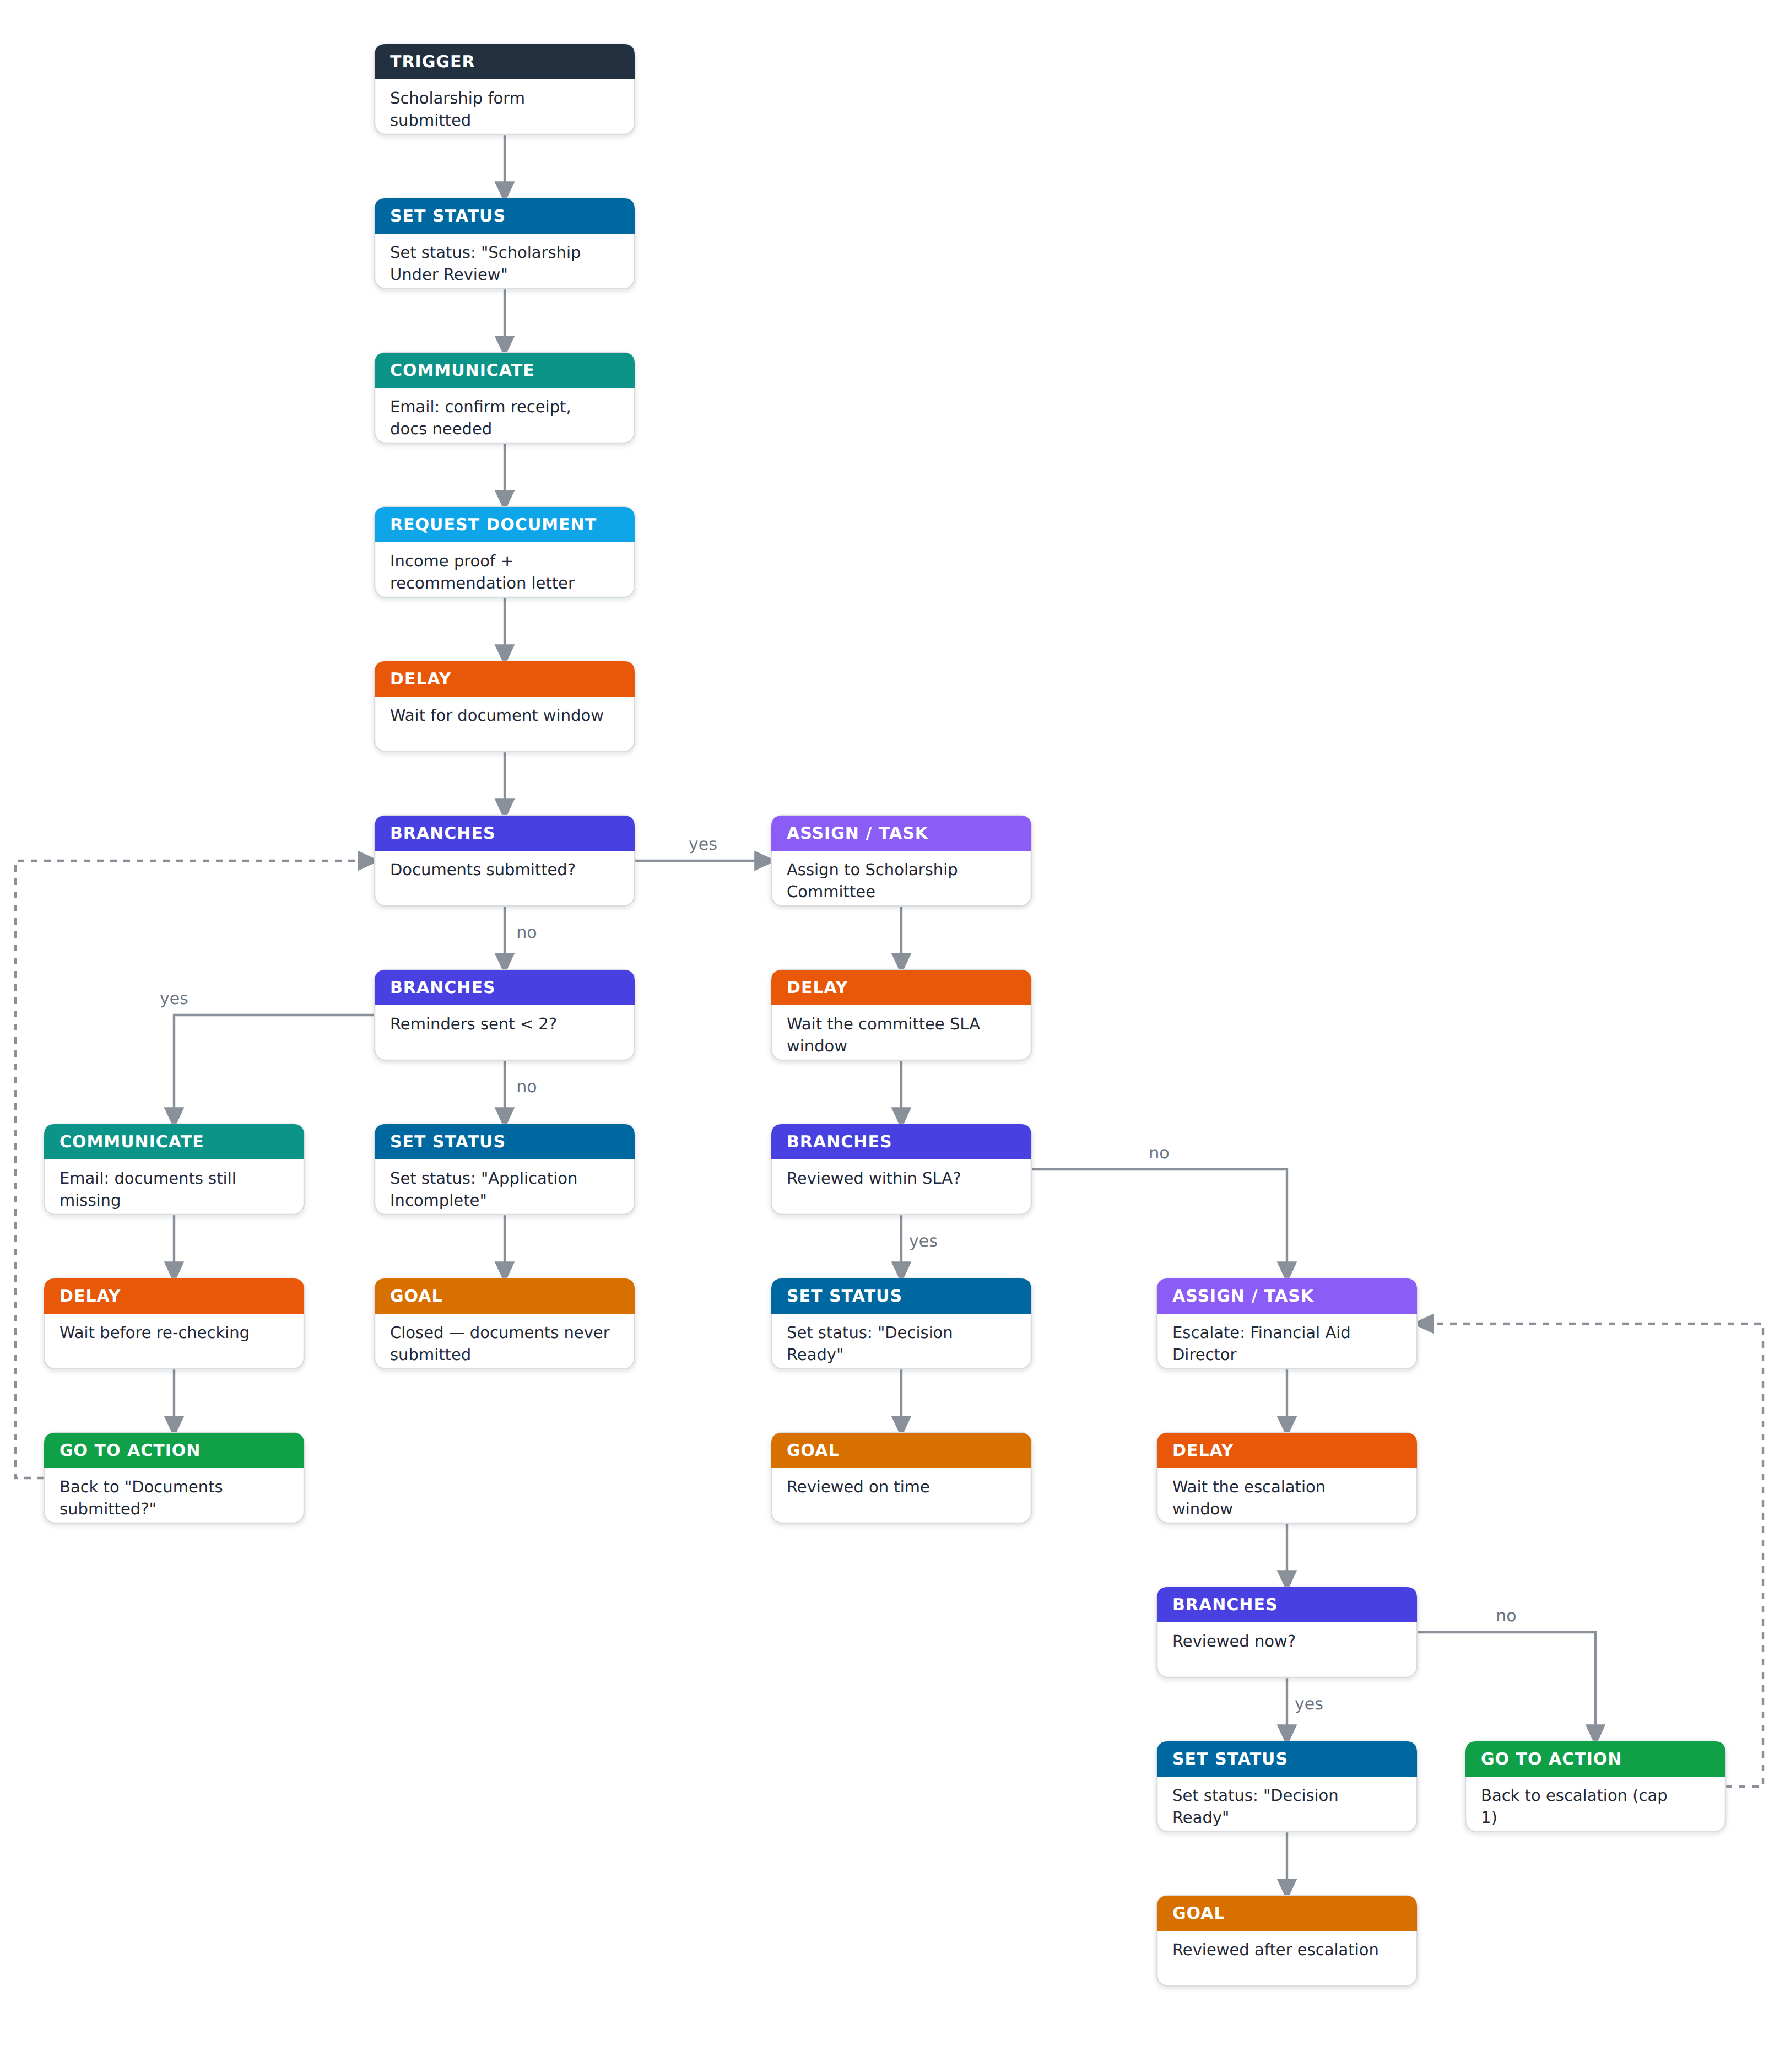
Figure B.4 — Scholarship application review
# | Type | Action | Why it belongs here
1 | Trigger | Fires when the Scholarship form is submitted. | Scoped to the scholarship form via the Trigger's form filter, so only scholarship applications start this flow.
2 | Set status | Set status to "Scholarship Under Review". | Immediately signals the application is active in the scholarship pipeline, not sitting untouched.
3 | Communicate | Email applicant and guardian confirming receipt and noting documents are still needed, using {{applicant_name}}, {{guardian_name}}, {{programme}}. | Sets expectations up front before the document request lands.
4 | Request Document | Request income proof and a recommendation letter from the guardian, due in 5 days. | A first-class, trackable request the branch below can read directly, rather than an inferred field.
5 | Delay | Wait for the document window. | Gives the family time to gather and submit before checking.
6 | Branches | "Documents submitted?" (reads the Request Document status) | Re-checks the real upload status; if satisfied, skip straight to committee review.
7 | Branches (no) | "Reminders sent < 2?" | Bounds the document-chase loop so it doesn't nag forever.
8 | Communicate (yes) | Remind the guardian which documents are still missing. | The nudge itself.
9 | Delay | Wait before re-checking. | Time for the reminder to land.
10 | Go to action | Jump back to "Documents submitted?" (cap 5). | Re-checks before another reminder or giving up.
11 | Set status (no, cap reached) | Set status to "Scholarship Application Incomplete". | Records that the required paperwork never arrived.
12 | Goal | "Closed — required documents never submitted". | A distinct, labelled non-completion.
13 | Assign / Create Task (yes) | Assign the application to the Scholarship Committee, due in 5 days. | Someone has to make the actual decision; a tracked task is reassignable and SLA-checkable.
14 | Delay | Wait the committee's SLA window. | Mirrors the task due date.
15 | Branches | "Reviewed within SLA?" (reads task status) | Checks task completion rather than assuming.
16 | Set status (yes) | Set status to "Scholarship Decision Ready". | The review is done and on time.
17 | Goal (yes) | "Reviewed on time". | A clean, on-time completion.
18 | Assign / Create Task (no) | Escalate: urgent task for the Financial Aid Director, due in 2 days. | The committee missed the SLA; escalate via the same trackable mechanism.
19 | Delay | Wait the shorter escalation window. | A tighter grace window for an already-late case.
20 | Branches | "Reviewed now?" (reads the escalated task's status) | Re-checks before escalating again or accepting completion.
21 | Set status (yes) | Set status to "Scholarship Decision Ready". | One consistent status regardless of which path got here.
22 | Goal (yes) | "Reviewed after escalation". | Distinguishes an escalated completion from an on-time one.
23 | Go to action (no) | Jump back to the escalation step, capped at 1. | Bounds the escalation loop with a hard human limit.

Part C — Solution Design

C.1 Design Principles
- Configuration over code — every workflow in Part B is expressed using the builder's step types: the original seven, plus the two proposed additions (Request Document, Assign to Staff / Create Task) specified in C.4. No step in Part B requires custom engineering to wire up.
- Read reality, don't trust memory — every Branches condition re-reads live state at the moment it's reached (application status, a document request's upload status, a task's completion status), rather than assuming nothing changed during a Delay.
- Bounded loops by default — every Go to action in Part B pairs with a Branches counter that eventually breaks out to escalation; the platform should enforce a hard ceiling as a safety net regardless of what the flow author configures (see C.4).
- One workflow, many independent runs — the same published workflow definition drives potentially thousands of concurrent, independent per-application runs (see C.3).
- The graph is the source of truth; the layout is derived — a workflow is steps[] plus edges, with no stored coordinates. The canvas computes every node's position from the graph shape on render (C.6.3), removing an entire class of "cards overlap" bugs.
- Catch mistakes before publish — structural validity is checked continuously and enforced at publish time (C.6.8), so a broken flow can't reach a real family.

C.2 System Architecture
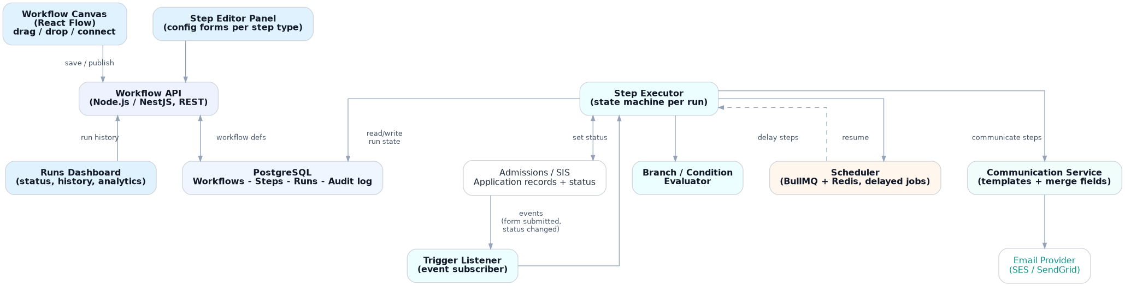
Figure C.1 — System architecture overview
The canvas (frontend) only ever talks to the Workflow API — it saves definitions and reads run history, but never executes anything itself. The Trigger Listener turns admissions-system events into new runs; the Step Executor is a small state machine that walks a run through its steps, handing off to the Scheduler whenever it hits a Delay so the wait survives restarts (NFR-1), and to the Communication Service whenever it hits a Communicate step. Set status writes flow back into the admissions/SIS system, which is also where Branches conditions are read from at execution time.

C.3 Core Domain Model
Entity | Key fields | Purpose
Workflow | id, name, trigger_config, status (draft/published), draft_revision, steps[] | The authored definition an admissions officer edits on the canvas. Only ever draft or published — no version history to manage.
Step | id, type, config (JSON), next[] (port → target-step references) | One node in the graph. Config shape depends on type. A step carries no canvas position — position is derived from the graph by the layout engine on render (C.6.3), never stored.
WorkflowRun | id, workflow_id, application_id, current_step_id, status (running/waiting/completed/escalated), started_at, steps_snapshot | One per application per trigger firing. Carries its own copy of the steps it needs (steps_snapshot) so a later edit to the workflow can't affect a run already in progress — without needing a version history.
RunStepHistory | id, run_id, step_id, executed_at, result, detail | The audit trail. Answers "what happened to this applicant's flow" (FR-10, NFR-4).
DocumentRequest | id, run_id, step_id, requested_files[] (checklist), uploaded_files[], status (pending/submitted), requested_at, submitted_at | Backs the Request Document step (FR-13). Branches reads status to decide "documents submitted?" instead of inferring it from an external field.
Task | id, run_id, step_id, assignee, title, due_at, completed_at, status (open/completed) | Backs the Assign to Staff / Create Task step (FR-14). Branches reads status/completed_at to decide "task completed?".
Application (external) | id, status, fee_status, documents[], assigned_reviewer, ... | The existing admissions record the workflow reads conditions from and writes Set status back to.

C.4 Step Type Specification
Step type | Purpose | Key config | Execution behaviour / edge cases
Trigger | Starts a new run. | Event type (e.g. form submitted, status changed to X); optional filter. | One run per matching event per application. Each run copies the steps it needs at that moment (steps_snapshot, C.3), so if the workflow is edited and republished later, runs already in progress keep executing the steps they started with (FR-11).
Delay | Pause a run. | Fixed duration (e.g. "3 days") or computed ("until date field"). | Implemented as a durable scheduled job, not an in-memory timer, so it survives restarts (NFR-1). Resuming must be idempotent — a job firing twice must not re-execute the step twice (NFR-2).
Branches | Split execution on a condition. | Condition type: status equals, field comparison, document/task status, or a run-scoped counter (e.g. "times this step has executed"); true/false next step. | Evaluated against live state at the moment the branch is reached — not at trigger time — or a fee paid (or document uploaded) mid-wait would be missed.
Communicate | Send an email. | Recipient (applicant / guardian / applicant & guardian / assigned staff), message body, merge-field variables scoped to the chosen recipient (see below). | Must be idempotent per (run, step, attempt) — a retried send must not double-email a family. A template render failure should surface, not silently drop the step. The variable picker only offers fields valid for the selected recipient.
Set status | Change the application's status. | Target field, new value. | Should be the one place status changes so two workflows can't race and leave status inconsistent — likely needs an optimistic-lock or defined "last writer wins" rule.
Go to action | Jump to another step in the same run. | Target step (chosen from a "Jump to" dropdown that lists steps by their visible number + title) and a max-iteration cap. | Without a hard cap this can loop forever. The builder should warn if a cycle has no reachable Branches condition able to break out of it.
Goal | Marks a run finished. | Free-text label (e.g. "Fee collected", "Escalated"). | Should support more than one distinct Goal per workflow, as in every flow in Part B, so run history can distinguish a clean finish from an escalation at a glance.
Request Document | Ask for one or more files and track their upload. | Recipient (applicant/guardian), checklist of requested files, optional due date. | Creates a DocumentRequest record the moment the step runs (C.3). Branches reads its status ("pending"/"submitted") at the moment it's reached. A reminder for an outstanding request is still an ordinary Communicate + Delay + Branches loop (see Workflow 2), not reinvented here.
Assign to Staff / Create Task | Assign the application to a person and create a tracked task. | Assignee (a person or a role, e.g. "Admissions Head"), task title, due date (fixed or relative, e.g. "+5 business days"). | Creates a Task record (C.3). Branches reads its completion status/timestamp rather than inferring completion from elapsed time alone. Escalation is just another instance of this step, targeting a different assignee (see Workflow 3).

Communicate — recipient-scoped variables
The Communicate editor's merge-field picker is populated from a per-recipient-type schema, so it only ever offers variables that make sense for whoever the message is addressed to — a staff-only field such as {{application_id}} simply isn't an option when "Applicant" is selected, and vice versa.
Send to | Available variables
Applicant | {{applicant_name}}, {{programme}}, {{deadline_date}}, {{portal_link}}
Parent / Guardian | {{guardian_name}}, {{applicant_name}}, {{programme}}, {{deadline_date}}, {{portal_link}}
Applicant and guardian | Union of the Applicant and Parent/Guardian rows above
Assigned staff member | {{staff_name}}, {{applicant_name}}, {{application_id}}, {{application_status}}, {{task_due_date}}

C.5 Execution Engine (Backend Overview)
Kept brief since this document's focus is the frontend (C.6) — enough backend context to place it in the whole system, not a full engine spec.
- Each WorkflowRun is a small state machine: a Trigger Listener starts one per matching event, and a Step Executor walks it through its steps — continuing straight through Set status / Communicate / Branches, or handing off to a durable job queue (the Scheduler) whenever it hits a Delay, so multi-day waits survive a restart (NFR-1).
- Every step execution is recorded in RunStepHistory before its side effect fires, so a retried step can never double-send an email, double-write a status, or create a duplicate document request or task (NFR-2). A per-run loop-iteration cap on Go to action is the safety net behind the reminder loops in Part B.
- That's the extent of backend mechanics the frontend needs to reason about — the rest (queue choice, retry policy) sits behind the same Step Executor that the frontend's step type registry (C.6.1) already describes the public shape of.

C.6 Frontend Architecture
React + TypeScript, with React Flow driving the canvas and dagre computing its layout.

C.6.1 Step Type Registry
its config schema (plain JSON Schema, not Zod), default config, icon, a portable colour token, category, a summary template
// backend/stepTypes/communicate.ts
const configSchema = {
type: "object",
properties: {
recipient: { type: "string", enum: ["applicant", "guardian", "both", "staff"] },
message: { type: "string" },
},
required: ["recipient", "message"],
};

export const communicateStepType: StepTypeDefinition = {
type: "communicate",
label: "Communicate",
icon: "mail",
color: "teal",
category: "communication",
configSchema, // plain JSON Schema, no Zod
defaultConfig: { recipient: "applicant", message: "" },
ports: { outputs: [{ id: "next" }] },
execute: async (config, ctx) => { /* server-only, never sent to client */ },
};
There is no Zod and no conversion step. configSchema is plain JSON Schema, authored directly inside the step type module as part of the workflow engine. The /api/step-types endpoint returns it exactly as received — no transformation in between — so the object the frontend validates against is byte-for-byte the same one the backend validates against; there is nothing to keep in sync and no shared package to version.
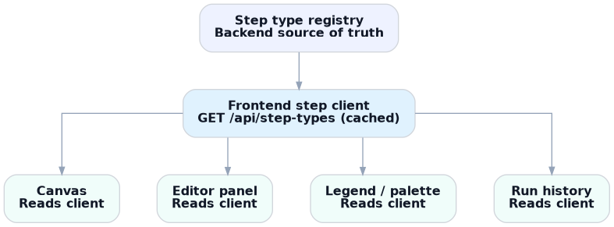
Figure C.2 — Step type registry, from backend source of truth to the four generic UI surfaces that consume it
The frontend fetches /api/step-types once (cached via React Query) and builds a local step client from it. Two small local maps translate the portable strings back into renderables — an icon-name map and a colour-token map — so the backend never needs to know about React components. Every consumer above (canvas, editor panel, legend/palette, run history) is written once, generically, against this client rather than against any specific step type; the Legend tab is literally a loop over it.
Most step types (Delay, Set status, Goal) need only a handful of simple fields, so a generic SchemaForm component renders their editor directly from the fetched JSON Schema — validated client-side with ajv against the exact same JSON Schema object the backend re-validates with (also via ajv) on save, so the two can never drift: there is only one schema, not two representations of it. Branches and Communicate need bespoke interaction (a condition builder; the recipient-aware variable textarea from C.4) and register a custom editor component in a small local map keyed by step type. If a step type has no custom editor registered — a brand-new backend step type nobody has built frontend UX for yet, say — it falls back to the generic form automatically, so it is usable immediately rather than blocked on frontend work.

C.6.2 Extending the Pattern: Pluggable Sub-Behaviours
The same "declare once, register, let generic UI read it" pattern repeats one level deeper, inside the two step types that have pluggable sub-behaviour — this is what lets a developer customise an existing step type without touching its editor component:
- Branches' condition types (status equals, date comparison, run-scoped counter, document status, task status) are themselves a small registry. Adding a new condition later — e.g. "field changed in the last N minutes" — is an additive registration, not a change to the Branches editor.
- Communicate's recipient-to-variable mapping (the table in C.4) is a data-driven map keyed by recipient type, not a switch statement inside the editor. Adding a recipient (e.g. a secondary guardian) or a variable is a data change to that map, not a code change.

C.6.3 Canvas as a Config Projection
A workflow's steps[] — each step's config and next-step references — is the only source of truth. Crucially, a step no longer stores a canvas position: a workflow is a pure DAG, and the canvas derives every node's coordinates from the graph shape on render, using dagre's layered top-down layout. Because layout is computed, the whole class of "cards overlap after an insert / branch / reorder" bugs cannot occur, and every edit is a pure edge edit with no coordinates to maintain
function workflowConfigToGraph(workflow, stepTypes) {
const nodes = workflow.steps.map(step => ({
id: step.id,
type: "stepNode", // one React Flow node type, always
position: step.position,
data: { step, def: stepTypes[step.type] }, // the registry lookup
}));
const edges = workflow.steps.flatMap(step =>
step.next.map(n => ({
id: `${step.id}-${n.portId}-${n.targetId}`,
source: step.id, sourceHandle: n.portId, target: n.targetId,
style: step.type === "go_to_action" ? { strokeDasharray: "5 5" } : undefined,
}))
);
return { nodes, edges };
}

function graphToWorkflowConfig(nodes, edges) {
return nodes.map(n => ({
id: n.id, type: n.data.step.type, config: n.data.step.config, position: n.position,
next: edges.filter(e => e.source === n.id)
.map(e => ({ targetId: e.target, portId: e.sourceHandle })),
}));
}
React Flow only ever registers one node type — a generic StepNode — so it has no idea Communicate and Delay are different things; it reads def.icon, def.color and def.summarize(step.config) from the registry lookup to render each card. The number and labels of a node's output handles (Branches' yes/no, a linear step's single "next") come from the same def.ports metadata rather than a hardcoded check on step type.
The design doc's original reverse mapper (graphToWorkflowConfig) was dropped as dead code — edits are applied straight to steps[] via a set of pure steps[] → steps[] transforms (insert, remove, reorder, retarget, set trigger, edit config) gathered in one module, so there is never a canvas-graph-to-config round-trip. Keeping those transforms pure makes each unit-testable, and the two splice paths (remove and reorder) share one edge-reconnection helper. Dragging a step is a pure reorder gesture: drop it onto another edge to splice it in there (a live "Drop to insert here" indicator marks the target); drop it anywhere else and it snaps back to its computed position.

C.6.4 Save Flow: Draft Autosave & Publish
Every canvas mutation — add a step, edit its config, drag it, rewire an edge — updates local state immediately for instant feedback, then passes through graphToWorkflowConfig and is pushed to the backend as a debounced autosave.
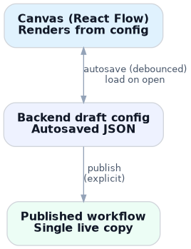
Figure C.3 — The canvas renders from the backend draft config and autosaves edits back to it; publishing is a separate, explicit action
- Autosave only ever touches the draft (PATCH /api/workflows/:id/draft), never the published copy — in line with the draft/publish distinction in FR-11 and C.10.
- Given these workflows run to a few dozen steps, the debounced save sends the whole draft snapshot rather than a per-step diff; granular patches would only be worth the added complexity if simultaneous multi-editor collaboration became a requirement (see Part D).
- A lightweight revision number guards against stale writes — each save includes the revision it was based on, and the server rejects with a conflict if it no longer matches. This is not full real-time collaborative merging, just enough to stop one save from silently overwriting another.
- Publish (POST /api/workflows/:id/publish) is a separate, explicit, non-debounced action that overwrites the single published copy with the current draft's contents. There's no version history to maintain: a run already in progress is unaffected because it captured its own steps_snapshot (C.3) when it started, not a live pointer to the workflow — so overwriting the published copy is safe by construction, not because anything was versioned.

C.6.5 State Management & Component Structure
- Canvas-local, ephemeral UI state (current selection, which panel is open, drag-in-progress position) lives in a lightweight store such as Zustand — it never needs to be persisted or synced.
- Server state — the draft config, the fetched step-type client, run history — is owned by React Query, so loading, autosaving and cache invalidation reduce to its normal mutation/query lifecycle rather than hand-rolled sync logic.
- All data reaches the frontend through plain REST calls, never server-pushed events. Step types, workflow draft, and run history are fetched (and, where something needs to feel live, polled on an interval or refetched on focus) — there are no WebSockets, no server-sent events, and no client-side event subscriptions anywhere in the frontend. One uniform request/response path is easier to reason about and debug than a REST path plus a separate event-driven one.
- Component structure stays small and generic throughout: WorkflowCanvas (React Flow shell) feeds StepNode (a single generic node type) feeds StepEditorPanel (a shared header/footer shell wrapping a generic SchemaForm or a registered custom editor) feeds Legend/Palette (a loop over the step client). None of these are written per step type.

C.6.6 Derived Auto-Layout
Because positions are computed rather than stored (C.6.3), the canvas lays itself out: the author never drags boxes into neat rows, and the graph stays readable as it grows. dagre runs on each render over the real step nodes and edges; the UI-only "+" insert affordances and dashed "End" markers are then placed relative to their parent's computed position. Dragging exists purely to reorder — a transient overlay gives live feedback during the drag, and on release the step either splices into the edge it was dropped on or returns to its computed spot. This keeps the data model minimal and makes insert / delete / reorder correct by construction.

C.6.7 Undo / Redo
The draft is modelled as a small reducer over { steps, past, future }. Every user edit is one commit (push the previous steps onto past, clear future); undo and redo move between the stacks; hydrating a different workflow resets history so you can't undo across a workflow switch. This was inexpensive precisely because every edit is already a pure transform of steps[] — the history is just snapshots of that array. It is wired to toolbar buttons and to Cmd/Ctrl+Z / Shift+Cmd/Ctrl+Z (ignored while typing in a field), and undone or redone states autosave like any other edit.

C.6.8 Workflow Validation & Publish Gate
A pure set of graph-integrity checks runs over steps[] continuously and is the single source of truth for three surfaces: a badge on each affected step's canvas card, an issues panel that lists every problem (click one to jump straight to the offending step), and the publish gate. Errors block publishing; warnings inform but don't. The checks include: a step missing or with invalid required config (validated with the same ajv schema the backend uses); a Goal (a terminal step) that has an outgoing connection; a Go to action with no target; an edge pointing at a step that no longer exists; a step unreachable from the trigger; an unconnected Branches output port; and a Go to action loop with no Branches step able to break out of it — the exact hazard the original design flagged. This turns the suggested "lightweight second-person review before publish" into an automated first line of defence: a structurally broken flow cannot be published at all.

C.6.9 Workflow Lifecycle Management
The builder manages a library of workflows end to end (FR-15): create a new (empty) workflow, which opens the trigger picker; rename it; delete it, cascading its runs, tasks and history; and toggle between published and draft with Publish / Unpublish. Selection after create or delete is chosen explicitly rather than by reacting to the list refetch, so the current workflow never briefly snaps to the wrong one while the cache catches up.

C.7 Backend Architecture & Tech Stack
Also kept brief for the same reason as C.5 — a whole-system reference, not a backend design document.
Layer | Choice | Reasoning
Frontend | React + TypeScript, React Flow | Matches the required stack; React Flow fits the node/edge canvas already shown in the demo directly.
API | Node.js + TypeScript (NestJS or Express) | Keeps the stack in one language; NestJS's module structure maps cleanly onto Workflow / Run / Step services.
Database | PostgreSQL | Relational integrity between Workflow → Step → WorkflowRun → RunStepHistory; JSONB columns hold per-step-type config without a new table per type.
Scheduling / queue | Redis + BullMQ (or an equivalent durable job queue) | Delay steps need "run this in exactly 3 days, survive a restart" — a real job queue is the only reliable way to satisfy NFR-1.
File storage | S3 (or equivalent object storage), pre-signed upload URLs | Request Document needs somewhere to actually store uploaded files; pre-signed URLs let the browser upload directly without proxying files through the API.
Email | SES or SendGrid, behind a Communication Service | Abstracts the provider from the Step Executor, and is the natural place to add SMS/WhatsApp later (C.9).
Auth / roles | The school's existing SSO + a role table | Reuses whatever identity the admissions system already has for FR-12, rather than inventing a second one.

C.7.1 As Built for This Exercise
The table above is the production target. The running implementation keeps every one of those seams but substitutes lighter, zero-setup choices so the whole thing runs from a single checkout: Webpack (bundler) and RTK Query (server-state) on the frontend; Express + better-sqlite3 on the backend, with the same relational shape a Postgres schema would have; an in-process 1-second poll over a due_at column in place of Redis/BullMQ — durable across restart, and the direct seam for a real queue; a stubbed email sender that logs the rendered message (idempotency and templating are real, only the transport is not); and local/stubbed file handling for Request Document. SSO and role enforcement (FR-12) are specified but not implemented in the exercise.

C.8 Security, Privacy & Compliance
- All applicant/guardian PII flows through Communicate; uploaded files (Request Document) can be more sensitive still — ID proofs, transcripts, immunisation records — and need encryption at rest and their own retention rule rather than inheriting the audit log's default.
- Role-based access (FR-12) so only authorised staff can publish a live, applicant-facing workflow; view-only access for anyone who only needs to see status. The full audit trail (FR-10/NFR-4) doubles as the record needed if a family disputes ever having been reminded.
- Education-data handling should follow whatever regulation applies in the school's jurisdiction (e.g. FERPA in the US, or a local equivalent) for anything touching student records — flagged as an open question in Part D, since the right regime depends on where the school operates.

C.9 Additional Step Types & Features Worth Adding
Workflows 2 and 3 already use two proposed additions beyond the original seven step types — Request Document and Assign to Staff / Create Task (fully specified in C.4). The items below go further still — features the product would benefit from as schools push past these examples.
- Wait until condition/date — Delay today is duration-based. A "wait until this specific date" (e.g. a term start date not known when the flow is authored) would let flows key off calendar deadlines, not just relative waits.
- Webhook / integration step — to receive events directly from an external fee-payment provider, and to push data out to a school's student information system.
- Additional Communicate channels (SMS/WhatsApp) — many families are more responsive to text than email for time-sensitive reminders.
- Saved, reusable message templates — Communicate already offers recipient-scoped merge-field variables for one-off messages (C.4); a template library on top of that would let staff save and re-apply a whole worded message across workflows, instead of re-typing similar wording each time.
- Simulate/test mode — run a workflow against a fake or historical application before publishing, to see the emails and branch outcomes without waiting real days or emailing a real family.
- Per-workflow analytics — how many applications are at each step right now, how many hit each Goal, where they get stuck — turning run history (FR-10) into something staff can act on, not just inspect one applicant at a time.

C.10 Publish & Rollout
No version history to manage (see C.3, C.6.4) — a workflow is simply draft or published, and publishing overwrites the one published copy. The product-level policy on top of that mechanism:
- Automated pre-publish validation (C.6.8) blocks a structurally broken flow from going live at all — the mechanical half of the review that used to rely entirely on a careful human.
- A small starter library of example flows (the demo already has "Load example") helps staff bootstrap new flows from the ones in Part B rather than a blank canvas.
- A lightweight second-person review before publish is worth considering, given these flows email applicants directly — a wrong condition or typo here is public-facing, not internal.

Part D — Open Questions for the Call
- What already emits the events these workflows listen to — is there a real "application submitted" / "status changed" event today, or would the engine need to poll the admissions system?
- Where does "fee paid" actually get decided — a payment gateway webhook, or a manually-set status? This determines whether Branches already has what it needs or needs a new condition type.
- Is there an existing task/notification system for staff (Workflow 3), or should "notify assigned staff" simply be another Communicate email for now?
- How many workflows might run concurrently in practice — tens or thousands of applicants per admissions cycle? This affects how much the scheduler needs to scale on day one versus later.
- Should the Go to action loop cap be a fixed platform default, or configurable per workflow by the admissions officer?
- What compliance regime applies to the student data involved, so the privacy section (C.8) can be made concrete rather than a placeholder?
- Does the product need simultaneous multi-editor collaboration on a single workflow draft, or is single-editor-at-a-time (with the lightweight revision guard in C.6.4) sufficient for the first version?

Appendix 1 — Step Type Legend
Step type | Description
Trigger | Starts the workflow.
Delay | Wait.
Branches | Split the path.
Communicate | Send an email.
Set status | Change the application's status.
Go to action | Jump to another step.
Goal | What counts as success.
Request Document * | Ask for and track an upload.
Assign / Create Task * | Assign the application to a person and track a task.
Additions specified in this document (see C.4) — now implemented alongside the original seven; the Scholarship Application Review workflow (B.4) uses all nine step types in one flow.

