#This web portal is named "Edgistify Industrial Web Portal" which provides basic functionality as described below:

1. Welcome to Home page of Web Portal.

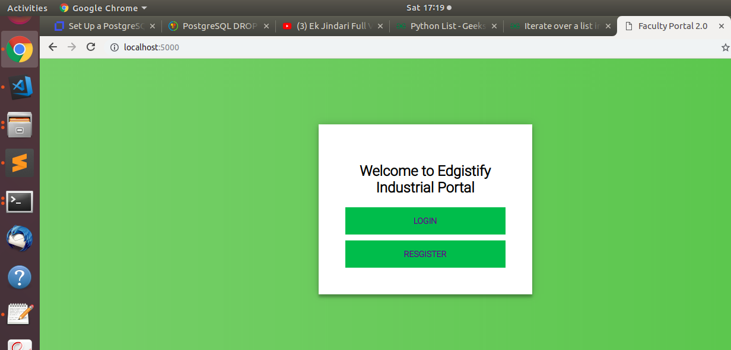

2. Register and login functionality with valid email id( User have to register first with his/her email ID and set the password, now the user can log in to the portal using his/her email id and password).

Step 1: Click on Register button and give detalis:

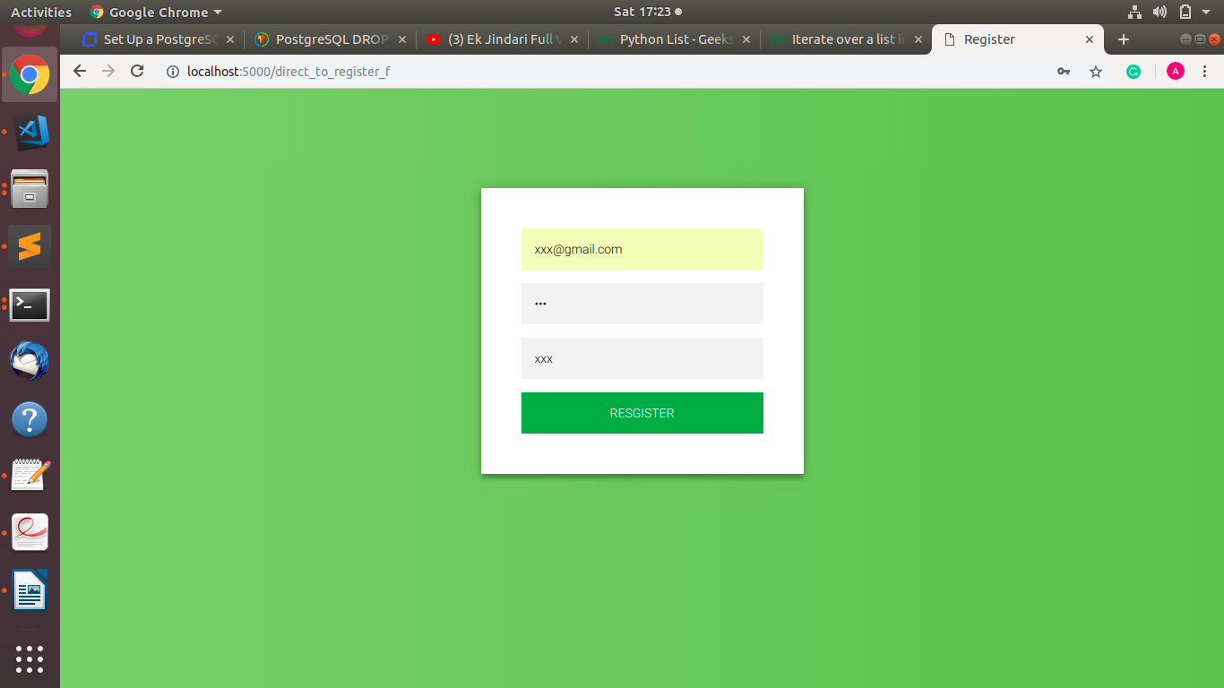

Step 2: Click on Login button and give Registered ID and Password detalis, this link redirect to User profile:
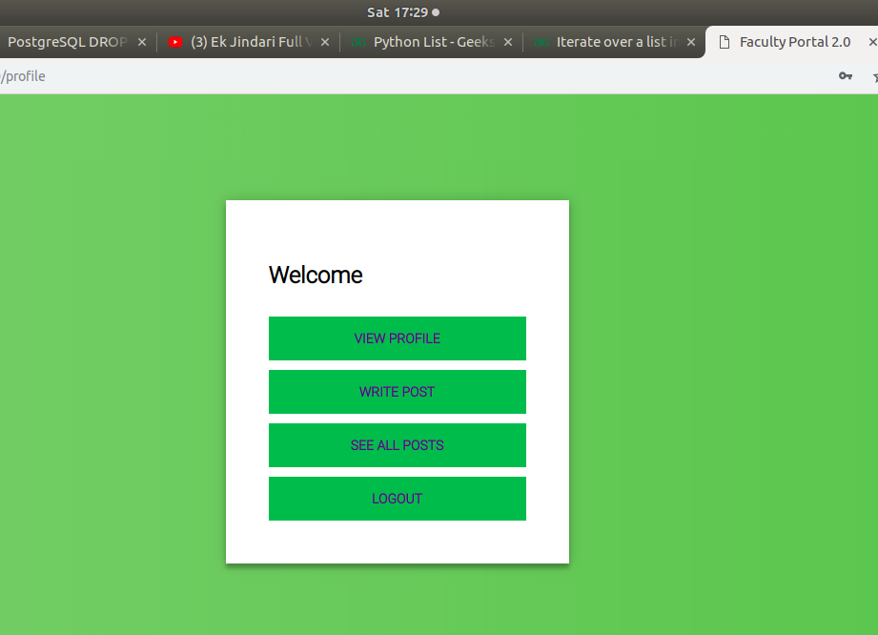

3. Users can write the Industrial post by clicking on the "Write Post" button after login the portal and publish it, so that all other users can see it.

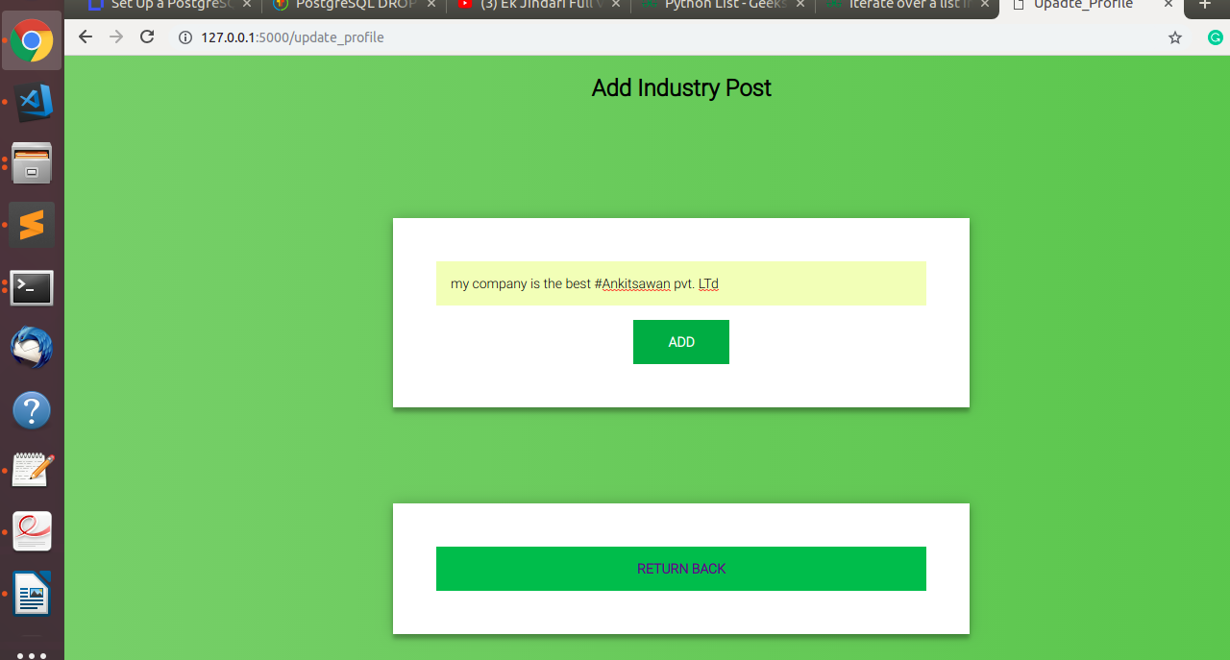

4. User can see his/her all posts by clicking on the "view profile" button.
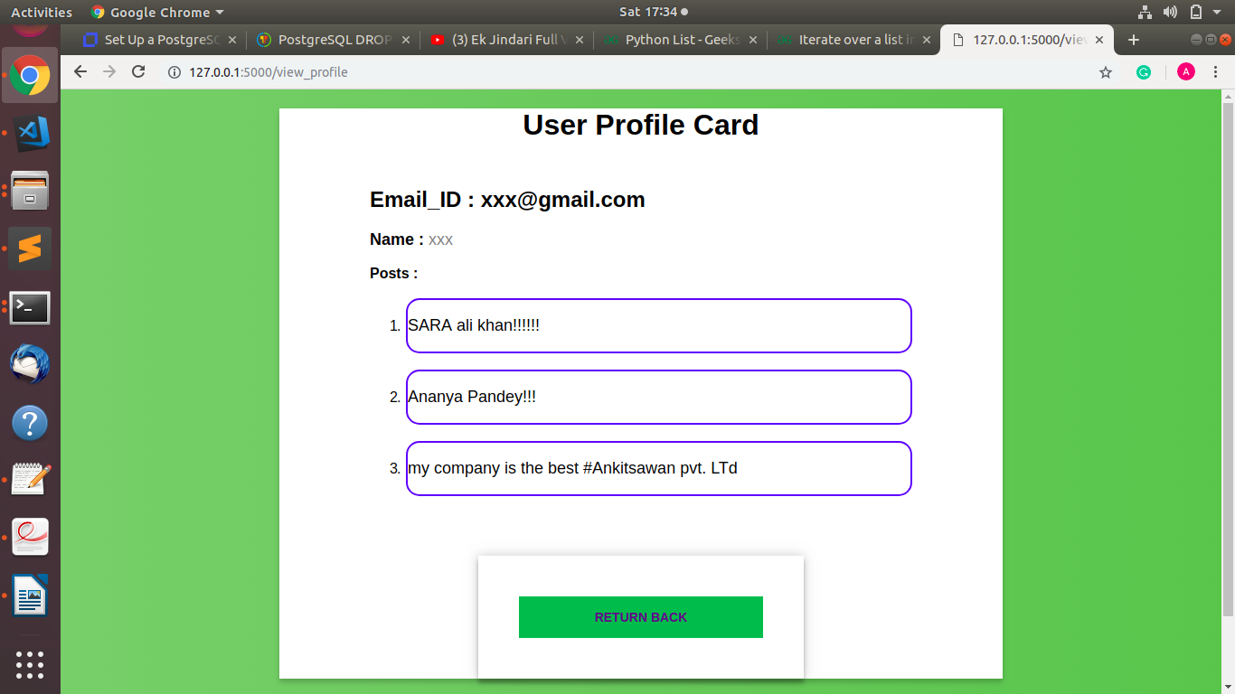

5. Users can see all the posts of the portal by clicking on the "SEE ALL POSTS" button.

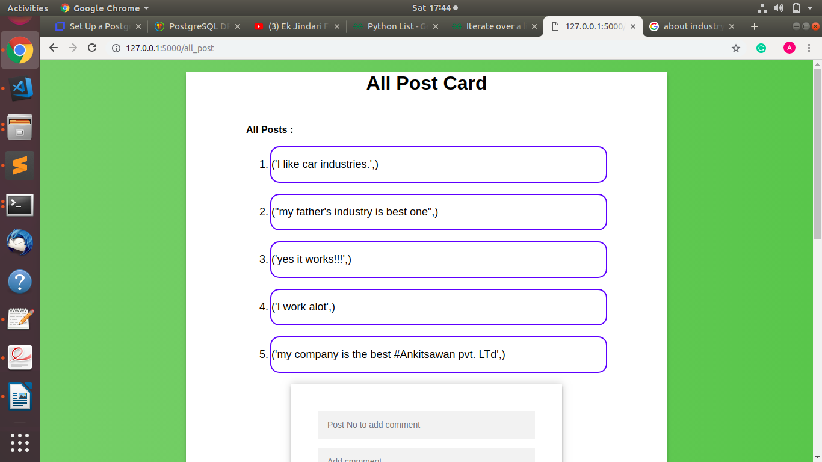

5. Users can comment on any post in the "SEE ALL POSTS" interface. For comments, users have to give Post no. of the Post for which users want to comment and type the comment in comment bar, then click the "Add comment" button.

For example: User yyy wants to comment on Post 4, then he/she can do this in this way:

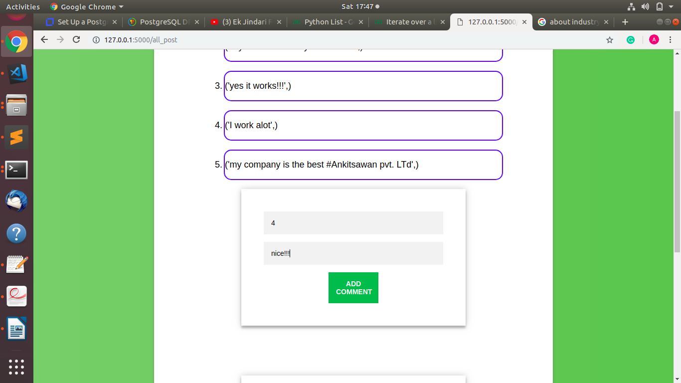

6. Users can see all the comments of a particular Post. For this, a user has to give Post no.
of the Post for which the user wants to see all written commands and click the "show comment"
button.

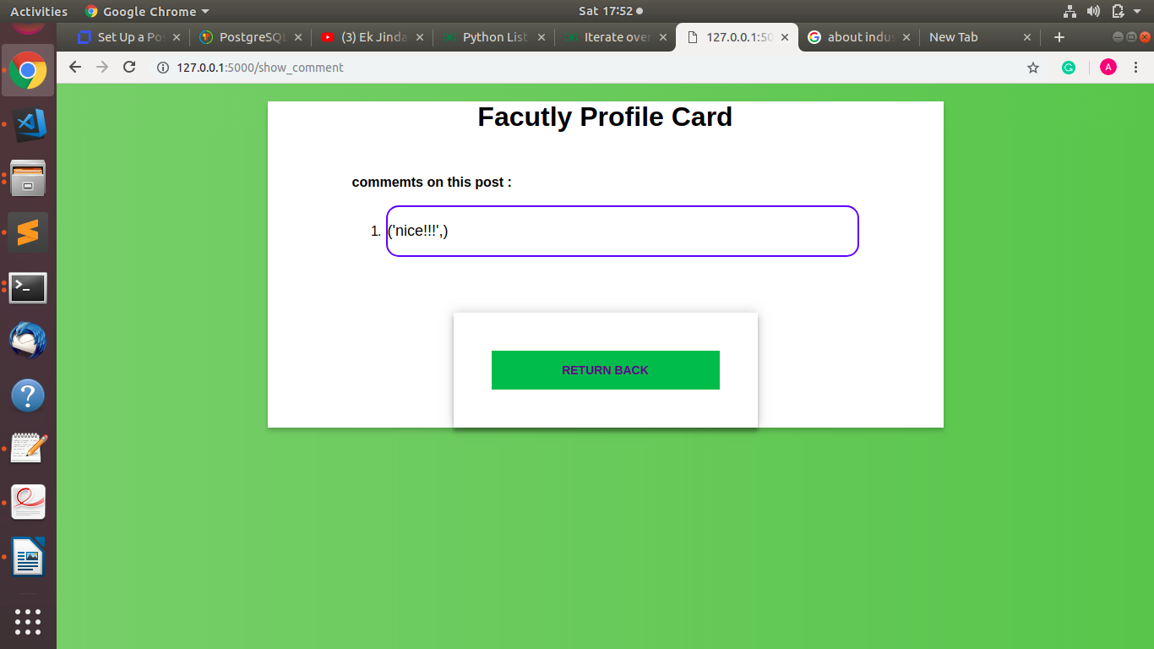

#HOW TO RUN THE CODE:
Step 1: Download the code file.

Step 2: Open the terminal in "Edgistify/Projects/cs301" directory.

Step 3: execute the code in the file "a.py" using command "python3 a.py".(it only work in
python3.....must remember).

Step 4 : Above command create a local web server on your PC that is "http://127.0.0.1:5000/" .

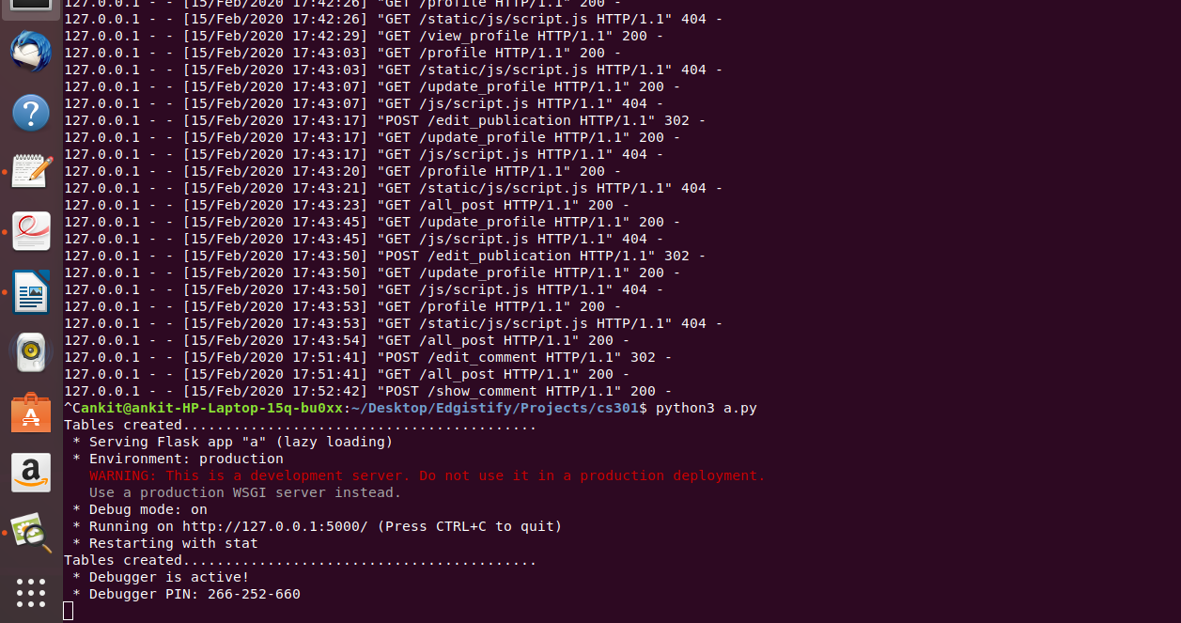

Step 5 : GO to web browser and type "localhost:5000" in web link bar of your browser, this
host redirect you to home page of "Edgistify Industrial Portal".
