III. PROPOSED METHODOLOGY
This work presents a vision-based deep learning framework for gait recognition, operating directly on spatial silhouette sequences extracted from video footage. The pipeline departs from the conventional approach of compressing temporal information into a single Gait Energy Image (GEI). Instead, individual frames are extracted, normalised, and classified independently, after which a sequence-level majority voting scheme is applied to produce the final biometric decision. The methodology is organised across five subsections: system architecture, dataset acquisition and visualisation, preprocessing, feature extraction via ResNet50, and the experimental configuration.

A. System Architecture Overview
The proposed system operates through four sequential processing stages: video capture and frame extraction, foreground segmentation, morphological bounding box localisation, and CNN- based inference. Input video is sampled at 10 frames per second, a rate sufficient to capture gait dynamics without incurring unnecessary computational overhead. Each frame is passed independently through the preprocessing pipeline, ensuring that the region of interest is consistently isolated prior to classification.
The decision to process frames individually, rather than as temporally stacked volumes, keeps the spatial classification task decoupled from temporal aggregation. This reduces model complexity and allows the backbone to generalise across varied walking speeds without retraining. Temporal coherence is instead recovered downstream through majority voting, which consolidates per-frame predictions at the sequence level. A practical consequence of this design is that frames where segmentation fails to produce a clean foreground region contribute only a single erroneous vote, and are therefore naturally suppressed by the majority rule — lending the pipeline passive robustness without additional error-handling logic.

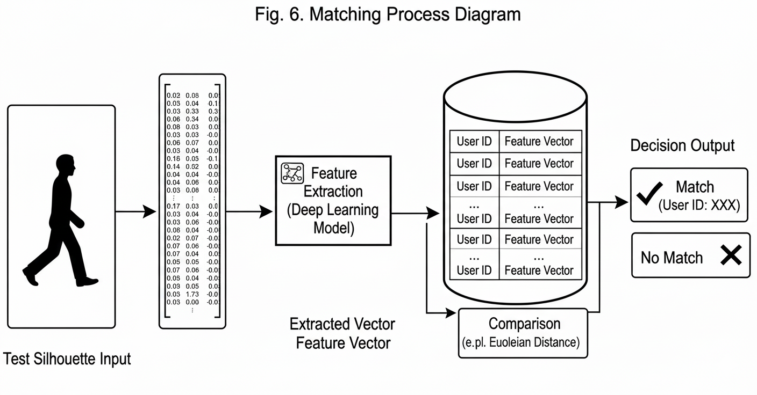
Fig. 1. Proposed framework of spatial gait recognition .(diagrams should be our own)

B. Dataset Acquisition and Visualisation
The CASIA-B gait dataset was used for training, validation, and evaluation. It is a widely adopted benchmark in the gait recognition literature, offering recordings of 124 subjects across multiple viewing angles—including 0°, 45°, and 90°—and under varied walking conditions: normal gait, bag-carrying, and coated. The experimental subset used in this study comprised over 1.1 million images. Prior to model training, dataset visualisation was performed to verify the quality of the transition from raw RGB frames to binary silhouette masks, ensuring preprocessing integrity before any data reached the network.
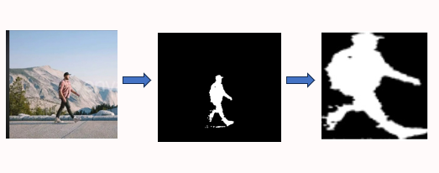
Fig. 2. Dataset visualisation
C. Data Preprocessing Pipeline
Raw video frames routinely contain environmental noise, stable background regions, and other visual artefacts that interfere with reliable silhouette extraction. The preprocessing pipeline was designed to address these systematically. Background subtraction was performed using the MOG2 Gaussian Mixture-based algorithm, which adaptively models the background across frames. Morphological opening and closing operations, applied with a 5×5 elliptical structuring element, were subsequently used to eliminate residual background fragments while preserving the subject's contour.
From the resulting binary mask, the largest contour was identified and a bounding box computed. The silhouette was then cropped with a 10% padding margin to account for minor positional variance across frames, and resized uniformly to 72×72 pixels. This standardisation ensures consistent spatial input regardless of subject scale or position within the frame. Finally, each three-channel spatial tensor was normalised using a mean and standard deviation of 0.5, mapping pixel intensities to a range conducive to stable gradient-based learning.
D. Spatial Feature Extraction and ResNet50 Architecture
The preprocessed 72×72 tensors constitute the spatial input features passed directly to the classification model. ResNet50 was selected as the backbone architecture. Its use of residual connections mitigates the vanishing gradient problem that commonly limits the effective depth of convolutional networks. Pre-trained ImageNet weights were loaded via the timm (PyTorch Image Models) library, providing the network with prior representations of low- and mid-level visual features—edges, textures, and structural patterns—relevant to silhouette-based classification.
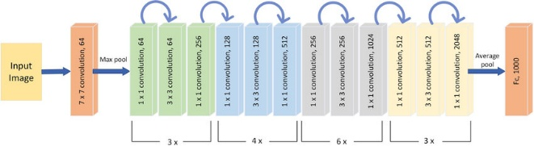
Fig. 3. Schematic of the ResNet50 architecture, illustrating residual blocks and skip connections employed for spatial feature extraction.
ResNet50 comprises 50 convolutional layers structured around residual learning blocks. The skip connections allow gradient signals to propagate unimpeded during backpropagation, which is particularly important given the depth of the network. The final fully connected layer was modified to output probability distributions over the 124 subject classes using a softmax activation. For sequence-level decision making, a temporal majority voting scheme was applied: per-frame top predictions were aggregated, and the class receiving the highest number of votes was assigned as the biometric identity for the full sequence.
E. Experimental Setup and Evaluation Metrics
All experiments were implemented in PyTorch with CUDA-enabled GPU acceleration. Data loading was optimised using 8 worker threads with pinned memory to reduce I/O bottlenecks during training. The CASIA-B dataset was partitioned into a 70% training split and a 30% validation split.
Training was conducted using the Adam optimiser with an initial learning rate of 0.001 and Cross-Entropy loss as the objective function. The model was trained for 10 epochs with a batch size of 32. Automatic Mixed Precision (AMP) training was enabled through PyTorch's GradScaler and autocast modules, reducing memory consumption and improving throughput without degrading model quality.
Performance was assessed using precision, recall, and F1-score in addition to overall classification accuracy. Precision quantifies the proportion of positive predictions that are correct:
Precision = TP / (TP + FP) (1)
Recall measures the model's sensitivity to true positive instances:
Recall = TP / (TP + FN) (2)
The F1-score consolidates both metrics via their harmonic mean:
F1 = 2 × (Precision × Recall) / (Precision + Recall) (3)
Confusion matrices were analysed to identify inter-class confusion patterns across the 124 subjects. Receiver Operating (should be image instead of formula it will create less cititation)Characteristic (ROC) curves and corresponding Area Under the Curve (AUC) scores were computed for each class to characterise the model's discriminative capacity under varying decision thresholds.

