Project Name: Credit Application, Car Loan, OAF,

Technology: Client Side Angualr6 and Server side alfresco (JAVA)

We have developed some complex component which alfresco tool is not provided. Please check below screen shots which one we have developed in angular.

**Screen 1**

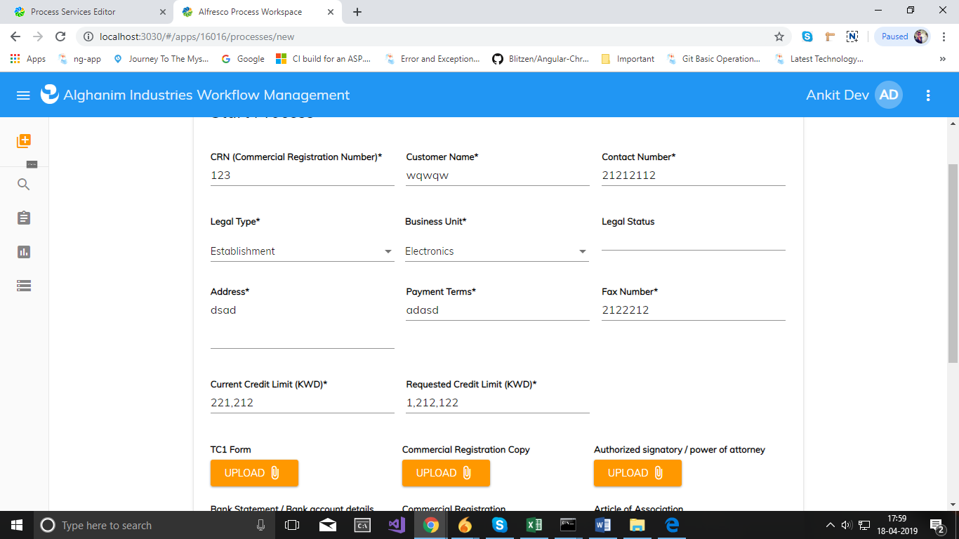

**Screen 2**

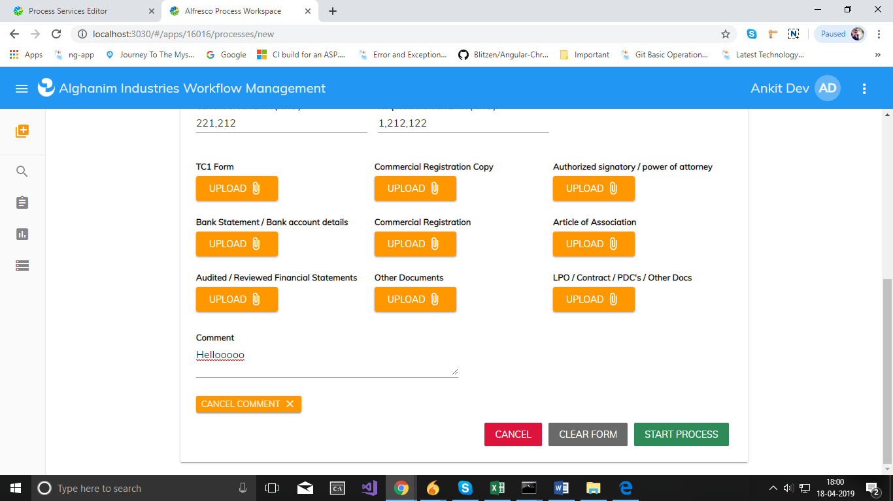Above Screen 1, 2 for used to start process. User added required data and upload multiple document then start process

**Screen 3**

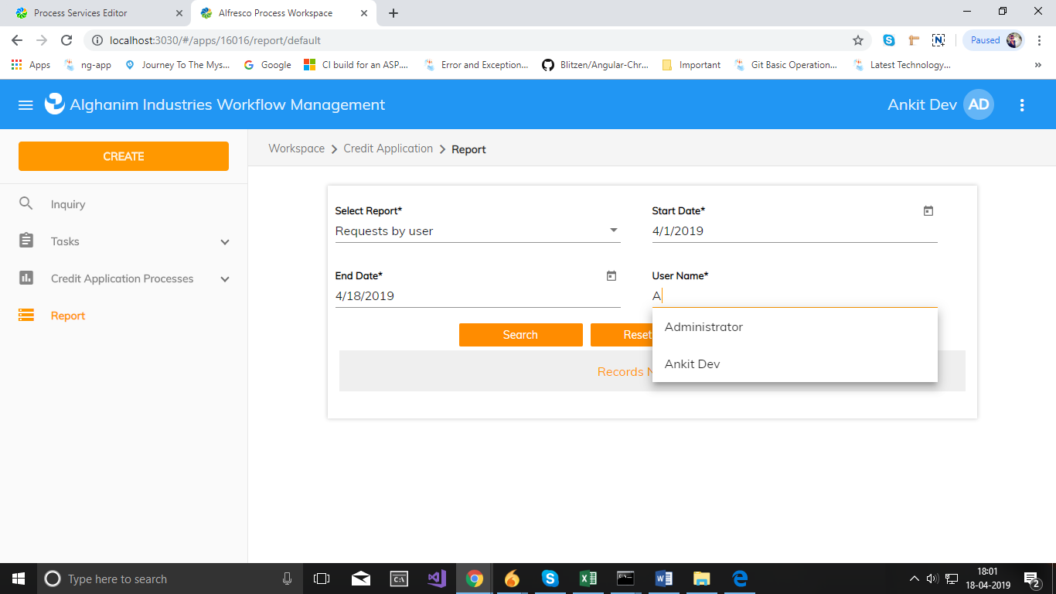

Above Screen 3 for used for report. User check report using different filter. We implement also **Autocomplete** field “User Name*”.

**Screen 4**

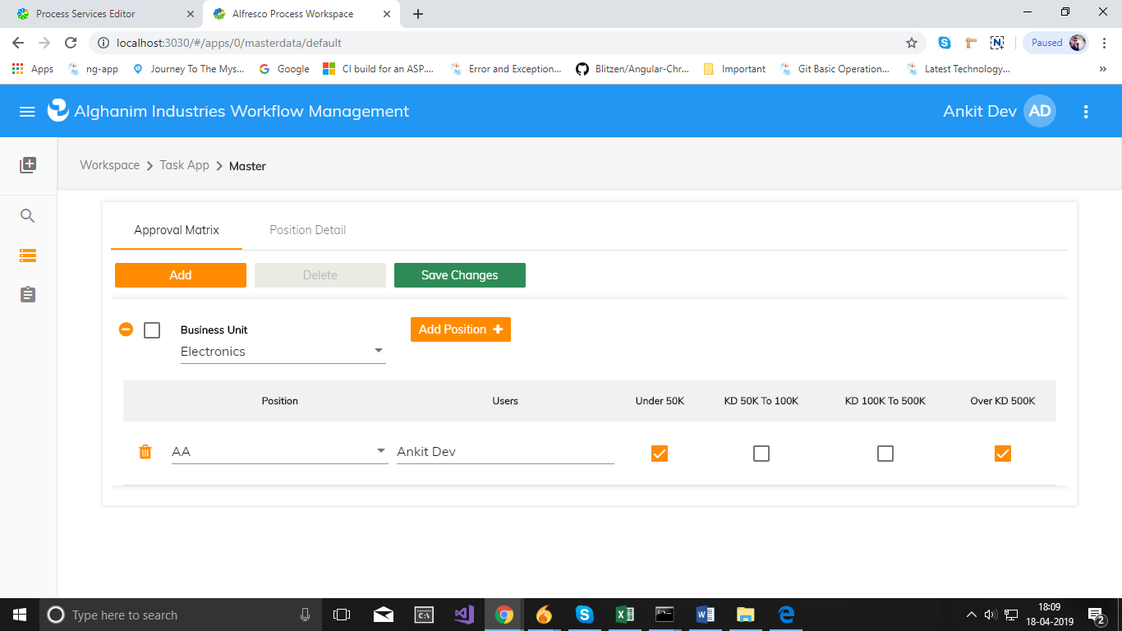

**Screen 5**

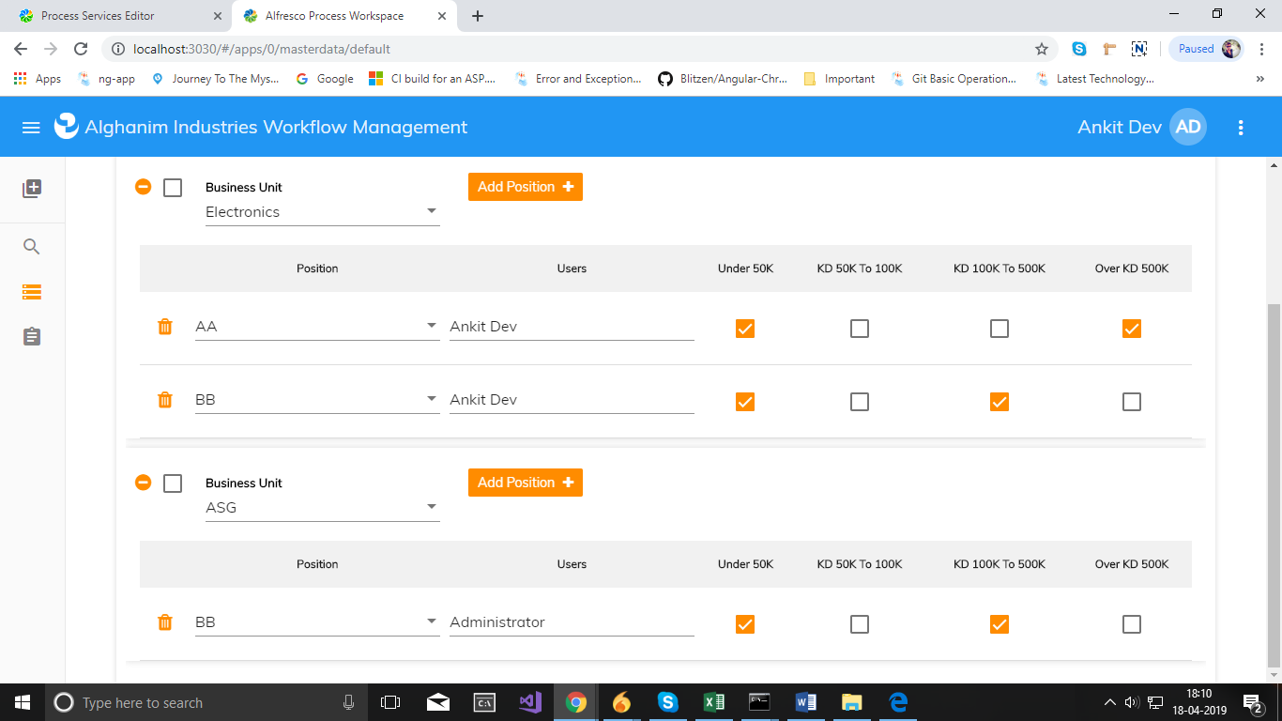

**Screen 6**

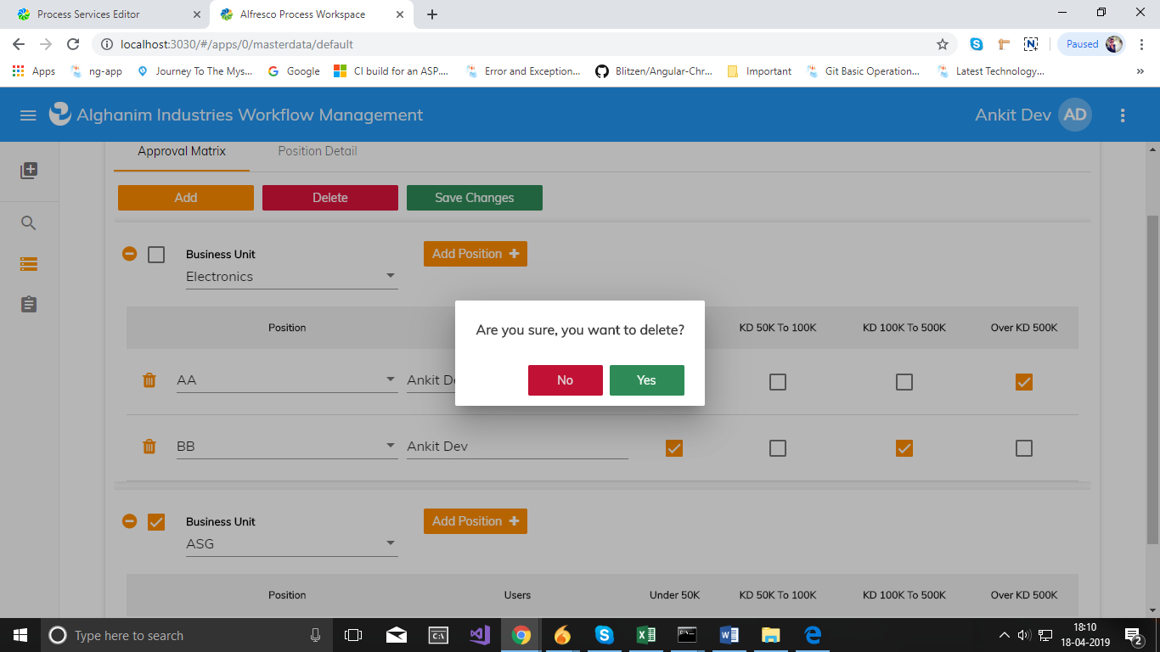

Above screen 4, 5, 6 used for Added dynamically Business Unit and Position. Edit and delete the existing position. We also allow to multiple delete. Check box is enable and disable depend on Position and User Selection.

**Screen 7**

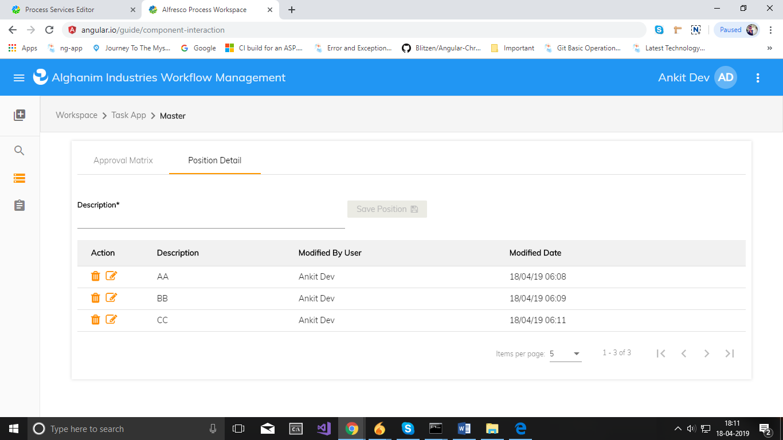

**Screen 8**

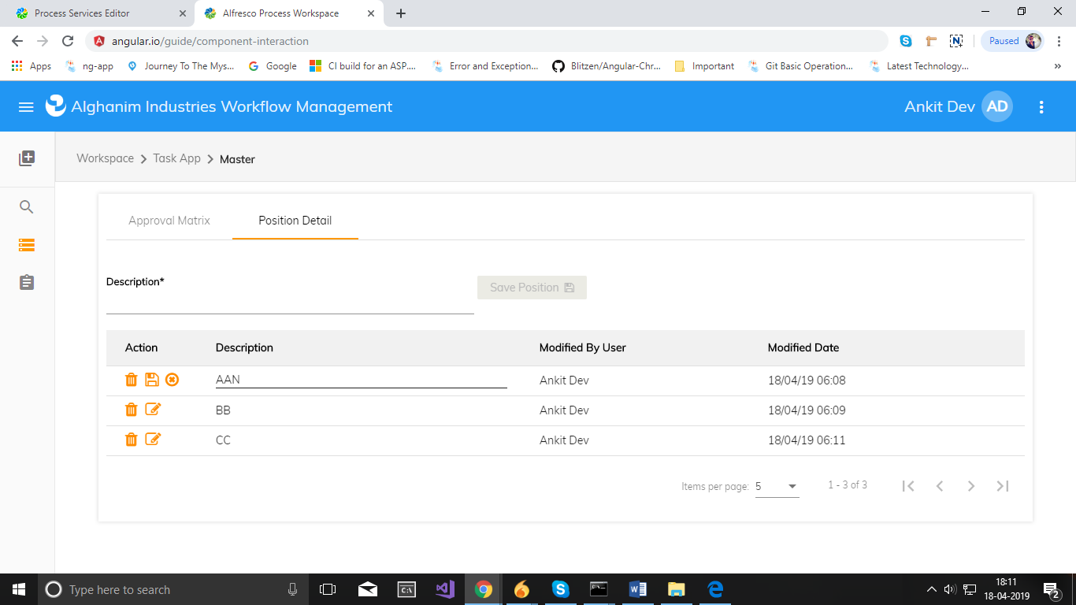

Above screen 7,8 add/edit/delete position in inline

**Screen 9**

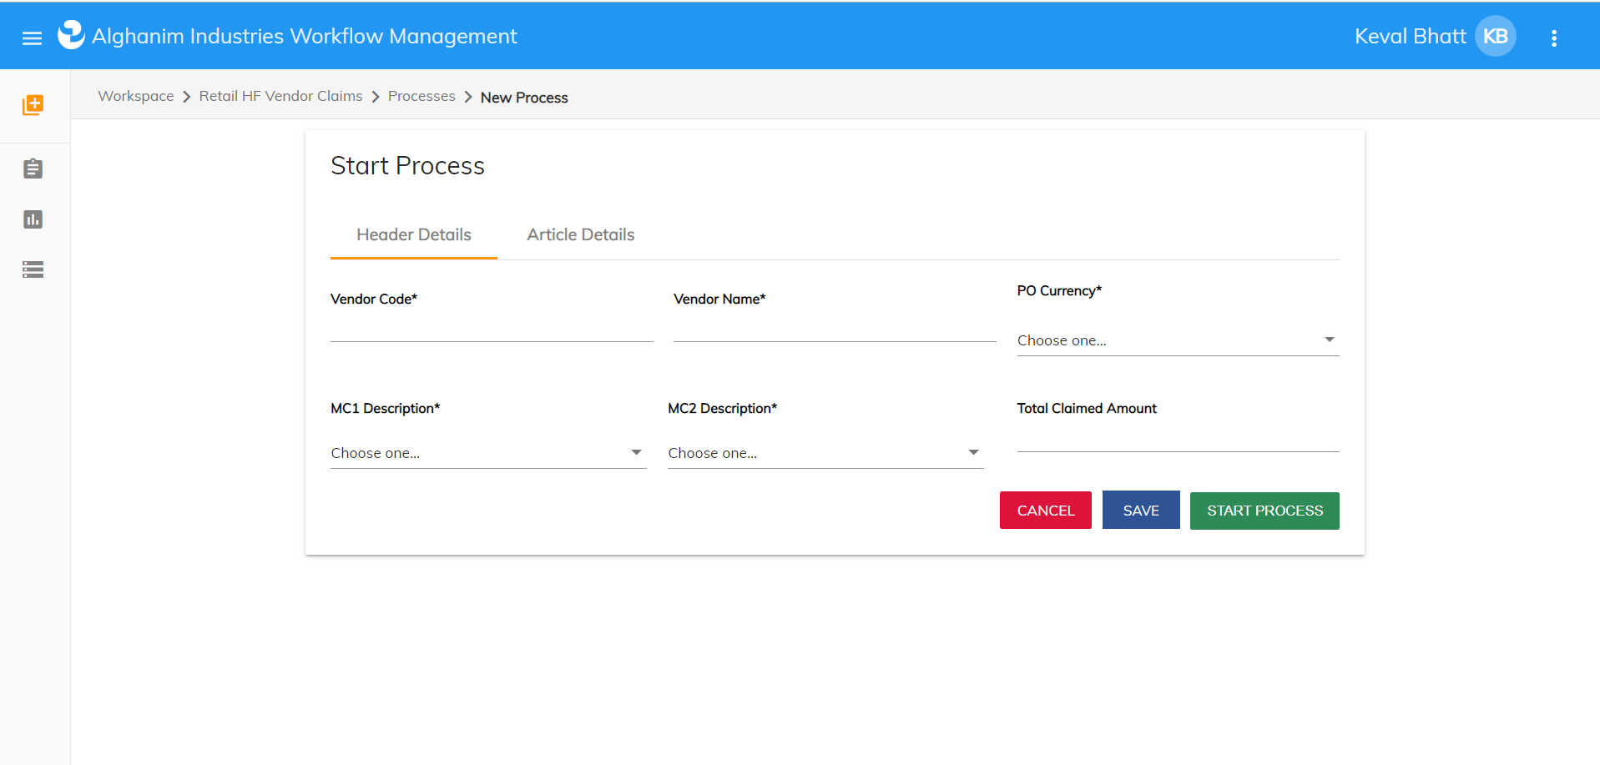

**Screen 10**

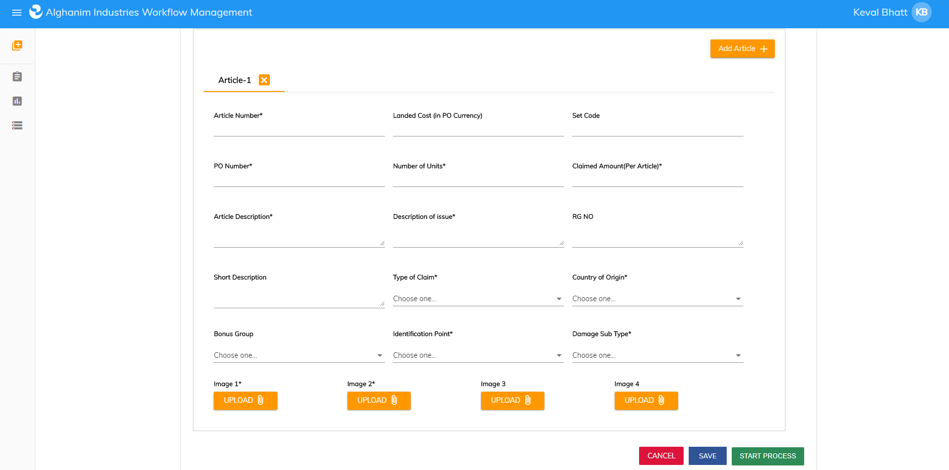

Above screen 10 is dynamic screen add/delete article and also added document in all article.

**Screen 11**

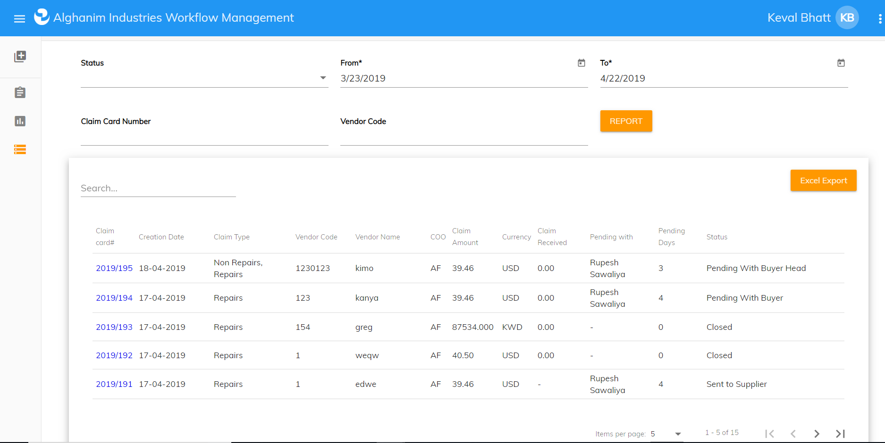

Above screen 11 is report screen, we can display report using given filter also we can export excel sheet.