**Homework#1**

**EC2 Link:-** <http://3.19.142.194/>

**Requirements:**

1. Launch an EC2 instance (any platform accepted but should be accessible through the internet). (**Points: 2**)
2. Configure web server (any variation, but help is available for limited variations). (**Points: 3**)

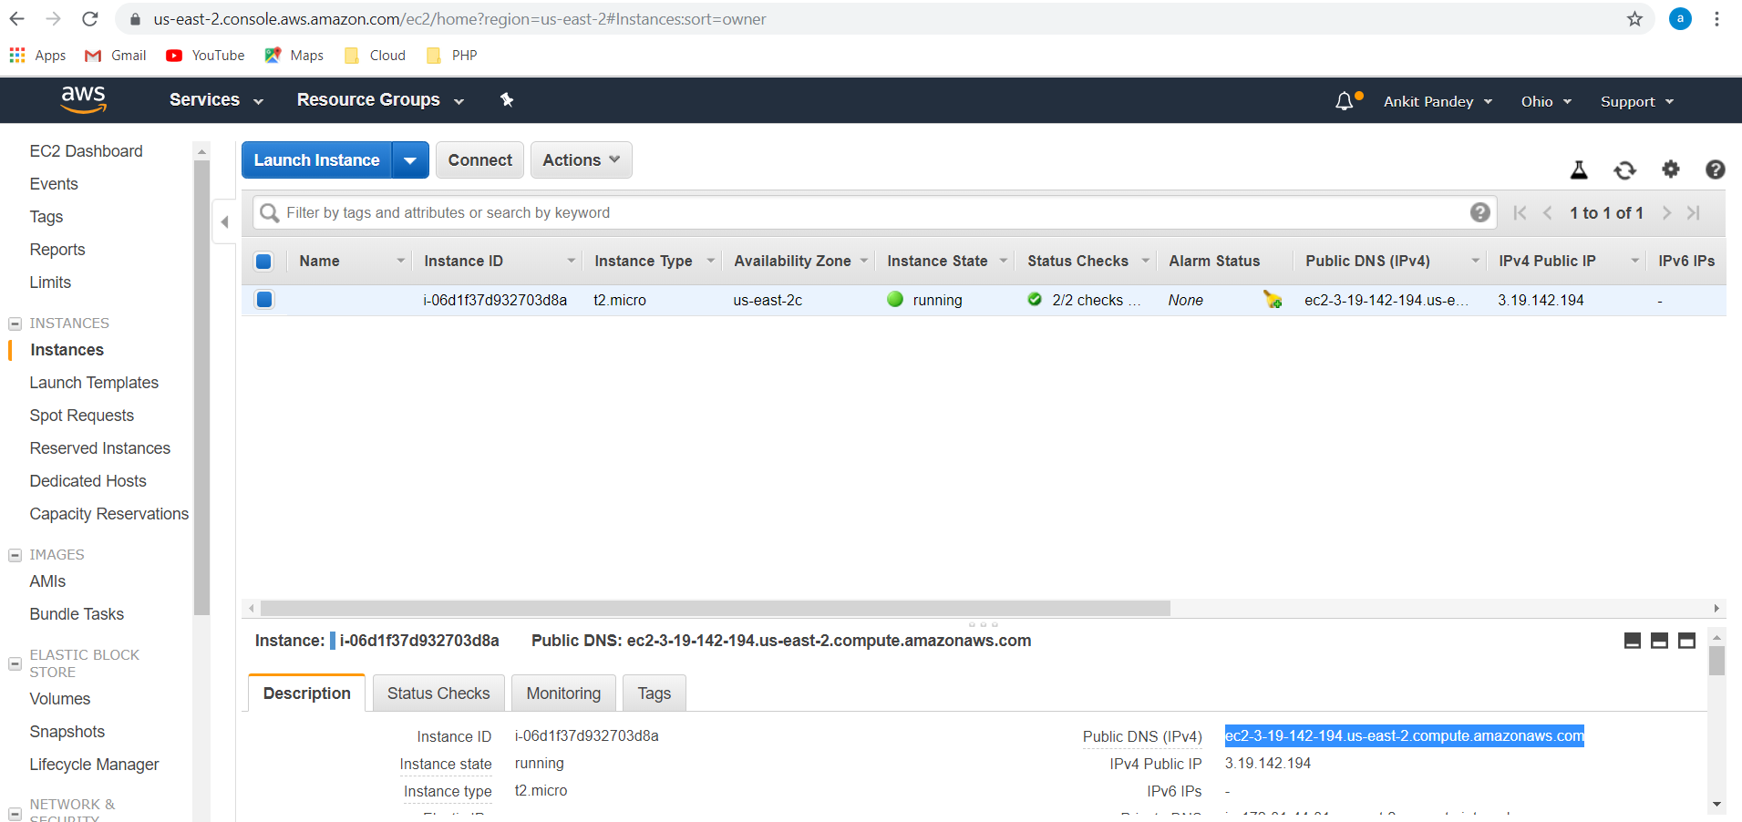

1. Design an interactive web page to do the following: (**Points: 5, broken as follows**)
   1. Create a registration page with (store it): (**Points: 1/5**)
      1. Username
      2. Password

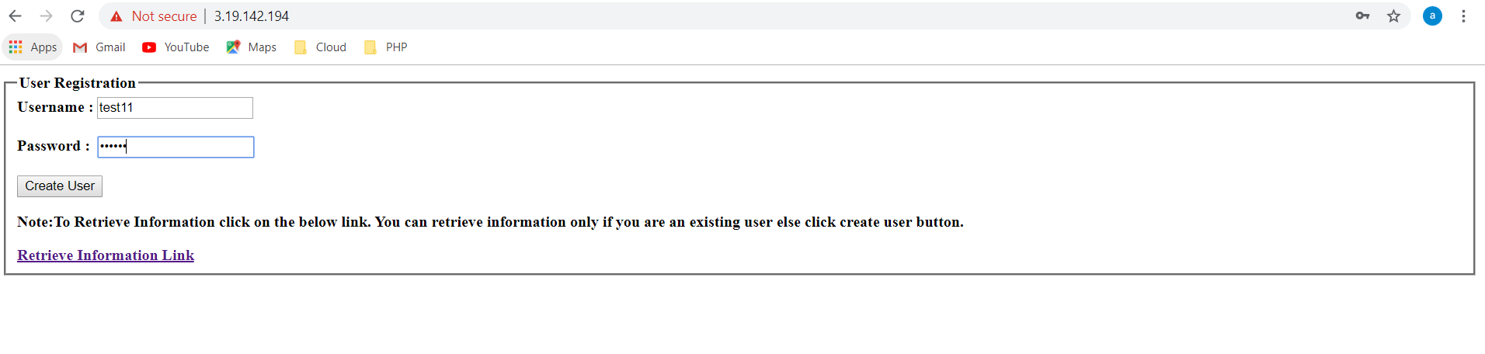

* 1. Accept users basic details (store it): (**Points: 1/5**)
     1. First name
     2. Last name
     3. Email

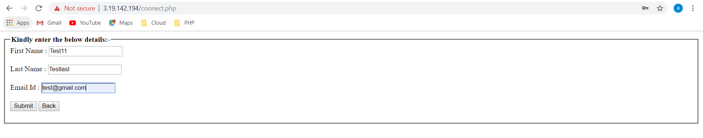

* 1. Upon submission redirect to next page (**Points: 1/5**)
     1. Display information accepted in step 3b

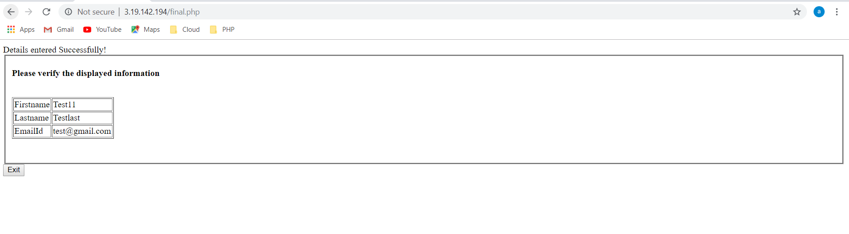

* 1. Should ask for username and password to retrieve user information. (**Points: 2/5**)

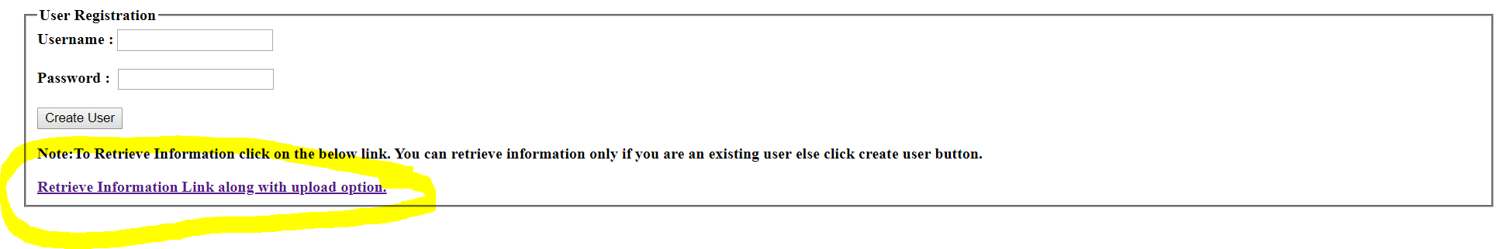

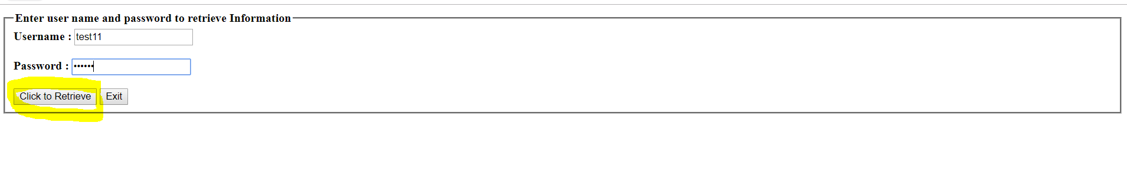

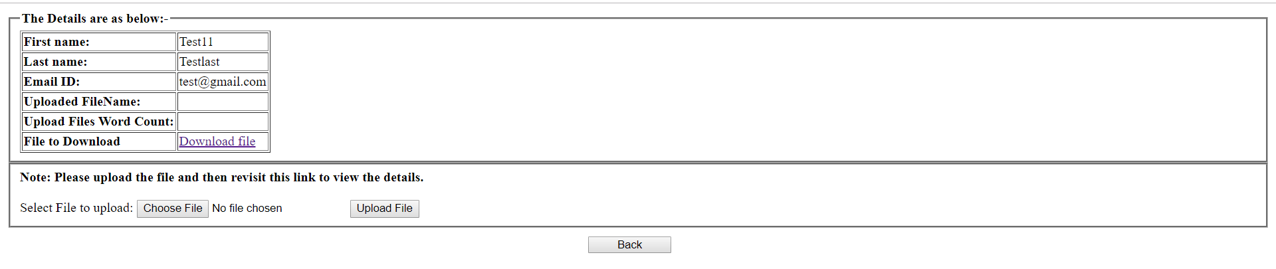

**Extra Credit (Points : 3)**

1. Upload a file with above designed form.
2. Store it.

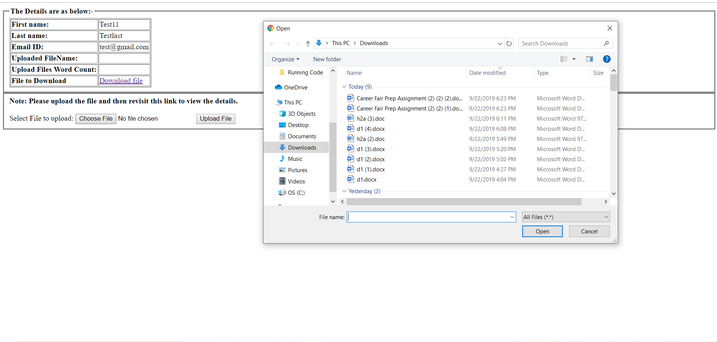

1. Display the count of words in the file on page designed in step#3c and provide link to download it.

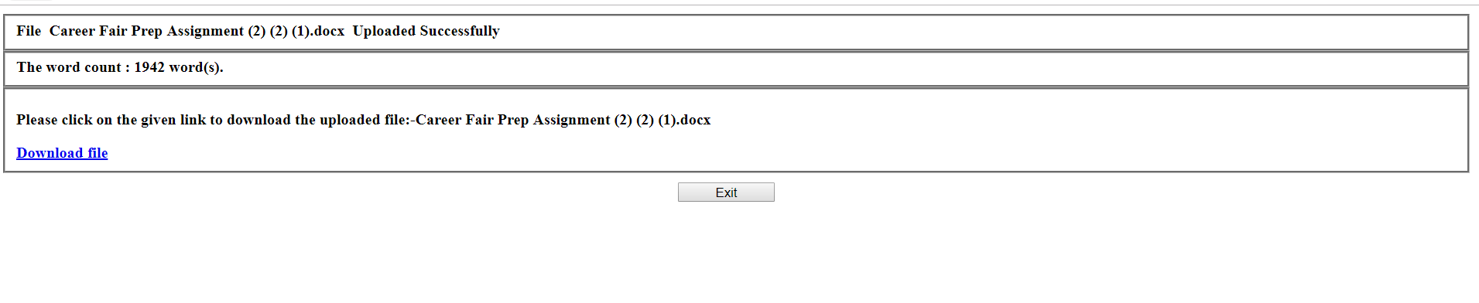

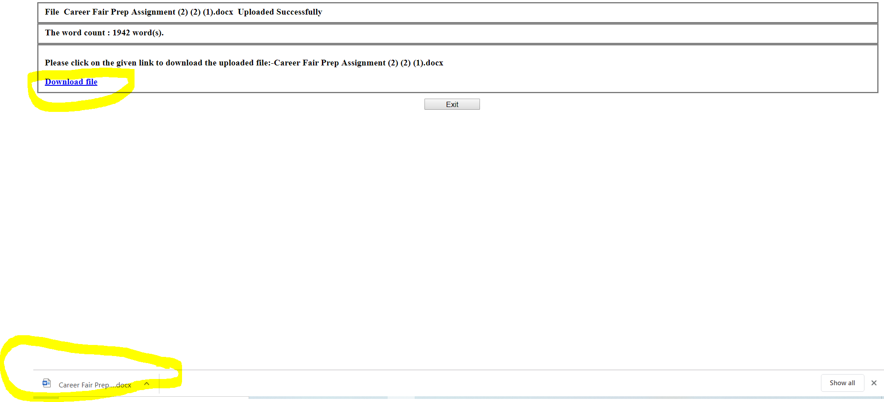

1. Display all the information from extra credit step#3 upon relogin.

