**Solution Document- Spark Project 3**

**Note:** I have attached all the SQL queries used to get this results in a zip file named spark_project3.zip. Kindly have a look. And below is the execution screenshot of the output obtained.

1. Find the hottest and coldest day along the station code and date for each year.
2. 2010

Coldest Day



Hottest Day



1. 2011

Coldest Day



Hottest Day



1. 2012

Coldest Day



Hottest Day



1. 2013

Coldest Day



Hottest Day

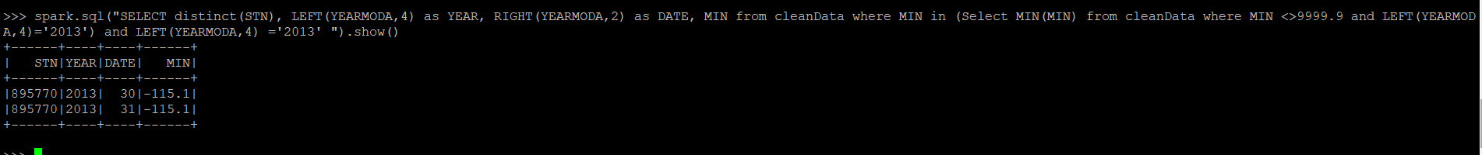

1. 2014

Coldest Day



Hottest Day



1. 2015

Coldest Day



Hottest Day



1. 2016

Coldest Day



Hottest Day

1. 2017

Coldest Day

Hottest Day

1. 2018

Coldest Day

Hottest Day

1. 2019

Coldest Day



Hottest Day



1. Find the hottest and coldest day across all years (2010 - 2019) along with station code and date.

Coldest Days across all years

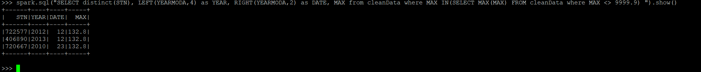

Hottest Days across all years



1. Maximum and minimum precipitation with station code and date for year 2015.

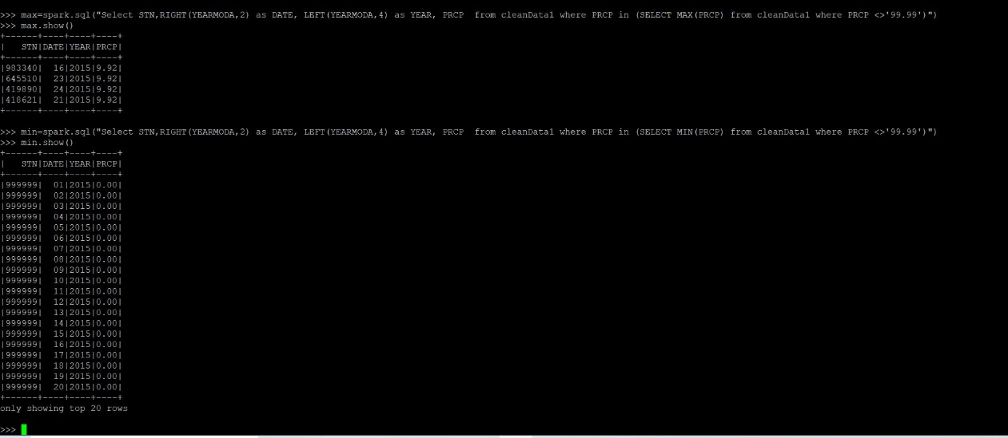

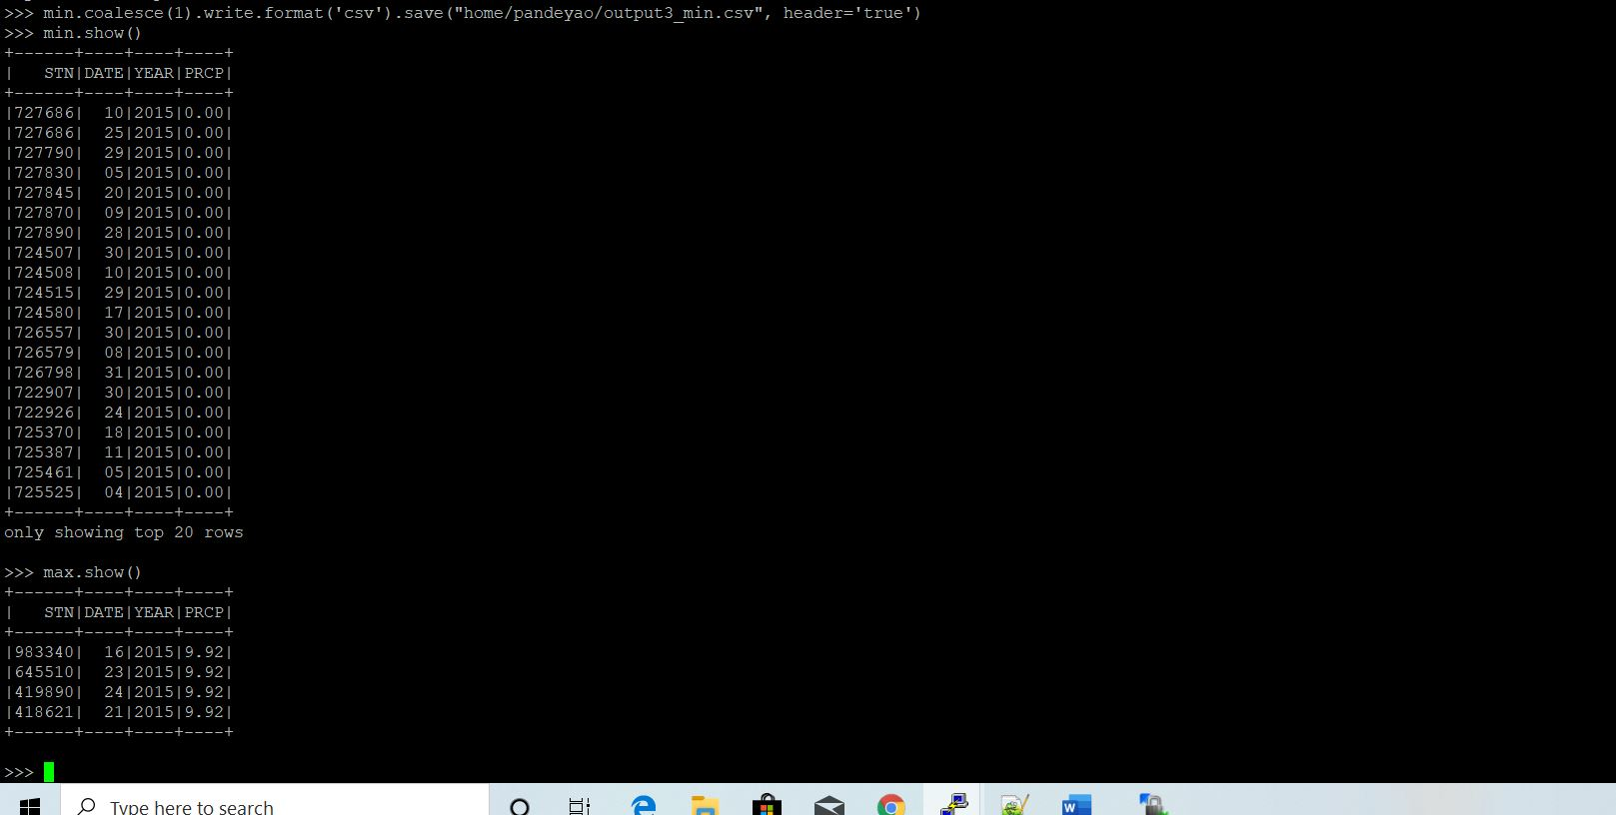

1. Count percentage missing values for mean station pressure (STP) for year 2019 and stations.

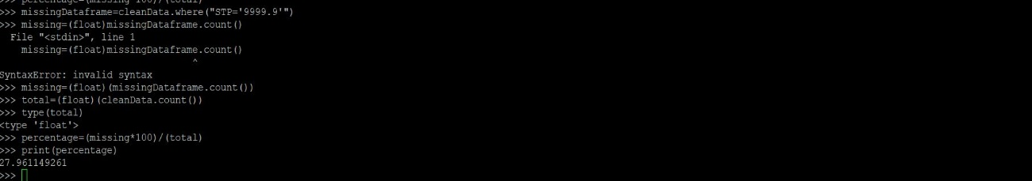

1. Station code with maximum wind gust and date for year 2019

