PrepAI
AI Interview & Smart Placement Preparation System

A Project Report submitted in partial fulfilment of the requirements for the degree of
Bachelor of Technology

Submitted by: [Student Name] | Roll No: [Roll No]
Guide: [Guide Name] | Department of [Department]
[College Name] | Academic Year 2025-26

Abstract
Campus placements demand strong technical knowledge and communication skills, yet most students have no way to practise interviews with instant, personalised feedback. PrepAI is a web-based system that generates interview questions from the student's profile using a large language model (Google Gemini), evaluates every answer with a score, strengths, improvements and a model answer, analyses the student's resume against a target role (ATS score) and tracks progress through analytics. A rule-based offline engine guarantees that the system keeps working even when the AI service is unavailable. The system is built with Flask, SQLite, Bootstrap and Chart.js and is protected with CSRF tokens, hashed passwords, input validation and rate limiting.

1. Introduction
Interview preparation today relies on static question lists and generic mock tests. They do not adapt to a student's skills and projects, do not explain mistakes and give no measurable progress. Recent large language models can understand free-text answers and give human-like feedback, which makes automated, personalised interview practice possible.

1.1 Problem statement
Students lack an accessible tool that (a) asks questions relevant to their own profile, (b) evaluates free-text and spoken answers, (c) reviews the resume for applicant tracking systems and (d) shows improvement over time.

1.2 Objectives
- Generate personalised technical and HR questions for a target role and difficulty.
- Evaluate each answer with a score and actionable feedback.
- Analyse resumes (PDF/TXT) and report an ATS score, missing keywords and fixes.
- Provide analytics, history and downloadable PDF reports.
- Remain functional without internet/API (offline fallback) and be secure by design.

1.3 Existing vs proposed system
Aspect | Existing (static question sites) | PrepAI
Questions | Fixed lists | Generated from profile, role, difficulty; no repeats
Feedback | None / model answer only | Score, strengths, improvements, sample answer per answer
Resume check | Separate paid tools | Built-in ATS analyser with keyword gap
Progress | Not tracked | History, analytics, streak, PDF report
Availability | Needs internet/AI | Offline rule-based fallback

2. Technology stack
- Backend: Python 3, Flask 3
- Database: SQLite (sqlite3)
- AI: Google Gemini API (google-genai SDK), JSON-mode responses
- Frontend: HTML5, Bootstrap 5, JavaScript, Chart.js, Web Speech API
- Libraries: pypdf (resume text), reportlab (PDF), pytest (testing)

3. System design

3.1 Architecture
Browser (HTML/JS) → Flask routes (app.py) → services layer (ai.py, offline.py, report.py) → SQLite (database.py). The AI service (Gemini) is called only from the services layer; if it fails, the offline engine produces a result of the same shape, so the rest of the system is unaware of the failure.

3.2 Modules
- Authentication: registration, login, logout, login throttling.
- Profile: skills, projects, certifications, target role.
- Mock interview: setup (type, difficulty, role) → questions → answering with timer/voice → evaluation → results.
- Resume analyser: text extraction, section checks, keyword matching, AI advice.
- Analytics: trend, per-type average, weakest answers, streak, practice time.
- History & report: stored sessions and PDF export.

3.3 Database design
Table | Important columns | Relation
users | id, full_name, email (unique), college, course, graduation_year, password (hash) | —
student_profiles | user_id (unique), skills, projects, certifications, target_role | 1—1 users
interview_sessions | user_id, interview_type, difficulty, role, average_score, total_time_sec, created_at | N—1 users
interview_answers | session_id, question, answer, score, feedback (JSON), time_sec | N—1 sessions (cascade delete)
resume_analyses | user_id, target_role, ats_score, source, result (JSON), created_at | N—1 users

4. Algorithms and implementation

4.1 Question generation
A prompt containing the target role, skills, projects, difficulty, a random focus area and the student's last 20 questions (to avoid repetition) is sent to Gemini, which returns a JSON array of five questions. A 10-second timeout protects the UI; on timeout or error a randomised built-in question bank is used.

4.2 Answer evaluation
Gemini receives a strict 0–10 rubric and the question/answer wrapped in marker blocks marked as data (prompt-injection defence). A score guard then caps very short answers (under 5 words ≤ 1, under 15 words ≤ 4, under 30 words ≤ 6). Answers are evaluated in parallel threads with an overall deadline.

4.3 Offline evaluator
For each bank question a list of key concepts (with synonyms) is defined. Score = 60% concept coverage + 20% length + 10% example usage + 10% structure (sentence count), scaled to 10. Generic questions use relevance to question keywords, STAR-style result/action words, length, structure and examples. A filler-word detector counts words such as 'um', 'basically', 'you know'.

4.4 Resume ATS score (out of 100)
ATS = 35% role-keyword match + 25% presence of standard sections/contact links + 15% action verbs + 10% quantified results + 15% suitable length (250–700 words). When AI is available, Gemini refines the score, summary, keyword gaps and suggestions.

4.5 Security measures
- Password hashing (werkzeug), minimum length 8.
- CSRF token on every POST; HttpOnly + SameSite cookies.
- Parameterised SQL; ownership checks so users can open only their own sessions/reports.
- AI output displayed via textContent / Jinja autoescape (no XSS).
- Rate limiting: 40 AI calls per 10 min per user; 5 failed logins per 10 min.
- Upload limits: 2 MB resume, 64 KB for all other requests; only PDF/TXT accepted.
- Secrets in environment variables (.env), not in code.

5. Results (screenshots)
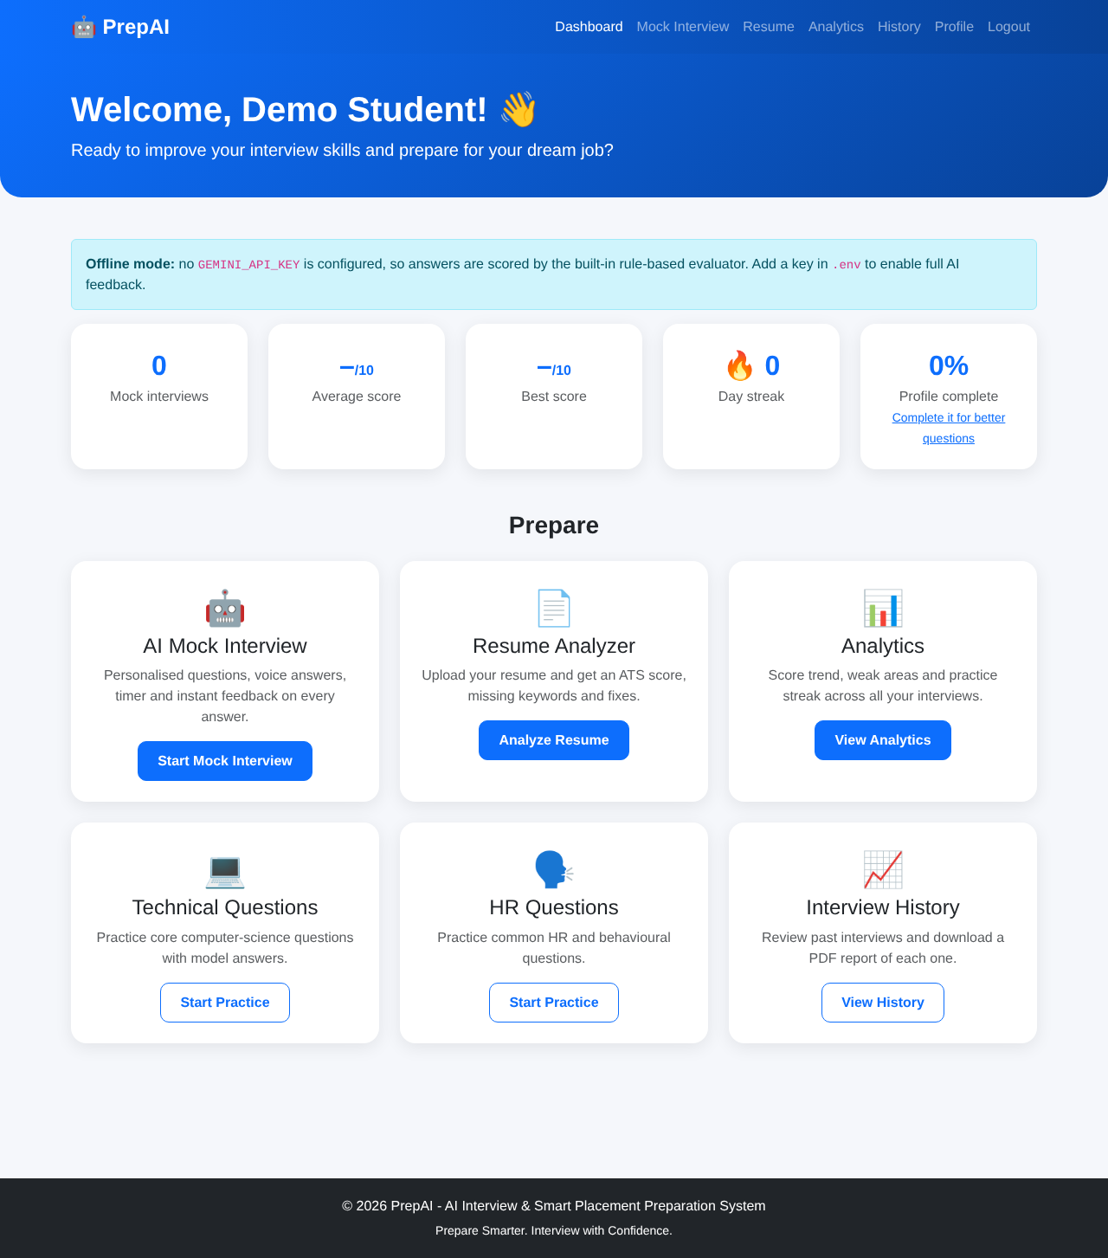
Figure 1: Dashboard
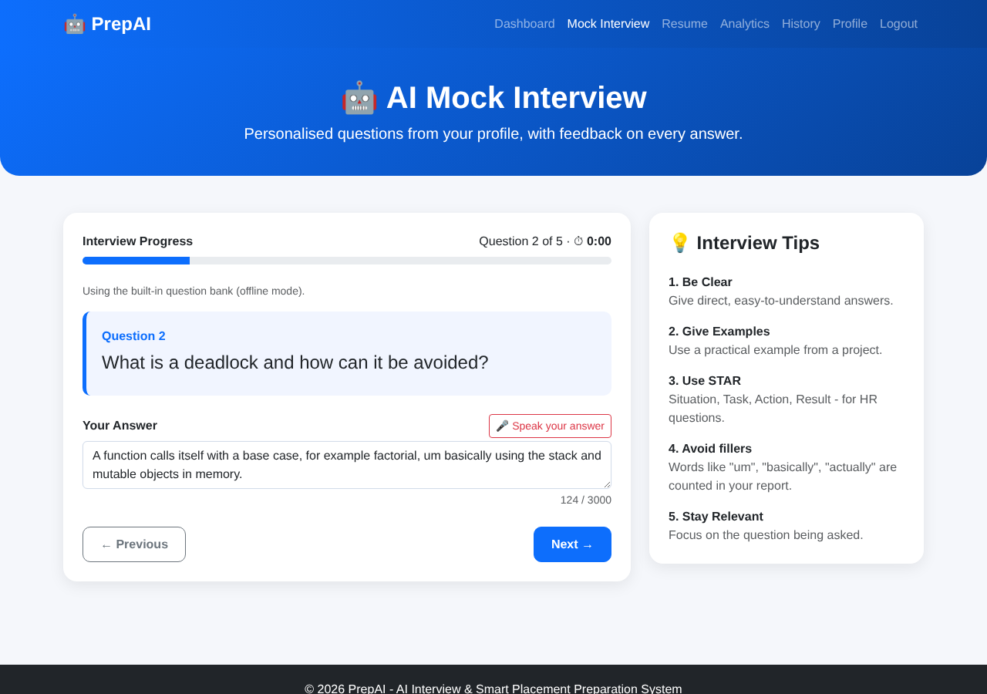
Figure 2: Mock interview with timer and voice input
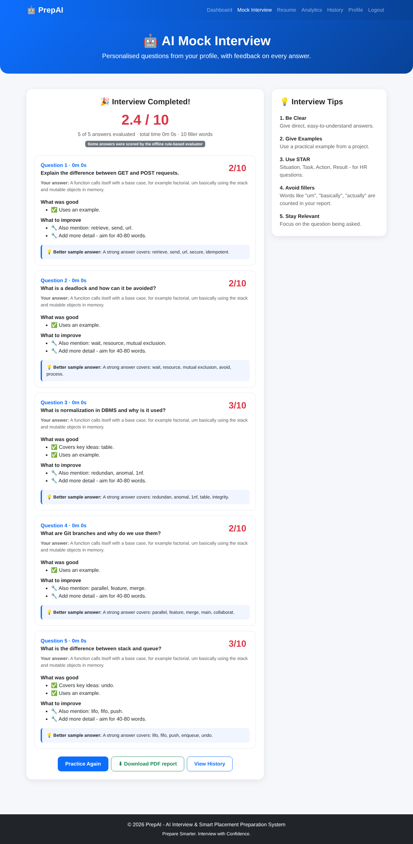
Figure 3: AI/offline feedback after interview
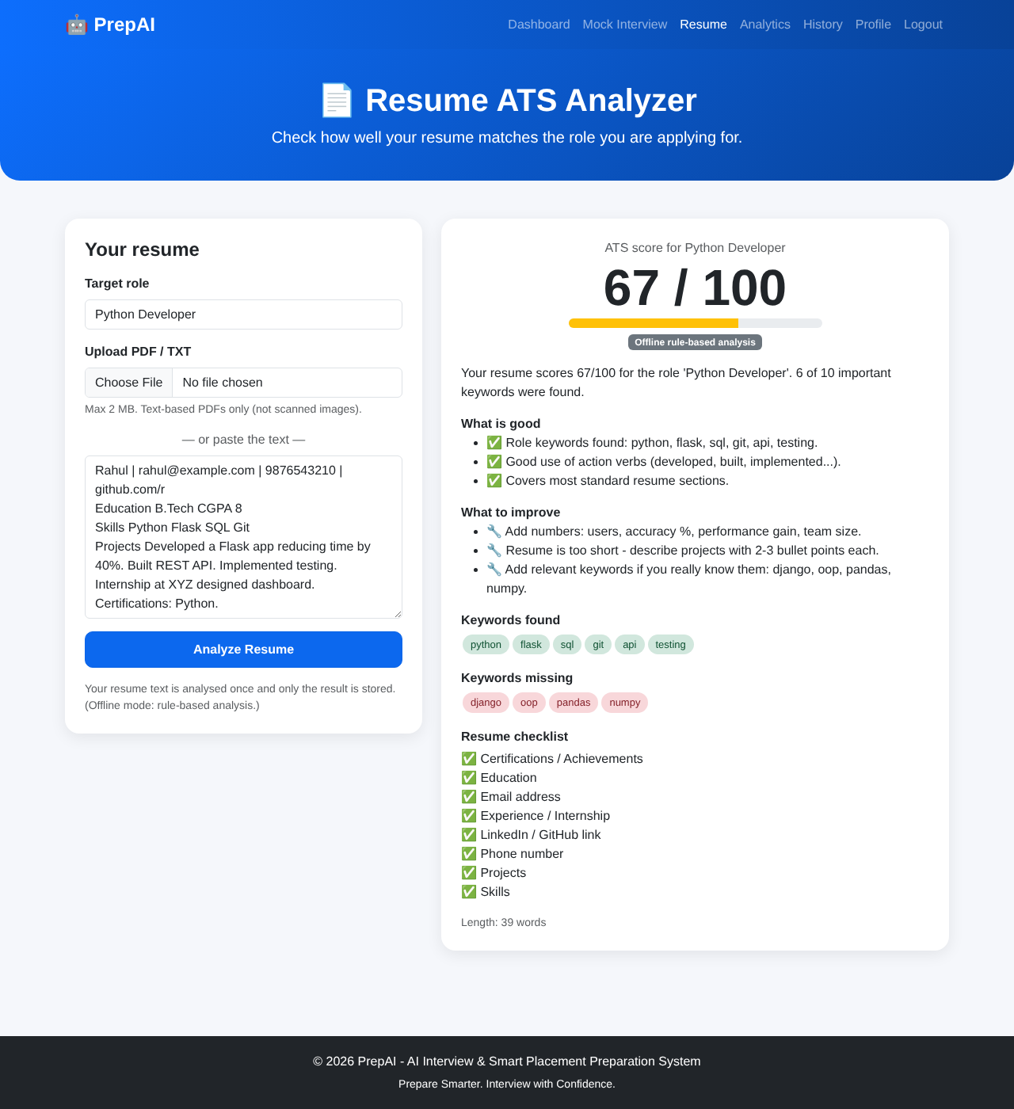
Figure 4: Resume ATS analyzer
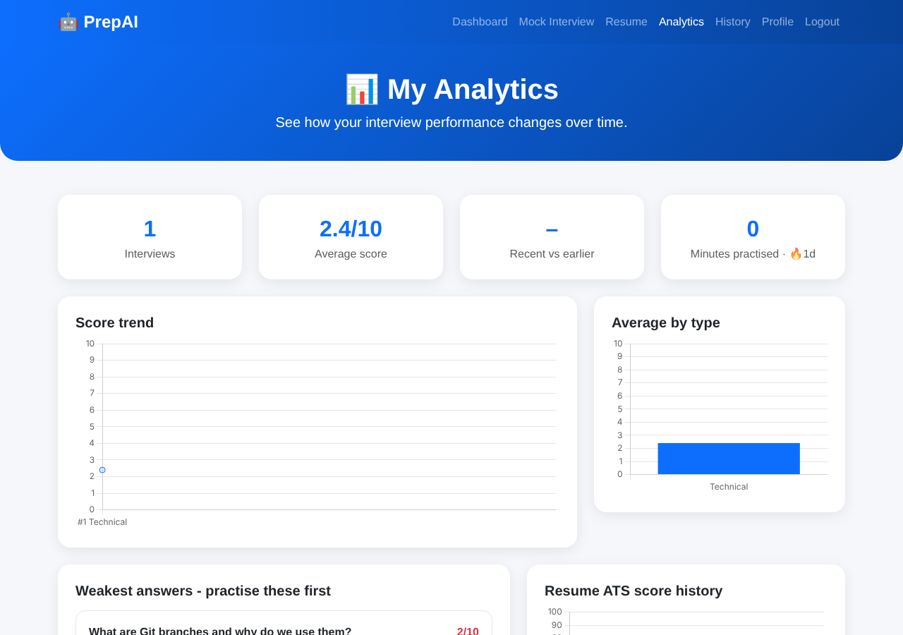
Figure 5: Analytics dashboard
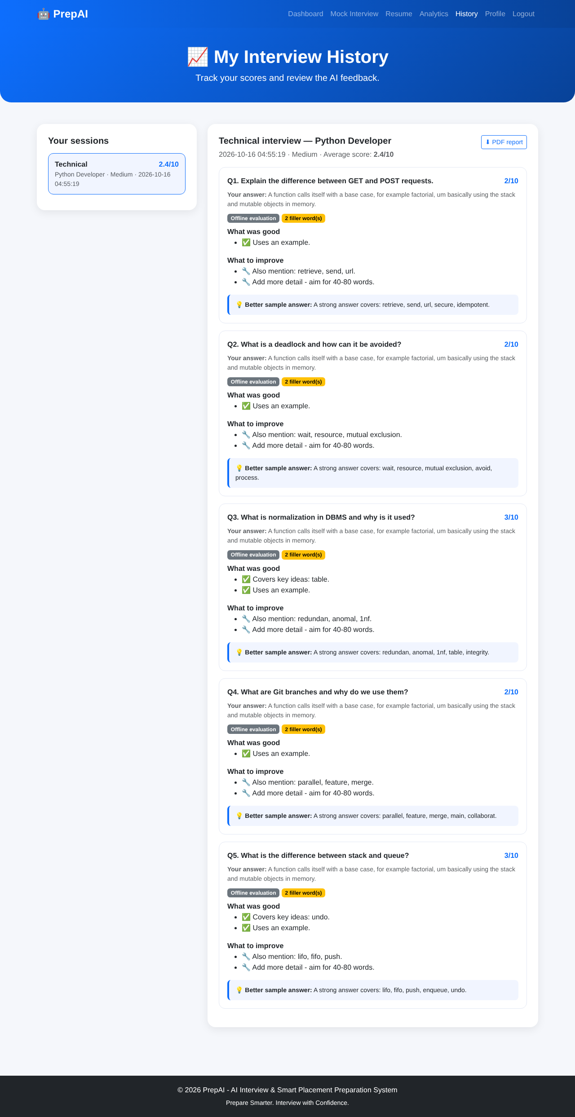
Figure 6: History with PDF report

6. Testing
16 automated pytest cases run without internet or API key, plus manual end-to-end testing in a browser (register → interview → results → resume → analytics → history).
Test case | Input | Expected / result
CSRF protection | POST without token | 400 – Pass
Registration validation | bad email / short password / duplicate | Proper error messages – Pass
Login throttling | 6 wrong passwords | 429 – Pass
Access control | Other user opens session / PDF | 404 / no data – Pass
Interview flow | Generate → evaluate → save | Scores saved, history shows it – Pass
AI failure | Gemini raises exception | Offline evaluation returned – Pass
Score guard | AI gives 10 for 'idk' | Capped to ≤ 1 – Pass
Resume upload | PDF, TXT, EXE, 3 MB file | Accepted / rejected / 413 – Pass
PDF report | Download session report | Valid PDF – Pass

7. Conclusion
PrepAI delivers a complete, secure and resilient interview-preparation platform: personalised questions, per-answer AI feedback, resume analysis, analytics and reports. The offline fallback makes it dependable in real use and demonstrations.

8. Future scope
- Coding round with sandboxed code execution.
- Video/emotion and eye-contact analysis.
- Company-specific question sets and aptitude tests.
- Admin/TPO panel for placement-cell statistics.
- PostgreSQL + Redis + background workers for large scale; mobile app.

References
- Flask documentation – https://flask.palletsprojects.com
- Google Gemini API – https://ai.google.dev/gemini-api/docs
- OWASP Cheat Sheet Series (CSRF, XSS, Password Storage) – https://cheatsheetseries.owasp.org
- Chart.js – https://www.chartjs.org
- ReportLab and pypdf documentation

