**Medical Analytics - niRog**

**An Engineering Project in Community Service**

**Phase – I Report**

***Submitted by***

**1. Somardh Jaiswal 20BCE10880**

**2. Aaditya Sreenivasan 20BCE10738**

**3. Akshat Mehrotra 20BCE10246**

**4. Ankit Deb 20BCE10495**

**5. Yaksh Goyani 20BCE10483**

**6. Shivam Dubey 20BCE10133**

***in partial fulfillment of the requirements for the degree of***

***Bachelor of Engineering and Technology***



**VIT Bhopal University**

**Bhopal**

**Madhya Pradesh**

**December, 2022**



**Bonafide Certificate**

Certified that this project report titled **“Medical Analytics - niRog”** is the bonafide work of **“**Somardh Jaiswal 20BCE10880, Aaditya Sreenivasan 20BCE10738, Akshat Mehrotra 20BCE10246, Ankit Deb 20BCE10495, Yaksh Goyani 20BCE10483, Shivam Dubey 20BCE11036” who carried out the project work under my supervision.

This project report (Phase I) is submitted for the Project Viva-Voce examination held on …………..

**Supervisor**

# INTRODUCTION

The topic of our Epics Project is an application based on Medical Analytics and Services. The application is named “niRog”. It is mainly focused on uplifting Health and Medical services to citizens of our nation. It’s a software tool that helps healthcare professionals and administrators collect and analyze data related to patient care and the assigned treatments. It is also focused on collecting insights and recommendations based on real-time data, prescriptions, etc.

Throughout our daily lives, we’ve learned about many incidents which have occurred and still occurring in many parts of our country where citizens face unnecessary encounters and feedback while they were trying to seek health facilities in government hospitals: be it standing in a queue, be it not being able to receive proper feedback, etc. Few of the problems faced by people are:

Out of all the APIs which the application uses, niRog is constantly dependent on Google Location Services so that it can function its features properly. One of the features it includes has, to locate nearby Government Hospitals which are linked with niRog to work seamlessly. Users can choose any of those mentioned hospitals and then seek out the software’s services.

One of the main drawbacks regarding our project is that, it is not equipped to provide services during the time of emergencies as it is not logically accurate to book appointments and wait otherwise.

## 1.1 Motivation

The application aims to eradicate the endless queues which is common among many government hospitals and dispensaries.

Cashless payments are convenient for both the doctor and the patient.

By introducing the above procedures, a revolutionary medical system will be established

niRog application comes forward with the helping motive to provide citizens receive proper Healthcare. They will have their own freedom to book appointments from the software itself. Initally, the portal will lead them to register their accounts by filling the required details. Then it’d lead them towards their profile dashboard where they will have a clear overview of all their requested appointments and medicines. The portal will also have specialized corners for Doctors and Admins. With the given permission of the user, medicine and appointment details will be stored in a reliable database to provide better analytics and services.

## Objective

The goal of our initiative is to provide the users, the immediate cure of their illness. In our busy lives, it is difficult to find and visit a good doctor nearby and get the required and correct treatment of our problem. As a result, many users browse through various websites for remedies but cannot find any due to a lot of information as there is a lot of incorrect content which confuses them and sometimes the treatment is so expensive that it prevents us from finding it. As a result, our website provides a list of remedies that may be suitable for you, as well as extensive information about the medicine, such as its dosing and potential adverse effects. If you want to see a doctor, click on the "Find a Doctor" option, input your location, and search for doctors in your region before choosing one from the list and book an appointment.

# 2. Existing Work / Literature Review

For precise, streamlined, and personalized healthcare delivery, there are 100s of digital portals and startups that exist on the internet. Many of them are feature rich and provide a variety of services.

Here are some of the features of the existing web-based solutions:

1. Online appointment: It makes appointments more convenient and easier for potential patients. The appointment can be scheduled as per the user’s convenience.
2. Opening Hours: It helps the users to the hospital’s active opening hours, making it easy for them to book their online appointment slot.
3. Forms for easy appointment scheduling.
4. Chatbot for 24/7 service.
5. Testimonials for reassurance of people.
6. Blogs on content relevant to healthcare.

Issues with the digital solutions available:

* User experience: Many websites are difficult to navigate or use, which is frustrating for users. There is so much content on the platform and is confusing for the users while looking for the target. Many times a user tends to forget what he/she was looking for. Most of the websites don’t get into the cures directly and rather make users get involved into their platform and eventually pay for their services so that he/she can be entangled into their business model.
* Lack of information: Some websites do not provide enough information about conditions, treatments, or other medical topics, which makes it difficult for users to understand their health or make informed decisions about their care.
* Cost: Perhaps the most pressing issue in health care currently is the high cost of cure. This is the potential factor that stops people from looking for a cure.
* Inaccurate or outdated information: Some websites have inaccurate or outdated information, which can be dangerous if it is relied upon for medical decision making. Sometimes, the side effects are not mentioned on the websites.
* Limited functionality: Some websites do not offer all the features or services that users need, such as appointment scheduling or the ability to message a healthcare provider.
* Lack of personalization: Some digital healthcare websites do not offer personalized recommendations or treatment plans based on individual user needs, which makes it difficult for users to find the information or services that are most relevant to them.
* Ayurvedic and homeopathic treatments are available in fewer platforms as compared to allopathic ones. So, people with the will for permanent cure or more reliable cure with less side effects and cost effective at the same time have to suffer.
* Lesser reach to the suburbs: The digital healthcare platforms are available in cities in a greater number than compared to villages.

# Topic of the work

1. **System Design / Architecture**

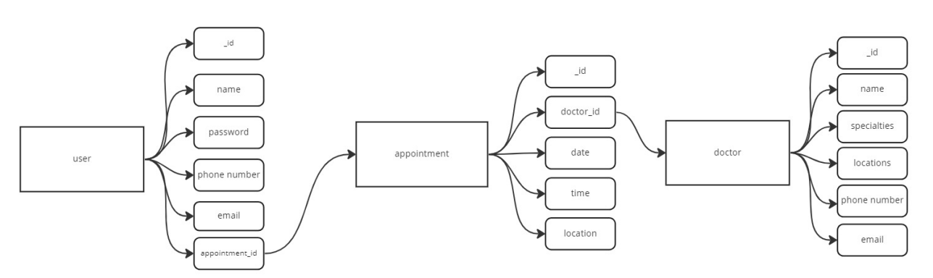

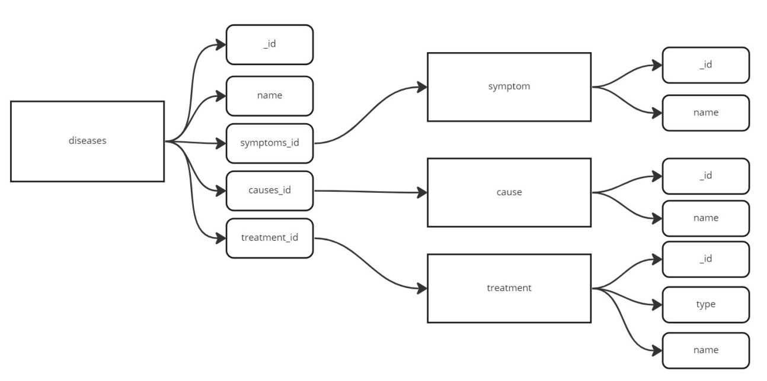

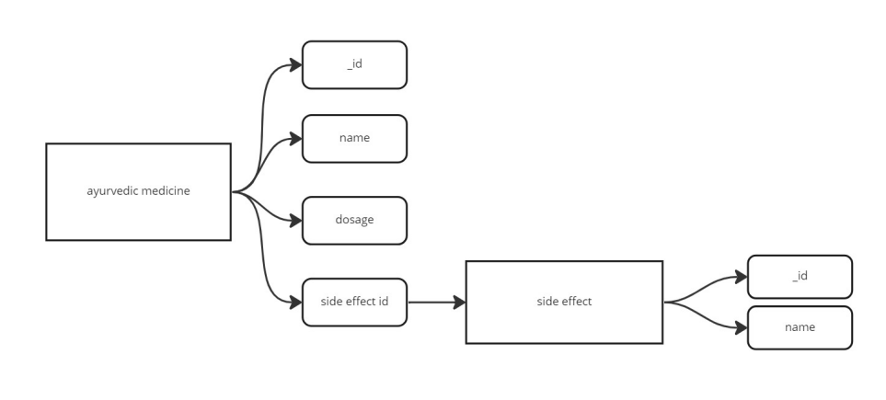

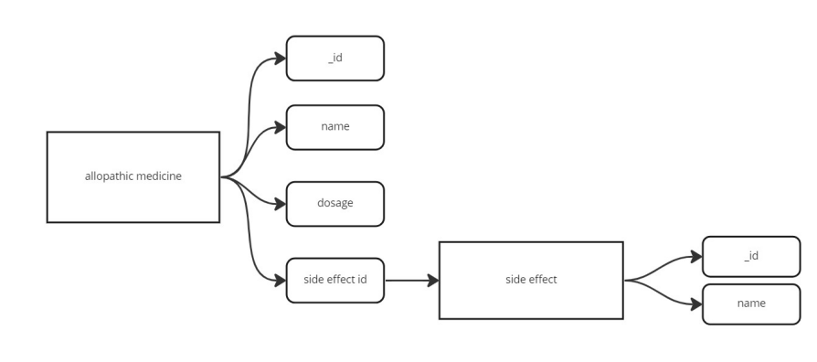

1. **Working Principle**

The basic principle behind working would be extraction of data according to the user requirement and a kind of sorting of things according to the filters. The website will make use of a wide database where information regarding user, doctor and medicines would be stored.

For knowing about types and symptoms of diseases, contents of medicine and dosage, API calls will be made to fetch this information. This information will help the user to retrieve all the data regarding a particular disease that he searched for.

The website will authenticate the user upon login and only the admin will have the access to adding code functionalities while the data will be kept abstract from the user as of how the calls are being made or all the work that is done behind the scene, keeping the user as a separate entity.

The site also has functionality where it is possible to book appointments with the doctors in the nearby hospital. To search these hospital users will have to accept the location sharing then the data can be fetched using google maps API.

The site will extensively make use of nodejs to browse to different routes and establish connection with the server. The basic frontend will be implemented using HTML, CSS and JavaScript and the backend part will be accomplished using nodejs, express, MongoDB and for deployment we will use firebase and other microservices.

To make a user connected experience there will be features like online consultations, online payment, chatbots and use of CTA which can be added in later stages.

1. **Expected Results**

After completion of phase 1 the website is prepared with wholesome design and the complete frontend part is ready which will be further worked upon in phase 2.

This full stack health care project is believed to solve a real world problem and provide a one stop solution to all the healthcare needs. The project is believed to be highly scalable, efficient and user friendly.

The completed website is supposed to undergo a complete testing and debugging before deploying to use. This will ensure that all the functionalities are working and the project is yielding the desired outcome.

# CONCLUSION ( Only for the phase – I work Completed) ( 1 Page)

In this project we have to make a website for health appointments by the doctor and also write some blogs for health related issues. In this we shall use the technology HTML,CSS,JAVASCRIPT for frontend part and backend part will be accomplished using Nodejs, Express, MongoDB in Phase 1 we shall complete the frontend part. Health care is moving into the home increasingly often and involves a mixture of people, a variety of tasks, and a broad diversity of devices and technologies; it is also occurring in a range of residential environments. The factors driving this migration include the rising costs of providing health care; the growing numbers of older adults; the increasing prevalence of chronic disease; improved survival rates of various diseases, injuries, and other conditions (including those of fragile newborns); large numbers of veterans returning from war with serious injuries; and a wide range of technological innovations. The health care that results varies considerably in its safety, effectiveness, and efficiency, as well as its quality and cost.

# Reference: ( 1 Page)

1. <https://www.netsolutions.com/insights/5-healthcare-problems-which-digital-technologies-can-solve-for-a-fit-and-healthy-world/>
2. Problems with Allopathy -

<https://www.pristyncare.com/blog/drawbacks-of-allopathic-medicines-pc0113/>

1. <https://nodejs.org/docs/latest-v16.x/api/>
2. <https://github.com/expressjs/session>
3. <https://www.mongodb.com/docs/manual/core/document/>
4. [https://developers.google.com/maps/documentation?_gl=1*18s6zmm*_ga*MjU3NjczODk5LjE2NzIyOTgwNzY.*_ga_NRWSTWS78N*MTY3MjI5ODA3NS4xLjAuMTY3MjI5ODA3NS4wLjAuMA](https://developers.google.com/maps/documentation?_gl=1*18s6zmm*_ga*MjU3NjczODk5LjE2NzIyOTgwNzY.*_ga_NRWSTWS78N*MTY3MjI5ODA3NS4xLjAuMTY3MjI5ODA3NS4wLjAuMA)..