2) Detail Case study on Pinterest recommendation system? How it works, If you wanted to clone it how will you do it. Mention the process. Which recommendation system do you like and why?

Case study:- The Evolution of a Real-World
Recommender System
Published by:- David C. Liu, Stephanie Rogers, Raymond Shiau, Dmitry
Kislyuk, Kevin C. Ma, Zhigang Zhong, Jenny Liu, Yushi Jing

- Related Pins is the Web-scale recommender system that powers over 40% of user engagement on Pinterest.
- The initial version of Related Pins, launched in 2013, was one of the first forays into recommender systems at Pinterest. Though successful in improving content discovery, Related Pins initially received minimal engineering attention.
- In 2014, about 10% of pins saved across Pinterest.
- In 2015, a small team began iterating and further developing Related Pins. It now drives over 40% of all saves and impressions through multiple product surfaces, and it is one of the primary discovery mechanisms on Pinterest.
- Process of pinterest Recommendation system.
- Pinterest is a visual discovery tool for saving and discovering content.
- Users save content they find on the Web as pins and create collections of these pins on boards.
- Related Pins leverages this human-curated content to provide personalized recommendations of pins based on a given query pin.
- 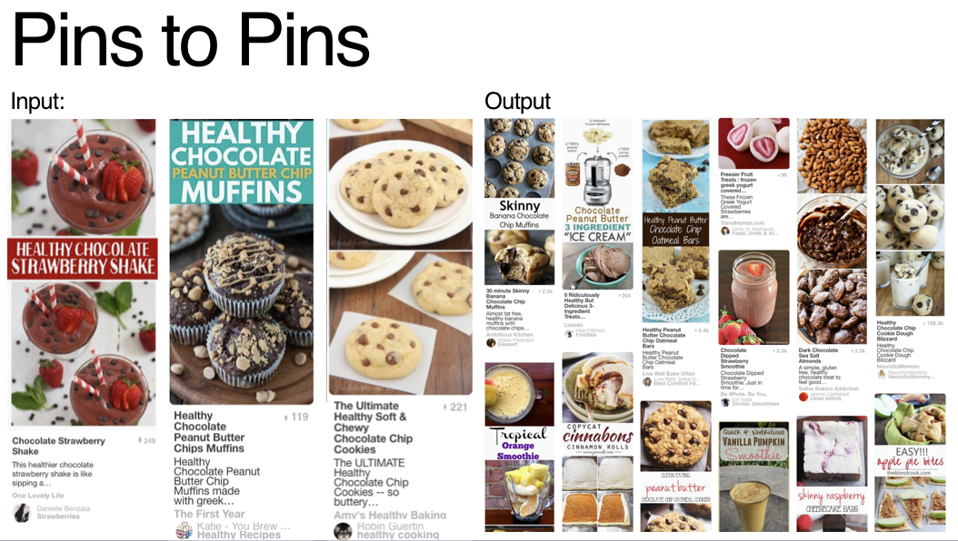
- Which recommendation system do you like and why?

- Recommender systems aim to predict users interests and recommend product items that quite likely are interesting for them.

- Collaborative Filtering
- It is considered to be one of the very smart recommender systems that work on the similarity between different users and also items that are widely used as an e-commerce website and also online movie websites.
- It checks about the taste of similar users and does recommendations.
- The similarity is not restricted to the taste of the user moreover there can be consideration of similarity between different items also.
- The system will give more efficient recommendations if we have a large volume of information about users and items.
- Mainly, there are two approaches used in collaborative filtering stated below:

User-based nearest-neighbor collaborative filtering

Item-based nearest-neighbor collaborative filtering

