**1) Explain how will you build the dataset. If we tell you**

**The requirements.**

**Method-1:-**

* **Step 1: Gathering the data.**
* **Step 2: Handling missing data.**
* **Step 3: Taking your data further with feature extraction.**
* **Step 4: Deciding which key factors are important.**
* **Step 5: Splitting the data into training & testing sets**
* **Method-2:-**
* 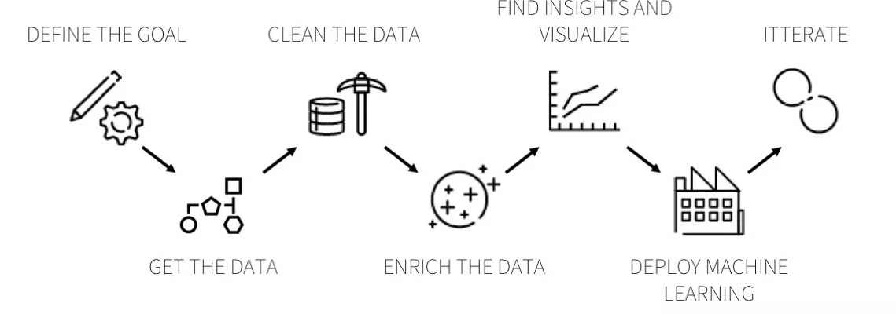
* **It depends for what purpose you are collecting the data.**
* **I have Mention two methods one for general and second one for Machine learning.**