**3. How can you turn your NLP chatbots or products into Cognitive (Something which can sense the feelings) Products. Describe the process in detail. Take one Product like chatbots/Phone-bot(bot over a call).**

* **Chatbots are tools that simplify the interaction between humans and computers.**
* **Natural Language Processing is what allows chatbots to understand your messages and respond appropriately.**
* **Natural Language Processing (NLP) helps provide context and meaning to text-based user inputs so that AI can come up with the best response.**
* **Humans have always loved the idea of robots having feelings.**
* **Hollywood has cashed in on this affinity in multiple films, from making robots fall in love with each other, to an alternative dystopian future where robots are taught to feel, leading them to overpower humans.**
* **But even with such narratives, humans like it better when chatbots are taught more about feelings and made to assist them with empathy**.
* 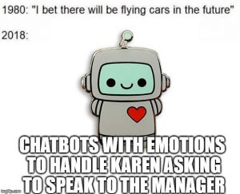
* **Chatbots in customer service are used to optimize your customer experience and filter out basic how-to and level 1 questions.**
* **However, there are bots that are designed to do much more than that.**
* **No matter what the goal is for your chatbot, building it to deliver empathetic answers is crucial for any business.**
* **When a conversation has a tone of empathy to it, the people or in case of chatbots,**
* **the person conversing with the bot will feel a sense of contentment.**
* **Though chatbots are built to collect data and assist accordingly, humans on the other side are trying to relate emotionally.**
* **Making chatbots converse with empathy helps with overall satisfaction in your customer support.**
* **Understanding human emotions also allow chatbots to deliver better customer service.**
* [**Empathy, however, branches into three types**](https://freshdesk.com/customer-service-skills/empathy-chat-support-blog/)**– cognitive empathy, emotional empathy, and compassionate empathy.**
* **Though all three forms of empathies make users feel better than having robotic assistance that is strictly advice-only, compassionate empathy seemed to work the best of them all.**
* **See it for yourself – “That can be quite disturbing” works better than “I’m sorry to hear that”.**
* **The initial statement feels sincere while the latter sounds detached.**
* **The second rule is to give options.**
* **When you ask a person “how are you feeling today?”, they probably are going to cut you off with an “I’m fine”, while absolutely not being fine.**
* **Paraphrasing it for the customer helps the bot to listen and understand the customer better.**
* **When you know a customer has had a bad experience, giving them options to choose from “Actually, I felt really bad” or “I’m feeling better now” can give a better peek**  **into their feelings.**
* 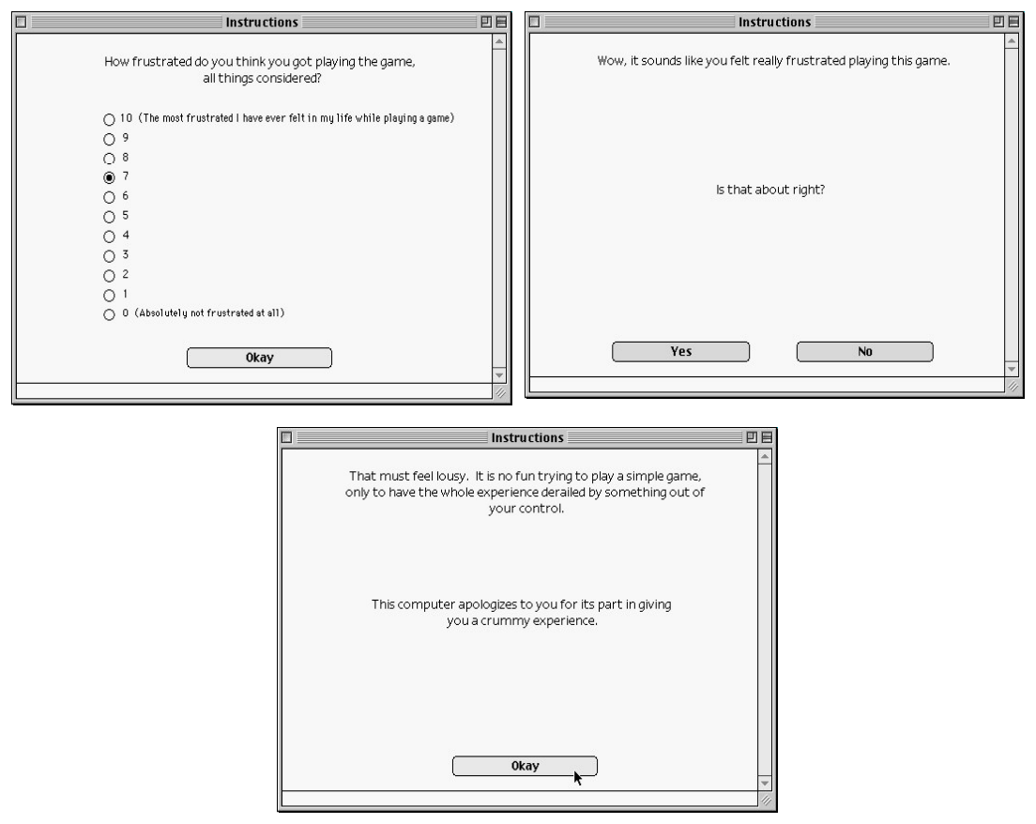
* **The above image shows how active listening, empathy, and sympathy can be used to help a frustrated user to feel better.**
* **Now that we’ve seen how empathy makes chatbot conversations better, let’s see how developers are enabling chatbots to empathize and learn the human way of thinking.**
* ***Natural Language Processing:-***
* **In short, NLP organizes human language in a structure that is understandable for the chatbot’s system.**
* **This structuring takes place under the basis of phrases, grammar, and syntactic analyzation.**
* **After understanding a sentence, the NLP plans and puts out linguistically correct phrases as responses.**
* **NLP also employs text analysis to understand the sentimental outcome of a customer’s message.**
* **They are classified into negative, positive, mixed, and neutral to identify user behavior and how to respond to customer queries in the future.**
* **This technique also helps brands to identify what features customers like the most, and what are the critical trouble points**.
* **A great example of efficient chatbots built using a**[***custom NLP model is Niki***](https://freshdesk.com/customer-engagement/innovative-chatbots-blog/)***.***
* **Niki is your one-stop-shop conversational commerce bot.**
* **The bot tips you off with the best offers on anything from booking hotels to paying utility bills.**
* 