**Colors**

<https://vimeo.com/273565899>

watch this to see the color slider.

[**Prerequisites: Installing the software environment**](https://computationalthinking.mit.edu/Fall20/lecture1/#prerequisites_installing_the_software_environment)

Course Content - <https://computationalthinking.mit.edu/Fall20/installation/>

Add PLUTO in Julia ( ] to go in package mode)

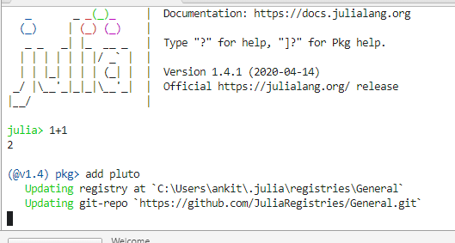

P is upper case use – add Pluto

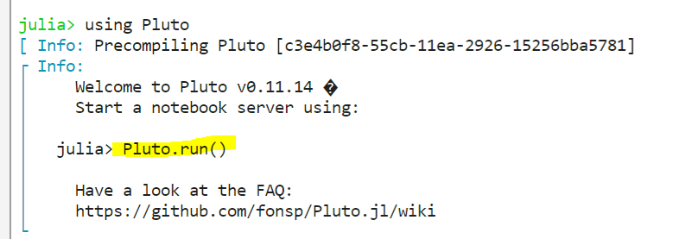

Pluto open here - <http://localhost:1234/>

<http://localhost:1234/sample> - has Julia learning material

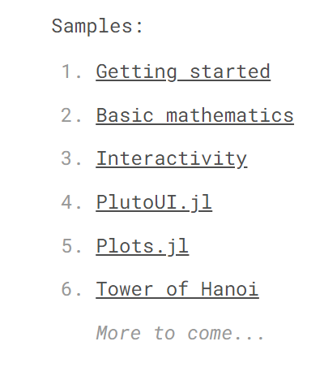

## How to Open PLUTO

Open Atom -> Terminal – Using Pluto -> Pluto.run() – screen shot is above

## [Introduction to Images in Julia](https://computationalthinking.mit.edu/Fall20/lecture1/#introduction_to_images_in_julia)

<https://github.com/mitmath/18S191/tree/master/lecture_notebooks/week1>

GitHub links for notebooks

<https://github.com/mitmath/18S191/tree/master/lecture_notebooks/week1>

youtube link

<https://www.youtube.com/watch?v=DGojI9xcCfg>

Ankit K @ankit48365 Oct 05 20:17

Guys, In Julia, If i have loaded an Image, what set of command should i use to see an image in Matrix form, , ie. to see a pixel in numerical form of a color (0-255) in RGB

BridgingBot @GitterIRCbot 20:18

[zulip] <mbaz> @ankit48365 check out channelview from Images.jl