**G. Colab advanced**

In this notebook, we mention the R programming language file handling (big - data) through the G. Colab and GPU, TPU & pro version features.

Q. How to use for use of G. Colab GPU (free)?

Answer: Open Colab new notebook > Go to Runtime > Click on Change Runtime Type > select any GPU option

G. Colab (freely) give System RAM = 0.00 / 12.7 GB, Disk = 0.00 / 107.7 GB and currently supportive R & Python3 languages for data mining.

**About T4 GPU**

T4 GPU: a model of GPU (Graphics Processing Unit) developed by NVIDIA. It is commonly used in data centers and cloud computing for tasks such as deep learning, machine learning, and data processing due to its performance and efficiency

Terminology:

1. GCP notebook: Google Cloud Platform
2. TPU: Tensor Processing Unit powered by Google, where GPU by NVIDIA (Tesla T4 or P100)

!nvidia-smi is a command that can be run in a terminal to access information about NVIDIA GPU devices. It displays details such as the GPU model, memory usage, temperature, and power usage.

<https://www.geeksforgeeks.org/how-to-use-gpu-in-google-colab/>

Q. Check which GPU is allotted to you VM (Virtual Machine). How?

Answer: By command nvidia-smi

As a virtual machine in Google Colab, the available GPUs are provided by Google Cloud. The specific GPU you will be allocated can vary, but typically they are NVIDIA Tesla K80, T4, P4, or P100 GPUs. You can check the GPU allocated to your session using the command! nvidia-smi in a code cell.

# checking GPU version providing in G. Colab (free)

!nvidia-smi

three distinct players have emerged as the powerhouses of processing: CPU, GPU, and TPU. These acronyms represent Central Processing Units, Graphics Processing Units, and Tensor Processing Units, each with its unique strengths and applications.

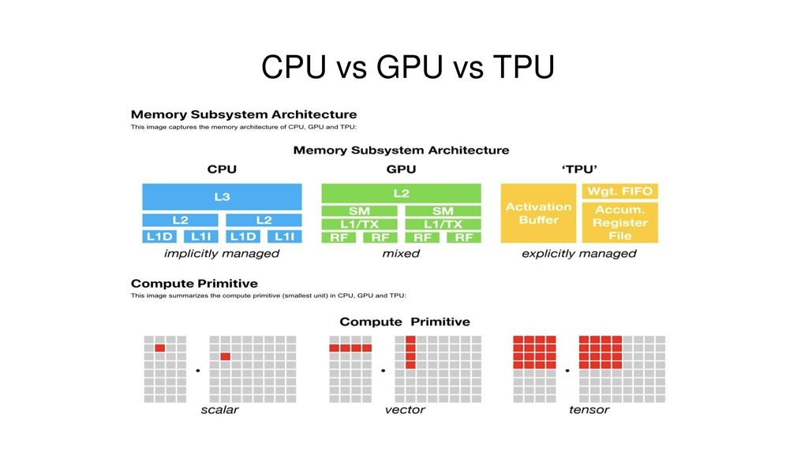

VPN (e.g. Surf shark) for changing the current location suggest by Krishn Naik

[https://chromewebstore.google.com/detail/surfshark-vpn-extension/ailoabdmgclmfmhdagmlohpjlbpffblp](https://chromewebstore.google.com/detail/surfshark-vpn-extension/ailoabdmgclmfmhdagmlohpjlbpffblp%20)

…………………………………………………………….

**3rd June’24 (Monday)**

setup puTTY in my system for GPU run of IIITG

<https://www.chiark.greenend.org.uk/~sgtatham/putty/latest.html>

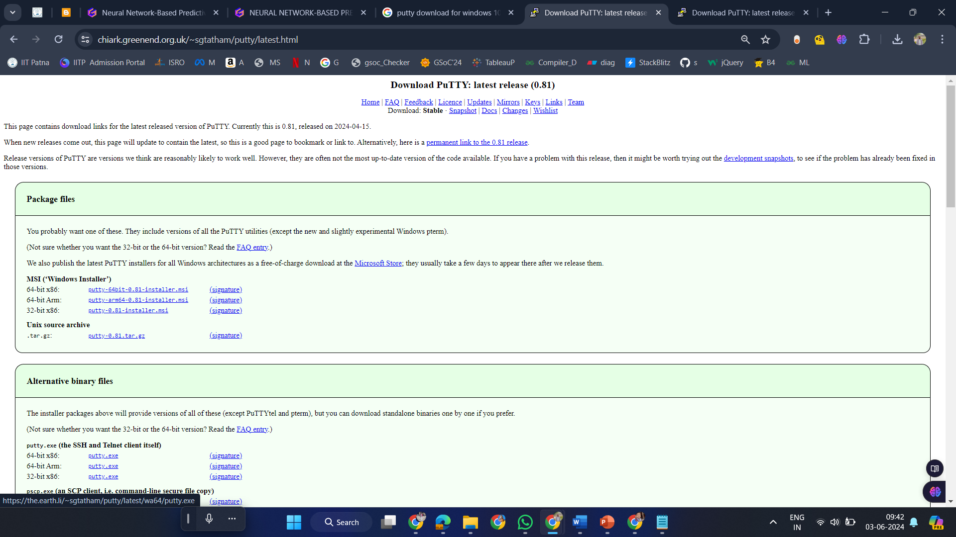

puTTY_README.md

PuTTY README

============

This is the README file for the PuTTY MSI installer distribution. If

you're reading this, you've probably just run our installer and

installed PuTTY on your system.

What should I do next?

----------------------

If you want to use PuTTY to connect to other computers, or use PSFTP

to transfer files, you should just be able to run them from the

Start menu.

If you want to use the command-line file transfer utility PSCP, you

will need to run this from a Command Prompt or equivalent, because it

will not do anything useful without command-line options telling it

what files to copy to and from where. You can do this by just running

the command **'pscp'** from a Command Prompt, if you used the installer's

option to put the PuTTY installation directory on your PATH.

Alternatively, you can always run pscp.exe by its full pathname, e.g.

"C:\Program Files\PuTTY\pscp.exe".

(Note that a Command Prompt that was already open before you ran the

installer will not have inherited the update of PATH.)

What do I do if it doesn't work?

--------------------------------

The PuTTY home web site is

[https://www.chiark.greenend.org.uk/~sgtatham/putty/](%20%20https:/www.chiark.greenend.org.uk/~sgtatham/putty/)

Here you will find our list of known bugs and pending feature

requests. If your problem is not listed in there, or in the FAQ, or

in the manuals, read the Feedback page to find out how to report

bugs to us. PLEASE read the Feedback page carefully: it is there to

save you time as well as us. Do not send us one-line bug reports

telling us `it doesn't work'.

NFHS dataset = National Family Health Survey

<https://rchiips.org/nfhs/index.shtml>

Port No:    22

Host Name (or IP address): **172.16.2.17**

username:   sanjib.singha

password same:    sanjib.singha

Download and Install

1. XMing <https://sourceforge.net/projects/xming/>
2. WinSCP <https://winscp.net/download/WinSCP-6.3.3-Setup.exe/download>
3. puTTY  [https://www.chiark.greenend.org.uk/~sgtatham/putty/](%20%20https:/www.chiark.greenend.org.uk/~sgtatham/putty/)

**10th June’24 (Monday)**

We successfully login to IIIT Guwahati GPU and also learn Jupyter Notebook & Jupyter Lab.

Q. How to open Laptop folder to Jupyter notebook?

Ans: Right click on folder and open with terminal. Give command pip install Jupyter notebook, then only type Jupyter notebook. This will auto redirect to new tab localhost where we can access notebook and Lab both.

Q. After terminal login to localhost, you Window PowerShell gets converted into npm prefix. Why?

Ans: This is the closest parent directory to contain a package. Json file or node modules directory, unless -g is also specified. If -g is specified, this will be the value of the global prefix.

The npm prefix is typically displayed in the terminal prompt to indicate the current working directory or the location of the npm packages being used in the environment. If your Windows PowerShell session is displaying the npm prefix, it could be due to a customization or configuration setting that you have implemented in your terminal environment.

Like we use in backend to create app.js (web-dev) through express node.js which run on the localhost and port which you define.

**IPython** stands for "Interactive Python". It is a tool that provides an interactive computing environment and a command shell for the Python programming language developed in 2015.

The name, Jupyter, comes from the core supported programming languages that it supports: Julia, Python, and R.

<https://realpython.com/jupyter-notebook-introduction/#:~:text=Jupyter%20Notebook%20is%20maintained%20by,Julia%2C%20Python%2C%20and%20R.>

Jupyter Notebook (formerly IPython Notebook) is a web-based interactive computational environment for creating notebook documents.

"kernel" refers to the computational engine that executes the code contained within a notebook document.