SWAMINARAYAN BOOK STALL

# AnkitKumar JagdishChandra Pandya

### **University Examination Number: 7**

##### November 2012

**Submitted To:**

G. H. Patel Post Graduate Department of Computer Science and Technology,

Sardar Patel University,

Near Jain Derasar, Nana Bazaar,

VallabhVidyanagar - 388120, Gujarat, India.

**G. H. Patel Post Graduate Department of Computer Science and Technology,**

**S A R D A R P A T E L U N I V E R S I T Y**

## C E R T I F I C A T E

This is to certify that Mr. **AnkitKumar JagdishChandra Pandya** of MCA Vth Semester (University Examination Number: 7) has successfully carried out a project entitled “**Swaminarayan BookStall**” towards partial fulfillment of the course **PS05CMCA05** In-house Project Work.

Signature of HOD

Date: Seal of Institute

## ACKNOWLEDGEMENT

With immense pleasure, I would like to present this report on the project assignment of **Swaminarayn BookStall.** It gives me a great pleasure to acknowledge the help and guidance available to me during the system development period from various eminent persons.

I offer my sincere thanks to **Dr. P.V.Virpariya Sir,Professor & Head of the G. H. Patel PG Department of Computer Science & Technology, Sardar Patel University,** for giving me an opportunity to develop my skills as a part of 5th semester In-house Project work and **Mr. B.V.Patel Sir** , our Project Guide for giving us their support to develop our application.

I also express my profound thanks to academic as well as non-academic staff authorities of GDCST family for providing me all facilities & helping me in clearing my doubts, without whom this project would not be a successful one.

Esteemed knowledge, dynamic and valuable advices are the backbone of this project. I am highly indebted to all, for helping me to give project its present shape. The success of this project is not due to any single person, but to the combined success of project guide and inspirational individuals including infallible staff members.

Thanking you all in anticipation.

**Ankit Pandya**

Index

|  |  |  |
| --- | --- | --- |
| **Chapter**  **No** | **Details** | **Page Numbers** |
| **1.** | **About the System** |  |
| 1.1 | Introduction | 5 |
| 1.2 | Objectives | 5 |
| 1.3 | Resource Requirements | 6 |
| 1.4 | Application Of Project | 7 |
| 1.5 | Limitations | 7 |
| 1.6 | Future Enhancement | 7 |
|  |  |  |
| **2.** | **Work Analysis** |  |
| 2.1 | Preliminary Study | 8 |
| 2.2 | Feasibility Study | 8 |
| 2.3 | Requirement Analysis | 9 |
| 2.4 | Design Constraints | 9 |
| 2.5 | User Interface | 9 |
| 2.6 | System Output | 10 |
|  |  |  |
| **3.** | **Work Design** |  |
| 3.1 | Data Dictionary | 11 |
| 3.2 | Context Level Diagram | 15 |
| 3.3 | Zero Level DFD | 15 |
| 3.4 | First Level DFD | 16 |
|  |  |  |
| **4.** | **System Output** |  |
| 4.1 | Screen Shots | 17 |

Chapter 1 AbouThe System

**Chapter 1**:**About the System**

* 1. **Introduction**
* The main application of the system is to enable user to connect with on Swaminarayan BookStall online from his/her home or remotely.
* One of the most important feature of the application is it uses HTTP/HTTPS protocol so no Firewall can block them, as compared to other systems which relies on Sockets may be blocked by the Firewall.
* The purpose of My Web-site is to facilitate users to see books, cd’s, dvd’s, e-book and also can be purchase that items.
* The other purpose of Swaminarayan BookStall is to globalizes books, cd’s, dvd’s selling, and also provide other some facilitates which related with this system. Everyone can get all facilitates easily by this system.

* 1. **Objective**
* Enable users to do Purchasing of different Product and downloading e-book.
* Provides the user very intuitive and easy to access user interface.
* Enables admin to manage users.
* Enable admin to manage orders.
* Enable admin to perform actions like inserting, editing, deleting of different items.
* Users can access different publications items, searching items and can buy it.
* Provides remote maintainability.
* Security becomes one of the most important issues for the trading so this application provides security mechanism for security purpose.

About The System

**1.3) Resource Requirement**

1. **Hardware Specification:**

* **CPU :** Intel Pentium IV or Higher Standard CPU
* **RAM :** 512 MB (Recommended 512 or higher)
* **Hard Disk :** 2GB or more
* **Display Monitor :** A good resolution monitor
* **Graphic Card :** Any latest graphics card.

1. **Software Specification:**

* **Operating System :** Windows XP or Higher Platform
* **Application Software** :

**Front-End:** Microsoft Visual Studio 2010 (ASP.NET with C#)

**Back-End:** Microsoft SQL Server 2008

* Internet Explorer 6.0 or higher version/Mozilla 3.0 or higher
* Web Server – IIS 6.0 or 7.0
* Adobe Photoshop CS2
* Ajax Control Toolkit

1. **Tools Used**

* Microsoft Visual Studio 2010
* Microsoft SQL Server 2008
* Adobe Photoshop CS2

**About the Technology**

* **Windows Presentation Foundation (WPF)**

WPF is a new way of creating User interface for windows application.WPF allows separation of UI & Code. It provides great flexibility to develop application with good looking interface WPF utilizes the GPU processing found in most of newer systems.

* **Windows Communication Foundation(WCF)**

WCF is a new way of creating Web Service & Inter Process communication. WCF allows developers to take complete control of their web service. Developers can control all serialization that happens in web service and also there are many bindings available for different needs.

* **ASP.Net**

ASP.net is a web development stack for developing great looking & dynamic website on .Net platform. It provides rich support for Data handling & provides a flexible programming model for it.

**1.3) Application of the Project**

* This application is for the all the clients of the Swaminarayan BookStall.
* The application is used for purchasing, downloading different e-book..
* The application can be used to view online different books, CD’s, DVD’s Information.

**1.4) Limitations**

* Internet Connection is required.
* Only registered users can purchase items so registration is required.
* Web Services are a bit slow then their TCP counterparts.
* WPF utilizes the power of GPU so Initial Runtime (bootstrap) may be slow.

**1.5) Future Enhancement**

* Users can get notification of their orders through SMS.
* Playing video and audio of different issues related to items.
* Users can make online transaction for the payment of items.

Work Analysis

**Chapter 2: Work Analysis**

**2.1) Preliminary Study**

* My initial study shows that all customer want to purchase their items they must visit to bookstall.
* Every time visit to bookstall is time consuming for customer.
* Administrator also maintains the clean up entire bookstall.
* If someone is in hurry, customer or worker then may be mistake occurs.
* So, I have been decided to develop a website to represent the products of bookstall.
* This website with a latest technology supports will have a skill to satisfy customer willingness.
* I shall advertise the latest publications of the Swaminarayn BookStall.
* Various kind of search, downloading, purchasing the items modules can be there.
  1. **) Feasibility Study:**

1. **Technical Feasibility:**

* The Application does not require any special kind of hardware or software.

1. **Operational Feasibility:**

* It is dependent upon determining human resources for the project. It refers to projecting whether the system will operate and be used once it is stalled.

r

* This system has a user friendly environment with good GUI (Graphics User Interface) with Images for easily understanding the functionality of the system.2 Analysis

1. **Economic Feasibility:**

* The application on client side requires a good PC with good graphic card for the rich user interface.
* The concerned business must be able to see the value of the investment it is considering before committing to an entire system study.
* Cost of the development is nominal for this system. Here we do not need to invest so much extra funds to develop the system. Thus, this system is economical feasible to the organization.

**2.3) Requirement Analysis**

1. **Specific Requirements:**

* This project needs a server where this application can be deployed.
* The server should be windows based.
* User will need a browser of standard IE6.0 or higher or Mozilla 3.0 or higher.

1. **Performance Requirements:**
   * + Good internet bandwidth is required.
     + The client has to have an operating system which can support IE 6.0 or higher version OR Mozilla 3.0 or higher version.
     + User might have RAM that is more than 512MB so that the system can operate smoothly
     + Good Graphic card can give better User Interface.
2. **Functional Requirements:**

* This application needs a computer and internet connection to run.

**2.4) Design Constraints**

* User cannot resize the Windows of the application.
* User cannot save any preferences to their local disk.
* User should have a Standard Keyboard to utilize the Keyboard bindings.
* User cannot change the Shortcut keys.

Chapter 2 Work Analysis

**2.5) User Interface**

* The interface Provides user with easy access to all the Recharging data he needs.
* User can easily place his orders from data grid or by login into site.
* User can download E-book.
* User can view list of Selling book, CD, DVD products in this site.

**2.6) System Output**

* The application provides an interface that enables the user to place an order purchase items.
* This application allows administrator to maintain the users’ information and their details also.
* Administrator can maintain orders details and address details of various customers.
* This application also provides different kinds of order lists which are required by the administrator.

Chapter 3 Work Design

# Chapter 3 : Work Design

**3.1) Data Dictionary:**

* **Item_master :**

|  |  |  |
| --- | --- | --- |
| **Field Name** | **Type** | **Size** |
| Book_id | Varchar | 5 |
| Book_nm | Varchar | 50 |
| Author | Varchar | 50 |
| Price | Numeric | 8,0 |
| Description | Varchar | 255 |
| Photo | Varchar | 100 |
| Stock | numeric | 6,0 |

* **Login:**

|  |  |  |
| --- | --- | --- |
| **Field Name** | **Type** | **Size** |
| Email | Varchar | 50 |
| Usrname | Varchar | 20 |
| Password | Varchar | 20 |
| Seque | Varchar | 40 |
| Seans | Varchar | 30 |

* **Personal Info:**

|  |  |  |
| --- | --- | --- |
| **Field Name** | **Type** | **Size** |
| Email | \Varchar | 50 |
| Fname | Varchar | 30 |
| Lname | Varchar | 40 |
| Gender | Varchar | 1 |
| Bdate | Date |  |
| Mno | Varchar | 15 |
| Lno | Varchar | 15 |

* **Address Detail:**

|  |  |  |
| --- | --- | --- |
| **Field Name** | **Type** | **Size** |
| Email | Varchar | 50 |
| Name | Varchar | 70 |
| Stadd | Varchar | 200 |
| City | Varchar | 40 |
| Taluka | Varchar | 40 |
| Dist | Varchar | 40 |
| State | Varchar | 30 |
| Country | Varchar | 30 |
| Pin | Numeric | 6,0 |

Chapter

* **Order Details:**

|  |  |  |
| --- | --- | --- |
| **Field Name** | **Type** | **Size** |
| Email | Varchar | 50 |
| Order_id | Varchar | 10 |
| Item_id | Varchar | 5 |
| Item_name | Varchar | 50 |
| Price | Numeric | 8,0 |
| Quantity | Numeric | 5,0 |
| Subtotal | Numeric | 10,0 |
| Order date | Date |  |
| Order status | Varchar | 10 |

* **Order Shipping:**

|  |  |  |
| --- | --- | --- |
| **Field Name** | **Type** | **Size** |
| Email | Varchar | 50 |
| Order id | Varchar | 10 |
| Name | Varchar | 70 |
| Address | Varchar | 200 |
| City | Varchar | 40 |
| Taluka | Varchar | 40 |
| Dist | Varchar | 40 |
| State | Varchar | 30 |
| Country | Varchar | 30 |
| Pin | Numeric | 6,0 |
| Mono | Numeric | 15,0 |

* **Feedback detail :**

|  |  |  |
| --- | --- | --- |
| **Field Name** | **Type** | **Size** |
| Email | Varchar | 50 |
| Book variety | Varchar | 1 |
| Web rat | Varchar | 1 |
| Remarks | Varchar | 255 |
| Satis | Varchar | 10 |

**3.2) Context Level Diagram:**

**3.3) Zero Level DFD:**

**3.4) First Level DFD:**

**3.4.1) First Level DFD for Process 1.0:**

**3.4.2) First Level DFD for Process 3.0:**

# Chapter 4 : System Output

**4.1) Screen Shots:**

* **Home Page:**

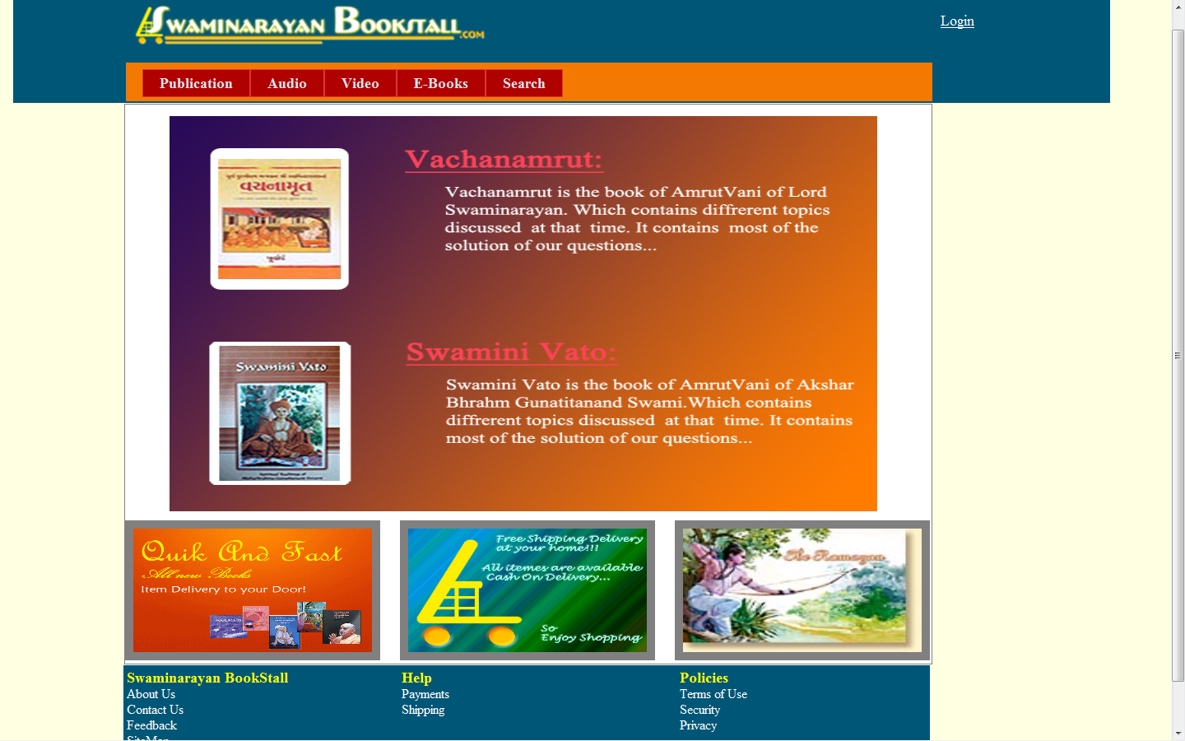

* **Publication:**

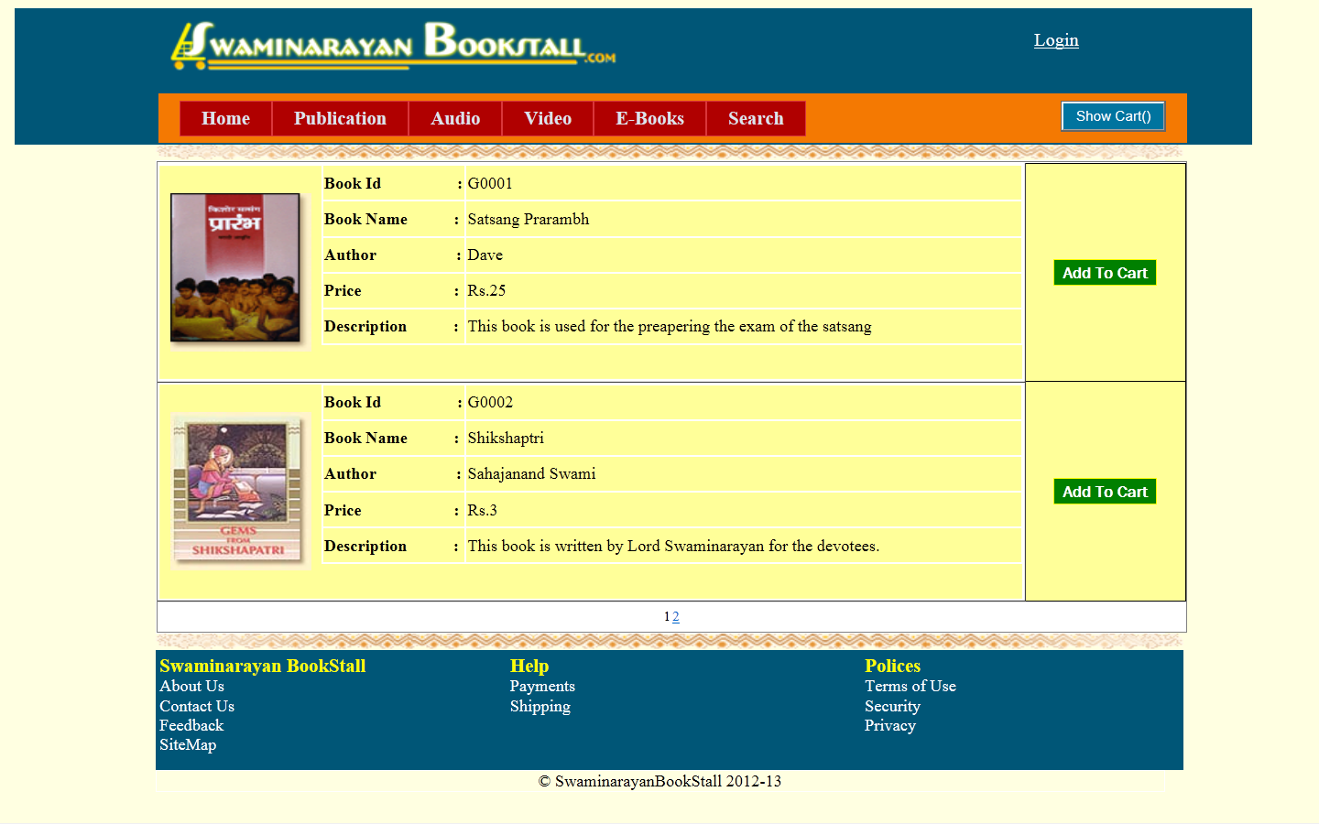

* **Search:**

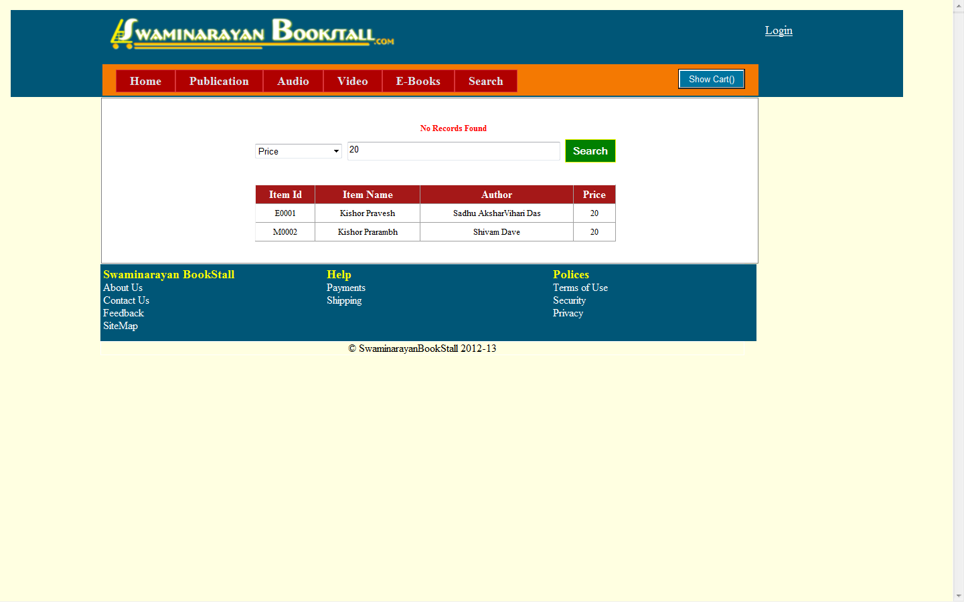

* **Admin – Insert Item:**

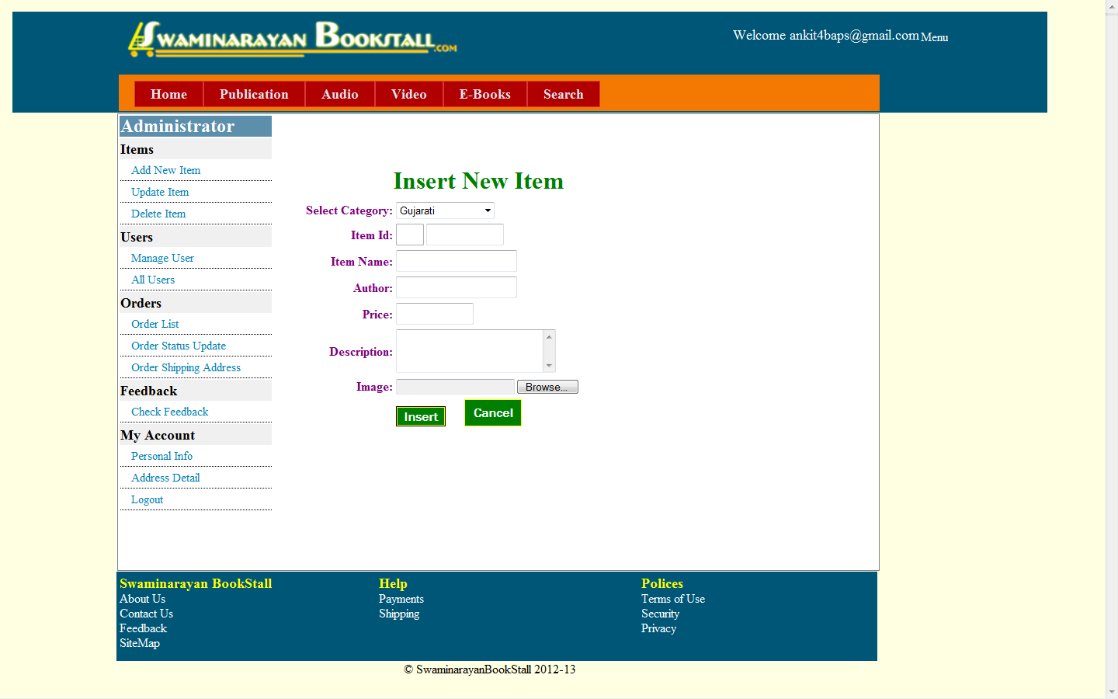

* **Admin – Update\Delete Item:**

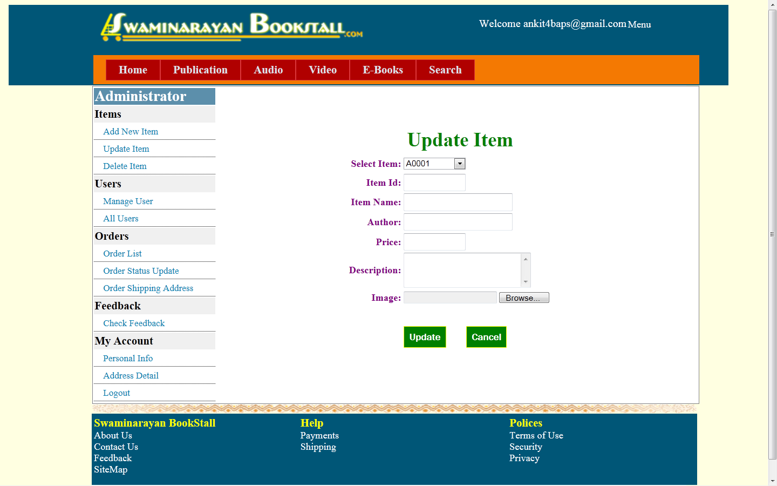

* **Admin – Order List:**

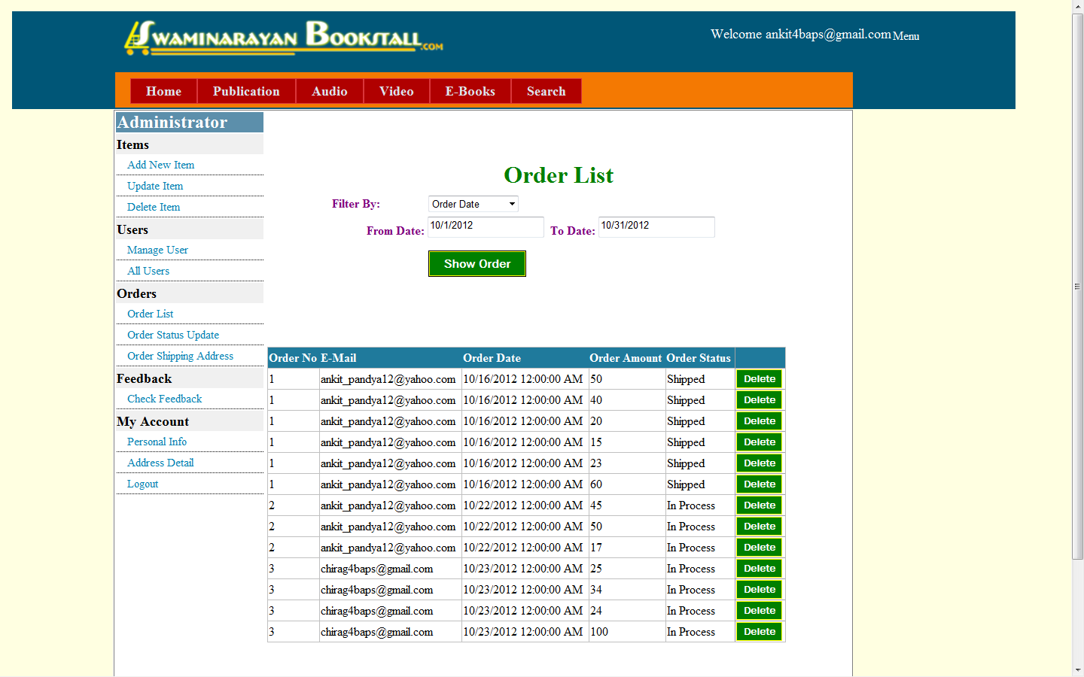

* **Personal Information:**

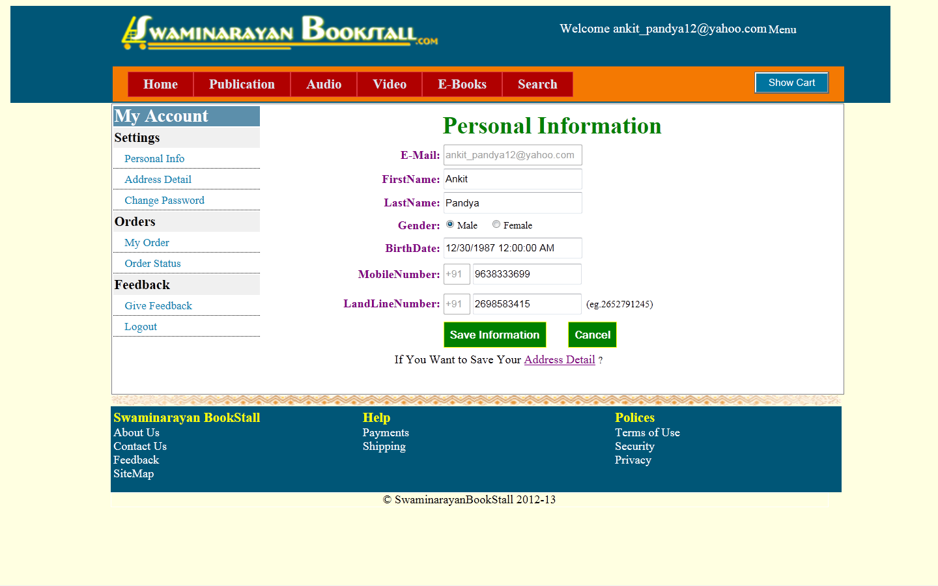

* **Address Detail:**

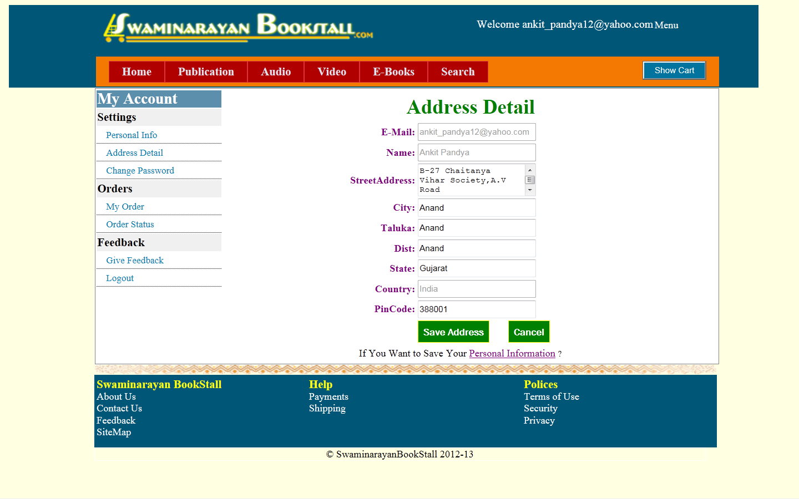

* **Show Cart:**

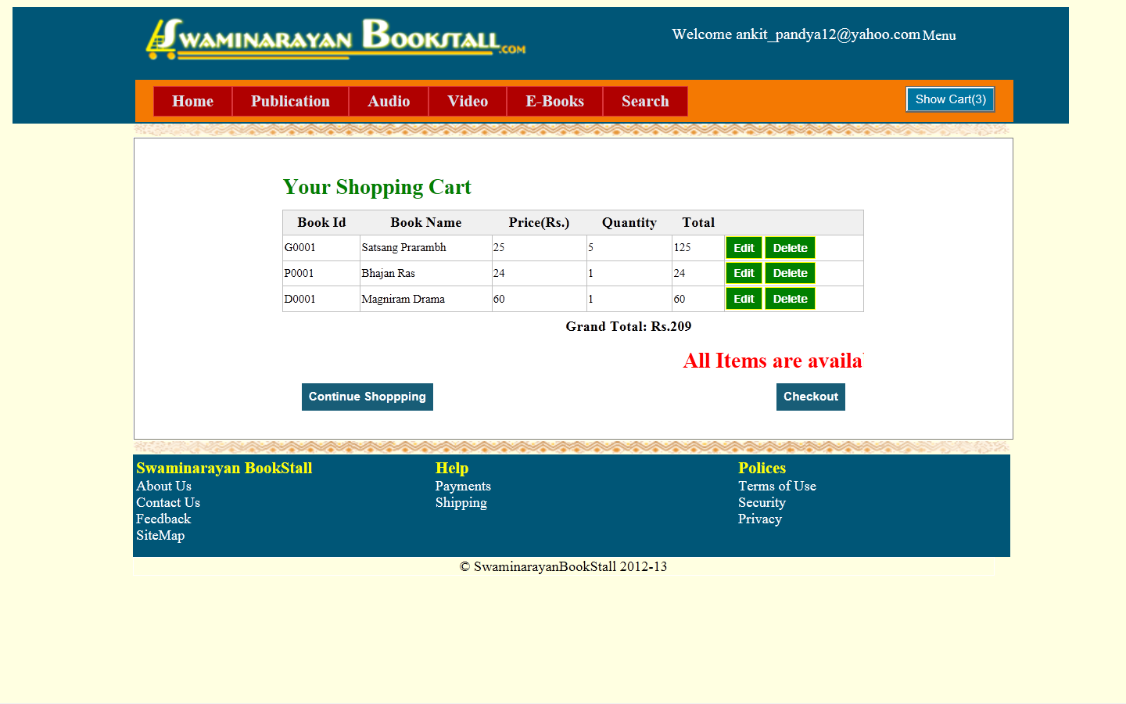

* **Check Out:**

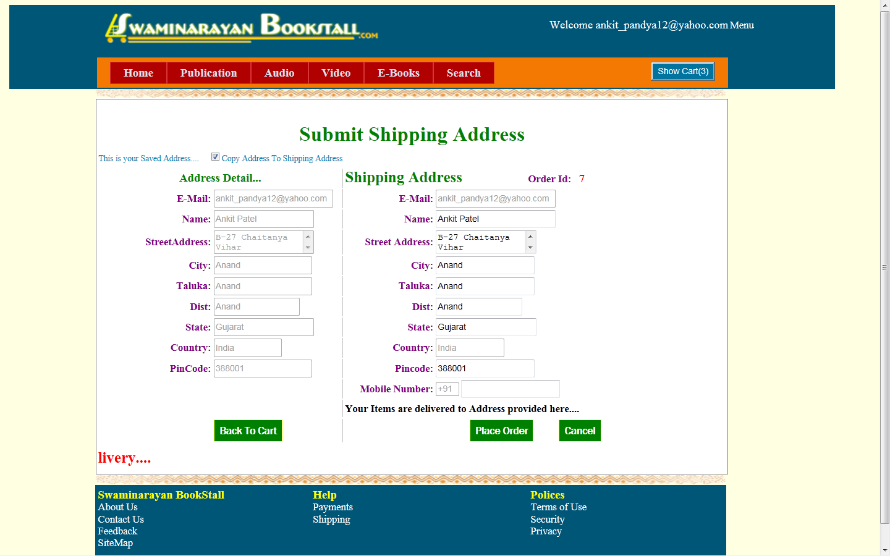

* **Feedback:**

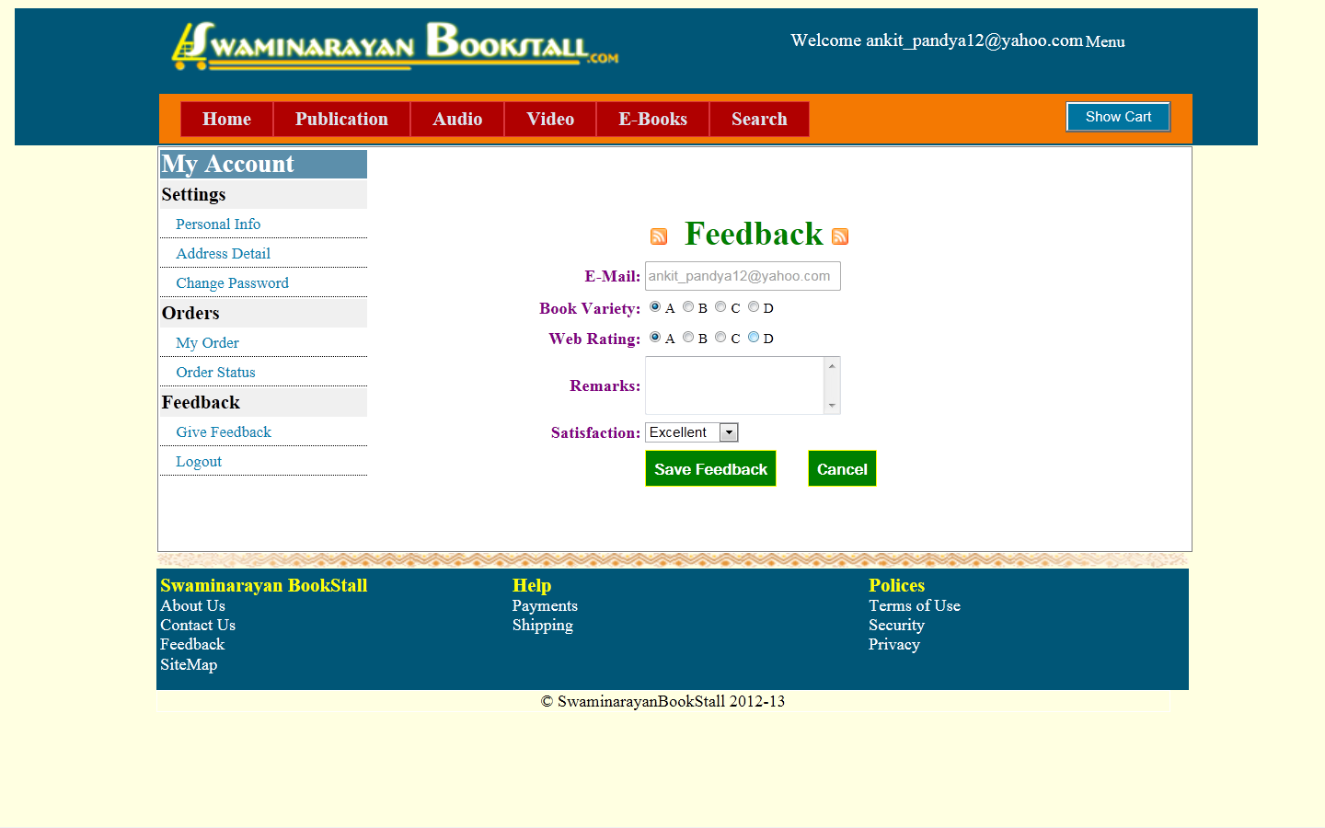

* **Sitemap:**

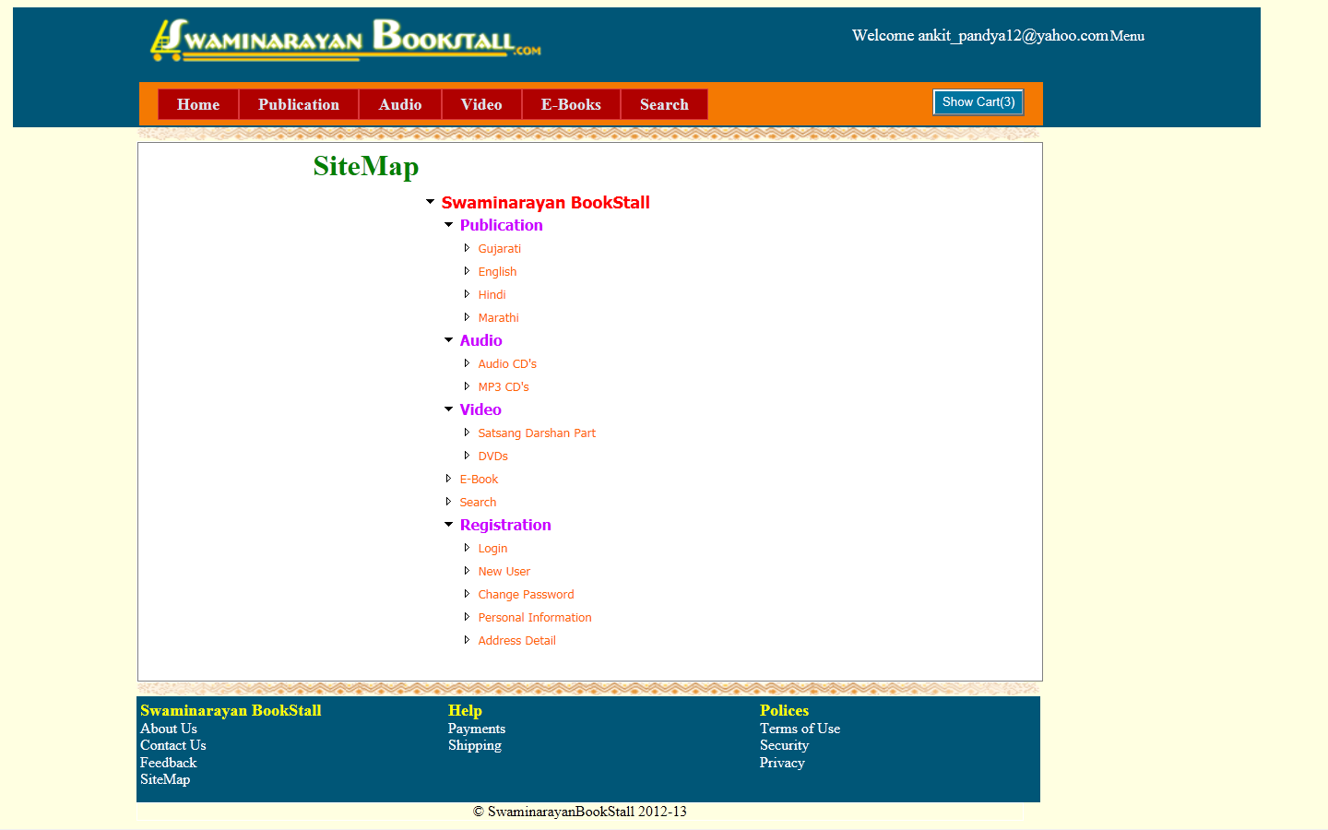

* **E-book:**

