Cypress Tests Execution

To run the Project, You need following tools in your System:

1. Nodejs
2. Npm
3. Vs code

Then install the cypress in you system by using --- npm install cypress

To config the project.

1. Open the project in the vs code
2. Run the command in command line : npm install (it will install all the project configuration/dependencies etc)

To run the Test cases: Run the commands in the vs code’s Terminal

1. npx cypress open : it will open the cypress dashboard, and the click on E2E Testing

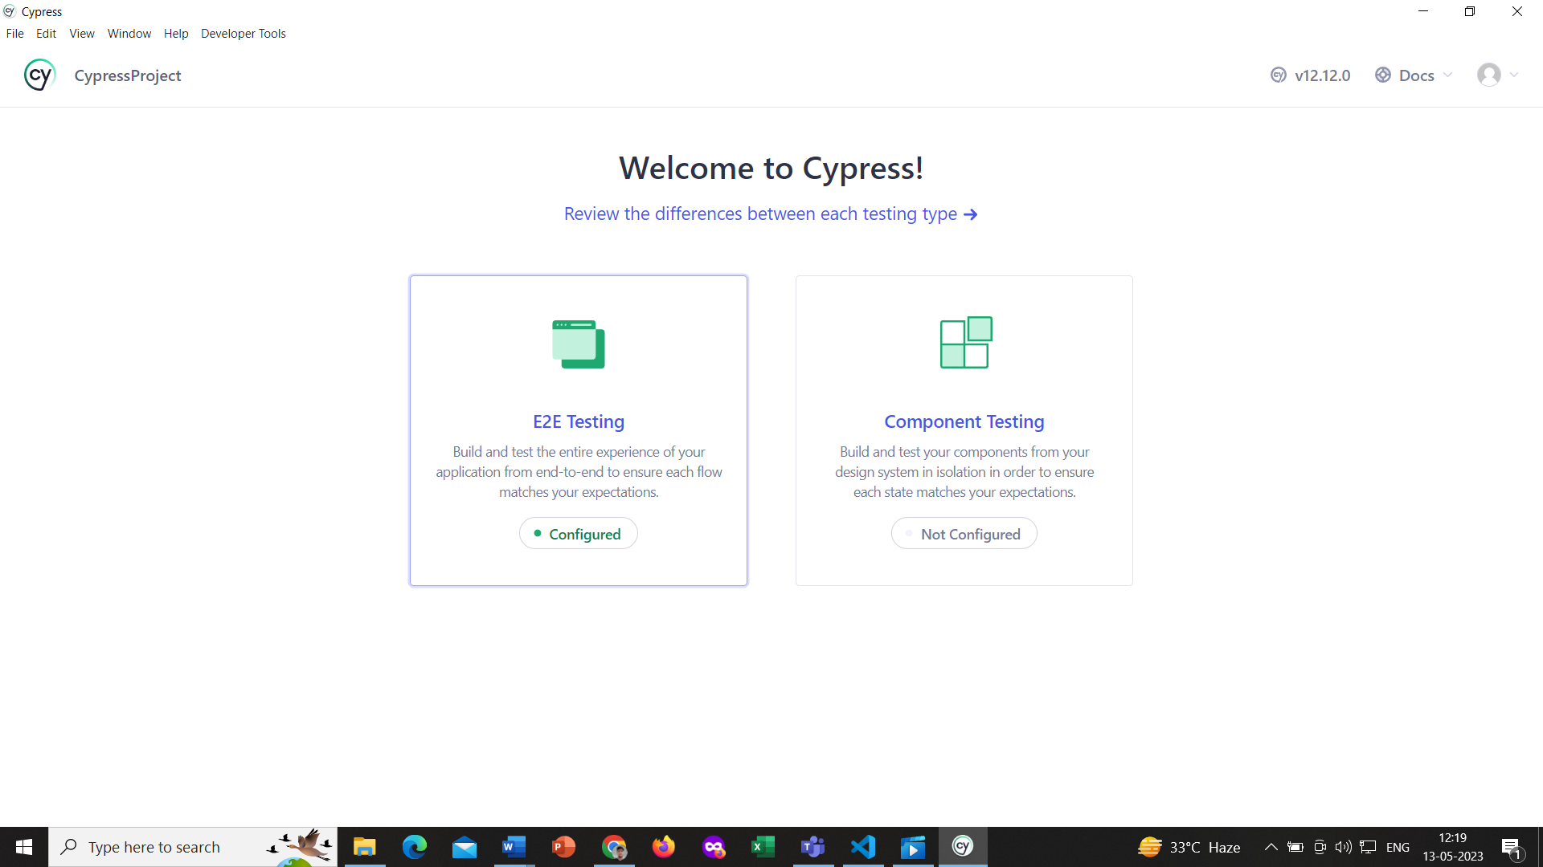

1. Then select the browsers, in which you want to execute your tests.

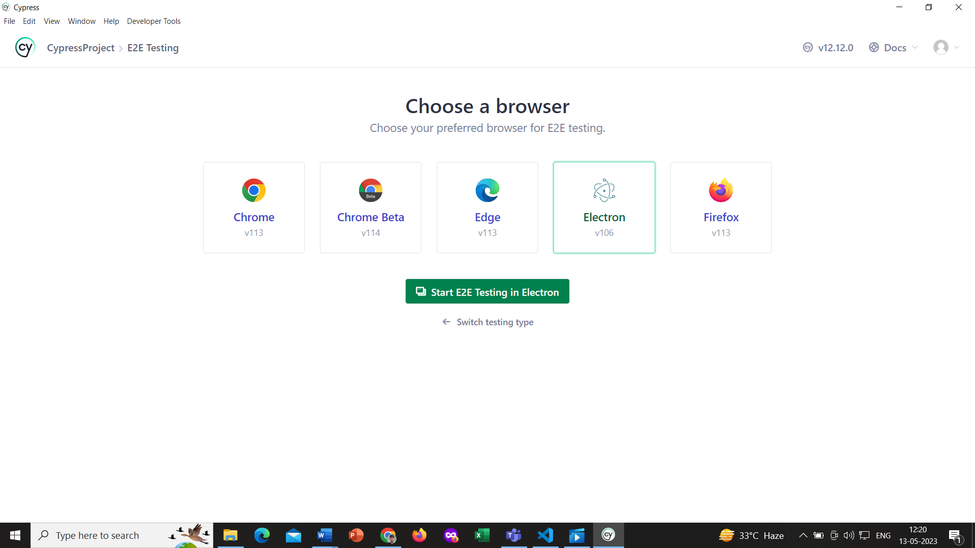

1. After selecting the browsers, it will open a new tab that show the test cases

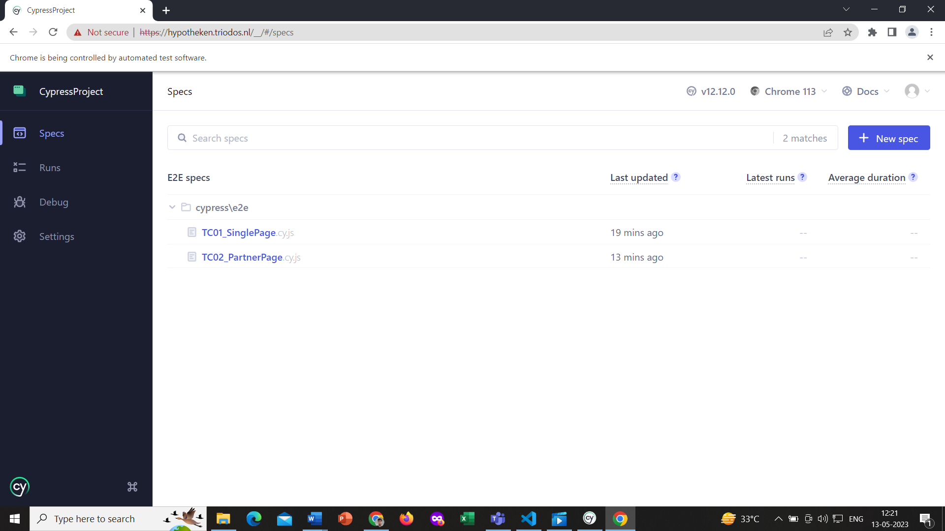

1. Then click on the test cases you want to execute or run.

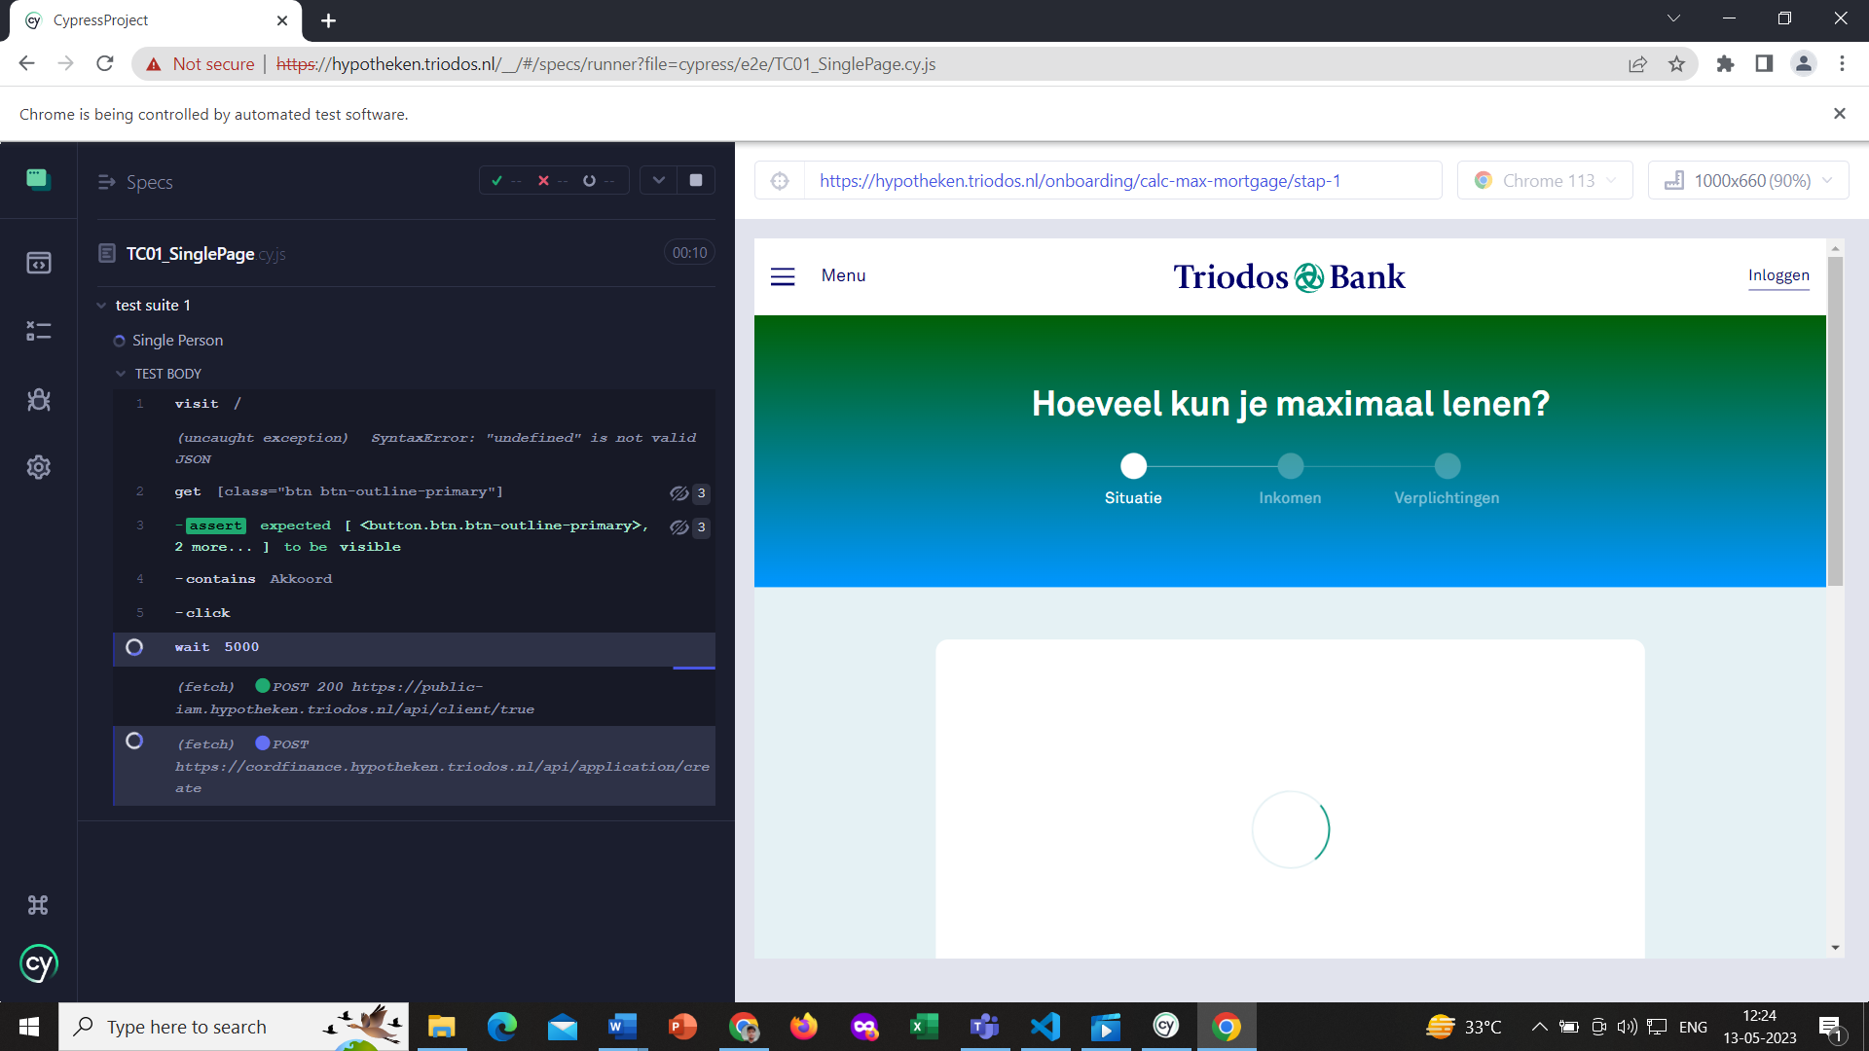

Others Commands that will used to run the test cases and to see the reports

1. npx cypress run : it will run test cases in headless mode without opening dashboard
2. npm test : This will execute test cases in headless mode and after the execution it will open the allure report in the browser itself.

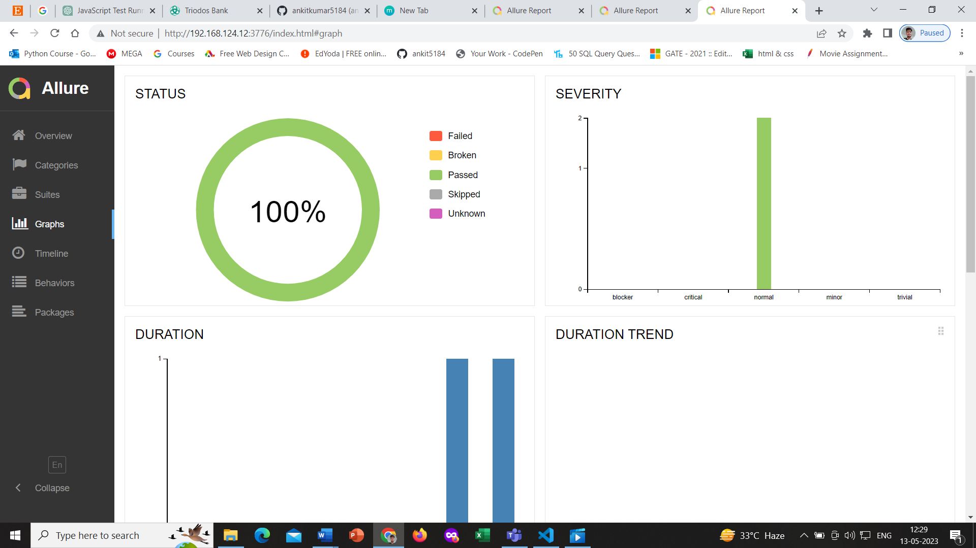

Thank you for your time and consideration. I look forward to hearing from you soon.