Amazon Sales Report Analysis

Prepared by: Data Analyst Team

Date: 2023

# Executive Summary

- T-shirts and Shirts dominate product sales, accounting for the majority of listings.  
- Most shipments are successfully delivered, but cancellations and returns are notable.  
- Sizes M, L, XL, and XXL are the most demanded.  
- Recommendations include inventory optimization and improving delivery performance.

# Introduction

This report presents an analysis of the Amazon Sale Report dataset. The goal is to identify key trends in product categories, shipping status, and size distribution to support business decisions.

# Data Overview

The dataset includes product categories, shipping statuses, and size information. Key metrics such as delivery success rate, cancellation rate, and return rate are derived from the data.

# Product Category Analysis

The chart below shows the distribution of product categories by quantity sold.

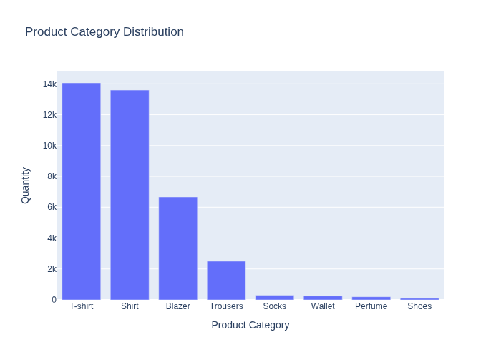

# Shipping Status Analysis

The pie chart below visualizes the distribution of shipping statuses.

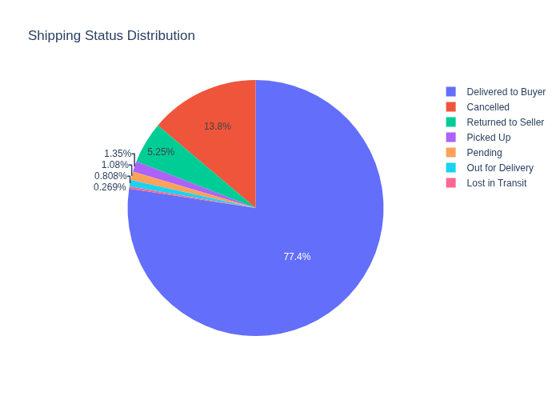

# Size Distribution Analysis

The chart below shows the distribution of product sizes.

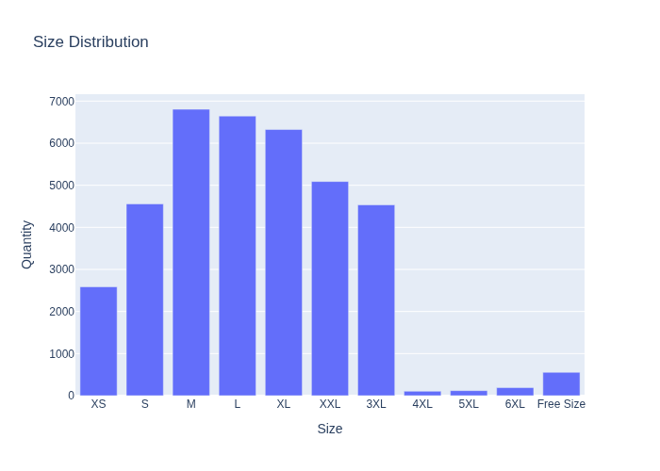

# Key Metrics

Delivery Success Rate: 77.43%  
Cancellation Rate: 13.82%  
Return Rate: 5.25%

# Recommendations

- Focus inventory on high-demand categories (T-shirts, Shirts) and sizes (M, L, XL, XXL).  
- Investigate reasons for cancellations and returns to improve customer satisfaction.  
- Optimize logistics to reduce pending and lost shipments.  
- Consider promotional strategies for mid-range and low-performing products.

# Conclusion

The analysis highlights strong performance in product delivery and identifies areas for improvement in inventory and logistics. Implementing the recommendations can enhance customer satisfaction and operational efficiency.

# Appendices

Charts included in the report:

1. Product Category Distribution

2. Shipping Status Distribution

3. Size Distribution