CHS Akash Singh – 2019UCO1528

**Power Bi**

Data Visualization

horizontal line

# 

# Introduction

**Power BI** is a collection of software services, apps, and connectors that work together to turn your unrelated sources of data into coherent, visually immersive, and interactive insights. Your data may be an Excel spreadsheet, or a collection of cloud-based and on-premises hybrid data warehouses. Power BI lets you easily connect to your data sources, visualize and discover what's important, and share that with anyone or everyone you want.

**Dataset**

I have gathered dataset from the Kaggle and then created a visualization of the sales of different products.

* Step 1

First I have adjusted the given data set to include different queries like Total Selling and buying values using SQL. I had also extracted information for date and time and month. I had also included new measure like, calculating profits and profit percentage.

* Step 2  
  Created different data cards with include different values of the product like profit, profit percentage, total quantity of the best products in the respective year.
* Step 3

I had customized the linkage of different visual panels accordingly. For example, I had removed links between the month, and dropdown sections. This is done so that only a certain number of visual panels are changed accordingly

* Step 4

Then I had added different graphs example, area chart, stacked column chart, donut charts and tree map.

Once I had added all the different things, I put them together formatted it accordingly to my needs.

This image below shows the sales for the month of February

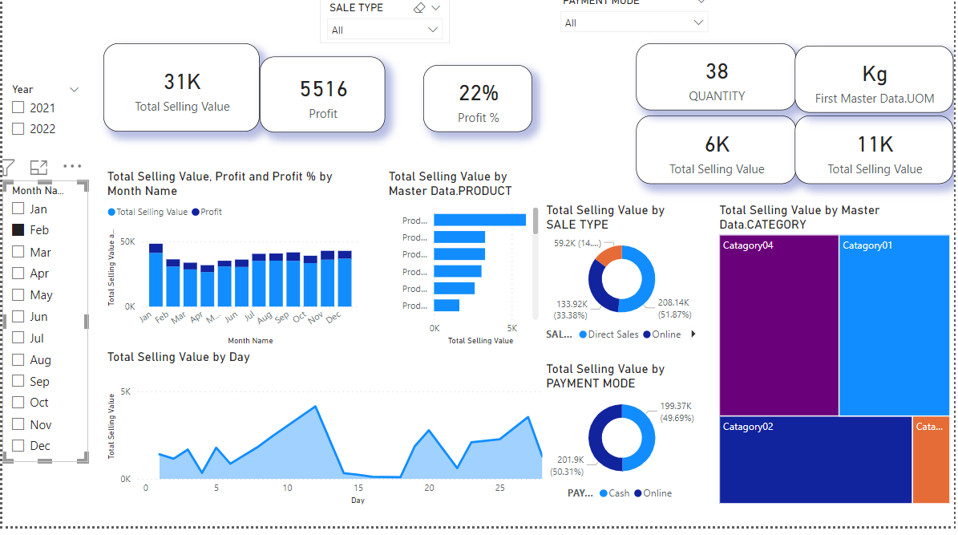

This Sale if for the year of 2022, month February, Direct Sales mode, Online Payment mode

