AI Driven Full Stack Development (AI308B)
Moodle ESE Submission Format

Name | Ankit Jaiswal
Branch | CSE AIML
Roll Number | 202401100400037
Section | A
Shift | MORNING
Case Study Name | AI-Based Smart Complaint Management System

- GitHub Repository Link
ankit7985605/AIFSDENDSEM

- Render Deployment Links for all Routes
Backend Deployment Link | https://aifsdendsem.onrender.com
Frontend Deployment Link | https://aifsdendsem.vercel.app/

RENDER DEPLOYMENT SCREENSHOT
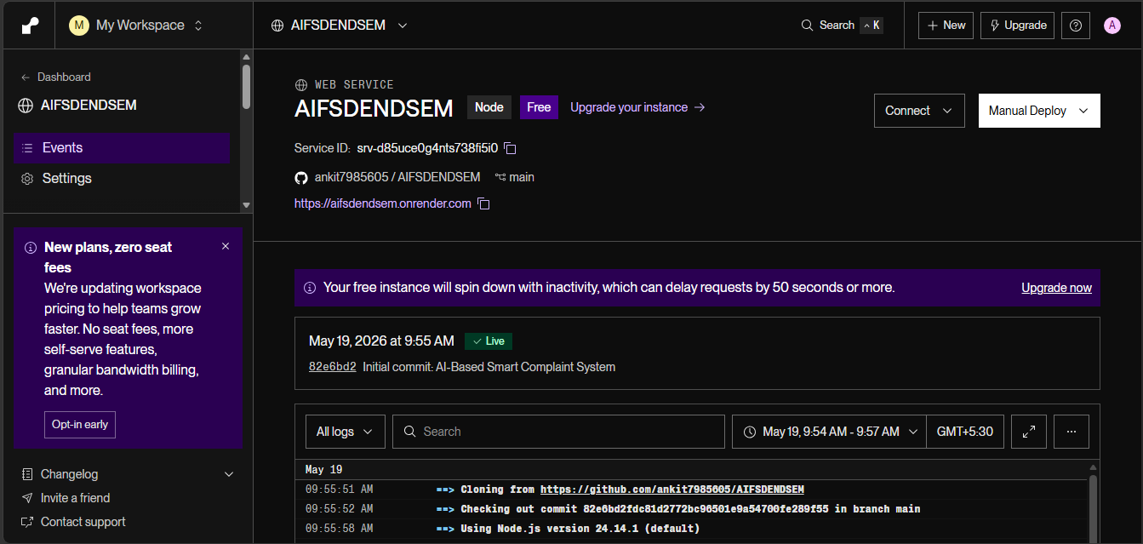
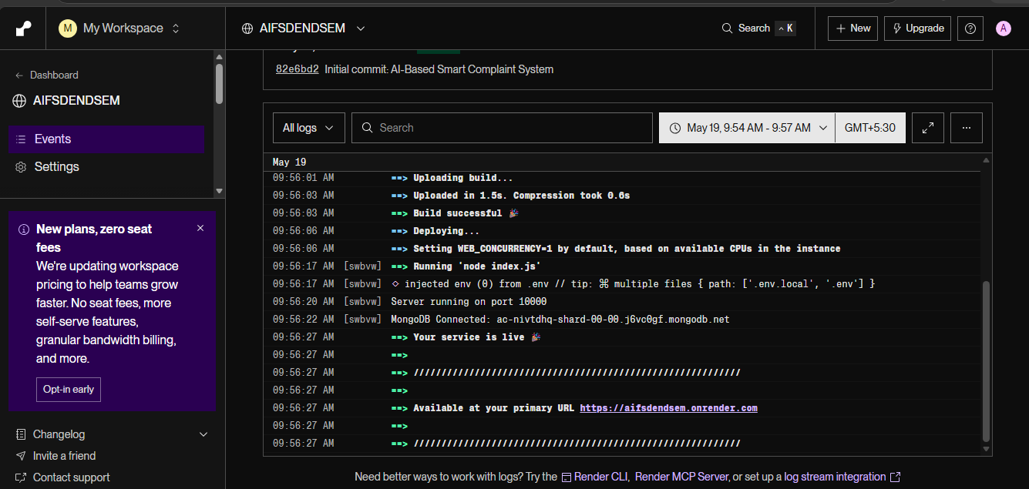
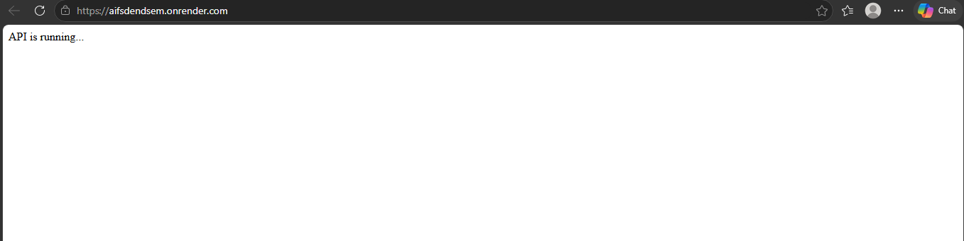
API’S
1.POST
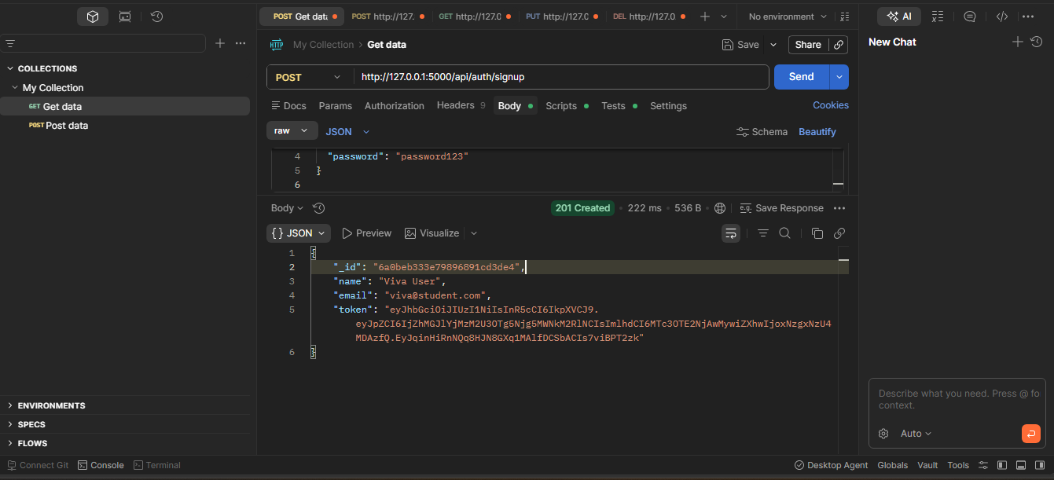
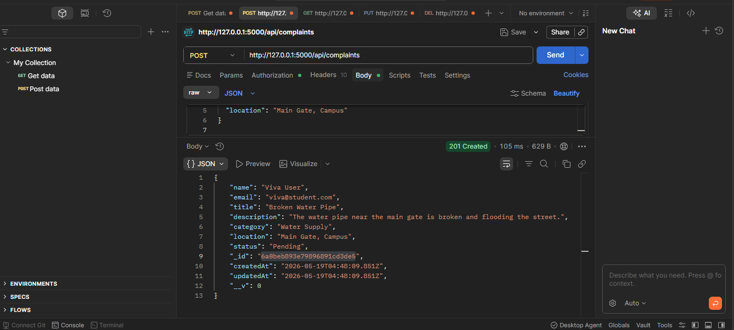
2.GET
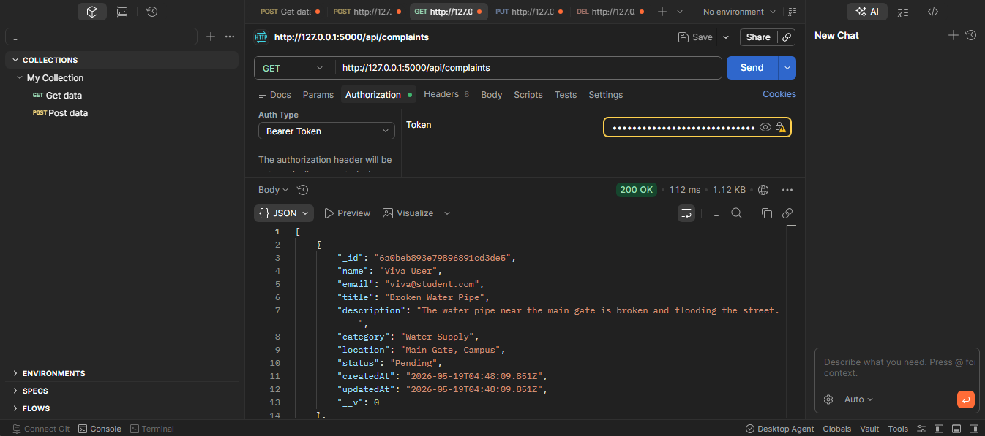
3.PUT
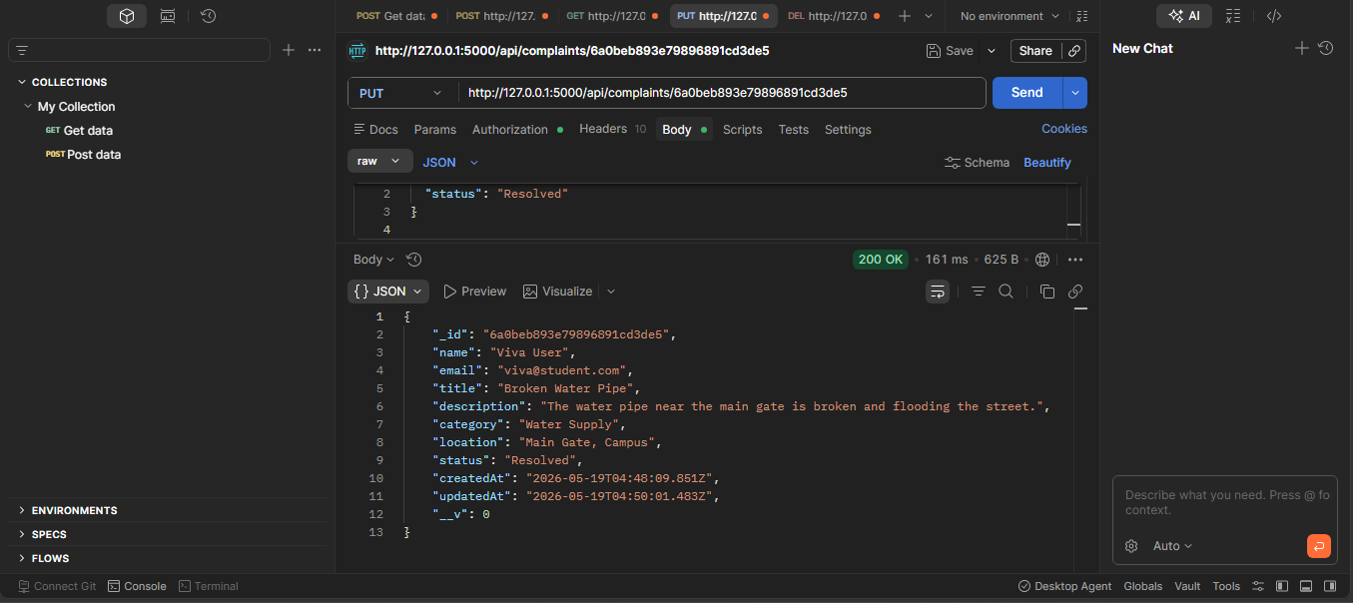
4.DELETE
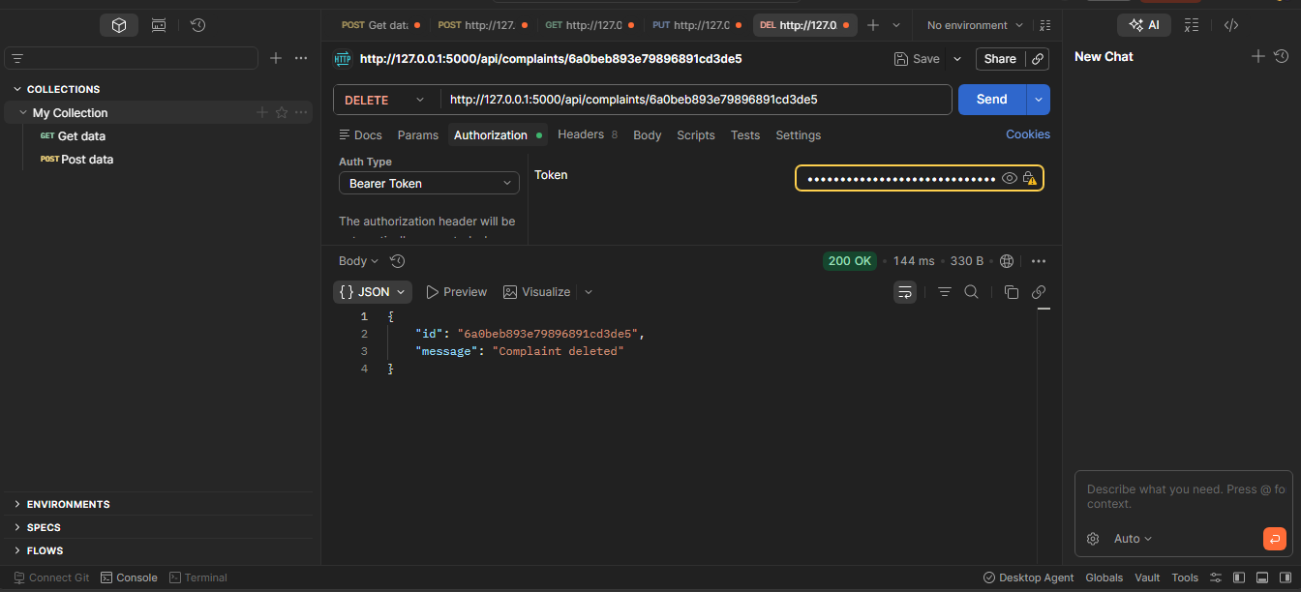
MONGODB SCREENSHOTS
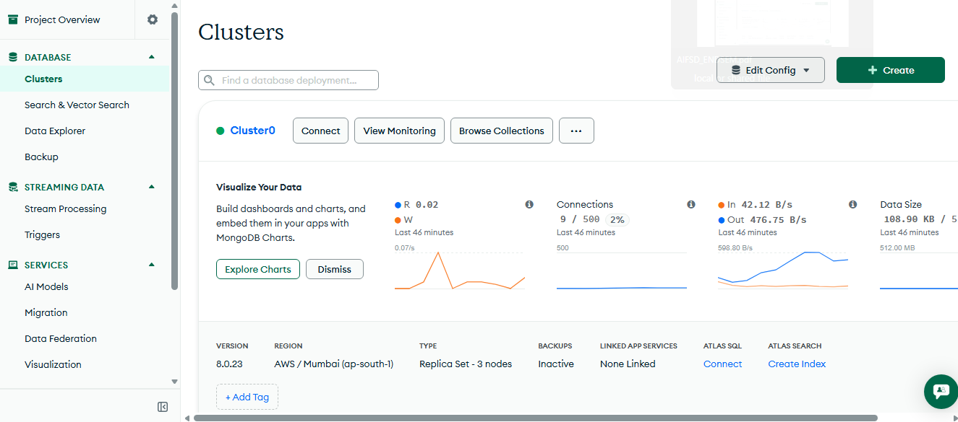
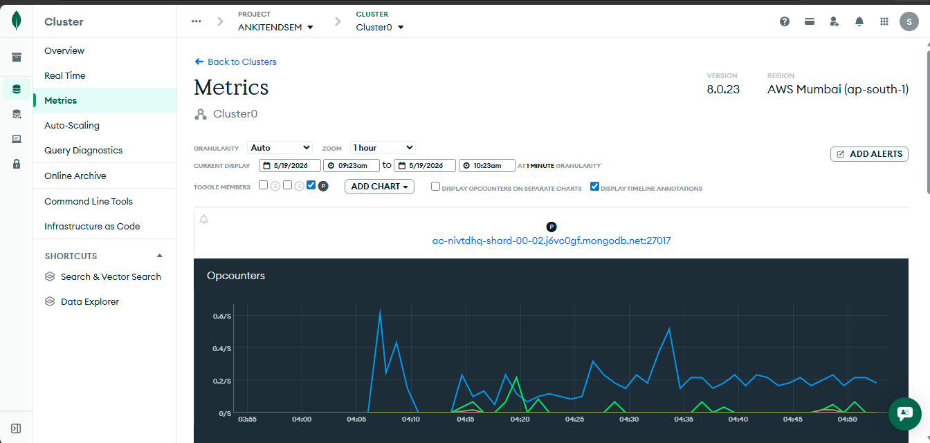

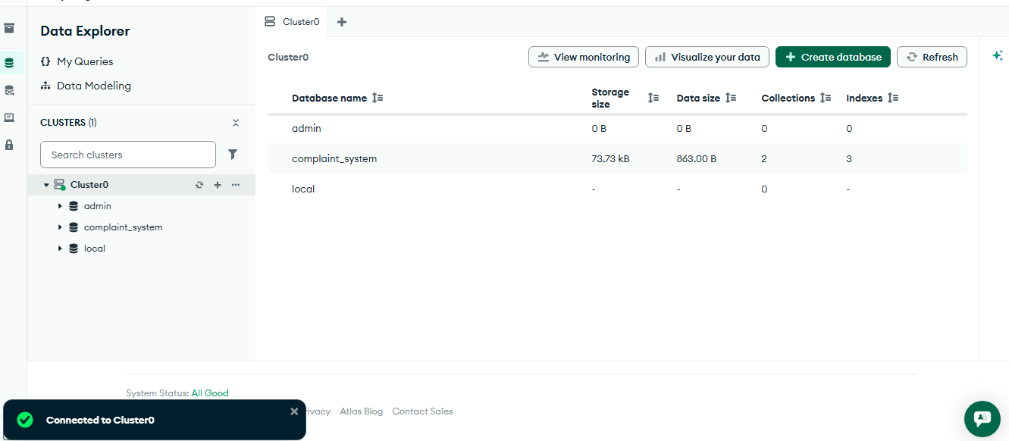
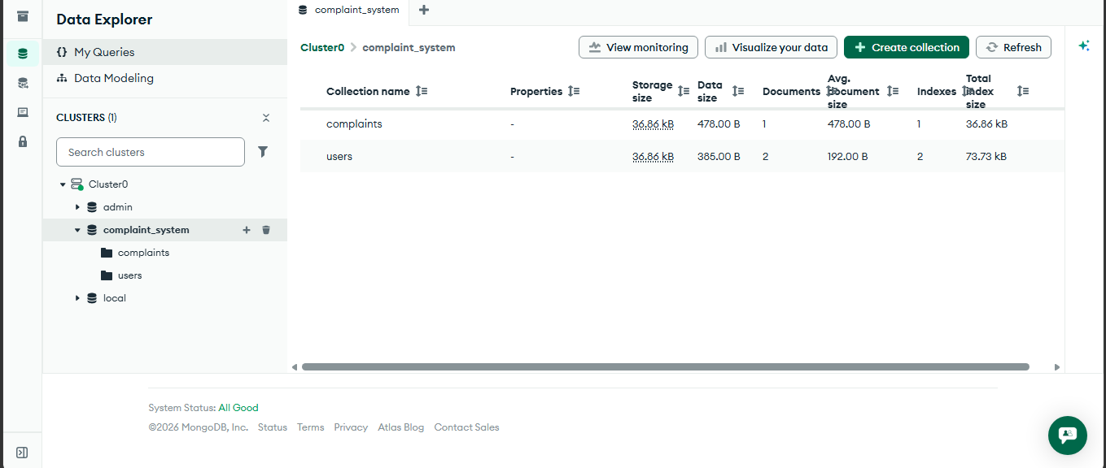
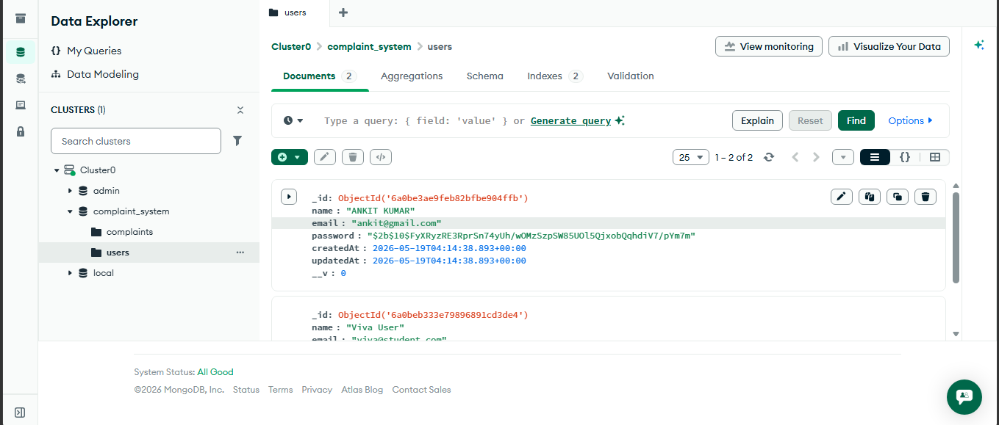
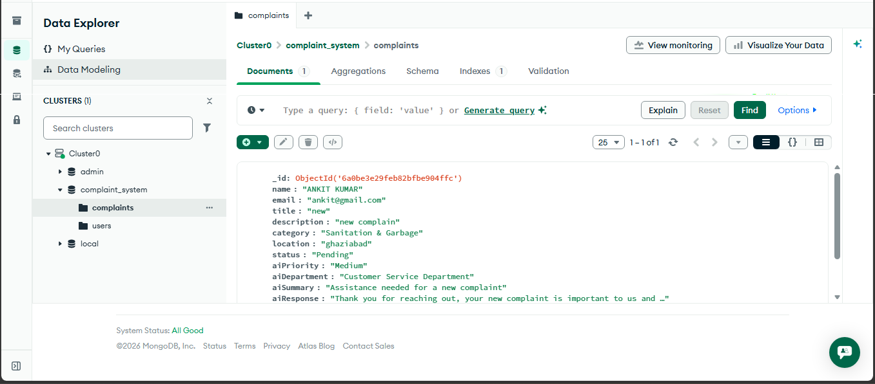
PROJECT FRONTEND SCREENSOTS
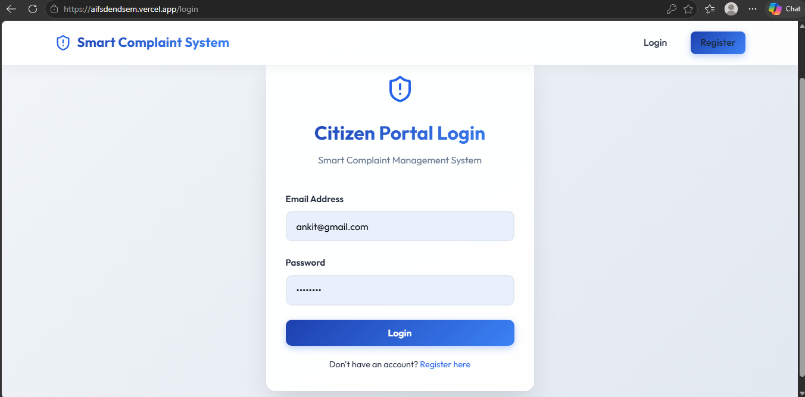
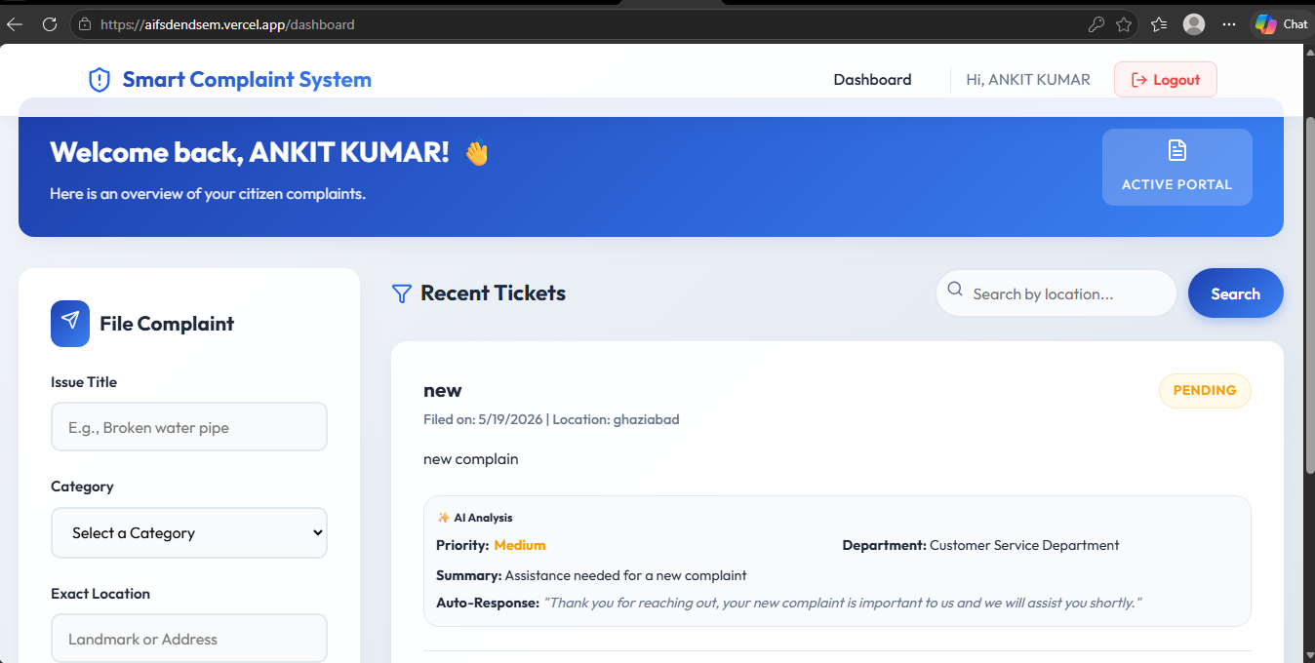
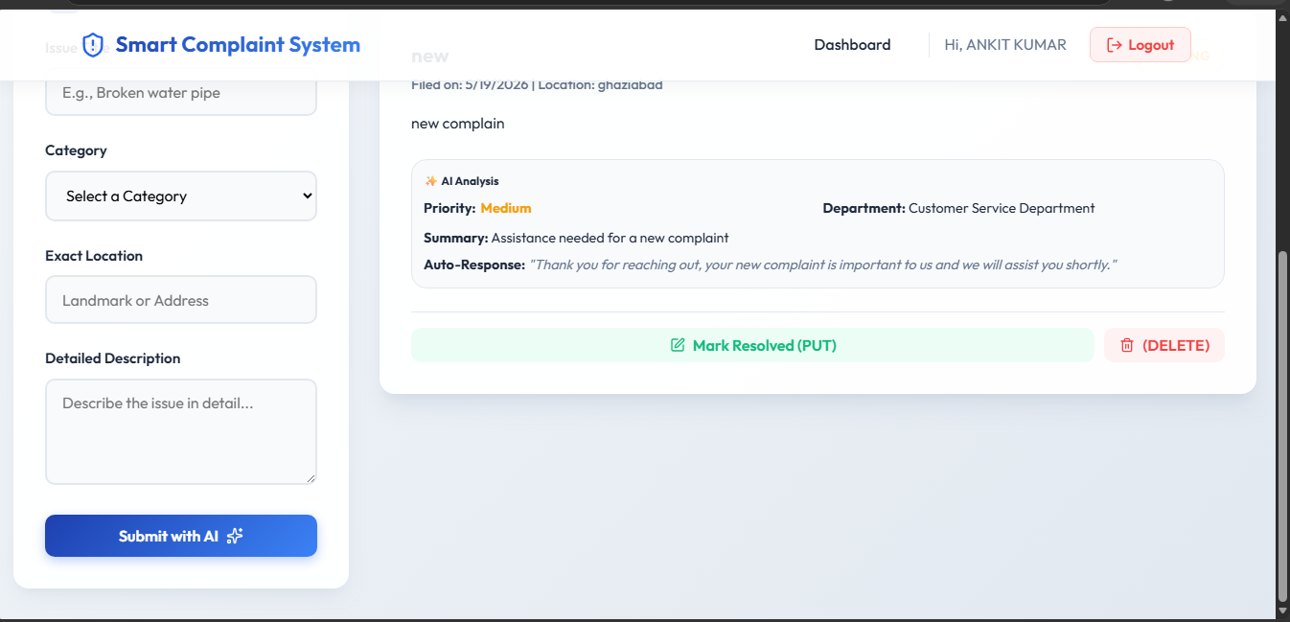
FRONT END CODE:
INDEX.HTML
<!doctype html>
<html lang="en">
<head>
<meta charset="UTF-8" />
<link rel="icon" type="image/svg+xml" href="/favicon.svg" />
<meta name="viewport" content="width=device-width, initial-scale=1.0" />
<title>client</title>
</head>
<body>
<div id="root"></div>
<script type="module" src="/src/main.jsx"></script>
</body>
</html>

PACKAGE-LOCK.JSON
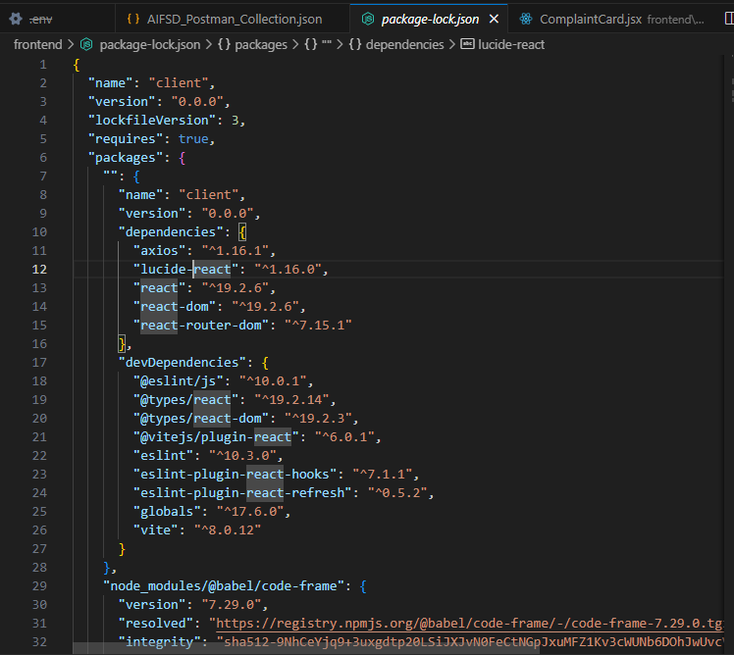
PACKAGE.JSON
{
"name": "client",
"private": true,
"version": "0.0.0",
"type": "module",
"scripts": {
"dev": "vite",
"build": "vite build",
"lint": "eslint .",
"preview": "vite preview"
},
"dependencies": {
"axios": "^1.16.1",
"lucide-react": "^1.16.0",
"react": "^19.2.6",
"react-dom": "^19.2.6",
"react-router-dom": "^7.15.1"
},
"devDependencies": {
"@eslint/js": "^10.0.1",
"@types/react": "^19.2.14",
"@types/react-dom": "^19.2.3",
"@vitejs/plugin-react": "^6.0.1",
"eslint": "^10.3.0",
"eslint-plugin-react-hooks": "^7.1.1",
"eslint-plugin-react-refresh": "^0.5.2",
"globals": "^17.6.0",
"vite": "^8.0.12"
}
}

BACKEND CODE:
DB.JS
const mongoose = require('mongoose');

const connectDB = async () => {
try {
const conn = await mongoose.connect(process.env.MONGO_URI);
console.log(`MongoDB Connected: ${conn.connection.host}`);
} catch (error) {
console.error(`Error connecting to MongoDB: ${error.message}`);
process.exit(1); // Exit process with failure
}
};

module.exports = connectDB;

AICONTROLLER.JS
// Using native fetch for OpenRouter API call

const analyzeComplaint = async (req, res) => {
try {
const { description } = req.body;

if (!description) {
return res.status(400).json({ message: 'Description is required for AI analysis' });
}

const prompt = `
Analyze the following complaint description and provide:
1. Priority (High, Medium, Low)
2. Department (e.g., Water Department, Electricity Board, Road & Transport, Public Health, etc.)
3. Summary (A short 1-line summary)
4. Auto-response (A polite 1-sentence auto-response to the citizen)

Complaint: "${description}"

Respond ONLY in the following JSON format without any extra markdown:
{
"priority": "High/Medium/Low",
"department": "Suggested Department",
"summary": "Short summary",
"autoResponse": "Auto response text"
}
`;

const response = await fetch('https://openrouter.ai/api/v1/chat/completions', {
method: 'POST',
headers: {
'Authorization': `Bearer ${process.env.OPENROUTER_API_KEY}`,
'Content-Type': 'application/json',
// Optional headers for OpenRouter
'HTTP-Referer': 'http://localhost:5000',
'X-Title': 'Complaint Management System'
},
body: JSON.stringify({
model: 'openai/gpt-3.5-turbo', // You can change this to a free model like 'google/gemma-7b-it:free' or 'huggingfaceh4/zephyr-7b-beta:free' if you prefer, but openrouter maps openai requests properly. Let's use standard openai/gpt-3.5-turbo which is cheap and fast, or meta-llama/llama-3-8b-instruct:free
messages: [
{ role: 'system', content: 'You are an AI assistant for a Smart Complaint Management System.' },
{ role: 'user', content: prompt }
]
})
});

if (!response.ok) {
const errorData = await response.text();
throw new Error(`OpenRouter API error: ${errorData}`);
}

const data = await response.json();
const aiMessage = data.choices[0].message.content;

// Parse JSON output and clean markdown blocks if AI adds them
let parsedResult;
try {
const cleanMessage = aiMessage.replace(/```json/g, '').replace(/```/g, '').trim();
parsedResult = JSON.parse(cleanMessage);
} catch (e) {
// Fallback if AI didn't return strict JSON
throw new Error("AI returned malformed JSON");
}

res.status(200).json(parsedResult);
} catch (error) {
console.error("AI Analysis Error:", error);
res.status(500).json({ message: error.message || 'Failed to analyze complaint' });
}
};

module.exports = { analyzeComplaint };

AUTHCONTROLLER.JS
const jwt = require('jsonwebtoken');
const bcrypt = require('bcrypt');
const User = require('../models/User');

// Generate JWT
const generateToken = (id) => {
return jwt.sign({ id }, process.env.JWT_SECRET, {
expiresIn: '30d',
});
};

// @desc Register new user
// @route POST /api/auth/signup
// @access Public
const registerUser = async (req, res) => {
try {
const { name, email, password } = req.body;

if (!name || !email || !password) {
return res.status(400).json({ message: 'Please add all fields' });
}

// Check if user exists
const userExists = await User.findOne({ email });
if (userExists) {
return res.status(400).json({ message: 'User already exists' });
}

// Hash password
const salt = await bcrypt.genSalt(10);
const hashedPassword = await bcrypt.hash(password, salt);

// Create user
const user = await User.create({
name,
email,
password: hashedPassword,
});

if (user) {
res.status(201).json({
_id: user.id,
name: user.name,
email: user.email,
token: generateToken(user._id),
});
} else {
res.status(400).json({ message: 'Invalid user data' });
}
} catch (error) {
res.status(500).json({ message: error.message });
}
};

// @desc Authenticate a user
// @route POST /api/auth/login
// @access Public
const loginUser = async (req, res) => {
try {
const { email, password } = req.body;

// Check for user email
const user = await User.findOne({ email });

if (user && (await bcrypt.compare(password, user.password))) {
res.json({
_id: user.id,
name: user.name,
email: user.email,
token: generateToken(user._id),
});
} else {
res.status(401).json({ message: 'Invalid credentials' });
}
} catch (error) {
res.status(500).json({ message: error.message });
}
};

module.exports = {
registerUser,
loginUser,
};

COMPLAINTCONTROLLER.JS
const Complaint = require('../models/Complaint');

// @desc Get all complaints (or filter by user/location)
// @route GET /api/complaints
// @access Private
const getComplaints = async (req, res) => {
try {
const complaints = await Complaint.find().sort({ createdAt: -1 });
res.status(200).json(complaints);
} catch (error) {
res.status(500).json({ message: error.message });
}
};

// @desc Search complaints by location
// @route GET /api/complaints/search
// @access Public or Private depending on requirement
const searchComplaints = async (req, res) => {
try {
const { location } = req.query;
if (!location) {
return res.status(400).json({ message: 'Please provide a location query' });
}
// Use regex for case-insensitive partial matching
const complaints = await Complaint.find({ location: { $regex: location, $options: 'i' } });
res.status(200).json(complaints);
} catch (error) {
res.status(500).json({ message: error.message });
}
};

// @desc Create new complaint
// @route POST /api/complaints
// @access Private
const createComplaint = async (req, res) => {
try {
const { name, email, title, description, category, location, aiPriority, aiDepartment, aiSummary, aiResponse } = req.body;

if (!title || !description || !category || !location) {
return res.status(400).json({ message: 'Please add all required fields' });
}

const complaint = await Complaint.create({
name: name || req.user.name,
email: email || req.user.email,
title,
description,
category,
location,
aiPriority,
aiDepartment,
aiSummary,
aiResponse
});

res.status(201).json(complaint);
} catch (error) {
res.status(500).json({ message: error.message });
}
};

// @desc Update complaint
// @route PUT /api/complaints/:id
// @access Private
const updateComplaint = async (req, res) => {
try {
const complaint = await Complaint.findById(req.params.id);

if (!complaint) {
return res.status(404).json({ message: 'Complaint not found' });
}

const updatedComplaint = await Complaint.findByIdAndUpdate(
req.params.id,
req.body,
{ new: true } // Returns the updated document
);

res.status(200).json(updatedComplaint);
} catch (error) {
res.status(500).json({ message: error.message });
}
};

// @desc Delete complaint
// @route DELETE /api/complaints/:id
// @access Private
const deleteComplaint = async (req, res) => {
try {
const complaint = await Complaint.findById(req.params.id);

if (!complaint) {
return res.status(404).json({ message: 'Complaint not found' });
}

await complaint.deleteOne();

res.status(200).json({ id: req.params.id, message: 'Complaint deleted' });
} catch (error) {
res.status(500).json({ message: error.message });
}
};

module.exports = {
getComplaints,
searchComplaints,
createComplaint,
updateComplaint,
deleteComplaint
};

AUTHMIDDLEWARE.JS
const jwt = require('jsonwebtoken');
const User = require('../models/User');

const protect = async (req, res, next) => {
let token;

if (req.headers.authorization && req.headers.authorization.startsWith('Bearer')) {
try {
// Get token from header
token = req.headers.authorization.split(' ')[1];

// Verify token
const decoded = jwt.verify(token, process.env.JWT_SECRET);

// Get user from the token
req.user = await User.findById(decoded.id).select('-password');

next();
} catch (error) {
console.error(error);
res.status(401).json({ message: 'Not authorized, token failed' });
}
}

if (!token) {
res.status(401).json({ message: 'Not authorized, no token' });
}
};

module.exports = { protect };

COMPLAINT.JS
const mongoose = require('mongoose');

const complaintSchema = new mongoose.Schema({
name: {
type: String,
required: [true, 'Please add a name']
},
email: {
type: String,
required: [true, 'Please add an email']
},
title: {
type: String,
required: [true, 'Please add a title for the complaint']
},
description: {
type: String,
required: [true, 'Please add a description']
},
category: {
type: String,
required: [true, 'Please select a category']
},
location: {
type: String,
required: [true, 'Please add a location']
},
status: {
type: String,
default: 'Pending',
enum: ['Pending', 'In Progress', 'Resolved', 'Rejected']
},
// AI Generated Fields
aiPriority: {
type: String
},
aiDepartment: {
type: String
},
aiSummary: {
type: String
},
aiResponse: {
type: String
}
}, {
timestamps: true
});

module.exports = mongoose.model('Complaint', complaintSchema);

USER.JS
const mongoose = require('mongoose');

const userSchema = new mongoose.Schema({
name: {
type: String,
required: [true, 'Please add a name']
},
email: {
type: String,
required: [true, 'Please add an email'],
unique: true
},
password: {
type: String,
required: [true, 'Please add a password'],
minlength: [6, 'Password must be at least 6 characters']
}
}, {
timestamps: true
});

module.exports = mongoose.model('User', userSchema);

INDEX.JS
require('dotenv').config();
const express = require('express');
const cors = require('cors');
const connectDB = require('./config/db');

// Connect to database
connectDB();

const app = express();

// Middleware
app.use(cors());
app.use(express.json()); // Allows us to accept JSON data in the body

// Basic route to test server
app.get('/', (req, res) => {
res.send('API is running...');
});

// Routes
app.use('/api/auth', require('./routes/authRoutes'));
app.use('/api/complaints', require('./routes/complaintRoutes'));
app.use('/api/ai', require('./routes/aiRoutes'));

const PORT = process.env.PORT || 5000;

app.listen(PORT, '0.0.0.0', () => {
console.log(`Server running on port ${PORT}`);
});

PROJECT STRUCTURE:
